OpenSim: Open-source Software for Generating Muscle-Actuated Simulations of Movement

Frank C. Anderson, Chand T. John, Eran Guendelman, Allison S. Arnold, Scott L. Delp
Stanford University, Stanford, California, United States of America

Introduction

Understanding and treating movement disorders in individuals with cerebral palsy, stroke, and Parkinson’s disease represents a challenging and major healthcare concern. The challenge arises in part because many elements of the neuromusculoskeletal system interact to produce movement. Abnormal movement may arise from a combination of many sources including

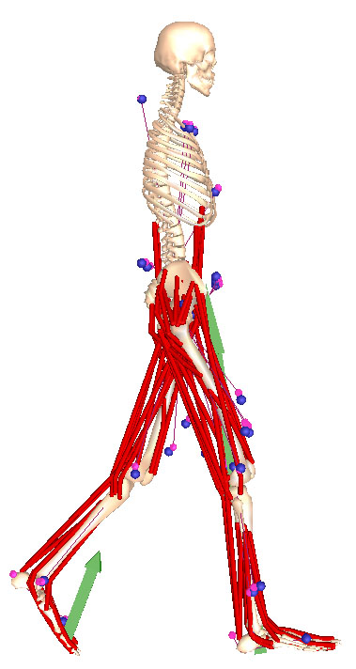

Methods

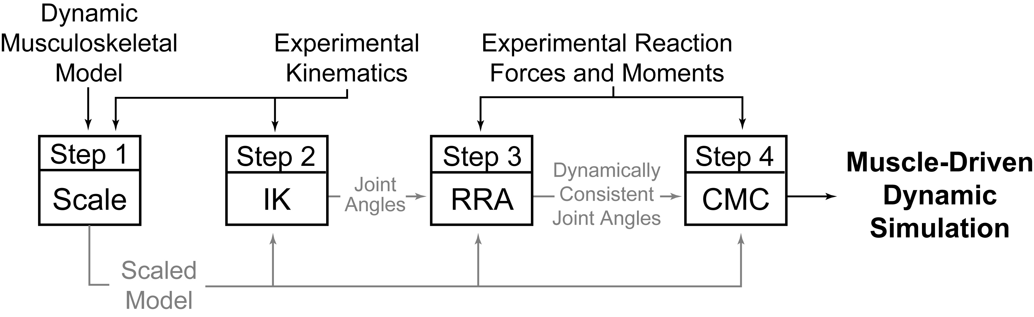

SimTrack guides users through four steps to create a dynamic simulation (Fig. 2). As input, SimTrack takes a dynamic model of the musculoskeletal system and experimentally-measured kinematics and reaction forces and moments. While this approach is general, we will describe it in the context of generating simulations of gait, since this is one of the most challenging applications.

In Step 1, a dynamic musculoskeletal model (e.g., a SIMM model [ref]) is scaled to match the anthropometry of an individual subject. The dimensions of each body segment in the model are scaled based on relative distances between pairs of markers obtained from a motion capture system and the corresponding marker locations in the model. The mass properties of the body segments are scaled proportionally so that the total measured mass of the subject is reproduced. Muscle fiber lengths and tendon slack lengths of the muscle-tendon actuators are scaled so that they each remain the same percentage of total actuator length, preserving the force-generating properties of the muscles.
In Step 2, an inverse kinematics (IK) problem is solved to determine the model generalized coordinates qik_discrete(t) that best reproduce the raw marker data obtained from motion capture. Step 2 is formulated as a least-squares problem that minimizes the differences between the measured marker locations and the model’s virtual marker locations, subject to joint constraints [ref]. If the experimental kinematics include a set of joint centers or joint angles produced by motion capture software, these may also be included in the formulation.
Inverse kinematics computes the 19 tracked generalized coordinates as a discrete vector function of time, qik_discrete(t). From motion capture, we are also given the force plate data as a discrete vector function of time, fexp_discrete(t), which has 18 components: 3 forces, 3 moments, and 3 center-of-pressure coordinates for each of the subject’s two feet. In Step 3, we first apply a Butterworth filter to the function qik_discrete(t) at 6 Hz, the maximum frequency at which significant changes in movement occur in gait [cite some papers]. We then fit qik_discrete(t) and fexp_discrete(t) with generalized cross-validated splines [Woltring] of order 5 and 3 respectively to produce smooth functions qik(t) and fexp(t). In practice, these two functions are inconsistent [cite Vaughan, Kuo, Cahouet], so a residual force Fresidual(t) is needed to allow the model to follow the given kinematics while the given forces are applied to it. By Newton’s 2nd Law,

Fground(t) + (Sum mi)g + Fresidual(t) = Sum miqik’’(t),

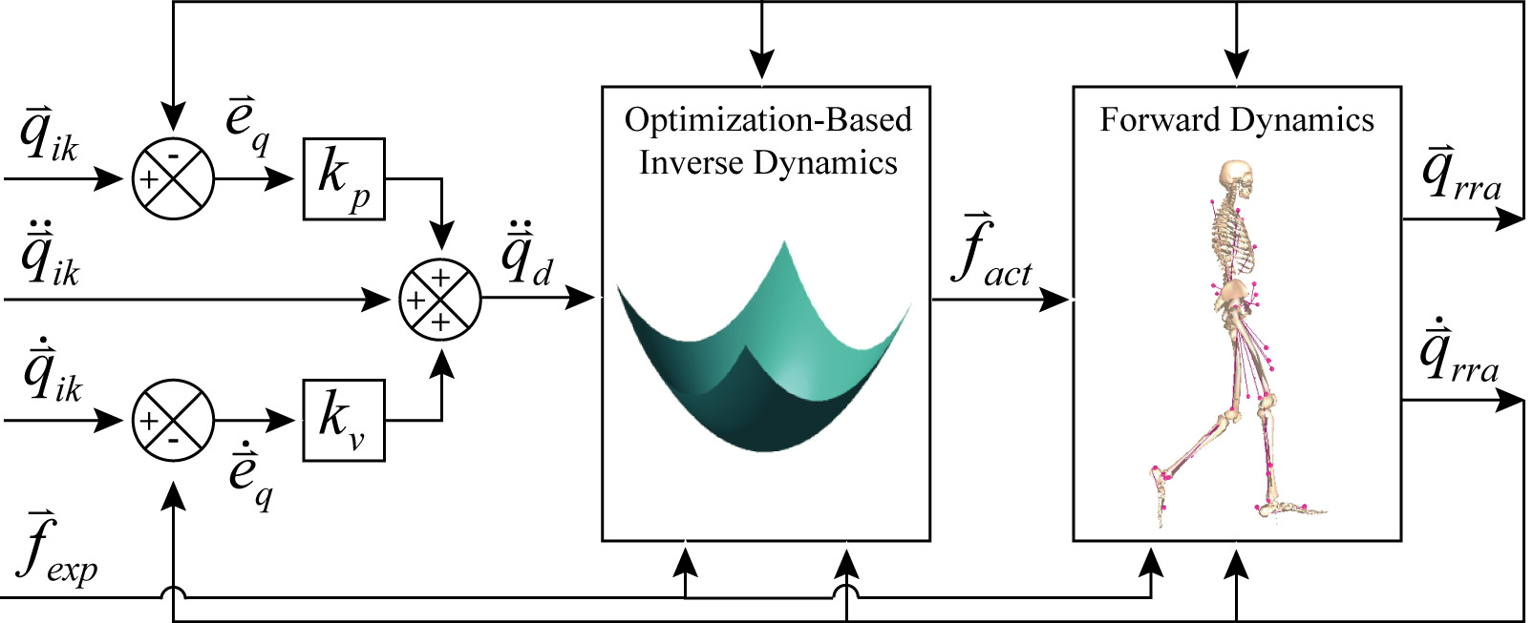

where Fground(t) is the net force applied to the model by the ground, mi is the mass of body segment i of the model, and g is acceleration due to gravity. An analogous equation relates the ground reaction moment Mground(t) to the residual moment Mresidual(t). The three components of Fresidual(t) and the three components of Mresidual(t) are collectively referred to as the residuals. The residuals are computed and averaged over the duration of the movement. Based on these averages, the specific changes are recommended in the center of mass location of the model’s torso that reduce the average values of the residuals over the duration of the movement. Then a residual reduction algorithm (RRA) computes altered kinematics that reduce the amplitudes of the residuals. Following these adjustments, a control problem is solved in which each generalized coordinate of the model is controlled by an idealized actuator. In particular, the six degrees of freedom between the model and the ground are actuated by the six residuals. RRA steps forward in time, computing a set of actuator forces fact(t) at each time step t that will cause the model to move from its current configuration qrra(t) to its desired configuration qdes(t+T) in the next time step. The actuator forces are computed by minimizing a performance criterion,

P(fact(t)) = Sum{i=1:19} (fact_i(t)/fact^opt_i)^2 + Sum{i=1:19} wi(qdes_i’’(t+T) – qrra_i’’(t))^2,

where fact_i(t) is the ith actuator force, fact^opt_i is the optimal force of the ith actuator, and wi is the weight of the acceleration error in the ith generalized coordinate. The desired acceleration qdes(t+T) is computed using a proportional-derivative control law [cite a CMC paper]. The first six components of fact(t) are the residuals and the remaining components are the joint moments. By attempting to keep the residuals low, the desired accelerations may not be met. Thus the new kinematics qrra(t) may differ from the original kinematics qik(t). The model with its altered torso center of mass location, the resulting kinematics qrra(t), the original kinematics qik_discrete(t), and the original ground reaction data fexp_discrete(t) are the inputs into Step 4.
In Step 4, computed muscle control (CMC) is used to generate a set of muscle excitations that produce a coordinated muscle-driven simulation of the subject’s movement [cite CMC 2006]. Computed muscle control uses a static optimization criterion to distribute forces across synergistic muscles and proportional-derivative control to generate a forward dynamic simulation that closely tracks the kinematics qrra(t) derived in Step 3. Although a static performance criterion is used, the full state equations representing the activation and contraction dynamics of the muscles are incorporated into the forward dynamic simulation. In our current implementation, the force between the foot and the ground is not modeled; rather, the measured ground reaction forces and moments are applied directly to the foot. When analyzing a simulation, spring-damper elements are introduced between the feet and the ground to allow the reaction forces and moments to respond to perturbations (e.g., altered muscle forces).
We used SimTrack to generate a simulation of normal walking for one human subject. First, the marker and force plate data from motion capture was preprocessed to format it appropriately for SimTrack. Second, the generic musculoskeletal model was scaled to fit the size and weight of the subject. Third, inverse kinematics was used to compute generalized coordinates describing the subject’s motion from the marker data. Fourth, RRA was used to compute an altered set of kinematics that reduced the residual forces needed to simulate the model’s motion. Fifth, CMC was used to generate a simulation of the subject’s motion.

Results

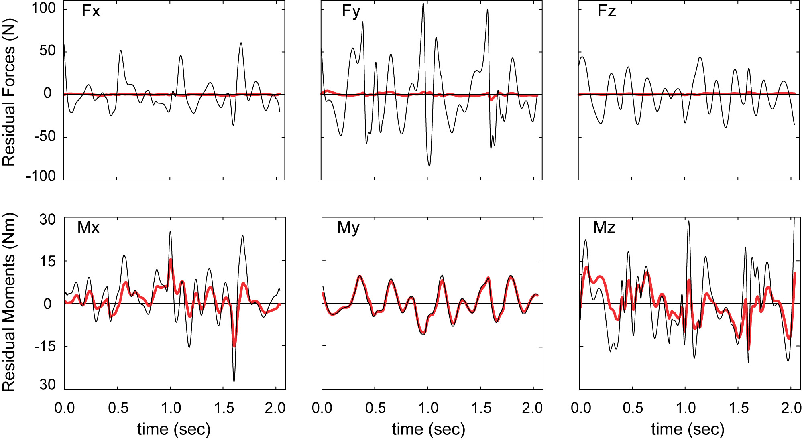

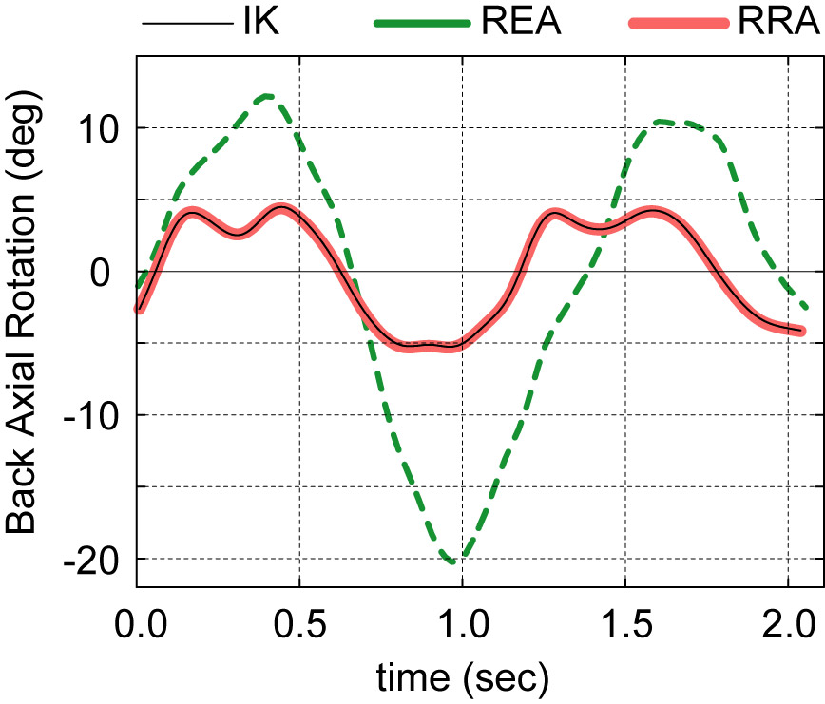

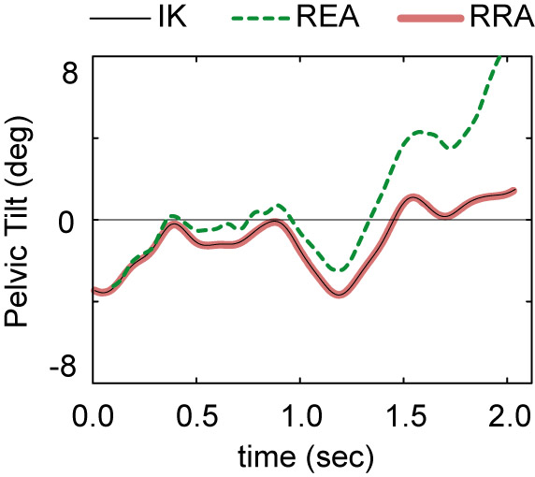

Discussion

Acknowledgements

Subject data from Gillette/Mike Schwartz; funding…
Paul’s plotting program; acknowledge any other OpenSim developers?

References

