Release 0.5.1

OpenSim
User’s Guide

Acknowledgements
OpenSim is a part of SimTK and the Simbios project funded by the National Institutes of Health through the NIH Roadmap for Medical Research, Grant U54 GM072970. Information on the National Centers for Biomedical Computing can be at http://nihroadmap.nih.gov/bioinformatics.

Intended Audience
This user’s manual is intended for users of the OpenSim. OpenSim is an object-oriented modeling framework written in C++ for the simulation, control, and analysis of neuromusculoskeletal systems. User’s of OpenSim are likely to range from programmer’s and engineers who model the neuromusculoskeletal system to scientists and clinicians who use simulation to investigate the biomechanics of movement. This manual, because it largely details the software engineering aspects of OpenSim, is likely to be of greater interest to the programmer and engineer. Although not required, a working knowledge of SIMM from Musculographics, Inc. and familiarity with the C++ programming language is recommended.

Licensing
OpenSim source code, binary executables, documentation, and tutorials are freely available and distributable under the MIT License.
Copyright (c) 2006 Stanford University
Permission is hereby granted, free of charge, to any person obtaining a copy of this software and associated documentation files (the "Software"), to deal in the Software without restriction, including without limitation the rights to use, copy, modify, merge, publish, distribute, sublicense, and/or sell copies of the Software, and to permit persons to whom the Software is furnished to do so, subject to the following conditions:
The above copyright notice and this permission notice shall be included in all copies or substantial portions of the Software.
THE SOFTWARE IS PROVIDED "AS IS", WITHOUT WARRANTY OF ANY KIND, EXPRESS OR IMPLIED, INCLUDING BUT NOT LIMITED TO THE WARRANTIES OF MERCHANTABILITY, FITNESS FOR A PARTICULAR PURPOSE AND NONINFRINGEMENT. IN NO EVENT SHALL THE AUTHORS OR COPYRIGHT HOLDERS BE LIABLE FOR ANY CLAIM, DAMAGES OR OTHER LIABILITY, WHETHER IN AN ACTION OF CONTRACT, TORT OR OTHERWISE, ARISING FROM, OUT OF OR IN CONNECTION WITH THE SOFTWARE OR THE USE OR OTHER DEALINGS IN THE SOFTWARE.
Table of Contents

Acknowledgements i
Intended Audience i
Licensing i
Chapter 1 _{º} What is OpenSim?
Relation to SimTK 1
Comptibility with SIMM 2
Architecture and Design 2
Applications written on top of OpenSim 2
Other Documentation and Resources 3
Chapter 2 _{º} Tools Library
Overview 1
Objects 1
Properties and Serialization 1
Input/Output 2
Vector and Matrix Operations 2
The Storage 4
Chapter 3 _{º} Simulation Library
Overview 1
The Model Class 1
States, Pseudostates, and Controls 2
Actuators and Contact Forces 2
Control Representations 4
Chapter 4 _{º} Additional Libraries
Analyses 1
Actuators 1
SQP – Optimization 3
Chapter 5 _{º} Performing a Simulation
Steps 1
Sample Main() 1
Chapter 6 _{º} Extending OpenSim
Authoring your own plugins and libraries 1
Inheritance and Plugins 1
Models 1
Analyses 1
Actuators 2
Controllers 2
Investigations 2
Chapter 7 _{º} Installation & Developer Setup
Downloads on SimTK.org 1
Windows Environment Variables 1
CMake 1
References 5
Index 5

Chapter
1

What is OpenSim?
OpenSim is an object-oriented modeling framework written in C++ for the simulation, control, and analysis of the neuromusculoskeletal system. The neuromusculoskeletal system is modeled in OpenSim using ordinary differential equations. Partial-differential-equation and finite-element modeling are not currently supported.

Relation to SimTK
SimTK, the Simulation Toolkit, is part of the Simbios National Center Center for Biomedical Computation funded by the National Institutes of Health. The purpose of SimTK is to enable groundbreaking biomedical research by providing open access to high-quality tools for modeling and simulating biological structures.

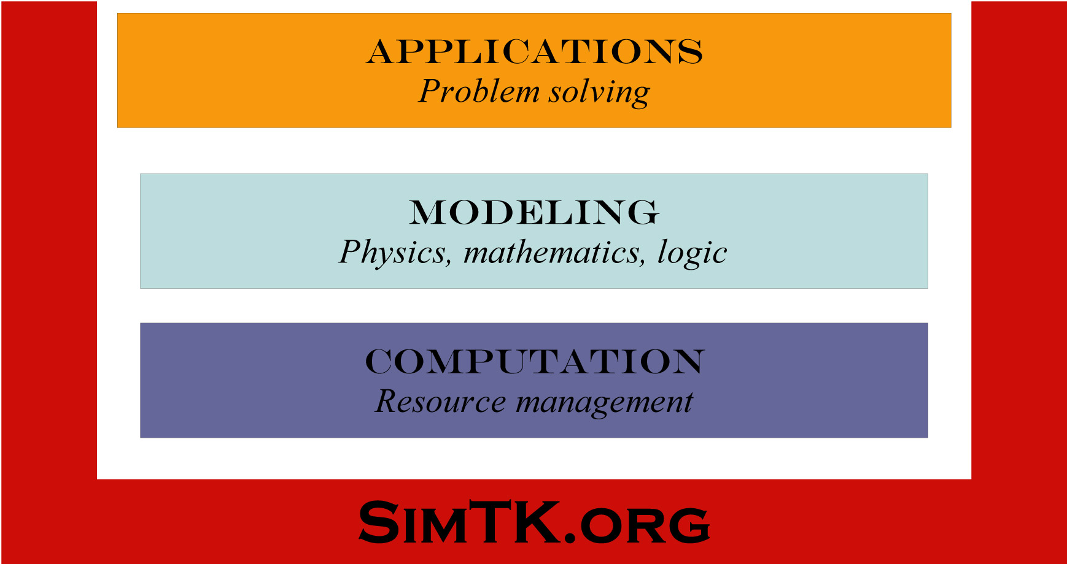
Figure 1.1: Organization of tools on SimTK.org.
The tools on SimTK.org consist of low-level computational tools, modeling frameworks that express the physics, mathematics, and logic of biological structures, and applications that help clinicians and scientists solve problems (Fig. 1.1).
OpenSim is one of the modeling-layer toolset of SimTK for the neuromusculoskeletal system(Fig. 1.2). In the current release, simulation in OpenSim is limited to It is build on top of computational tools that include integrators, optimization algorithms, and multibody dynamics engines such as SD/Fast. Future releases of OpenSim will use the CVODE numerical integrator and the Simbody Multibody Dynamics Toolset, two computational tools available on SimTK.org. The Gait Workflow is an application built on top of OpenSim. It consists of a suite of executables for generating and analyzing subject-specific, muscle-actuated simulations of gait.

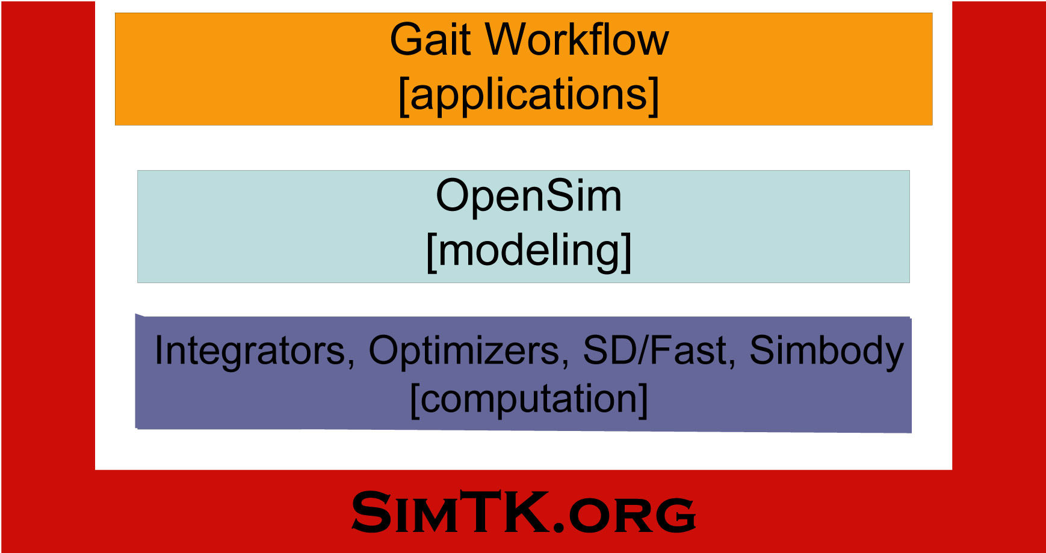
Figure 1.2: Relation of OpenSim to SimTK
The source code, compiled binaries, and documentation for OpenSim are available on SimTK.org under the project title OpenSim. The source code in OpenSim is freely available and distributable under the MIT License.

Compatibility with SIMM
SIMM (Software for Interactive Musculoskeletal Modeling) from Musculographics, Inc. is a widely-used software application for biomechanical analysis, surgical planning, and ergonomics. The joint (*.jnt) and muscle files (*.msl) used by SIMM to describe models of the musculoskeletal system can be converted into OpenSim models (*.osim) and brought into the OpenSim modeling framework.
OpenSim augments the functionality of SIMM and the SIMM Dynamics Pipeline by providing advanced simulation and control capabilities. In addition, the object-oriented, modular design of OpenSim allows users to extend its functionality and share functionality with other OpenSim users.

Architecture and Design
OpenSim has originated in the Neuromuscular Biomechanics Lab at Stanford University as an open platform to support the needs of the researchers in the lab during the planning phase of the SimTK Project. Since then, SimTK has evolved into a framework and a set of tools that will eventually be used as a framework to perform modeling in OpenSim. SimTK’s core will also provide a new multibody dynamics engine (SimBody) that promises to be a fast recursive dynamics engine that is under development by the SimTK team. Another potential benefit of using SimTK will be to use the numerical methods libraries that will be incorporated into SimTK either by the SimTK staff, Stanford Researchers or other contributors to the SimTK effort. These include core linear algebra packages, numerical integrators, optimizers, and root solvers. This should provide for an open environment to test/compare these functional components and pick up best of breed algorithms/methods at the disposal of the NMBL application users

Applications written in OpenSim
Version 1.0 of the OpenSim application addresses the creation of subject specific neuromuscular models to simulate gait based on gait data obtained from gait labs, along with a generic model that originates from SIMM. Although the techniques to scale models, or perform IK are general and can be used on most neuromuscular biomechanics models and not necessarily lower-extremity models, the focus has been on gait primarily because of the availability of data from gait labs and ??.
Subject specific Simulation Pipeline addresses the creation and investigation of subject specific models to try to reproduce experimental data obtained from a gait lab, in a muscle actuated forward simulation.

Other Documentation and Resources
Version 1.0 of the OpenSim application addresses the creation of subject specific neuromuscular models to simulate gait based on gait data obtained from gait labs, along with a generic model that originates from SIMM. Although the techniques to.
Version 1.0 of the OpenSim application addresses the creation of subject specific neuromuscular models to simulate gait based on gait data obtained from gait labs, along with a generic model that originates from SIMM. Although the techniques to.
Version 1.0 of the OpenSim application addresses the creation of subject specific neuromuscular models to simulate gait based on gait data obtained from gait labs, along with a generic model that originates from SIMM. Although the techniques to.
Version 1.0 of the OpenSim application addresses the creation of subject specific neuromuscular models to simulate gait based on gait data obtained from gait labs, along with a generic model that originates from SIMM. Although the techniques to.
Version 1.0 of the OpenSim application addresses the creation of subject specific neuromuscular models to simulate gait based on gait data obtained from gait labs, along with a generic model that originates from SIMM. Although the techniques to.
Version 1.0 of the OpenSim application addresses the creation of subject specific neuromuscular models to simulate gait based on gait data obtained from gait labs, along with a generic model that originates from SIMM. Although the techniques to.
Version 1.0 of the OpenSim application addresses the creation of subject specific neuromuscular models to simulate gait based on gait data obtained from gait labs, along with a generic model that originates from SIMM. Although the techniques to.
Version 1.0 of the OpenSim application addresses the creation of subject specific neuromuscular models to simulate gait based on gait data obtained from gait labs, along with a generic model that originates from SIMM. Although the techniques to.
Version 1.0 of the OpenSim application addresses the creation of subject specific neuromuscular models to simulate gait based on gait data obtained from gait labs, along with a generic model that originates from SIMM. Although the techniques to.
Version 1.0 of the OpenSim application addresses the creation of subject specific neuromuscular models to simulate gait based on gait data obtained from gait labs, along with a generic model that originates from SIMM. Although the techniques to.
Version 1.0 of the OpenSim application addresses the creation of subject specific neuromuscular models to simulate gait based on gait data obtained from gait labs, along with a generic model that originates from SIMM. Although the techniques to.
Version 1.0 of the OpenSim application addresses the creation of subject specific neuromuscular models to simulate gait based on gait data obtained from gait labs, along with a generic model that originates from SIMM. Although the techniques to.
Version 1.0 of the OpenSim application addresses the creation of subject specific neuromuscular models to simulate gait based on gait data obtained from gait labs, along with a generic model that originates from SIMM. Although the techniques to.

Installation
along with a generic model that originates from SIMM. Although the techniques to.
Version 1.0 of the OpenSim application addresses the creation of subject specific neuromuscular models to simulate gait based on gait data obtained from gait labs, along with a generic model that originates from SIMM. Although the techniques to.

