Spec. for the Gait Workflow Tool in SimTK OpenSim
Draft 0.2

General
The Gait Workflow is a wizard dialog for subject specific gait simulation. This dialog is accessible in SimTK OpenSim through Tools -> Gait Workflow. The wizard will be a modeless dialog so that the user can interact with the visualization window, object browser and the rest of the OpenSim application.

The wizard and any associated actions/menus and or dialogs will be part of one module that can be enabled/disabled from the OpenSim Module manager. All panels and or data entry fields will have bubble/tooltip help. An execute button will be added to every page (rather than use “Next” to execute various Steps of the workflow) to allow users to selectively execute/re-execute or skip steps.

We’ll use “Page” to describe the dialogs corresponding to individual steps of the gait workflow. In particular, the Wizard displays 8 Pages corresponding to the following “Steps”:
1. Generic Model Loading
2. Scaling
3. Marker Placement
4. Inverse Kinematics
5. Creating Dynamic Model
6. Reduce Residuals
7. Track Motion
8. Analyze
Every step will have a page on the wizard with a help panel. The following sections show the pages and describe the behavior expected from the OpenSim gait workflow.

Step 1: Load generic model

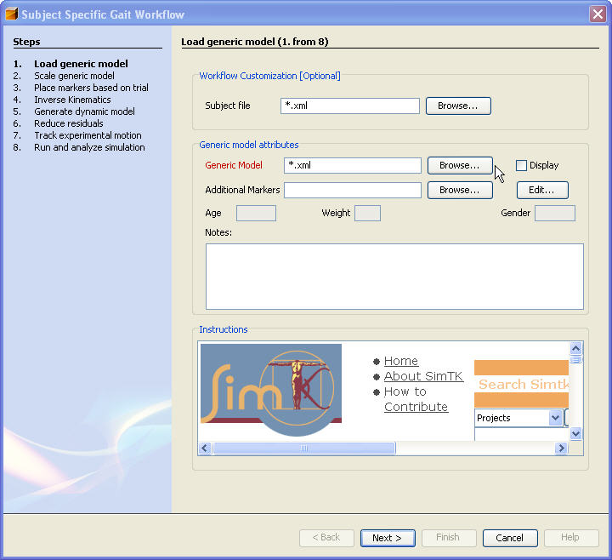
- If user selects a subject file (a prepared xml file with name for generic model file, scaling, marker placement and IK parameters) then the rest of this page and remaining pages will be initialized from the file.
- An execute button will be added to the bottom and will be enabled only if a "valid" model file selection has been made.
- When execute is selected the generic model will be loaded into the visualization window. Options available from the visualization window are described separately.
- Clicking the hyperlinks in the help area will open up a browser window.

Scaling:

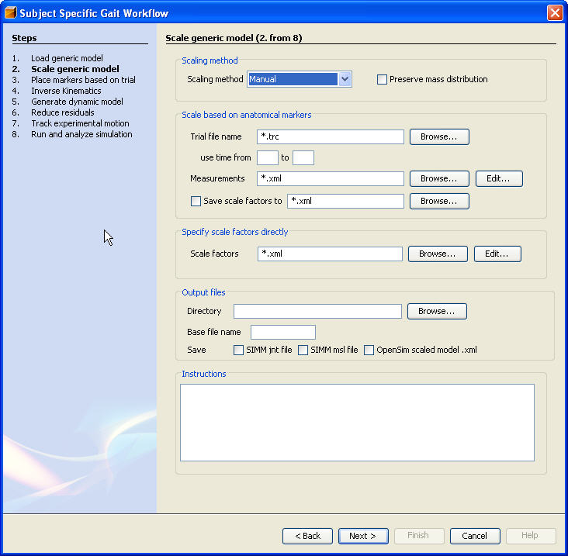
- Options for scaling method are: Manual, Measurements, Manual+Measurements, Measurements+Manual.
- Combinations of options are validated and Execute will be available only if the combination make sense as follows (based on the selection made in the scaling method drop-down):
  - Manual needs a pre-computed scale factors.
  - Measurements needs a trial file and a specification for how marker pairs are used to scale segments.
  - If selected scaling method is "Manual" then only options that make sense for "Manual" scaling are enabled, same for "Measurements".
- Measurements, scale factors and all other objects to follow that have a browse/edit button bring the generic object editor as specified below under "generic object editing".
- The output files will have same name as generic model selected in "Step 1" but with the suffix "_Scaled" appended. The user can override this behavior.
- The Scaled model is loaded automatically into a new Visualization window.

Marker placement:

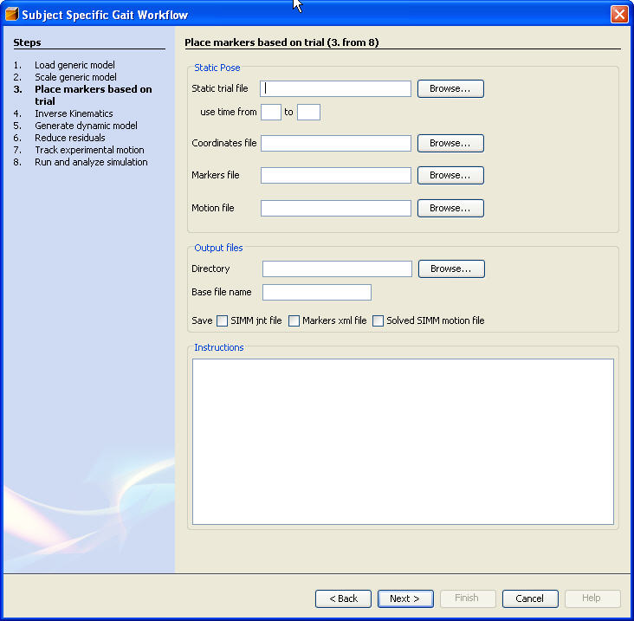
1. If additional markers are specified they will be displayed (in a different color?).
2. We will color code or give some visual feedback on how far markers were moved and correspondence between pre/post marker placement which should help with setting weights when “Measurements” are selected.
3. Display is updated in place since old and new marker positions are shown.
4. Auto-generated file names will have an "MP" suffix to indicate that markers have been placed. But users can override default names.

Inverse Kinematics:
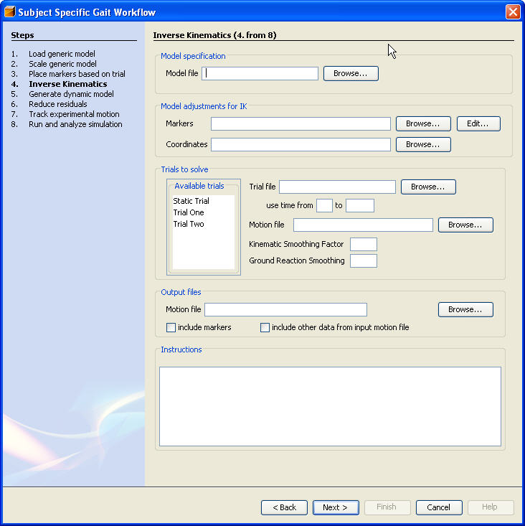
- Model Specification field will be initialized to the result from the previous step but users can override this with a new model of their choosing.
- If a new model is specified it will be loaded in the visualization window and a warning will be issued (on the dialog) in blinking red.
- When a trial is selected from “available trials” the time bounds are extracted and the time range fields will be filled but the user will have the option to change it (We’ll check that the new range is a subset of what’s in the file).
- A default value for the Cutoff frequency for smoothing will be provided.

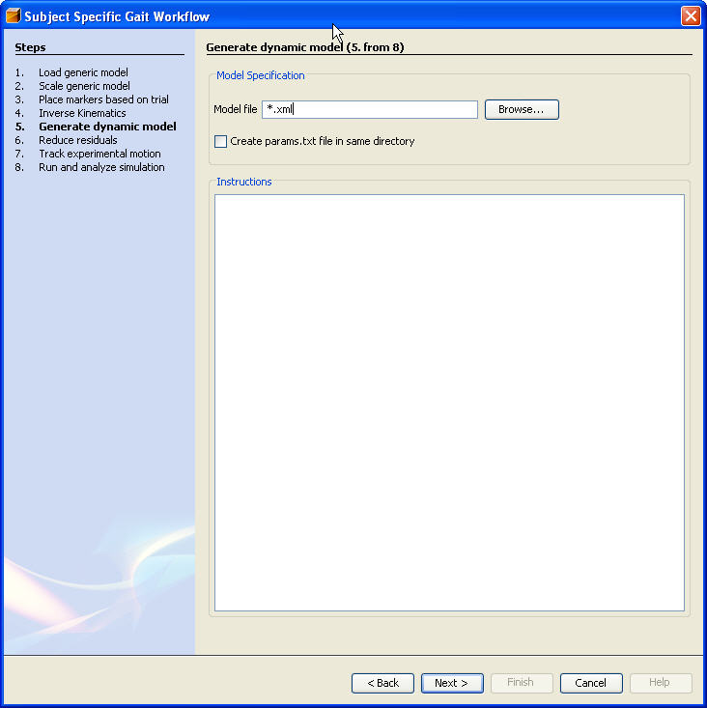
- The model representation has to be converted to a dll/so that includes the equations of motion as generated by SDFast. Instructions on how to perform this will be given in the help panel with a recommended place and name for the dll. When we transition to SimBody this specific step will go away.
- Can we automate some part of that messy step?

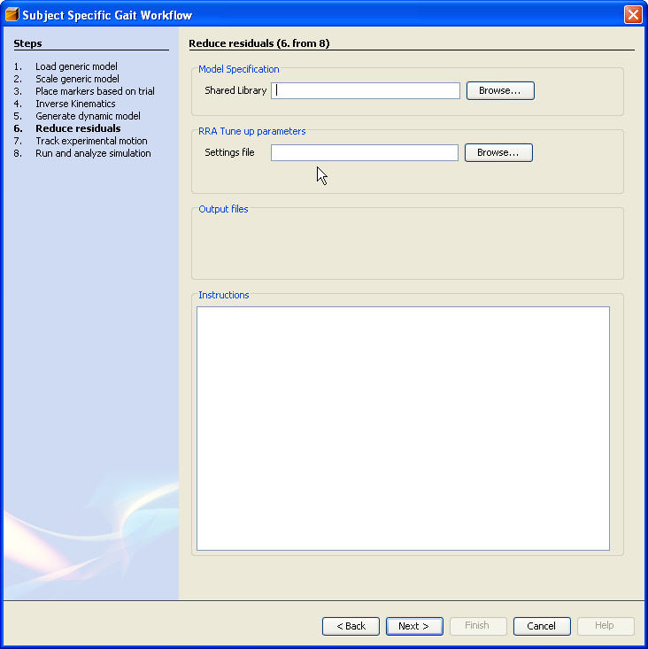
- Settings need to be exposed here with potentially hooks to run pass 1, pass2, get feedback, propagate errors/problems and trouble shooting utilities.
- Default name for input file will be generated based on previous step.
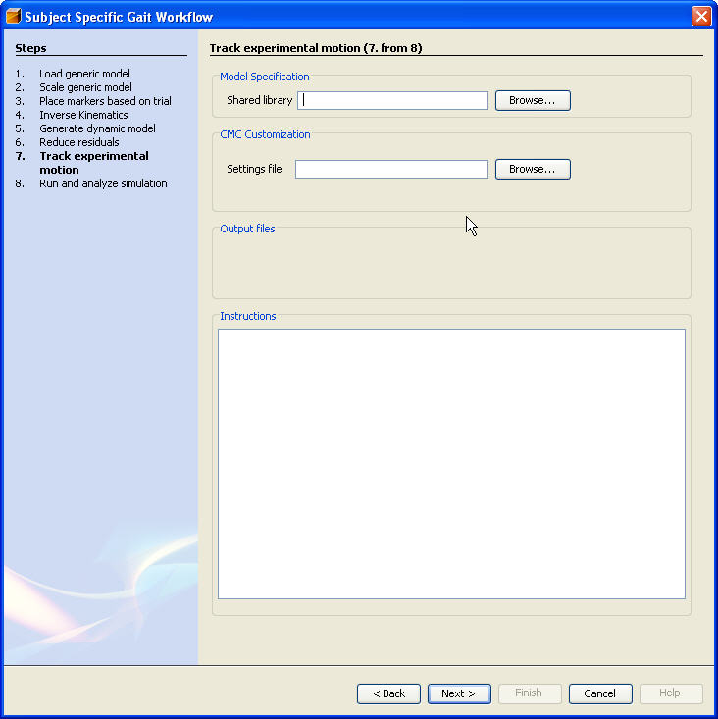

- Settings need to be exposed here with potentially hooks to run/control CMC, get feedback, propagate errors/problems and trouble shooting utilities.
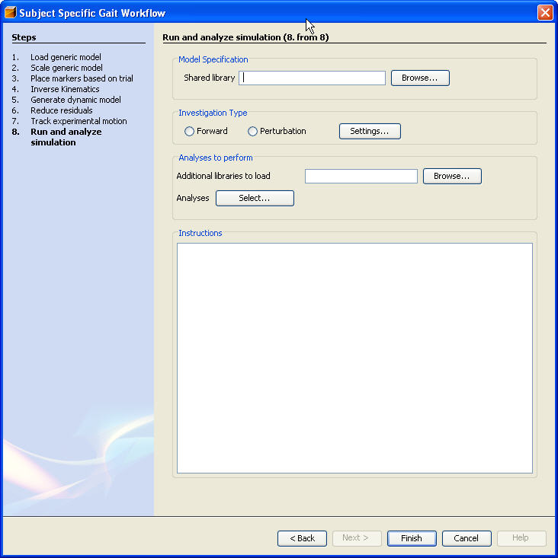

- This would be a good place to use/demo external analyses created as dlls, adding them to the GUI, editing them and attaching them to a forward or perturbation investigation.
- Results should be plotted/visualized live with ability to break/cancel.
The Visualization Window

When a model is loaded into the GUI either through an Open Model menu pick, toolbar or programmatically during execution of the workflow, the model is displayed in the graphics/visualization window. Features we must have:
- Ability to select objects and do something with them (e.g. edit)
- Ability to control the visibility of objects (at least as exposed by VTK).
- Ability to modify mouse tracking/interactions
- Ability to refit the model to window.
- Ability to specify, save, restore and use standard camera positions
- Potentially the ability to control other effects (texture, lighting,)
- Ability to control display quality.
- Ability to take a snapshot of the window as is.

