**My Between-Term Break**

Chris DeVisser

cndeviss / 20521027

2017-09-15

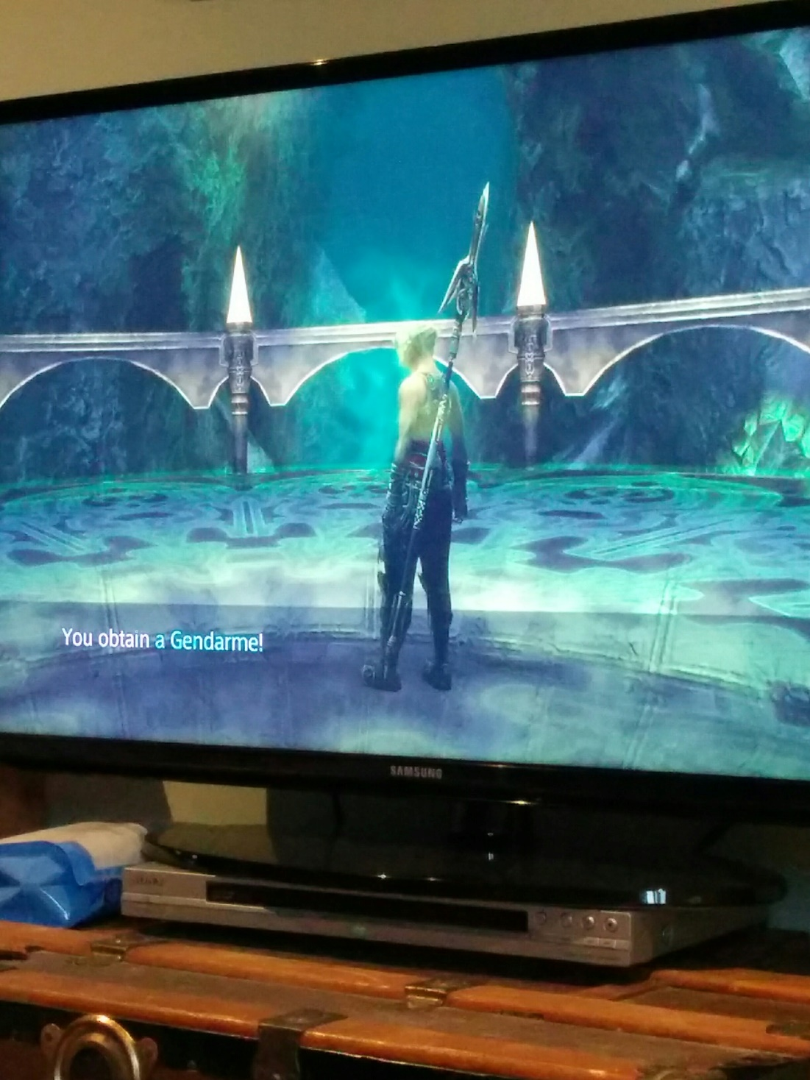

This is a picture of a game. Many people have already lost interest. To me, though, it’s more. This picture could be seen as the culmination of a project that I planned, followed through on, and finished ahead of schedule.

As the end of the previous term approached, I bought a PS4 and got the idea in my head to replay a childhood classic, Final Fantasy XII, in all its remastered glory. But I’d already played through both the vanilla version and the enhanced, Japan-exclusive version multiple times, being thorough on most playthroughs. I wanted to make this remaster playthrough special and go further than I had before. To that end, I decided that on top of my usual completionist-based play, I would collect one of every equipment and unlock every bazaar item, as well as take more early opportunities to acquire items. In addition, I would not take the easy route of buying that first piece of equipment from shops, at least where I could help it. For context, the game opens up very early in terms of exploration and treasure hunting, so much of the optional content can be done in tandem with the story.

With numerous different aspects to the completionist playthrough, I wanted it to be reasonably efficient. Therefore, I started putting together a guide[1] built from combining about five other reference-style sources with a whole lot of cross-referencing and research. My plan was to finish before exams ended so that I could get going on the playthrough distraction-free as soon as possible. As the end of exams approached, I gradually worked on the guide, typing every one of the over 3800 lines by hand. Given the substantial amount of work, I surprisingly finished a bit early. When exams finished, I got to work on the playthrough, also playtesting and updating the guide, until at last, I had something that felt complete. I shared my work with the FF12 community so others interested in a similar style of playthrough could benefit. The picture was taken late in the playthrough. It’s the result of me getting an exceedingly rare item (1/2500 chance per area entry) legitimately. There are few people willing to get it without manipulation, but I actually found the process relaxing enough to get four more.

In short, I’m not great at completing the projects I start. Most of them sit half-done indefinitely and undergo significant fundamental changes the whole way through. It’s a nice change for me to see that not only did I finish, and before my self-imposed deadline, but I had a good reception from the community, and was also patient enough for even the more tedious aspects of my challenge run.

[1]: <https://github.com/chrisdevisser/ff12-tza-guide>