e

Wonder Blog

CRASH TEST DUMMIES

PIOTR STARZEC, RUAIRI GRAY, RYAN JOHNSON, LLOYD JACK

2015



Table of content

Brief background information

Project Description

The motivation

The intended users

Main Functional requirements

Major Constraints

Project Plan

Work breakdown

Gantt Chart

Requirements Specification

Hardware and software requirements

Hardware required

Software required

List of functional and non-functional requirements

Functional requirements

Non-functional requirements

Risk Assessment

Quality Plan

Project Design

Use Case diagram

Activity Diagrams

Admin Activity Diagram

Author Activity Diagram

Reader Activity Diagram

Wireframes

Home page

Adventure page

Login and register dialog

Author page

Other pages

# Brief background information

## Project Description

WonderBlog is a new website concept for travel authors and photographers to help share their experiences with other travellers whilst providing reviews and fellow traveller comments. Our development team has been asked to create a web application which fulfils the concepts core ideas.

## The motivation

This is a university coursework project. The main motivation is to get the best grade and pass the module.

## The intended users

There will be four main types of user, administrators, authors, contributors and public. The public users form the most basic use of the site. The readers are the main consumers of the information on the site. They do not really create content but they do add to it based on comments and reviews. The authors are really the main focus for the site. They are the main source of content for the site. The administrators are responsible for managing the site as well as monitoring the site’s content.

## Main Functional requirements

The site will essentially be a blogging platform which allows authors to enter stories and upload photographs about trips they have been on. Like a blog readers will be able to leave comments about the posts, which the authors will be able to reply to, creating discussion threads about a trip.

## Major Constraints

The website must be hosted on the AZURE platform as illustrated in class. Submission using any other media, will not be accepted. All the code mustbe available on GitHub. The content of the pages must be loaded dynamically from a data base using server side scripting. To demonstrate the site it should include the following:

* at least 3 Authors with at least 3 Adventures each.
* at least 5 registered readers.
* at least 2 administrators, one of which is also an Author.

In terms of time constraint the project needs to be completed before 18th December.

# Project Plan

## Work breakdown

|  |  |  |  |  |
| --- | --- | --- | --- | --- |
| Task Name | Duration | Start | Finish | Resource Names |
| **Create the company** | **2 days** | **Thu Oct 08** | **Fri Oct 09** |  |
| Create name | 1 day | Thu Oct 08 | Thu Oct 08 | Ruairi |
| Create logo | 1 day | Fri Oct 09 | Fri Oct 09 | Ruairi |
| **Company is created** | 0 days | Fri Oct 09 | Fri Oct 09 |  |
| **Initiation and analysis** | **5 days** | **Mon Oct 12** | **Fri Oct 16** |  |
| Create a project plan | 5 days | Mon Oct 12 | Fri Oct 16 | Piotr |
| **Requirement Specification** | **5 days** | **Mon Oct 12** | **Fri Oct 16** | **Lloyd** |
| Software/Hardware requirements | 5 days | Mon Oct 12 | Fri Oct 16 | Lloyd |
| Client requirements | 5 days | Mon Oct 12 | Fri Oct 16 | Lloyd |
| functional and non-functional requirements | 5 days | Mon Oct 12 | Fri Oct 16 | Lloyd |
| Requirement Specification Report | 0 days | Fri Oct 16 | Fri Oct 16 |  |
| Risk Assessment | 5 days | Mon Oct 12 | Fri Oct 16 | Ruairi |
| Quality Report | 5 days | Mon Oct 12 | Fri Oct 16 | Ryan |
| **Complete project plan** | 0 days | Fri Oct 16 | Fri Oct 16 |  |
| **Design** | **10 days** | **Mon Oct 19** | **Fri Oct 30** |  |
| User Interface design (front end) | 10 days | Mon Oct 19 | Fri Oct 30 | TEAM |
| Produce DB design | 5 days | Mon Oct 19 | Fri Oct 23 | Piotr; Ryan; Ruairi |
| **Create Diagrams** | **10 days** | **Mon Oct 19** | **Fri Oct 30** |  |
| Use Case Diagrams | 10 days | Mon Oct 19 | Fri Oct 30 | Ruairi |
| Activity Diagrams | 10 days | Mon Oct 19 | Fri Oct 30 | Ryan |
| **Complete diagrams** | 0 days | Fri Oct 30 | Fri Oct 30 | Piotr; TEAM |
| **Database design** | 0 days | Fri Oct 30 | Fri Oct 30 |  |
| **Submit a project plan** | 0 days | Mon Oct 26 | Mon Oct 26 |  |
| **Implement design (build)** | **25 days** | **Mon Nov 02** | **Fri Dec 04** | **TEAM** |
| Fron end | 10 days | Mon Nov 02 | Fri Nov 13 | Ruairi; Lloyd |
| Back end | 15 days | Mon Nov 16 | Fri Dec 04 | Piotr; Ryan |
| **Site flow** | 1 day | Fri Nov 13 | Fri Nov 13 | Piotr; Ruairi; Ryan |
| **Requiremens specification** | 0 days | Fri Nov 20 | Fri Nov 20 | Lloyd |
| **Testing** | **5 days** | **Mon Dec 07** | **Fri Dec 11** |  |
| Test components | 5 days | Mon Dec 07 | Fri Dec 11 | Ryan |
| Fix bugs | 5 days | Mon Dec 07 | Fri Dec 11 | Piotr |
| Validate the site | 3 days | Wed Dec 09 | Fri Dec 11 | Ruairi |
| **Release the website** | 0 days | Fri Dec 11 | Fri Dec 11 | TEAM |
| **Presentation** | 0 days | Mon Dec 14 | Mon Dec 14 |  |
| **Implementation and summation** | 0 days | Fri Dec 18 | Fri Dec 18 |  |
| **Weekly meeting** | **46 days** | **Mon Oct 12** | **Mon Dec 14** | **TEAM** |

## Gantt Chart

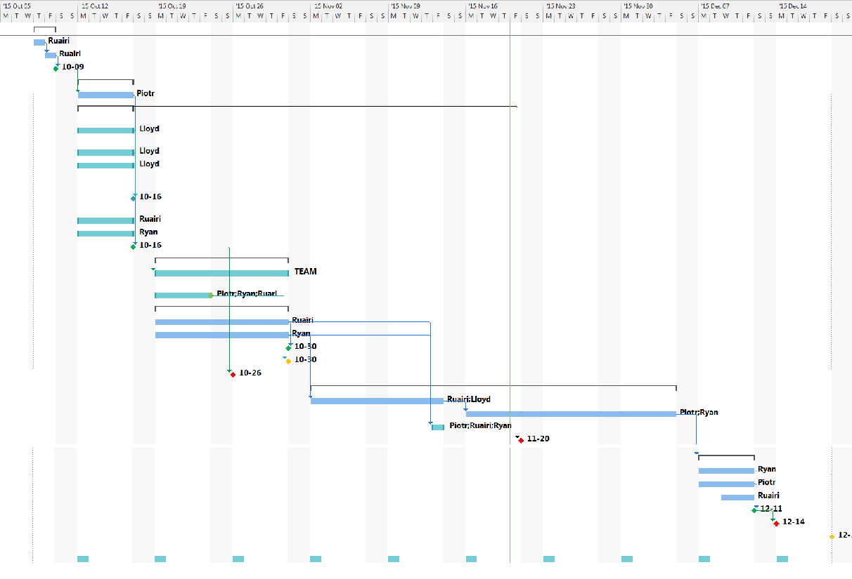

# Requirements Specification

## Hardware and software requirements

### Hardware required

* Monitors
* Keyboards
* Mice
* Some form of Internet connection i.e. Router
* Desktop of higher or equal specification than listed below.

|  |  |
| --- | --- |
| **Item** | **Requirement** |
| CPU | 1 GHz clock speed, IA-32 or x64 architecture with SSE2 support |
| RAM | IA-32 edition: 1 GB x64 edition: 2 GB |
| Hard disk drive | 3.0 GB free disk space |
| Operating system | Windows 7/8.1/10 |

### Software required

* Microsoft office 2013
  + MS Project for creating the group’s project plan
  + MS PowerPoint for creating the group’s presentation
  + MS Word for creating any word documents i.e. this document
* Astah professional 6.9
  + For creating any database diagrams
* Microsoft Azure
* Clouds:
  + GitHub
  + Google Drive
  + Dropbox
* Trello
* Messengers :
  + Facebook messenger
  + Slack
* IDE:
  + PHP Storm
  + PHP Interpreter
* Internet browsers:
  + Mozilla Firefox
  + Google chrome

## List of functional and non-functional requirements

### Functional requirements

* The web app's welcome page must display top 5 rated adventures.
* The web app will limit access to authorised users.
* The web app will ensure public users cannot post comments or contact other users
* The web app will enable registered users to post comments.
* The web app will enable registered users to edit or remove their own comments.
* The web app will enable registered users to vote for any adventure.
* The web app will enable authors to create a new adventure.
* The web app will enable authors to edit their own adventure.
* The web app will enable authors to remove comments by any user on their own adventure.
* The web app will ensure authors cannot vote for their own adventure.
* The web app will enable administrators to remove any adventure.
* The web app will enable administrators to remove any or all photographs from an adventure.
* The web app will enable administrators to remove any or all comments from an adventure.
* The web app will enable administrators to add or remove votes from a particular adventure.
* The web app will enable users to search for an adventure.
* The web app will ensure that clicking on an adventure will display that adventure's page.

### Non-functional requirements

* Web app’s page loading must load between 3 to 5 seconds.
* Search must respond within 3 seconds.
* Web app must run on the Azure platform.
* Web app’s login and registration service must be secure.
* Web app must be easy and clear to use.
* Web app’s admin and adventure panel must be easy to use.

## Risk Assessment

When it comes to a project of this size there can be a lot of potential risks that must be taken into account when trying to plan out the project. The fact that it is a group project in its self will bring with it a unique set of risks that must be considered before the project can go ahead. The main risks are set out in the bellow table.

The scale is 1 – 10, where 1 is unlikely to happen/not severity and 10 is most likely to happen/very severity.

|  |  |  |  |  |  |  |  |
| --- | --- | --- | --- | --- | --- | --- | --- |
| Risk Category | Risk Name | Risk Number | Probability | Severity | Mitigation | Contingency | Action By |
| Group | Illness | 1.1 | 3 | 3 | Post all meeting minutes online so absent group members are still kept up to date with project and project plan. | Split ill members group work among other members of the group | Group |
| Skills | Technical ability | 2.1 | 2 | 3 | Discuss the skill level of each group member before tasks are started to insure members are able to complete given tasks. | Provide help to a group member that is unable to complete a task due to technical ability/discuss with the rest of the group in order to gain tips on how to move forward with the given task | Group |
| Group | Over Ambition | 3.1 | 2 | 3 | Reviewing the project and its progress weekly to insure that all elements will be completed on time. | Plan out the group project allocating set amounts of time for each part, as well as making sure all required elements of the project are completed before additional extras are added. | Group |
| Data | Loss of Data | 4.1 | 1 | 4 | Insure all data is backed up on a regular basis in multiply forms, including external hard drives as well as in the cloud. | Make sure that hard copies of all work are taken to insure that is all forms of digital backup fail, we still have some form of copy. | Group |

## Quality Plan

#### Introduction

This quality plan is for our group project WonderBlog, it describes how different parts of the project and how to ensure that the quality is to a high standard throughout the lifetime of it, the more we concentrate on quality assurance the better outcome we will have.

#### How will the project files be organized?

The files for our project must be stored neatly within a folder structure so that each file can be located and accessed easily. If our group members can find files faster, they can accomplish more work than if they had to spend time trying to locate a file.

#### How can we ensure the quality of our Project Plan?

To ensure the quality of our project plan we need to work as a team to indicate and discuss each of the project phases, and making sure that we select the right time frames for each. Being able to do this with precision means that we can stick to our plan and not fall behind.

#### How can we ensure the quality of our design and coding?

When coding and designing the website we need to separate the different coding languages into different files, e.g. HTML/PHP, CSS and JavaScript. This is a lot neater and allows us to identify certain parts of code quicker for editing. We need to code in a way that everyone involved is able to read and understand what the code is doing, this makes it easier for the group and external entities to take part and edit the code. To ensure we are getting the best coding style we need to use proper indentation, use of white space, use of sensible variable and file names. This minimises confusion.

#### How should we assess our progress?

Group meetings are a way of checking the group’s progress, this allows us to discuss with one another about what has and hasn’t been done. Going back and checking the project plan, ticking things we have completed. Sharing and inspecting each other's allocated work is a great way to assess other group member’s work. Skim reading and making amendments gives the group a better potential of getting a higher grade of work.

#### Are we building the right product?

To make sure we are building the right product with an acceptable graphical user interface we need to get the customer involved in the project. Getting face-to-face with the customer frequently, keeping them updated all the time, asking them questions about how they would like the end system to work and look. This is very important at an early stage because if the customer doesn’t like the end product our group could have problems and may need to redesign the whole product.

#### Testing

Testing is a very important process and will be carried out all the way through the implementation stage to make sure the code works correctly for the client. The most crucial and intensive testing will be when we join the different parts of code together. This part of the testing is most important, therefore needs to be tested thoroughly to eliminate any errors before it reaches the client. We will also use the W3C validator to check our HTML and CSS code. This website checks our code and informs us of any errors and where they lie allowing us to go back and fix them if necessary.

#### Conclusion

For WonderBlog one of our most important tasks are to ensure that every step we take we make sure the quality is of the highest standard. We believe that quality assurance allows the project to flow smoothly, perform efficiently and end up with a top class website.

# Project Design

## Use Case diagram

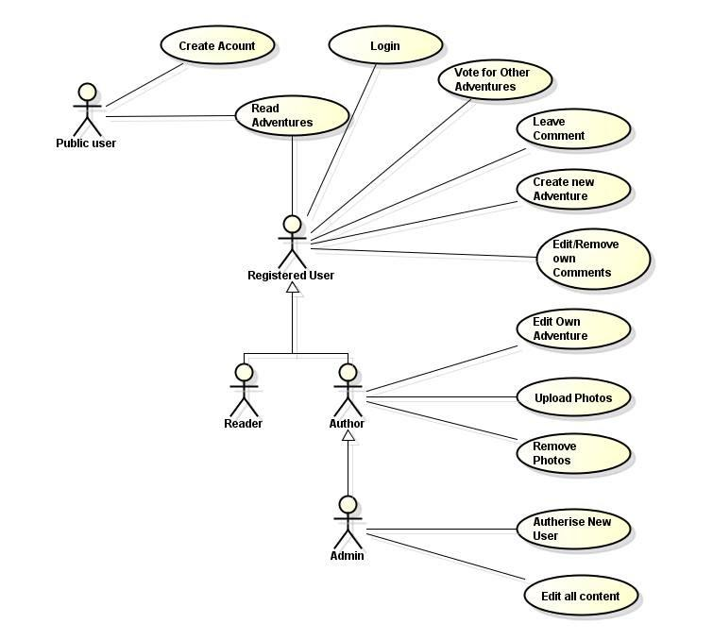

## Activity Diagrams

### Admin Activity Diagram

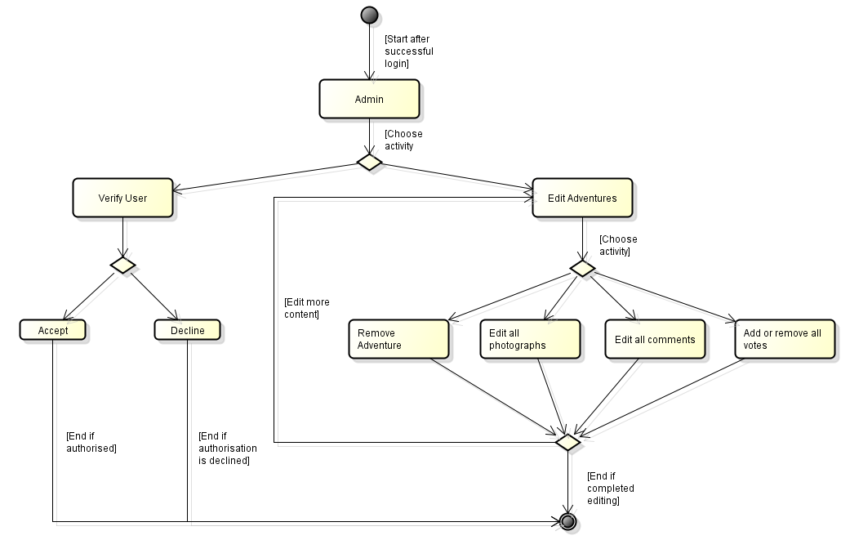

### Author Activity Diagram

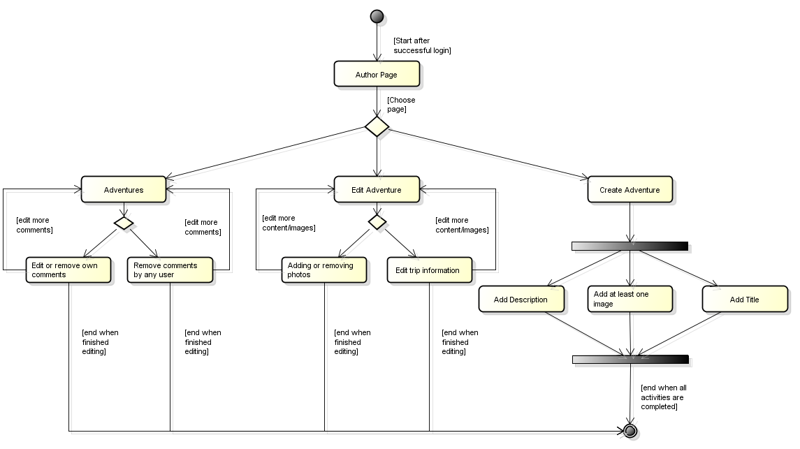

### Reader Activity Diagram

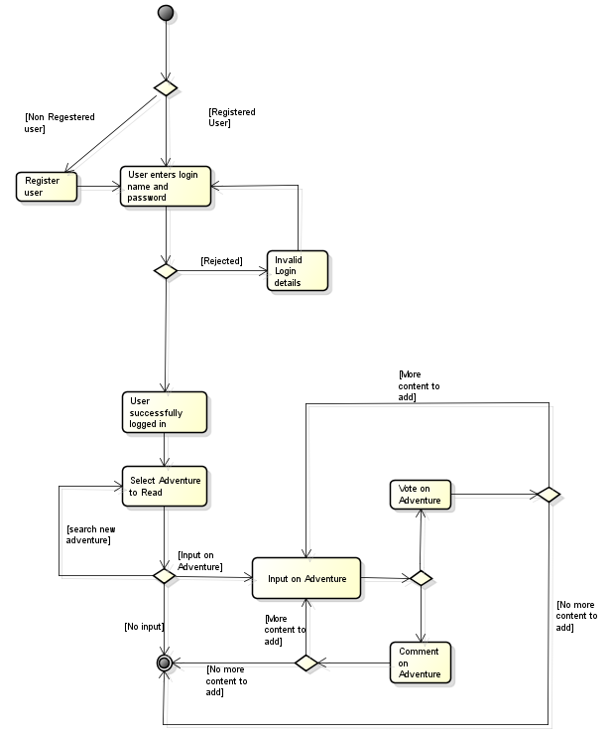

## Wireframes

### Home page

Home page will have a search box with two buttons: one to search for adventures and one to search for authors. From these searcher bars users will be able to search by key words and be presented with a list of search result.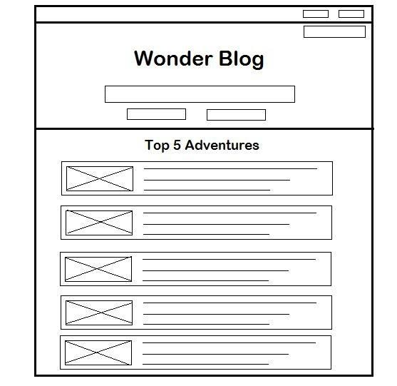

It also display the top 5 adventures currently on the website. These will be in the format shown in the adjacent wire frame. With a picture from the adventure on the left hand site and a description next to it. This will be based on user votes.

Purpose: welcome every user to the website and allow them to easily see the top adventures available on the site.

### Adventure page

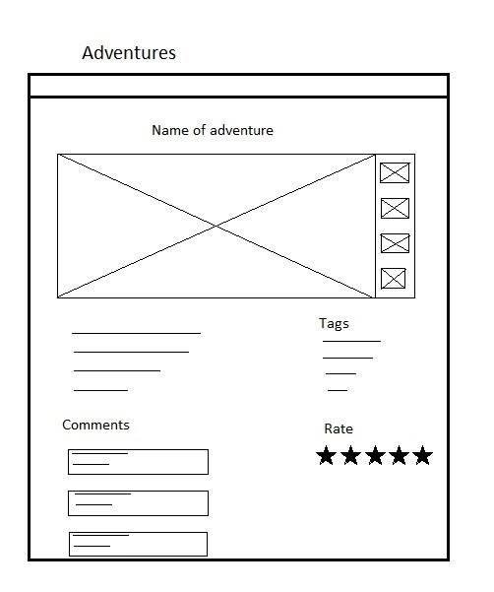

The adventure page will show all details about the adventure. It have a carousel of picture as seen in the wire frame adjacent. Each adventure will have tags displayed below the picture carousel showing what can be searched in order to find the adventure.

The adventure page will also have a comments section where readers can leave their thoughts on a particular adventure.

At the top of the page will be the given name of the adventure and at the bottom will be the users overall rating.

Purpose: view adventures and allow other users to comment and rate on adventure

### Login and register dialog

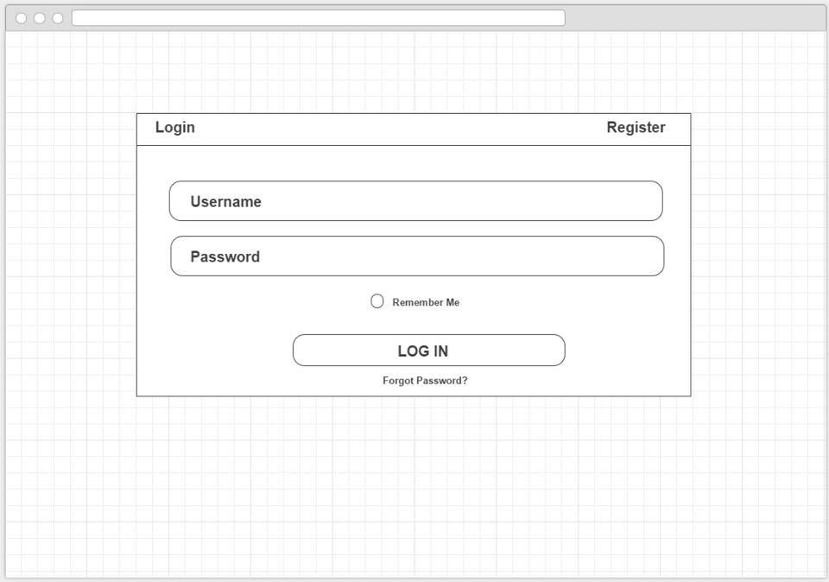 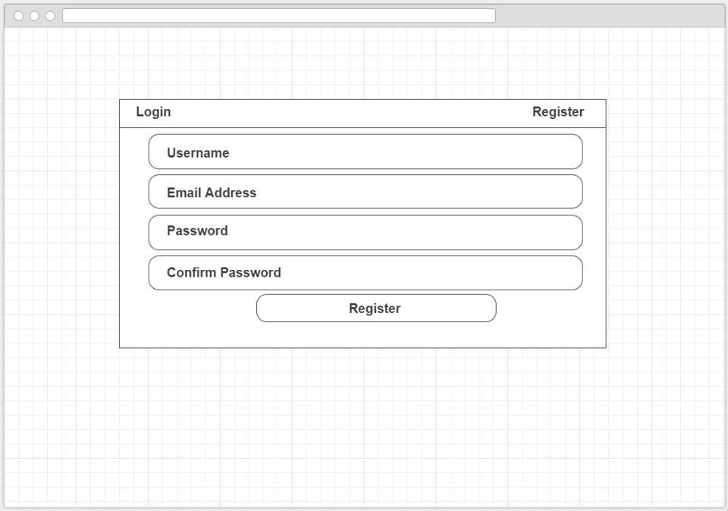

There are two models to allow new users to register as reader and then to log in to the system. A visitor to the site can pick to login if they already have an account or click register to sign up to an account. Once logged in a user will be redirected to the home page.

Purpose: register and log in

### Author page

Author page will have user image, his description and a list of contribution (list of adventures and comments). This page allows users to search for a certain author and view their content 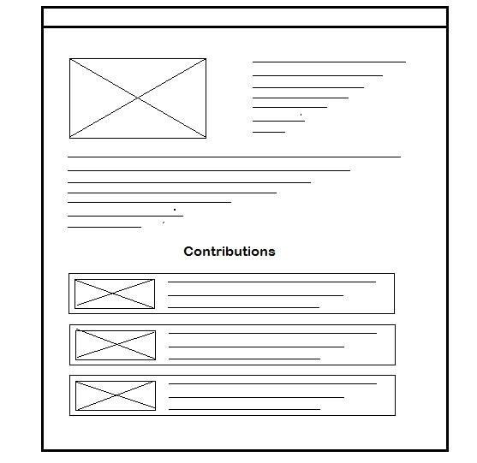

Purpose: View author and his contributions

### Other pages

Besides the above describe pages, there will be:

* Admin tools page.  
  Admin page is necessary to for admin to be able to see new registered users, newly created adventures which he need to approve.  
  Purpose: Administrate the website content
* Profile page.  
  On this page registered users will be able to see and change information about themselves.   
  Purpose: View and change information about the user himself.