© Endalkachew Asnake, Christoph Kieslich, Manuel Lindorfer, Bernhard Stemmer

Mobile Health project  FH Hagenberg 2013

Project description “Drugme”



1. **Project description**

The main goal of our application is to make people who have to take medications for whatever reasons aware of actually taking their medications in time. Very often it is the case that patients forget to take their medication at the appropriate time or to even take it at all, simply because they forget it or they are over challenged, e.g. because they have to take many different medications. In order to overcome this issue, a medication plan should assist the user to keep track of his medications.

We came up with a solution which alleviates the user from the effort of setting up a plan for his medications by implementing a simple web interface which can be used by physicians in order to create such plans for their patients. The physician defines everything starting from the medication to be taken, the desired amount and form (tablet, injection …), the input frequency and time as well as an additional intake advice for the patient. The patients on the other hand can use their smartphone and our implemented Android application to keep their medication plans up-to-date. Via a push-notification mechanism the physician is able to forward the created medication plans to the user’s smartphone from his web interface. The smartphone application informs the user that his medication plans have been update. Additionally, the user can gather detailed information about every single medication plan, such as a short description and an image of the medication, the desired input amount and additional information like the input frequency. What’s more, the application automatically creates alarms for every single medication which are triggered shortly before the corresponding medication has to be taken.

The implemented solution should not only assist the patients to keep track of their medication but should also provide an easy method for physicians to create customized medication plans, fitting the specific needs of every single patient. The fact that the medication plans are pushed directly to the patients’ smartphone provides additional comfort for both the physician and the patient.

1. **Related work and research**

For any related work and research objectives please refer to *“ProjectResearch.docx”*.

1. **Technical solution**

This section is used to outline the technical background of the developed system, covering a system architecture and some control flows between the single components. The following descriptions should help to better understand how our system operates.

* 1. **Used technologies**

The web application and the web backend are implemented using the NodeJS framework. For the graphical lay outing the node template ending Jade was used. Both allow the easy integration of HTML and java-script and provide a lot of pre-defined libraries which can be used.

In the server backend we use Mongo DB as a storage for registered patient and medication plans. Mongo DB is a non-relational database which comes with a very easy setup of tables and collections and allows the easily store data without really caring about data formats and table structures. Moreover it offers high performance which is also an important factor when it comes to usability.

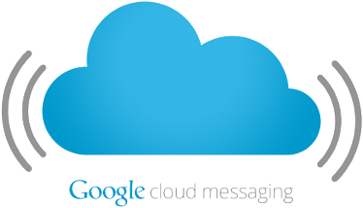We use the Google Cloud Messaging service for informing patients that their medication plans have been updated. Within the push-notification a URL is transmitted which represents the link to a RESTful API provided by our web application. The Android application queries the given API link and retrieves all medication plans assigned to the application user. Every time a message is received by the application over GCM a notification is displayed.

The client application is implemented for the Android platform, which provides a lot of open libraries and especially an easy integration of the Google Cloud Messaging service, which is necessary for realizing the message transfer from our web interface to the user’s smartphone.

* 1. **System architecture**

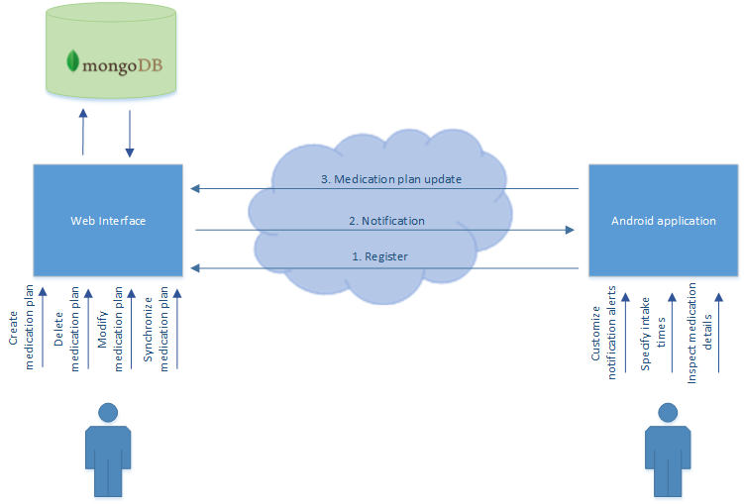The picture below outlines a coarse system architecture of the developed system and some of the control flows between the separate components. A more detailed description of the exchanged messages is given afterwards.

Figure 1 - System architecture

**Message exchange**

1. Register: When the Android application is started for the first time, the user has to provide his name and his EC-card number in order to register at the web server. This user information together with a device-unique API key is sent to the web interface via a RESTful API (a simple HTTP POST request). The according information is stored on the server side in a Mongo DB collection for later usage.
2. Notification: At any point in time the physician using the web portal is able of synchronizing the medication plans with a certain user. If he does so, a push-notification is sent to the user’s smartphone which can be identified using the API key provided at registration. This notification is transmitted using the Google Cloud Messaging service and just contains a specific URL which provides the patient with all medication plans that are assigned to him.
3. Medication plan update: Once the application receives such a push notification (as described in step 2) it automatically queries the provided URL and fetches all medication plans from the web server. The RESTful API provides this information in form of a JSON string, which is processed and stored locally by the Android application.

**Use cases**

On the server side the user (physician) is able to use to following functionalities:

* *Inspect information about all registered patients*
  + All patients which have registered are listed in the home screen of the web application.
* *Create a new medication plan*
  + After selecting one of the patients in the home screen the physician can create a new medication plan for the dedicated user
* *Modify an existing plan*
  + Plans which have already been created in the past are also listed in the patient’s details page and can modified, e.g. the same plan can be used again at a later point in time by simply changing the start and end date of the plan.
* *Delete a medication plan*
  + Plans which are not needed anymore can be easily deleted by the physician
* *Synchronize medication plans*
  + The physician can trigger a synchronization of all active medication plans in a specific users’ details page. After pressing the according button a push-notification will be sent to the user triggering a HTTP request at the web servers RESTful API. The medication plans will then be fetched by the user’s Android application automatically.

The Android application used by the patient is kept rather simple and supports the following functionalities:

* *Specify intake times*
  + The user can set the intake times for medication as he likes. In our prototype the user therefore is able to specify three different intake times, one for “morning”, “noon” and “evening” respectively.
* *Customize notifications*
  + It is possible to customize the notification metaphor the user wants to have applied when he gets informed about new notifications. He can choose between a simple vibration, a light indicator and a notification sound.
* *Inspect medication details*
  + The user is able to request a detailed information about a single medication plan by simply clicking the according item in the application. He is then forwarded to a details page showing an image of the medication, the next intake time, the intake time, the overall progress of the plan and a calendar highlighting the intake days.

1. **User manual**

In the following section we show various screenshots of the developed web interface and the Android application. We shortly describe what the corresponding screens relate to and describe shortly what functions are offered to the user.

1. **Web interface**

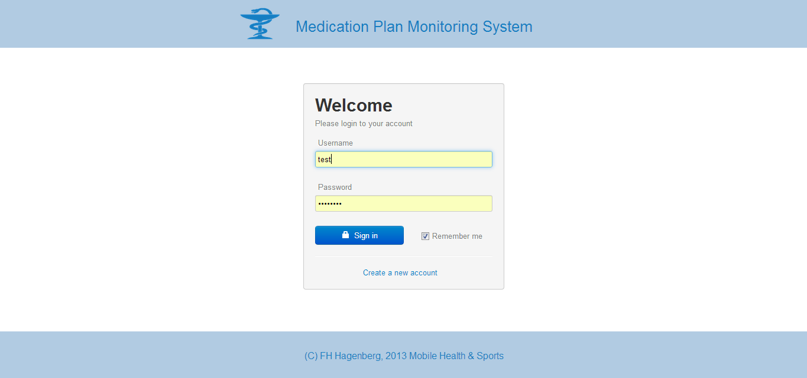

A login screen provides the possibility to log on to the web interface by providing both the user name and a password

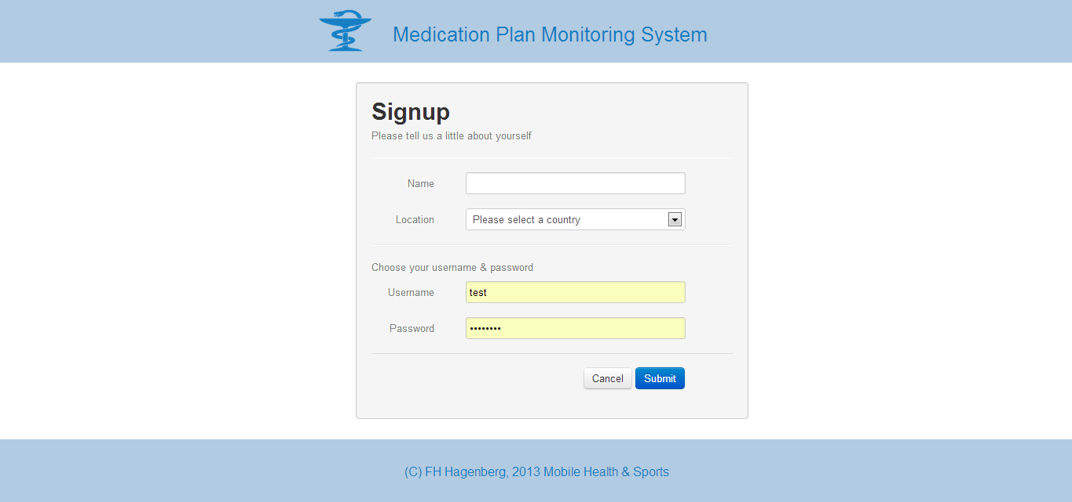

A signup page allows to register as new user at our web interface. The provided username and password have to be used for logging on to our system

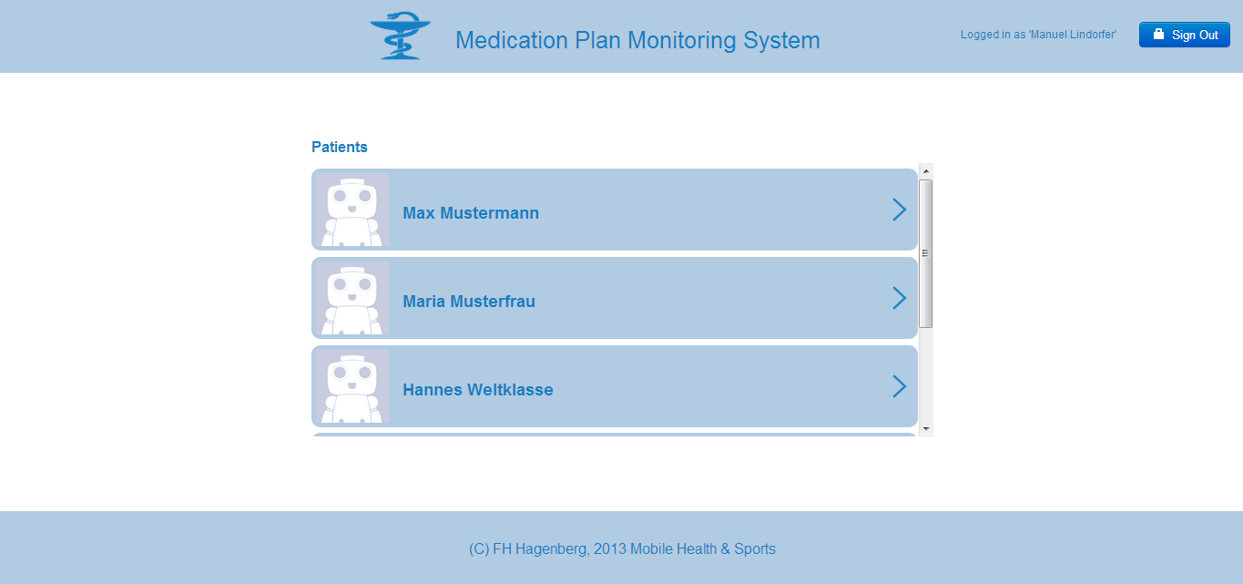

The home screen gives an overview over all patients that have already been registered at our service. By clicking on one of the patient items the user gets forwarded to the details page of the dedicated patient.

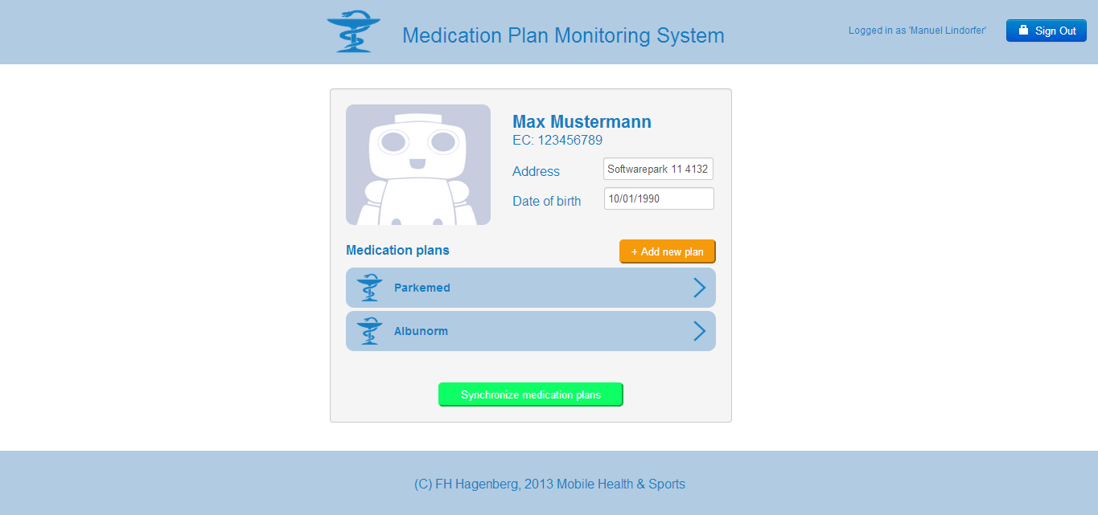

The details page provides the user with additional information about the associated patient, such as his EC-card number, his address or his date of birth. Additionally a list of all medication plans which have been created for this user is shown. By clicking the button “Add new plan” the physician can create a new plan for the user. By clicking on one of the medication plan items he is able to edit the plan. For synchronizing the medication plans with the patient’s smartphone the user has to press the green synchronize button.

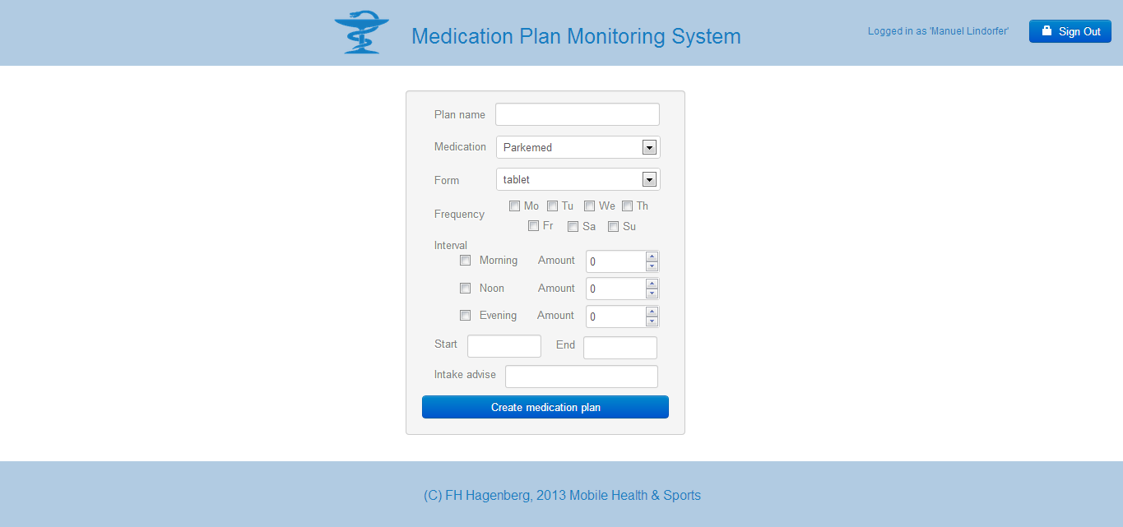

The page for creating a new medication plan provides the user with several input fields that have to be filled out in order to create a new plan. Starting from a plan name, the desired medication and intake frequency, the dedicated intake times as well as a start and an end date for the plan can be provided. Optionally the physician can enter an intake advice which is shown to the patient when notifying him for an upcoming intake.

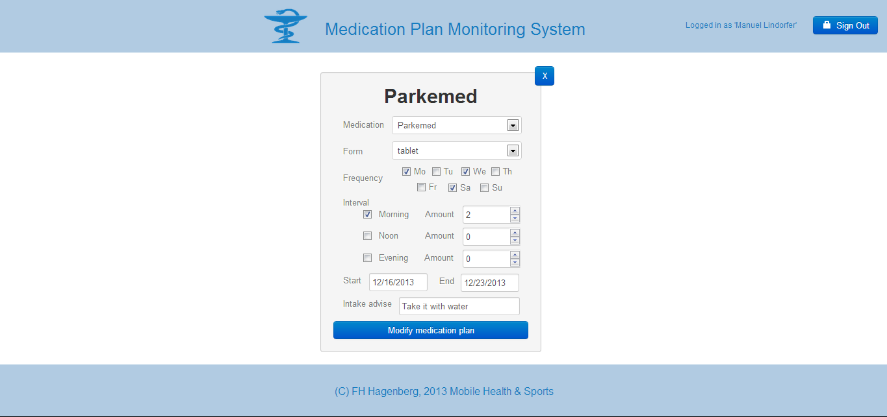

This picture shows the medication plan modification screen which is shown after the user clicked on a certain medication plan item in the details screen. All input fields are pre-filled according to the medication plan’s properties. By changing some of the properties and confirming with the “modify” button, the plan is updated accordingly. By clicking the “X” button in the top-right corner the medication plan is deleted.

1. 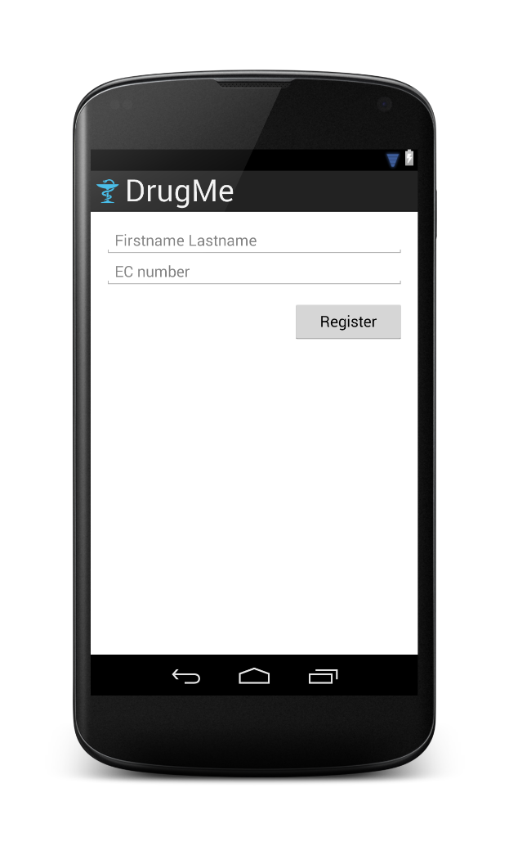**Android application**

At the first start of the application the user is prompted a login form where he has to provide his name (first name and last name) as well as his personal EC-card number. This information is sent to the web server and the user is registered at the web interface. From this point in time the physician is able to create and push medication plans to the registered user.

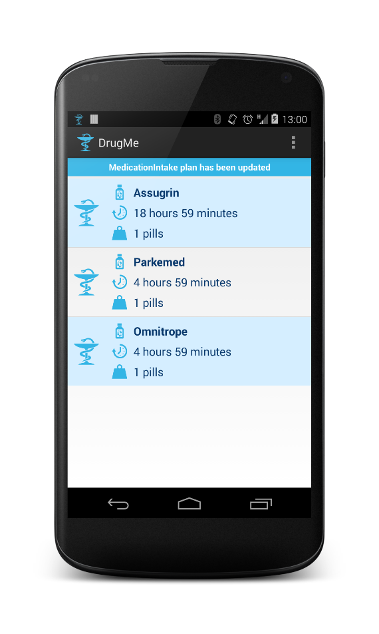

On the home screen of the application the user sees and overview of all currently active medication plan, and for each and every plan the next intake is displayed. By clicking on one of the plan items the user is forwarded to a details page. The blue bar in the top of the page indicates a notification and signalizes that the user’s medication plans have been update recently.

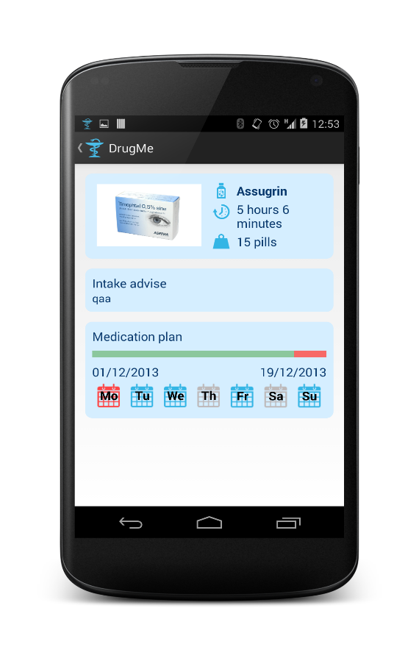

The details screen is shown after the user   
has clicked on a medication plan item in the applications home screen. This page displays useful information to the user about the medication itself, the intake amount and advice, the overall progress of the medication plan and the days where the medication has to be taken.

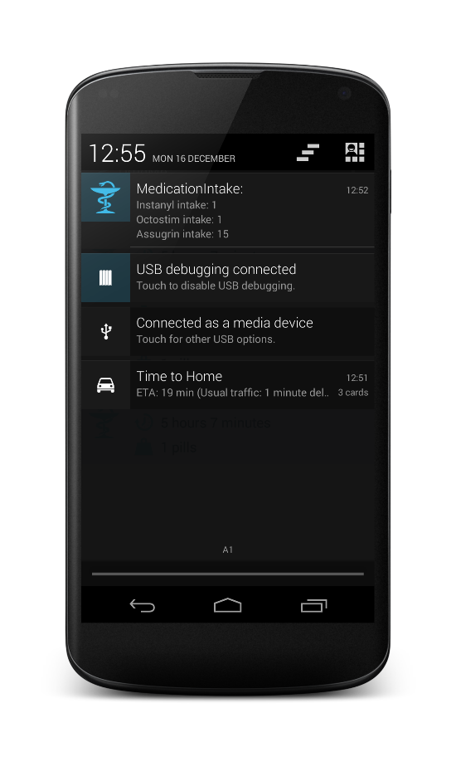

Every time the application recognizes that a medication has to be taken according to the active medication plans the user gets a notification showing all medication he has to take. The time when this notification is shown can be configured by the user in the settings page.

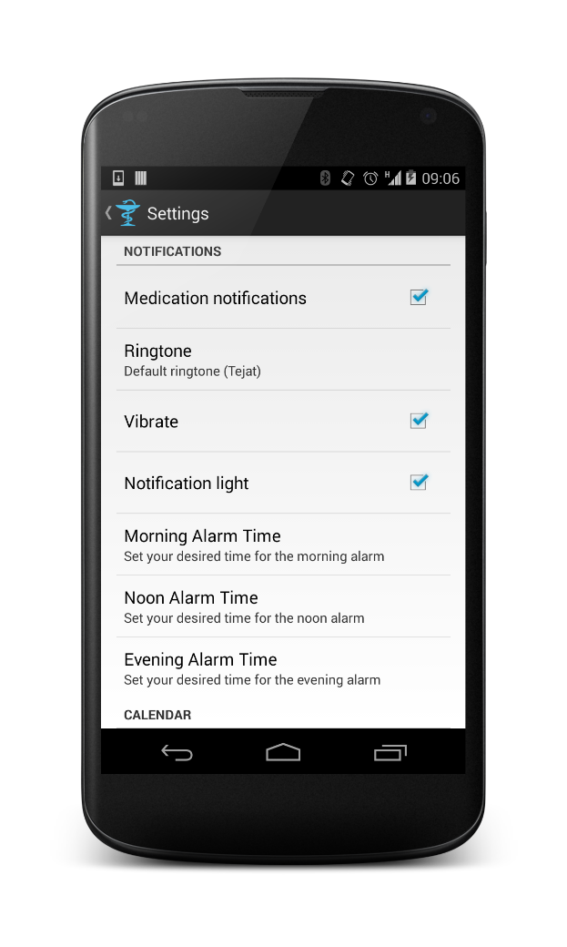

In the settings screen the user is able to define several application preferences. Besides his customized notification the user is also able to set the alarms for the three intake times (morning, noon, evening).

1. **Possible extensions**

We clearly state that the system as described is not a final product, but a prototype. We therefore agree on the fact that there are a lot of functionalities and additional features that could be integrated in our system, the main goals however have been achieved by showing that the distribution of medication plans using push-notifications is a comfortable method for both the physicians and the patients. For reasons of completeness we list here a number of features which would be nice extensions to the existing system from our point of view.

1. **Enhanced data transmission security**

Since medical data contains a lot of very private information it might be necessary to assure that no unauthorized person is able to get access to the data which is transferred between the patient’s smartphone and the web application. We therefore came up with the idea of implementing a simple public-key encryption scheme for encrypting the sensitive data which is sent from the web application to the smart phone. Although already implemented (see CryptoUtils classes in both the Android and the web project) we did not manage to integrate this feature due to problems that came up when installing the required libraries and extensions.

1. 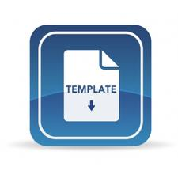**Medication plan templates**

In the current version of the web interface it is quite cumbersome to create a new medication plan from scratch, because all of the required input fields have to be filled out for each and every plan. A possible improvement would be the integration of several medication plan templates, e.g. plans with a pre-defined intake frequency or duration. The corresponding input fields would be pre-filled and alleviate the effort the physician has to spend when creating a new medication plan. This makes especially sense because a lot of medication plans might only differ in their start and end date, because they are targeting the same sickness.

1. **Intake confirmation**

Our application does not support the confirmation of a medication intake at the current point in time. It might be useful if a certain way of confirmation has to be performed by the application user every time he has to take a medication. This confirmation information can be used by the physician or by relatives in order to see whether the patient is taking the medication as expected or not. In case the patient misses a certain amount of intakes either the physician or closely related persons could be informed via e-mail or SMS.

1. 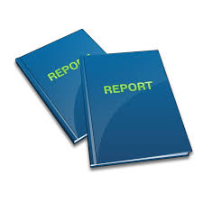**Medication reports**

Another useful feature would be the integration of medication reports in the Android application. This reports should help the user to keep track of his current process and highlight occasions where e.g. the user missed to take a certain medication. This reports could be shared with the physician in order to intervene if it is necessary.

1. **Medication “playlist”**

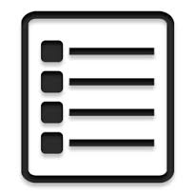For certain illnesses it is quite common that more than one single medication have to be applied. An enhancement of our developed system would be that the web interface supports the generation of so called “medication playlists”. A playlist is nothing more than a composition of several medications. Like a medication plan, such a playlist can be assigned to a patient in order to counteract common sicknesses such as flew.

1. **Notification songs**

At the current point in time our application only supports text, vibration and a light notifications. An even better user experience could be achieved by providing the possibility to defined customized notification songs. The user could specify a separate song for each single medication, and once the next intake comes close, the corresponding song starts playing. This extension might make the medication intake even more intuitive because the user links a certain medication to a certain melody.

1. **Daydream**

Currently the user has to start our application in order to get an overview over the next upcoming medication intakes and so forth. To make it even more comfortable for the user, the implementation of a daydream would be one possibility. Daydreams in Android allow to display information on the smartphone even if the device is locked. This could be used in order to display the next medication intake in a periodic interval, so the user is always up-to-date even though the application is not running in the foreground.