© Endalkachew Asnake, Christoph Kieslich, Manuel Lindorfer, Bernhard Stemmer

mobile health project  FH Hagenberg 2013

Project research “Drugme”



# **Care4Today**

Care4Today is an app which is available for Android and iOS. Care4Today describes itself as a new way to organize your medication plans. Users can setup medication plans for each of their medication. Care4Today automatically setup a reminder which notifies the user to take the medication. Family members can be assigned which receive a notification if their relative took or took not the medication. Statistical graphs can be generate which show you the medication intake over time.

**Pros:**

* Easy setup of medication lists
* Family involvement
* Reminder

**Cons:**

* No verification of medication plan
* User interface is not designed for elderly people
* The UI is bloated, too much information on the main screen
* No storyboard

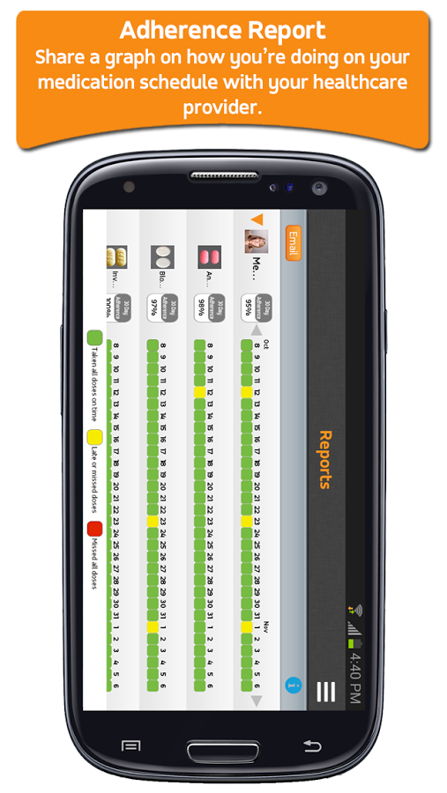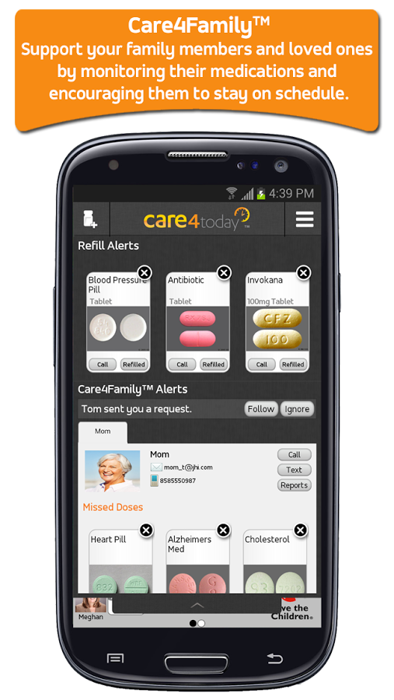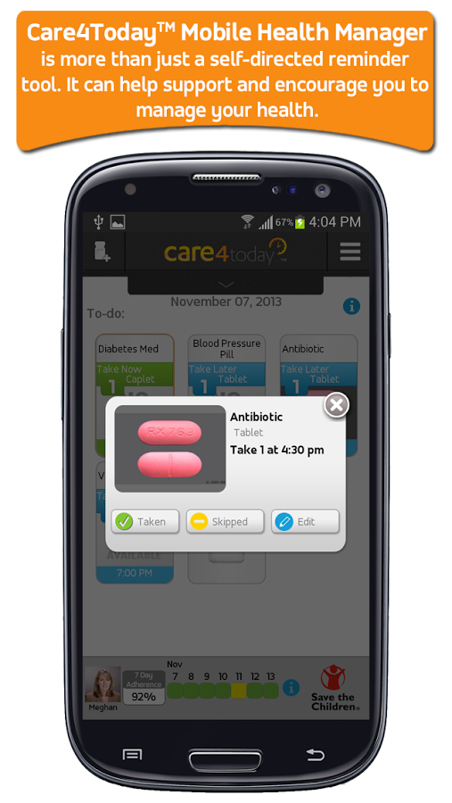

# **Diagnosia**

Diagnosia is an online medication database. It provides you easily with information about ingredients and complications with other medications. Diagnosia focuses on doctors and hospital staff. It allows you to access its database either online via a web browser or a dedicated app for Android and iOS.

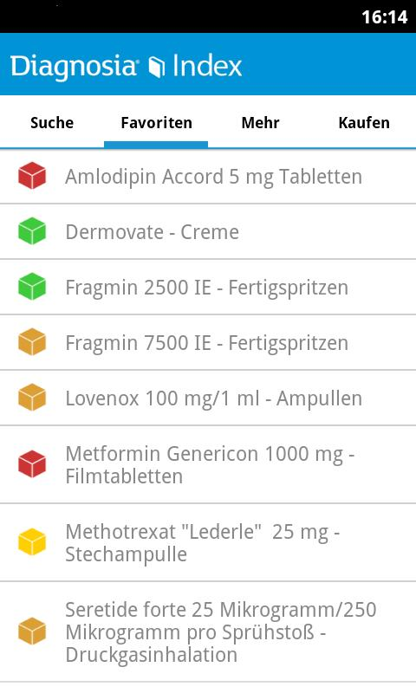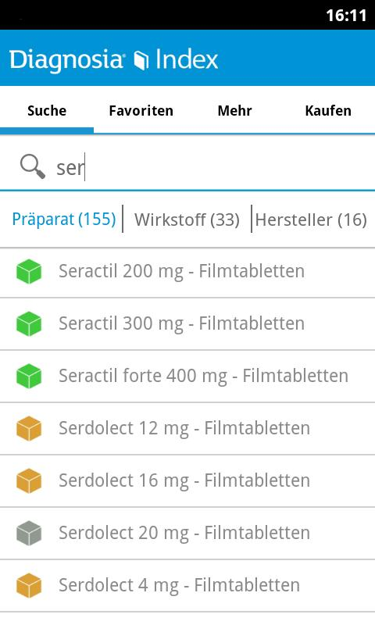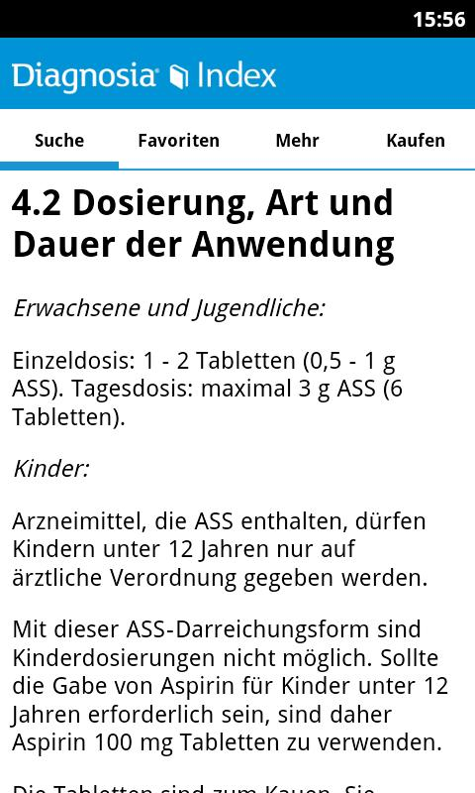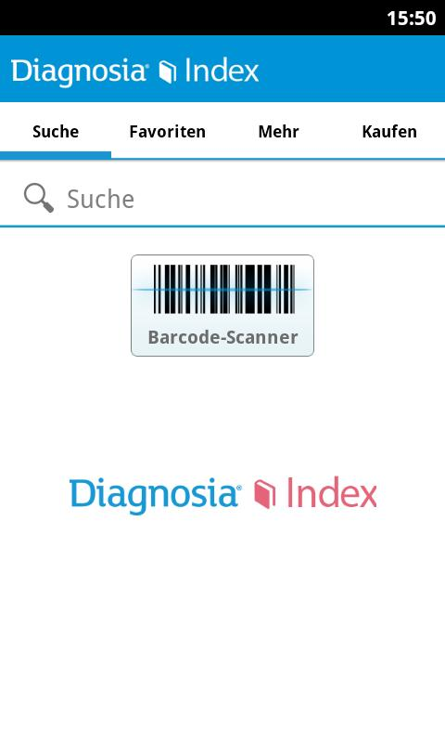

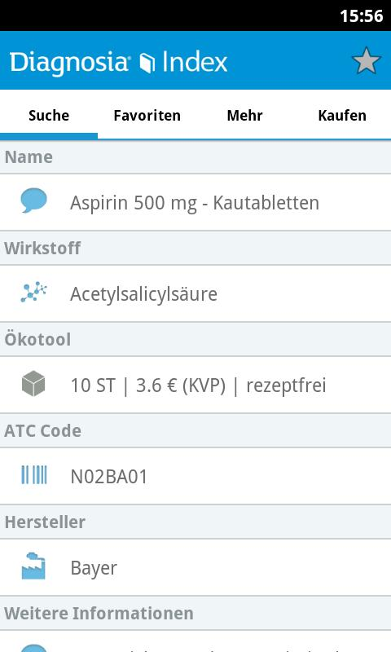

# **Qualcomm Glowcaps**

Glowcaps is different to the previous stated products because it consists of soft and hardware. Glowcaps as the name states are glowing caps which can be attached to medication bucket. You can replace the normal cap with the Glowcap. The glowcaps consists of a small microcomputer which will trigger a LED when you have to take your medication. Additionally to a light pulse notification a sound can be played. The configuration for each Glowcap is carried out by Smartphone.

**Pros:**

* Brilliant notification (sound and light)
* Helps you finding the medication

**Cons:**

* Energy consumption
* Complicated setup
* Expensive if you have to take many medications

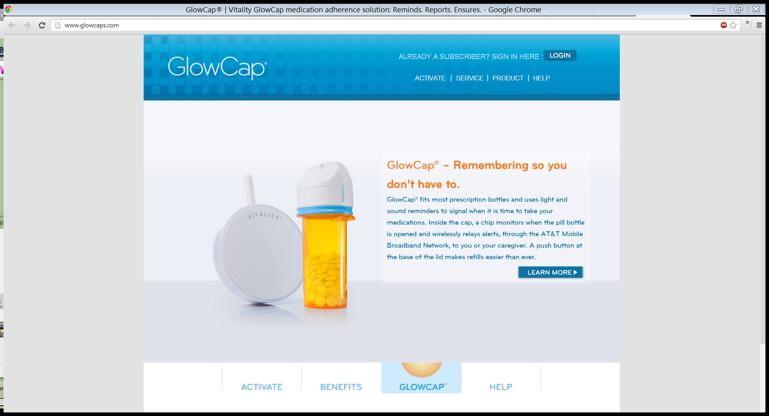

# **Node.js**

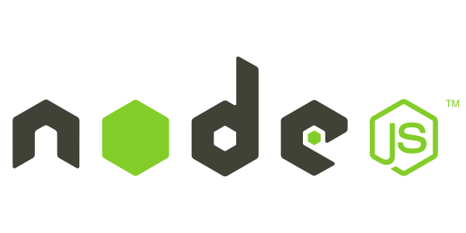

Node.js enables you to write client side and server side code in one language. Node.js is developed in JavaScript and executed by Googles V8 Engine. It is the same JavaScript Engine that powers Google Chrome. Node.js is an asynchronous web framework which helps you to build faster web applications.

## **Express**

* **Web Applications**

Express is a minimal and flexible node.js web application framework, providing a robust set of features for building single and multi-page, and hybrid web applications.

* **APIs**

With a myriad of HTTP utility methods and Connect middleware at your disposal, creating a robust user-friendly API is quick and easy.

* **Performance**

Express provides a thin layer of features fundamental to any web application, without obscuring features that you know and love in Node.js

# **MongoDB**

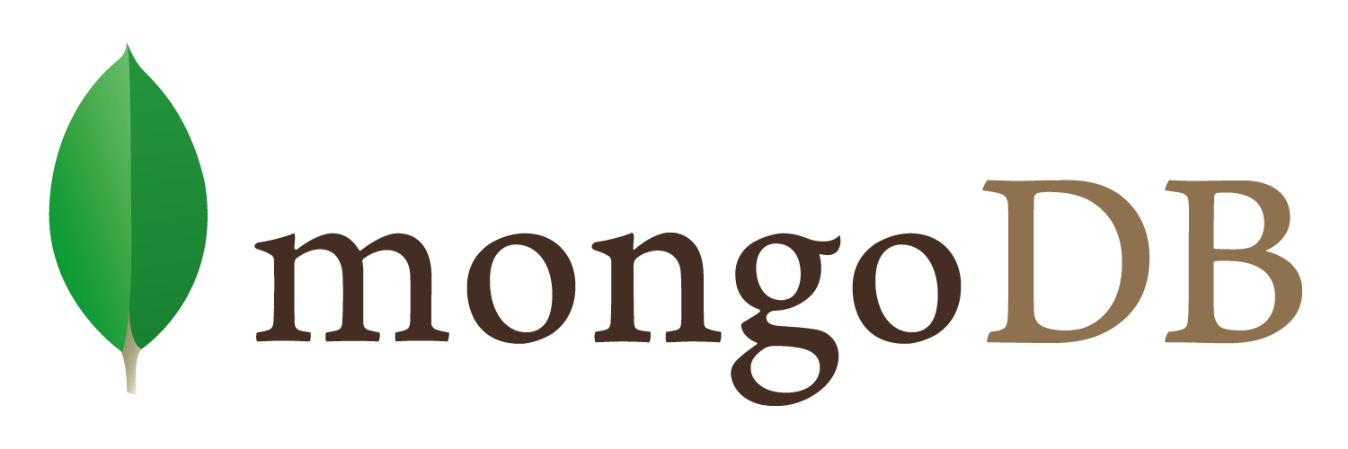

MongoDB (from "humongous") is an open-source document database, and the leading NoSQL database, written in C++. Some of the features of MongoDB are listed below:

1. **Document-Oriented Storage**

JSON-style documents with dynamic schemas offer simplicity and power.

1. **Full Index Support**

Index on any attribute, just like you're used to.

1. **Replication & High Availability**

Mirror across LANs and WANs for scale and peace of mind.

1. **Auto-Sharding**

Scale horizontally without compromising functionality.

1. **Querying**

Rich, document-based queries.

1. **Fast In-Place Updates**

Atomic modifiers for contention-free performance.

1. **Map/Reduce**

Flexible aggregation and data processing.