Notes to try and understand the effect of the scenarios

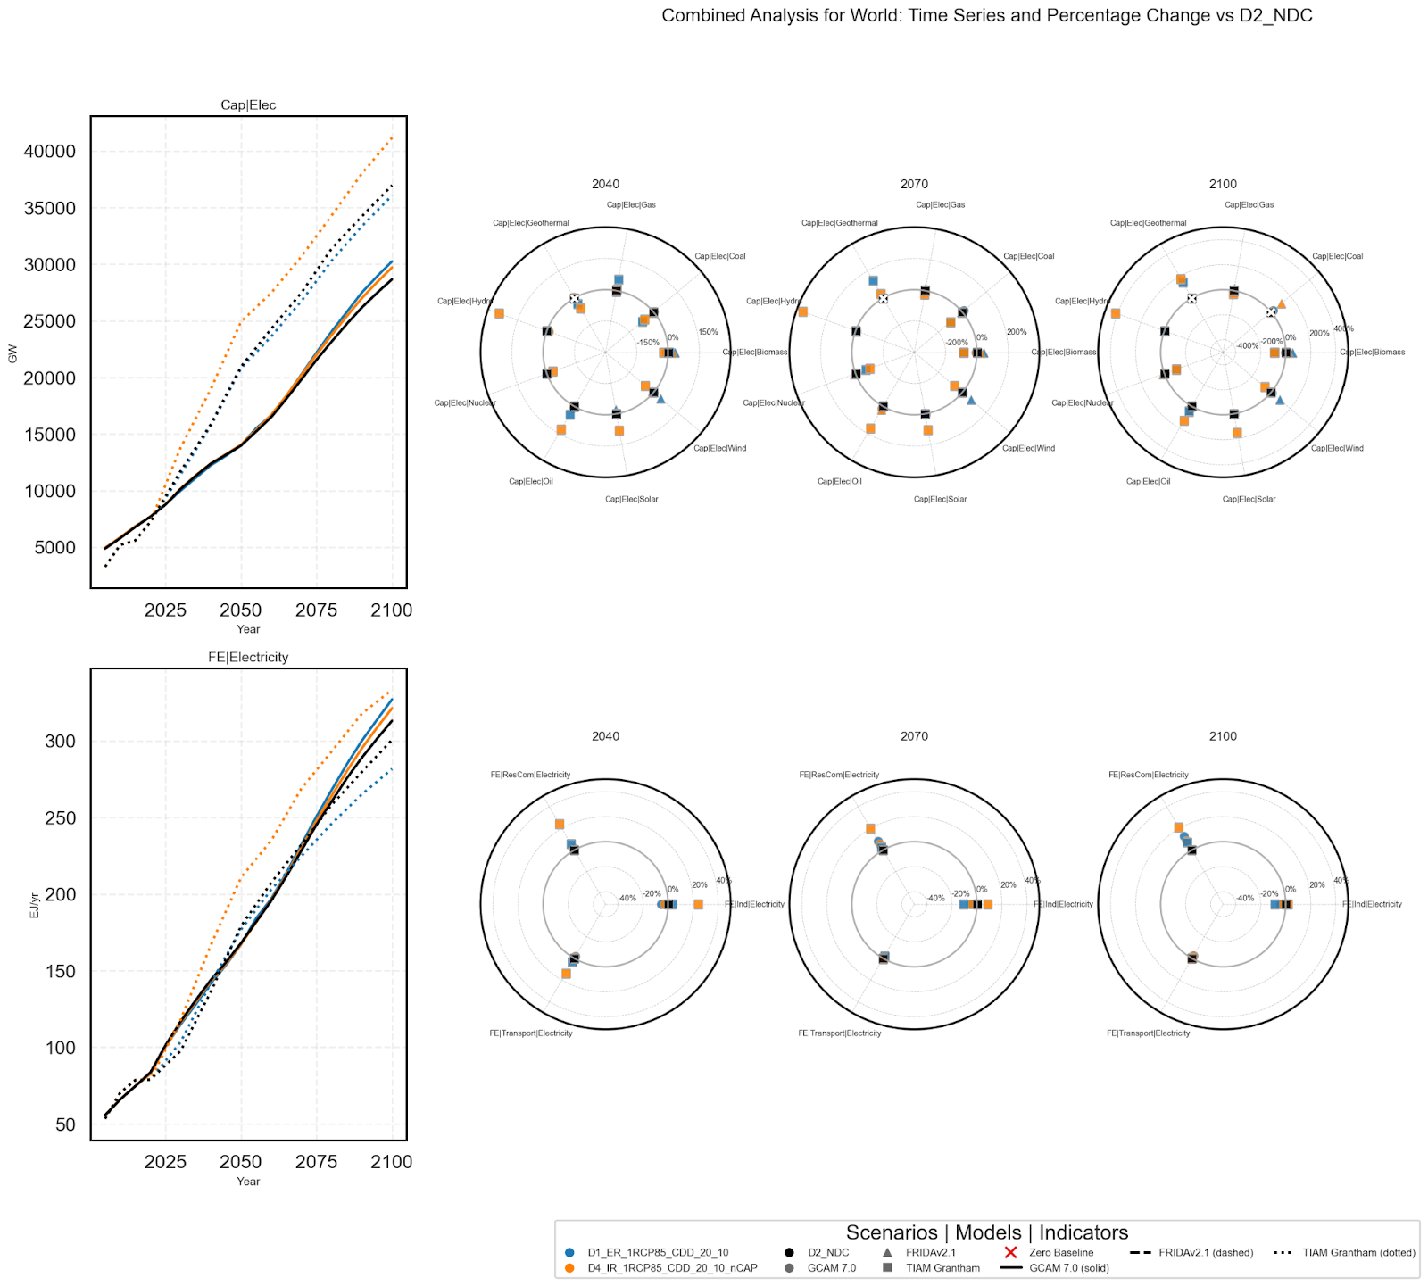

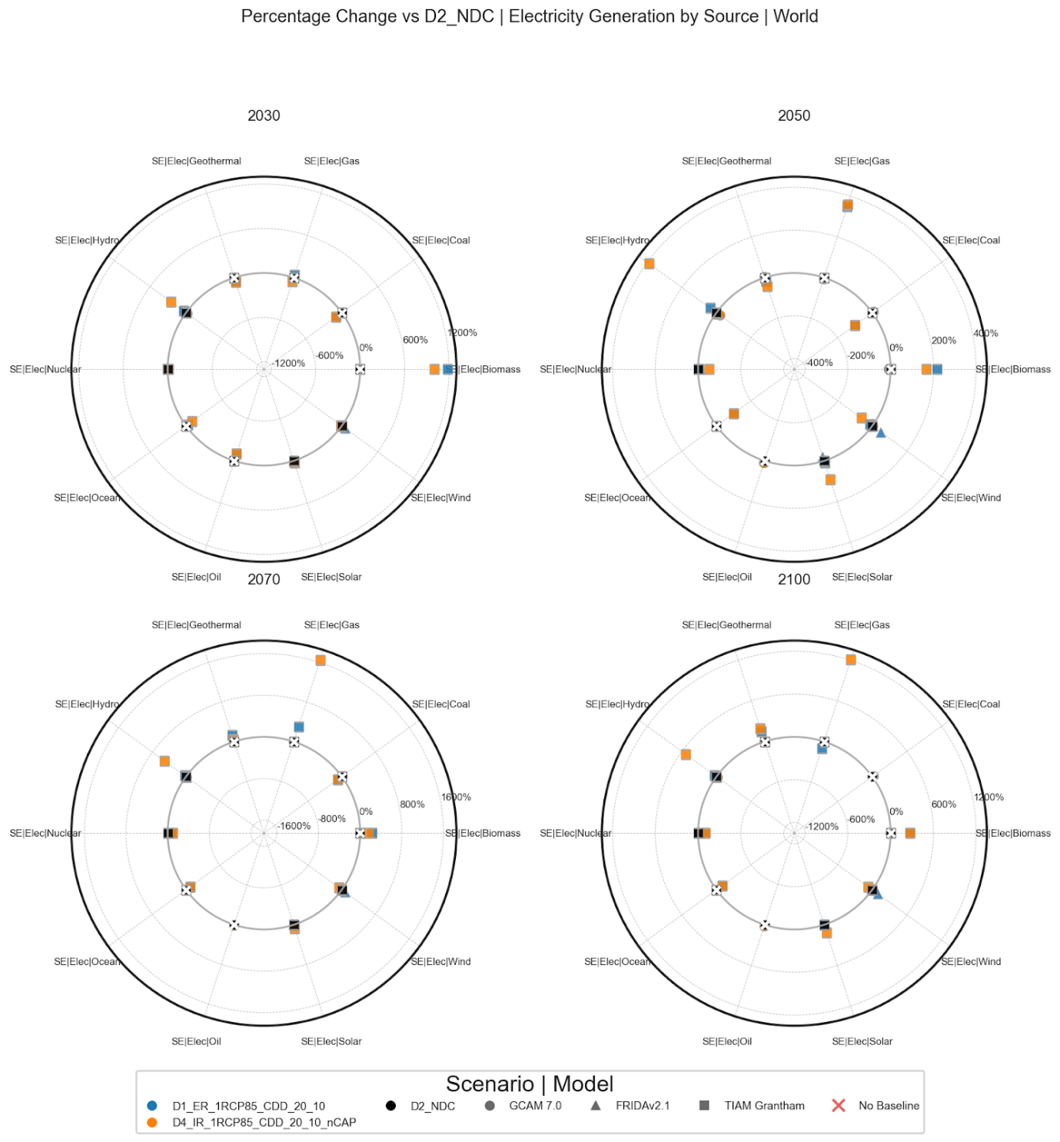

Baseline, black - NDC

2 scenarios of focus:

1. HD_ER_RCP85_1_CDD_20_10, blue – increased energy for cooling, damages to thermos and hydro, increases in costs, plus no allowed increases in elec capacity of the damaged sources (ie all except solar, wind, some biomass)
2. HD_ER_RCP85_1_CDD_20_10_nCAP, orange – as above, but with no limits on capacity additions

Increased cooling demand, and reduced efficiency of thermo and hydro, in general requires new energy output.

This is met in 2) by relative increases across a range of sources – nuclear, gas, oil, hydro, some biomass, but not wind and solar, which actually see slight drops. Coal capacity continues to decline as in all scenarios. Secondary energy is then higher, but overall electricity capacity is lower. Fossil fuels are being brought in, at the expense of renewables.

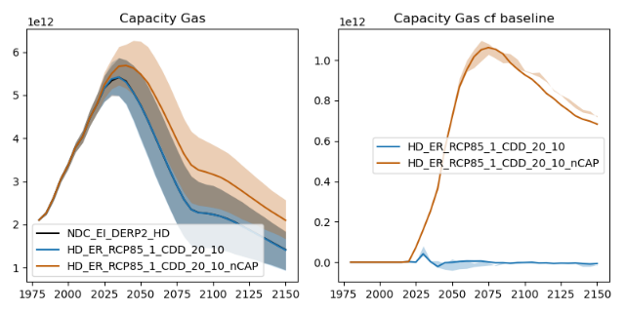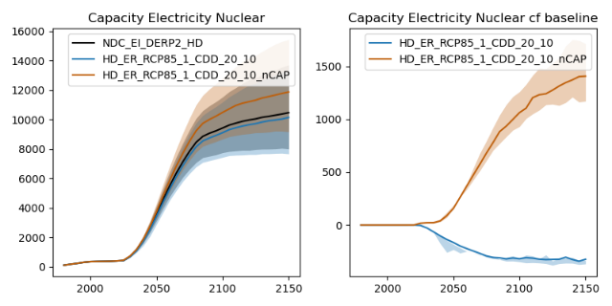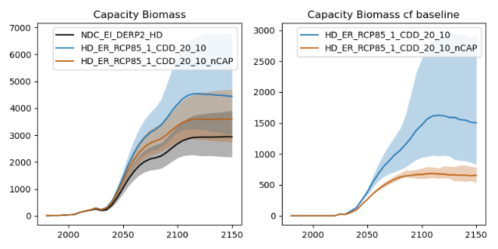

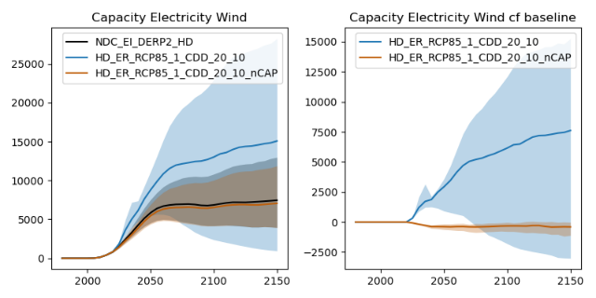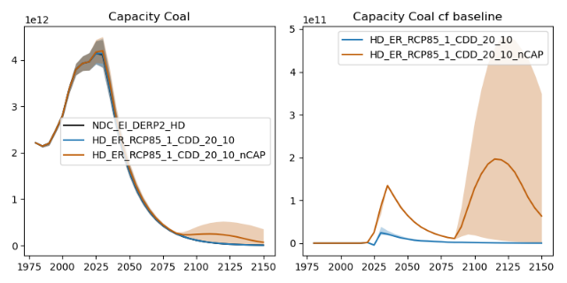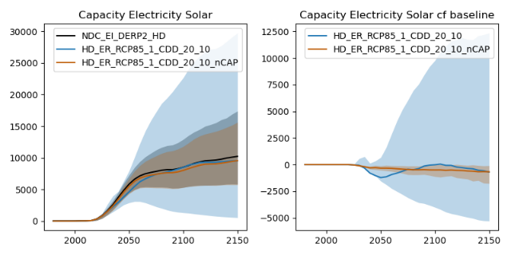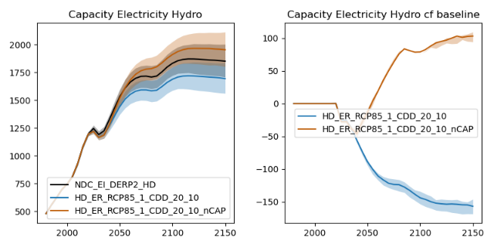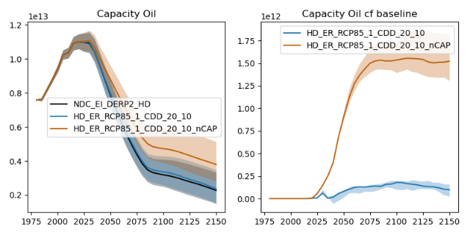

This reduction in renewables seems to be due to the cost increase damage.

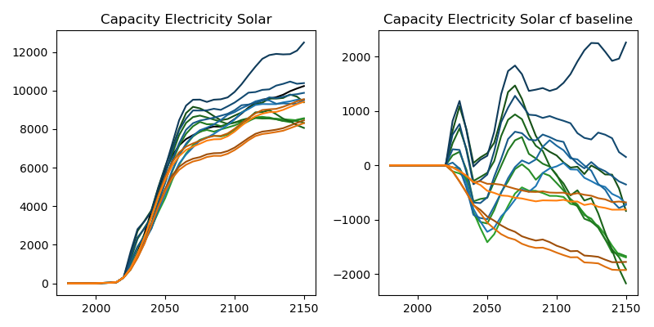 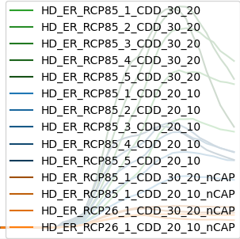

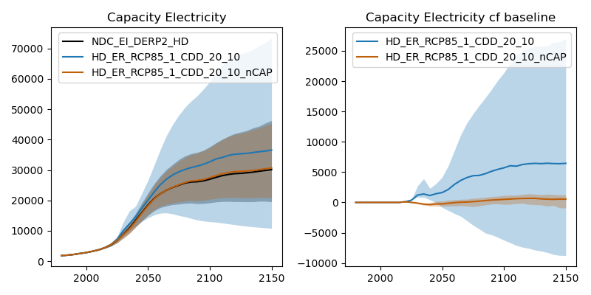

In 1), this has to be met by renewables (inc. biomass). In the median, this is provided by wind, not solar, but the contribution of solar and wind have huge uncertainties; in some scenarios solar contributes a substantial increase. Biomass increases somewhat higher than in 2), to contribute additional energy.

CO2 emissions from energy are therefore higher in 2) than the baseline, with immediate deviations, while still falling overall; the gap begins to narrow past 2100 due to a general fossil fuel phase out. In 1), emissions from energy are higher due to the overall biomass energy use; emissions from the land use sector are higher than in 2). Overall CO2 emissions are substantially higher in 2) still. Global temperatures are therefore slightly higher in both scenarios than the baseline, with 2) exhibiting 0.1C warmer, and 1) around 0.02C, around 2100.

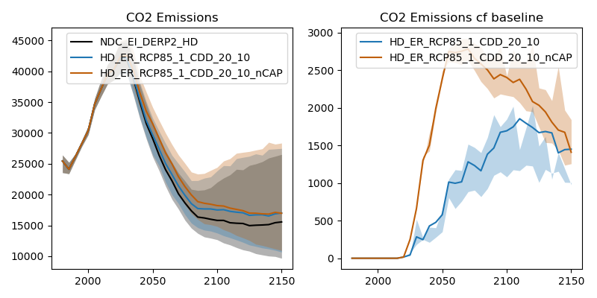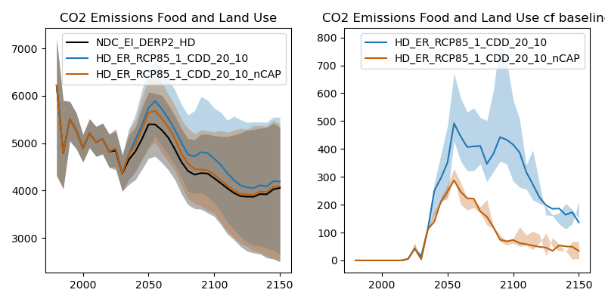 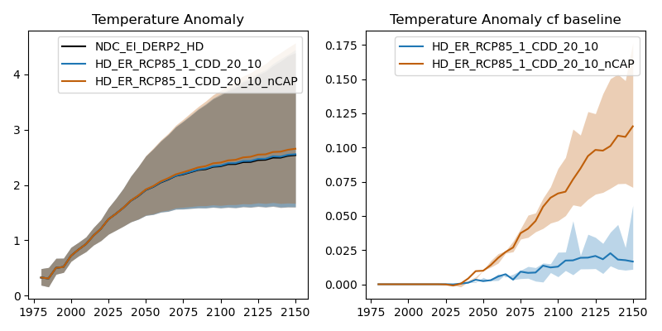

Proposed text for paper

In the system dynamics IAM FRIDAv2.1, the DERPs (see Methods for implementation details) cause cascading responses through the energy and other systems. Overall, the reduced efficiency reduces secondary energy output, and increased cooling demand raises the overall energy demand. Together, these effects imply additional energy supply requirements. Additionally, the scaled increases in energy capital costs modify the prioritisation of investment.

When there are no barriers to increasing capacity for any sources, the increased demand is met via a range of energy sources (Fig. 2) - nuclear, gas, oil, hydropower, and some biomass, but not wind and solar, which experience slight relative drops in capacity (while still increasing in magnitude). Fossil fuels are expanded at the expense of renewables. This reduction in renewables seems to be connected to the cost increase damage, and its effect on the allocation of investment in energy systems. It is likely also modified by the general feedback effect of the energy system damages, which will hamper overall growth and available investment. As a result, overall electricity capacity is barely affected under this scenario (Fig. 2).

In the case when strict barriers are raised to increases in capacity of thermo- and hydro-electricity above the baseline, the gap in supply must be met via other sources. Note that, since FRIDAv2.1 does not distinguish between energy sources by carrier, limits were applied to new investment in all energy sources with thermoelectric components, since investments in the electric capacity component are not separated out (see Methods). Therefore, only solar, wind, and biomass energy are able to expand to meet this demand. Increases in all three of these occur, with substantial uncertainty in the contributions of solar and wind, but with wind exhibiting the largest increase in the median. Electricity capacity is therefore substantially higher in this scenario than the baseline (Fig. 2), with biomass energy also increasing substantially.

The increases in renewable capacity under capacity addition limitations are substantially faster than in the baseline, with wind capacity more than twice as high in the median case than the baseline, while higher-end ensemble members feature several times higher rollout of renewable technologies.

The effect of the higher fossil fuel utilisation under the climate damages without limits to energy investments is to cause emissions of CO2 to be higher than in the baseline (Fig. Supp.), with a peak difference of around 3GtCO2/yr in the middle of the century. CO2 emissions are also higher when investments in thermos- and hydro-electric expansion are limited, due to the rollout of biomass; this difference is smaller, rising to a peak under 2GtCO2/yr around 2100. The resultant effect on temperature is to increase GMST around 0.1C and 0.02C in 2100 respectively. In FRIDAv2.1, these different GMST levels alter the coupled trajectory of the system via the representation of climate damages (Methods), though these relatively small differences can be expected to have slight effects. Note that the damages to energy systems are uncoupled in these experiments, to be consistent with the DERPs protocol.