gb_wim

Christopher Eshleman

11/5/2019

Use iANALYZE to eat the raw data files and spit them back out as .csv files. There are two files, one covering a day — June 15, 2018, a Friday — of eastbound traffic and a second — June 4, 2018, a Monday — for a day of westbound traffic.

##   
## e w  
## 4 0 42101  
## 15 56655 0

Above: there are a few more trucks headed eastbound on the Friday headed westbound on the Monday.

The software gives us two data sets per day - one raw and one “extended.” I’m not sure what to do with the raw unextended data - doesn’t come with variable names. But the “extended” data set is rich and has data parsed by variable, which makes it slightly easier to manage than the data dumps we receive for the Alexander Hamilton Bridge in the Bronx.

Anyway, are tractor trailers crossing the bridge westbound heavier than those crossing eastbound? I would expect them to be.

We can group the data for analysis and visualization after a little munging. One annoying thing is that IRD reports weight in metric units and they’ve been scaled - for example, they’re stored for the Alexander Hamilton as tonnes*10. Here, they’re something else — perhaps one-tenths of a tonne. Either way “GVW” needs to be converted to pounds.

# Question:

### Are trucks headed west heavier than those headed east?

Do a basic t-test - are they heavier?

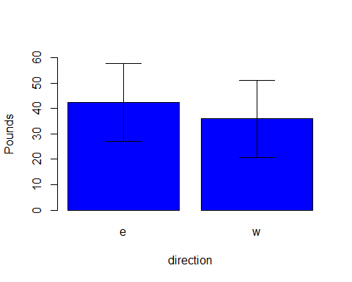

##   
## Call:  
## lm(formula = gb.test$GVW ~ gb.test$direction)  
##   
## Residuals:  
## Min 1Q Median 3Q Max   
## -4.252 -1.952 -0.780 0.220 88.848   
##   
## Coefficients:  
## Estimate Std. Error t value Pr(>|t|)   
## (Intercept) 2.98008 0.02433 122.47 <2e-16 ***  
## gb.test$directionw 1.27204 0.03727 34.13 <2e-16 ***  
## ---  
## Signif. codes: 0 '***' 0.001 '**' 0.01 '*' 0.05 '.' 0.1 ' ' 1  
##   
## Residual standard error: 5.792 on 98754 degrees of freedom  
## Multiple R-squared: 0.01166, Adjusted R-squared: 0.01165   
## F-statistic: 1165 on 1 and 98754 DF, p-value: < 2.2e-16

# Answer:

### Absolutely not.

Trucks crossing EASTBOUND are heavier than westbound, on average, for those two days.