Start the App

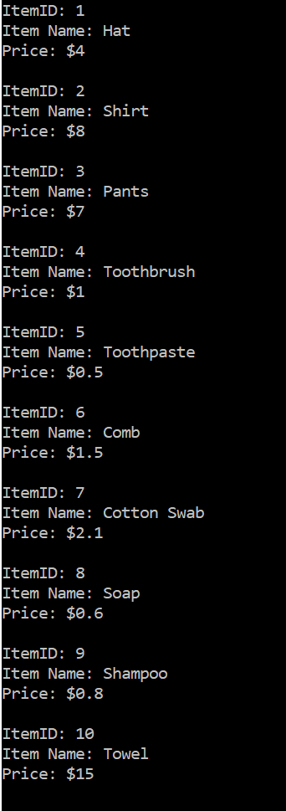

The following prompt will appear:



Enter the ID of the item you want to buy. I entered 6 which represents the item “comb”.



The following prompt will appear.



Enter the quantity you want to buy. I entered 3 as I would like to buy 3 combs.



The following message will appear showing that I have purchased 3 combs and that the transaction cost me $4.50 ( 3 x $1.50 per comb = $4.50 ).

