**LIRI Bot by Christopher Fernandes**

**Bash command:** node liri concert-this pink

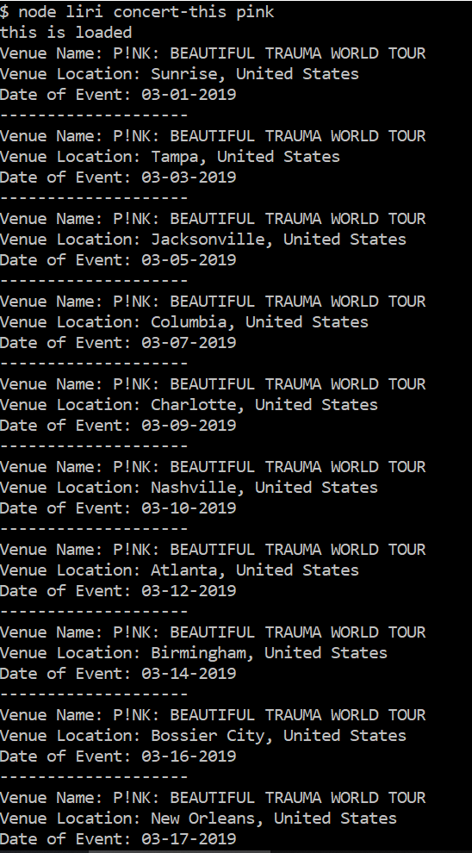

**Bash command:** node liri spotify-this-song started from the bottom

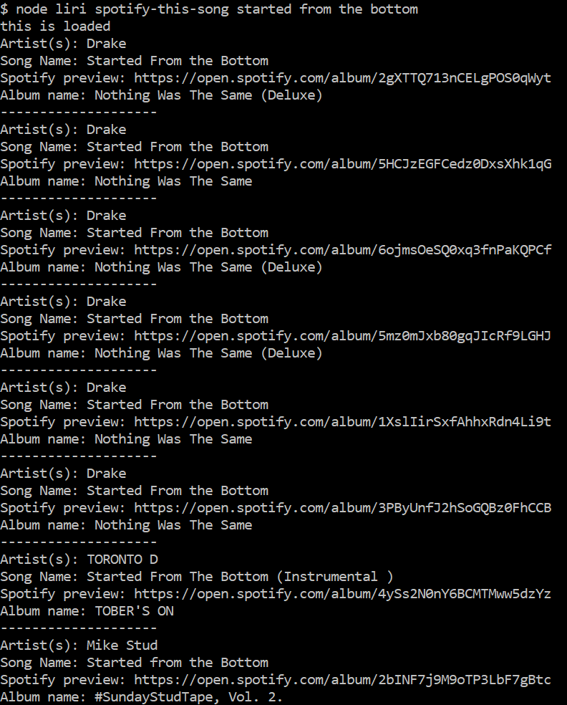

**Bash command:** node liri movie-this robin hood

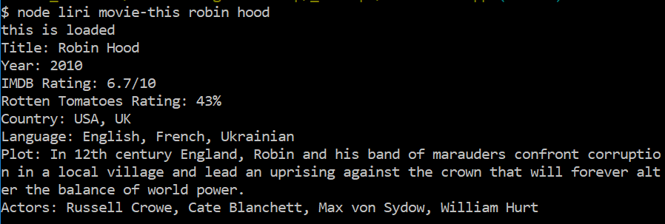

**Bash command:** node liri do-what-it-says

