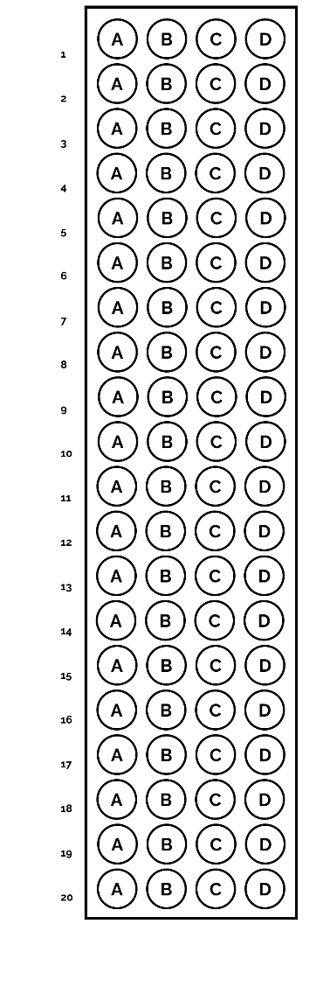NAME: ______________________ COURSE & SECTION: ______________________________