DATABASE: Course Work 1

Q1a.

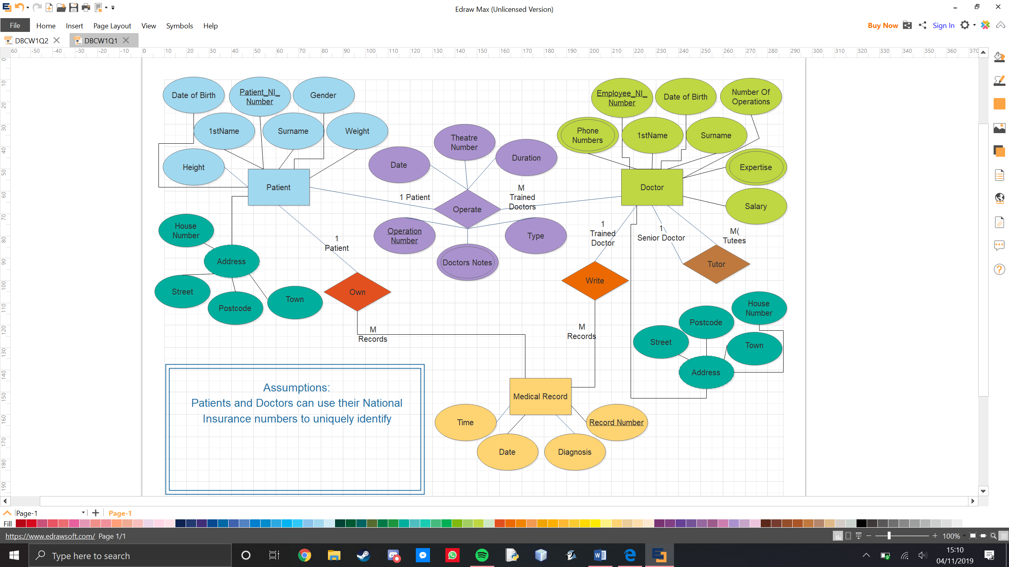

Q1b.

Doctor(Employee_NI_Number, 1stName, Surname, Number_Of_Operations, Salary, DoB)

primary key (Employee_NI_Number)

Patient(Patient_NI_Number, 1stName, Surname, Gender, Weight, Height, DoB)

primary key(Patient_NI_Number)

Address(Patient_NI_Number, Employee_NI_Number, House_Number, Street, Town, Postcode)

primary key(Patient_NI_Number or Employee_NI_Number)

foreign key Patient_NI_Number references Patient(Patient_NI_Number)

foreign key Employee_NI_Number references Doctors(Employee_NI_Number)

Operate(Operation_Number, Patient_Number, Employees, Date, Theatre_Number, Type, Duration)

primary key (Operation_Number)

foreign key Patient_NI_Number references Patient(Patient_NI_Number)

foreign key Employees references Doctors(Employee_NI_Number)

Medical_Record(Record_Number, Patient_NI_Number, Employee_NI_Number, Time, Date, Diagnosis)

primary key (Record_Number)

foreign key Patient_NI_Number references Patient(Patient_NI_Number)

foreign key Employee_NI_Number references Doctors(Employee_NI_Number)

Q2.

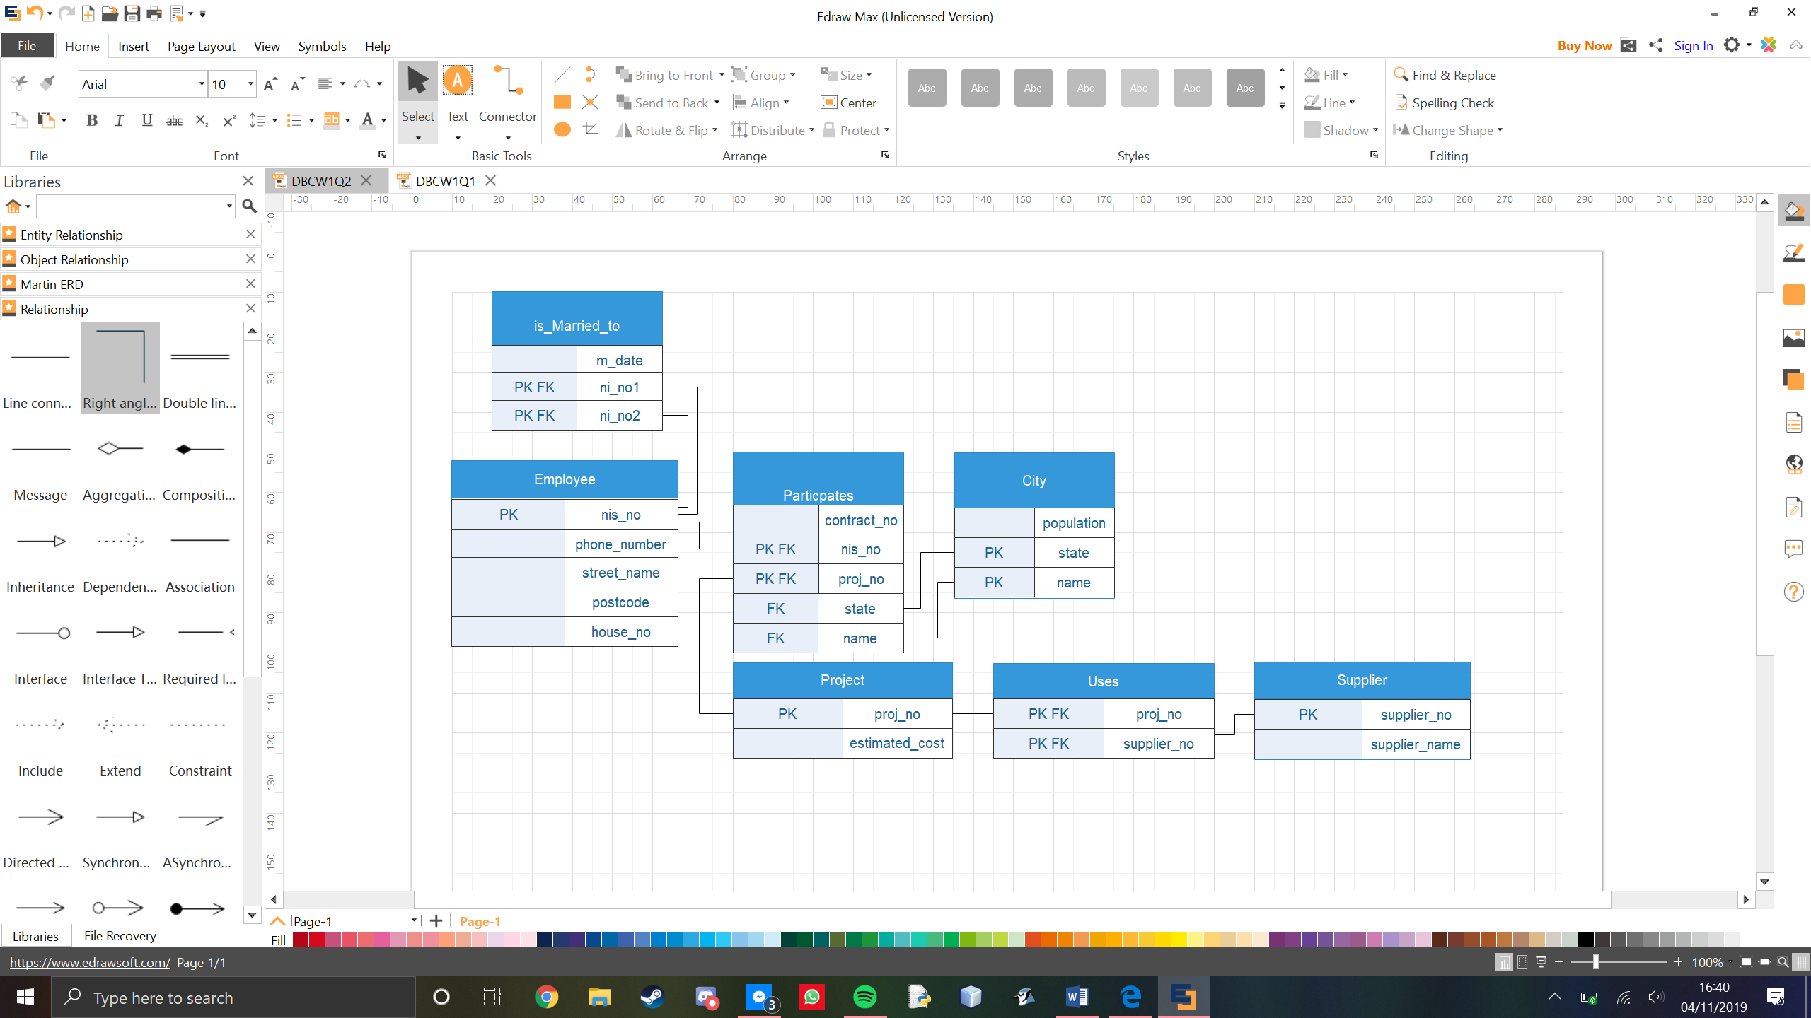

Q3.