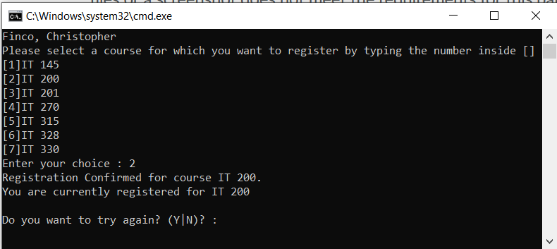

Program registers the correct course corresponding to the integer input by the user

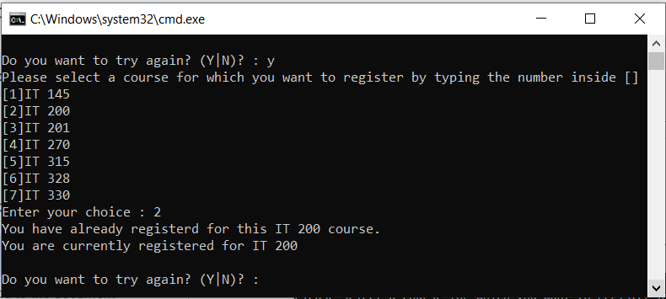

Program doesn’t allow the user to register for a course they are already registered for

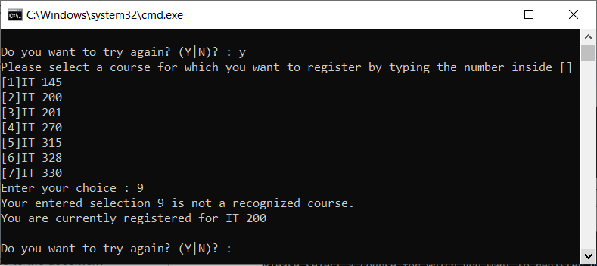

Program doesn’t allow the user to register for courses that don’t exist

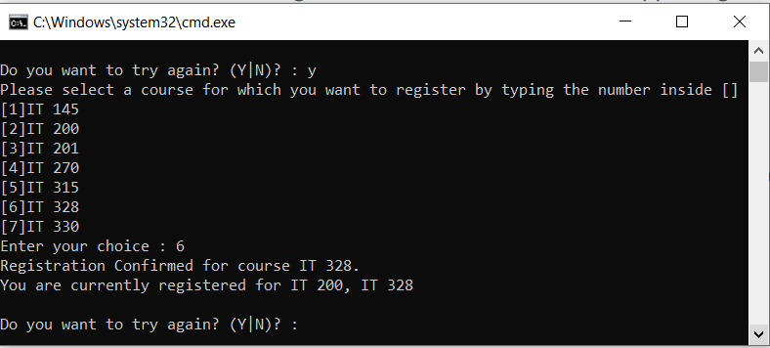

Program lists all courses that were previously registered

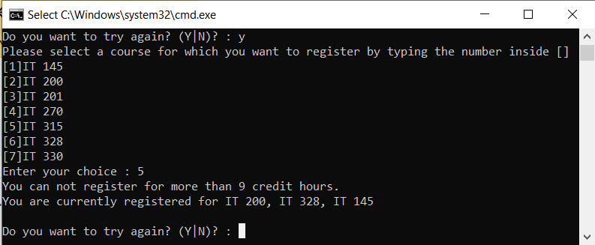

Program does not allow the user to register for more than 3 courses

using System;

using System.Collections.Generic;

using System.Linq;

using System.Text;

using System.Threading.Tasks;

namespace ConsoleRegisterStudent

{

class Program

{

static void Main(string[] args)

{

(new Program()).run();

}

void run()

{

int choice;

int firstChoice = 0, secondChoice = 0, thirdChoice = 0;

int totalCredit = 0;

string yesOrNo = "";

System.Console.WriteLine("Finco, Christopher");

do

{

WritePrompt();

choice = Convert.ToInt32(Console.ReadLine());

switch (ValidateChoice(choice, firstChoice, secondChoice, thirdChoice, totalCredit))

{

case -1:

Console.WriteLine("Your entered selection {0} is not a recognized course.", choice);

break;

case -2:

Console.WriteLine("You have already registerd for this {0} course.", ChoiceToCourse(choice));

break;

case -3:

Console.WriteLine("You can not register for more than 9 credit hours.");

break;

case 0:

Console.WriteLine("Registration Confirmed for course {0}.", ChoiceToCourse(choice));

totalCredit += 3;

if (firstChoice == 0)

firstChoice = choice;

else if (secondChoice == 0)

secondChoice = choice;

else if (thirdChoice == 0)

thirdChoice = choice;

break;

}

WriteCurrentRegistration(firstChoice, secondChoice, thirdChoice);

Console.Write("\nDo you want to try again? (Y|N)? : ");

yesOrNo = (Console.ReadLine()).ToUpper();

} while (yesOrNo == "Y");

Console.WriteLine("Thank you for registering with us");

}

void WritePrompt()

{

Console.WriteLine("Please select a course for which you want to register by typing the number inside []");

Console.WriteLine("[1]IT 145\n[2]IT 200\n[3]IT 201\n[4]IT 270\n[5]IT 315\n[6]IT 328\n[7]IT 330");

Console.Write("Enter your choice : ");

}

int ValidateChoice(int choice, int firstChoice, int secondChoice, int thirdChoice, int totalCredit)

{

//Error 4: Should check if choice is greater than 7, not 70

if (choice < 1 || choice > 7)

return -1;

//Error 2: Should use OR operator, not AND

else if (choice == firstChoice || choice == secondChoice || choice == thirdChoice)

return -2;

//Error 3: Check if total credits is greater than OR EQUAL to 9, not just greater

else if (totalCredit >= 9)

return -3;

//Error 1: Should return 0, not -4

return 0;

}

void WriteCurrentRegistration(int firstChoice, int secondChoice, int thirdChoice)

{

//Not sure if counts as an error, but added an option for if the user doesn't have any registered courses

if (firstChoice == 0)

Console.WriteLine("You are not currently registered for any courses.");

else if (secondChoice == 0)

Console.WriteLine("You are currently registered for {0}", ChoiceToCourse(firstChoice));

else if (thirdChoice == 0)

Console.WriteLine("You are currently registered for {0}, {1}", ChoiceToCourse(firstChoice), ChoiceToCourse(secondChoice));

else

Console.WriteLine("You are currently registered for {0}, {1}, {2}", ChoiceToCourse(firstChoice), ChoiceToCourse(secondChoice), ChoiceToCourse(thirdChoice));

}

string ChoiceToCourse(int choice)

{

string course = "";

switch (choice)

{

case 1:

course = "IT 145";

break;

case 2:

course = "IT 200";

break;

case 3:

course = "IT 201";

break;

case 4:

course = "IT 270";

break;

case 5:

course = "IT 315";

break;

case 6:

course = "IT 328";

break;

case 7:

course = "IT 330";

break;

default:

break;

}

return course;

}

}

}