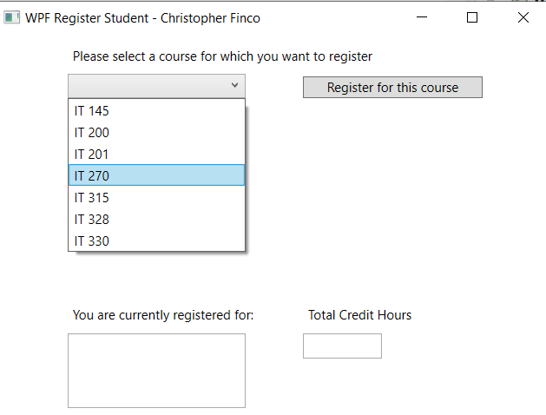

Program allows user to choose courses from a dropdown list to register for

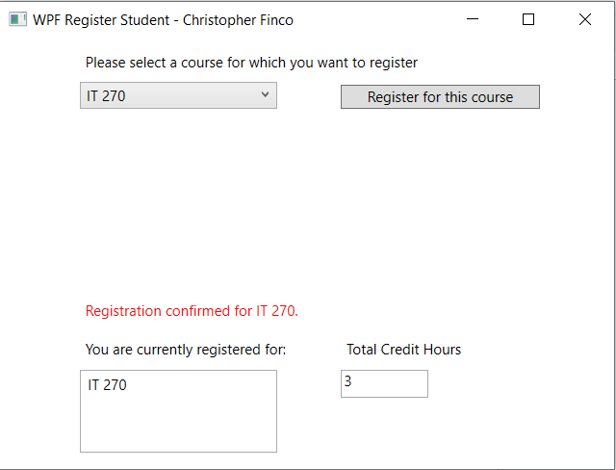

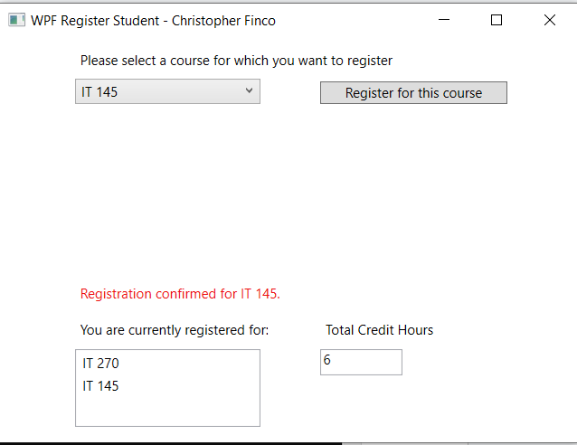

Clicking “Register for this course” adds the chosen course to the registered course list and adds 3 credits to the credit hours count, if the choice is valid

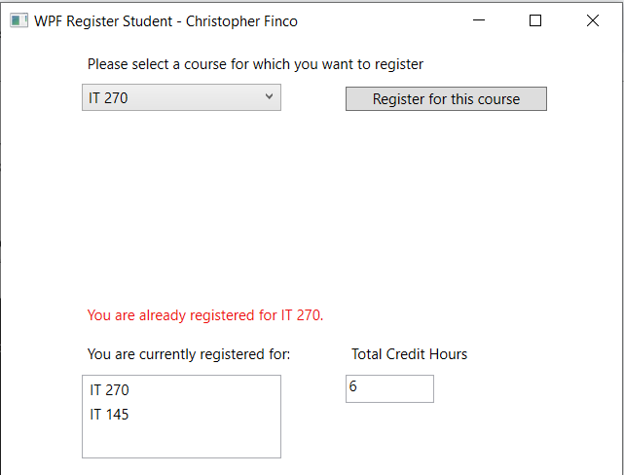

Program doesn’t allow the user to register for a course they are already registered for

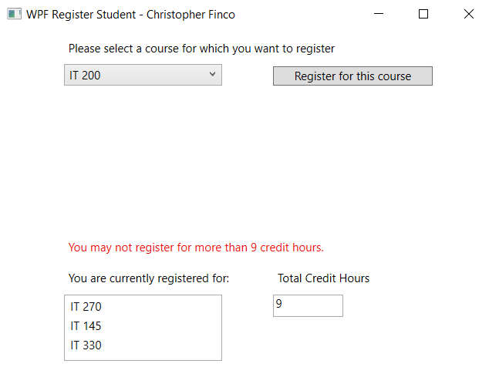

Program does not allow the user to register for more than 3 courses

using System;

using System.Collections.Generic;

using System.Linq;

using System.Text;

using System.Threading.Tasks;

using System.Windows;

using System.Windows.Controls;

using System.Windows.Data;

using System.Windows.Documents;

using System.Windows.Input;

using System.Windows.Media;

using System.Windows.Media.Imaging;

using System.Windows.Navigation;

using System.Windows.Shapes;

namespace WPFRegisterStudent

{

/// <summary>

/// Interaction logic for MainWindow.xaml

/// </summary>

public partial class MainWindow : Window

{

Course choice;

//Added variable to keep track of credit hours

int creditHours = 0;

int maxCreditHours = 9;

public MainWindow()

{

InitializeComponent();

}

private void Window_Loaded(object sender, RoutedEventArgs e)

{

Course course1 = new Course("IT 145");

Course course2 = new Course("IT 200");

Course course3 = new Course("IT 201");

Course course4 = new Course("IT 270");

Course course5 = new Course("IT 315");

Course course6 = new Course("IT 328");

Course course7 = new Course("IT 330");

this.comboBox.Items.Add(course1);

this.comboBox.Items.Add(course2);

this.comboBox.Items.Add(course3);

this.comboBox.Items.Add(course4);

this.comboBox.Items.Add(course5);

this.comboBox.Items.Add(course6);

this.comboBox.Items.Add(course7);

this.textBox.Text = "";

}

private void button_Click(object sender, RoutedEventArgs e)

{

choice = (Course)(this.comboBox.SelectedItem);

if (creditHours >= maxCreditHours) {

//Display error message if user has registered for the max number of courses

label3.Content = "You may not register for more than 9 credit hours.";

} else if (choice.IsRegisteredAlready()) {

//Display error message if the chosen course is already registered

label3.Content = "You are already registered for " + choice + ".";

} else {

//Add course to course list

listBox.Items.Add(choice);

//Set course as registered

choice.SetToRegistered();

//Update credit hours

creditHours += 3;

//Display current credit hours and display confirmation message

textBox.Text = creditHours.ToString();

label3.Content = "Registration confirmed for " + choice + ".";

}

}

}

}