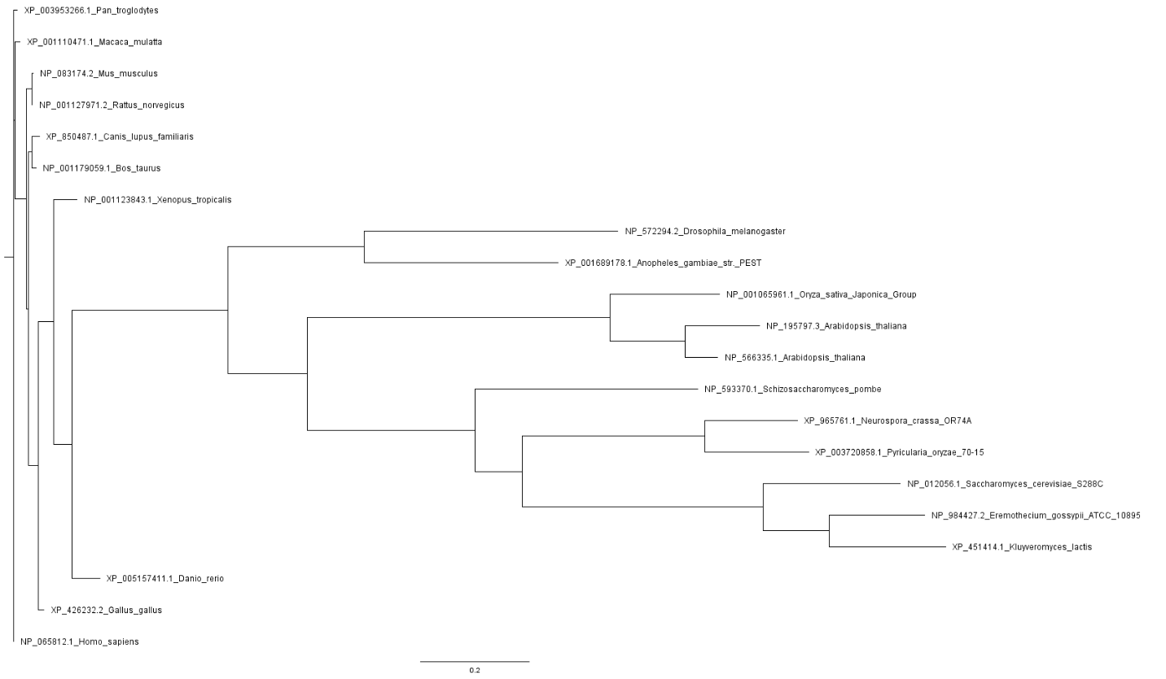

**Supplementary figure.** Phylogenetic tree reconstructed using RaxML for RAPTORB homologs using HomoloGene database. Query protein is depicted un red underline.

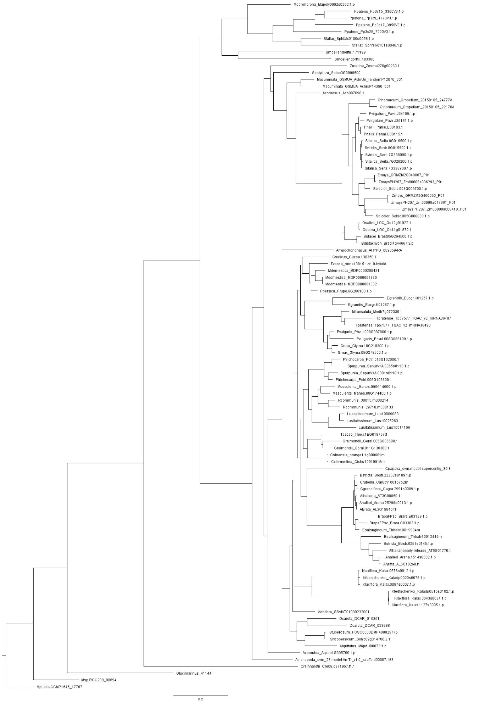

**Supplementary figure.**Phylogenetic tree reconstructed using RaxML for RAPTORB homologs using Phytozome database. Query protein is depicted un red underline

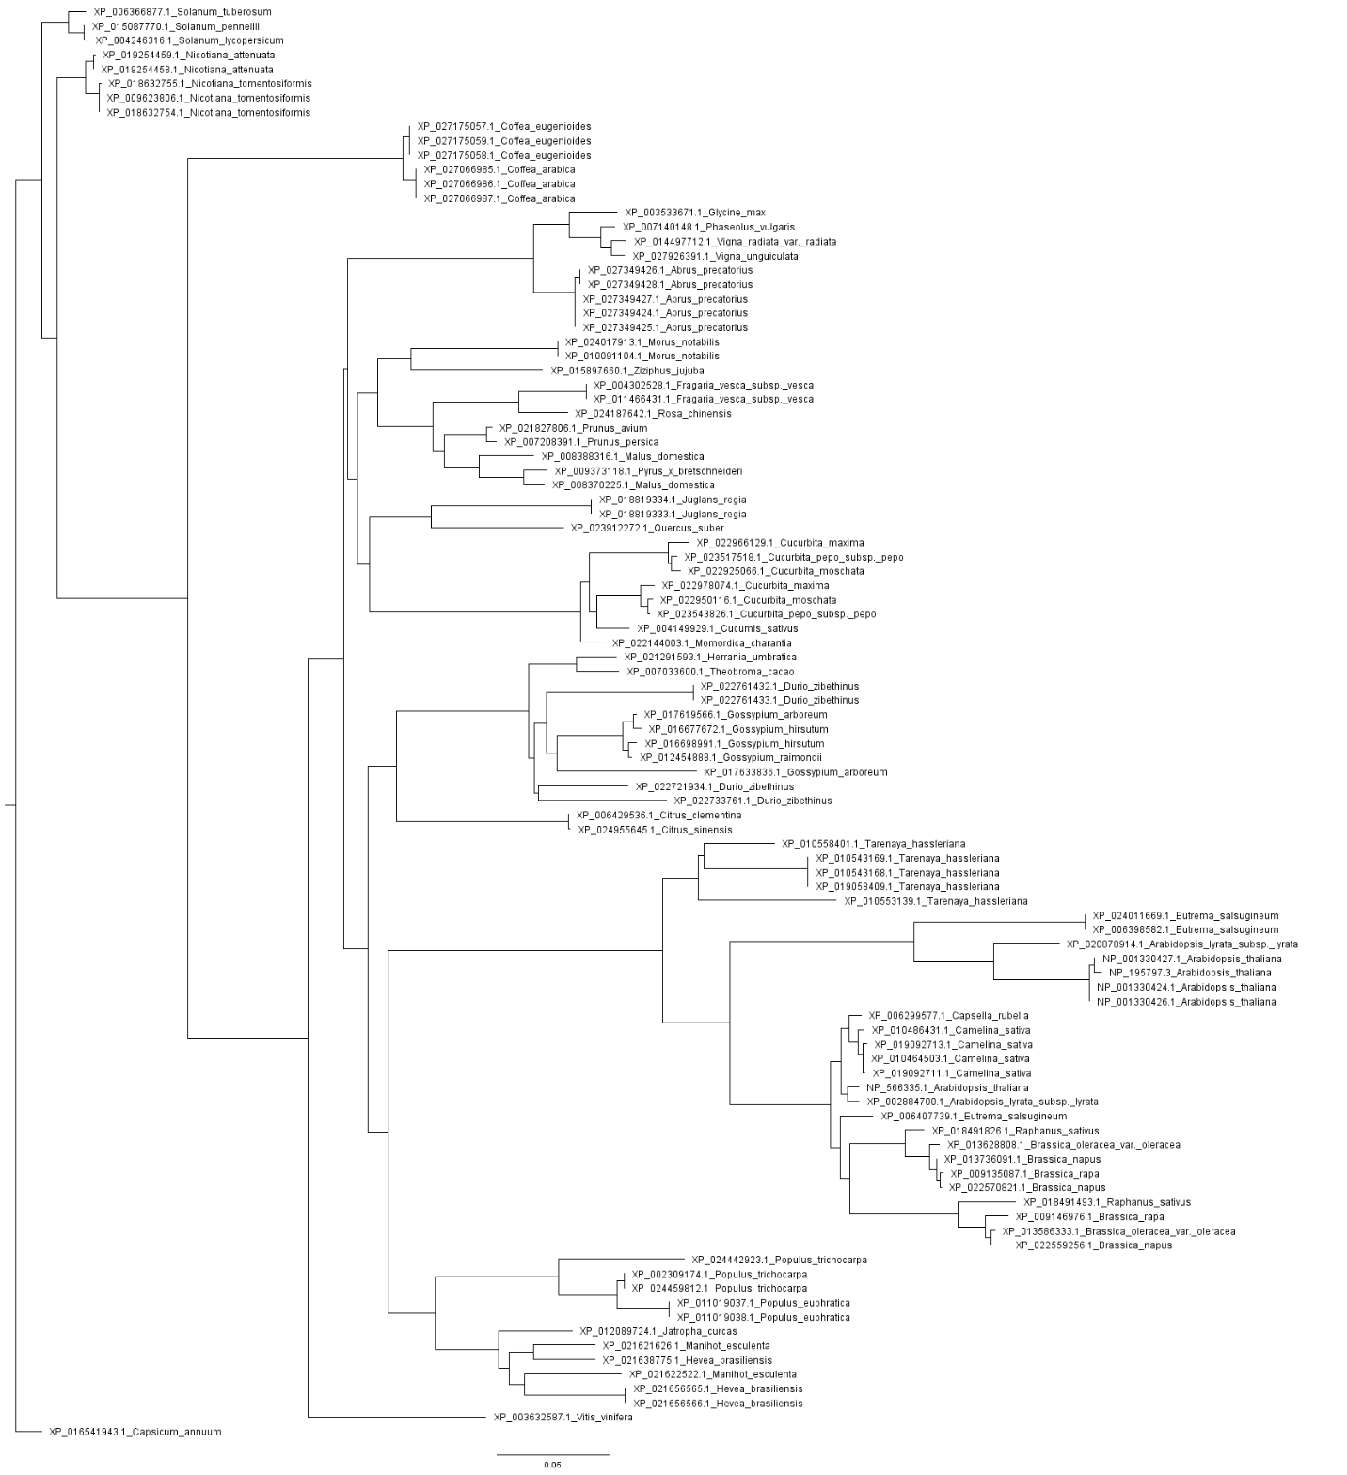

**Supplementary figure.** Phylogenetic tree reconstructed using RaxML for RAPTORB homologs using BLAST database. Query protein is depicted un red underline

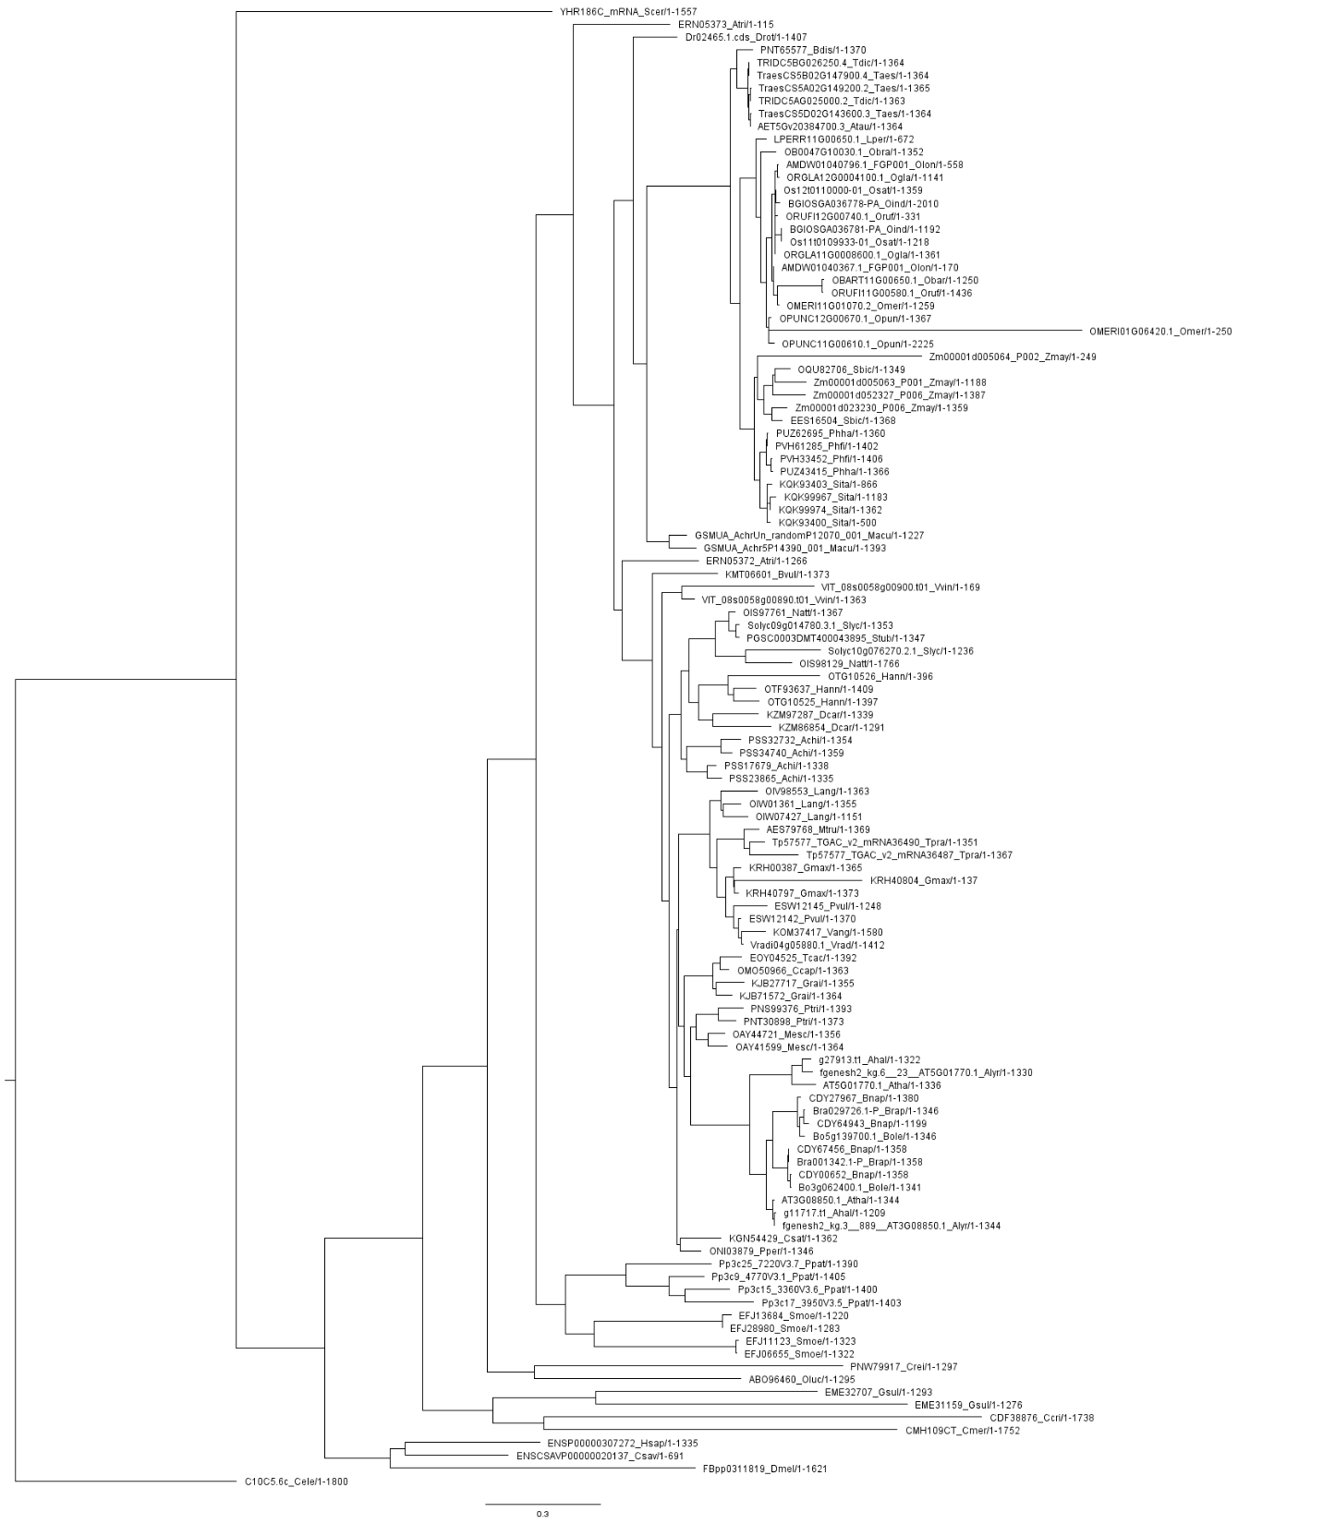

**Supplementary figure.** Phylogenetic tree reconstructed using RaxML for RAPTORB homologs using ENSEMBL database. Query protein is depicted un red underline

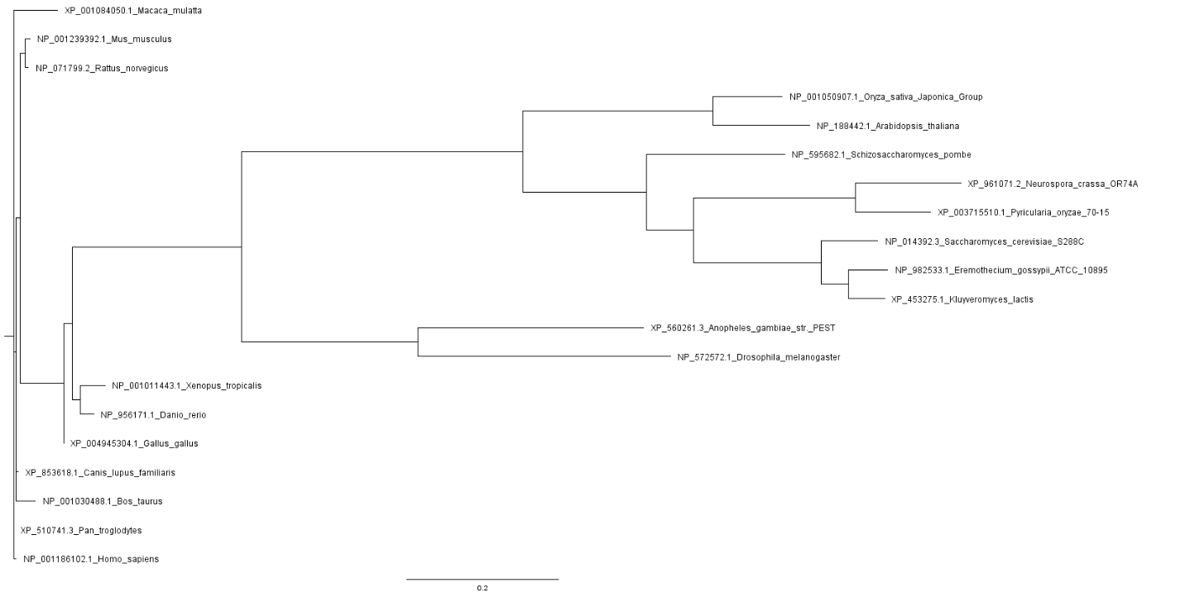

**Supplementary figure.** Phylogenetic tree reconstructed using RaxML for LST8 homologs using HomoloGene database. Query protein is depicted un red underline.

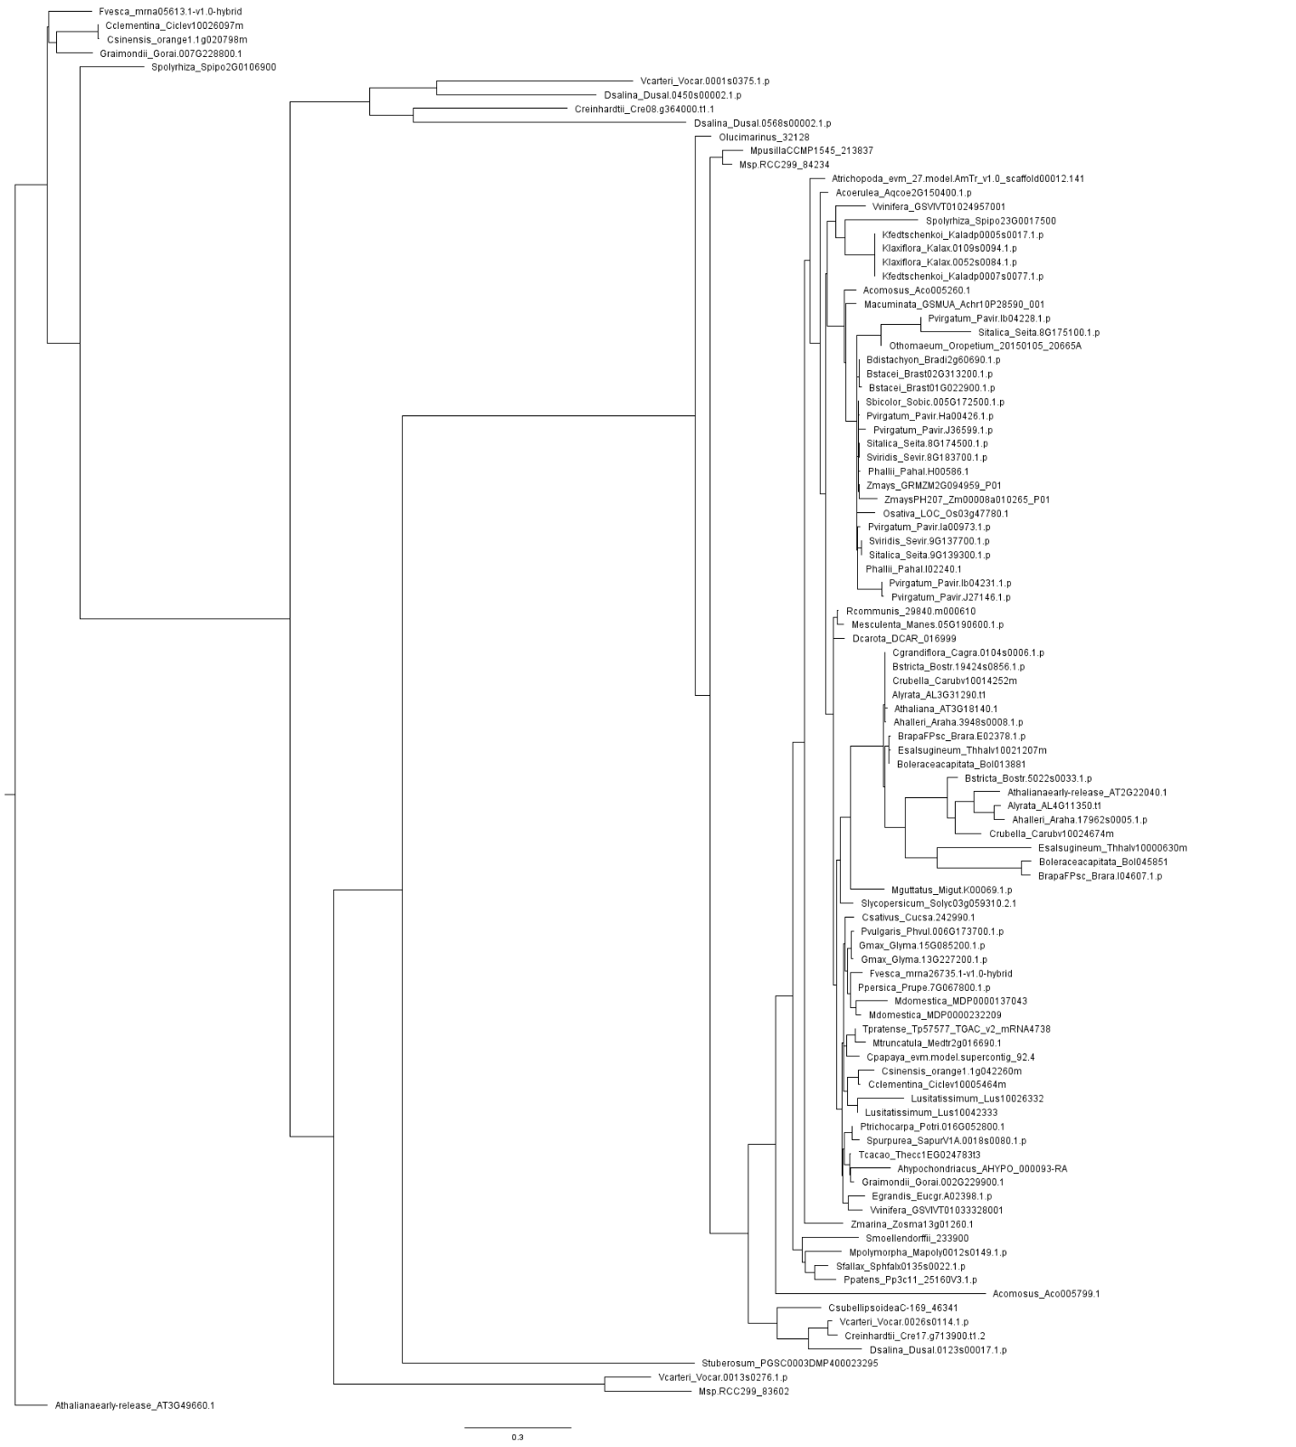

**Supplementary figure.** Phylogenetic tree reconstructed using RaxML for LST8 homologs using Phytozome database. Query protein is depicted un red underline.

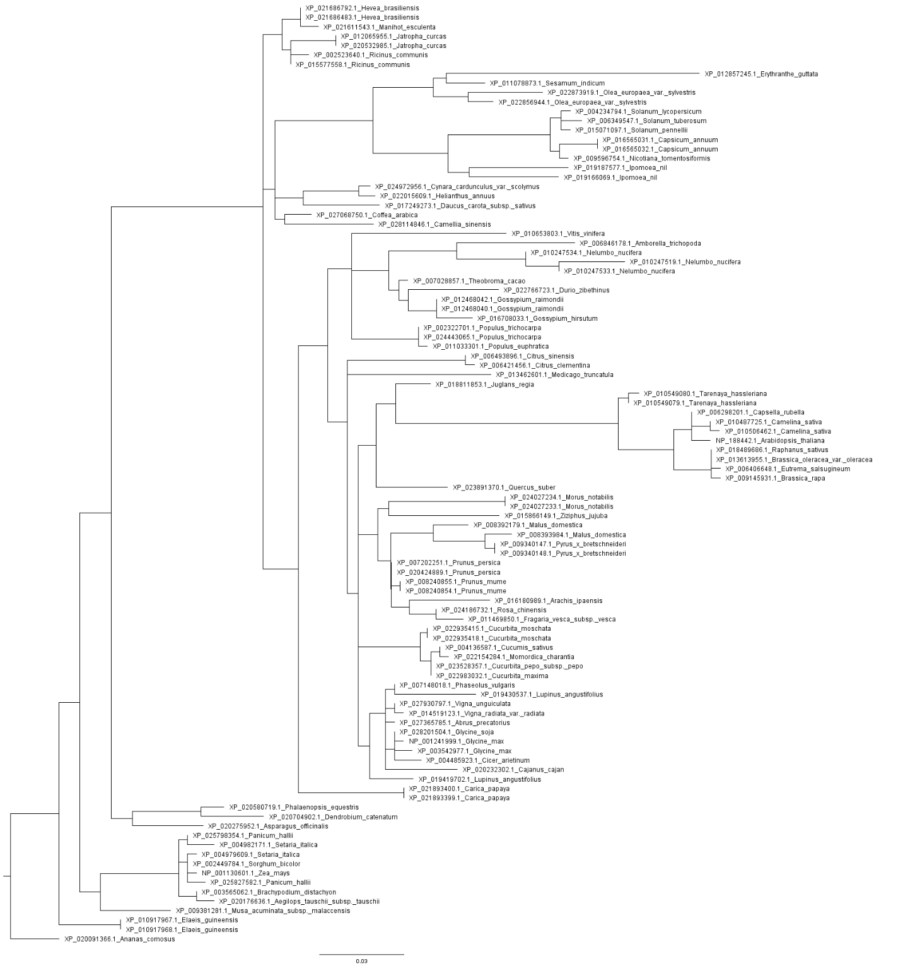

**Supplementary figure.** Phylogenetic tree reconstructed using RaxML for LST8 homologs using BLAST database. Query protein is depicted un red underline.

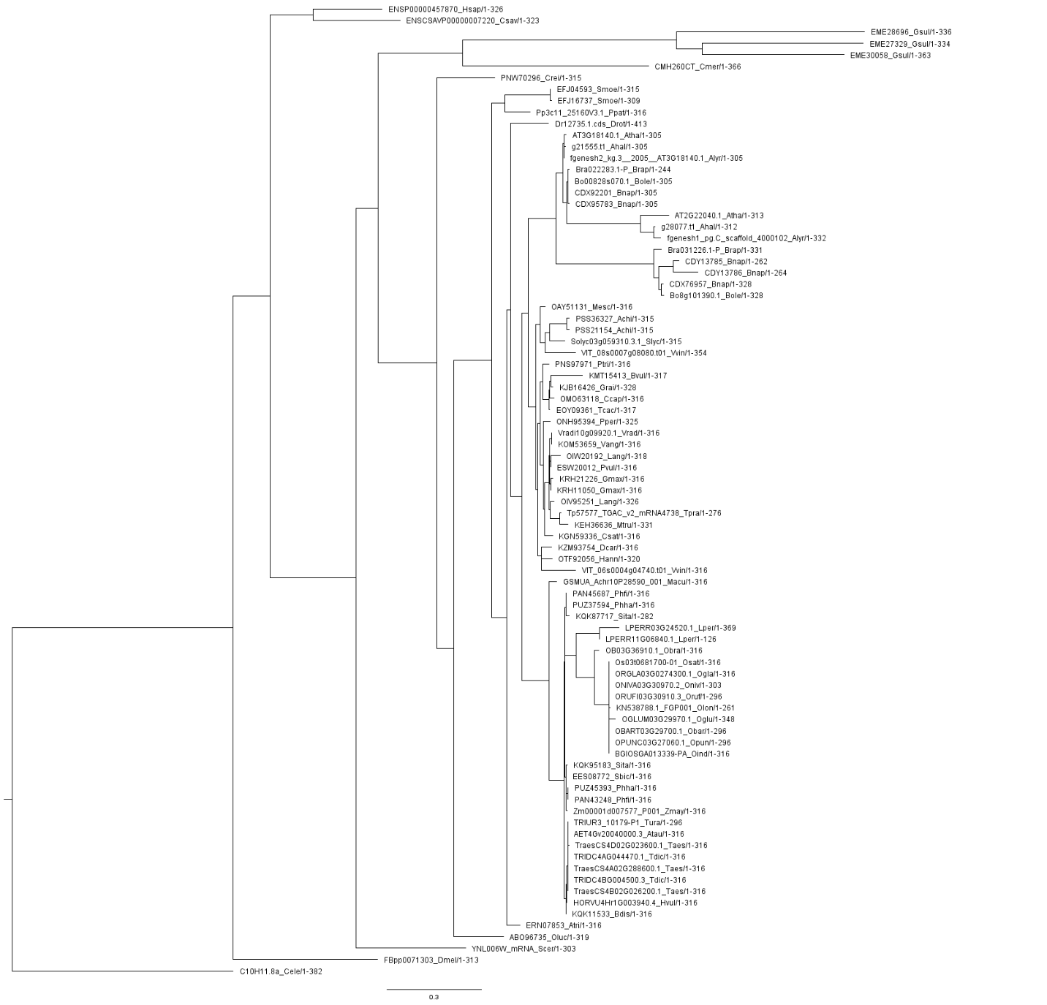

**Supplementary figure.** Phylogenetic tree reconstructed using RaxML for LST8 homologs using ENSEMBL database. Query protein is depicted un red underline.

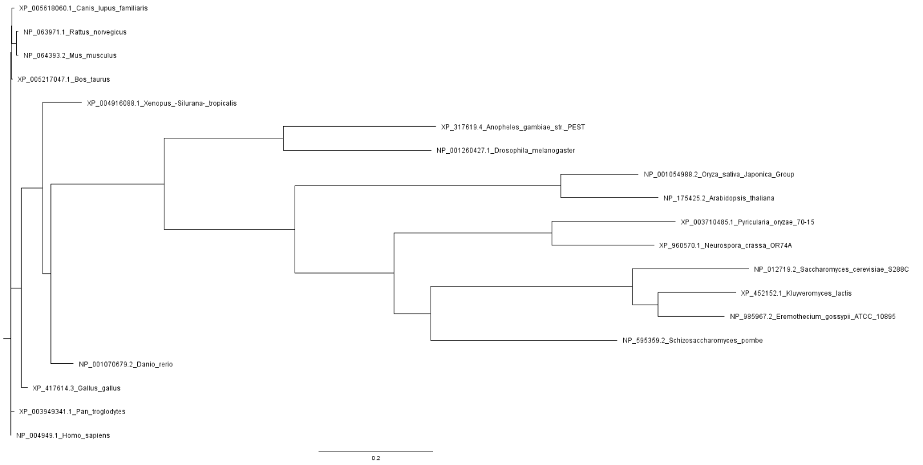

**Supplementary figure.** Phylogenetic tree reconstructed using RaxML for TOR homologs using HomoloGene database. Query protein is depicted un red underline.

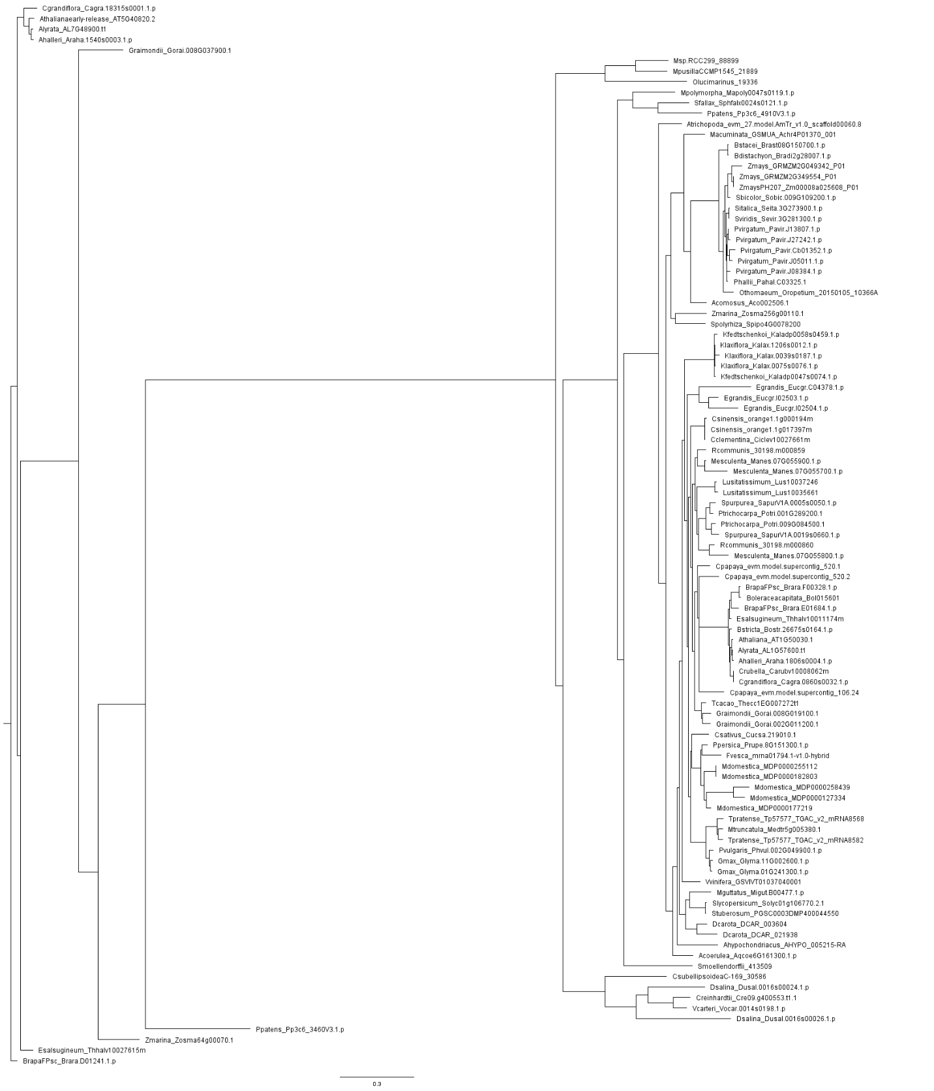

**Supplementary figure.** Phylogenetic tree reconstructed using RaxML for TOR homologs using Phytozome database. Query protein is depicted un red underline.

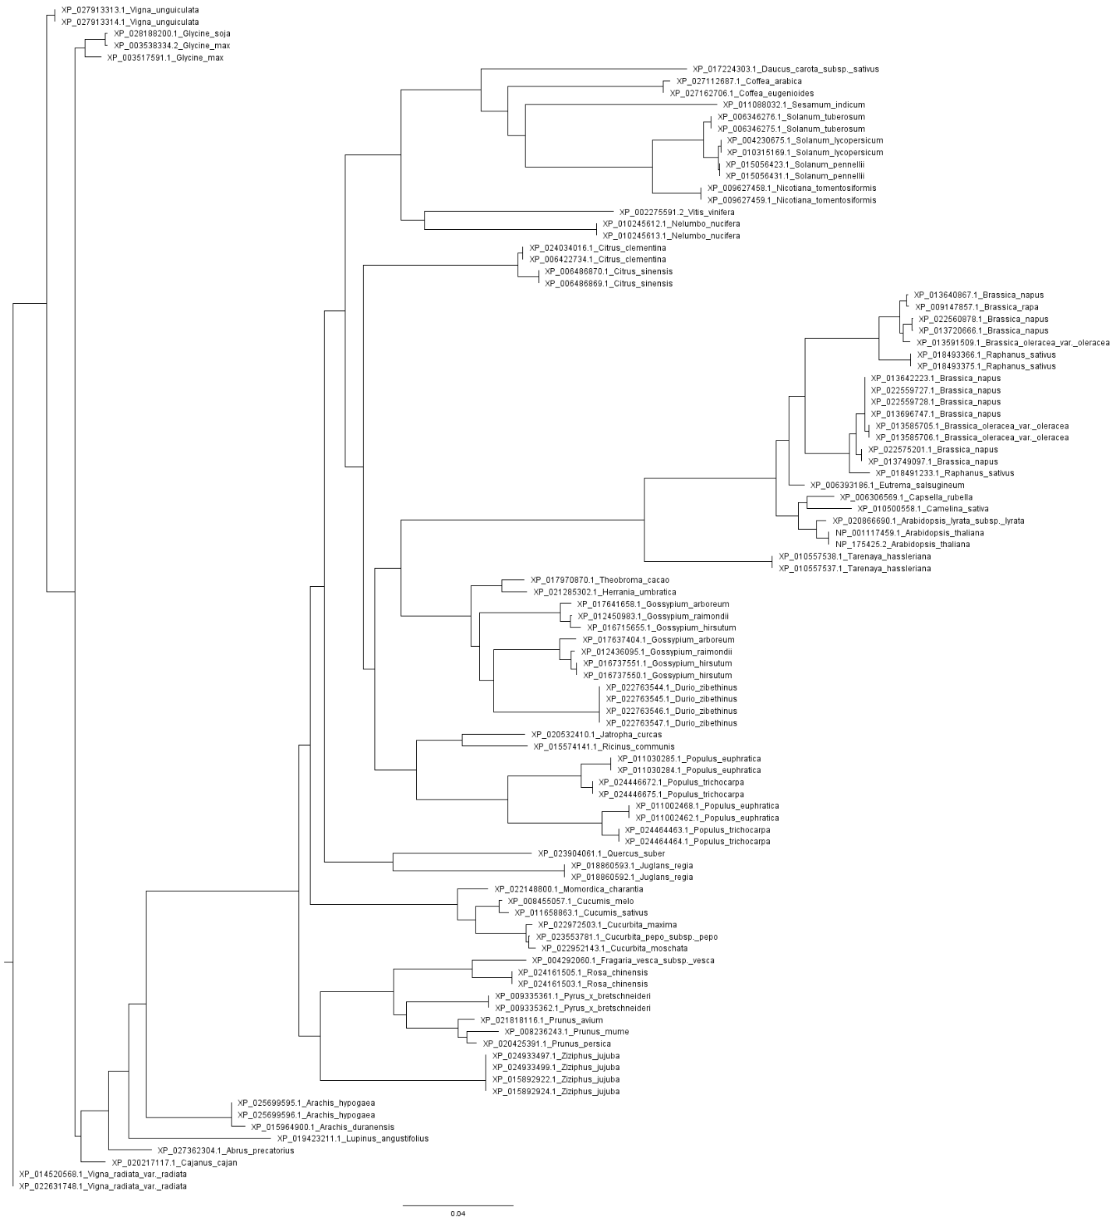

**Supplementary figure.** Phylogenetic tree reconstructed using RaxML for TOR homologs using BLAST database. Query protein is depicted un red underline.

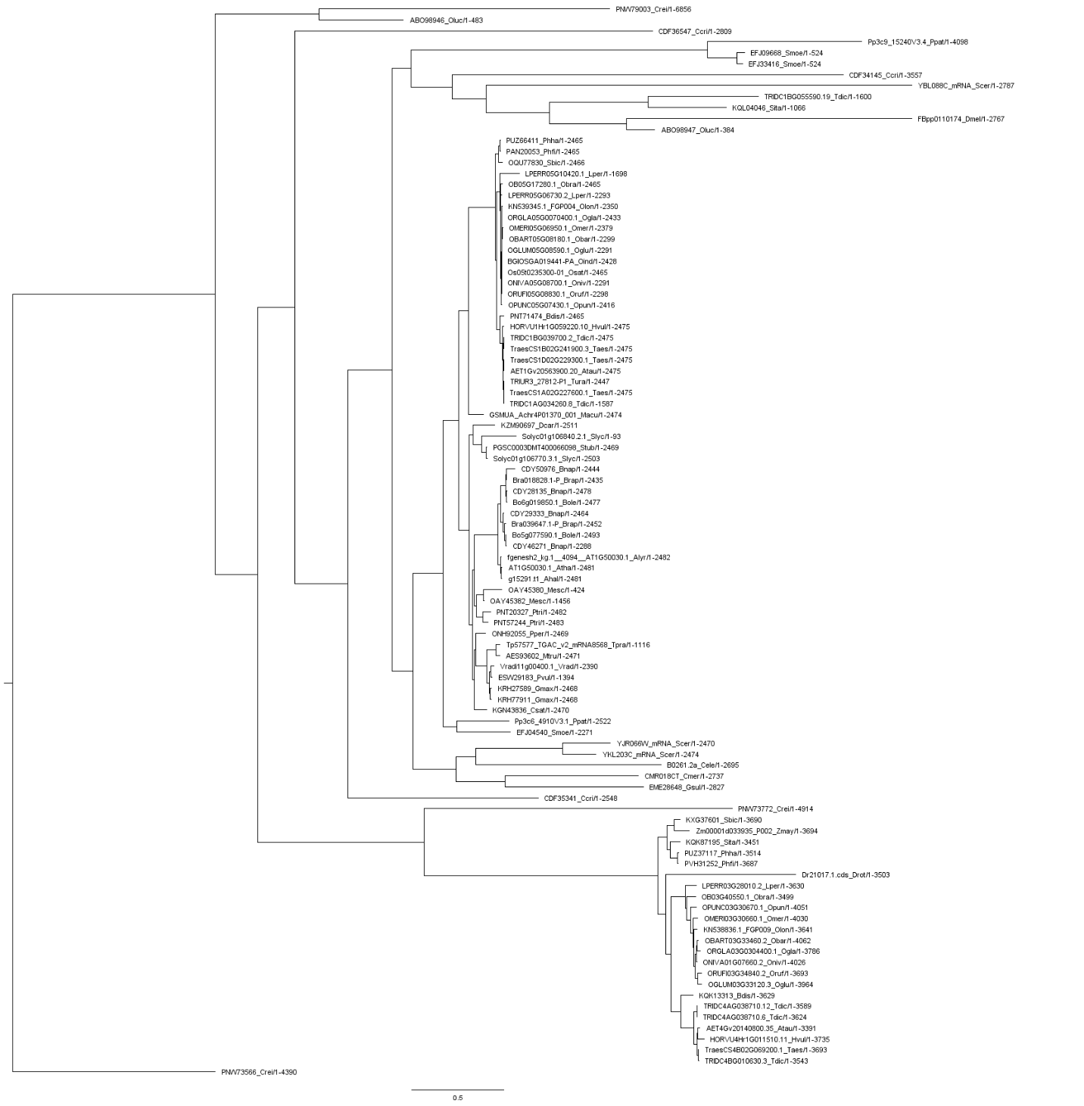

**Supplementary figure.** Phylogenetic tree reconstructed using RaxML for TOR homologs using ENSEMBL database. Query protein is depicted un red underline.