**Final Project Drive:**

<https://drive.google.com/drive/folders/1tWA_FSdIOMZsGmPn8la2-q3KLqRIXD_k>

**Heroku D3 app:**

https://project-gw.herokuapp.com/

**Data Sets for possible use:**

**Global Climate Change Data from 1750－2015 (**this data has been cleaned up and looks ok. There are 4 different files to use depending on what we want to show, temperature is in celsius. Map example at the end of the data set description.

C TO F: CELSIUS TO FAHRENHEIT CONVERSION FORMULA

To convert temperatures in degrees Celsius to Fahrenheit, multiply by 1.8 (or 9/5) and add 32.

* Example: 30°C x 1.8 + 32 = 86°F

**Data.World:** <https://data.world/data-society/global-climate-change-data>

**Some say climate change is the biggest threat of our age while others say it’s a myth based on dodgy science. We are turning some of the data over to you so you can form your own view.**

In this dataset, we have include several files:

＊ Global Land and Ocean-and-Land Temperatures (GlobalTemperatures.csv):

Date: starts in 1750 for average land temperature and 1850 for max and min land temperatures and global ocean and land temperatures

LandAverageTemperature: global average land temperature in celsius

LandAverageTemperatureUncertainty: the 95% confidence interval around the average

LandMaxTemperature: global average maximum land temperature in celsius

LandMaxTemperatureUncertainty: the 95% confidence interval around the maximum land temperature

LandMinTemperature: global average minimum land temperature in celsius

LandMinTemperatureUncertainty: the 95% confidence interval around the minimum land temperature

LandAndOceanAverageTemperature: global average land and ocean temperature in celsius

LandAndOceanAverageTemperatureUncertainty: the 95% confidence interval around the global average land and ocean temperature

(<https://skepticalscience.com/temperature_trend_calculator.html> this link goes into some explanation of the confidence interval; basically the more data you have to include reduces the uncertainty in the trend)

＊ Other files include:

Global Average Land Temperature by Country (GlobalLandTemperaturesByCountry.csv)

Global Average Land Temperature by State (GlobalLandTemperaturesByState.csv)

Global Land Temperatures By Major City (GlobalLandTemperaturesByMajorCity.csv)

Global Land Temperatures By City (GlobalLandTemperaturesByCity.csv)

**Original Data Source:**

**Kaggle:** <https://www.kaggle.com/berkeleyearth/climate-change-earth-surface-temperature-data>

**Raw data:** Berkeley Earth data page <http://berkeleyearth.org/data/>

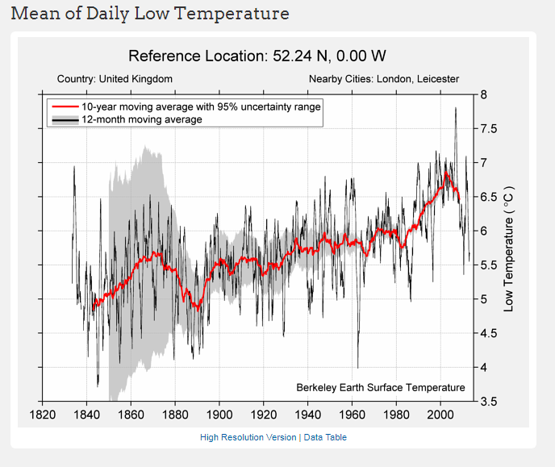

**Notes from Peleke:**

**# Read in the csv and inspect the data**

df = pd.read_csv('co2_emissions.csv')

df.head(5)

df.describe()

**## Create a scatter matrix**

df.corr()

* Correlation can help in predicting one quantity from another
* Correlation can (but often does not) indicate the presence of a causal relationship
* Correlation is used as a basic quantity and foundation for many other modeling techniques
* <https://www.datascience.com/blog/introduction-to-correlation-learn-data-science-tutorials>

**## Create a series of plots - box, hist, lag_plot**

* df['col1'].plot(kind='box')
* df['col1'].plot(kind='hist')
* df['col1'].plot(kind='line')

from pandas.plotting import lag_plot

plt.figure()

data = gltc12_df["avg_yly_tmp_f"]

lag_plot(data)

plt.show()

**Charts and Maps:**

<https://community.plot.ly/t/map-with-custom-choropleth-areas/991/2?u=monfera>

[http://geopandas.org/279](http://geopandas.org/)

**Choropleth Maps - plot.ly** (Option to make an interactive map)

**How to make a D3.js-based choropleth map in JavaScript. A choropleth map shades geographic regions by value.**

<https://plot.ly/javascript/choropleth-maps/>

**D3 3d plots site:**

<http://christopheviau.com/d3list/>

**Slope graph highlight line fade others:**

<http://bl.ocks.org/eesur/a4679ee453aa9357977c>

**Story Presentation Ideas:**

**School lunch program Orange County:**

<https://data.world/dwpeterson/students-eligible-for-free-meal-programs-in-california/insights/af82fa23-43bb-4a45-b454-0c54df8a39fe>

**The Paradise Papers story:**

<https://www.svt.se/special/the-swedes-in-paradise-papers/>

**Video or Links on Climate Change:**

**Bill Nye vs. Ken Ham YouTube video:** <https://www.youtube.com/watch?v=z6kgvhG3AkI>

**CNN:** <http://www.cnn.com/2016/04/22/politics/bill-nye-the-science-guy-climate-change/index.html>

**BigThink.com:** <http://bigthink.com/videos/bill-nye-on-tucker-carlson>

**a-tag link to Climate Change 101 with Bill Nye:**

<a href="http://smartplayer.captionsync.com/play.php?vid=1509669950apetrash_741a3839075d" target="_blank" > Climate Change 101 with Bill Nye</a>

**Links for the GW Home Page:**

**A link to Climate Change deniers myths:**

<https://www.skepticalscience.com/argument.php>

**A link to Climate Change supporters:**

<https://www.skepticalscience.com/global-warming-scientific-consensus-intermediate.htm>

**A link to article on the 2.9% of science studies supporting Climate Change Denial:**

<https://link.springer.com/article/10.1007/s00704-015-1597-5>

**Climate Deniers:**

**A link to an article on Climate Deniers in Congress and possible choropleth plotly.js map of USA:**

<https://thinkprogress.org/115th-congress-climate-denier-caucus-65fb825b3963/>

**Other Links to Review:**

[**api.nasa.gov/api.html**](http://api.nasa.gov/api.html)  
[**https://www.programmableweb.com/category/climate/api**](https://www.programmableweb.com/category/climate/api)  
[**https://www.ncdc.noaa.gov/cdo-web/webservices/v2**](https://www.ncdc.noaa.gov/cdo-web/webservices/v2)[**https://data.worldbank.org/data-catalog/climate-change**](https://data.worldbank.org/data-catalog/climate-change) [**https://catal og.data.gov/dataset?tags=global-warming**](https://catalog.data.gov/dataset?tags=global-warming)

**Global Warming - Union of Concerned Scientists Articles:**

These two links have PDF files so there is information but we would need to do data entry to use the raw data for charting or analysis.

[http://www.ucsusa.org/global_warming/regional_information/ca-and-western-states.html#.WgYeQcanHU8](http://www.ucsusa.org/global_warming/regional_information/ca-and-western-states.html%23.WgYeQcanHU8)

[http://www.ucsusa.org/global_warming/regional_information/ca-and-western-states.html#.WgY24FtSy1t](http://www.ucsusa.org/global_warming/regional_information/ca-and-western-states.html%23.WgY24FtSy1t)

**ProgrammableWeb:**

<https://www.programmableweb.com/category/climate/api>

Top Climate APIs including APIs from Breezometer, Growstuff, World Bank Climate Data, Iteris Clearag Map Overlay, Global Forest Watch & Pressurenet.Io

**Climate Data Online (CDO):**

<https://www.ncdc.noaa.gov/cdo-web/webservices/v2>

Web Services API (version 2) Documentation | Climate Data Online (CDO) | National Climatic Data Center (NCDC)

Currently available Web Services from Climate Data Online (CDO).

**Climate Change Data from The World Bank: data.worldbank.org**

<https://data.worldbank.org/data-catalog/climate-change>

**Greek Alphabet:**

|  |  |  |
| --- | --- | --- |
| CAP | lower | NAME (pronunciation) Description. |
| A | α | ALPHA (AL-fuh) First letter of the Greek alphabet. |
| B | β | BETA (BAY-tuh) |
| Γ | γ | GAMMA (GAM-uh) |
| Δ | δ | DELTA (DEL-tuh) |
| E | ϵ | EPSILON (EP-sil-on) A stylized form of the lower case epsilon, ∈, is used as the “set membership” symbol. |
| Z | ζ | ZETA (ZAY-tuh) |
| H | η | ETA (AY-tuh) |
| ΘΘ | θ | THETA (THAY-tuh) |
| I | ι | IOTA (eye-OH-tuh) |
| K | κ | KAPPA (KAP-uh) |
| Λ | λ | LAMBDA (LAM-duh) |
| M | μ | MU (MYOO) |
| N | ν | NU (NOO) |
| Ξ | ξ | XI (KS-EYE) |
| O | ο | OMICRON (OM-i-KRON) |
| Π | π | PI (PIE) The lower-case π is universally used to represent that number which is the ratio of the circumference of a circle to its diameter. The upper-case Π is used as the “product” symbol. |
| P | ρ | RHO (ROW) |
| Σ | σ | SIGMA (SIG-muh) The capital Σ is used as the “summation” symbol. |
| T | ττ | TAU (TAU) |
| Υ | υ | UPSILON (OOP-si-lon) |
| Φ | ϕ | PHI (FEE) |
| X | χ | CHI (K-EYE) |
| Ψ | ψ | PSI (SIGH) |
| Ω | ω | OMEGA (oh-MAY-guh) Last letter of the Greek alphabet. The lower-case ω denotes the smallest [infinite](http://platonicrealms.com/encyclopedia/infinity) ordinal in set-theory, isomorphic to the set of [natural numbers](http://platonicrealms.com/encyclopedia/natural-number). |