**Final Project Drive:**

<https://drive.google.com/drive/folders/1tWA_FSdIOMZsGmPn8la2-q3KLqRIXD_k?usp=sharing>

<https://drive.google.com/drive/folders/1tWA_FSdIOMZsGmPn8la2-q3KLqRIXD_k>

**Global Warming - Union of Concerned Scientists:**

These two links have PDF files so there is information but we would need to do data entry to use the raw data for charting or analysis.

[http://www.ucsusa.org/global_warming/regional_information/ca-and-western-states.html#.WgYeQcanHU8](http://www.ucsusa.org/global_warming/regional_information/ca-and-western-states.html%23.WgYeQcanHU8)

[http://www.ucsusa.org/global_warming/regional_information/ca-and-western-states.html#.WgY24FtSy1t](http://www.ucsusa.org/global_warming/regional_information/ca-and-western-states.html%23.WgY24FtSy1t)

**Data Sets for possible use - see Global_Warming_research.ipynb:**

There are some multi-byte characters in this data set so it needs more cleaning.

<https://data.world/crowdflower/sentiment-of-climate-change>

(<https://www.crowdflower.com/data-for-everyone/>)

**Global Climate Change Data from 1750－2015 (**this data has been cleaned up and looks ok. There are 4 different files to use depending on what we want to show, temperature is in celsius. Map example at the end of the data set description.

C TO F: CELSIUS TO FAHRENHEIT CONVERSION FORMULA

To convert temperatures in degrees Celsius to Fahrenheit, multiply by 1.8 (or 9/5) and add 32.

* Example: 30°C x 1.8 + 32 = 86°F

**Data.World:** <https://data.world/data-society/global-climate-change-data>

Some say climate change is the biggest threat of our age while others say it’s a myth based on dodgy science. We are turning some of the data over to you so you can form your own view.

In this dataset, we have include several files:

＊ Global Land and Ocean-and-Land Temperatures (GlobalTemperatures.csv):

Date: starts in 1750 for average land temperature and 1850 for max and min land temperatures and global ocean and land temperatures

LandAverageTemperature: global average land temperature in celsius

LandAverageTemperatureUncertainty: the 95% confidence interval around the average

LandMaxTemperature: global average maximum land temperature in celsius

LandMaxTemperatureUncertainty: the 95% confidence interval around the maximum land temperature

LandMinTemperature: global average minimum land temperature in celsius

LandMinTemperatureUncertainty: the 95% confidence interval around the minimum land temperature

LandAndOceanAverageTemperature: global average land and ocean temperature in celsius

LandAndOceanAverageTemperatureUncertainty: the 95% confidence interval around the global average land and ocean temperature

＊ Other files include:

Global Average Land Temperature by Country (GlobalLandTemperaturesByCountry.csv)

Global Average Land Temperature by State (GlobalLandTemperaturesByState.csv)

Global Land Temperatures By Major City (GlobalLandTemperaturesByMajorCity.csv)

Global Land Temperatures By City (GlobalLandTemperaturesByCity.csv)

**Original Data Source:**

**Kaggle:** <https://www.kaggle.com/berkeleyearth/climate-change-earth-surface-temperature-data>

**Raw data:** Berkeley Earth data page <http://berkeleyearth.org/data/>

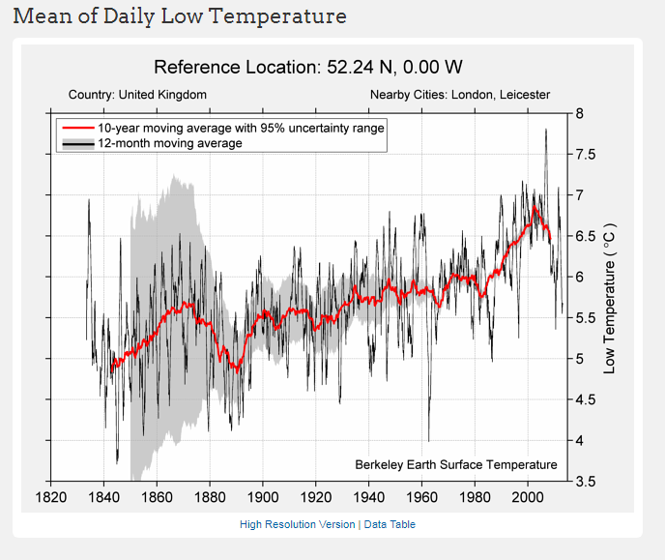

**Maps:**

<https://community.plot.ly/t/map-with-custom-choropleth-areas/991/2?u=monfera>

[http://geopandas.org/279](http://geopandas.org/)

**Choropleth Maps - plot.ly** (Option to make an interactive map)

**How to make a D3.js-based choropleth map in JavaScript. A choropleth map shades geographic regions by value.**

<https://plot.ly/javascript/choropleth-maps/>

**D3 3d plots site:**

<http://christopheviau.com/d3list/>

**Slope graph highlight line fade others:**

<http://bl.ocks.org/eesur/a4679ee453aa9357977c>

**Story Presentation Ideas:**

**School lunch program Orange County:**

<https://data.world/dwpeterson/students-eligible-for-free-meal-programs-in-california/insights/af82fa23-43bb-4a45-b454-0c54df8a39fe>

**The Paradise Papers story:**

<https://www.svt.se/special/the-swedes-in-paradise-papers/>

Bill Nye the Science Guy - debates Creationist Ken Ham

**YouTube video:** <https://www.youtube.com/watch?v=z6kgvhG3AkI>

**CNN:** <http://www.cnn.com/2016/04/22/politics/bill-nye-the-science-guy-climate-change/index.html>

**BigThink.com:** <http://bigthink.com/videos/bill-nye-on-tucker-carlson>

**Links to Review:**

[**api.nasa.gov/api.html**](http://api.nasa.gov/api.html)  
[**https://www.programmableweb.com/category/climate/api**](https://www.programmableweb.com/category/climate/api)  
[**https://www.ncdc.noaa.gov/cdo-web/webservices/v2**](https://www.ncdc.noaa.gov/cdo-web/webservices/v2)[**https://data.worldbank.org/data-catalog/climate-change**](https://data.worldbank.org/data-catalog/climate-change) [**https://catal og.data.gov/dataset?tags=global-warming**](https://catalog.data.gov/dataset?tags=global-warming)

ProgrammableWeb

<https://www.programmableweb.com/category/climate/api>

Top Climate APIs including APIs from Breezometer, Growstuff, World Bank Climate Data, Iteris Clearag Map Overlay, Global Forest Watch & Pressurenet.Io

Climate Data Online (CDO)

<https://www.ncdc.noaa.gov/cdo-web/webservices/v2>

Web Services API (version 2) Documentation | Climate Data Online (CDO) | National Climatic Data Center (NCDC)

Currently available Web Services from Climate Data Online (CDO).

data.worldbank.org

<https://data.worldbank.org/data-catalog/climate-change>

Climate Change Data | Data

Climate Change Data from The World Bank: Data