Your objective is to build a [Bubble Plot](https://en.wikipedia.org/wiki/Bubble_chart) that showcases the relationship between four key variables:

* Read about and create a bubble plot ( use Matplotlib and Seaborn library - <http://seaborn.pydata.org/examples/>
  + Average Fare ($) Per City
  + Total Number of Rides Per City
  + Total Number of Drivers Per City
  + City Type (Urban, Suburban, Rural)
* In addition, you will be expected to produce the following three pie charts:
  + Sum total fares by city, type and percentage is (sum by city, type)/100
    - percentage of Total Fares by City Type
    - percentage of Total Rides by City Type
    - percentage of Total Drivers by City Type
* You must include an exported markdown version of your Notebook called  `README.md` in your GitHub repository.

1. Set up homework folders and files under Python-Challenges, and push all files to GitHub.
2. Create the Jupyter Notebook - Pyber_hw4.ipynb.
   1. Add library imports.
   2. Add code to read and display city_data.csv and ride_data.csv.
   3. Merge the two data sets.
   4. city, date, fare, ride_id, driver_count, type
3. Break down the Pyber assignment into reasonable size packages, and using the .PDF example file, put comments as placeholders in the Pyber_hw4.ipynb notebook.
   1. # Written analysis of the data highlighting 3 data trends:
      1. Trend 1
      2. Trend 2
      3. Trend 3
   2. Bubble Chart Analysis:
      1. Average Fare ($) Per City - x axis.
      2. Total Number of Rides Per City - y axis.
      3. Total Number of Drivers Per City - s to set the size for each plot.
      4. City type-Color for each plot
      5. Legend = City Type (Urban, Suburban, Rural) /Color - located top right.
         1. Need to relate bubble color to typed (rural, urban, suburban).
         2. Need to create a stack of color bubbles and type text.
         3. 1 and 2 above would be taken care of without effort using 3 ax.plot commands and the ax.legend command. Not sure how this will work with seaborn.

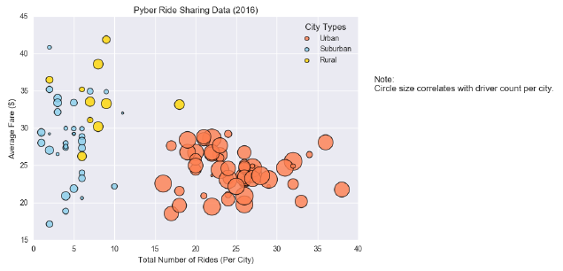

* 1. 3 Pie Charts (in 3 parts) with Analysis:
     1. % of Total Fares by City Type and written analysis.
     2. % of Total Rides by City Type and written analysis.
     3. % of Total Drivers by City Type and written analysis.

1. Other requirements:
   1. You must use the Pandas Library and the Jupyter Notebook.
   2. You must use the Matplotlib and Seaborn libraries.
   3. You must include a written description of three observable trends based on the data.
   4. You must use proper labeling of your plots, including aspects like: Plot Titles, Axes Labels, Legend Labels, Wedge Percentages, and Wedge Labels.
   5. Remember when making your plots to consider aesthetics!
      1. You must stick to the Pyber color scheme (Gold, Light Sky Blue, and Light Coral) in producing your plot and pie charts.
      2. When making your Bubble Plot, experiment with effects like alpha, edgecolor, and linewidths.
      3. When making your Pie Chart, experiment with effects like shadow, startangle, and explosion.
   6. You must include an exported markdown version of your Notebook called README.md in your GitHub repository.
      1. Open Git-Bash
      2. My version:

jupyter nbconvert --to markdown Pyber_hw4.ipynb

* + 1. Submit version:

jupyter nbconvert --to markdown Pyber_hw4-submit-version.ipynb

* + 1. Clean up files: rename and or delete if necessary.
  1. See for Pyber_example.pdf a reference on expected format of the notebook and charts.