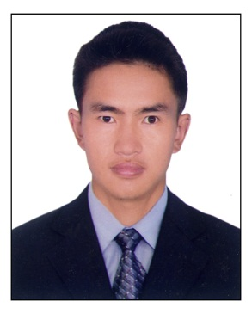**Curriculum- vitae**

Mr. Santa Bahadur Tamang

E-mail :-:- santas_11@yahoo.com

c/o mobile no:-+971-0552330603

**career objective**

seeking could continue my career in the hotel (hospitality ) industry for achieving experience as much as possible in order to enhance my knowledge and performance for better position and service the company.

**Skills**

I am flexible, dependable and fast learner. I can communicate with different levels of people with respect and integrity and always dedicate to the company’s objective.

**Job title:- housekeeping attendant**

**Work experience**

* Position :-room attendant
* Organizatio :- Hotel Northfield & cafe, Kathamandu,Nepal

Period :- jan 2009 to march, 2010

Present :- Emirates Flight Catering in Dubai

:- July 2010 to till currently date

**Education qualification**

* High school passed from board of NEpal
* Basic computer knowledge

|  |  |  |  |  |
| --- | --- | --- | --- | --- |
| Personal details | | passport details | | |
| Name | Santa bahadur Tamang | | Passport no | 2776258 |
| Date of birth | 10/03/1988 | | Place of issue | Nuwakot, Nepal |
| Nationality | Nepal | | Date of issue | 30/10/2005 |
| Permanent add | Nuwakot | | Date of expiry | 30/10/2015 |

Duty responsibilities

* Attend to guest requests in a timely and efficient manner
* Pick up daily room report and collect key from the security/housekeeping office
* Once we are in our own floor clear all ash in guest corridors and vacuum the guest corridor a day (before start cleaning rooms and before finishing the shif)
* Restock and maintain trolley on daily basis
* To clean all assigned  guestrooms  including: dusting, making beds and remove soiled linen and retrieval of clean linen from linen closets
* Perform special cleaning of the day
* To sign in and out master keys daily
* To report necessary maintenance items
* Return and properly tag all lost and found articles in the Housekeeping Office
* Support Senior HK Supervisor or HK Supervisor in the daily operation and work
* Provide courteous, professional service and maintain a good working relationship with your own colleagues and all departments
* Scraping, buffing, polices on the floor
* Ability to speak English clearly, distinctly and cordially with guests
* Report necessary maintenance to the supervisor
* When the section is completed arrange the linen room clear thrash and mop

**Key of skills and abilities**

* Willingness to work a variety of day/night and weekend sifts.
* Able to read, write and speak English.
* An energetic personality

I declare that the information I have provided is true and accurate to the best of my knowledge hoping for your kind’s acceptance and immediate and responses.