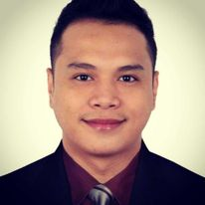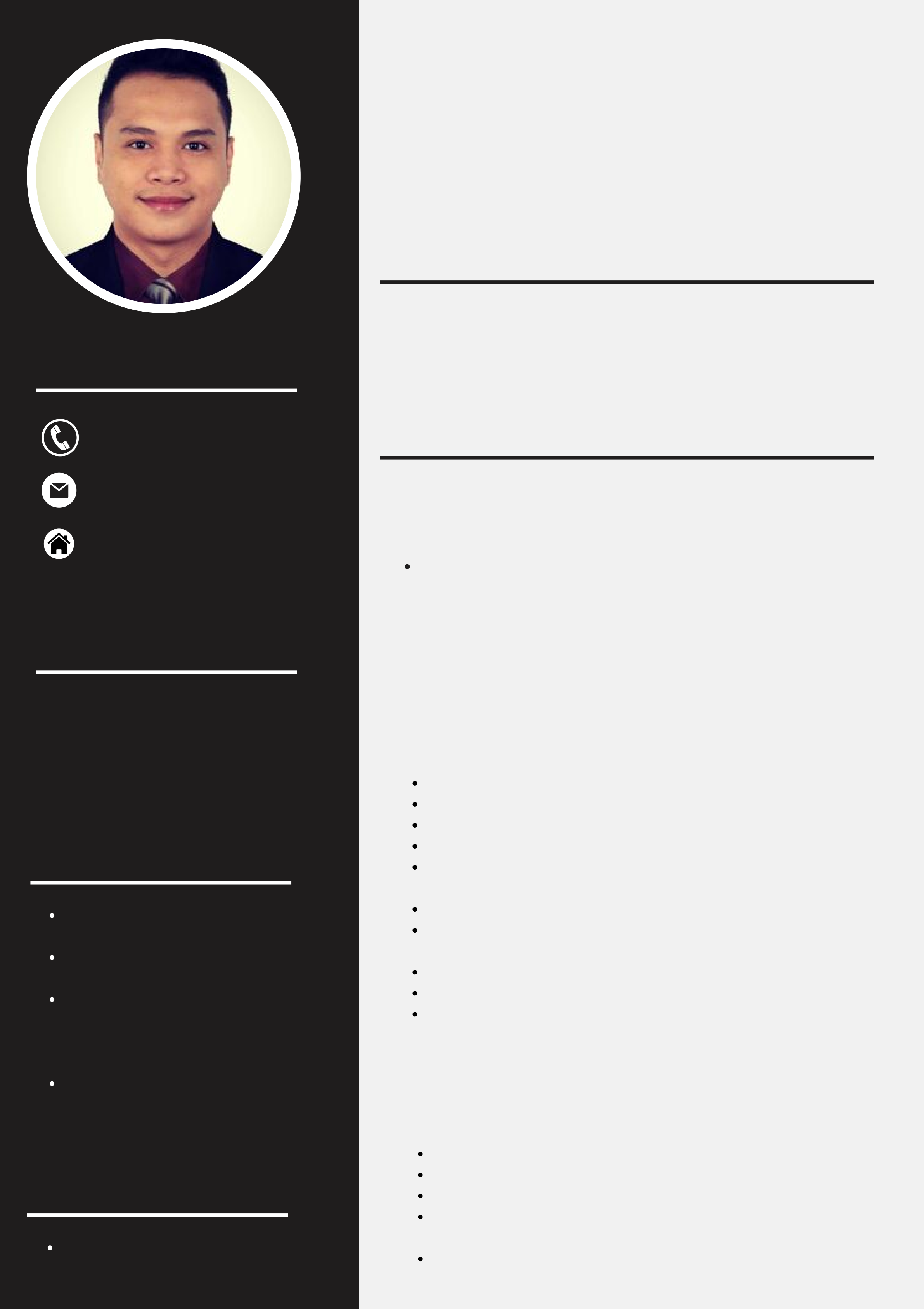

HAROLD P. ONGUE PROFESSIONAL PROFILE

To secure a position at your company or industry that is a good fit for

my abilities, skills, and knowledge and where my characteristics may

|  |  |
| --- | --- |
| CONTACT  +63 908 980 4921 | be put to use as a primary goal toward excellence and worldwide competitiveness.  WORK EXPERIENCE |

haroldongue03@gmail.com

**CARNIVAL CRUISE LINE**

|  |  |  |  |
| --- | --- | --- | --- |
| Eusebio | Bliss | Residential, | 2018 - 2023  Passengers aboard cruise ships are served by cruise ship crew members. In addition to helping with shipboard operations, they might serve food and beverages, keep cabins and common areas clean, organize activities, and offer entertainment. |
| Jenny’s Ave Maybunga Pasig City 1604  EDUCATION | | |

**Bachelor of Science in Hotel, Resort and**

**SHANGRI-LA HOTEL AT THE FORT MANILA**

**Restaurant Management**  2016 - 2018

Eastern State University - 2014 Makes bed.   
 Dusts the room and furniture.

Replenishes guestroom and bath supplies.

|  |  |
| --- | --- |
| SKILLS | Replenish amenities according to operational standards. Deliver and retrieve items on loan to guests, e.g., irons and |

ironing boards.

|  |  |
| --- | --- |
| Team Work | Ensure the security of guest rooms and the privacy of guests. Perform rotational cleaning duties (e.g., steam cleaning carpets, |

Time Management   
Food and Beverage

spring cleaning, super cleaning, etc.) as required.

Cleans guest bathrooms, bedrooms, and floor corridors. Responsible for replenishment of guest complimentary water. Responsible for the cleanliness and maintenance of the work

|  |  |
| --- | --- |
| Service/Room Attendant Verbal & Written  Communication | area.  **GREENWICH STARMALL MANDALUYONG CITY**  October - March 2016 |

Welcome customers as they come into the restaurant.

LANGUAGE Help customers settle down and also take their orders. Process customers’ orders and generate their bills.

Provide answers to queries presented by clients regarding

|  |  |
| --- | --- |
| English | services and offers made available by the restaurant. Clean all tables after clients have left and get such tables |

prepared for the next set of clients.