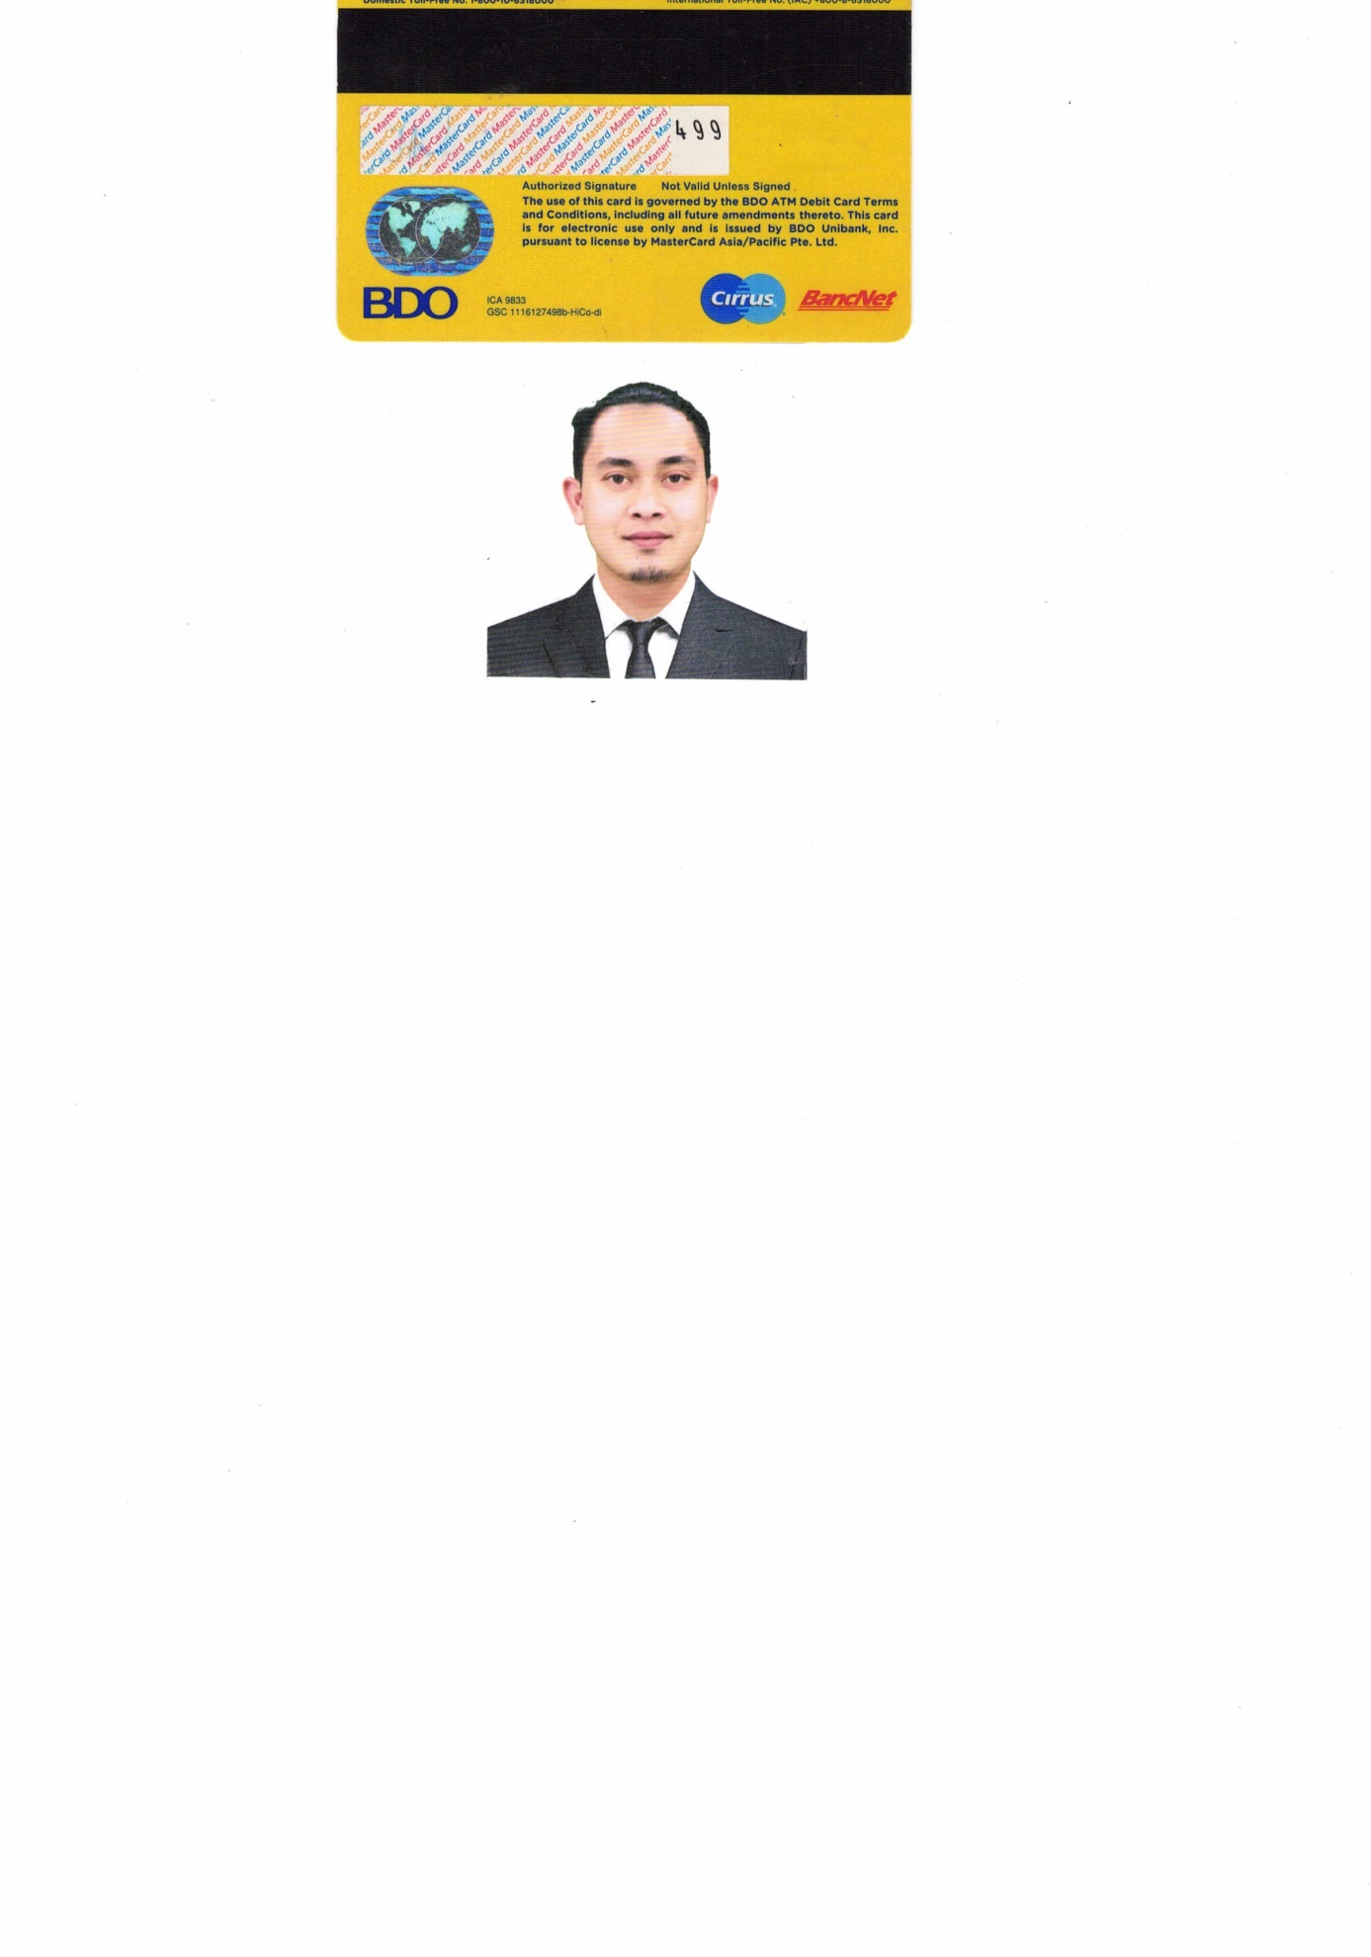**CHRISTIAN ERGEN C. LUCAS**

ADDRESS: SABANG LIPA CITY BATANGAS

CONTACT #: 0918-280-3523

EMAIL: ergen.lucas30@gmail.com

**OBJECTIVES**

To acquire valuable knowledge and skills and to complement those that I have learned in school, in actual Job Environment. In return, I offer my service and determination to be asset to your company throughout the duration in my training period.

**PERSONAL INFORMATION**

**DATE OF BIRTH** : NOV 30, 1995

**AGE** : 26 YEARS OLD

**CIVILSTATUS** : SINGLE

**CITIZENSHIP** : FILIPINO

**HEIGHT :** 5’8

**WEIGHT** : 61 KGS.

**RELIGION :** ROMAN CATHOLIC

**SEX :** MALE

**EDUCATIONAL ATTAINMENT**

**COLLEGE ASSOCIATION IN COMPUTER TECH.**

**KOLEHIYO NG LUNGSOD NG LIPA**

**(UNDERGRAD)**

**SECONDARY STA. LUTGARDA NATIONAL HIGH SHOOL**

**PRIMARY CABUSAO CENTRAL SCHOOL** S.Y. 2004 – 2005

**WORK EXPERIENCE**

COMPANY : MACAO IMPERIAL TEA

ADDRESS : THE OUTLETS @ LIPA CITY BATANGAS

POSITION : BARISTA

DATE : JAN 15, 2021 – UP TO PRESENT

COMPANY : PAINT CENTER CAR HOUSE

ADDRESS : PADRE GARCIA BATANGAS

POSITION : CASHIER/MIXER

DATE : JULY 2017 – DEC 2020

I hereby certified that the information above is true and correct to the best of my knowledge and belief.

**CHRISTIAN ERGEN C. LUCAS Applicant’s Signature**