Ronald Macmaster and Parth Adhia
EID: Rpm953 and Pda375
09/05/2016
EE 445L – Lab 2: Performance Debugging
1.0: Objectives
We will practice various performance debugging techniques for real-time systems. Also, we will practice profiling our software with time and data dumps into arrays. Then, we will learn to use an oscilloscope and logic analyzer. We will also experience the concepts of real-time, probability mass functions, and the Central Limit Theorem. Finally, we will experiment with critical sections and gain a head-start on lab 3 by writing a line drawing function.
2.0: Software Design
TODO: draw a call diagram and mention submitted files. Optional flow chart.
Draw-line fn is for lab3 , but maybe you can mention data/time dump, pmf, and time jitter.
We have uploaded the fixed.h, fixed.c, and main.c files to Canvas prior to implementing the software on our hardware. Below is the high level call graph designed by Professor Valvano.
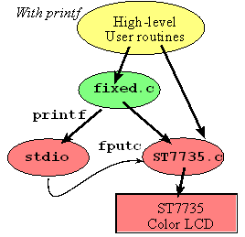
3.0: Measurement Data:
3.1: Preparation Questions
a) What is the purpose of all the DCW statements?
DCW declares a 16 bit half word global variable in memory. These specific DCW statements define GPIO port addresses for PORT F access (system control, digital enable, data base, and directional).
b) The main program toggles PF1. Neglecting interrupts for this part, estimate how fast PF1 will toggle.
It takes 6 instructions to toggle the LED, and each instruction takes about 25 ns to execute.
Thus, it takes about 6 * 25ns = 150ns to toggle the LED. The LED toggles at 6.7 MHz.
c) What is in R0 after the first LDR is executed? What is in R0 after the second LDR is executed?
After the first LDR, R0 contains the base address of GPIO Port F.
After the second LDR, R0 contains the current data value of PF1.
d) How would you have written the compiler to remove an instruction?
Instead of overwriting the Port F address (in R0) with the data value, load the data value of PF1 into R1 instead. Then, you can avoid reloading the Port F address into R1 (instruction 4).
e) 100-Hz ADC sampling occurs in the Timer0 ISR. The ISR toggles PF2 three times. Toggling three times in the ISR allows you to measure both the time to execute the ISR and the time between interrupts. See Figure 2.1. Do these two read-modify write sequences to Port F create a critical section? If yes, describe how to remove the critical section? If no, justify your answer?
No, these read-modify write sequences do not create a critical section.
PF2 is accessed through bit-specific addressing, and the ISR does not share PF2 with any other program threads. The value read into PF1 and modified in the main thread will always be accurate because it is unaffected by updates to PF2 in the ISR.
3.2: Debugging Profile (Oscilloscope)
Estimated sample time (interrupt, ADC, return from interrupt): 9.84 us
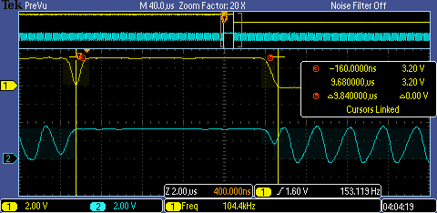
Figure A): Oscilloscope profile of Timer ISR (ADC sampling).

3.3: Debugging Profile (Logic Analyzer)
Figure B): Zoomed out logic profile of PF1 (channel 1) and PF2 (channel 2). The ISR runs every 10 ms
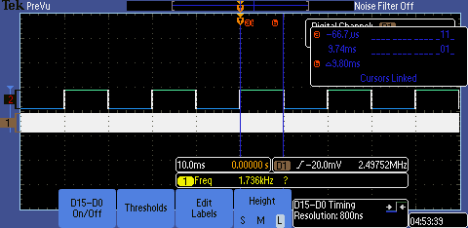

Figure C): Zoomed in logic profile of PF1 (channel 1) and PF2 (channel 2).
Sampling the ADC and completing the ISR takes about 10us to run.
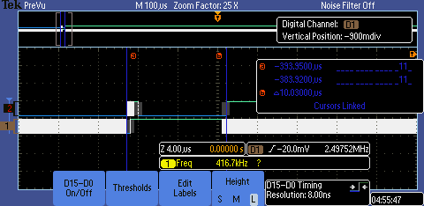
Estimate percentage of time running in the main versus running in the ISR.
% Time running in main versus running in the ISR
= (time running in main) / (time running in ISR ) * 100%
= (9.80 ms / 10.03 us) * 100% = 95,415.63%
3.4: Critical Section Analysis
Figure B): Logic analyzer profile on our critical section.
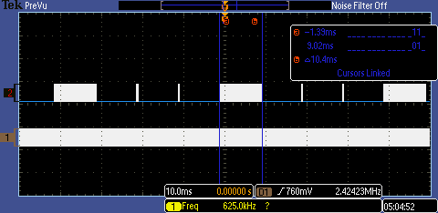
Figure C): Logic analyzer profile on our critical section.
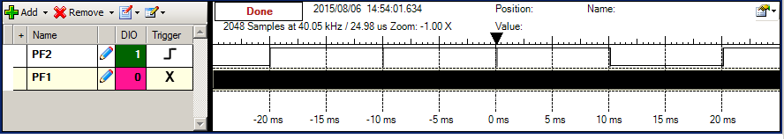
Figure D): Assembly Language for Critical Section.
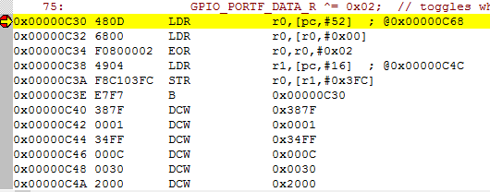
Which pin is incorrect PF1 or PF2? Look at the assembly language of the main program and explain the sequence of steps that results in the corruption of the debugging profile. Other than using bit specific addressing (PF1 PF2) what other solutions could you have used to have two debugging profile pins without a critical section?
In our critical section diagram, PF2 is the incorrect pin. The vulnerable sequence occurs when the PC is between 0x0C32 and 0x0C3A (LDR r0, [r0, #0x00]; and STR r0, [r1, #0x3FC];). First, the main thread reads the data in PORTF. Then, the timer interrupts and the ISR is called, updating the LED profile on PF2. When execution returns to the main thread, R0 still contains the old value of PF2 in its PORTF data. Finally, the store instruction corrupts the current value of PF2.
There are many other things we could do besides bit-specific addressing to remove the critical section. Instead of using both profile pins on PORTF, we could place one on a different port and link it to an LED on a breadboard. We could also disable interrupts to make the sequence of events atomic. However, we would prefer that as a last resort to avoid design issues later on in development.
In General (Extra):
When two threads have shared access to global data or an I/O port, and one of the accesses is a write, then there exists a critical section in the lower priority thread. This usually occurs when the write access is a multistep, non-atomic sequence of read-modify-write, write-write, or write-read.
We can remove critical sections by removing shared access between threads or making the vulnerable sequences atomic. That involves utilizing bit-specific addressing, adjusting thread priority, packing global data, or disabling interrupts.
3.5: Time-Jitter Measurements
measurements and generalization of contributing factors to jitter.
Figure C): Time Jitter measurement with only 1 ISR. (Jitter = 0).
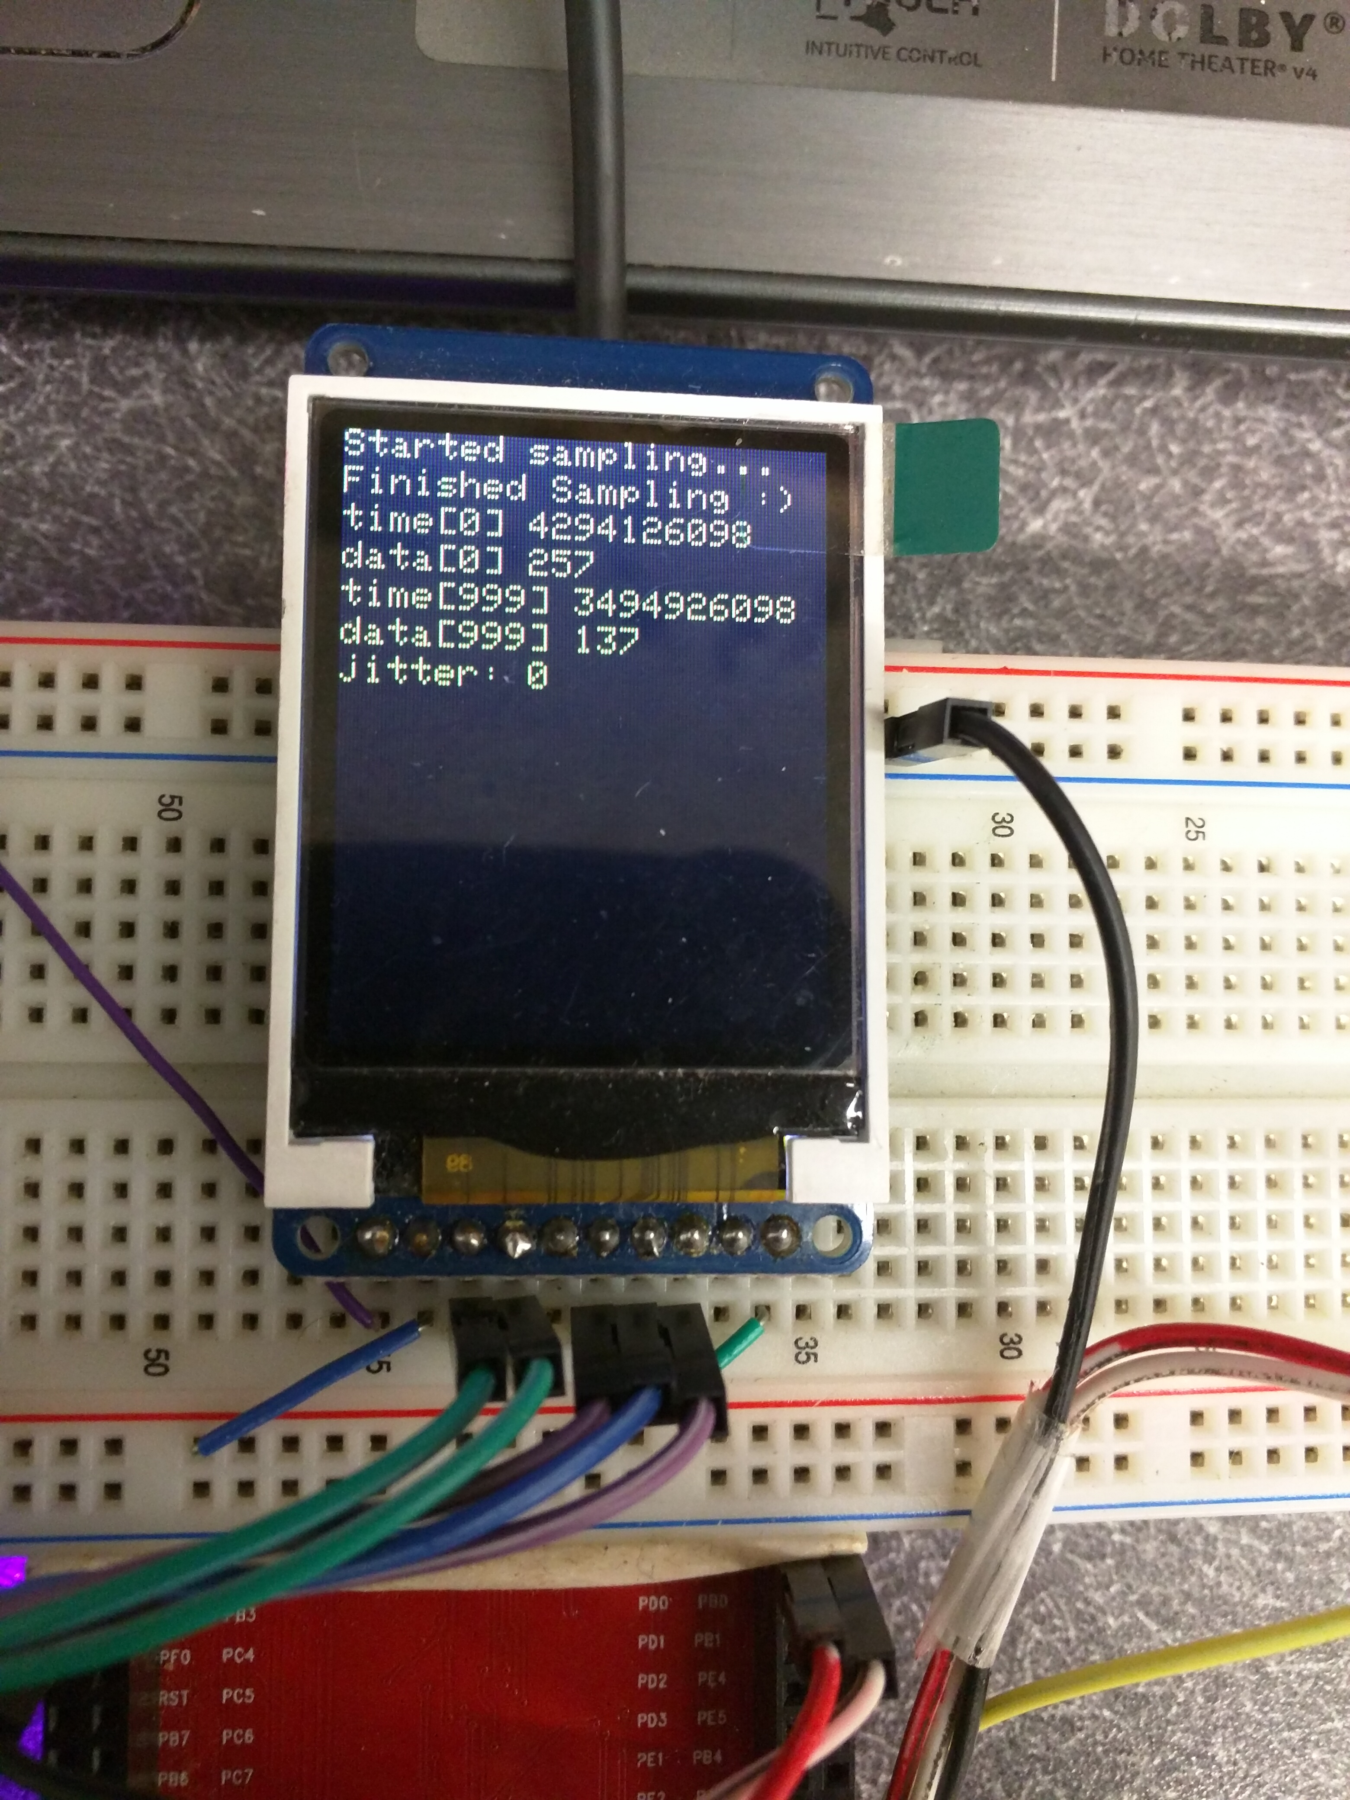
3.6: PMF data and Analysis
Input voltage
DC Voltage: 1.66V AC Voltage: 0.006V
How would you describe the shape of the noise process?
When you run it over and over do you get the same shape of the PMF?
The noise process is bimodal in nature. As we plot the PMF repeatedly, we do not get the same shape of the PMF. The ADC noise it not stationary and varies from sample session to sample session.
Does your data support the CLT? If not, why?
Yes, as we increase the Hardware Averaging of the ADC, the data distribution approaches a Gaussian distribution. This is really evident when examining the 4X and no averaging figures in comparison to the 64X averaging figure.
Describe qualitatively the effect of hardware averaging on the noise process. Consider two issues 1) the shape of the PMF and 2) the signal to noise ratio
As we increase hardware averaging, the ADC sampling noise decreases. We can infer this from the position of PMF, which shifts to lower values as hardware averaging increases. Also, the shape of the PMF approaches a Gaussian distribution as we increase hardware averaging. Also, the signal to noise ratio increases as hardware averaging increases.
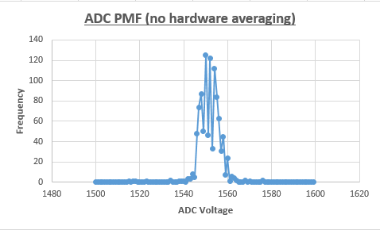

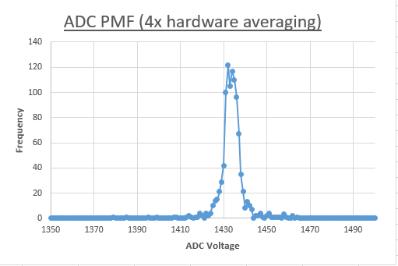

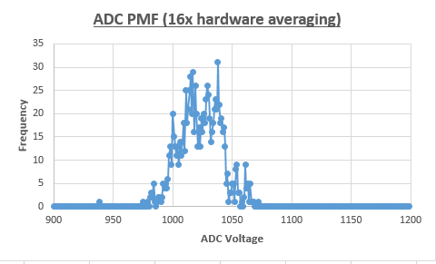

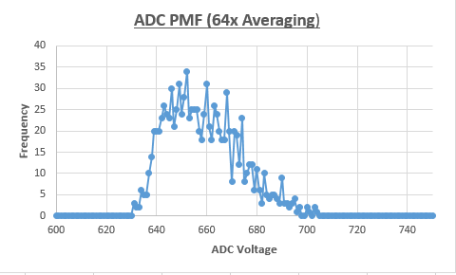
3.6: ISR Execution with Hardware Averaging
Use the logic analyzer or scope to determine the effect of hardware averaging on the time to execute the ISR. Why is the thread profile like Figure 2.1 very different with hardware averaging?
Utitilizing higher levels of hardware averaging will linearly increase the time to execute the ISR. Hardware averaging requires multiple samples from the ADC. Thus, a hardware averaging rate of 64X will require us to sample the ADC 64 times in the ISR. That means we can expect the ISR to run 64X slower.

4.0: Analysis and Discussion:
1) The ISR toggles PF2 three times. Is this debugging intrusive, nonintrusive or minimally intrusive? Justify your answer.
Toggling PF2 is a minimally intrusive debugging technique. The effect on the real-time interaction of the system is negligible.
2) In this lab we dumped strategic information into arrays and processed the arrays later. Notice this approach gives us similar information we could have generated with a printf statement. In ways are printf statements better than dumps? In what ways are dumps better than printf statements?
Printf statements require almost no extra memory to operate. They are also extremely convenient and easy to use while debugging traditionally. Dumps require a lot of extra memory overhead, but they are much less intrusive than print statements. Writing to a dump requires nanoseconds, while calling a printf statement requires about a millisecond. Dumps are overall much better for debugging real-time systems.
3) What are the necessary conditions for a critical section to occur? In other words, what type of software activities might result in a critical section?
When two threads have shared access to global data or an I/O port, and one of the accesses is a write, then there exists a critical section in the lower priority thread. This usually occurs when the write access is a multistep, non-atomic sequence of read-modify-write, write-write, or write-read.
4) Define “minimally intrusive”.
We classify a debugging instrument as minimally intrusive if it has a neglibile effect on the system being debugged. With respect to real-time systems, it cannot disturb the real-time interaction or interfere with the bounded latency.
5) The PMF results should show hardware averaging is less noisy than not averaging. If it is so good why don’t we always use it?
Hardware averaging increases the time it takes to run the sampling interrupt service routine (ISR). Thus, it decreases the throughput, and we could possibly miss some samples.

