Ronald Macmaster and Parth Adhia
EID: Rpm953 and Pda375
10/28/2016
EE 445L – Lab 7:
Design and Layout of an Embedded System
1.0: Objectives:
We will explore the aspects of embedded system design by completing full iterations of the design cycle for a PCB-based home alarm system. Consequently, it will be important for us to understand the systems-level approach to designing an embedded system. That will require us to study the issues of power, clock, reset, and programming in an embedded system context. Various mechanical aspects of our system, the availability of electronic parts, the cost of our embedded system, and the power budget of our embedded system will also be considered. We will undergo organized forward planning so we can design a system that is not only functional, but also testable throughout the full design cycle.

Requirements Document
1. Overview
1.1. Objectives: Why are we doing this project? What is the purpose?
Our primary objective for this project is to design, build and test a motion-detection home alarm system. We will learn how to interface a motion sensor, connect an embedded system to WIFI, and design and test an embedded system with a specific purpose. If the time constraints of our project allow for it, we will also experiment with an embeddable camera and store JPEG images on an SD card with an independent file system.
We also hope to explore and better understand the engineering design life cycle. The high level steps to this process include Analysis, Design, Development, Testing, and Deployment. These steps will be used to describe our process of analyzing the project through a requirements document, designing the high level software and hardware diagrams, developing the system’s software, testing the full implementation, and repeating the process until a functional product can be deployed. By the end of the semester, we hope to have reach the development stage of the cycle with a fully functional, motion-sensing home alarm system.

1.2. Process: How will the project be developed?
The project will be developed using the TM4C123 board. There will be at least two inputs to the system to control the alarm system. The system will be laid out and soldered onto a PCB board and powered through a battery of our choice. The alarm system will utilize a keypad that will be easily accessible through the external system enclosure. A hardware/software interface will be designed that allows software to control the player and the hardware to respond to special events. The final system will include at least two outputs and two interrupt service routines. The process will be to design and test each module independently from the other modules. After each module is tested, the system will be built and tested.

1.3. Roles and Responsibilities: Who will do what? Who are the clients?
Ronald Macmaster and Parth are the engineers and the Dylan Zika (TA) is the client. We have modified this document to clarify exactly what we plan to build. We are allowed to divide responsibilities of the project however we wish, but, at the time of demonstration, both of us are expected to understand all aspects of the design.
Who will do what?
Ronald Macmaster will be responsible for drafting the requirements document and the lab report. He will also create the software design diagrams that will consist of a call graph and a data-flow graph. He will draft up the interface files for the various software modules and create program skeletons for the various driver files. He will build the webserver and notification application for Android phone users. Finally, he will supervise and contribute to the software development process and submit all of the assignment documentation.
Parth Adhia will be responsible for drafting the hardware design documentation. This will require a schematic diagram of the external system hardware that should be built using the PCB Artist program. He will also be responsible to supervise proper assembly of the external system hardware circuit. He is responsible for providing the speaker and tactile switches as well as the motion sensor, camera, and wifi booster circuit. Finally, he will edit and contribute to the various project documentation as fit.
Both engineers will contribute equally to the schematic layout. Each engineer will also have a chance to contribute to the PCB layout and trace routing as well as the low-level software drivers. The entire project will require both engineers to research the datasheets for the many different hardware devices.

1.4. Interactions with Existing Systems: How will it fit in? How will it connect to other systems?
The system will run on a TM4C12GH6PM processor mounted on a completed PCB board. The final system is required to communicate data over WIFI, so it will be required to implement WIFI capability according to the IEEE 802.11 standard. The home alarm system will specifically send notifications to a web server that runs on the Google Cloud API. Notifications will be send through HTTP GET requests. Subscribed devices will be notified of intruders through the server independent of the embedded system. If time permits, the home alarm system will also upload a JPEG image of the intruder to the web server too.

2. Function Description
2.1. Functionality: What will the system do precisely?
The operator will arm the alarm system by entering a password to the keypad on the local system. They will have approximately two seconds to exit the vicinity of the motion sensor. When a person enters the vicinity of the alarm system, it will sound a warning alarm and post the alarm request to the Google Cloud server. The server will then forward notifications to all of the alarm system subscribers (Anrdoid app holders). The operator can set the duration limit of the alarm sound the after it is triggered. Optionally, the device will also upload a JPEG image of the intruder to the web server if the development cycle time constraints permit.

2.4. Performance: Define the measures and describe how they will be determined.
The system will be judged by four qualitative measures. First, the software modules must be easy to understand and well-organized. Second, the system must employ an abstract data structures to hold the JPEG images and interface the low level hardware. Third, the PCB layout will conform to a large set of quality guidelines. The trace routing of the system PCB will be examined closely through multiple design iterations. All software will be judged according to style guidelines. Software must follow the style described in Kerrigan and Ritchie’s book, The C Programming Language. There are three quantitative measures. First, the thresholds of the motion sensor should be measured. Second, the maximum current to power the system will be estimated and confirmed. Power analysis will play an important role in ensuring the long-term functionality of our alarm system. Third, we will measure the accuracy of the alarm system. These measurements will include the conditional probabilities of a false positive and a true negative. The minimum accuracy of our alarm system will be primarily judged off of these probabilities and determined at a later date.

2.5. Usability: Describe the interfaces. Be quantitative if possible.
The primary input component of our system is the SEN-13285 Motion Sensor. The motion sensor will detect human presence within a monitoring zone. Another system input is the keypad, which can be used to input a secret passcode and arm the alarm device. Output will include sound delivered to an 8-ohm or 32-ohm speaker driven by a PWM. The numerous Android devices subscribed to the web server will also receive alarm notifications as output. If time permits, an embedded camera will record snapshots of the intruder as an input JPEG image. We may also decide to add control functionality to Android subscribers as well.
The final system will be printed and soldered onto a PCB with all of the electronic components attached. The speaker and battery supply will be encapsulated along with the PCB inside of a custom enclosure. The motion sensor will perturb out of the enclosure’s side to improve its accuracy. The keypad will be easily accessible through the enclosure. If we implement a snapshot camera, it will perturb out of the enclosure’s side as well.
3. Deliverables
3.1. Reports: How will the system be described?
A lab report described below is due by the due date listed in the syllabus. This report includes the final requirements document.
The final lab report is due on Friday, October 28th at Midnight. This report will include the final requirements document. The outline of the lab report is as follows:
A) Objectives (final requirements document)
B) Hardware Design (Circuit diagram (SCH file),
PCB layout, and three printouts (top, bottom and combined))
C) Software Design (Include the requirements document)
D) Measurement Data (Estimated current and Estimated cost (BOM))

3.2. Audits: How will the clients evaluate progress?
Clients will be given a high level Marketing Requirements Document presentation two weeks before checkout. They will be presented with a preparation the week before the final checkout. The lab report will be presented at conclusion of the project.

3.3. Outcomes: What are the deliverables? How do we know when it is done?
There are four deliverables: pre-preperation, preparation, demonstration, and report. Most of our work and design will be documented in the final lab report.
2.0: Hardware Design:
Our system will interact with an SE-10 dual element motion sensor. It will implement WIFI connectivity by interfacing with the ESP8266 module. It will also interface with a 16-button keypad for user input. The final output will be exerted on an 8-Ohm speaker. The speaker will be interfaced through a BJT and connected in parallel with a snubber diode.
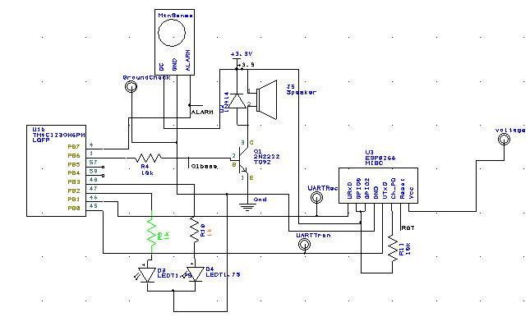
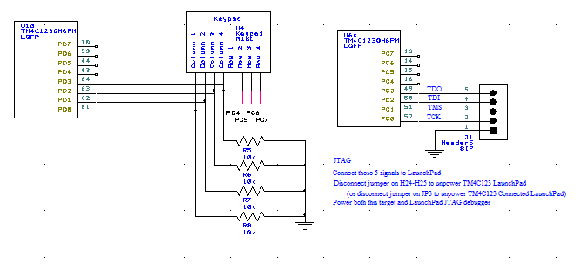
Figure 2.1: Hardware Schematic for our Home Alarm system. The keypad utilizes positive logic to implement the passcode interface. The speaker is interfaced through the BJT and PWM. Various test points exist to continually verify our system functionality.
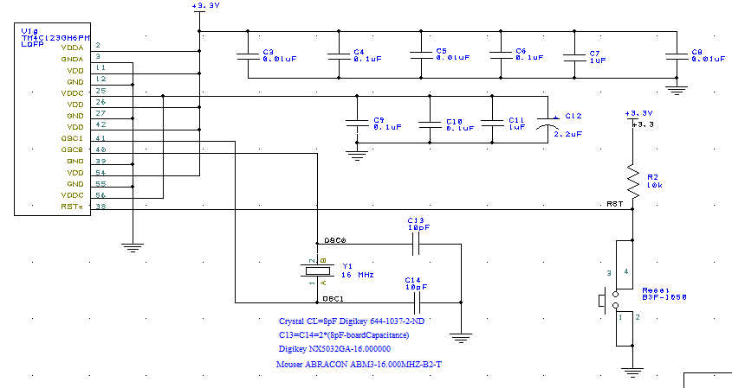

Figure 2.2: Layout for the Power Supply capacitors, Reset Switch, and Crystal Oscillator. C13 and C14 (10pF capacitors for crystal) are very important capacitors with low tolerance values.

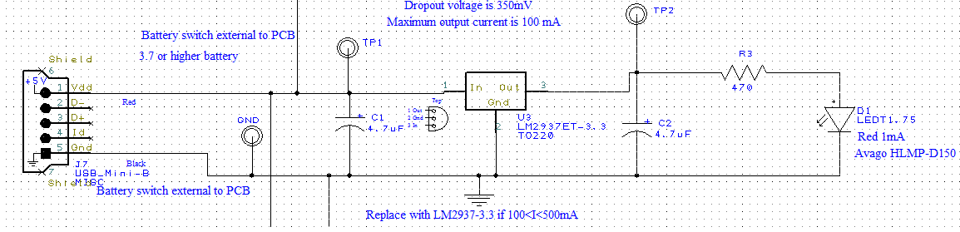
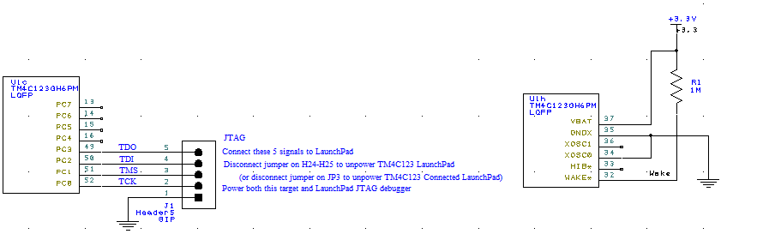

Figure 2.3: Details for our Regulator and JTAG Debugger circuits. The JTAG will allow us to flash our software onto our PCB board. The regulator provides a stable output voltage of 3.3V from the unregulated power supply input. The board is powered from a USB power input.
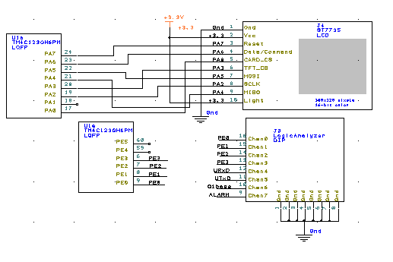
Figure 2.4: Hardware schematic detailing the LCD and Logic Analyzer setups on Port A and Port E. The logic analyzer observes some very important signals on the ESP8266, Motion sensor, and speaker output.

Layout of the PCB (Top, Bottom, Both)

PCB Top Copper and SilkScreen

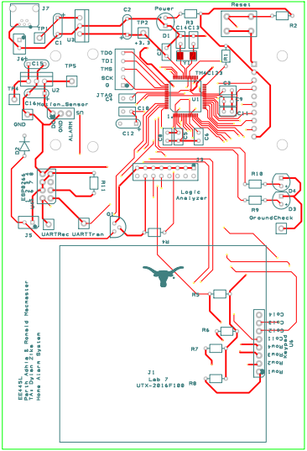

PCB Bottom Copper and SilkScreen
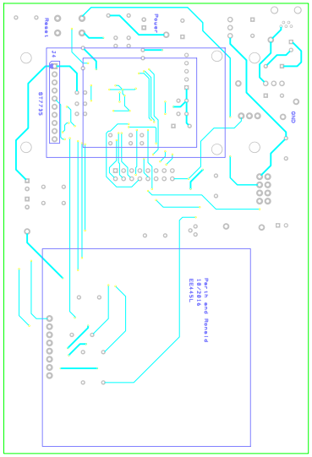

PCB Both Copper and SilkScreen

3.0: Software Design:
All of our required and additional functionality can be implemented using four basic modules — Keypad, Motion Sensor, WIFI, and Speaker Control. Submitted along with this report are the interface and driver files (.h and .c) for our software modules (Motion, ST7735, Speaker, WIFI, and Keypad).
Figure 3.1: Call graph for our Home Alarm system. A main driver program manages hardware through secondary software modules.
Figure 3.2: Client-Server architecture for our Alarm System. Various Android and E-mail users can subscribe to the alarm system notifications. Alarm notifications are sent over WIFI to the alarm web server. The notifications are forwarded to the Mobile and E-mail subscribers.
4.0: Measurement Data:
Estimated Current (procedure d)
Approximate current drawn by ESP8266: 70mA
Approximate current drawn by SE-10 Motion Sensor: 1.6mA
Approximate current drawn by LCD and SPEAKER and CONTROLLER: 111mA
Approximate current drawn by Keypad: 0.33mA
Approximate current drawn by LEDS: 5mA total for all 3 LEDS
TOTAL CURRENT ESTIMATE: 70mA + 1.6mA + 111mA + 0.33mA + 5mA = 187.93mA Total
Bill of Materials / Cost
Total unsubsidized cost of parts: $61.44

Total unsubsidized cost of parts + PCB: $117.44

Total subsidized 445L Cost: $20.39

Quantity | Description | Cost | Current(mA)
1 | 8-ohm speaker | $0.50 | 41
2 | Ceramic, Z5U, -20/+80%, 0.47 uF | $0.80 | 0
4 | Ceramic, Z5U, -20/+80%, 0.1 uF | $0.18 | 0
3 | Ceramic, Z5U, -20/+80%, 0.01 uF | $1.20 | 0
2 | Ceramic C0G, 10%, 10 pF | $0.62 | 0
1 | Tantalum, 16V, 20% 2.2 uF | $0.29 | 0
2 | Tantalum, 16V, 10% 4.7 uF | $0.44 | 0
7 | Test point, black | $1.61 | 0
1 | Logic Analyzer connector | $0.27 | 0
1 | JTAG 1 by 5 male header | $0.29 | 0
1 | TM4C123GH6PM 64-pin LQFP | $11.55 | 131
1 | NX5032GA-16.000000 | $0.51 | 0
1  1 | 1N914 diode  USB Mini-B socket, board mount, through hole | $0.05  $0.65 | 0
1 | LM2937 3.3 V regulator TO220, 500mA | $1.17 | 0
1 | LM4041CILPR shunt diode reference | $0.90 | 0
1 | 3 by 4 common bus (D), keypad | $2.99 | 3
1 | 18-bit color 128*160 1.8" TFT LCD display | $19.96 | 90
1 | Green 2mA 5mm diffused | $0.29 | 0
1 | Red 1.6V 1mA 5mm diffused | $0.29
1 | Yellow 2mA 5mm diffused | $0.29
1 | Carbon 1/6W, 5%, 470 | $0.02 | 0
2 | Carbon 1/6W, 5%, 1K | $0.05
7 | Carbon 1/6W, 5%, 10K | $0.17 | 0
1 | Carbon 1/6W, 5%, 100K | $0.02 | 0
1 | Carbon 1/6W, 5%, 1M | $0.02 | 0
1 | B3F tactile push button switch | $0.17 | 0
1 | PN2222 NPN transistor | $0.13
1 | ESP8266 | $6.95 | 70
1 | PIR Motion Sensor (JST) | $9.95 | 3
2 | 8-pin connector
1 | 3-pin connector

