Ronald Macmaster and Parth Adhia
EID: Rpm953 and Pda375
11/11/2016
EE 445L – Lab 9:
Temperature Data Acquisition System
0.0: Objectives:
We will further study the concepts of ADC conversion and the Nyquist Theorem. Specifically, we plan to develop a temperature measurement system that uses a thermistor. We plan to analyze different performance measurements of the system including precision, resolution, and accuracy. To realize a working system, we will also have to understand some general concepts of analog circuit design. Our circuit will require the use of an operational amplifier and instrumentation amplifier. We need to calibrate these analog circuits in a way that will allow for the most accurate temperature measurements in the overall system. That means we also must gain a deep understanding of how these integrated circuits work and the parameters associated with them.
1.0: Sensor Calibration:
Here is a snapshot of our calibration Excel sheet.
2.0: ADC Initializations:
There are many ways to trigger the ADC, but we implemented Processor, Timer, and Continuous trigger initialization methods.
- Hardware Triggered (GP Timer 0A)
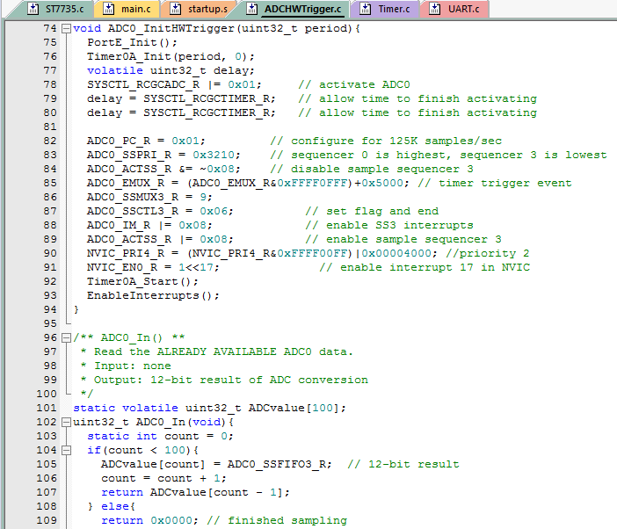
- Software Triggered (Processor)
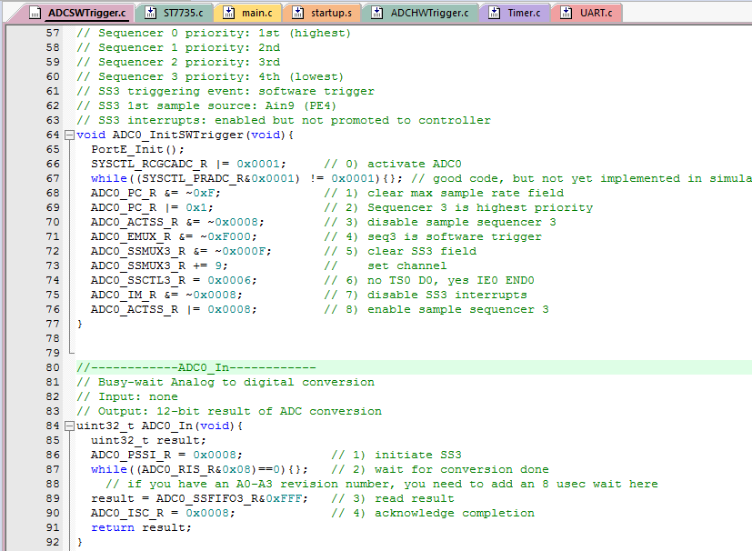
- Continuous (Automatic and Endless)
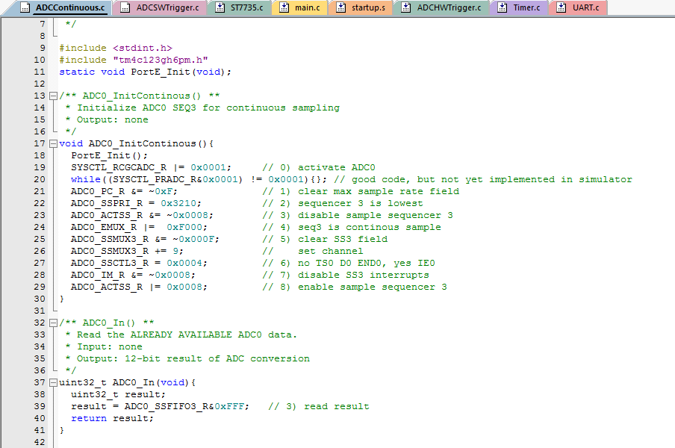

3.0: Hardware Design:
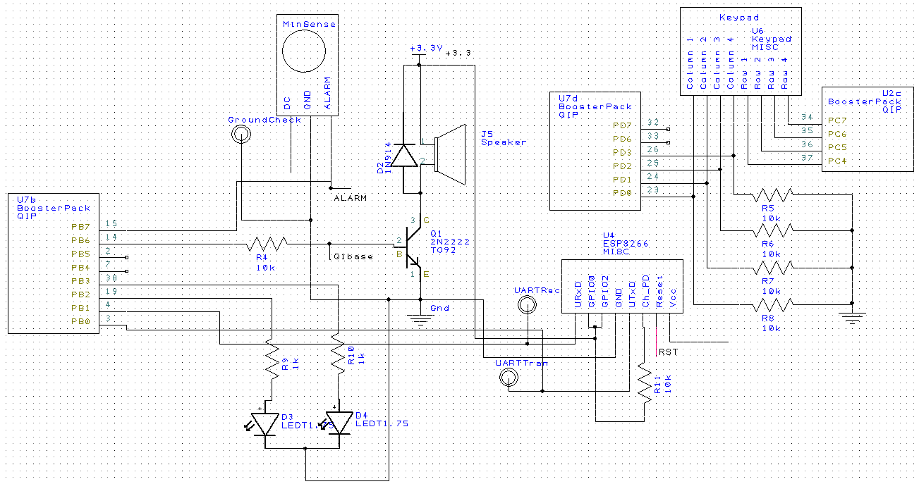
Below is the schematic design of our thermistor interface and Butterworth filter.

4.0: Nyquist Sampling Driver:
Below is a snapshot of our main sampling driver. It also includes the preparation questions.
