Detailed Design
for
DegreeOverview
Version 1.0 approved
Prepared by:
Lei XIA (1830026125)
Yiping GAO (1830026026)
Zhenyu REN (1830026095)
Zhengyang SHEN (1730026092)

Jasmine

2021/4/28
Table of Contents
Table of Contents ii
Revision History ii
1. Overview 1
1.1 Project description 1
1.2 References 1
1.3 Design purpose 1
2. Overall description 2
2.1 Class diagram 2
2.2 Refinements 2
3. Detailed design 3
3.1 Class diagram 3
3.2 Classes 3
3.2.1 LoginInfo 3
3.2.2 User 4
3.2.3 Course 4
3.2.4 CILO 4
3.2.5 Assessment 5
3.2.6 GradeReport 5
3.2.7 Student 6
3.2.8 Lecture 6
3.2.9 Course Designer 6
3.2.10 Analysis 6
3.2.11 ProgramDegree 7
3.2.12 Log 7
3.2.13 Performance 7
3.2.14 CILOFile 7
3.2.15 AssessmentFile 8
3.2.16 File 8
4. Alternative detailed design (Optional) 8
5. More considerations 8

Revision History
Name | Date | Reason For Changes | Version
Initial version | 2021/4/28 |  | 1.0

Overview

Project description
- The purpose of: Present a detail description of the course definition system (DegreeOverview).
- The DegreeOverview project is to help university student and teacher better understand the relationship between courses.
- The course designer could do some operation on the course, such as add, edit, import or modify. The students could visualize their outcomes about each course directly and easily.

References
- LeiXIA, Yiping GAO, Zhenyu REN, Zhengyang SHEN. (April 19, 2021). SRS_Jasmine1.4.docx.
- SDWIII Project V4.docx.

Design purpose
- This detailed design looks clearly that help engineer programming the program easily.
- Based on our detailed design, the program could be developed by several groups and each group could program the project parallelly.
- This design purport more details on programming and give the details what attributes and which type need input.

Overall description

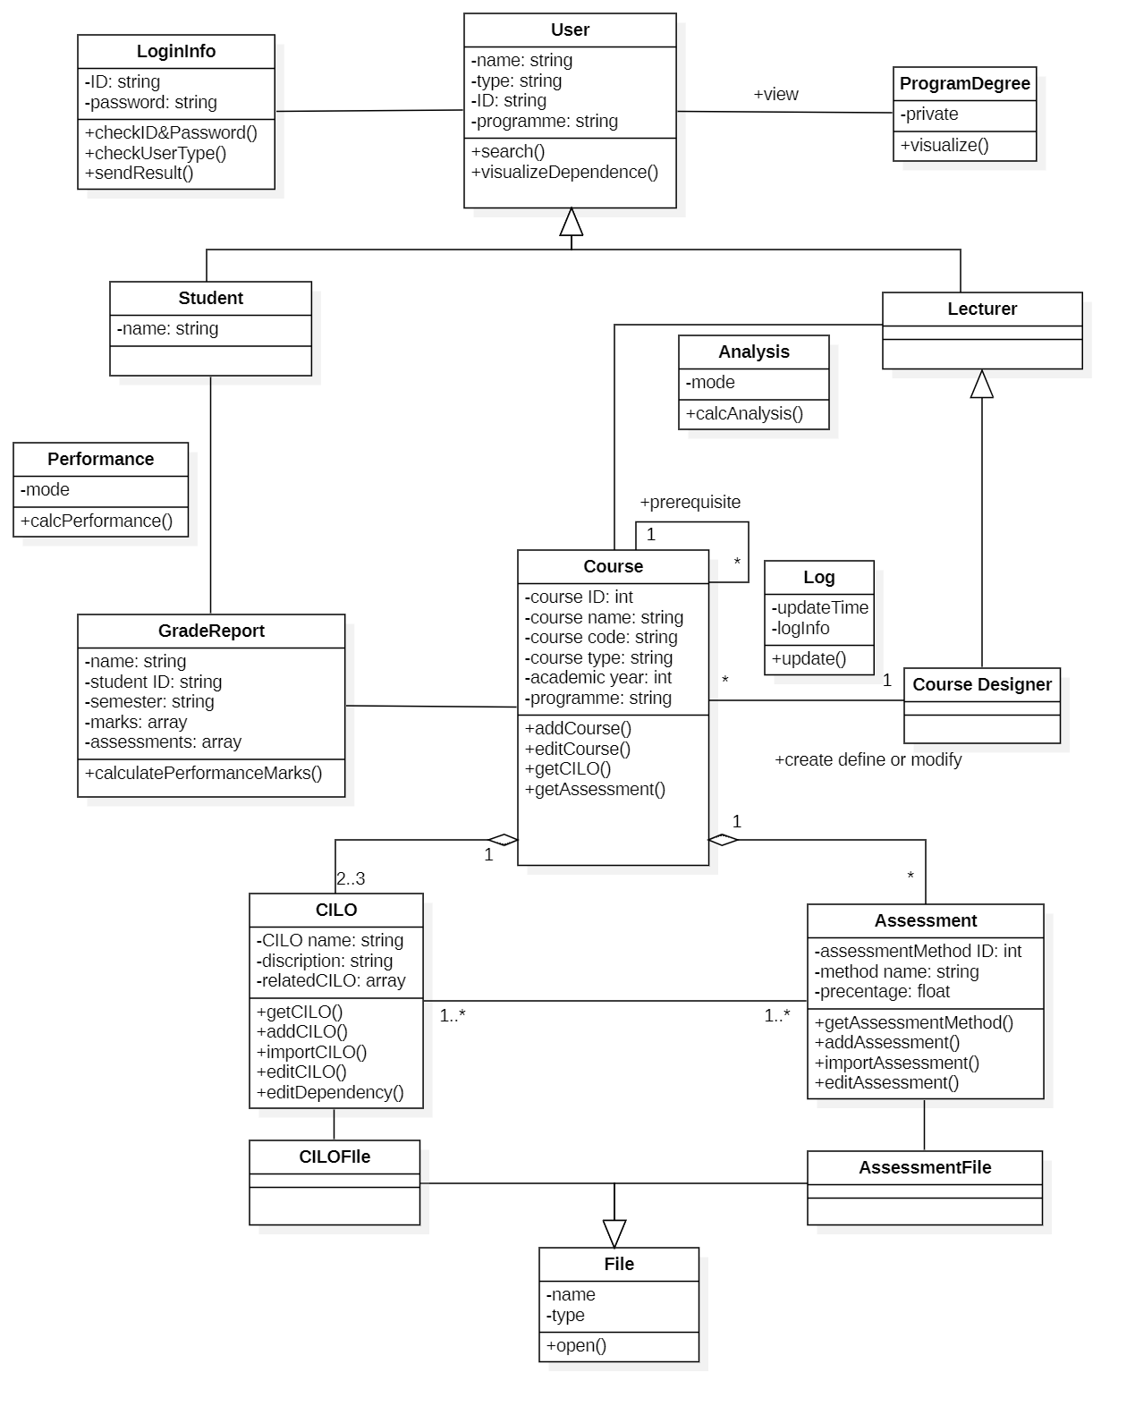
Class diagram

Refinements
We make a progress on the class diagram especially simplify the log class and file class. In addition, transfer some operation and clear the relationship between some classes.

Detailed design

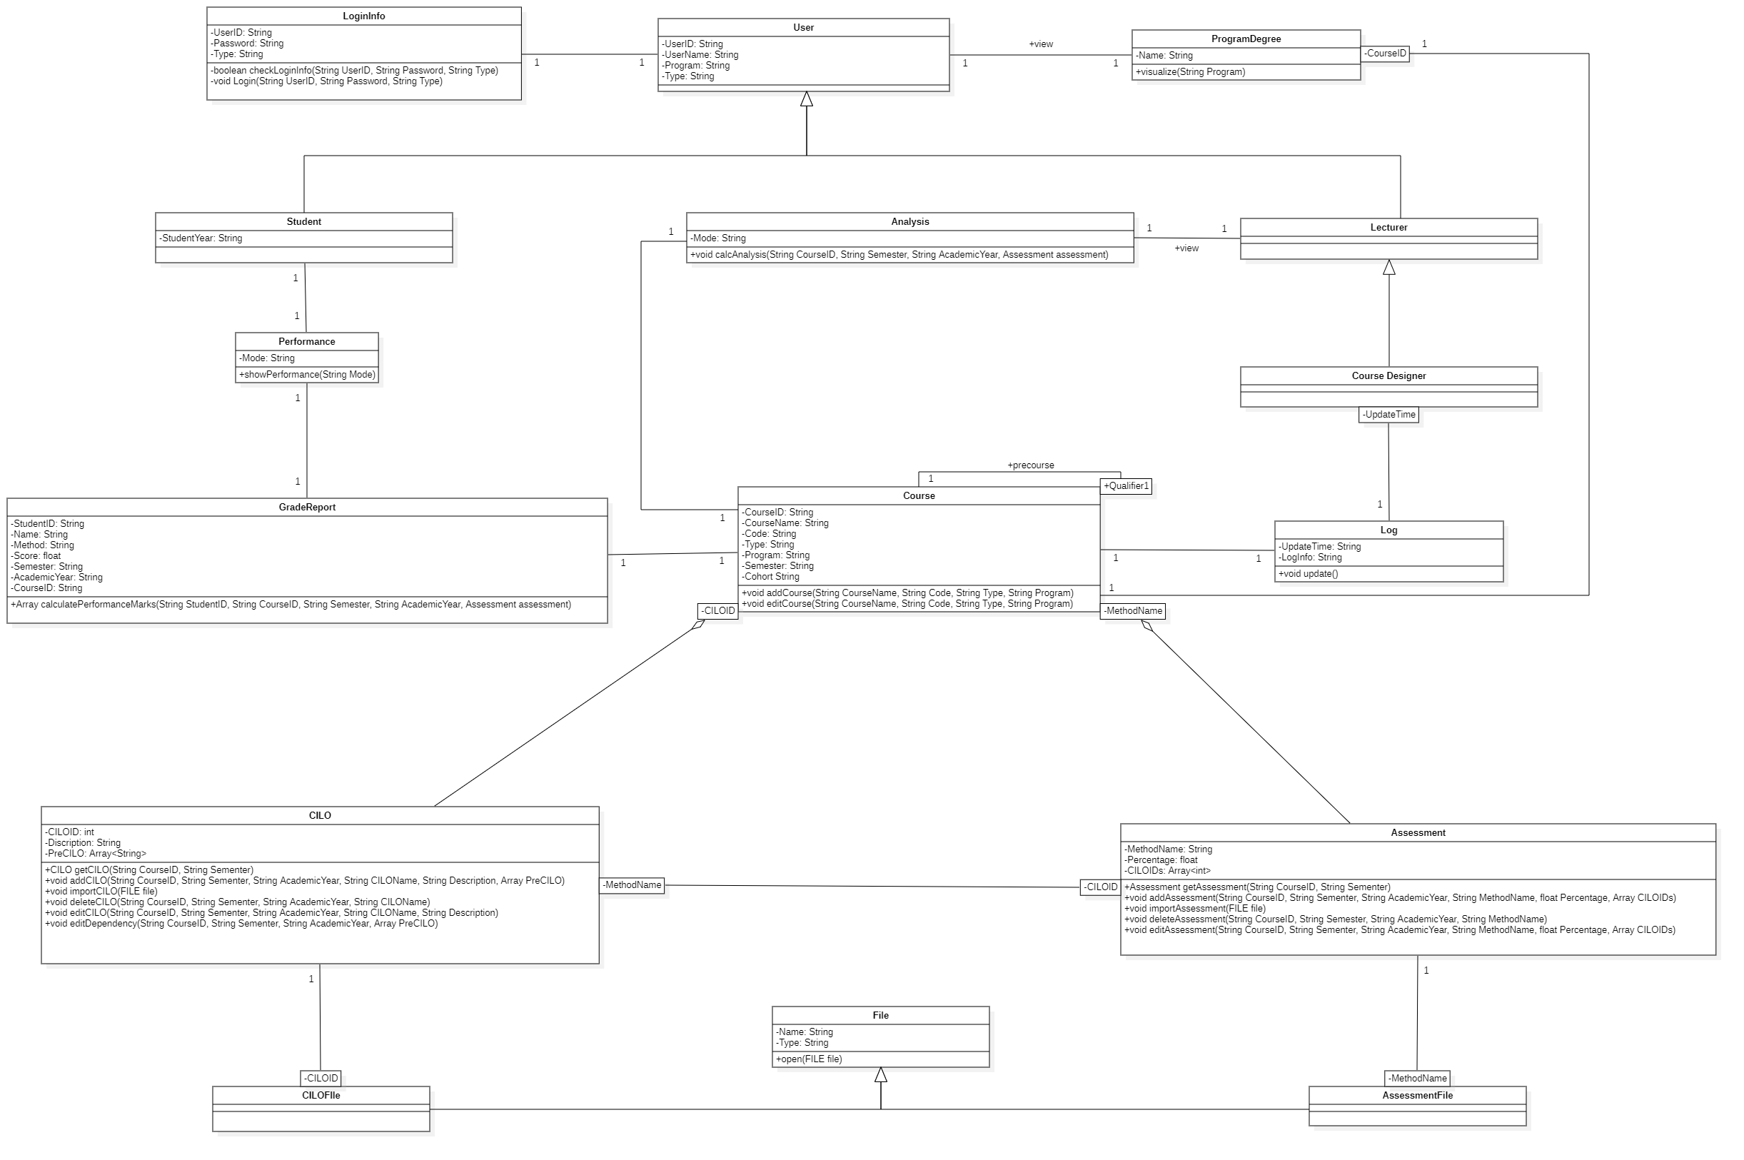
Class diagram

Classes

LoginInfo
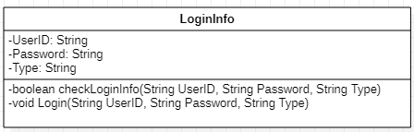

Explanations
We add an attribute called Type that are used to identify the user type and jump to corresponding page.
Add the operation checkLoginInfo for check whether the UesrID and Password are corresponded.

User
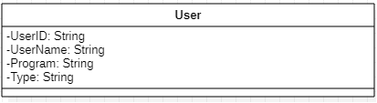

Explanations
We add an attribute called UserID that to be the primary key of the user.

Course
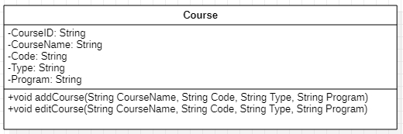

Explanations
We remove the attribute academic year because it is more associative to the CILO and assessment.
We remove the getCILO and getAssessment method because they are more associated with CILO and assessment.

Constraints
void addCourse(String CourseName, String Code, String Type, String Program)
Pre-condition: CourseName , Code, Type and Program are not null. Code, Type and Program input should follow the specific rule. Type and Program should exist in our system.
Post-condition: A new course is added with CourseName , Code, Type and Program information.
It has no return value.

void editCourse(String CourseName, String Code, String Type, String Program)
Pre-condition: CourseName , Code, Type and Program are not null. Code, Type and Program input should follow the specific rule. Type and Program should exist in our system.
Post-condition: This is a void function to edit the course information with no return value.

CILO
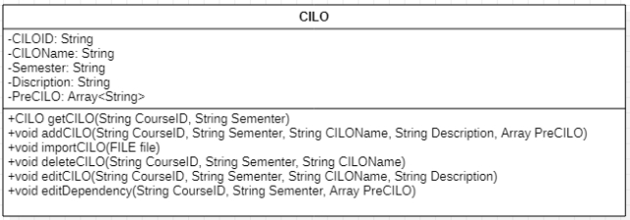

Explanations
We add the attribute Semester to specifically identify the assessment with the attribute CILOID.
We add the getCILO operation to return CILO itself.
We add the void deteleCILO operation to delete a CILO.

Assessment
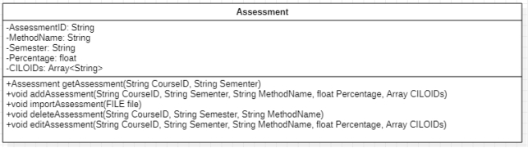

Explanations
We add the attribute Semester to specifically identify the assessment with the attribute AssessmentID. CILOIDs is added and assigned as an array to store the CILOs associate with the Assessment.
We add the getAssessment operation to return CILO itself.
We add the void deleteAssessment operation to delete Assessment.

GradeReport
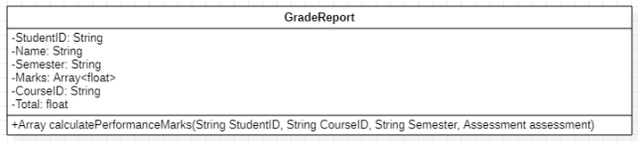

Explanations
We add the attribute CourseID to specifically identify the grade report with the attribute studentID.
Total is also added to store the final marks of the grade. We remove the attribute assessment because assessment just used to calculate the total but not belong to grade report.
Add the calculatePerformanceMarks for specific student calculate their performance of a sutdent.

Student
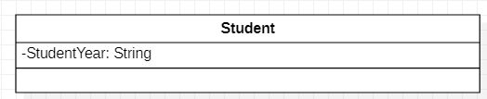
Explanations
The Student class inherit the User class and only add one attribute: Student year


Lecture

Explanations
The Lecture class inherit to the User class and no change about that


Course Designer

Explanations
The Course Designer inherit the Lecture class and no need add more attributes and opertions.

Analysis
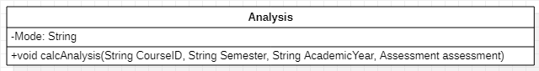
Explanations

Add the new operation called valcAnalysis which calculate the specific course and return type is void.

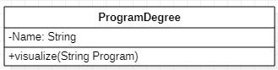
ProgramDegree

Explanations

Add the new visualize operation and add the new parameter for different program.

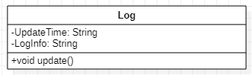
Log

Explanations

Add the new attributes called the update Time for storing the time information of update.
Add the new operation to store some info about update log.

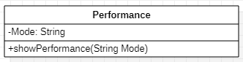
Performance

Explanations

Add the new attribute to describe the mode of the performance.

CILOFile

Explanations

Add the new class called CILOFile in order to distinguish the File class and more specification.


AssessmentFile

Explanations

Add the new class called AssessmentFile in order to distinguish the File class and more speciation.

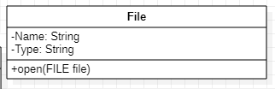
File

Explanations
For the open() operation, we add the new parameter file for specific the File type and name.

Alternative detailed design (Optional)
N/A

More considerations
To understand what the user interface looks like and how does the user case work, it’s better to refer to Jasmine_UI1.3_20210414.docx, ArchitectureDesign_Jasmine1.0.docx.

