Test Report
for
<DegreeOverview>
Prepared by
Lei XIA(1830026125)
Yiping GAO(1830026026)
Zhenyu REN(1830026095)
Zhengyang SHEN(1730026092)
jasmine
<2021/5/26>

Contents
1. Brief description 1
2. Test date and performer 1
3. References 1
4. Error report 1
5. Appendix 1

Brief description
Testing time:
The testing process last about 1 mins
Difficulties:
Install the “TestComplete” software and try to know how to use it.
Merge the whole subsystems and pick up to test a specific use case.

Test date and performer
Test date: 2021/5/26
Tester name: Zhenyu Ren, Yiping GAO, Lei XIA, Zhenyang SHEN

References
Test_plan_jasmine.docx
SWDIII projectV4.docx
SRS_Jasmine.docx

Error report

Test case ID | Expected result | Actual result
3 | The system give the warning error result, couldn’t add the new Assessment | The page lost and not found
6 | The system give the warning error result, couldn’t add the new | The assessment still could added
7 | The system give the warning error result, couldn’t delete the Assessment | The Assessment still could deleted

Appendix

One Vuser script copy for edit assessment

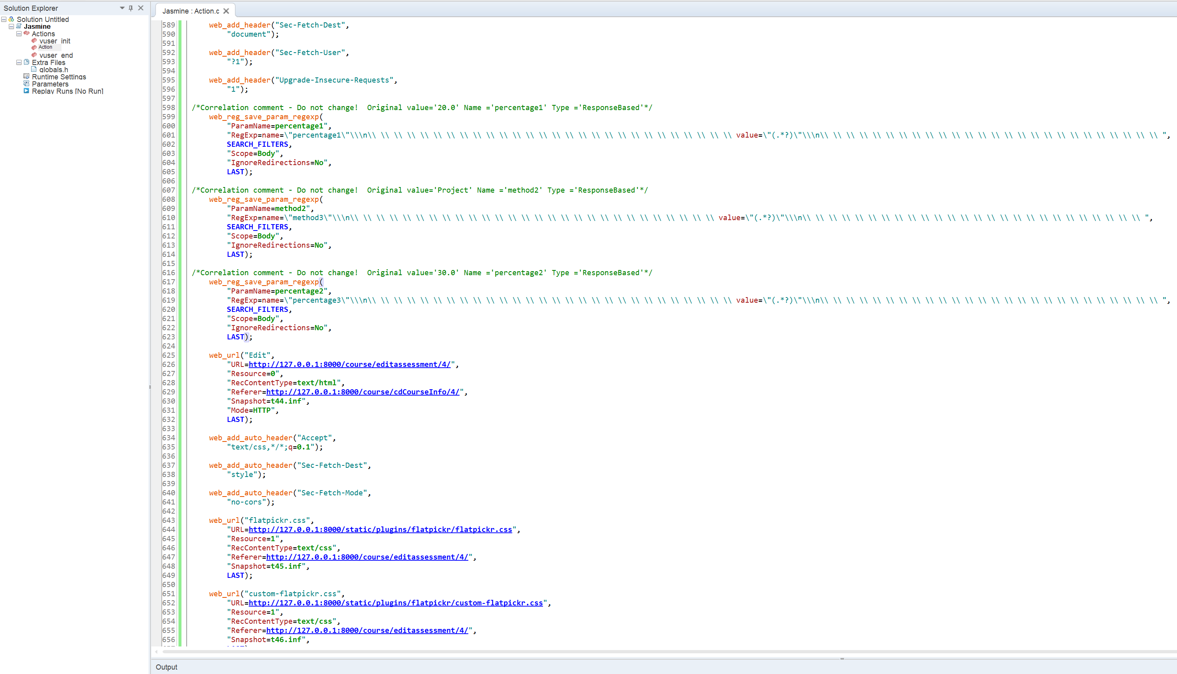

Three screenshots of TestComplete

Figure1: add new assessment
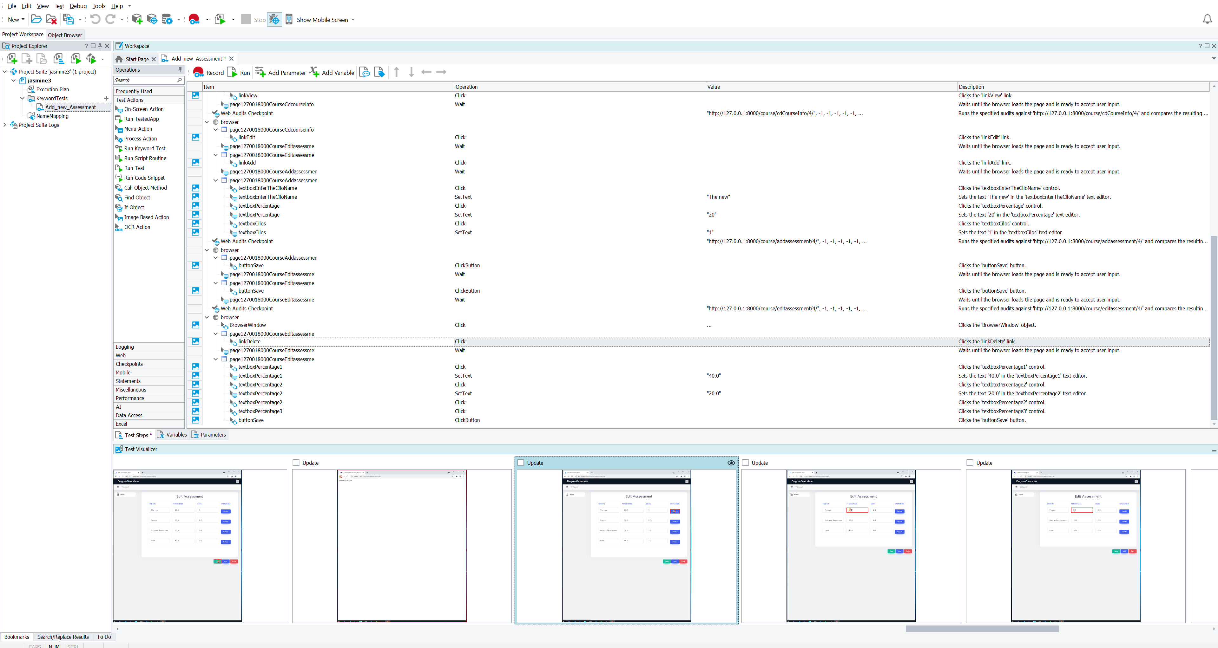

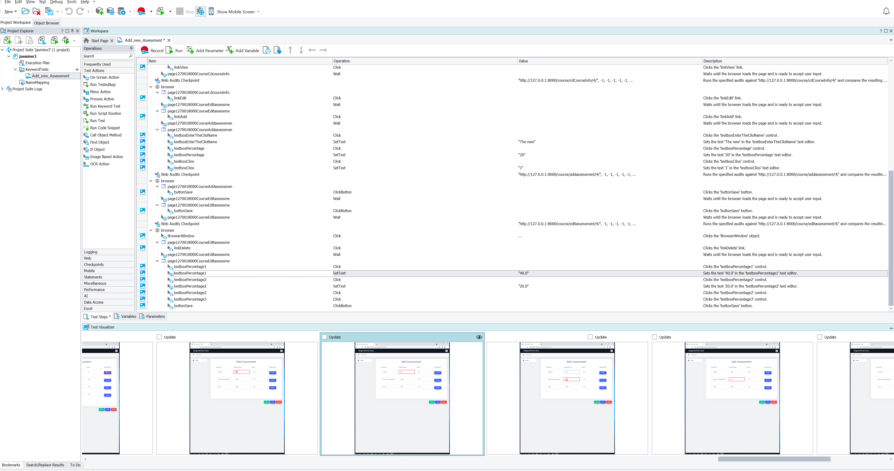
Figure 2: Delete the Assessment

Figuer3: Edit the assessment

