Software Requirements Specification

for

DegreeOverview

Version 1.0 approved

Prepared by:

Lei XIA (1830026125)

Yiping GAO (1830026026)

Zhenyu REN (1830026095)

Zhengyang SHEN (1730026092)

Jasmine

2021/3/15

Table of Contents

Table of Contents ii

Revision History ii

1. Introduction 1

1.1 Purpose 1

1.2 Document Conventions 1

1.3 Intended Audience and Reading Suggestions 1

1.4 Project Scope 1

1.5 References 1

2. Overall Description 2

2.1 Product Perspective 2

2.2 Product Features 2

2.3 User Classes and Characteristics 2

2.4 Operating Environment 2

2.5 Design and Implementation Constraints 2

2.6 User Documentation 2

2.7 Assumptions and Dependencies 3

3. System Features 3

3.1 System Feature 1 3

3.2 System Feature 2 (and so on) 4

4. External Interface Requirements 4

4.1 User Interfaces 4

4.2 Hardware Interfaces 4

4.3 Software Interfaces 4

4.4 Communications Interfaces 4

5. Other Nonfunctional Requirements 5

5.1 Performance Requirements 5

5.2 Safety Requirements 5

5.3 Security Requirements 5

5.4 Software Quality Attributes 5

6. Other Requirements 5

Appendix A: Glossary 5

Appendix B: Analysis Models 6

Appendix C: Issues List 6

Revision History

|  |  |  |  |
| --- | --- | --- | --- |
| **Name** | **Date** | **Reason For Changes** | **Version** |
| Initial version | 2021/3/15 |  | 1.0 |
|  |  |  |  |

# Introduction

## Purpose

* The purpose of this SRS document is going to present a detail description of the course definition system called **DegreeOverview**.
* This document is intended for users of the software, such as the students and course designers, and the software developers. It will explain the purpose and features of this software, the interfaces of the software, what the software will do and the constraints under which it must operate.
* The scope of the product is the independent web application. The software is a part-of stand-alone application connecting to two databases (security information database and “Grade Report System”), which provides users with access to course-related information and the ability to quantify skills.

## Document Conventions

**The standards of writing this SRS:**

* + **Heading 1:**

Font: Times, Font size: 18

* + **Heading 2:**

Font: Times, Font size: 14

* + **Normal:**

Font: Arial; Font size:11; Line space: 1.0

Bold font: Higher priority or significance or a title

The underlined part: The part that should be paid special attention to.

**Proper noun：**

* **DegreeOverview**: project name

**Acronyms and abbreviations:**

* SRS (software requirements specification)
* GPA (Grade-Point Average)
* N/A （none）
* I/O （input and output）

## Intended Audience and Reading Suggestions

* Typical Users, such as students and course designers, who want to use **DegreeOverview** to help with acquiring skills assessment.
* Programmers and tester who are working on the project by further developing it or fix existing bugs.

**All readers** are advised to read **section 1, 2, 3** first since these sections contain the basic structure of the product. For **developers and project managers**, you are strongly advised to pay more attention to **section 2, 3 and 4**.

## Project Scope

* **DegreeOverview** is designed to make it easier for teachers and students to access pre-course and course information, then assess the level of skill acquisition after the course is completed, and visualize the information for uses.
* The course designer can also update changes in relevant information to increase students' understanding of the course. With the help of **DegreeOverview,** students and teachers can manage their courses and academic careers more conveniently and easily.

## References

* IEEE Template for System Requirement Specification Documents: <https://goo.gl/nsUFwy>
* SDWIII Project V2
* To be continue…

# Overall Description

## Product Perspective

This is a new, part-of stand-alone system about the visualization of the dependency between the learning outcomes.

**System environment:**

The major components of the system are:

* Grade report system: Store the student’s marks for each course.
* Visualization system: the visualization of the dependency between the learning outcomes.
* Security information: Contains the users login information like accounts and passwords, also includes the information about whether a staff member is a legal course designer.

**Out of system boundary:**

Other parts we want to separates out of the environment:

* Performance calculate system: To calculate the student’s performance on various learning outcome according each CILO and assessment methods.
* Log recording system: To record maintenance each course’s operations, including creation and modification, and the information of operation maker.
* User information database: Stores users’ information like user name, student performance.
* Course information database: Contains CILOs and assessments methods and some basic information like course name, course code and type (MR, ME or FE) and prerequisite courses.

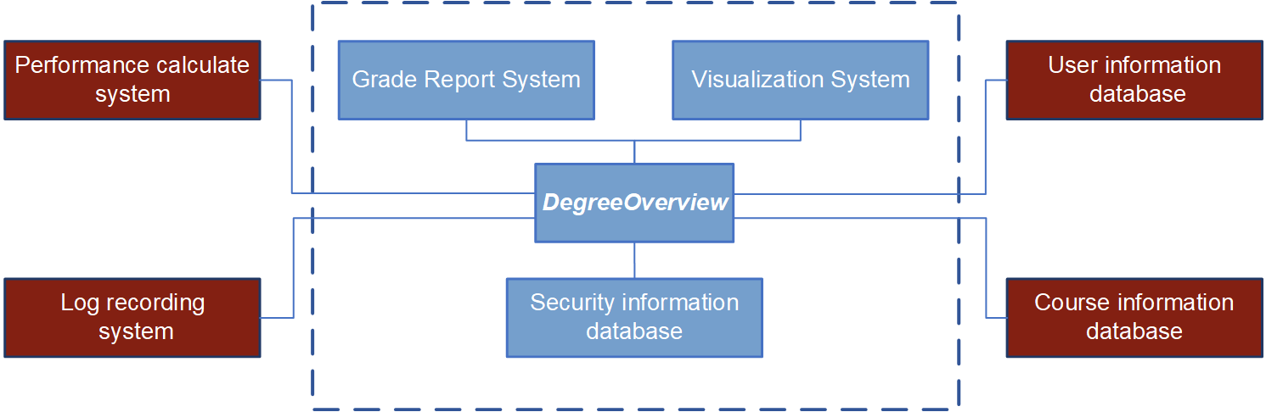**Context Model:**

## Product Features

The major features this program contains are the following:

**Search function:**

* Can search by keywords and courses.
* Course search will return prerequisite courses or the courses that use this course as a prerequisite.
* Keyword search will return the courses or CILOs.

**Course:**

* Besides CILOs and assessment methods, each course also includes some basic information such as course name, course code and type (MR, ME or FE).

**Visualize students’ grades(performance):**

* Assume that students’ marks for each course have been prepared by another system “Grade Report System” and stored in database. It cannot be modified.
* The assessment methods of a course in database are strictly same as that in the syllabus. It should change after we change the assessment method.

**Login system:**

* All user will login with their school accounts and passwords and we can identify whether a staff member is a legal course designer.

**Log:**

* Each course has a log recording any operations on this course, including creation and modification. information of course designer who do these operations.
* Answer the eternal question: The student and lectures (course designer or not) could always answer the eternal question: what have I learned in my degree?
* Search course information: The student and lectures could search any course information available.
* Modify course information: The course designer could input or import, edit the CILO and assessment method of a course.
* Dependence and relationship between courses: The course designer define the visualize dependences and relationship between CILOs of the course and visualize for students.
* Check outcome: The course designer and students could see what course offer a particular learning outcome.
* Check own performance: The students could check their own performance on various learning outcome.

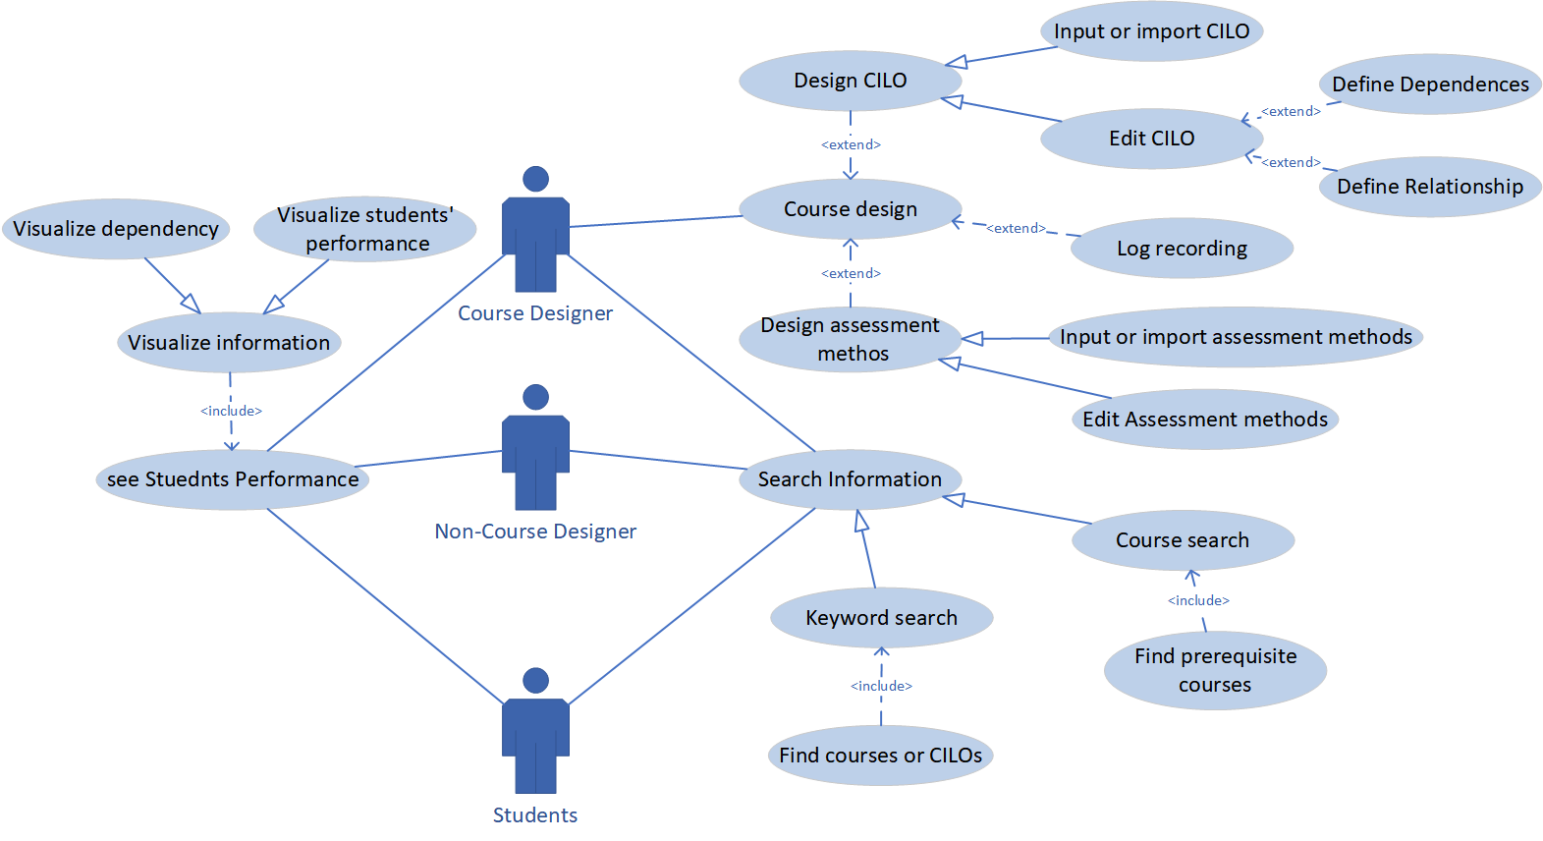**Case diagram:**

## User Classes and Characteristics

**Course designers:**

* See CILO dependences between learning outcomes across a degree.
* Search for course information like description, CILO, prerequisite.
* Input CILOs and dependences of a course.
* Modify CILOs and dependences of a course.
* Define dependences between CILOs.
* Define relations between courses.

**Non-Course Designers:**

* See CILO dependences between learning outcomes across a degree.
* Search for course information like description, CILO, prerequisite.
* See students’ performance.
* See the information of courses.

**Students:**

* See CILO dependences between learning outcomes across a degree.
* Search for course information like description, CILO, prerequisite.
* See their own performances
* See the learning outcome from courses

## Operating Environment

* Support OS: Windows 7 or above
* Support browser: Chrome or IE browser

## Design and Implementation Constraints

* Using Html5 CSS Django and python.
* At least 64mb of RAM
* CPU over 400mhz.

## User Documentation

* There is no need for user manual and online help

## Assumptions and Dependencies

* For creating the webpages forms and setting the core program we are using the bootstrap 3.0 framework. It offers a complete set of interfaces for developing website.
* For better understanding the know-what to do rather than the know-how to do it, we assume that the reader is not interested for knowing how to create and design the website framework and how to code it.

# System Features

## System Feature 1 (change name in future)

3.1.1 Description and Priority

To be continue

3.1.2 Stimulus/Response Sequences

To be continue

3.1.3 Functional Requirements

To be continue

## System Feature 2 (and so on)

To be continue

# External Interface Requirements

## User Interfaces

To be continue

## Hardware Interfaces

* The system can support Chrome browser and IE browser.
* The operating system that we can support is windows 7 or above.
* Part of students’ data and course data are from UIC database. A data interface from UIC database system will be provided to developers.

## Software Interfaces

* The system will connect with our UIC database. There will be an interface that will provide us students’ data and course data that will be used in our system.
* The system will be implemented as a part of UIC official system. From the UIC official system you may visit our system.
* There may be more details about tools, libraries, and integrated commercial components we will replenish latter.

## Communications Interfaces

* Application does not need to support social networking functions
* Other communication standards will be updated….

# Other Nonfunctional Requirements

## Performance Requirements

* **Number of concurrent users:**

1. At least half of the total number of students and faculty on campus.
2. The system supports the user use their own account to log in at the same time on 2 or more devices.

* **Data Accuracy:**

1. When course designer executes the operation of adding, deleting and modifying course information or CILOs, it is not allowed that the operation fails due to the program.
2. When performing course information addition, multiple additions or duplicate additions are not allowed to occur.
3. when performing course information deletion, multiple deletion of the same course is not allowed to occur.
4. When performing CILOs or assessment methods modification, it is also required to maintain the accuracy and the correspondence of students’ performance.

* **Time characteristics**:

1. when administrators perform operations such as adding and deleting, the database response time is required to be within 2 seconds.
2. When web users browse, the page response time is required to be within 4 seconds.
3. Restart time on failure within 2 seconds.
4. Mean time to failure (MTTF) at least three months.

## Safety Requirements

* Using log to record any operations on each course, then use it to prevent the system from damage by some inappropriate actions.

## Security Requirements

* All users can only login the system with their school accounts and passwords.
* Using a security information database to store the login information, which includes the information about whether a staff member is a legal course designer or not.
* Using another “Grade Report System” to store the students’ grade report.
* Students’ grade reports and login information cannot be modified

## Software Quality Attributes

* **Interoperability:** Make the system can easily get the data from “security information system” and “grade report system”
* **Flexibility:** Increasing the capacity by adding more servers to maintain high quality of service.

# Other Requirements

* The imported file format should be .xlsx format
* The learning outcomes should be visualized by tabular or other **statistical diagrams**.

Appendix A: Glossary

|  |  |
| --- | --- |
| **Acronyms and Abbreviations** | **Meaning** |
| MTTF | Mean time to failure |
| CILO | Course Intended Learning Outcomes |

Appendix B: Analysis Models

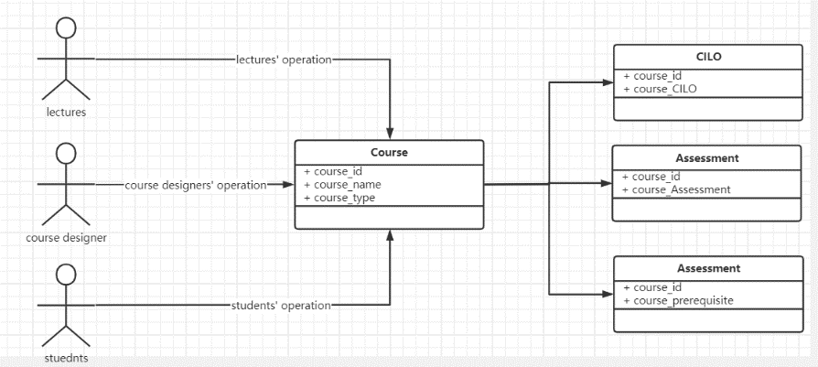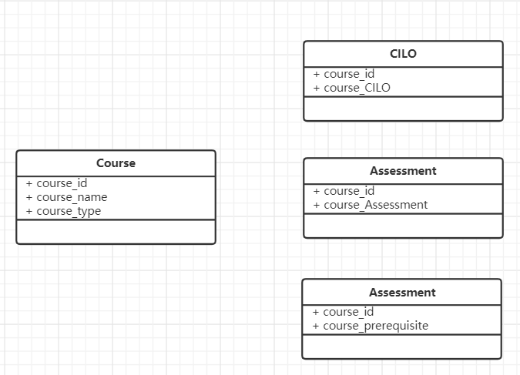**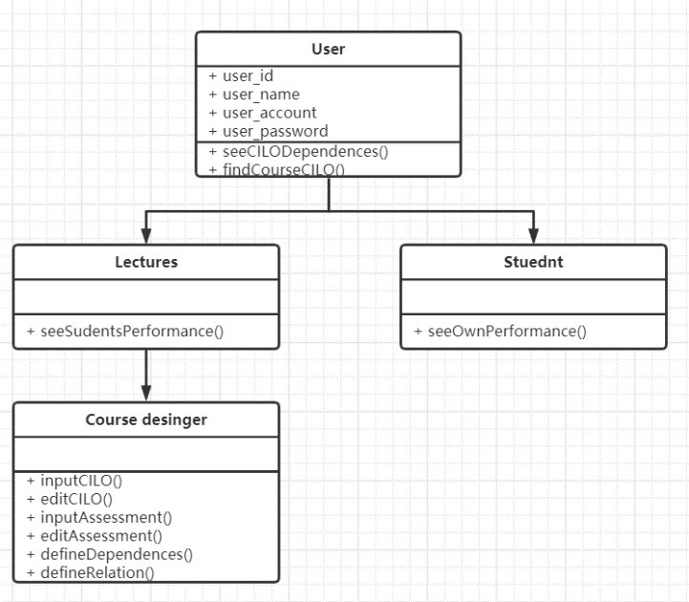Class diagrams:**

Appendix C: Issues List

1. How to make the user login at the same time on 2 or more devices.
2. How to use log to record the course operation. Automatically or manually?
3. To be continue…