Software Requirements Specification

for

DegreeOverview

Version 1.2 approved

Prepared by:

Lei XIA (1830026125)

Yiping GAO (1830026026)

Zhenyu REN (1830026095)

Zhengyang SHEN (1730026092)

Jasmine

2021/3/30

Table of Contents

Table of Contents ii

Revision History ii

1. Introduction 1

1.1 Purpose 1

1.2 Document Conventions 1

1.3 Intended Audience and Reading Suggestions 1

1.4 Project Scope 1

1.5 References 1

2. Overall Description 2

2.1 Product Perspective 2

2.2 Product Features 2

2.3 User Classes and Characteristics 3

2.4 Operating Environment 3

2.5 Design and Implementation Constraints 4

2.6 User Documentation 4

2.7 Assumptions and Dependencies 4

3. System Features 4

3.1 Login 4

3.2 Create a New Course 5

3.3 Edit an Exist Course 6

3.4 Search for Course Info 7

3.5 Visualize Dependency 8

3.6 Display Analysis Result 8

3.7 Show Student Performance 9

4. External Interface Requirements 10

4.1 User Interfaces 10

4.2 Hardware Interfaces 10

4.3 Software Interfaces 10

4.4 Communications Interfaces 10

5. Other Nonfunctional Requirements 10

5.1 Performance Requirements 10

5.2 Safety Requirements 10

5.3 Security Requirements 11

5.4 Software Quality Attributes 11

6. Other Requirements 11

Appendix A: Glossary 11

Appendix B: Analysis Models 11

Appendix C: Issues List 12

Revision History

|  |  |  |  |
| --- | --- | --- | --- |
| **Name** | **Date** | **Reason For Changes** | **Version** |
| Initial version | 2021/3/15 |  | 1.0 |
| Partial version | 2021/3/22 | Update according to feedback and complicate state transformation machine diagram | 1.1 |
| Complete version | 2021/3/30 | Finish State transition diagram and UI (all) | 1.2 |

# Introduction

## Purpose

* The purpose of: Present a detail description of the course definition system (**DegreeOverview)**.
* This specification is about the system **DegreeOverView** V1.0. It describes the whole system
* The intended users of the software: Students, Lecturers, and Software Developers.

## Document Conventions

**The standards of writing this SRS:**

* + **Normal:**

Bold font: Higher priority or significance or a title

The Italic: The part that should be paid special attention to.

**Proper noun：**

* **DegreeOverview**: project name

**Acronyms and abbreviations:**

* SRS (software requirements specification)
* GPA (Grade-Point Average)
* N/A （none）
* I/O （input and output）

## Intended Audience and Reading Suggestions

* All readers: section 1, 2
* Developers: section 2, 3, 4.
* Project manager: section 2, 3

## Project Scope

* **DegreeOverview** is designed:

1. For teachers and students to access pre-course and course information
2. For students to access their skill acquisition.
3. Visualize the information for uses.

## References

* SDWIII Project V3
* To be continue…

# Overall Description

## Product Perspective

This is a new, part-of stand-alone system about the visualization of the dependency between the learning outcomes.

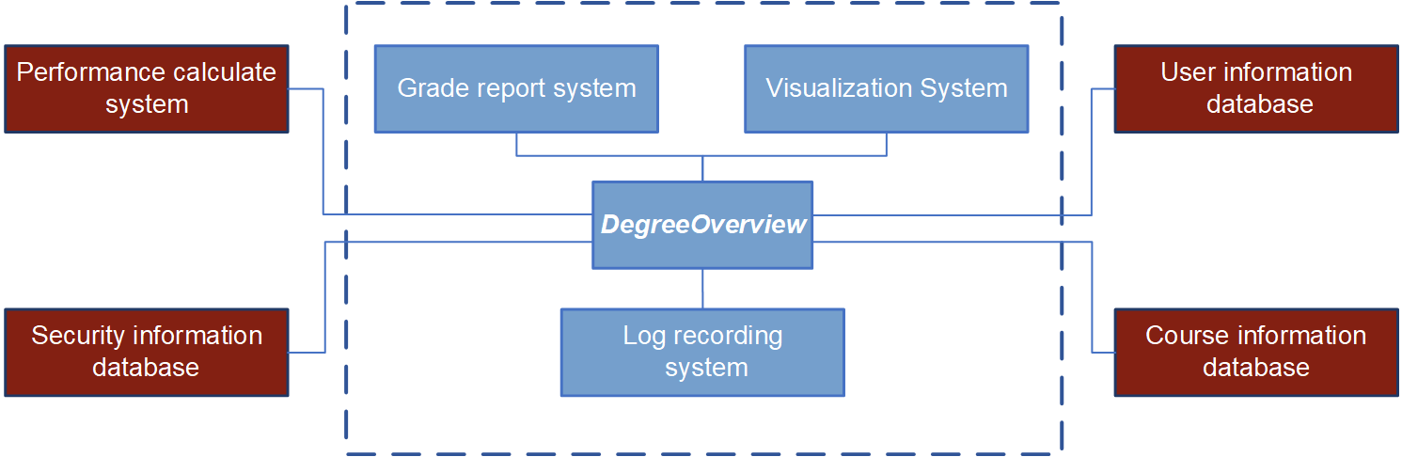**Context Model:**

## Product Features

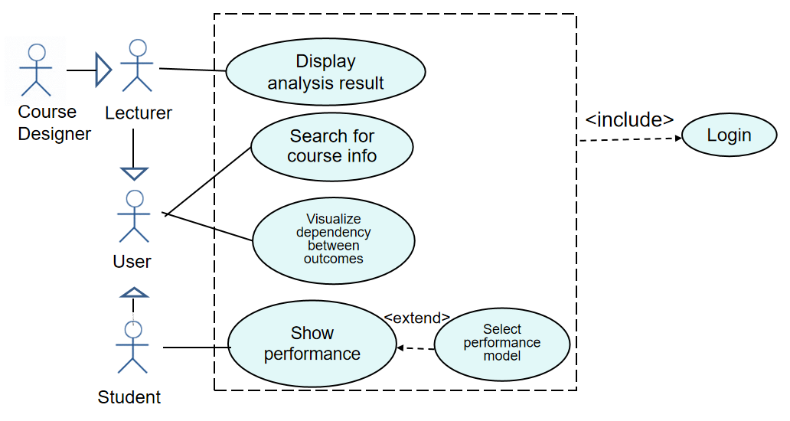**Case diagram:**

## User Classes and Characteristics

**Course designers:**

* Use system each semester and vacation to modify or add course.
* The modification and add course operation need to be as easy as possible to use.

**Non-Course Designers:**

* Use the system almost all the time.
* The visualization should be clear and accurate.

**Students:**

* Use system frequently before choosing the course.
* All the system operations should be easy to implement.

## Operating Environment

* Support OS: Windows 7 or above
* Support browser: Chrome or IE browser

## Design and Implementation Constraints

* Using Html5 CSS Django and python.
* At least 64mb of RAM
* CPU over 400mhz.

## User Documentation

* There is no need for user manual and online help

## Assumptions and Dependencies

* Assumption: Excel tool, Neo4g tool (visualization tool).
* No dependency.

# System Features

## Login

3.1.1 Description and Priority

In this function, lecturer and student login with the same login page, and different users should select the type of user they want to log in. Users log in to their account after the account and password verification, and after login verification, system will skip to different main page base on user’s identity. The priority of this system feature is high, which is 9.

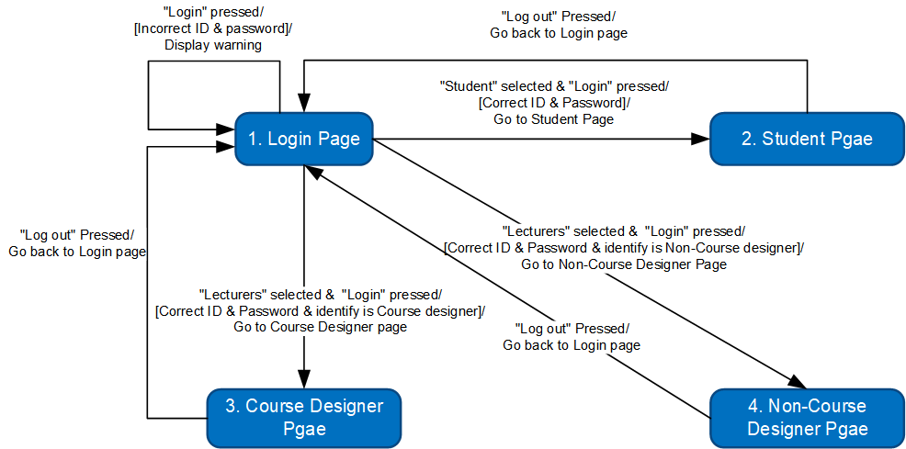3.1.2 Stimulus/Response Sequences

3.1.3 Functional Requirements

* + - REQ-1: The database shall distinguish the types of user from the user’s name.
    - REQ-2: Account and password format need to follow the rules (including upper case\lower case\number).

## Create a New Course

3.2.1 Description and Priority

Only the Course designer can edit or import the assessments methods and CILOs and can also create the course. Non-course designer can only view the information in course page. The import file should be excel file which has the special data format, and create a course should has its dependency. The priority of this system feature is high, which is 8.

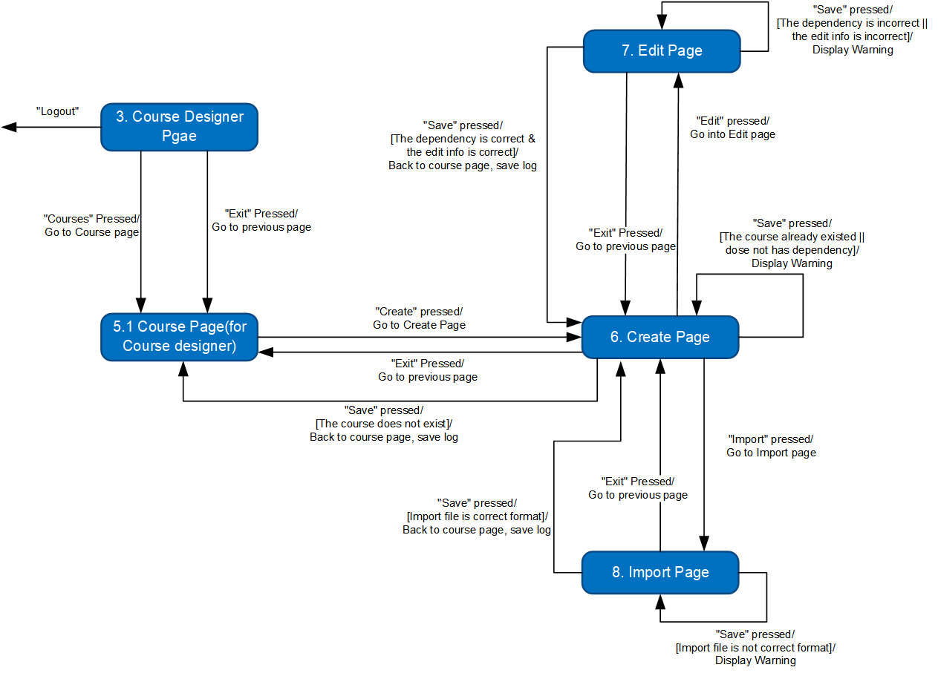3.2.2 Stimulus/Response Sequences

* + Basic scenario for create a new course -> import file for CILO -> save.
    - Course designers click “Create” button in course page.
    - System enters the course creation page.
    - Course designers enter the information name and dependencies in the course creation page. Click save to return the course page and finish the creation.
    - System goes back to the course page.
    - Course designers click “import” to import file for CILOs of the course.
    - System enters the CILOs import page.
    - Course designer click save to return the course page and finish the import.
    - System goes back to the course page.
  + Alternative scenario – wrong data type
    - Course designers click “Create” button in course page.
    - System enters the course creation page.
    - Course designers enter the information name and dependencies in the course creation page. Click save to return the course page and finish the creation.
    - System pops a warning of “Wrong data type entered!” and stay in the course creation page.
  + Alternative scenario – wrong file type
    - Course designers click “Create” button in course page.
    - System enters the course creation page.
    - Course designers enter the information name and dependencies in the course creation page. Click save to return the course page and finish the creation.
    - System goes back to the course page.
    - Course designers click “import” to import file for CILOs of the course.
    - System enters the import page.
    - Course designer click save to return the course page and finish the import.
    - System pops a warning of “Wrong file type entered!” and stay in the CILOs import page.

3.2.3 Functional Requirements

* + - REQ-1: For CILOs and assessments edition, the input data and description should be same type as the original ones.
    - REQ-2: For CILOs and assessments import, the import file type should be .xls, .xlsx and other file types that can load data into our system.
    - REQ-3: If a course does not have CILOs or assessment methods, user cannot edit them.
    - REQ-4: If the CILOs and assessment methods have already hit the up bound, user cannot import new CILOs and assessments.

## Edit an Exist Course

3.3.1 Description and Priority

Only Course Designer could edit the Course by clicking each button at Course Info Page and Non-Course Designer could not edit that. Course Designer could change the Course name, Course code, Course type, CILO and assessment. Course Designer could back to the Course Info page by clicking “Exit” button.

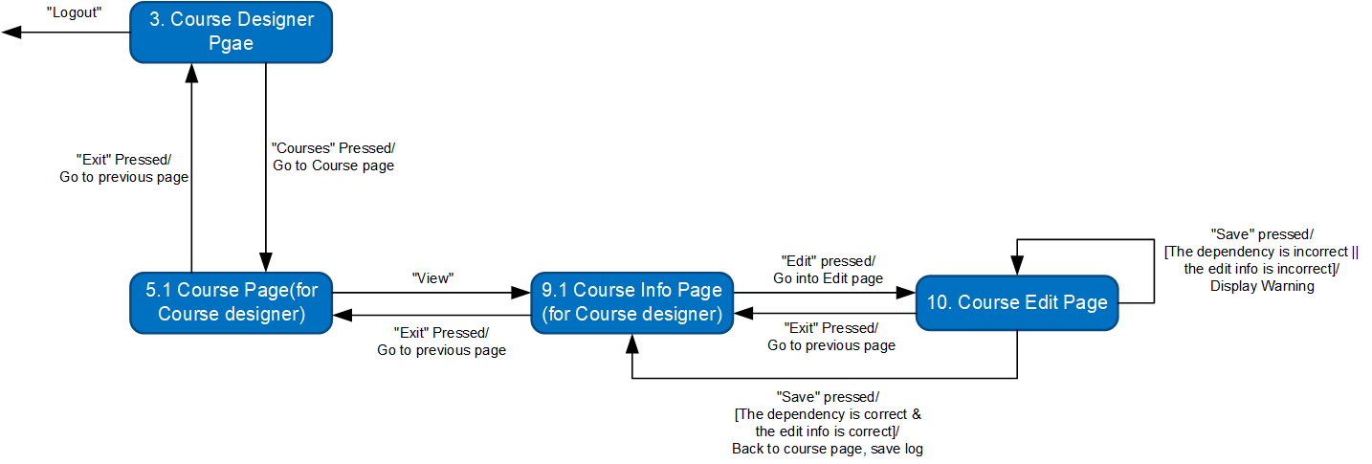3.3.2 Stimulus/Response Sequences

3.3.3 Functional Requirements

* + - REQ-1: If the dependence is incorrect, when click “Save” button, will pop-up the warning window. Otherwise back to the Course information page.
    - REQ-2: If click “save” button without modifying information in course page, the course information will remine the same as before.
    - REQ-3: There are specific data types for course code and course type.
    - REQ-4: If click “save” button with none value in course code or course name, there will be a warning.

## Search for Course Info

3.4.1 Description and Priority

All the users (Students, Non-Course Designer, Course Designer) could search the course information by inputting the Course name or keyworks and click the Search button. If the key for search is valid, go to the search page otherwise pop-out “No result”. All the users could go back to their home page by clicking “Exit” button.

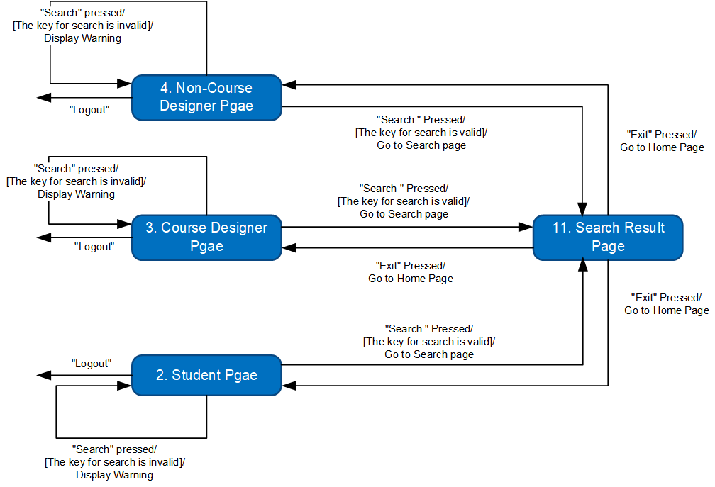3.4.2 Stimulus/Response Sequences

3.4.3 Functional Requirements

* + - REQ-1: The key must be only Course name or Keyword about course CILOs.
    - REQ-2: There must be no more than 3 words in the search bar.
    - REQ-3: Search result are displayed by a table and each page are no more than ten items.

## Visualize Dependency

3.5.1 Description and Priority

All the users (Course Designer, Non-Course Designer and Student) could check the visualization of the dependence by clicking the “Visualize” button at the course page. And back to their page by clicking “Exit” page.

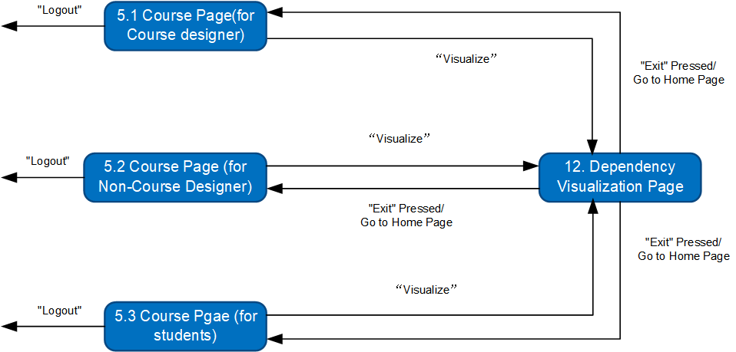3.5.2 Stimulus/Response Sequences

3.5.3 Functional Requirements

* + - REQ-1: The database shall distinguish the types of user from the user’s name.
    - REQ-2: All the course CILOSs dependency are displayed in graph.

## Display Analysis Result

3.6.1 Description and Priority

Only the Course Designer and Non-Course Designer could check the analysis result by clicking “Result” button at Course Info page. And they could back to Course Info page by clicking “Exit” button.

3.6.2 Stimulus/Response Sequences

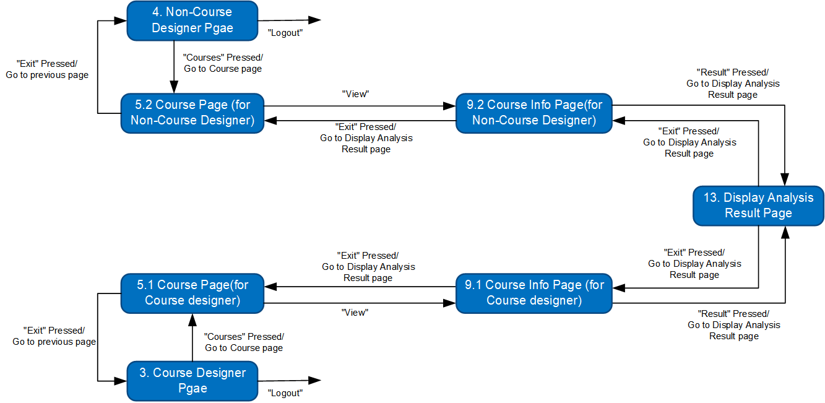

3.6.3 Functional Requirements

* + - REQ-1 The result is displayed in a table and there are at most ten items in each page.

## Show Student Performance

3.7.1 Description and Priority

The system will display the course performance for student at the Course Page. The student could check different display in different model by change “model-x”.

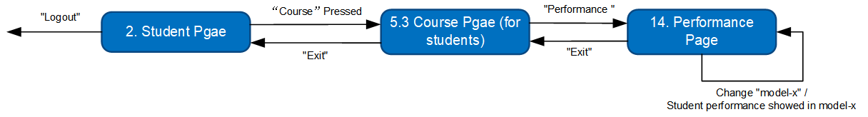3.7.2 Stimulus/Response Sequences

3.7.3 Functional Requirements

* + - REQ-1: Model-x contains table model, graph model and so on.
    - REQ-2: For the table, there are at most ten items in each page.

# External Interface Requirements

## User Interfaces

Refer to Jasmine_UI1.2_20210330.docx

## Hardware Interfaces

N/A

## Software Interfaces

* Database interface: To connect with campus database, provide students’ data and course data.
* Visualization tool interface: To visualize the student performance in each course on system.
* Security system interface: To prevent the system from external attack.
* Operating system: Windows 7 or above

## Communications Interfaces

* Communication standard: HTTP
* To be continue.

# Other Nonfunctional Requirements

## Performance Requirements

* **Number of concurrent users:**

1. At least half of the total number of students and faculty on campus.
2. Support the user use their own account to log in at the same time on 2 or more devices.

* **Data Accuracy:**

1. It is not allowed that the data incorrect due to the program.

* **Time characteristics**:

1. The database response time is required to be within 2 seconds.
2. The system page response time is required to be within 4 seconds.
3. Restart time on failure within 2 seconds.
4. Mean time to failure (MTTF) at least three months.

## Safety Requirements

* Reduce the probability of data breaches.
* Reducing code vulnerabilities.
* Improve the system to reduce the adverse consequences caused by user misuse.

## Security Requirements

* All users can only login the system with their school accounts and passwords.
* Using a security information database to store the login information to avoid external attack.
* Using another “Grade Report System” to store the students’ grade report.
* Students’ grade reports and login information cannot be modified.

## Software Quality Attributes

* **Interoperability:** Make the system can easily get the data from “security information system” and “grade report system”
* **Flexibility:** Increasing the capacity by adding more servers to maintain high quality of service.

# Other Requirements

* The imported file format should be .xlsx format
* The learning outcomes should be visualized by tabular or other **statistical diagrams**.

Appendix A: Glossary

|  |  |
| --- | --- |
| **Acronyms and Abbreviations** | **Meaning** |
| MTTF | Mean time to failure |
| CILO | Course Intended Learning Outcomes |

Appendix B: Analysis Models

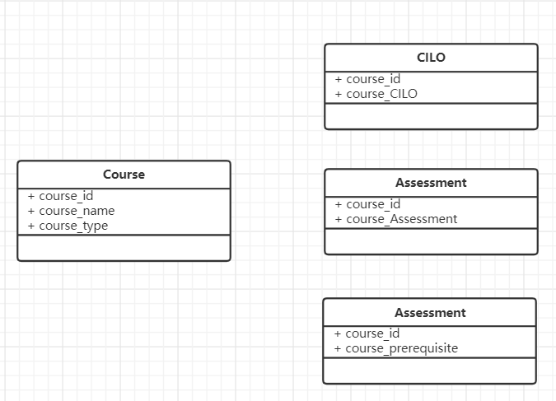**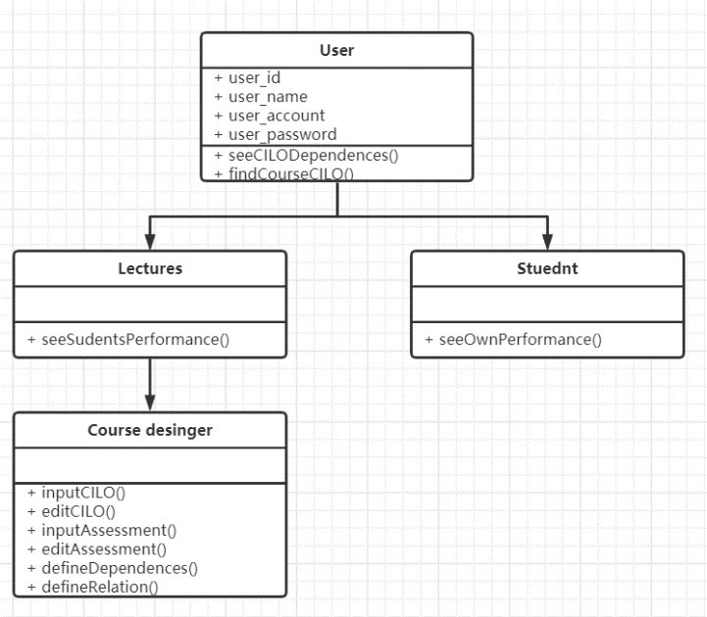Class diagrams:**

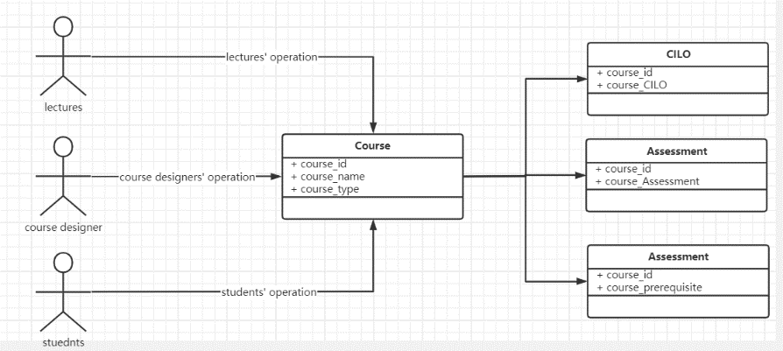

Appendix C: Issues List

1. How to make the user login at the same time on 2 or more devices.
2. How to use log to record the course operation. Automatically or manually?
3. To be continue…