State Transition Model

& User Interface

for

DegreeOverview

Version 1.2 approved

Prepared by:

Lei XIA (1830026125)

Yiping GAO (1830026026)

Zhenyu REN (1830026095)

Zhengyang SHEN (1730026092)

Jasmine

2021/3/30

Figure 1 Login page

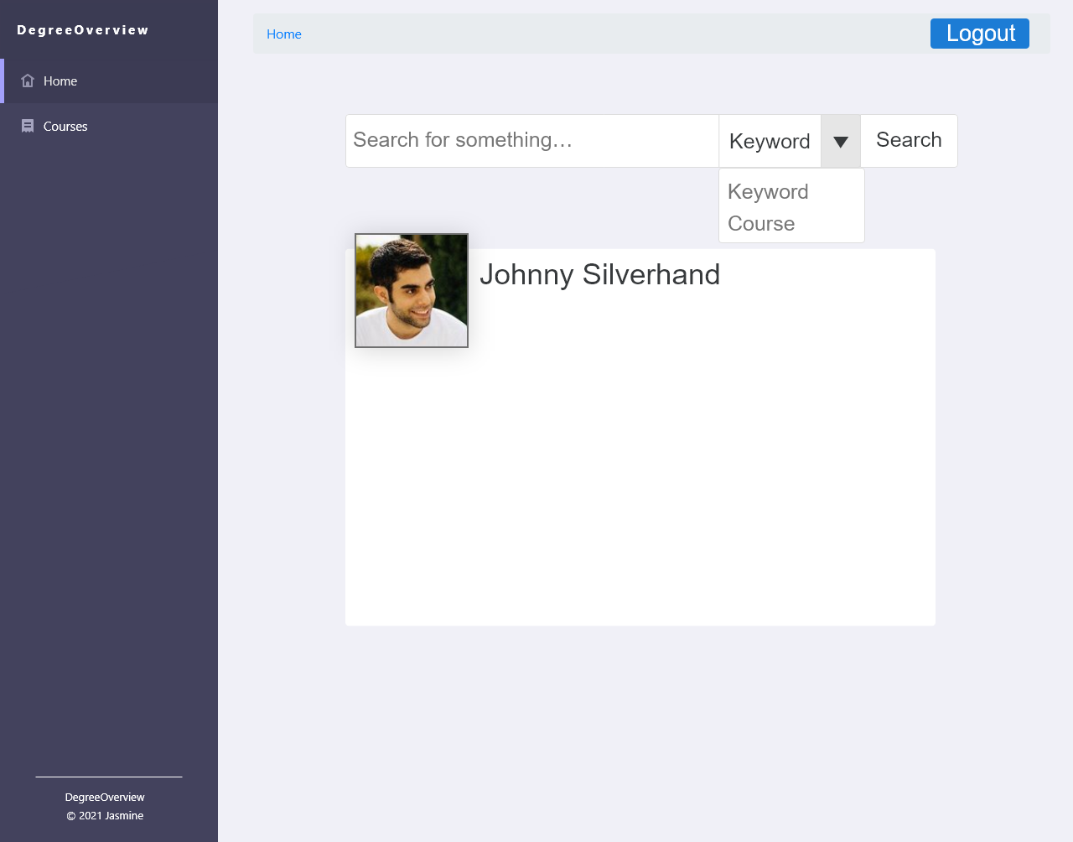

Figure 2 3 4 Student/Course Designer/ Non-course Designer Homepage

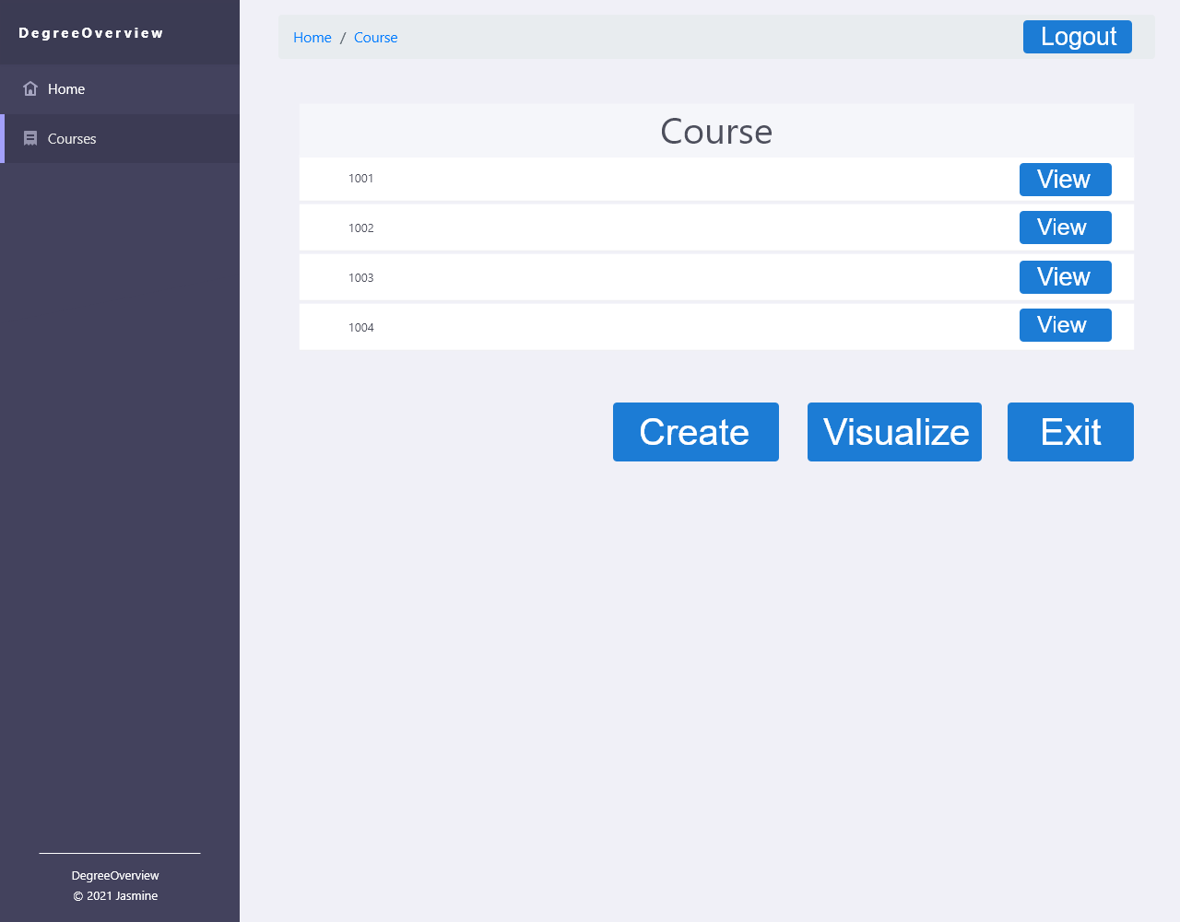

Figure 5.1 Course page (for Course designer)

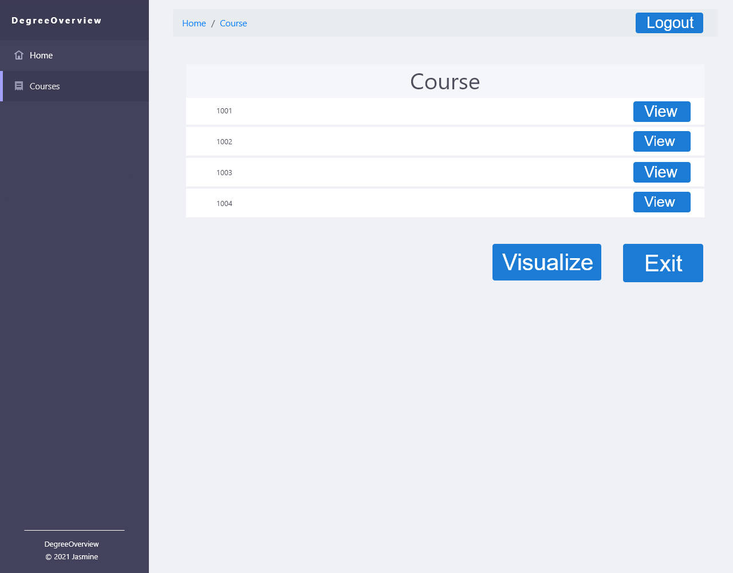

Figure 5.2 Course Page (for Non-Course Designer)

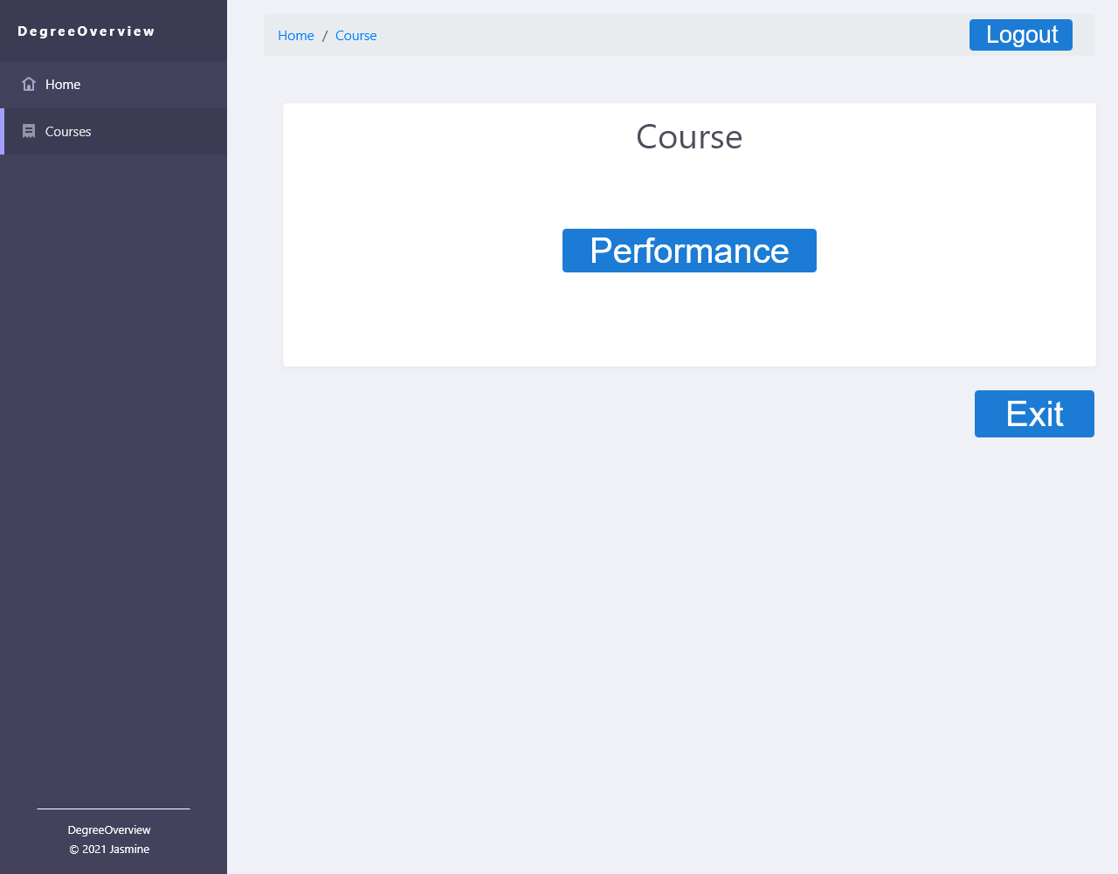

Figure 5.3 Course Page (for Students)

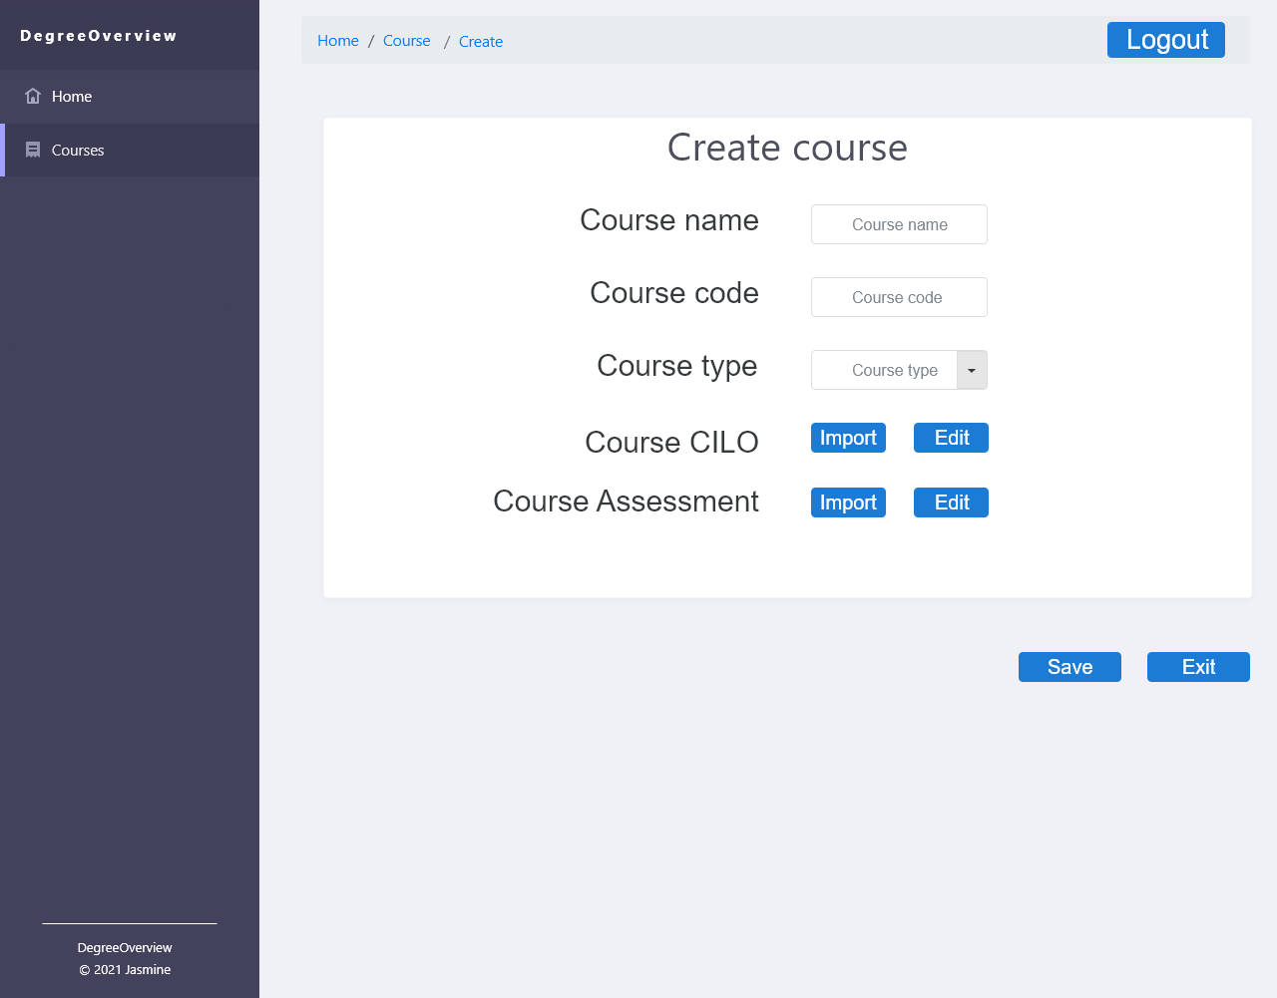

Figure 6 Create Page

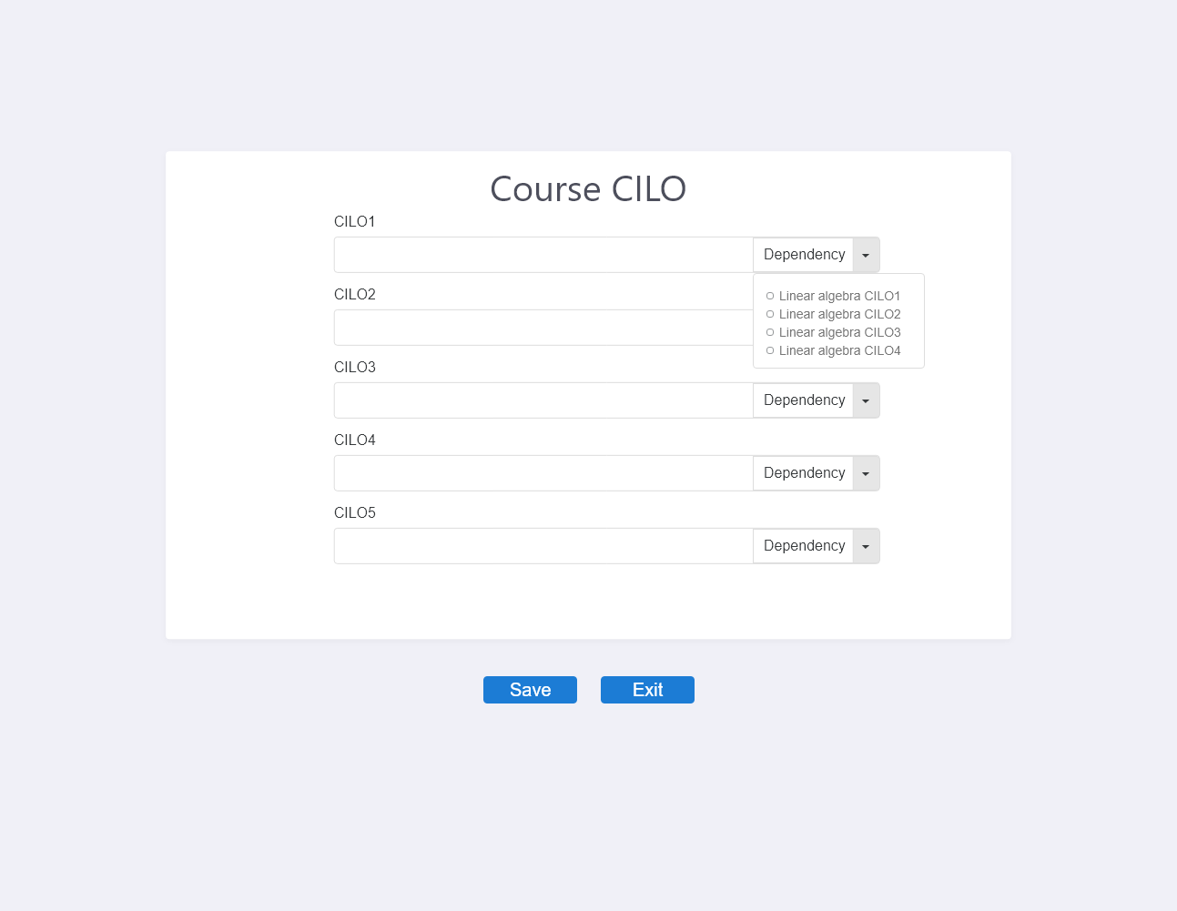

Figure 7 Edit Page (CILOs)

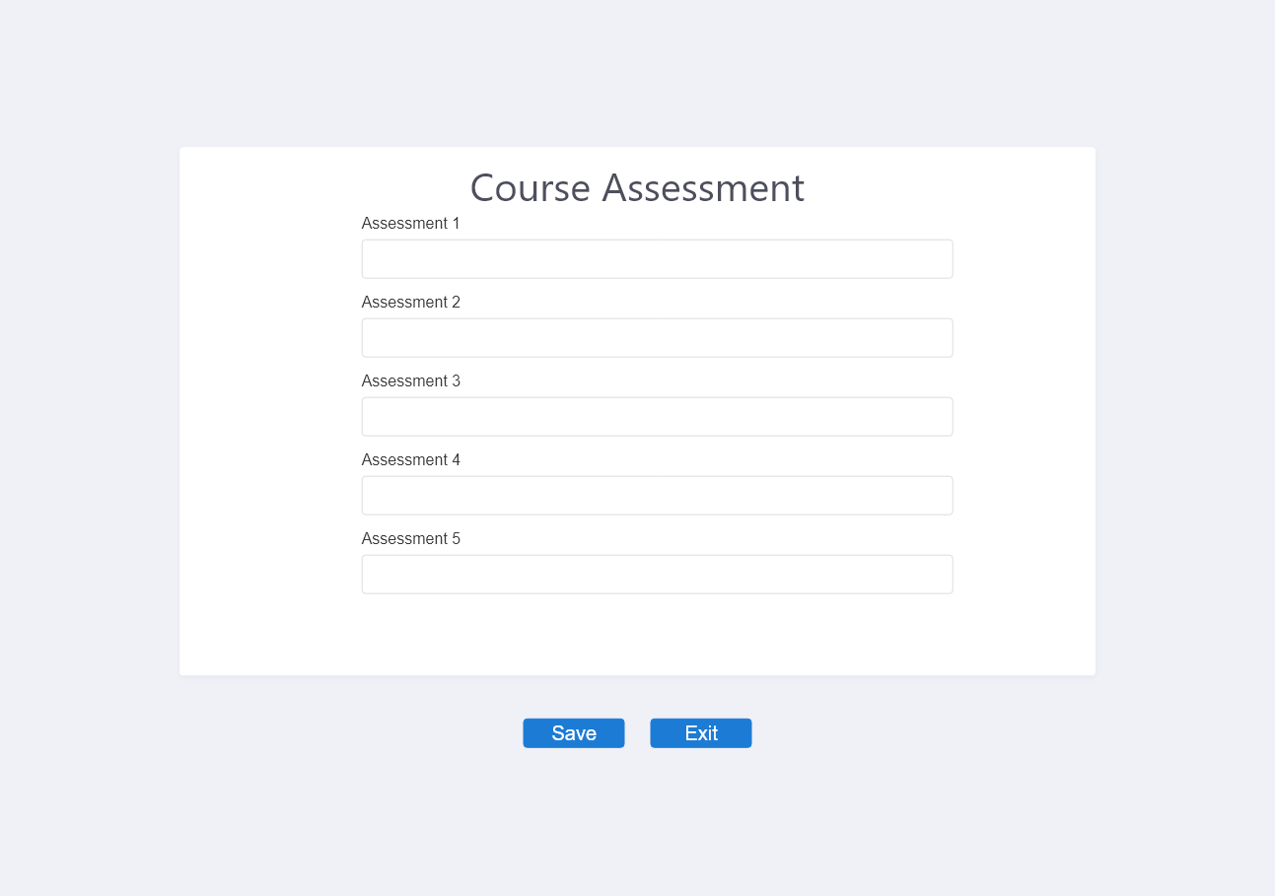

Figure 7 Edit Page (Assessment)

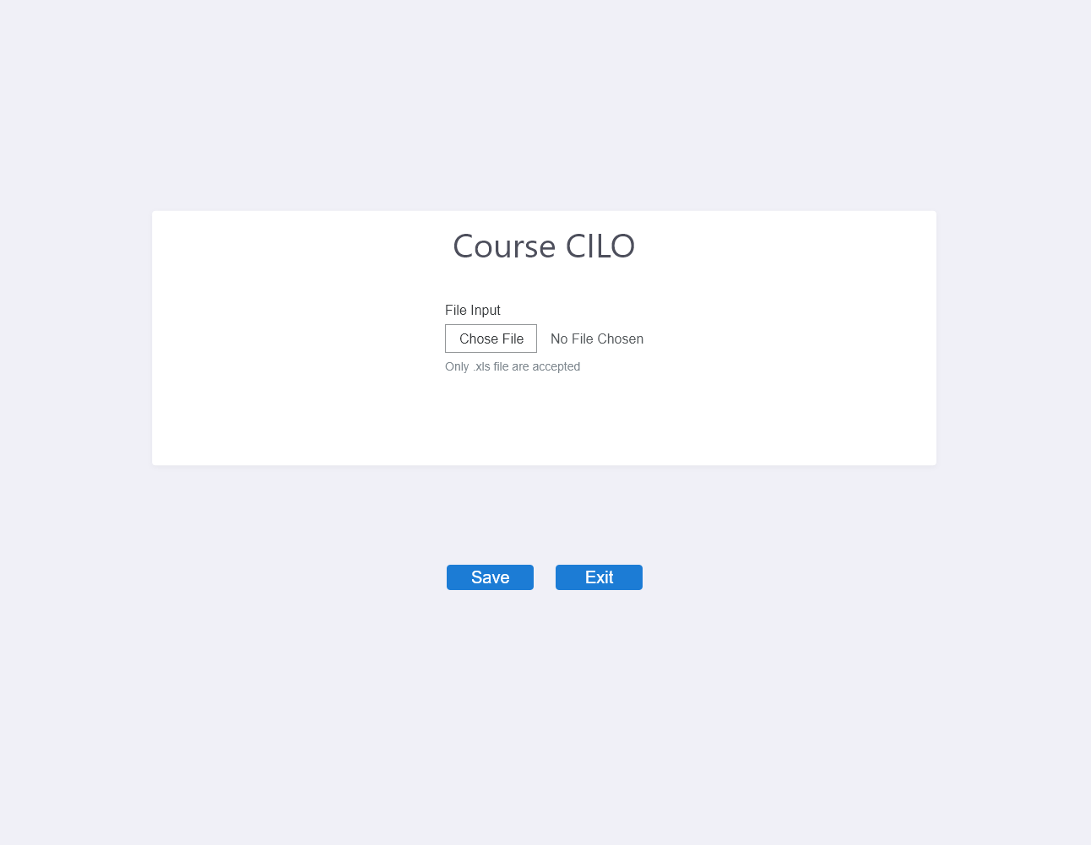

Figure 8 Import Page (CILO)

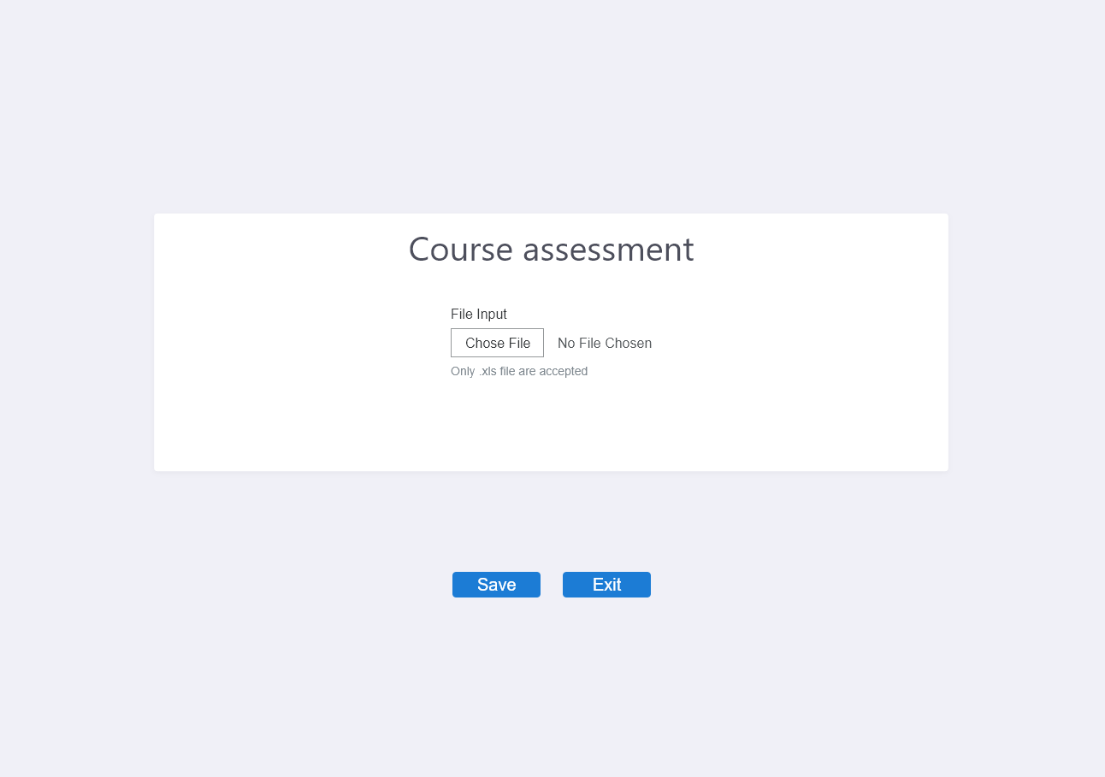

Figure 8 Import Page (Assessment)

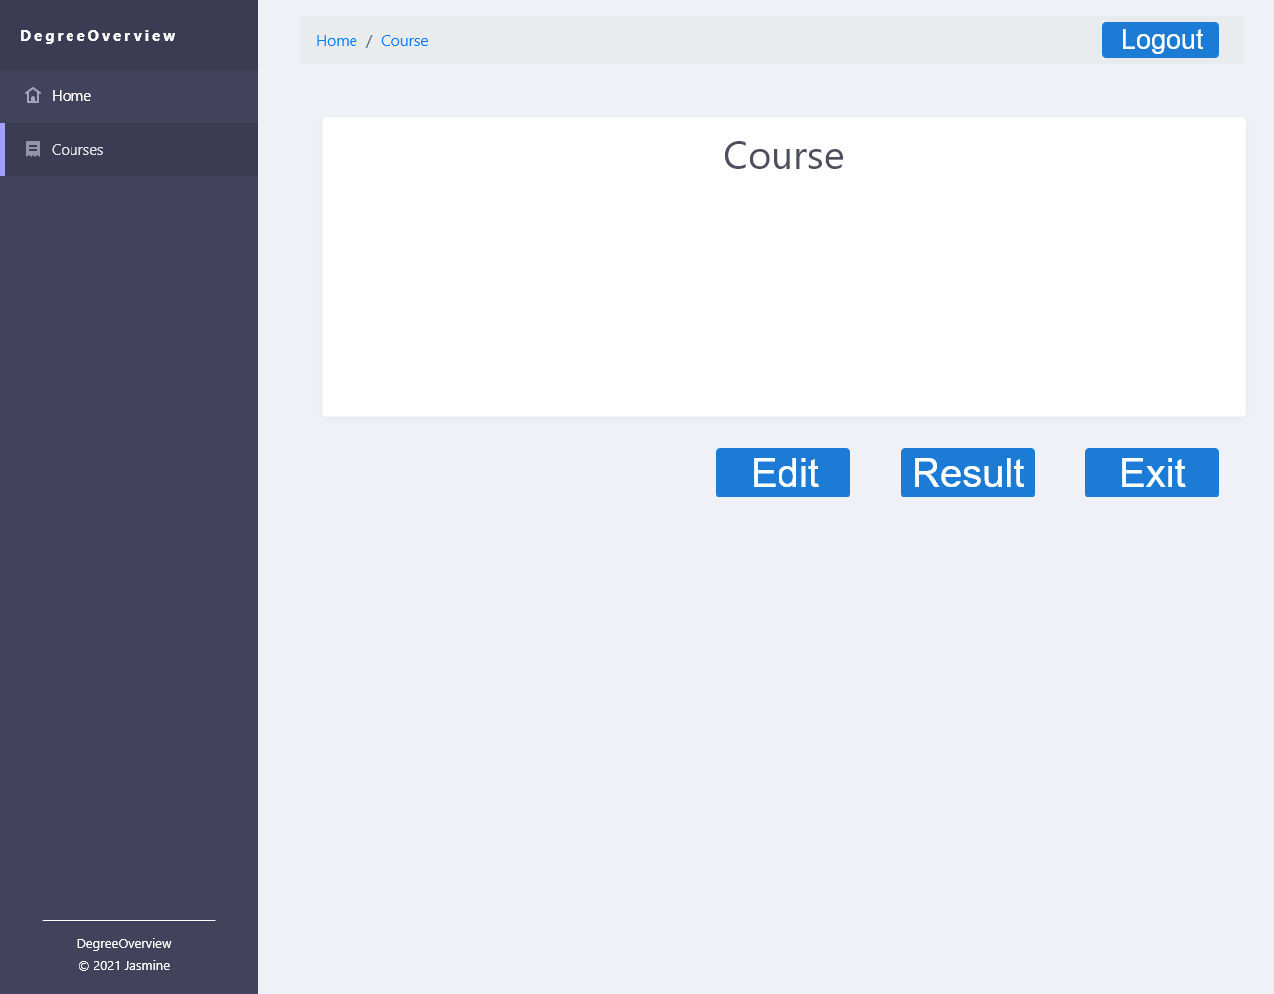

Figure 9.1 Course Info Page (for Course designer)

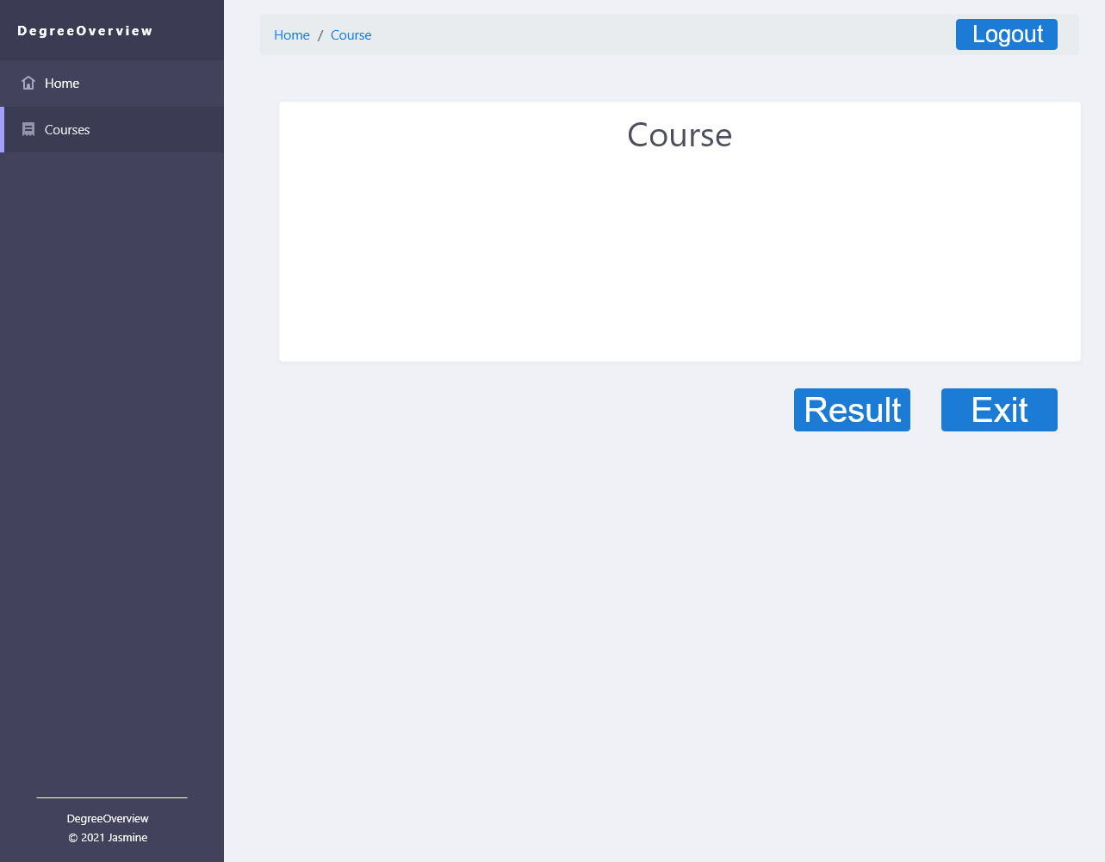

Figure 9.2 Course Info Page (for Non-Course Designer)

Figure 10 Course Edit Page

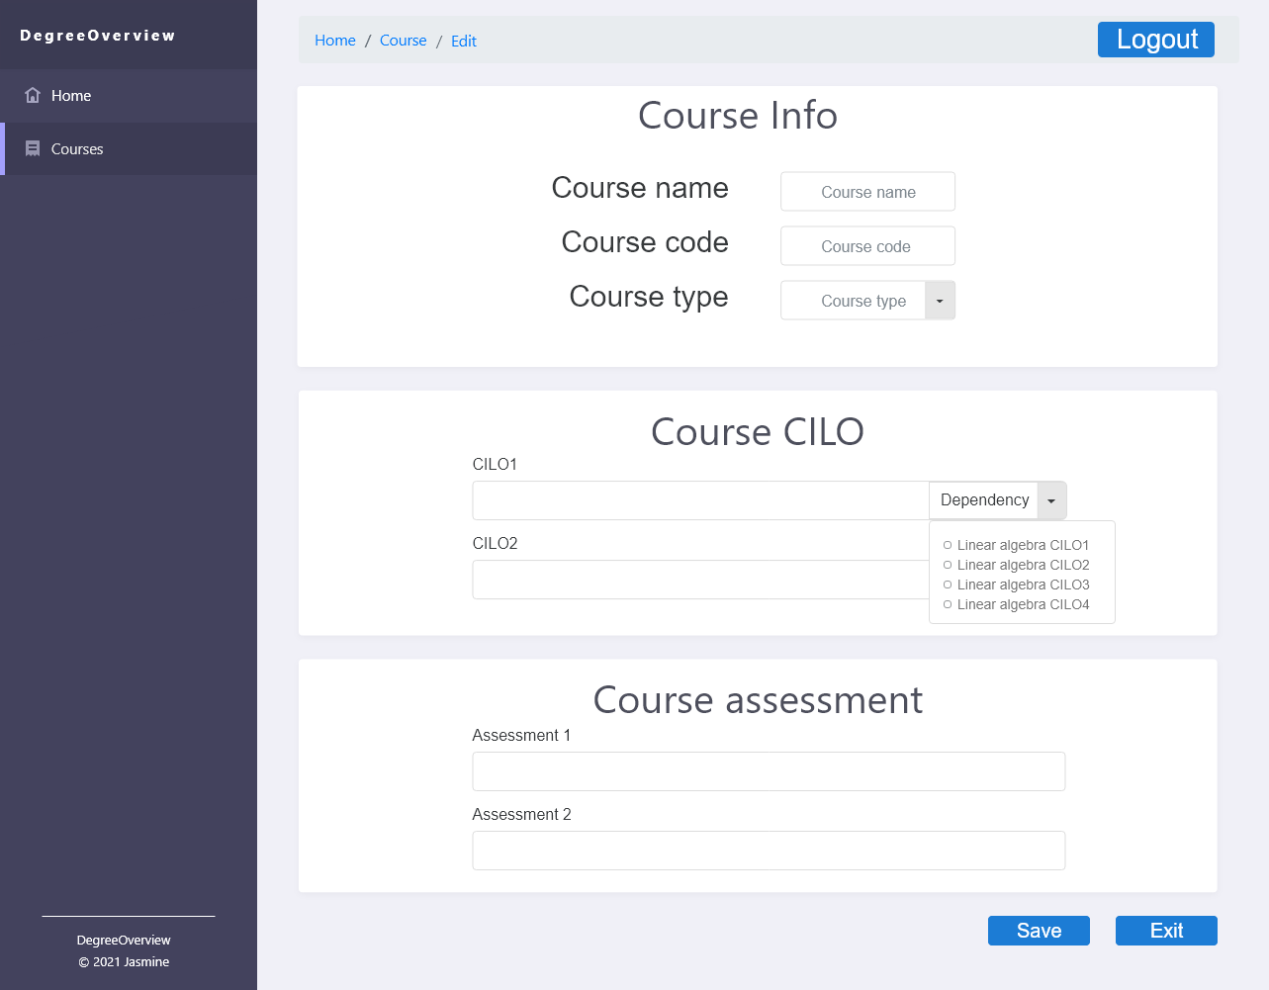

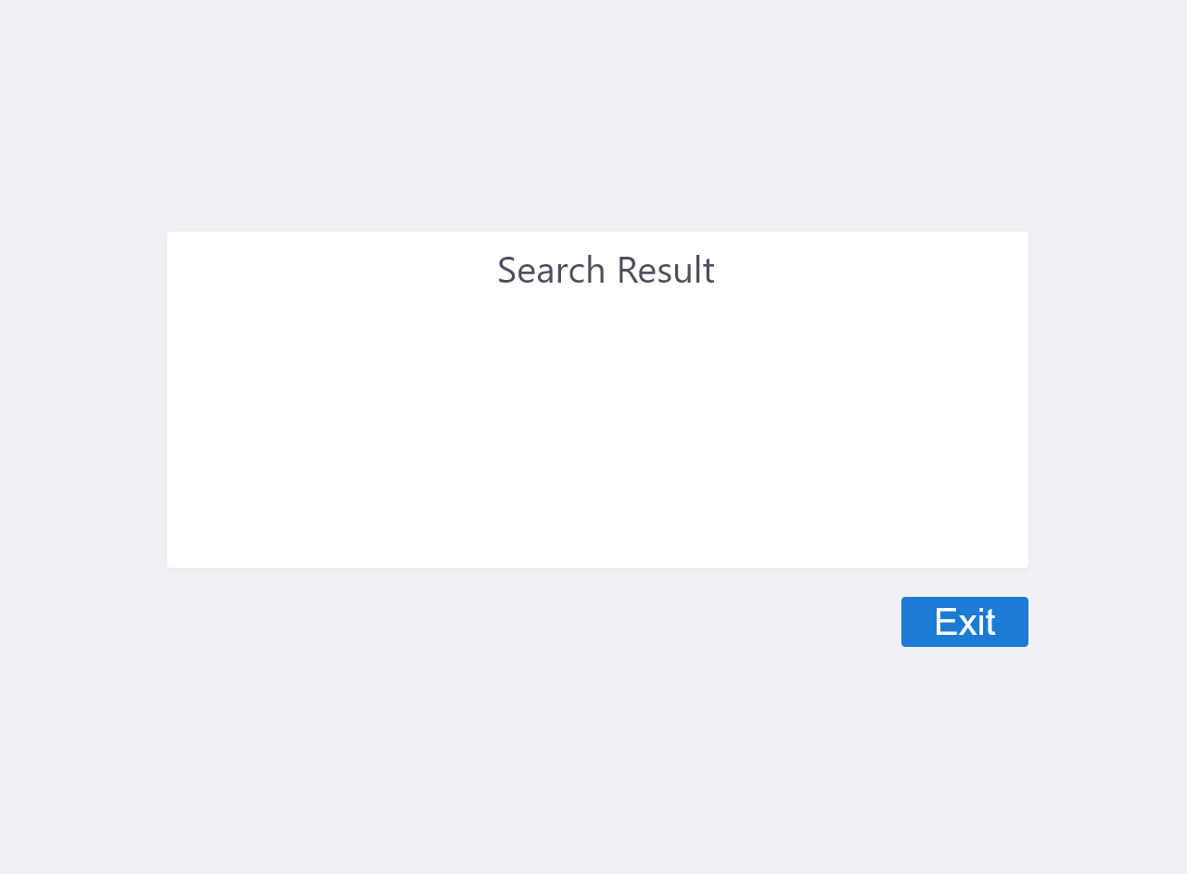

Figure 11 Search Result Page

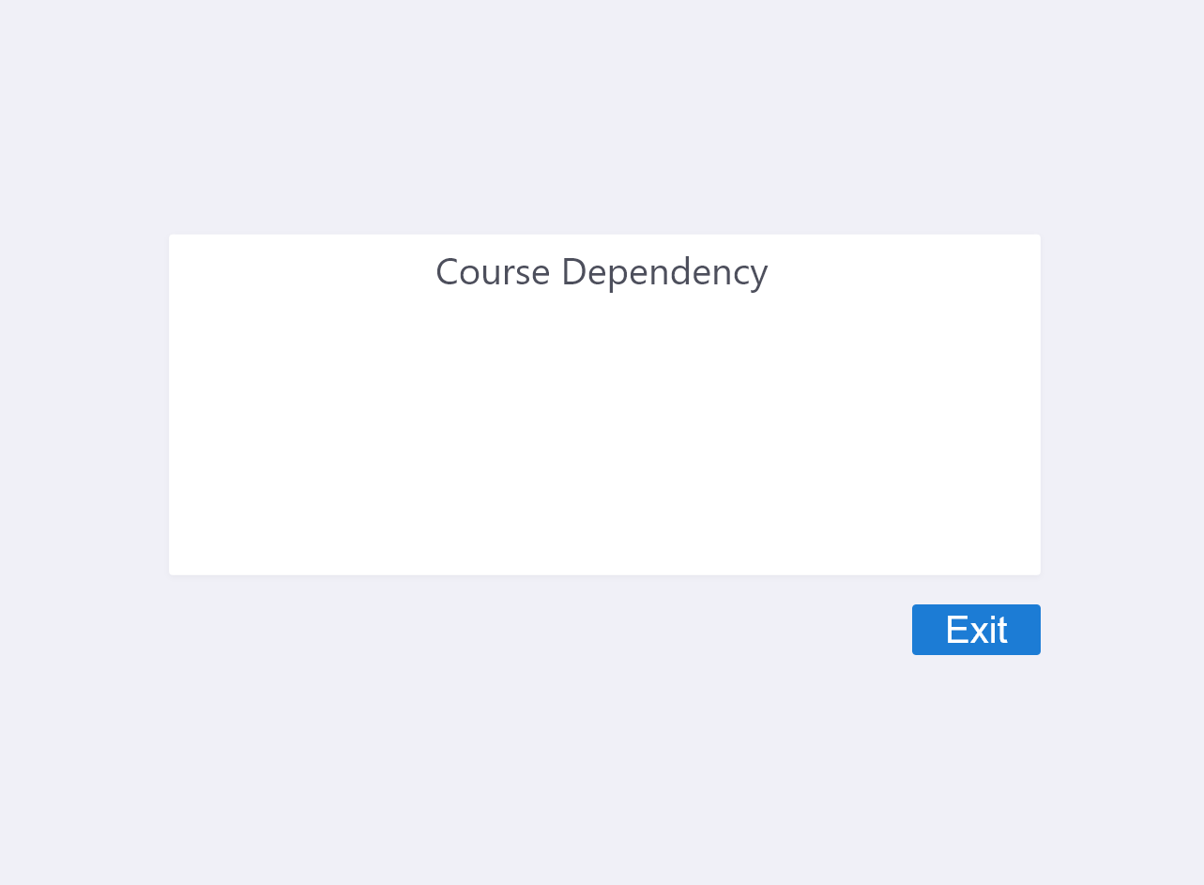

Figure 12 Dependency Visualization Page

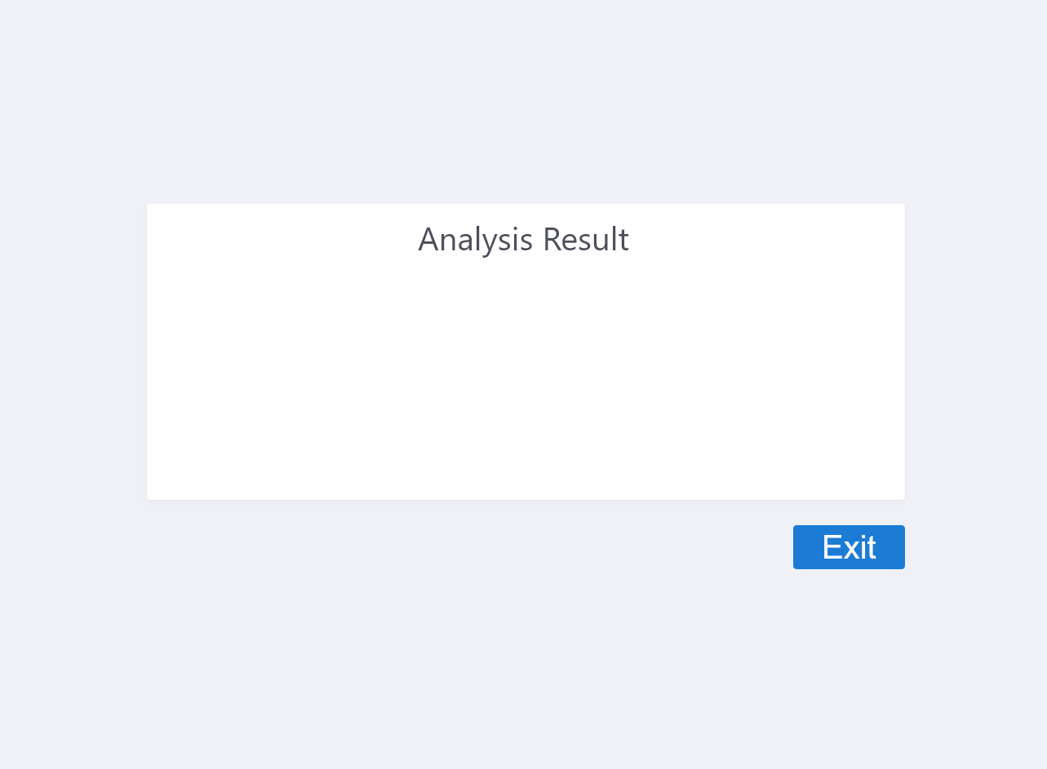

Figure 13 Display Analysis Result Page

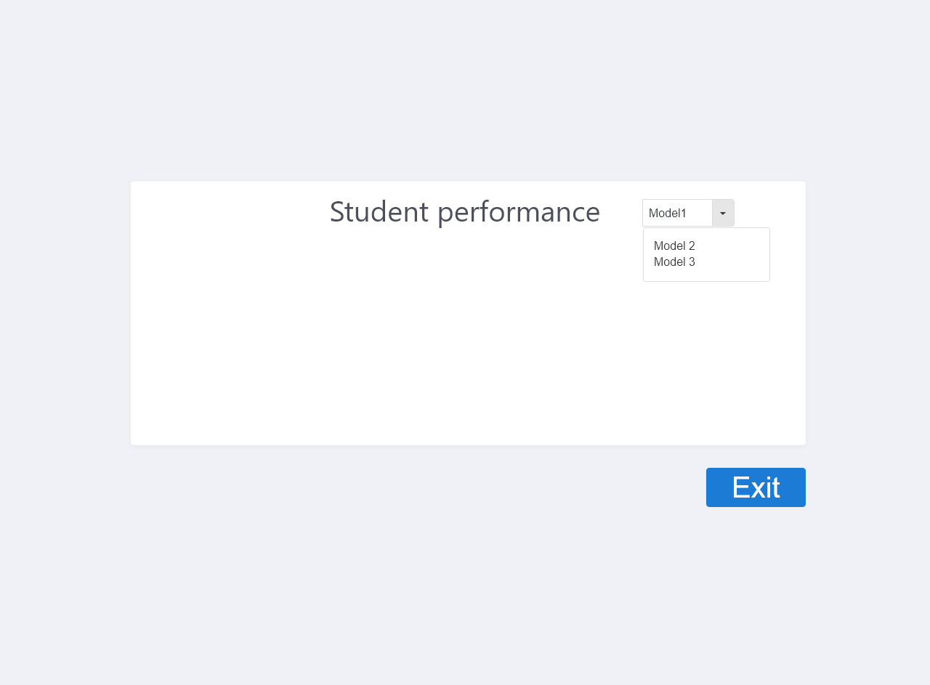

Figure 14 Performance Page