State Transition Model

& User Interface

for

DegreeOverview

Version 1.3 approved

Prepared by:

Lei XIA (1830026125)

Yiping GAO (1830026026)

Zhenyu REN (1830026095)

Zhengyang SHEN (1730026092)

Jasmine

2021/4/14

Figure 1 Login page

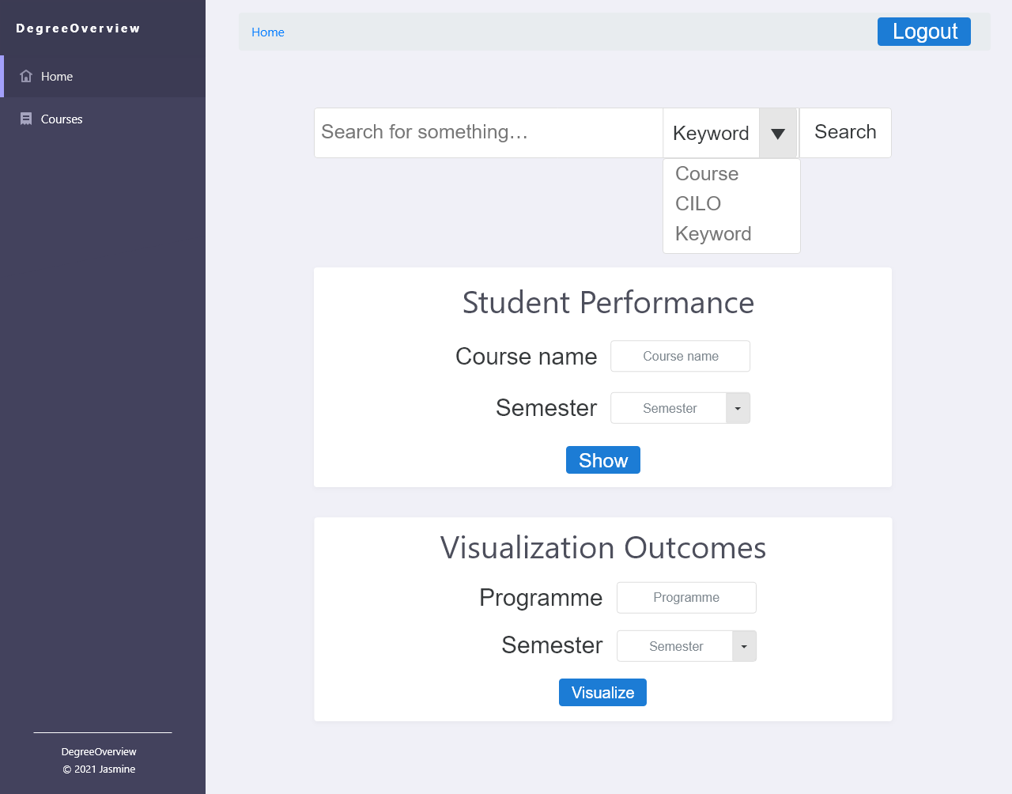

Figure 2 Student Homepage

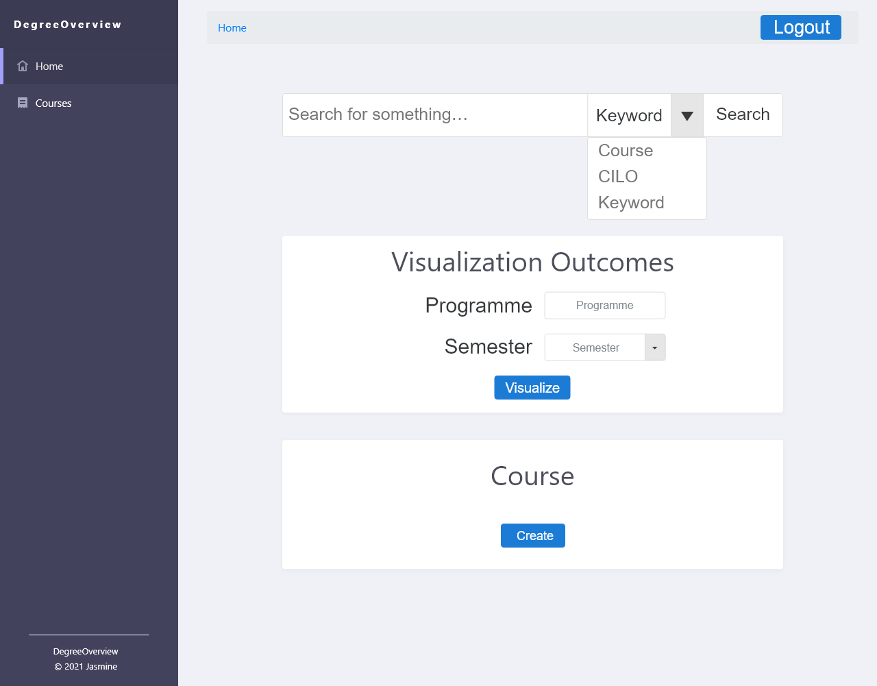

Figure 3 Course Designer Homepage

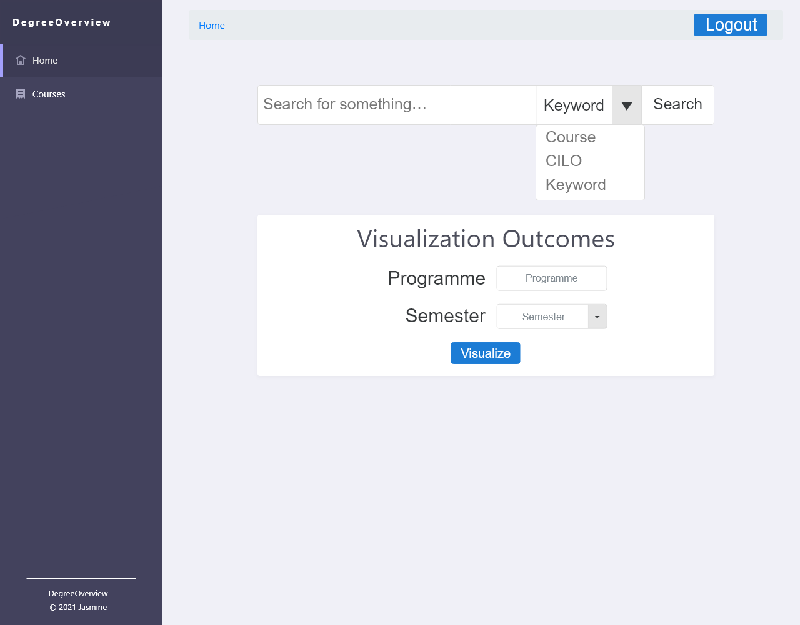

Figure 4 Non-course Designer Homepage

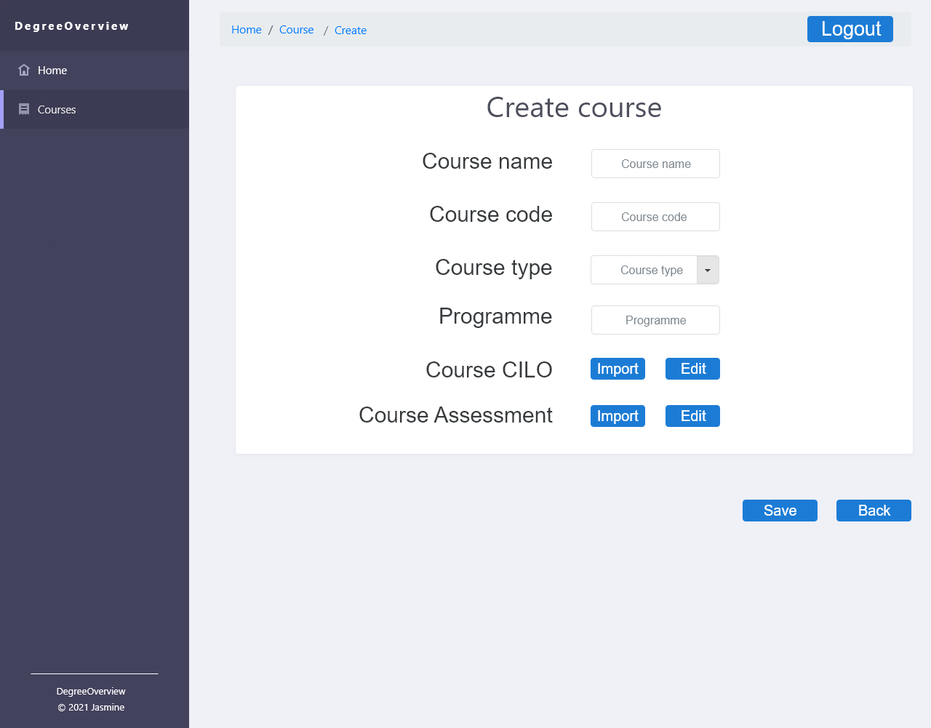

Figure 5 Create Page

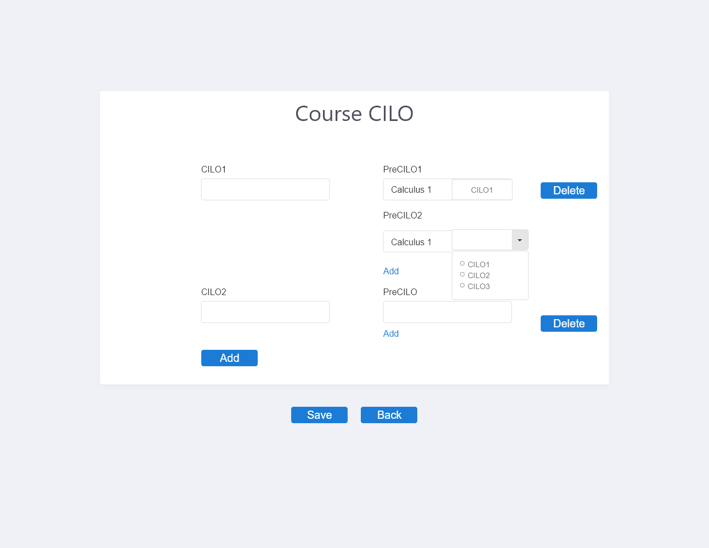

Figure 6 Edit Page (CILOs)

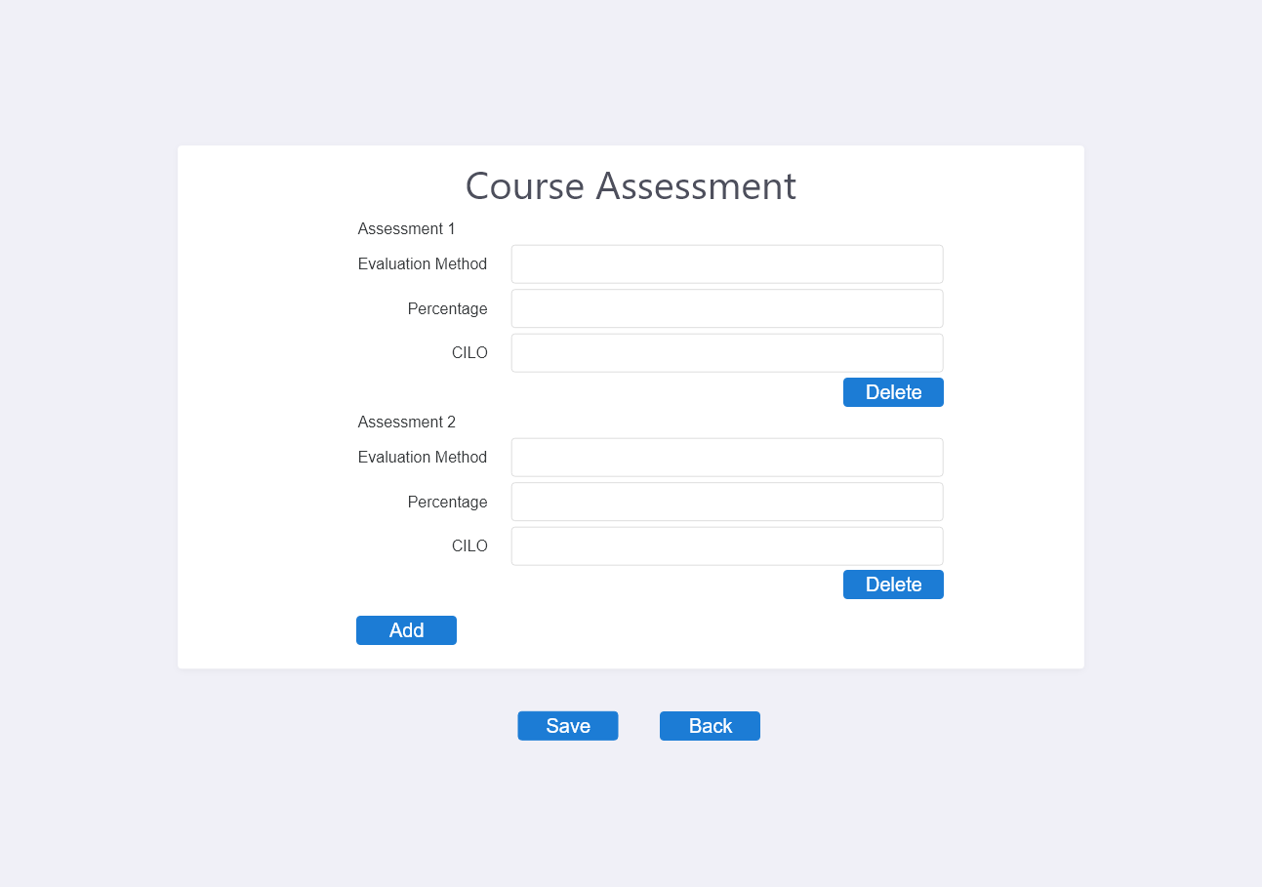

Figure 7 Edit Page (Assessment)

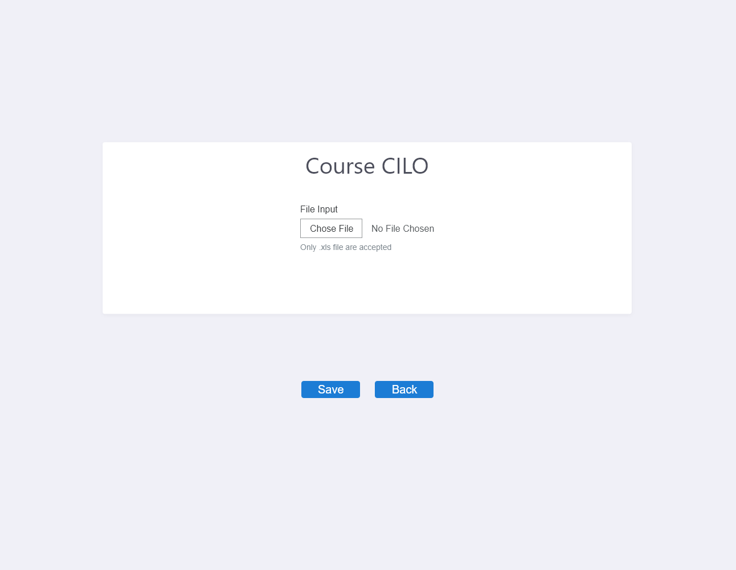

Figure 8 Import Page (CILO)

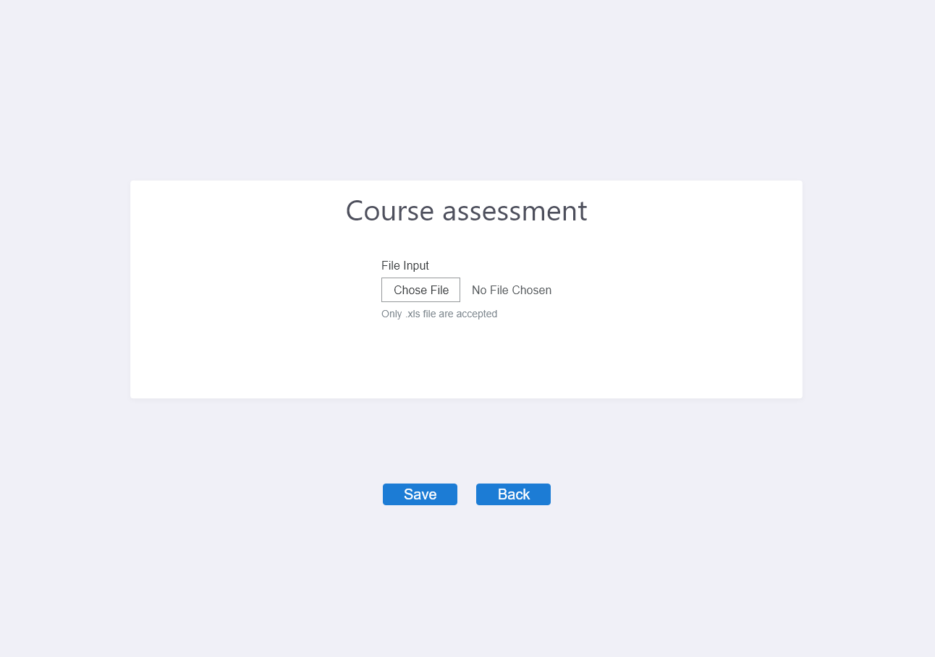

Figure 8 Import Page (Assessment)



Figure 9.1 Course Info Page (for Course designer)



Figure 9.2 Course Info Page (for Non-Course Designer)

Figure 10 Course Edit Page

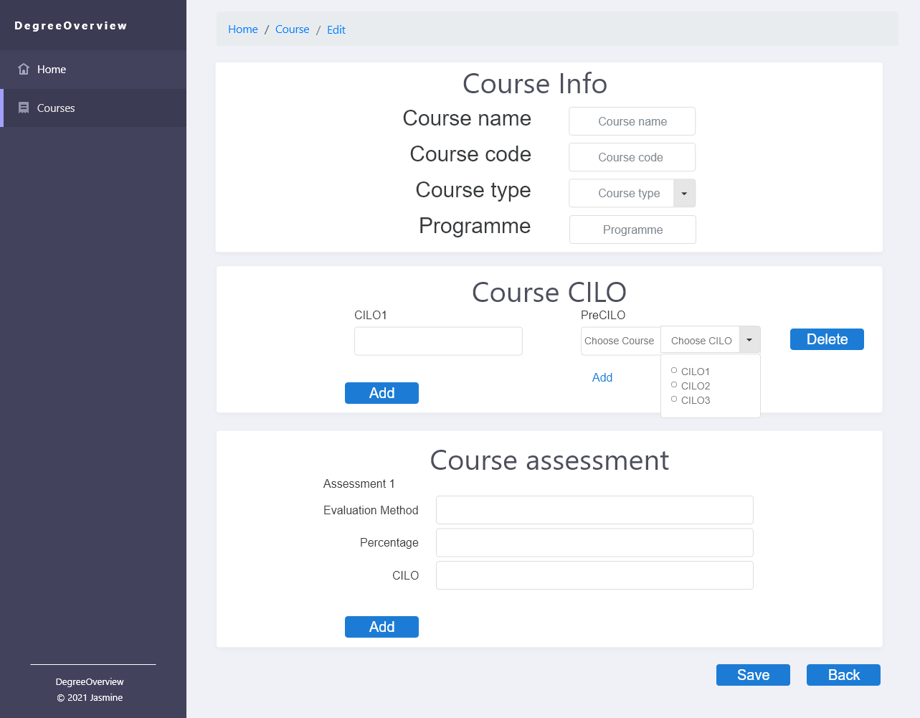

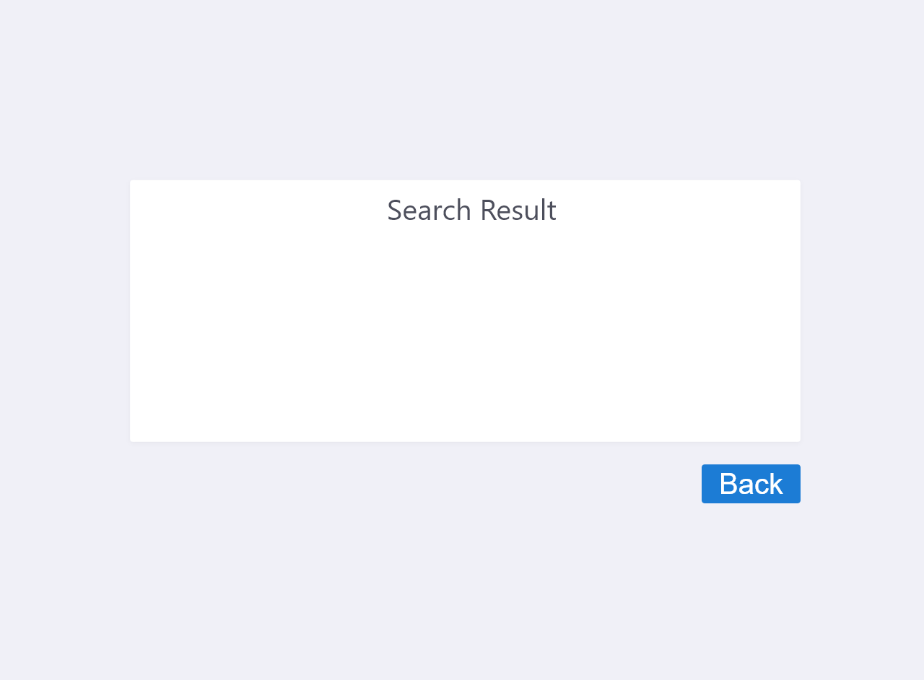

Figure 11 Search Result Page

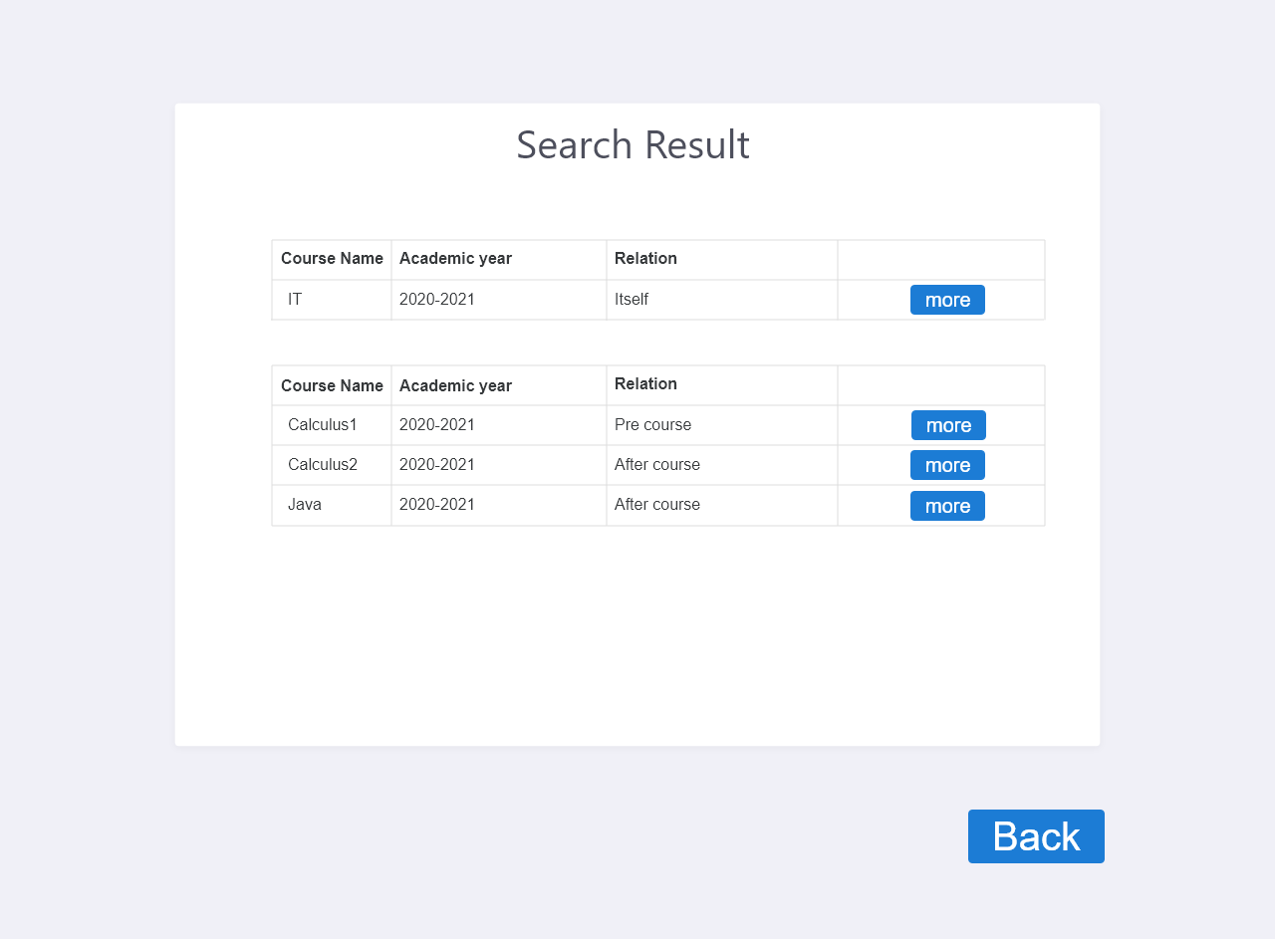

Figure 11.1 Search Result Page(for course)

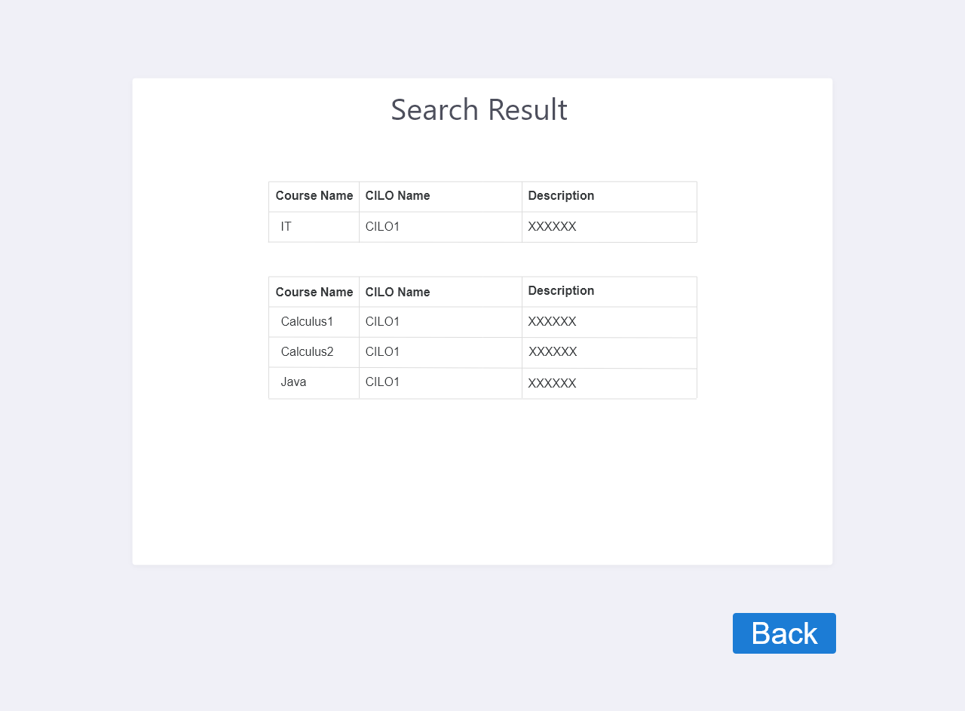

Figure 11.2 Search Result Page(for CILO)

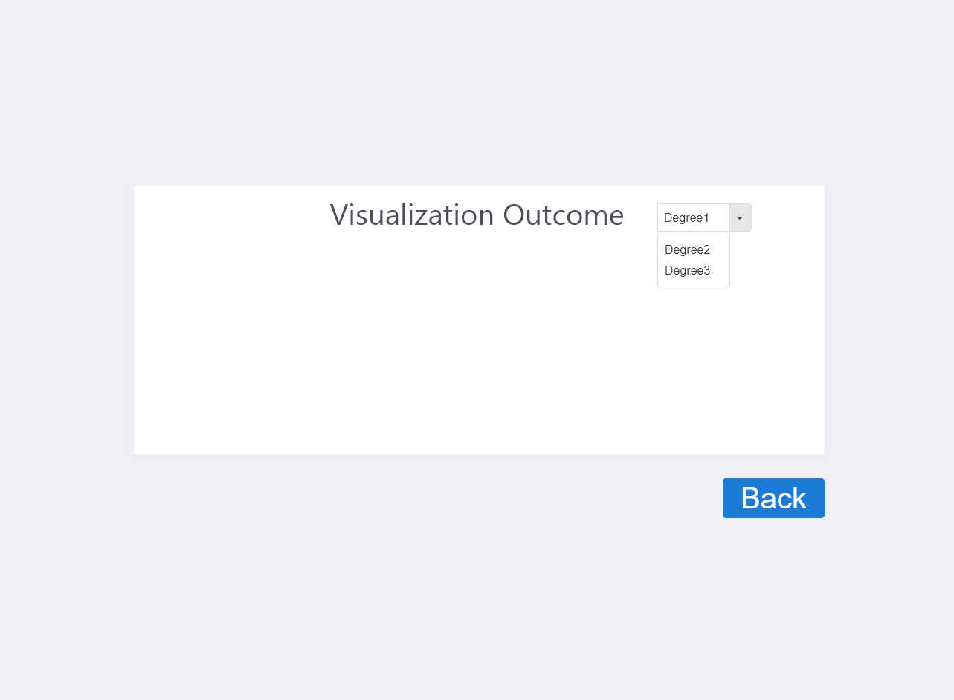

Figure 12 Dependency Visualization Page

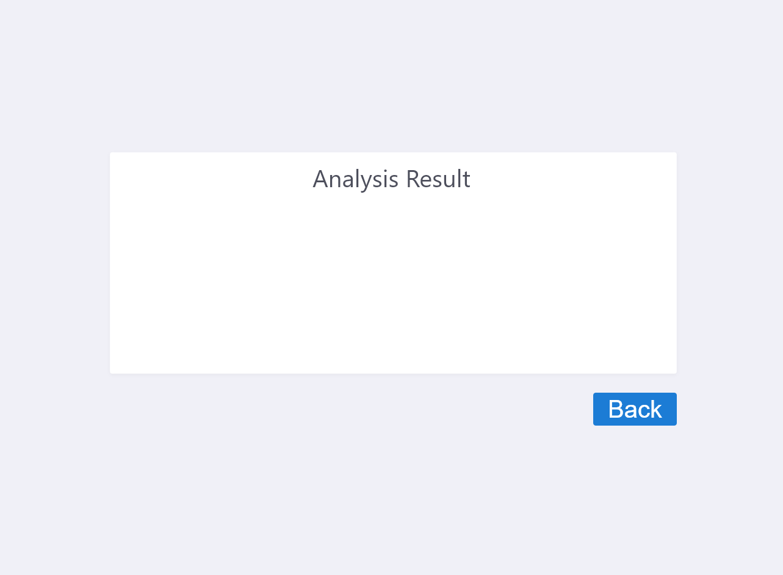

Figure 13 Display Analysis Result Page

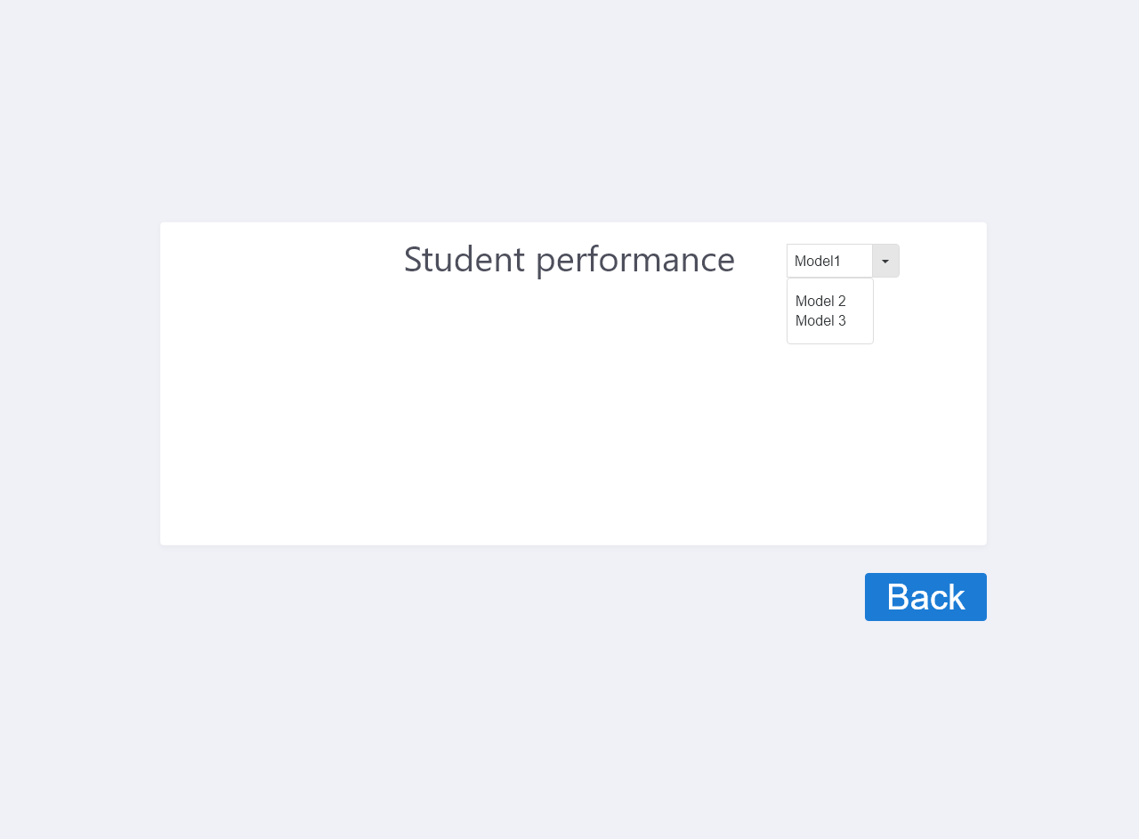

Figure 14 Performance Page