State Transition Model

& User Interface

for

DegreeOverview

Version 1.1 approved

Prepared by:

Lei XIA (1830026125)

Yiping GAO (1830026026)

Zhenyu REN (1830026095)

Zhengyang SHEN (1730026092)

Jasmine

2021/3/22

Figure 2 Student page

Figure 1 Login page

Figure Course designer page

Figure Non-course designer page

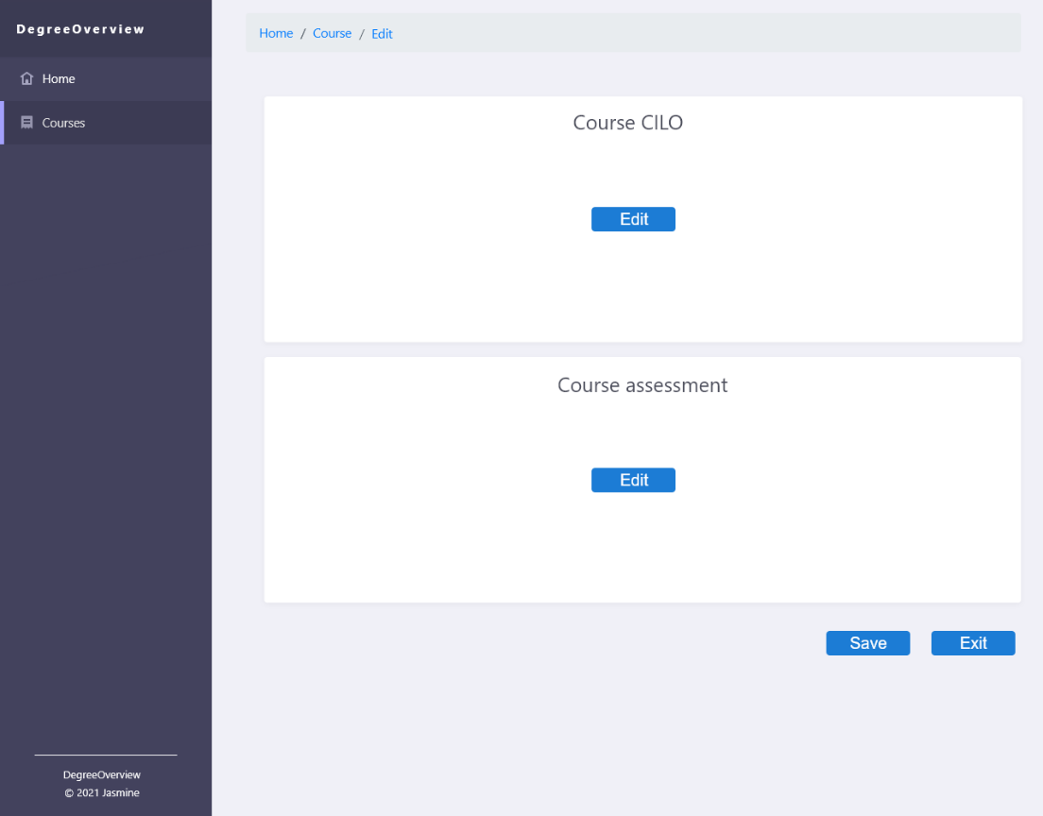

Figure 6 CILO & Assessment Edit page

Figure 5 Course page

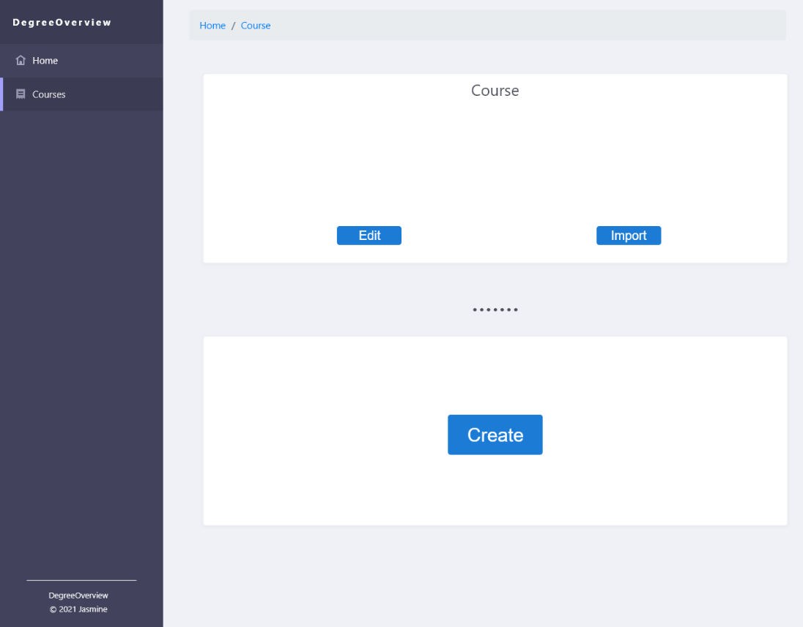

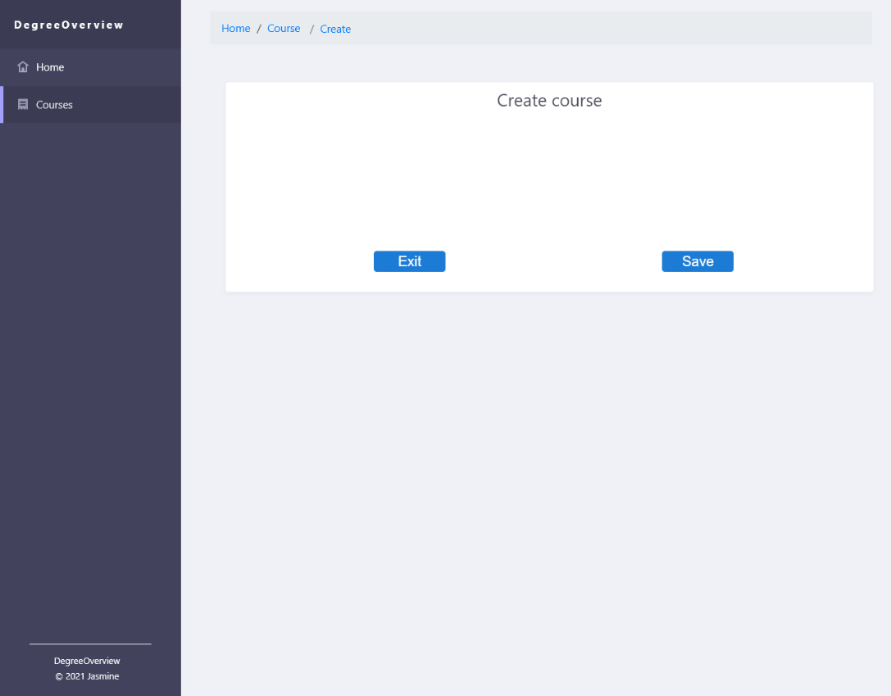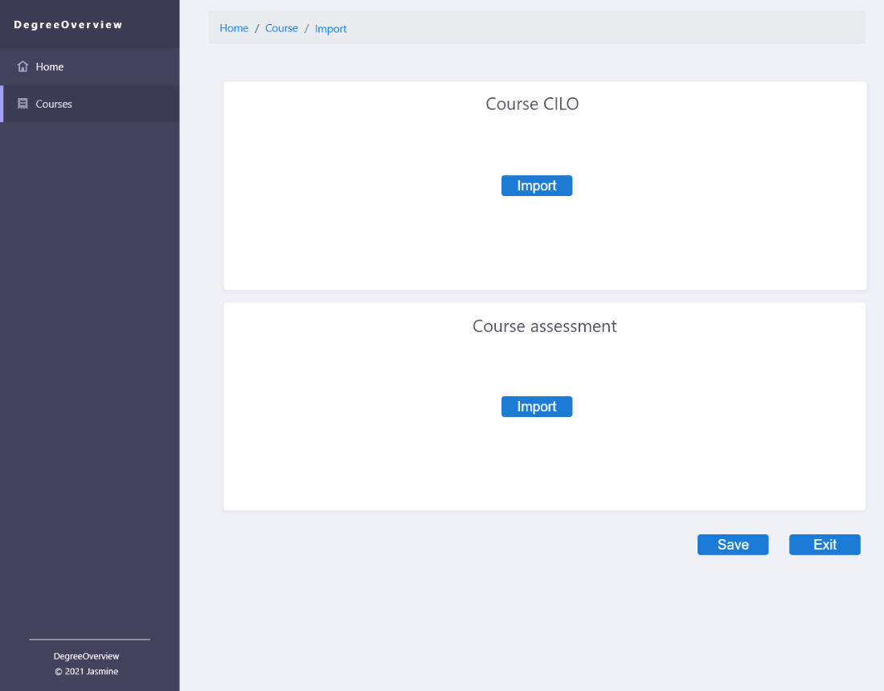

Figure 8 Create course page

Figure 7 CILO & Assessment Import page