Section 2: Data Modeling and SQL

*It is a capital mistake to theorize before one has data.*

Sir Arthur Conan Doyle, “A Scandal in Bohemia,” *The Adventures of Sherlock Holmes*, 1891

The application backlog, a large number of requests for new information systems, has been a recurring problem in many organizations for decades. The demand for new information systems and the need to maintain existing systems have usually outstripped available information systems skills. The application backlog, unfortunately, is not a new problem. In the 1970s, Codd laid out a plan for improving programmer productivity and accelerating systems development by improving the management of data. Codd’s **relational model**, designed to solve many of the shortcomings of earlier systems, is currently the most popular database model.

This section develops two key skills—data modeling and query formation—that are required to take advantage of the relational model. We concentrate on the design and use of relational databases. This very abrupt change in focus is part of the plan to give you a dual understanding of data management. Section 1 is the managerial perspective, whereas this section covers technical skills development. Competent data managers are able to accommodate both views and apply whichever (or some blend of the two) is appropriate.

In Chapter 1, many forms of organizational memory were identified, and in this section we focus on files and their components. Thus, only the files branch of organizational memory is detailed in the following figure.

**Organizational memory**

**|**

**Database**

**(collection of related files)**

**|**

**File**

**(table)**

**|**

**Record**

**(row)**

**|**

**Field**

**(column)**

**|**

**Character**

**(byte)**

**|**

**Bit**

A collection of related files is a **database**. Describing the collection of files as related means that it has a common purpose (e.g., data about students). Sometimes files are also called tables, and there are synonyms for some other terms (the alternative names are shown in parentheses). Files contain **records** (or rows). Each record contains the data for one instance of the data the file stores. For example, if the file stores data about students, each record will contain data about a single student. Records have **fields** (or columns) that store the fine detail of each instance (e.g., student’s first name, last name, and date of birth). Fields are composed of **characters** (a, b, c, . . , 1, 2, 3, . . . , %, $, #, . . . , A, B, etc.). A **byte**, a unit of storage sufficient to store a single letter (in English) or digit, consists of a string of eight contiguous **bits** or binary digits.

The data management hierarchy stimulates three database design questions:

* What collection of files should the database contain?
* How are these files related?
* What fields should each record in the file contain?

The first objective of this section is to describe data modeling, a technique for answering the three questions. Data modeling helps you to understand the structure and meaning of data, which is necessary before a database can be created. Once a database has been designed, built, and loaded with data, the aim is to deploy it to satisfy management’s requests for information. Thus, the second objective is to teach you to query a relational database. The learning of modeling and querying will be intertwined, making it easier to grasp the intent of database design and to understand why data modeling is so critical to making a database an effective tool for managerial decision making.

Chapter 3 covers modeling a single entity and querying a single-table database. This is the simplest database that can be created. As you will soon discover, a **data model** is a graphical description of the components of a database. One of these components is an entity, some feature of the real world about which data must be stored. This section also introduces the notions of a **data definition language** (DDL), which is used to describe a database, and a **data manipulation language** (DML), which is used to maintain and query a database. Subsequent chapters in this section cover advanced data modeling concepts and querying capabilities.

3. The Single Entity

I want to be alone.

Attributed to Greta Garbo

## Learning objectives

Students completing this chapter will be able to

* model a single entity;
* define a single database;
* write queries for a single-table database.

# The relational model

The relational model introduced by Codd in 1970 is the most popular technology for managing large collections of data. In this chapter, the major concepts of the relational model are introduced. Extensive coverage of the relational model is left until Chapter  8, by which time you will have sufficient practical experience to appreciate fully its usefulness, value, and elegance.

A relation, similar to the mathematical concept of a set, is a two-dimensional table arranged in rows and columns. This is a very familiar idea. You have been using tables for many years. A relational database is a collection of relations, where relation is a mathematical term for a table. One row of a table stores details of one observation, instance, or case of an item about which facts are retained—for example, one row for details of a particular student. All the rows in a table store data about the same type of item. Thus, a database might have one table for student data and another table for class data. Similarly, each column in the table contains the same type of data. For example, the first column might record a student’s identification number. A key database design question is to decide what to store in each table. What should the rows and columns contain?

In a relational database, each row must be uniquely identified. There must be a primary key, such as student identifier, so that a particular row can be designated. The use of unique identifiers is very common. Telephone numbers and e-mail addresses are examples of unique identifiers. Selection of the primary key, or unique identifier, is another key issue of database design.

**Global legal entity identifier (LEI)**

There is no global standard for identifying legal entities across markets and jurisdictions. The need for such a standard was amplified by Lehman Brothers collapse in 2008. Lehman had 209 registered subsidiaries, legal entities, in 21 countries, and it was party to more than 900,000 derivatives contracts upon its collapse. Key stakeholders, such as financial regulators and Lehman’s creditors, were unable to assess their exposure. Furthermore, others were unable to assess the possible ripple on them of the effects of the collapse because of the transitive nature of many investments (i.e., A owes B, B owes C, and C owes D).

The adoption of a global legal entity identifier (LEI), should improve financial system regulation and corporate risk management. Regulators will find it easier to monitor and analyze threats to financial stability and risk managers will be more able evaluate their companies’ risks.

Source: www.ny.frb.org/research/epr/2014/1403flem.pdf

The tables in a relational database are connected or related by means of the data in the tables. You will learn, in the next chapter, that this connection is through a pair of values—a primary key and a foreign key. Consider a table of airlines serving a city. When examining this table, you may not recognize the code of an airline, so you then go to another table to find the name of the airline. For example, if you inspect the following table, you find that AM is an international airline serving Atlanta.

International airlines serving Atlanta

| Airline |
| --- |
| AM |
| JL |
| KX |
| LM |
| MA |
| OS |
| RG |
| SN |
| SR |
| LH |
| LY |

If you don’t know which airline has the abbreviation AM, then you need to look at the following table of airline codes to discover that AeroMexico, with code AM, serves Atlanta. The two tables are related by airline code. Later, you will discover which is the primary key and which is the foreign key.

A partial list of airline codes

| Code | Airline |
| --- | --- |
| AA | American Airlines |
| AC | Air Canada |
| AD | Lone Star Airlines |
| AE | Mandarin Airlines |
| AF | Air France |
| AG | Interprovincial Airlines |
| AI | Air India |
| AM | AeroMexico |
| AQ | Aloha Airlines |

When designing the relational model, Codd provided commands for processing multiple records at a time. His intention was to increase the productivity of programmers by moving beyond the record-at-a-time processing that is found in most programming languages. Consequently, the relational model supports set processing (multiple records-at-a-time), which is most frequently implemented as Structured Query Language (SQL).[1]

The relational model separates the logical design of a database from its physical storage. This notion of data independence simplifies data modeling and database programming. In this section, we focus on logical database design, and now that you have had a brief introduction to the relational model, you are ready to learn data modeling.

# Getting started

As with most construction projects, building a relational database must be preceded by a design phase. Data modeling, our design technique, is a method for creating a plan or blueprint of a database. The data model must accurately mirror real-world relationships if it is to support processing business transactions and managerial decision making.

Rather than getting bogged down with a theory first, application later approach to database design and use, we will start with application. We will get back to theory when you have some experience in data modeling and database querying. After all, you did not learn to talk by first studying sentence formation; you just started by learning and using simple words. We start with the simplest data model, a single entity, and the simplest database, a single table, as follows.

| Firm code | Firm’s name | Price | Quantity | Dividend | PE ratio |
| --- | --- | --- | --- | --- | --- |
| FC | Freedonia Copper | 27.5 | 10,529 | 1.84 | 16 |
| PT | Patagonian Tea | 55.25 | 12,635 | 2.5 | 10 |
| AR | Abyssinian Ruby | 31.82 | 22,010 | 1.32 | 13 |
| SLG | Sri Lankan Gold | 50.37 | 32,868 | 2.68 | 16 |
| ILZ | Indian Lead & Zinc | 37.75 | 6,390 | 3 | 12 |
| BE | Burmese Elephant | 0.07 | 154,713 | 0.01 | 3 |
| BS | Bolivian Sheep | 12.75 | 231,678 | 1.78 | 11 |
| NG | Nigerian Geese | 35 | 12,323 | 1.68 | 10 |
| CS | Canadian Sugar | 52.78 | 4,716 | 2.5 | 15 |
| ROF | Royal Ostrich Farms | 33.75 | 1,234,923 | 3 | 6 |

# Modeling a single-entity database

The simplest database contains information about one entity, which is some real-world thing. Some entities are physical—CUSTOMER, ORDER, and STUDENT; others are conceptual—WORK ASSIGNMENT and AUTHORSHIP. We represent an entity by a rectangle: the following figure shows a representation of the entity SHARE. The name of the entity is shown in singular form in uppercase in the top part of the rectangle.

The entity SHARE

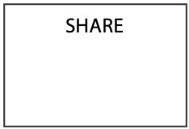

An entity has characteristics or attributes. An attribute is a discrete element of data; it is not usually broken down into smaller components. Attributes identify data we want to store. Some attributes of the entity SHARE are identification code, firm name, price, quantity owned, dividend, and price-to-earnings ratio.[2] Attributes are shown below the entity’s name. Notice that we refer to share price, rather than price, to avoid confusion if there should be another entity with an attribute called price. Attribute names must be carefully selected so that they are self-explanatory and unique. For example, share dividend is easily recognized as belonging to the entity SHARE.

The entity SHARE and its attributes

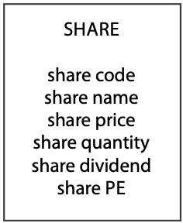

An instance is a particular occurrence of an entity (e.g., facts about Freedonia Copper). To avoid confusion, each instance of an entity needs to be uniquely identified. Consider the case of customer billing. In most cases, a request to bill Smith $100 cannot be accurately processed because a firm might have more than one Smith in its customer file. If a firm has carefully controlled procedures for ensuring that each customer has a unique means of identification, then a request to bill customer number 1789 $100 can be accurately processed. An attribute or collection of attributes that uniquely identifies an instance of an entity is called an identifier. The identifier for the entity SHARE is share code, a unique identifier assigned by the stock exchange.

There may be several attributes, or combinations of attributes, that are feasible identifiers for an instance of an entity. Attributes that are identifiers are prefixed by an asterisk. The following figure shows an example of a representation of an entity, its attributes, and identifier.

The entity SHARE, its attributes, and identifier

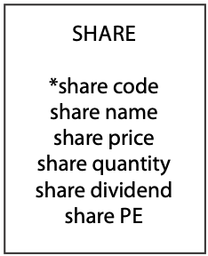

Briefly, entities are things in the environment about which we wish to store information. Attributes describe an entity. An entity must have a unique identifier.

### Data modeling

The modeling language used in this text is designed to record the essential details of a data model. The number of modeling symbols to learn is small, and they preserve all the fundamental concepts of data modeling. Since data modeling often occurs in a variety of settings, the symbols used have been selected so that they can be quickly drawn using pencil-and-paper, whiteboard, or a general-purpose drawing program. This also means that models can be quickly revised as parts can be readily erased and redrawn.

The symbols are distinct and visual clutter is minimized because only the absolutely essential information is recorded. This also makes the language easy for clients to learn so they can read and amend models.

Models can be rapidly translated to a set of tables for a relational database. More importantly, since this text implements the fundamental notions of all data modeling languages, you can quickly convert to another data modeling dialect. Data modeling is a high-level skill, and the emphasis needs to be on learning to think like a data modeler rather than on learning a modeling language. This text’s goal is to get you off to a fast start.

Skill builder

A ship has a name, registration code, gross tonnage, and a year of construction. Ships are classified as cargo or passenger. Draw a data model for a ship.

# Creating a single-table database

The next stage is to translate the data model into a relational database. The translation rules are very direct:

* Each entity becomes a table.
* The entity name becomes the table name.
* Each attribute becomes a column.
* The identifier becomes the primary key.

The American National Standards Institute’s (ANSI) recommended language for relational database definition and manipulation is SQL, which is both a data definition language (DDL) (to define a database), a data manipulation language (DML) (to query and maintain a database), and a data control language (DCL) (to control access). SQL is a common standard for describing and querying databases and is available with many commercial relational database products, including DB2, Oracle, and Microsoft SQL Server, and open source products such as MySQL and PostgreSQL.

In this book, MySQL is the relational database for teaching SQL. Because SQL is a standard, it does not matter which implementation of the relational model you use as the SQL language is common across both the proprietary and open variants.[3]

SQL uses the CREATE[4] statement to define a table. It is not a particularly friendly command, and most products have friendlier interfaces for defining tables. However, it is important to learn the standard, because this is the command that SQL understands. Also, a table definition interface will generate a CREATE statement for execution by SQL. Your interface interactions ultimately translate into a standard SQL command.

It is common practice to abbreviate attribute names, as is done in the following example.

## Defining a table

The CREATE command to establish a table called share[5] is as follows:

CREATE TABLE share (

shrcode CHAR(3),

shrfirm VARCHAR(20) NOT NULL,

shrprice DECIMAL(6,2),

shrqty DECIMAL(8),

shrdiv DECIMAL(5,2),

shrpe DECIMAL(2),

PRIMARY KEY (shrcode));

The first line of the command names the table; subsequent lines describe each of its columns. The first component is the name of the column (e.g., shrcode). The second component is the data type (e.g., CHAR), and its length is shown in parentheses. shrfirm is a variable-length character field of length 20, which means it can store up to 20 characters, including spaces. The column shrdiv stores a decimal number that can be as large as 999.99 because its total length is 5 digits and there are 2 digits to the right of the decimal point. Some examples of allowable data types are shown in the following table. The third component (e.g., NOT NULL), which is optional, indicates any instance that cannot have null values. A column might have a null value when it is either unknown or not applicable. In the case of the share table, we specify that shrfirm must be defined for each instance in the database.

The final line of the CREATE statement defines shrcode as the primary key, the unique identifier for share. When a primary key is defined, the relational database management system (RDBMS) will enforce the requirement that the primary key is unique and not null. Before any row is added to the table share, the RDBMS will check that the value of shrcode is not null and that there does not already exist a duplicate value for shrcode in an existing row of share. If either of these constraints is violated, the RDBMS will not permit the new row to be inserted. This constraint, the entity integrity rule, ensures that every row has a unique, non-null primary key. Allowing the primary key to take a null value would mean there could be a row of share that is not uniquely identified. Note that an SQL statement is terminated by a semicolon, though this is not always enforced.

SQL statements can be written in any mix of valid upper and lowercase characters. To make it easier for you to learn the syntax, this book adopts the following conventions:

* SQL keywords are in uppercase.
* Table and column names are in lowercase.

There are more elaborate layout styles, but we will bypass those because it is more important at this stage to learn SQL. You should lay out your SQL statements so that they are easily read by you and others.

The following table shows some of the data types supported by most relational databases. Other implementations of the relational model may support some of these data types and additional ones. It is a good idea to review the available data types in your RDBMS before defining your first table.

Some allowable data types

| Category | Data type | Description |
| --- | --- | --- |
| Numeric | SMALLINT | A 15-bit signed binary value |
| INTEGER | A 31-bit signed binary value |
| FLOAT(p) | A scientific format number of *p* binary digits precision |
| DECIMAL(p,q) | A packed decimal number of *p* digits total length; *q* decimal spaces to the right of the decimal point may be specified |
| String | CHAR(n) | A fixed-length string of *n* characters |
| VARCHAR(n) | A variable-length string of up to *n* characters |
| text | A variable-length string of up to 65,535 characters |
| Date/time | DATE | Date in the form *yyyymmdd* |
| TIME | Time in the form *hhmmss* |
| timesTAMP | A combination of date and time to the nearest microsecond |
| time with time zone | Same as time, with the addition of an offset from universal time coordinated (UTC) of the specified time |
| timestamp with time zone | Same as timestamp, with the addition of an offset from UTC of the specified time |
| Logical | Boolean | A set of truth values: TRUE, FALSE, or UNKNOWN |

The CHAR and VARCHAR data types are similar but differ in the way character strings are stored and retrieved. Both can be up to 255 characters long. The length of a CHAR column is fixed to the declared length. When values are stored, they are right-padded with spaces to the specified length. When CHAR values are retrieved, trailing spaces are removed. VARCHAR columns store variable-length strings and use only as many characters as are needed to store the string. Values are not padded; instead, trailing spaces are removed. In this book, we use VARCHAR to define most character strings, unless they are short (less than five characters is a good rule-of-thumb).

# Data modeling with MySQL Workbench

MySQL Workbench is a professional quality, open source, cross-platform tool for data modeling and SQL querying.[6] In this text, you will also learn some of the features of Workbench that support data modeling and using SQL. You will find it helpful to complete the MySQL Workbench tutorial on creating a data model[7] prior to further reading, as we will assume you have such proficiency.

The entity share created with MySQL Workbench

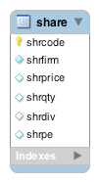

You will notice some differences from the data model we have created previously. Workbench automatically generates the SQL code to create the table, so when modeling you establish the names you want for tables and columns. A gold key symbol is used to indicate the identifier, which becomes the primary key. An open diamond indicates that a column can be null, whereas a closed blue diamond indicate the column must have a value, as with shrfirm in this case.

When specifying columns in Workbench you must also indicate the datatype. We opt to turn off the display of a column’s datatype[8] in a model to maintain focus on the entity.

A major advantage of using a tool such as Workbench is that it will automatically generate the CREATE statement code (Database > Forward Engineer …) and execute the code to create the database. The Workbench tutorial will have shown you how to do this, and you should try this out for yourself by creating a database with the single share table.

## Inserting rows into a table

The rows of a table store instances of an entity. A particular shareholding (e.g., Freedonia Copper) is an example of an instance of the entity share. The SQL statement INSERT is used to add rows to a table. Although most implementations of the relational model use a spreadsheet for row insertion and you can also usually import a structured text file, the INSERT command is defined for completeness.

The following command adds one row to the table share:

INSERT INTO share

(shrcode,shrfirm,shrprice,shrqty,shrdiv,shrpe)

VALUES ('FC','Freedonia Copper',27.5,10529,1.84,16);

There is a one-to-one correspondence between a column name in the first set of parentheses and a value in the second set of parentheses. That is, shrcode has the value “FC,” shrfirm the value “Freedonia Copper,” and so on. Notice that the value of a column that stores a character string (e.g., shrfirm) is contained within straight quotes.

The list of field names can be omitted when values are inserted in all columns of the table in the same order as that specified in the CREATE statement, so the preceding expression could be written

INSERT INTO share

VALUES ('FC','Freedonia Copper',27.5,10529,1.84,16);

The data for the share table will be used in subsequent examples. If you have ready access to a relational database, it is a good idea to now create a table and enter the data. Then you will be able to use these data to practice querying the table.

Data for share

| shrcode | shrfirm | shrprice | shrqty | shrdiv | shrpe |
| --- | --- | --- | --- | --- | --- |
| FC | Freedonia Copper | 27.5 | 10,529 | 1.84 | 16 |
| PT | Patagonian Tea | 55.25 | 12,635 | 2.5 | 10 |
| AR | Abyssinian Ruby | 31.82 | 22,010 | 1.32 | 13 |
| SLG | Sri Lankan Gold | 50.37 | 32,868 | 2.68 | 16 |
| ILZ | Indian Lead & Zinc | 37.75 | 6,390 | 3 | 12 |
| BE | Burmese Elephant | 0.07 | 154,713 | 0.01 | 3 |
| BS | Bolivian Sheep | 12.75 | 231,678 | 1.78 | 11 |
| NG | Nigerian Geese | 35 | 12,323 | 1.68 | 10 |
| CS | Canadian Sugar | 52.78 | 4,716 | 2.5 | 15 |
| ROF | Royal Ostrich Farms | 33.75 | 1,234,923 | 3 | 6 |

Notice that shrcode,the primary key, is underlined in the preceding table. This is a convention we will use for denoting the primary key. In the relational model, an identifier becomes a primary key, a column that guarantees that each row of the table can be uniquely addressed.

MySQL Workbench offers a spreadsheet interface for entering data, as explained in the tutorial on adding data to a database.[9]

Inserting rows with MySQL Workbench

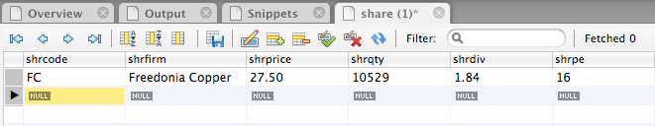

Skill builder

Create a relational database for the ship entity you modeled previously. Insert some rows.

# Querying a database

The objective of developing a database is to make it easier to use the stored data to solve problems. Typically, a manager raises a question (e.g., How many shares have a PE ratio greater than 12?). A question or request for information, usually called a query, is then translated into a specific data manipulation or query language. The most widely used query language for relational databases is SQL. After the query has been executed, the resulting data are displayed. In the case of a relational database, the answer to a query is always a table.

There is also a query language called relational algebra, which describes a set of operations on tables. Sometimes it is useful to think of queries in terms of these operations. Where appropriate, we will introduce the corresponding relational algebra operation.

Generally we use a four-phase format for describing queries:

1. A brief explanation of the query’s purpose
2. The query italics, prefixed by •, and some phrasing you might expect from a manager
3. The SQL version of the query
4. The results of the query.

## Displaying an entire table

All the data in a table can be displayed using the SELECT statement. In SQL, the all part is indicated by an asterisk (*).

* List all data in the share table.

SELECT * FROM share;

| shrcode | shrfirm | shrprice | shrqty | shrdiv | shrpe |
| --- | --- | --- | --- | --- | --- |
| FC | Freedonia Copper | 27.5 | 10529 | 1.84 | 16 |
| PT | Patagonian Tea | 55.25 | 12635 | 2.5 | 10 |
| AR | Abyssinian Ruby | 31.82 | 22010 | 1.32 | 13 |
| SLG | Sri Lankan Gold | 50.37 | 32868 | 2.68 | 16 |
| ILZ | Indian Lead & Zinc | 37.75 | 6390 | 3 | 12 |
| BE | Burmese Elephant | 0.07 | 154713 | 0.01 | 3 |
| BS | Bolivian Sheep | 12.75 | 231678 | 1.78 | 11 |
| NG | Nigerian Geese | 35 | 12323 | 1.68 | 10 |
| CS | Canadian Sugar | 52.78 | 4716 | 2.5 | 15 |

## Project—choosing columns

The relational algebra operation project creates a new table from the columns of an existing table. Project takes a vertical slice through a table by selecting all the values in specified columns. The projection of share on columns shrfirm and shrpe produces a new table with 10 rows and 2 columns. These columns are shaded in the table.

Projection of shrfirm and shrpe

| shrcode | shrfirm | shrprice | shrqty | shrdiv | shrpe |
| --- | --- | --- | --- | --- | --- |
| FC | Freedonia Copper | 27.5 | 10,529 | 1.84 | 16 |
| PT | Patagonian Tea | 55.25 | 12,635 | 2.5 | 10 |
| AR | Abyssinian Ruby | 31.82 | 22,010 | 1.32 | 13 |
| SLG | Sri Lankan Gold | 50.37 | 32,868 | 2.68 | 16 |
| ILZ | Indian Lead & Zinc | 37.75 | 6,390 | 3 | 12 |
| BE | Burmese Elephant | 0.07 | 154,713 | 0.01 | 3 |
| BS | Bolivian Sheep | 12.75 | 231,678 | 1.78 | 11 |
| NG | Nigerian Geese | 35 | 12,323 | 1.68 | 10 |
| CS | Canadian Sugar | 52.78 | 4,716 | 2.5 | 15 |
| ROF | Royal Ostrich Farms | 33.75 | 1,234,923 | 3 | 6 |

The SQL syntax for the project operation simply lists the columns to be displayed.

* Report a firm’s name and price-earnings ratio.

SELECT shrfirm, shrpe FROM share;

| shrfirm | shrpe |
| --- | --- |
| Freedonia Copper | 16 |
| Patagonian Tea | 10 |
| Abyssinian Ruby | 13 |
| Sri Lankan Gold | 16 |
| Indian Lead & Zinc | 12 |
| Burmese Elephant | 3 |
| Bolivian Sheep | 11 |
| Nigerian Geese | 10 |
| Canadian Sugar | 15 |
| Royal Ostrich Farms | 6 |

## Restrict—choosing rows

The relational algebra operation restrict creates a new table from the rows of an existing table. The operation restricts the new table to those rows that satisfy a specified condition. Restrict takes all columns of an existing table but only those rows that meet the specified condition. The restriction of share to those rows where the PE ratio is less than 12 will give a new table with five rows and six columns. These rows are shaded.

Restriction of share

| shrcode | shrfirm | shrprice | shrqty | shrdiv | shrpe |
| --- | --- | --- | --- | --- | --- |
| FC | Freedonia Copper | 27.5 | 10,529 | 1.84 | 16 |
| PT | Patagonian Tea | 55.25 | 12,635 | 2.5 | 10 |
| AR | Abyssinian Ruby | 31.82 | 22,010 | 1.32 | 13 |
| SLG | Sri Lankan Gold | 50.37 | 32,868 | 2.68 | 16 |
| ILZ | Indian Lead & Zinc | 37.75 | 6,390 | 3 | 12 |
| BE | Burmese Elephant | 0.07 | 154,713 | 0.01 | 3 |
| BS | Bolivian Sheep | 12.75 | 231,678 | 1.78 | 11 |
| NG | Nigerian Geese | 35 | 12,323 | 1.68 | 10 |
| CS | Canadian Sugar | 52.78 | 4,716 | 2.5 | 15 |
| ROF | Royal Ostrich Farms | 33.75 | 1,234,923 | 3 | 6 |

Restrict is implemented in SQL using the WHERE clause to specify the condition on which rows are restricted.

* Get all firms with a price-earnings ratio less than 12.

SELECT * FROM share WHERE shrpe < 12;

| shrcode | shrfirm | shrprice | shrqty | shrdiv | shrpe |
| --- | --- | --- | --- | --- | --- |
| PT | Patagonian Tea | 55.25 | 12635 | 2.5 | 10 |
| BE | Burmese Elephant | 0.07 | 154713 | 0.01 | 3 |
| BS | Bolivian Sheep | 12.75 | 231678 | 1.78 | 11 |
| NG | Nigerian Geese | 35 | 12323 | 1.68 | 10 |
| ROF | Royal Ostrich Farms | 33.75 | 1234923 | 3 | 6 |

In this example, we have a less than condition for the WHERE clause. All permissible comparison operators are listed below.

| Comparison operator | Meaning |
| --- | --- |
| = | Equal to |
| < | Less than |
| <= | Less than or equal to |
| > | Greater than |
| >= | Greater than or equal to |
| <> | Not equal to |

In addition to the comparison operators, the BETWEEN construct is available.

a BETWEEN x AND y is equivalent to a >= x AND a <= y

## Combining project and restrict—choosing rows and columns

SQL permits project and restrict to be combined. A single SQL SELECT statement can specify which columns to project and which rows to restrict.

* List the name, price, quantity, and dividend of each firm where the share holding is at least 100,000.

SELECT shrfirm, shrprice, shrqty, shrdiv FROM share

WHERE shrqty >= 100000;

| shrfirm | shrprice | shrqty | shrdiv |
| --- | --- | --- | --- |
| Burmese Elephant | 0.07 | 154713 | 0.01 |
| Bolivian Sheep | 12.75 | 231678 | 1.78 |
| Royal Ostrich Farms | 33.75 | 1234923 | 3 |

## More about WHERE

The WHERE clause can contain several conditions linked by AND or OR. A clause containing AND means all specified conditions must be true for a row to be selected. In the case of OR, at least one of the conditions must be true for a row to be selected.

* Find all firms where the PE is 12 or higher and the share holding is less than 10,000.

SELECT * FROM share

WHERE shrpe >= 12 AND shrqty < 10000;

| shrcode | shrfirm | shrprice | shrqty | shrdiv | shrpe |
| --- | --- | --- | --- | --- | --- |
| ILZ | Indian Lead & Zinc | 37.75 | 6390 | 3 | 12 |
| CS | Canadian Sugar | 52.78 | 4716 | 2.5 | 15 |

## The power of the primary key

The purpose the primary key is to guarantee that any row in a table can be uniquely addressed. In this example, we use shrcode to return a single row because shrcode is unique for each instance of share. The sought code (AR) must be specified in quotes because shrcode was defined as a character string when the table was created.

* Report firms whose code is AR.

SELECT * FROM share WHERE shrcode = 'AR';

| shrcode | shrfirm | shrprice | shrqty | shrdiv | shrpe |
| --- | --- | --- | --- | --- | --- |
| AR | Abyssinian Ruby | 31.82 | 22010 | 1.32 | 13 |

A query based on a non-primary-key column cannot guarantee that a single row is accessed, as the following illustrates.

* Report firms with a dividend of 2.50.

SELECT * FROM share WHERE shrdiv = 2.5;

| shrcode | shrfirm | shrprice | shrqty | shrdiv | shrpe |
| --- | --- | --- | --- | --- | --- |
| PT | Patagonian Tea | 55.25 | 12635 | 2.5 | 10 |
| CS | Canadian Sugar | 52.78 | 4716 | 2.5 | 15 |

## The IN crowd

The keyword IN is used with a list to specify a set of values. IN is always paired with a column name. All rows for which a value in the specified column has a match in the list are selected. It is a simpler way of writing a series of OR statements.

* Report data on firms with codes of FC, AR, or SLG.

SELECT * FROM share WHERE shrcode IN ('FC','AR','SLG');

The foregoing query could have also been written as

SELECT * FROM share

WHERE shrcode = 'FC' or shrcode = 'AR' or shrcode = 'SLG';

| shrcode | shrfirm | shrprice | shrqty | shrdiv | shrpe |
| --- | --- | --- | --- | --- | --- |
| FC | Freedonia Copper | 27.5 | 10529 | 1.84 | 16 |
| AR | Abyssinian Ruby | 31.82 | 22010 | 1.32 | 13 |
| SLG | Sri Lankan Gold | 50.37 | 32868 | 2.68 | 16 |

## The NOT IN crowd

A NOT IN list is used to report instances that do not match any of the values.

* Report all firms other than those with the code CS or PT.

SELECT * FROM share WHERE shrcode NOT IN ('CS','PT');

is equivalent to

SELECT * FROM share WHERE shrcode <> 'CS' AND shrcode <> 'PT';

| shrcode | shrfirm | shrprice | shrqty | shrdiv | shrpe |
| --- | --- | --- | --- | --- | --- |
| FC | Freedonia Copper | 27.5 | 10529 | 1.84 | 16 |
| AR | Abyssinian Ruby | 31.82 | 22010 | 1.32 | 13 |
| SLG | Sri Lankan Gold | 50.37 | 32868 | 2.68 | 16 |
| ILZ | Indian Lead & Zinc | 37.75 | 6390 | 3 | 12 |
| BE | Burmese Elephant | 0.07 | 154713 | 0.01 | 3 |
| BS | Bolivian Sheep | 12.75 | 231678 | 1.78 | 11 |
| NG | Nigerian Geese | 35 | 12323 | 1.68 | 10 |
| ROF | Royal Ostrich Farms | 33.75 | 1234923 | 3 | 6 |

Skill builder

List those shares where the value of the holding exceeds one million.

## Ordering columns

The order of reporting columns is identical to their order in the SQL command. For instance, compare the output of the following queries.

SELECT shrcode, shrfirm FROM share WHERE shrpe = 10;

| shrcode | shrfirm |
| --- | --- |
| PT | Patagonian Tea |
| NG | Nigerian Geese |

SELECT shrfirm, shrcode FROM share WHERE shrpe = 10;

| shrfirm | shrcode |
| --- | --- |
| Patagonian Tea | PT |
| Nigerian Geese | NG |

## Ordering rows

People can generally process an ordered (e.g., sorted alphabetically) report faster than an unordered one. In SQL, the ORDER BY clause specifies the row order in a report. The default ordering sequence is ascending (A before B, 1 before 2). Descending is specified by adding DESC after the column name.

* List all firms where PE is at least 10, and order the report in descending PE. Where PE ratios are identical, list firms in alphabetical order.

SELECT * FROM share WHERE shrpe >= 10

ORDER BY shrpe DESC, shrfirm;

| shrcode | shrfirm | shrprice | shrqty | shrdiv | shrpe |
| --- | --- | --- | --- | --- | --- |
| FC | Freedonia Copper | 27.5 | 10529 | 1.84 | 16 |
| SLG | Sri Lankan Gold | 50.37 | 32868 | 2.68 | 16 |
| CS | Canadian Sugar | 52.78 | 4716 | 2.5 | 15 |
| AR | Abyssinian Ruby | 31.82 | 22010 | 1.32 | 13 |
| ILZ | Indian Lead & Zinc | 37.75 | 6390 | 3 | 12 |
| BS | Bolivian Sheep | 12.75 | 231678 | 1.78 | 11 |
| NG | Nigerian Geese | 35 | 12323 | 1.68 | 10 |
| PT | Patagonian Tea | 55.25 | 12635 | 2.5 | 10 |

## Numeric versus character sorting

Numeric data in character fields (e.g., a product code) do not always sort the way you initially expect. The difference arises from the way data are stored:

* Numeric fields are right justified and have leading zeros.
* Character fields are left justified and have trailing spaces.

For example, the value 1066 stored as CHAR(4) would be stored as ‘1066’ and the value 45 would be stored as ‘45 ’. If the column containing these data is sorted in ascending order, then ‘1066’ precedes ‘ 45 ’ because the leftmost character ‘1’ is less than ‘4’. You can avoid this problem by always storing numeric values as numeric data types (e.g., integer or decimal) or preceding numeric values with zeros when they are stored as character data. Alternatively, start numbering at 1,000 so that all values are four digits, though the best solution is to store numeric data as numbers rather than characters.

## Derived data

One of the important principles of database design is to avoid redundancy. One form of redundancy is including a column in a table when these data can be derived from other columns. For example, we do not need a column for yield because it can be calculated by dividing dividend by price and multiplying by 100 to obtain the yield as a percentage. This means that the query language does the calculation when the value is required.

* Get firm name, price, quantity, and firm yield.

SELECT shrfirm, shrprice, shrqty, shrdiv/shrprice*100 AS yield FROM share;

| shrfirm | shrprice | shrqty | yield |
| --- | --- | --- | --- |
| Freedonia Copper | 27.5 | 10529 | 6.69 |
| Patagonian Tea | 55.25 | 12635 | 4.52 |
| Abyssinian Ruby | 31.82 | 22010 | 4.15 |
| Sri Lankan Gold | 50.37 | 32868 | 5.32 |
| Indian Lead & Zinc | 37.75 | 6390 | 7.95 |
| Burmese Elephant | 0.07 | 154713 | 14.29 |
| Bolivian Sheep | 12.75 | 231678 | 13.96 |
| Nigerian Geese | 35 | 12323 | 4.8 |
| Canadian Sugar | 52.78 | 4716 | 4.74 |
| Royal Ostrich Farms | 33.75 | 1234923 | 8.89 |

You can give the results of the calculation a column name. In this case, a good choice is yield. Note the use of AS to indicate the name of the column in which the results of the calculation are displayed.

In the preceding query, the keyword AS is introduced to specify an alias, or temporary name. The statement specifies that the result of the calculation is to be reported under the column heading yield. You can rename any column or specify a name for the results of an expression using an alias.

## Aggregate functions

SQL has built-in functions to enhance its retrieval power and handle many common aggregation queries, such as computing the total value of a column. Four of these functions (AVG, SUM, MIN, and MAX) work very similarly. COUNT is a little different.

### COUNT

COUNT computes the number of rows in a table. Use COUNT(*) to count all rows irrespective of their content (i.e., null or not null), and use COUNT(columnname) to count rows without a null value for columname. Count can be used with a WHERE clause to specify a condition.

* How many firms are there in the portfolio?

SELECT COUNT(shrcode) AS investments FROM share;

| investments |
| --- |
| 10 |

* How many firms have a holding greater than 50,000?

SELECT COUNT(shrfirm) AS bigholdings FROM share WHERE shrqty > 50000;

| bigholdings |
| --- |
| 3 |

### AVG—averaging

AVG computes the average of the values in a column of numeric data. Null values in the column are not included in the calculation.

* Find the average dividend.

SELECT AVG(shrdiv) AS avgdiv FROM share;

| avgdiv |
| --- |
| 2.03 |

* What is the average yield for the portfolio?

SELECT AVG(shrdiv/shrprice*100) AS avgyield FROM share;

| avgyield |
| --- |
| 7.53 |

### SUM, MIN, and MAX

SUM, MIN, and MAX differ in the statistic they calculate but are used similarly to AVG. As with AVG, null values in a column are not included in the calculation. SUM computes the sum of a column of values. MIN finds the smallest value in a column; MAX finds the largest.

## Subqueries

Sometimes we need the answer to another query before we can write the query of ultimate interest. For example, to list all shares with a PE ratio greater than the portfolio average, you first must find the average PE ratio for the portfolio. You could do the query in two stages:

a. SELECT AVG(shrpe) FROM share;

b. SELECT shrfirm, shrpe FROM share WHERE shrpe > x;

where x is the value returned from the first query.

Unfortunately, the two-stage method introduces the possibility of errors. You might forget the value returned by the first query or enter it incorrectly. It also takes longer to get the results of the query. We can solve these problems by using parentheses to indicate the first query is nested within the second one. As a result, the value returned by the inner or nested subquery, the one in parentheses, is used in the outer query. In the following example, the nested query returns 11.20, which is then automatically substituted in the outer query.

* Report all firms with a PE ratio greater than the average for the portfolio.

SELECT shrfirm, shrpe FROM share

WHERE shrpe > (SELECT AVG(shrpe) FROM share);

| shrfirm | shrpe |
| --- | --- |
| Freedonia Copper | 16 |
| Abyssinian Ruby | 13 |
| Sri Lankan Gold | 16 |
| Indian Lead & Zinc | 12 |
| Canadian Sugar | 15 |

|  |
| --- |
| Warning: The preceding query is often mistakenly written as  SELECT shrfirm, shrpe from share  WHERE shrpe > avg(shrpe); |

Skill builder

Find the name of the firm for which the value of the holding is greatest.

## Regular expression—pattern matching

Regular expression is a concise and powerful method for searching for a specified pattern in a nominated column. Regular expression processing is supported by languages such as Java, R, and PHP. In this chapter, we introduce a few typical regular expressions and will continue developing your knowledge of this feature in the next chapter.

### Search for a string

* List all firms containing 'Ruby' in their name.

SELECT shrfirm FROM share WHERE shrfirm REGEXP 'Ruby';

| shrfirm |
| --- |
| Abyssinian Ruby |

### Search for alternative strings

In some situations you want to find columns that contain more than one string. In this case, we use the alternation symbol ‘|’ to indicate the alternatives being sought. For example, a|b finds ‘a’ or ‘b’.

* List the firms containing gold or zinc in their name, irrespective of case.

SELECT shrfirm FROM share WHERE shrfirm REGEXP 'gold|zinc|Gold|Zinc';

| shrfirm |
| --- |
| Sri Lankan Gold |
| Indian Lead & Zinc |

### Search for a beginning string

If you are interested in finding a value in a column that starts with a particular character string, then use ^ to indicate this option.

* List the firms whose name begins with Sri.

SELECT shrfirm FROM share WHERE shrfirm REGEXP '^Sri';

| shrfirm |
| --- |
| Sri Lankan Gold |

### Search for an ending string

If you are interested in finding if a value in a column ends with a particular character string, then use $ to indicate this option.

* List the firms whose name ends with Geese.

SELECT shrfirm FROM share WHERE shrfirm REGEXP 'Geese$';

| shrfirm |
| --- |
| Nigerian Geese |

Skill builder

List the firms containing “ian” in their name.

## DISTINCT—eliminating duplicate rows

The DISTINCT clause is used to eliminate duplicate rows. It can be used with column functions or before a column name. When used with a column function, it ignores duplicate values.

* Report the different values of the PE ratio.

SELECT DISTINCT shrpe FROM share;

| shrpe |
| --- |
| 3 |
| 10 |
| 11 |
| 12 |
| 13 |
| 15 |
| 16 |

* Find the number of different PE ratios.

SELECT COUNT(DISTINCT shrpe) as 'Different PEs' FROM share;

| Different PEs |
| --- |
| 8 |

When used before a column name, DISTINCT prevents the selection of duplicate rows. Notice a slightly different use of the keyword AS. In this case, because the alias includes a space, the entire alias is enclosed in straight quotes.

## DELETE

Rows in a table can be deleted using the DELETE clause in an SQL statement. DELETE is typically used with a WHERE clause to specify the rows to be deleted. If there is no WHERE clause, all rows are deleted.

* Erase the data for Burmese Elephant. All the shares have been sold.

DELETE FROM share WHERE shrfirm = 'Burmese Elephant';

In the preceding statement, shrfirm is used to indicate the row to be deleted.

## UPDATE

Rows can be modified using SQL’s UPDATE clause, which is used with a WHERE clause to specify the rows to be updated.

* Change the share price of FC to 31.50.

UPDATE share SET shrprice = 31.50 WHERE shrcode = 'FC';

* Increase the total number of shares for Nigerian Geese by 10% because of the recent bonus issue.

UPDATE share SET shrqty = shrqty*1.1 WHERE shrfirm = 'Nigerian Geese’;

## Quotes

There are three types of quotes that you can typically use with SQL. Double and single quotes are equivalent and can be used interchangeably. Note that single and double quotes must be straight rather than curly, and the back quote is to the left of the 1 key.

| Type of quote | Representation |
| --- | --- |
| Single | **'** |
| Double | **"** |
| Back | **`** |

The following SQL illustrates the use of three types of quotes to find a person with a last name of O’Hara and where the column names are person first and person last.

SELECT `person first` FROM person WHERE `person last` = "O'Hara";

## Debriefing

Now that you have learned how to model a single entity, create a table, and specify queries, you are on the way to mastering the fundamental skills of database design, implementation, and use. Remember, planning occurs before action. A data model is a plan for a database. The action side of a database is inserting rows and running queries.

## Summary

The relational database model is an effective means of representing real-world relationships. Data modeling is used to determine what data must be stored and how data are related. An entity is something in the environment. An entity has attributes, which describe it, and an identifier, which uniquely distinguishes an instance of an entity. Every entity must have a unique identifier. A relational database consists of tables with rows and columns. A data model is readily translated into a relational database. The SQL statement CREATE is used to define a table. Rows are added to a table using INSERT. In SQL, queries are written using the SELECT statement. Project (choosing columns) and restrict (choosing rows) are common table operations. The WHERE clause is used to specify row selection criteria. WHERE can be combined with IN and NOT IN, which specify values for a single column. The rows of a report are sorted using the ORDER BY clause. Arithmetic expressions can appear in SQL statements, and SQL has built-in functions for common arithmetic operations. A subquery is a query within a query. Regular expressions are used to find string patterns within character strings. Duplicate rows are eliminated with the DISTINCT clause. Rows can be erased using DELETE or modified with UPDATE.

## Key terms and concepts

Alias

AS

Attribute

AVG

Column

COUNT

CREATE

Data modeling

Data type

Database

DELETE

DISTINCT

Entity

Entity integrity rule

Identifier

IN

INSERT

Instance

MAX

MIN

NOT IN

ORDER BY

Primary key

Project

Relational database

Restrict

Row

SELECT

SQL

Subquery

SUM

Table

UPDATE

WHERE

## Exercises

1. Draw data models for the following entities. In each case, make certain that you show the attributes and identifiers. Also, create a relational database and insert some rows for each of the models.
   1. Aircraft: An aircraft has a manufacturer, model number, call sign (e.g., N123D), payload, and a year of construction. Aircraft are classified as civilian or military.
   2. Car: A car has a manufacturer, range name, and style code (e.g., a Honda Accord DX, where Honda is the manufacturer, Accord is the range, and DX is the style). A car also has a vehicle identification code, registration code, and color.
   3. Restaurant: A restaurant has an address, seating capacity, phone number, and style of food (e.g., French, Russian, Chinese).
   4. Cow: A dairy cow has a name, date of birth, breed (e.g., Holstein), and a numbered plastic ear tag.
2. Do the following queries using SQL:
   1. List a share’s name and its code.
   2. List full details for all shares with a price less than $1.
   3. List the names and prices of all shares with a price of at least $10.
   4. Create a report showing firm name, share price, share holding, and total value of shares held. (Value of shares held is price times quantity.)
   5. List the names of all shares with a yield exceeding 5 percent.
   6. Report the total dividend payment of Patagonian Tea. (The total dividend payment is dividend times quantity.)
   7. Find all shares where the price is less than 20 times the dividend.
   8. Find the share(s) with the minimum yield.
   9. Find the total value of all shares with a PE ratio > 10.
   10. Find the share(s) with the maximum total dividend payment.
   11. Find the value of the holdings in Abyssinian Ruby and Sri Lankan Gold.
   12. Find the yield of all firms except Bolivian Sheep and Canadian Sugar.
   13. Find the total value of the portfolio.
   14. List firm name and value in descending order of value.
   15. List shares with a firm name containing “Gold.”
   16. Find shares with a code starting with “B.”
3. Run the following queries and explain the differences in output. Write each query as a manager might state it.
   1. SELECT shrfirm FROM share WHERE shrfirm NOT REGEXP 's';
   2. SELECT shrfirm FROM share WHERE shrfirm NOT REGEXP 'S';
   3. SELECT shrfirm FROM share WHERE shrfirm NOT REGEXP 's|S';
   4. SELECT shrfirm FROM share WHERE shrfirm NOT REGEXP '^S';
   5. SELECT shrfirm FROM share WHERE shrfirm NOT REGEXP 's$';
4. A weekly newspaper, sold at supermarket checkouts, frequently reports stories of aliens visiting Earth and taking humans on short trips. Sometimes a captured human sees Elvis commanding the spaceship. To keep track of all these reports, the newspaper has created the following data model.

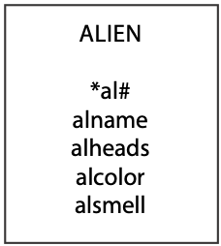

The paper has also supplied some data for the last few sightings and asked you to create the database, add details of these aliens, and answer the following queries:

* 1. What’s the average number of heads of an alien?
  2. Which alien has the most heads?
  3. Are there any aliens with a double o in their names?
  4. How many aliens are chartreuse?
  5. Report details of all aliens sorted by smell and color.

1. Eduardo, a bibliophile, has a collection of several hundred books. Being a little disorganized, he has his books scattered around his den. They are piled on the floor, some are in bookcases, and others sit on top of his desk. Because he has so many books, he finds it difficult to remember what he has, and sometimes he cannot find the book he wants. Eduardo has a simple personal computer file system that is fine for a single entity or file. He has decided that he would like to list each book by author(s)’ name and type of book (e.g., literature, travel, reference). Draw a data model for this problem, create a single entity table, and write some SQL queries.
   1. How do you identify each instance of a book? (It might help to look at a few books.)
   2. How should Eduardo physically organize his books to permit fast retrieval of a particular one?
   3. Are there any shortcomings with the data model you have created?
2. What is an identifier? Why does a data model have an identifier?
3. What are entities?
4. What is the entity integrity rule?

## CD library case[10]

Ajay, a DJ in the student-operated radio station at his university, is impressed by the station’s large collection of CDs but is frustrated by the time he spends searching for a particular piece of music. Recently, when preparing his weekly jazz session, he spent more than half an hour searching for a recording of Duke Ellington’s “Creole Blues.” An IS major, Ajay had recently commenced a data management class. He quickly realized that a relational database, storing details of all the CDs owned by the radio station, would enable him to find quickly any piece of music.

Having just learned how to model a single entity, Ajay decided to start building a CD database. He took one of his favorite CDs, John Coltrane’s Giant Steps, and drew a model to record details of the tracks on this CD.

CD library V1.0

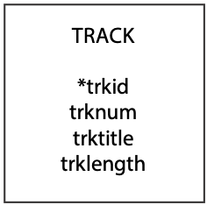

Ajay pondered using track number as the identifier since each track on a CD is uniquely numbered, but he quickly realized that track number was not suitable because it uniquely identifies only those tracks on a specific CD. So, he introduced trackid to identify uniquely each track irrespective of the CD on which it is found.

He also recorded the name of the track and its length. He had originally thought that he would record the track’s length in minutes and seconds (e.g., 4:43) but soon discovered that the TIME data type of his DBMS is designed to store time of day rather than the length of time of an event. Thus, he concluded that he should store the length of a track in minutes as a decimal (i.e., 4:43 is stored as 4.72).

| trkid | trknum | trktitle | trklength |
| --- | --- | --- | --- |
| 1 | 1 | Giant Steps | 4.72 |
| 2 | 2 | Cousin Mary | 5.75 |
| 3 | 3 | Countdown | 2.35 |
| 4 | 4 | Spiral | 5.93 |
| 5 | 5 | Syeeda’s Song Flute | 7 |
| 6 | 6 | Naima | 4.35 |
| 7 | 7 | Mr. P.C. | 6.95 |
| 8 | 8 | Giant Steps | 3.67 |
| 9 | 9 | Naima | 4.45 |
| 10 | 10 | Cousin Mary | 5.9 |
| 11 | 11 | Countdown | 4.55 |
| 12 | 12 | Syeeda’s Song Flute | 7.03 |

Skill builder

Create a single table database using the data in the preceding table.

Justify your choice of data type for each of the attributes.

Ajay ran a few queries on his single table database.

* On what track is “Giant Steps”?

SELECT trknum, trktitle FROM track

WHERE trktitle = 'Giant Steps';

| trknum | trktitle |
| --- | --- |
| 1 | Giant Steps |
| 8 | Giant Steps |

Observe that there are two tracks with the title “Giant Steps.”

* Report all recordings longer than 5 minutes.

SELECT trknum, trktitle, trklength FROM track

WHERE trklength > 5;

| trknum | trktitle | trklength |
| --- | --- | --- |
| 2 | Cousin Mary | 5.75 |
| 4 | Spiral | 5.93 |
| 5 | Syeeda's Song Flute | 7 |
| 7 | Mr. P.C. | 6.95 |
| 10 | Cousin Mary | 5.9 |
| 12 | Syeeda's song Flute | 7.03 |

* What is the total length of recordings on the CD?

This query makes use of the function SUM to total the length of tracks on the CD.

SELECT SUM(trklength) AS sumtrklen FROM track;

| sumtrklen |
| --- |
| 62.65 |

When you run the preceding query, the value reported may not be exactly 62.65. Why?

* Find the longest track on the CD.

SELECT trknum, trktitle, trklength FROM track

WHERE trklength = (SELECT MAX(trklength) FROM track);

This query follows the model described previously in this chapter. First determine the longest track (i.e., 7.03 minutes) and then find the track, or tracks, that are this length.

| trknum | trktitle | trklength |
| --- | --- | --- |
| 12 | Syeeda’s Song Flute | 7.03 |

* How many tracks are there on the CD?

SELECT COUNT(*) AS tracks FROM track;

| tracks |
| --- |
| 12 |

* Sort the different titles on the CD by their name.

SELECT DISTINCT(trktitle) FROM track

ORDER BY trktitle;

| trktitle |
| --- |
| Countdown |
| Cousin Mary |
| Giant Steps |
| Mr. P.C. |
| Naima |
| Spiral |
| Syeeda’s Song Flute |

* List the shortest track containing “song” in its title.

SELECT trknum, trktitle, trklength FROM track

WHERE trktitle REGEXP 'song'

AND trklength = (SELECT MIN(trklength) FROM track

WHERE trktitle REGEXP 'song');

The subquery determines the length of the shortest track with “song” in its title. Then any track with a length equal to the minimum and also containing “song” in its title (just in case there is another without “song” in its title that is the same length) is reported.

| trknum | trktitle | trklength |
| --- | --- | --- |
| 5 | Syeeda’s Song Flute | 7 |

* Report details of tracks 1 and 5.

SELECT trknum, trktitle, trklength FROM track

WHERE trknum IN (1,5);

| trknum | trktitle | trklength |
| --- | --- | --- |
| 1 | Giant Steps | 4.72 |
| 5 | Syeeda’s Song Flute | 7 |

Skill builder

1. Write SQL commands for the following queries:
   1. Report all tracks between 4 and 5 minutes long.
   2. On what track is “Naima”?
   3. Sort the tracks by descending length.
   4. What tracks are longer than the average length of tracks on the CD?
   5. How many tracks are less than 5 minutes?
   6. What tracks start with “Cou”?
2. Add the 13 tracks from The Manhattan Transfer’s Swing CD in the following table to the track table:

| Track | Title | Length |
| --- | --- | --- |
| 1 | Stomp of King Porter | 3.2 |
| 2 | Sing a Study in Brown | 2.85 |
| 3 | Sing Moten’s Swing | 3.6 |
| 4 | A-tisket, A-tasket | 2.95 |
| 5 | I Know Why | 3.57 |
| 6 | Sing You Sinners | 2.75 |
| 7 | Java Jive | 2.85 |
| 8 | Down South Camp Meetin’ | 3.25 |
| 9 | Topsy | 3.23 |
| 10 | Clouds | 7.2 |
| 11 | Skyliner | 3.18 |
| 12 | It’s Good Enough to Keep | 3.18 |
| 13 | Choo Choo Ch’ Boogie | 3 |

1. Write SQL to answer the following queries:
   1. What is the longest track on Swing?
   2. What tracks on Swing include the word Java?
2. What is the data model missing?

4. The One-to-Many Relationship

*Cow of many—well milked and badly fed.*

Spanish proverb

## Learning objectives

Students completing this chapter will be able to

* model a one-to-many relationship between two entities;
* define a database with a one-to-many relationship;
* write queries for a database with a one-to-many relationship.

Alice sat with a self-satisfied smirk on her face. Her previous foray into her attaché case had revealed the extent of her considerable stock holdings. She was wealthy beyond her dreams. What else was there in this marvelous, magic attaché case? She rummaged further into the case and retrieved a folder labeled “Stocks—foreign.” More shares!

On the inside cover of the folder was a note stating that the stocks in this folder were not listed in the United Kingdom. The folder contained three sheets of paper. Each was headed by the name of a country and followed by a list of stocks and the number of shares. The smirk became the cattiest of Cheshire grins. Alice ordered another bottle of champagne and turned to her iPad to check the latest prices on the Google Finance page. She wanted to calculate the current value of each stock and then use current exchange rates to convert the values into British pounds.

# Relationships

Entities are not isolated; they are related to other entities. When we move beyond the single entity, we need to identify the relationships between entities to accurately represent the real world. Once we recognize that all stocks in our case study are not listed in the United Kingdom, we need to introduce an entity called NATION. We now have two entities, STOCK and NATION. Consider the relationship between them. A NATION can have many listed stocks. A stock, in this case, is listed in only one nation. There is a 1:m (one-to-many) relationship between NATION and STOCK.

A 1:m relationship between two entities is depicted by a line connecting the two with a crow’s foot at the many end of the relationship. The following figure shows the 1:m relationship between NATION and STOCK. This can be read as: “a nation can have many stocks, but a stock belongs to only one nation.” The entity NATION is identified by *nation code* and has attributes *nation name* and *exchange rate*.

A 1:m relationship between NATION and STOCK

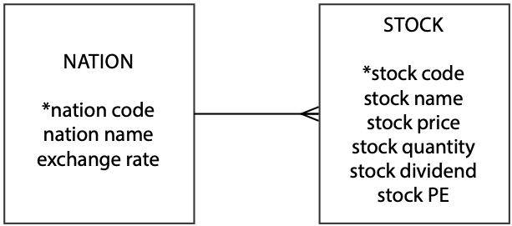

The 1:m relationship occurs frequently in business situations. Sometimes it occurs in a tree or hierarchical fashion. Consider a very hierarchical firm. It has many divisions, but a division belongs to only one firm. A division has many departments, but a department belongs to only one division. A department has many sections, but a section belongs to only one department.

A series of 1:m relationships

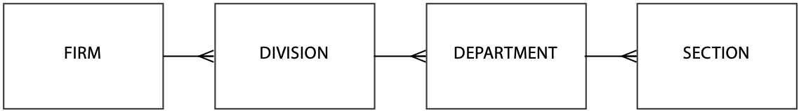

## Why did we create an additional entity?

Another approach to adding data about listing nation and exchange rate is to add two attributes to STOCK: *nation name* and *exchange rate*. At first glance, this seems a very workable solution; however, this will introduce considerable redundancy, as the following table illustrates.

The table stock with additional columns

| stkcode | stkfirm | stkprice | stkqty | stkdiv | stkpe | natname | exchrate |
| --- | --- | --- | --- | --- | --- | --- | --- |
| FC | Freedonia Copper | 27.5 | 10529 | 1.84 | 16 | United Kingdom | 1 |
| PT | Patagonian Tea | 55.25 | 12635 | 2.5 | 10 | United Kingdom | 1 |
| AR | Abyssinian Ruby | 31.82 | 22010 | 1.32 | 13 | United Kingdom | 1 |
| SLG | Sri Lankan Gold | 50.37 | 32868 | 2.68 | 16 | United Kingdom | 1 |
| ILZ | Indian Lead & Zinc | 37.75 | 6390 | 3 | 12 | United Kingdom | 1 |
| BE | Burmese Elephant | 0.07 | 154713 | 0.01 | 3 | United Kingdom | 1 |
| BS | Bolivian Sheep | 12.75 | 231678 | 1.78 | 11 | United Kingdom | 1 |
| NG | Nigerian Geese | 35 | 12323 | 1.68 | 10 | United Kingdom | 1 |
| CS | Canadian Sugar | 52.78 | 4716 | 2.5 | 15 | United Kingdom | 1 |
| ROF | Royal Ostrich Farms | 33.75 | 1234923 | 3 | 6 | United Kingdom | 1 |
| MG | Minnesota Gold | 53.87 | 816122 | 1 | 25 | USA | 0.67 |
| GP | Georgia Peach | 2.35 | 387333 | 0.2 | 5 | USA | 0.67 |
| NE | Narembeen Emu | 12.34 | 45619 | 1 | 8 | Australia | 0.46 |
| QD | Queensland Diamond | 6.73 | 89251 | 0.5 | 7 | Australia | 0.46 |
| IR | Indooroopilly Ruby | 15.92 | 56147 | 0.5 | 20 | Australia | 0.46 |
| BD | Bombay Duck | 25.55 | 167382 | 1 | 12 | India | 0.0228 |

The exact samenation nameandexchange rate data pair occurs 10 times for stocks listed in the United Kingdom. Redundancy presents problems when we want to insert, delete, or update data. These problems, generally known as update anomalies, occur with these three basic operations.

### Insert anomalies

We cannot insert a fact about a nation’s exchange rate unless we first buy a stock that is listed in that nation. Consider the case where we want to keep a record of France’s exchange rate and we have no French stocks. We cannot skirt this problem by putting in a null entry for stock details because stkcode, the primary key, would be null, and this is not allowed. If we have a separate table for facts about a nation, then we can easily add new nations without having to buy stocks. This is particularly useful when other parts of the organization, say International Trading, also need access to exchange rates for many nations.

### Delete anomalies

If we delete data about a particular stock, we might also lose a fact about exchange rates. For example, if we delete details of Bombay Duck, we also erase the Indian exchange rate.

### Update anomalies

Exchange rates are volatile. Most companies need to update them every day. What happens when the Australian exchange rate changes? Every row in stock with nation = 'Australia' will have to be updated. In a large portfolio, many rows will be changed. There is also the danger of someone forgetting to update all the instances of the nation and exchange rate pair. As a result, there could be two exchange rates for the one nation. If exchange rate is stored in nation, however, only one change is necessary, there is no redundancy, and there is no danger of inconsistent exchange rates.

# Creating a database with a 1:m relationship

As before, each entity becomes a table in a relational database, the entity name becomes the table name, each attribute becomes a column, and each identifier becomes a primary key. The 1:m relationship is mapped by adding a column to the entity at the many end of the relationship. The additional column contains the identifier of the one end of the relationship.

Consider the relationship between the entities STOCK and NATION. The database has two tables: stock and nation. The table stock has an additional column, natcode, which contains the primary key of nation. If natcode is not stored in stock, then there is no way of knowing the identity of the nation where the stock is listed.

A relational database with tables nation and stock

| nation |  |  |  |
| --- | --- | --- | --- |
| natcode | natname | exchrate |  |
| AUS | Australia | 0.46 |  |
| IND | India | 0.0228 |  |
| UK | United Kingdom | 1 |  |
| USA | United States | 0.67 | → |

| stock |  |  |  |  |  |  |  |
| --- | --- | --- | --- | --- | --- | --- | --- |
| stkcode | stkfirm | stkprice | stkqty | stkdiv | stkpe | natcode |  |
| FC | Freedonia Copper | 27.5 | 10,529 | 1.84 | 16 | UK |  |
| PT | Patagonian Tea | 55.25 | 12,635 | 2.5 | 10 | UK |  |
| AR | Abyssinian Ruby | 31.82 | 22,010 | 1.32 | 13 | UK |  |
| SLG | Sri Lankan Gold | 50.37 | 32,868 | 2.68 | 16 | UK |  |
| ILZ | Indian Lead & Zinc | 37.75 | 6,390 | 3 | 12 | UK |  |
| BE | Burmese Elephant | 0.07 | 154,713 | 0.01 | 3 | UK |  |
| BS | Bolivian Sheep | 12.75 | 231,678 | 1.78 | 11 | UK |  |
| NG | Nigerian Geese | 35 | 12,323 | 1.68 | 10 | UK |  |
| CS | Canadian Sugar | 52.78 | 4,716 | 2.5 | 15 | UK |  |
| ROF | Royal Ostrich Farms | 33.75 | 1,234,923 | 3 | 6 | UK |  |
| MG | Minnesota Gold | 53.87 | 816,122 | 1 | 25 | USA | ← |
| GP | Georgia Peach | 2.35 | 387,333 | 0.2 | 5 | USA | ← |
| NE | Narembeen Emu | 12.34 | 45,619 | 1 | 8 | AUS |  |
| QD | Queensland Diamond | 6.73 | 89,251 | 0.5 | 7 | AUS |  |
| IR | Indooroopilly Ruby | 15.92 | 56,147 | 0.5 | 20 | AUS |  |
| BD | Bombay Duck | 25.55 | 167,382 | 1 | 12 | IND |  |

Notice that natcode appears in both the stock and nation tables. In nation, natcode is the primary key; it is unique for each instance of nation. In table stock, natcode is a foreign key because it is the primary key of nation, the one end of the 1:m relationship. The column natcode is a foreign key in stock because it is a primary key in nation. A matched primary key–foreign key pair is the method for recording the 1:m relationship between the two tables. This method of representing a relationship is illustrated using shading and arrows for the two USA stocks. In the stock table, natcode is italicized to indicate that it is a foreign key. This method, like underlining a primary key, is a useful reminder.

Although the same name has been used for the primary key and the foreign key in this example, it is not mandatory. The two columns can have different names, and in some cases you are forced to use different names. When possible, we find it convenient to use identical column names to help us remember that the tables are related. To distinguish between columns with identical names, they must by qualified by prefixing the table name. In this case, use nation.natcode and stock.natcode. Thus, nation.natcode refers to the natcode column in the table nation.

Although a nation can have many stocks, it is not mandatory to have any. That is, in data modeling terminology, many can be zero, one, or more, but it is mandatory to have a value for natcode in nation for every value of natcode in stock. This requirement, known as the **referential integrity constraint**, maintains the accuracy of a database. Its application means that every foreign key in a table has an identical primary key in that same table or another table. In this example, it means that for every value of natcode in stock, there is a corresponding entry in nation. As a result, a primary key row must be created before its corresponding foreign key row. In other words, details for a nation must be added before any data about its listed stocks are entered.

Every foreign key must have a matching primary key (referential integrity rule), and every primary key must be non-null (entity integrity rule). A foreign key cannot be null when a relationship is mandatory, as in the case where a stock must belong to a nation. If a relationship is optional (a person can have a boss), then a foreign key can be null (i.e., a person is the head of the organization, and thus has no boss). The ideas of mandatory and optional will be discussed later in this book.

Why is the foreign key in the table at the “many” end of the relationship? Because each instance of stock is associated with exactly one instance of nation. The rule is that a stock must be listed in one, and only one, nation. Thus, the foreign key field is single-valued when it is at the “many” end of a relationship. The foreign key is not at the “one” end of the relationship because each instance of nation can be associated with more than one instance of stock, and this implies a multivalued foreign key. The relational model does not support multivalued fields.

Using SQL, the two tables are defined in a similar manner to the way we created a single table in Chapter 3. Here are the SQL statements:

CREATE TABLE nation (

natcode CHAR(3),

natname VARCHAR(20),

exchrate DECIMAL(9,5),

PRIMARY KEY(natcode));

CREATE TABLE stock (

stkcode CHAR(3),

stkfirm VARCHAR(20),

stkprice DECIMAL(6,2),

stkqty DECIMAL(8),

stkdiv DECIMAL(5,2),

stkpe DECIMAL(5),

natcode CHAR(3),

PRIMARY KEY(stkcode),

CONSTRAINT fk_has_nation FOREIGN KEY(natcode)

REFERENCES nation(natcode) ON DELETE RESTRICT);

Notice that the definition of stock includes an additional phrase to specify the foreign key and the referential integrity constraint. The CONSTRAINT clause defines the column or columns in the table being created that constitute the foreign key. A referential integrity constraint can be named, and in this case, the constraint’s name is fk_has_nation. The foreign key is the column natcode in stock, and it references the primary key of nation, which is natcode.

The ON DELETE clause specifies what processing should occur if an attempt is made to delete a row in nation with a primary key that is a foreign key in stock. In this case, the ON DELETE clause specifies that it is not permissible (the meaning of RESTRICT) to delete a primary key row in nation while a corresponding foreign key in stock exists. In other words, the system will not execute the delete. You must first delete all corresponding rows in stock before attempting to delete the row containing the primary key. ON DELETE is the default clause for most RDBMSs, so we will dispense with specifying it for future foreign key constraints.

Observe that both the primary and foreign keys are defined as CHAR(3). The relational model requires that a primary key–foreign key pair have the same data type and are the same length.

Skill Builder

The university architect has asked you to develop a data model to record details of the campus buildings. A building can have many rooms, but a room can be in only one building. Buildings have names, and rooms have a size and purpose (e.g., lecture, laboratory, seminar). Draw a data model for this situation and create the matching relational database.

## MySQL Workbench

In Workbench, a 1:m relationship is represented in a similar manner to the method you have just learned. Also, note that the foreign key is shown in the entity at the many end with a red diamond. We omit the foreign key when data modeling because it can be inferred. You will observe some additional symbols on the line between the two entities, and these will be explained later, but take note of the crow’s foot indicating the 1:m relationship between nation and stock. Because Workbench can generate automatically the SQL to create the tables,[11] we use lowercase table names and abbreviated column names.

Specifying a 1:m relationship in MySQL Workbench

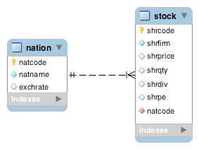

# Querying a two-table database

A two-table database offers the opportunity to learn more SQL and another relational algebra operation: join.

## Join

Join creates a new table from two existing tables by matching on a column common to both tables. Usually, the common column is a primary key–foreign key pair: The primary key of one table is matched with the foreign key of another table. Join is frequently used to get the data for a query into a single row. Consider the tables nation and stock. If we want to calculate the value—in British pounds—of a stock, we multiply stock price by stock quantity and then exchange rate. To find the appropriate exchange rate for a stock, get its natcode from stock and then find the exchange rate in the matching row in nation, the one with the same value for natcode. For example, to calculate the value of Georgia Peach, which has natcode = 'US', find the row in nation that also has natcode = 'US'. In this case, the stock’s value is 2.35*387333*0.67 = £609,855.81.

Calculation of stock value is very easy once a join is used to get the three values in one row. The SQL command for joining the two tables is:

SELECT * FROM stock JOIN nation

ON stock.natcode = nation.natcode;

The join of stock and nation

| stkcode | stkfirm | stkprice | stkqty | stkdiv | stkpe | natcode | natcode | natname | exchrate |
| --- | --- | --- | --- | --- | --- | --- | --- | --- | --- |
| NE | Narembeen Emu | 12.34 | 45619 | 1 | 8 | AUS | AUS | Australia | 0.4600 |
| IR | Indooroopilly Ruby | 15.92 | 56147 | 0.5 | 20 | AUS | AUS | Australia | 0.4600 |
| QD | Queensland Diamond | 6.73 | 89251 | 0.5 | 7 | AUS | AUS | Australia | 0.4600 |
| BD | Bombay Duck | 25.55 | 167382 | 1 | 12 | IND | IND | India | 0.0228 |
| ROF | Royal Ostrich Farms | 33.75 | 1234923 | 3 | 6 | UK | UK | United Kingdom | 1.0000 |
| CS | Canadian Sugar | 52.78 | 4716 | 2.5 | 15 | UK | UK | United Kingdom | 1.0000 |
| FC | Freedonia Copper | 27.5 | 10529 | 1.84 | 16 | UK | UK | United Kingdom | 1.0000 |
| BS | Bolivian Sheep | 12.75 | 231678 | 1.78 | 11 | UK | UK | United Kingdom | 1.0000 |
| BE | Burmese Elephant | 0.07 | 154713 | 0.01 | 3 | UK | UK | United Kingdom | 1.0000 |
| ILZ | Indian Lead & Zinc | 37.75 | 6390 | 3 | 12 | UK | UK | United Kingdom | 1.0000 |
| SLG | Sri Lankan Gold | 50.37 | 32868 | 2.68 | 16 | UK | UK | United Kingdom | 1.0000 |
| AR | Abyssinian Ruby | 31.82 | 22010 | 1.32 | 13 | UK | UK | United Kingdom | 1.0000 |
| PT | Patagonian Tea | 55.25 | 12635 | 2.5 | 10 | UK | UK | United Kingdom | 1.0000 |
| NG | Nigerian Geese | 35 | 12323 | 1.68 | 10 | UK | UK | United Kingdom | 1.0000 |
| MG | Minnesota Gold | 53.87 | 816122 | 1 | 25 | US | US | United States | 0.6700 |
| GP | Georgia Peach | 2.35 | 387333 | 0.2 | 5 | US | US | United States | 0.6700 |

The columns stkprice and stkdiv record values in the country’s currency. Thus, the price of Bombay Duck is 25.55 Indian rupees. To find the value in U.K. pounds (GPB), multiply the price by 0.0228, because one rupee is worth 0.0228 GPB. The value of one share of Bombay Duck in U.S. dollars (USD) is 25.55*0.0228/0.67 because one USD is worth 0.67 GBP.

There are several things to notice about the SQL command and the result:

* To avoid confusion because natcode is a column name in both stock and nation, it needs to be qualified. If natcode is not qualified, the system will reject the query because it cannot distinguish between the two columns titled natcode.
* The new table has the natcode column replicated. Both are called natcode. The naming convention for the replicated column varies with the RDBMS. The columns, for example, should be labeled stock.natcode and nation.natcode.
* The SQL command specifies the names of the tables to be joined, the columns to be used for matching, and the condition for the match (equality in this case).
* The number of columns in the new table is the sum of the columns in the two tables.
* The stock value calculation is now easily specified in an SQL command because all the data are in one row.

Remember that during data modeling we created two entities, STOCK and NATION, and defined the relationship between them. We showed that if the data were stored in one table, there could be updating problems. Now, with a join, we have combined these data. So why separate the data only to put them back together later? There are two reasons. First, we want to avoid update anomalies. Second, as you will discover, we do not join the same tables every time.

Join comes in several flavors. The matching condition can be =, <>, <=, <, >=, and >. This generalized version is called a theta join. Generally, when people refer to a join, they mean an equijoin, when the matching condition is equality.

In an alphabetical list of employees, how many appear before Clare?

SELECT count(*) FROM emp A JOIN emp B

ON A.empfname > B.empfname

WHERE A.empfname = "Clare"

A join can be combined with other SQL commands.

* Report the value of each stockholding in UK pounds. Sort the report by nation and firm.

SELECT natname, stkfirm, stkprice, stkqty, exchrate,

stkprice*stkqty*exchrate as stkvalue

FROM stock JOIN nation

ON stock.natcode = nation.natcode

ORDER BY natname, stkfirm;

| natname | stkfirm | stkprice | stkqty | exchrate | stkvalue |
| --- | --- | --- | --- | --- | --- |
| Australia | Indooroopilly Ruby | 15.92 | 56147 | 0.4600 | 411176 |
| Australia | Narembeen Emu | 12.34 | 45619 | 0.4600 | 258952 |
| Australia | Queensland Diamond | 6.73 | 89251 | 0.4600 | 276303 |
| India | Bombay Duck | 25.55 | 167382 | 0.0228 | 97507 |
| United Kingdom | Abyssinian Ruby | 31.82 | 22010 | 1.0000 | 700358 |
| United Kingdom | Bolivian Sheep | 12.75 | 231678 | 1.0000 | 2953895 |
| United Kingdom | Burmese Elephant | 0.07 | 154713 | 1.0000 | 10830 |
| United Kingdom | Canadian Sugar | 52.78 | 4716 | 1.0000 | 248910 |
| United Kingdom | Freedonia Copper | 27.5 | 10529 | 1.0000 | 289548 |
| United Kingdom | Indian Lead & Zinc | 37.75 | 6390 | 1.0000 | 241223 |
| United Kingdom | Nigerian Geese | 35 | 12323 | 1.0000 | 431305 |
| United Kingdom | Patagonian Tea | 55.25 | 12635 | 1.0000 | 698084 |
| United Kingdom | Royal Ostrich Farms | 33.75 | 1234923 | 1.0000 | 41678651 |
| United Kingdom | Sri Lankan Gold | 50.37 | 32868 | 1.0000 | 1655561 |
| United States | Georgia Peach | 2.35 | 387333 | 0.6700 | 609856 |
| United States | Minnesota Gold | 53.87 | 816122 | 0.6700 | 29456210 |

## Control break reporting

The purpose of a join is to collect the necessary data for a report. When two tables in a 1:m relationship are joined, the report will contain repetitive data. If you re-examine the report from the previous join, you will see that nation and exchrate are often repeated because the same values apply to many stocks. A more appropriate format is shown in the following figure, an example of a control break report.

|  |
| --- |
| Nation Exchange rate  Firm Price Quantity Value  Australia 0.4600  Indooroopilly Ruby 15.92 56,147 411,175.71  Narembeen Emu 12.34 45,619 258,951.69  Queensland Diamond 6.73 89,251 276,303.25  India 0.0228  Bombay Duck 25.55 167,382 97,506.71  United Kingdom 1.0000  Abyssinian Ruby 31.82 22,010 700,358.20  Bolivian Sheep 12.75 231,678 2,953,894.50  Burmese Elephant 0.07 154,713 10,829.91  Canadian Sugar 52.78 4,716 248,910.48  Freedonia Copper 27.50 10,529 289,547.50  Indian Lead & Zinc 37.75 6,390 241,222.50  Nigerian Geese 35.00 12,323 431,305.00  Patagonian Tea 55.25 12,635 698,083.75  Royal Ostrich Farms 33.75 1,234,923 41,678,651.25  Sri Lankan Gold 50.37 32,868 1,655,561.16  United States 0.6700  Georgia Peach 2.35 387,333 609,855.81  Minnesota Gold 53.87 816,122 29,456,209.73 |

A control break report recognizes that the values in a particular column or columns seldom change. In this case, natname and exchrate are often the same from one row to the next, so it makes sense to report these data only when they change. The report is also easier to read. The column natname is known as a *control field*. Notice that there are four groups of data, because natname has four different values.

Many RDBMS packages have report-writing languages to facilitate creating a control break report. These languages typically support summary reporting for each group of rows having the same value for the control field(s). A table must usually be sorted on the control break field(s) before the report is created.

### GROUP BY—reporting by groups

The GROUP BY clause is an elementary form of control break reporting. It permits grouping of rows that have the same value for a specified column or columns, and it produces one row for each different value of the grouping column(s).

* Report by nation the total value of stockholdings.

SELECT natname, sum(stkprice*stkqty*exchrate) as stkvalue

FROM stock JOIN nation ON stock.natcode = nation.natcode

GROUP BY natname;

| natname | stkvalue |
| --- | --- |
| Australia | 946431 |
| India | 97507 |
| United Kingdom | 48908364 |
| United States | 30066066 |

SQL’s built-in functions (COUNT, SUM, AVERAGE, MIN, and MAX) can be used with the GROUP BY clause. They are applied to a group of rows having the same value for a specified column. You can specify more than one function in a SELECT statement. For example, we can compute total value and number of different stocks and group by nation using:

* Report the number of stocks and their total value by nation.

SELECT natname, COUNT(*), SUM(stkprice*stkqty*exchrate) AS stkvalue

FROM stock JOIN nation ON stock.natcode = nation.natcode

GROUP BY natname;

| natname | count | stkvalue |
| --- | --- | --- |
| Australia | 3 | 946431 |
| India | 1 | 97507 |
| United Kingdom | 10 | 48908364 |
| United States | 2 | 30066066 |

You can group by more than one column name; however, all column names appearing in the SELECT clause must be associated with a built-in function or be in a GROUP BY clause.

* List stocks by nation, and for each nation show the number of stocks for each PE ratio and the total value of those stock holdings in UK pounds.

SELECT natname,stkpe,COUNT(*),

SUM(stkprice*stkqty*exchrate) AS stkvalue

FROM stock JOIN nation ON stock.natcode = nation.natcode

GROUP BY natname, stkpe;

| natname | stkpe | count | stkvalue |
| --- | --- | --- | --- |
| Australia | 7 | 1 | 276303 |
| Australia | 8 | 1 | 258952 |
| Australia | 20 | 1 | 411176 |
| India | 12 | 1 | 97507 |
| United Kingdom | 3 | 1 | 10830 |
| United Kingdom | 6 | 1 | 41678651 |
| United Kingdom | 10 | 2 | 1129389 |
| United Kingdom | 11 | 1 | 2953895 |
| United Kingdom | 12 | 1 | 241223 |
| United Kingdom | 13 | 1 | 700358 |
| United Kingdom | 15 | 1 | 248910 |
| United Kingdom | 16 | 2 | 1945109 |
| United States | 5 | 1 | 609856 |
| United States | 25 | 1 | 29456210 |

In this example, stocks are grouped by both natname and stkpe. In most cases, there is only one stock for each pair of natname and stkpe; however, there are two situations (U.K. stocks with PEs of 10 and 16) where details of multiple stocks are grouped into one report line. Examining the values in the COUNT column helps you to identify these stocks.

### HAVING—the WHERE clause of groups

HAVING does in the GROUP BY what the WHERE clause does in a SELECT. It restricts the number of groups reported, whereas WHERE restricts the number of rows reported. Used with built-in functions, HAVING is always preceded by GROUP BY and is always followed by a function (SUM, AVG, MAX, MIN, or COUNT).

* Report the total value of stocks for nations with two or more listed stocks.

SELECT natname, SUM(stkprice*stkqty*exchrate) AS stkvalue

FROM stock JOIN nation ON stock.natcode = nation.natcode

GROUP BY natname

HAVING COUNT(*) >= 2;

| natname | stkvalue |
| --- | --- |
| Australia | 946431 |
| United Kingdom | 48908364 |
| United States | 30066066 |

Skill Builder

Report by nation the total value of dividends.

## Regular expression—pattern matching

Regular expression was introduced in the previous chapter, and we will now continue to learn some more of its features.

### Search for a string not containing specified characters

The ^ (carat) is the symbol for NOT. It is used when we want to find a string not containing a character in one or more specified strings. For example, [^a-f] means any character not in the set containing a, b, c, d, e, or f.

* List the names of nations with non-alphabetic characters in their names

SELECT natname FROM nation WHERE natname REGEXP '[^a-z|A-Z]'

| natname |
| --- |
| United Kingdom |
| United States |

Notice that the nations reported have a space in their name, which is a character not in the range a-z and not in A-Z.

### Search for string containing a repeated pattern or repetition

A pair of curly brackets is used to denote the repetition factor for a pattern. For example, {n} means repeat a specified pattern n times.

* List the names of firms with a double ‘e’.

SELECT stkfirm FROM stock WHERE stkfirm REGEXP '[e]{2}';

| stkfirm |
| --- |
| Bolivian Sheep |
| Freedonia Copper |
| Narembeen Emu |
| Nigerian Geese |

### Search combining alternation and repetition

Regular expressions becomes very powerful when you combine several of the basic capabilities into a single search expression.

* List the names of firms with a double ‘s’ or a double ‘n’.

SELECT stkfirm FROM stock WHERE stkfirm REGEXP '[s]{2}|[n]{2}';

| stkfirm |
| --- |
| Abyssinian Ruby |
| Minnesota Gold |

### Search for multiple versions of a string

If you are interested in find a string containing several specified string, you can use the square brackets to indicate the sought strings. For example, [ea] means any character from the set containing e and a.

* List the names of firms with names that include ‘inia’ or ‘onia’.

SELECT stkfirm FROM stock WHERE stkfirm REGEXP '[io]nia';

| shrfirm |
| --- |
| Abyssinian Ruby |
| Freedonia Copper |
| Patagonian Tea |

### Search for a string in a particular position

Sometimes you might be interested in identifying a string with a character in a particular position.

* Find firms with ‘t’ as the third letter of their name.

SELECT stkfirm FROM stock WHERE stkfirm REGEXP '^(.){2}t';

| shrfirm |
| --- |
| Patagonian Tea |

The regular expression has three elements:  
 ^ indicates start searching at the beginning of the string;

(.){2} specifies that anything is acceptable for the next two characters;

t indicates what the next character, the third, must be.

You have seen a few of the features of a very powerful tool. To learn more about regular expressions, see regexlib.com,[12] which contains a library of regular expressions and a feature for finding expressions to solve specific problems. Check out the regular expression for checking whether a character string is a valid email address.

## Subqueries

A subquery, or nested SELECT, is a SELECT nested within another SELECT. A subquery can be used to return a list of values subsequently searched with an IN clause.

* Report the names of all Australian stocks.

SELECT stkfirm FROM stock

WHERE natcode IN

(SELECT natcode FROM nation

WHERE natname = 'Australia');

| stkfirm |
| --- |
| Narembeen Emu |
| Queensland Diamond |
| Indooroopilly Ruby |

Conceptually, the subquery is evaluated first. It returns a list of values for natcode ('AUS') so that the query then is the same as:

SELECT stkfirm FROM stock

WHERE natcode IN ('AUS');

When discussing subqueries, sometimes a subquery is also called an inner query. The term outer query is applied to the SQL preceding the inner query. In this case, the outer and inner queries are:

|  |  |
| --- | --- |
| Outer query | SELECT stkfirm FROM stock  WHERE natcode IN |
| Inner query | (SELECT natcode FROM nation  WHERE natname = 'Australia'); |

Note that in this case we do not have to qualify natcode. There is no identity crisis, because natcode in the inner query is implicitly qualified as nation.natcode and natcode in the outer query is understood to be stock.natcode.

This query also can be run as a join by writing:

SELECT stkfirm FROM stock JOIN nation

ON stock.natcode = nation.natcode

AND natname = 'Australia';

### Correlated subquery

In a correlated subquery, the subquery cannot be evaluated independently of the outer query. It depends on the outer query for the values it needs to resolve the inner query. The subquery is evaluated for each value passed to it by the outer query. An example illustrates when you might use a correlated subquery and how it operates.

* Find those stocks where the quantity is greater than the average for that country.

An approach to this query is to examine the rows of stock one a time, and each time compare the quantity of stock to the average for that country. This means that for each row, the subquery must receive the outer query’s country code so it can compute the average for that country.

SELECT natname, stkfirm, stkqty FROM stock JOIN nation

ON stock.natcode = nation.natcode

WHERE stkqty >

(SELECT avg(stkqty) FROM stock

WHERE stock.natcode = nation.natcode);

| natname | stkfirm | stkqty |
| --- | --- | --- |
| Australia | Queensland Diamond | 89251 |
| United Kingdom | Bolivian Sheep | 231678 |
| United Kingdom | Royal Ostrich Farms | 1234923 |
| United States | Minnesota Gold | 816122 |

Conceptually, think of this query as stepping through the join of stock and nation one row at a time and executing the subquery each time. The first row has natcode = 'AUS' so the subquery becomes

SELECT AVG(stkqty) FROM stock

WHERE stock.natcode = 'AUS';

Since the average stock quantity for Australian stocks is 63,672.33, the first row in the join, Narembeen Emu, is not reported. Neither is the second row reported, but the third is.

The term correlated subquery is used because the inner query’s execution depends on receiving a value for a variable (nation.natcode in this instance) from the outer query. Thus, the inner query of the correlated subquery cannot be evaluated once and for all. It must be evaluated repeatedly—once for each value of the variable received from the outer query. In this respect, a correlated subquery is different from a subquery, where the inner query needs to be evaluated only once. The requirement to compare each row of a table against a function (e.g., average or count) for some rows of a column is usually a clue that you need to write a correlated subquery.

Skill builder

Why are no Indian stocks reported in the correlated subquery example? How would you change the query to report an Indian stock?

Report only the three stocks with the largest quantities (i.e., do the query without using ORDER BY).

## Views—virtual tables

You might have noticed that in these examples we repeated the join and stock value calculation for each query. Ideally, we should do this once, store the result, and be able to use it with other queries. We can do so if we create a ***view***, a virtual table. A view does not physically exist as stored data; it is an imaginary table constructed from existing tables as required. You can treat a view as if it were a table and write SQL to query it.

A view contains selected columns from one or more tables. The selected columns can be renamed and rearranged. New columns based on arithmetic expressions can be created. GROUP BY can also be used when creating a view. Remember, a view contains no actual data. It is a virtual table.

This SQL command does the join, calculates stock value, and saves the result as a view:

CREATE VIEW stkvalue

(nation, firm, price, qty, exchrate, value)

AS SELECT natname, stkfirm, stkprice, stkqty, exchrate,

stkprice*stkqty*exchrate

FROM stock JOIN nation

ON stock.natcode = nation.natcode;

There are several things to notice about creating a view:

* The six names enclosed by parentheses are the column names for the view.
* There is a one-to-one correspondence between the names in parentheses and the names or expressions in the SELECT clause. Thus the view column named value contains the result of the arithmetic expression stkprice*stkqty*exchrate.

A view can be used in a query, such as:

* Find stocks with a value greater than £100,000.

SELECT nation, firm, value FROM stkvalue WHERE value > 100000;

| nation | firm | value |
| --- | --- | --- |
| United Kingdom | Freedonia Copper | 289548 |
| United Kingdom | Patagonian Tea | 698084 |
| United Kingdom | Abyssinian Ruby | 700358 |
| United Kingdom | Sri Lankan Gold | 1655561 |
| United Kingdom | Indian Lead & Zinc | 241223 |
| United Kingdom | Bolivian Sheep | 2953895 |
| United Kingdom | Nigerian Geese | 431305 |
| United Kingdom | Canadian Sugar | 248910 |
| United Kingdom | Royal Ostrich Farms | 41678651 |
| United States | Minnesota Gold | 29456210 |
| United States | Georgia Peach | 609856 |
| Australia | Narembeen Emu | 258952 |
| Australia | Queensland Diamond | 276303 |
| Australia | Indooroopilly Ruby | 411176 |

There are two main reasons for creating a view. First***,*** as we have seen, query writing can be simplified. If you find that you are frequently writing the same section of code for a variety of queries, then isolate the common section and put it in a view. This means that you will usually create a view when a fact, such as stock value, is derived from other facts in the table.

The second reason is to restrict access to certain columns or rows. For example, the person who updates stock could be given a view that excludes stkqty. In this case, changes in stock prices could be updated without revealing confidential information, such as the value of the stock portfolio.

Skill builder

How could you use a view to solve the following query that was used when discussing the correlated subquery?

Find those stocks where the quantity is greater than the average for that country.

## Summary

Entities are related to other entities by relationships. The 1:m (one-to-many) relationship occurs frequently in data models. An additional entity is required to represent a 1:m relationship to avoid update anomalies. In a relational database, a 1:m relationship is represented by an additional column, the foreign key, in the table at the many end of the relationship. The referential integrity constraint insists that a foreign key must always exist as a primary key in a table. A foreign key constraint is specified in a CREATE statement.

Join creates a new table from two existing tables by matching on a column common to both tables. Often the common column is a primary key–foreign key combination. A theta-join can have matching conditions of =, <>, <=, <, >=, and >. An equijoin describes the situation where the matching condition is equality. The GROUP BY clause is used to create an elementary control break report. The HAVING clause of GROUP BY is like the WHERE clause of SELECT. A subquery, which has a SELECT statement within another SELECT statement, causes two SELECT statements to be executed—one for the inner query and one for the outer query. A correlated subquery is executed as many times as there are rows selected by the outer query. A view is a virtual table that is created when required. Views can simplify report writing and restrict access to specified columns or rows.

## Key terms and concepts

Constraint

Control break reporting

Correlated subquery

Delete anomalies

Equijoin

Foreign key

GROUP BY

HAVING

Insert anomalies

JOIN

One-to-many (1:m) relationship

Referential integrity

Relationship

Theta-join

Update anomalies

Views

Virtual table

## Exercises

1. Draw data models for the following situations. In each case, make certain that you show the attributes and feasible identifiers:
   1. A farmer can have many cows, but a cow belongs to only one farmer.
   2. A university has many students, and a student can attend at most one university.
   3. An aircraft can have many passengers, but a passenger can be on only one flight at a time.
   4. A nation can have many states and a state many cities.
   5. An art researcher has asked you to design a database to record details of artists and the museums in which their paintings are displayed. For each painting, the researcher wants to know the size of the canvas, year painted, title, and style. The nationality, date of birth, and death of each artist must be recorded. For each museum, record details of its location and specialty, if it has one.
2. Report all values in British pounds:
   1. Report the value of stocks listed in Australia.
   2. Report the dividend payment of all stocks.
   3. Report the total dividend payment by nation.
   4. Create a view containing nation, firm, price, quantity, exchange rate, value, and yield.
   5. Report the average yield by nation.
   6. Report the minimum and maximum yield for each nation.
   7. Report the nations where the average yield of stocks exceeds the average yield of all stocks.
3. How would you change the queries in exercise 4-2 if you were required to report the values in American dollars, Australian dollars, or Indian rupees?
4. What is a foreign key and what role does it serve?
5. What is the referential integrity constraint? Why should it be enforced?
6. Kisha, against the advice of her friends, is simultaneously studying data management and Shakespearean drama. She thought the two subjects would be an interesting contrast. However, the classes are very demanding and often enter her midsummer dreams. Last night, she dreamed that William Shakespeare wanted her to draw a data model. He explained, before she woke up in a cold sweat, that a play had many characters but the same character never appeared in more than one play. “Methinks,” he said, “the same name may have appeareth more than the once, but ‘twas always a person of a different ilk.” He then, she hazily recollects, went on to spout about the quality of data dropping like the gentle rain. Draw a data model to keep old Bill quiet and help Kisha get some sleep.
7. An orchestra has four broad classes of instruments (strings, woodwinds, brass, and percussion). Each class contains musicians who play different instruments. For example, the strings section of a full symphony orchestra contains 2 harps, 16 to 18 first violins, 14 to 16 second violins, 12 violas, 10 cellos, and 8 double basses. A city has asked you to develop a database to store details of the musicians in its three orchestras. All the musicians are specialists and play only one instrument for one orchestra.
8. Answer the following queries based on the following database for a car dealer: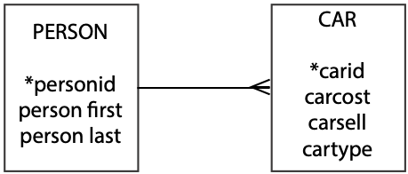
   1. What is the personid of Sheila O’Hara?
   2. List sales personnel sorted by last name and within last name, first name.
   3. List details of the sales made by Bruce Bush.
   4. List details of all sales showing the gross profit (selling price minus cost price).
   5. Report the number of cars sold of each type.
   6. What is the average selling price of cars sold by Sue Lim?
   7. Report details of all sales where the gross profit is less than the average.
   8. What was the maximum selling price of any car?
   9. What is the total gross profit?
   10. Report the gross profit made by each salesperson who sold at least three cars.
   11. Create a view containing all the details in the car table and the gross profit
9. Find stocks where the third or fourth letter in their name is an 'm'.
10. An electricity supply company needs a database to record details of solar panels installed on its customers’ homes so it can estimate how much solar energy will be generated based on the forecast level of solar radiation for each house’s location. A solar panel has an area, measured in square meters, and an efficiency expressed as a percentage (e.g., 22% efficiency means that 22% of the incident solar energy is converted into electrical energy). Create a data model. How will you identify each customer and each panel?

## CD library case

Ajay soon realized that a CD contains far more data that just a list of track titles and their length. Now that he had learned about the 1:m relationship, he was ready to add some more detail. He recognized that a CD contains many tracks, and a label (e.g., Atlantic) releases many CDs. He revised his data model to include these additional entities (CD and LABEL) and their relationships.

CD library V2.0

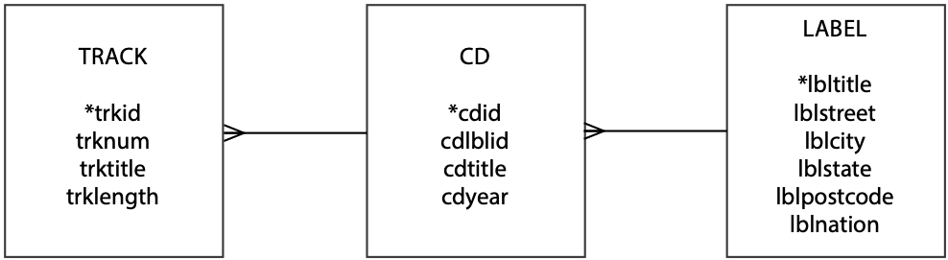

*Giant Steps* and *Swing* are both on the Atlantic label; the data are

| lbltitle | lblstreet | lblcity | lblstate | lblpostcode | lblnation |
| --- | --- | --- | --- | --- | --- |
| Atlantic | 75 Rockefeller Plaza | New York | NY | 10019 | USA |

The cd data, where lbltitle is the foreign key, are

| cdid | cdlblid | cdtitle | cdyear | l*bltitle* |
| --- | --- | --- | --- | --- |
| 1 | A2 1311 | Giant Steps | 1960 | Atlantic |
| 2 | 83012-2 | Swing | 1977 | Atlantic |

The track data, where cdid is the foreign key, are

| trkid | trknum | trktitle | trklength | cdid |
| --- | --- | --- | --- | --- |
| 1 | 1 | Giant Steps | 4.72 | 1 |
| 2 | 2 | Cousin Mary | 5.75 | 1 |
| 3 | 3 | Countdown | 2.35 | 1 |
| 4 | 4 | Spiral | 5.93 | 1 |
| 5 | 5 | Syeeda’s Song Flute | 7 | 1 |
| 6 | 6 | Naima | 4.35 | 1 |
| 7 | 7 | Mr. P.C. | 6.95 | 1 |
| 8 | 8 | Giant Steps | 3.67 | 1 |
| 9 | 9 | Naima | 4.45 | 1 |
| 10 | 10 | Cousin Mary | 5.9 | 1 |
| 11 | 11 | Countdown | 4.55 | 1 |
| 12 | 12 | Syeeda’s Song Flute | 7.03 | 1 |
| 13 | 1 | Stomp of King Porter | 3.2 | 2 |
| 14 | 2 | Sing a Study in Brown | 2.85 | 2 |
| 15 | 3 | Sing Moten’s Swing | 3.6 | 2 |
| 16 | 4 | A-tisket, A-tasket | 2.95 | 2 |
| 17 | 5 | I Know Why | 3.57 | 2 |
| 18 | 6 | Sing You Sinners | 2.75 | 2 |
| 19 | 7 | Java Jive | 2.85 | 2 |
| 20 | 8 | Down South Camp Meetin’ | 3.25 | 2 |
| 21 | 9 | Topsy | 3.23 | 2 |
| 22 | 10 | Clouds | 7.2 | 2 |
| 23 | 11 | Skyliner | 3.18 | 2 |
| 24 | 12 | It’s Good Enough to Keep | 3.18 | 2 |
| 25 | 13 | Choo Choo Ch’ Boogie | 3 | 2 |

Skill builder

Create tables to store the label and CD data. Add a column to track to store the foreign key. Then, either enter the new data or download it from the Web site. Define lbltitle as a foreign key in cd and cdid as a foreign key in track.

Ajay ran a few queries on his revised database.

* What are the tracks on Swing?

This query requires joining track and cd because the name of a CD (*Swing* in this case) is stored in cd and track data are stored in track. The foreign key of track is matched to the primary key of cd (i.e., track.cdid = cd.cdid).

SELECT trknum, trktitle, trklength FROM track JOIN cd

ON track.cdid = cd.cdid

WHERE cdtitle = 'Swing';

| trknum | trktitle | trklength |
| --- | --- | --- |
| 1 | Stomp of King Porter | 3.2 |
| 2 | Sing a Study in Brown | 2.85 |
| 3 | Sing Moten’s Swing | 3.6 |
| 4 | A-tisket, A-tasket | 2.95 |
| 5 | I Know Why | 3.57 |
| 6 | Sing You Sinners | 2.75 |
| 7 | Java Jive | 2.85 |
| 8 | Down South Camp Meetin’ | 3.25 |
| 9 | Topsy | 3.23 |
| 10 | Clouds | 7.2 |
| 11 | Skyliner | 3.18 |
| 12 | It’s Good Enough to Keep | 3.18 |
| 13 | Choo Choo Ch’ Boogie | 3 |

* What is the longest track on Swing?

Like the prior query, this one requires joining track and cd. The inner query isolates the tracks on *Swing* and then selects the longest of these using the MAX function. The outer query also isolates the tracks on *Swing* and selects the track equal to the maximum length. The outer query must restrict attention to tracks on *Swing* in case there are other tracks in the track table with a time equal to the value returned by the inner query.

SELECT trknum, trktitle, trklength FROM track JOIN cd

ON track.cdid = cd.cdid

WHERE cdtitle = 'Swing'

AND trklength =

(select max(trklength) FROM track, cd

WHERE track.cdid = cd.cdid

AND cdtitle = 'Swing');

| trknum | trktitle | trklength |
| --- | --- | --- |
| 10 | Clouds | 7.2 |

* What are the titles of CDs containing some tracks less than 3 minutes long and on U.S.-based labels? List details of these tracks as well.

This is a three-table join since resolution of the query requires data from cd (cdtitle), track (trktitle), and label (lblnation).

SELECT cdtitle, trktitle, trklength FROM track JOIN cd

ON track.cdid = cd.cdid

JOIN label

ON cd.lbltitle = label.lbltitle

WHERE trklength < 3

AND lblnation = 'USA';

| cdtitle | trktitle | trklength |
| --- | --- | --- |
| Giant Steps | Countdown | 2.35 |
| Swing | Sing a Study in Brown | 2.85 |
| Swing | A-tisket, A-tasket | 2.95 |
| Swing | Sing You Sinners | 2.75 |
| Swing | Java Jive | 2.85 |

* Report the number of tracks on each CD.

This query requires GROUP BY because the number of tracks on each CD is totaled by using the aggregate function COUNT.

SELECT cdtitle, count(*) AS tracks FROM track JOIN cd

ON track.cdid = cd.cdid

GROUP BY cdtitle;

| cdtitle | tracks |
| --- | --- |
| Giant Steps | 12 |
| Swing | 13 |

* Report, in ascending order, the total length of tracks on each CD.

This is another example of GROUP BY. In this case, SUM is used to accumulate track length, and ORDER BY is used for sorting in ascending order, the default sort order.

SELECT cdtitle, SUM(trklength) AS sumtrklen FROM track JOIN cd

ON track.cdid = cd.cdid

GROUP BY cdtitle

ORDER BY SUM(trklength);

| cdtitle | sumtrklen |
| --- | --- |
| Swing | 44.81 |
| Giant Steps | 62.65 |

* Does either CD have more than 60 minutes of music?

This query uses the HAVING clause to limit the CDs reported based on their total length.

SELECT cdtitle, SUM(trklength) AS sumtrklen FROM track JOIN cd

ON track.cdid = cd.cdid

GROUP BY cdtitle HAVING SUM(trklength) > 60;

| cdtitle | sumtrklen |
| --- | --- |
| Giant Steps | 62.65 |

Skill builder

1. Write SQL for the following queries:
   1. List the tracks by CD in order of track length.
   2. What is the longest track on each CD?
2. What is wrong with the current data model?
3. Could cdlblid be used as an identifier for CD?

5. The Many-to-Many Relationship

Fearful concatenation of circumstances.

Daniel Webster

## Learning objectives

Students completing this chapter will be able to

* model a many-to-many relationship between two entities;
* define a database with a many-to-many relationship;
* write queries for a database with a many-to-many relationship.

Alice was deeply involved in uncovering the workings of her firm. She spent hours talking to the staff, wanting to know everything about the products sold. She engaged many a customer in conversation to find out why they shopped at The Expeditioner, what they were looking for, and how they thought the business could be improved. She examined all the products herself and pestered the staff to tell her who bought them, how they were used, how many were sold, who supplied them, and a host of other questions. She plowed (or should that be “ploughed”) through accounting journals, sales reports, and market forecasts. She was more than a new broom; she was a giant vacuum cleaner sucking up data about the firm so that she would be prepared to manage it successfully.

Ned, the marketing manager, was a Jekyll and Hyde character. By day he was a charming, savvy, marketing executive. Walking to work in his three-piece suit, bowler hat, and furled umbrella, he was the epitome of the conservative English businessman. By night he became a computer nerd with ragged jeans, a T-shirt, black-framed glasses, and unruly hair. Ned had been desperate to introduce computers to The Expeditioner for years, but he knew that he could never reveal his second nature. The other staff at The Expeditioner just would not accept such a radical change in technology. Why, they had not even switched to fountain pens until their personal stock of quill pens was finally depleted. Ned was just not prepared to face the indignant silence and contempt that would greet his mere mention of computers. It was better to continue a secret double life than admit to being a cyber punk.

But times were changing, and Ned saw the opportunity. He furtively suggested to Lady Alice that perhaps she needed a database of sales facts. Her response was instantaneous: “Yes, and do it as soon as possible.” Ned was ecstatic. This was truly a wonderful woman.

# The many-to-many relationship

Consider the case when items are sold. We can immediately identify two entities: SALE and ITEM. A sale can contain many items, and an item can appear in many sales. We are not saying the same item can be sold many times, but the particular type of item (e.g., a compass) can be sold many times; thus we have a many-to-many (m:m) relationship between SALE and ITEM. When we have an m:m relationship, we create a third entity to link the entities through two 1:m relationships. Usually, it is fairly easy to name this third entity. In this case, this third entity, typically known as an associative entity, is called LINE ITEM. A typical old style sales form lists the items purchased by a customer. Each of the lines appearing on the order form is generally known in retailing as a line item, which links an item and a sale.

A sales form

| The Expeditioner Sale of Goods | | | | | |
| --- | --- | --- | --- | --- | --- |
| Sale# | | | Date: |  |  |
| Item# | | Description | Quantity | Unit price | Total |
| 1 |  |  |  |  |  |
| 2 |  |  |  |  |  |
| 3 |  |  |  |  |  |
| 4 |  |  |  |  |  |
| 5 |  |  |  |  |  |
| 6 |  |  |  |  |  |
| Grand total | | | | |  |

The representation of this m:m relationship is shown. We say many-to-many because there are two relationships—an ITEM is related to many SALEs, and a SALE is related to many ITEMs. This data model can also be read as: “a sale has many line items, but a line item refers to only one sale. Similarly, an item can appear as many line items, but a line item references only one item.”

An m:m relationship between SALE and ITEM

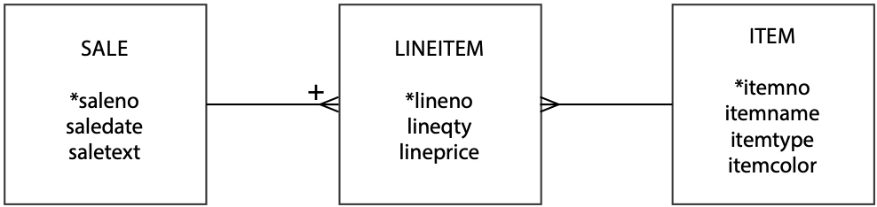

The entity SALE is identified by saleno and has the attributes saledate and saletext (a brief comment on the customer—soft information). LINEITEM is partially identified by lineno and has attributes lineqty (the number of units sold) and lineprice (the unit selling price for this sale). ITEM is identified by itemno and has attributes itemname, itemtype (e.g., clothing, equipment, navigation aids, furniture, and so on), and itemcolor.

If you look carefully at the m:m relationship figure, you will notice that there is a plus sign (+) above the crow’s foot at the “many” end of the 1:m relationship between SALE and LINEITEM. This plus sign provides information about the identifier of LINEITEM. As you know, every entity must have a unique identifier. A sales order is a series of rows or lines, and lineno is unique only within a particular order. If we just use lineno as the identifier, we cannot guarantee that every instance of LINEITEM is unique. If we use saleno and lineno together, however, we have a unique identifier for every instance of LINEITEM. Identifier saleno is unique for every sale, and lineno is unique within any sale. The plus indicates that LINEITEM’s unique identifier is the concatenation of saleno and lineno. The order of concatenation does not matter.

LINEITEM is termed a weak entity because it relies on another entity for its existence and identification.

## MySQL Workbench

Workbench automatically creates an associative entity for an m:m relationship and populates it with a composite primary key based on concatenating the primary keys of the two entities forming the m:m relationship. First, draw the two tables and enter their respective primary keys and columns. Second, select the m:m symbol and connect the two tables through clicking on one and dragging to the second and releasing. You can then modify the associative entity as required, such as changing its primary key. The capability to automatically create an associative entity for an m:m relationship is a very useful Workbench feature.

An m:m relationship with Workbench

## 

Workbench distinguishes between two types of relationships. An identifying relationship, shown by a solid line, is used when the entity at the many end of the relationship is a weak entity and needs the identifier of the one end of the relationship to uniquely identify an instance of the relationship, as in LINEITEM. An identifying relationship corresponds to the + sign associated with a crow’s foot. The other type of relationship, shown by a dashed line, is known as a *non-identifying* relationship. The mapping between the type of relationship and the representation (i.e., dashed or solid line) is arbitrary and thus not always easily recalled. We think that using a + on the crow’s foot is a better way of denoting weak entities.

When the relationship between SALE and ITEM is drawn in Workbench, as shown in the following figure, there are two things to notice. First, the table, lineitem, maps the associative entity generated for the m:m relationship. Second, lineitem has an identifying relationship with sale and a non-identifying relationship with item.

An m:m relationship between SALE and ITEM in MySQL Workbench

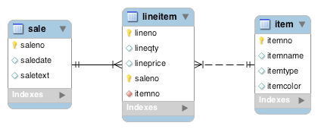

## Why did we create a third entity?

When we have an m:m relationship, we create an associative entity to store data about the relationship. In this case, we have to store data about the items sold. We cannot store the data with SALE because a sale can have many items, and an instance of an entity stores only single-value facts. Similarly, we cannot store data with ITEM because an item can appear in many sales. Since we cannot store data in SALE or ITEM, we must create another entity to store data about the m:m relationship.

You might find it useful to think of the m:m relationship as two 1:m relationships. An item can appear on many line item listings, and a line item entry refers to only one item. A sale has many line items, and each line item entry refers to only one sale.

## Social Security number is not unique!

Two girls named Sarah Lee Ferguson were born on May 3, 1959. The U.S. government considered them one and the same and issued both the same Social Security number (SSN), a nine-digit identifier of U.S. residents. Now Sarah Lee Ferguson Boles and Sarah Lee Ferguson Johnson share the same SSN.[13]

Mrs. Boles became aware of her SSN twin in 1987 when the Internal Revenue Service claimed there was a discrepancy in her reported income. Because SSN is widely used as an attribute or identifier in many computer systems, Mrs. Boles encountered other incidents of mistaken identity. Some of Mrs. Johnson’s purchases appeared on Mrs. Boles’ credit reports.

In late 1989, the Social Security Administration notified Mrs. Boles that her original number was given to her in error and she had to provide evidence of her age, identity, and citizenship to get a new number. When Mrs. Boles got her new SSN, it is likely she had to also get a new driver’s license and establish a new credit history.

# Creating a relational database with an m:m relationship

As before, each entity becomes a table in a relational database, the entity name becomes the table name, each attribute becomes a column, and each identifier becomes a primary key. Remember, a 1:m relationship is mapped by adding a column to the entity of the many end of the relationship. The new column contains the identifier of the one end of the relationship.

Conversion of the foregoing data model results in the three tables following. Note the one-to-one correspondence between attributes and columns for sale and item. Observe the lineitem has two additional columns, saleno and itemno. Both of these columns are foreign keys in lineitem (remember the use of italics to signify foreign keys). Two foreign keys are required to record the two 1:m relationships. Notice in lineitem that saleno is both part of the primary key and a foreign key.

Tables sale, lineitem, and item

| saleno | saledate | saletext |
| --- | --- | --- |
| 1 | 2003-01-15 | Scruffy Australian—called himself Bruce. |
| 2 | 2003-01-15 | Man. Rather fond of hats. |
| 3 | 2003-01-15 | Woman. Planning to row Atlantic—lengthwise! |
| 4 | 2003-01-15 | Man. Trip to New York—thinks NY is a jungle! |
| 5 | 2003-01-16 | Expedition leader for African safari. |

| lineno | lineqty | lineprice | *saleno* | itemno |
| --- | --- | --- | --- | --- |
| 1 | 1 | 4.5 | 1 | 2 |
| 1 | 1 | 25 | 2 | 6 |
| 2 | 1 | 20 | 2 | 16 |
| 3 | 1 | 25 | 2 | 19 |
| 4 | 1 | 2.25 | 2 | 2 |
| 1 | 1 | 500 | 3 | 4 |
| 2 | 1 | 2.25 | 3 | 2 |
| 1 | 1 | 500 | 4 | 4 |
| 2 | 1 | 65 | 4 | 9 |
| 3 | 1 | 60 | 4 | 13 |
| 4 | 1 | 75 | 4 | 14 |
| 5 | 1 | 10 | 4 | 3 |
| 6 | 1 | 2.25 | 4 | 2 |
| 1 | 50 | 36 | 5 | 10 |
| 2 | 50 | 40.5 | 5 | 11 |
| 3 | 8 | 153 | 5 | 12 |
| 4 | 1 | 60 | 5 | 13 |
| 5 | 1 | 0 | 5 | 2 |

| itemno | itemname | itemtype | itemcolor |
| --- | --- | --- | --- |
| 1 | Pocket knife—Nile | E | Brown |
| 2 | Pocket knife—Avon | E | Brown |
| 3 | Compass | N | — |
| 4 | Geopositioning system | N | — |
| 5 | Map measure | N | — |
| 6 | Hat—Polar Explorer | C | Red |
| 7 | Hat—Polar Explorer | C | White |
| 8 | Boots—snake proof | C | Green |
| 9 | Boots—snake proof | C | Black |
| 10 | Safari chair | F | Khaki |
| 11 | Hammock | F | Khaki |
| 12 | Tent—8 person | F | Khaki |
| 13 | Tent—2 person | F | Khaki |
| 14 | Safari cooking kit | E | — |
| 15 | Pith helmet | C | Khaki |
| 16 | Pith helmet | C | White |
| 17 | Map case | N | Brown |
| 18 | Sextant | N | — |
| 19 | Stetson | C | Black |
| 20 | Stetson | C | Brown |

The SQL commands to create the three tables are as follows:

CREATE TABLE sale (

saleno INTEGER,

saledate DATE NOT NULL,

saletext VARCHAR(50),

PRIMARY KEY(saleno));

CREATE TABLE item (

itemno INTEGER,

itemname VARCHAR(30) NOT NULL,

itemtype CHAR(1) NOT NULL,

itemcolor VARCHAR(10),

PRIMARY KEY(itemno));

CREATE TABLE lineitem (

lineno INTEGER,

lineqty INTEGER NOT NULL,

lineprice DECIMAL(7,2) NOT NULL,

saleno INTEGER,

itemno INTEGER,

PRIMARY KEY(lineno,saleno),

CONSTRAINT fk_has_sale FOREIGN KEY(saleno)

REFERENCES sale(saleno),

CONSTRAINT fk_has_item FOREIGN KEY(itemno)

REFERENCES item(itemno));

Although the sale and item tables are created in a similar fashion to previous examples, there are two things to note about the definition of lineitem. *First,* the primary key is a composite of lineno and saleno, because together they uniquely identify an instance of lineitem. *Second*, there are two foreign keys, because lineno is at the "many" end of two 1: m relationships.

Skill builder

A hamburger shop makes several types of hamburgers, and the same type of ingredient can be used with several types of hamburgers. This does not literally mean the same piece of lettuce is used many times, but lettuce is used with several types of hamburgers. Draw the data model for this situation. What is a good name for the associative entity?

# Querying an m:m relationship

## A three-table join

The join operation can be easily extended from two tables to three or more merely by specifying the tables to be joined and the matching conditions. For example:

SELECT * FROM sale JOIN lineitem

ON sale.saleno = lineitem.saleno

JOIN item

ON item.itemno = lineitem.itemno;

There are two matching conditions: one for sale and lineitem (sale.saleno = lineitem.saleno) and one for the item and lineitem tables (item.itemno = lineitem.itemno). The table lineitem is the link between sale and item and must be referenced in both matching conditions.

You can tailor the join to be more precise and report some columns rather than all.

* List the name, quantity, price, and value of items sold on January 16, 2011.

SELECT itemname, lineqty, lineprice, lineqty*lineprice AS total

FROM sale, lineitem, item

WHERE lineitem.saleno = sale.saleno

AND item.itemno = lineitem.itemno

AND saledate = '2011-01-16';

| itemname | lineqty | lineprice | total |
| --- | --- | --- | --- |
| Pocket knife—Avon | 1 | 0 | 0 |
| Safari chair | 50 | 36 | 1800 |
| Hammock | 50 | 40.5 | 2025 |
| Tent—8 person | 8 | 153 | 1224 |
| Tent—2 person | 1 | 60 | 60 |

## EXISTS—does a value exist

EXISTS is used in a WHERE clause to test whether a table contains at least one row satisfying a specified condition. It returns the value true if and only if some row satisfies the condition; otherwise it returns false. EXISTS represents the existential quantifier of formal logic. The best way to get a feel for EXISTS is to examine a query.

* Report all clothing items (type “C”) for which a sale is recorded.

SELECT itemname, itemcolor FROM item

WHERE itemtype = 'C'

AND EXISTS (SELECT * FROM lineitem

WHERE lineitem.itemno = item.itemno);

| itemname | itemcolor |
| --- | --- |
| Hat—Polar Explorer | Red |
| Boots—snake proof | Black |
| Pith helmet | White |
| Stetson | Black |

Conceptually, we can think of this query as evaluating the subquery for each row of item. The first item with itemtype = 'C', Hat—Polar Explorer (red), in item has itemno = 6. Thus, the query becomes

SELECT itemname, itemcolor FROM item

WHERE itemtype = 'C'

AND EXISTS (SELECT * FROM lineitem

WHERE lineitem.itemno = 6);

Because there is at least one row in lineitem with itemno = 6, the subquery returns true. The item has been sold and should be reported. The second clothing item, Hat—Polar Explorer (white), in item has itemno = 7. There are no rows in lineitem with itemno = 7, so the subquery returns false. That item has not been sold and should not be reported.

You can also think of the query as, “Select clothing items for which a sale exists.” Remember, for EXISTS to return true, there needs to be only one row for which the condition is true.

## NOT EXISTS—select a value if it does not exist

NOT EXISTS is the negative of EXISTS. It is used in a WHERE clause to test whether all rows in a table fail to satisfy a specified condition. It returns the value true if there are no rows satisfying the condition; otherwise it returns false.

* Report all clothing items that have not been sold.

SELECT itemname, itemcolor FROM item

WHERE itemtype = 'C'

AND NOT EXISTS

(SELECT * FROM lineitem

WHERE item.itemno = lineitem.itemno);

| itemname | itemcolor |
| --- | --- |
| Hat—Polar Explorer | White |
| Boots—snake proof | Green |
| Pith helmet | Khaki |
| Stetson | Brown |

You can also think of the query as, “Select clothing items for which no sales exist.” Also remember, for NOT EXISTS to return true, no rows should satisfy the condition.

Skill builder

Report all red items that have not been sold. Write the query twice, once using EXISTS and once without EXISTS.

## Divide (and be conquered)

In addition to the existential quantifier that you have already encountered, formal logic has a universal quantifier known as forall that is necessary for queries such as

* Find the items that have appeared in all sales.

If a universal quantifier were supported by SQL, this query could be phrased as, “Select item names where forall sales there exists a lineitem row recording that this item was sold.” A quick inspection of the first set of tables shows that one item satisfies this condition (itemno = 2).

While SQL does not directly support the universal quantifier, formal logic shows that forall can be expressed using EXISTS. The query becomes, “Find items such that there does not exist a sale in which this item does not appear.” The equivalent SQL expression is

SELECT itemno, itemname FROM item

WHERE NOT EXISTS

(SELECT * FROM sale

WHERE NOT EXISTS

(SELECT * FROM lineitem

WHERE lineitem.itemno = item.itemno

AND lineitem.saleno = sale.saleno));

| itemname |
| --- |
| Pocket knife–Avon |

If you are interested in learning the inner workings of the preceding SQL for divide, see the additional material for Chapter 5 on the book’s Web site.

Relational algebra (Chapter 9) has the divideoperation, which makes divide queries easy to write. Be careful: Not all queries containing the word all are divides. With experience, you will learn to recognize and conquer divide.

To save the tedium of formulating this query from scratch, we have developed a template for dealing with these sorts of queries. Divide queries typically occur with m:m relationships.

A template for divide

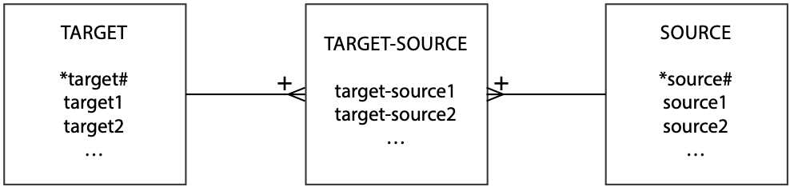

An appropriate generic query and template SQL command are

* Find the target1 that have appeared in all sources.

SELECT target1 FROM target

WHERE NOT EXISTS

(SELECT * FROM source

WHERE NOT EXISTS

(SELECT * FROM target-source

WHERE target-source.target# = target.target#

AND target-source.source# = source.source#));

Skill builder

Find the brown items that have appeared in all sales.

## Beyond the great divide

Divide proves troublesome to most people because of the double negative—we just don’t think that way. If divide sends your neurons into knots, then try the following approach.

The query “Find the items that have appeared in all sales” can be rephrased as “Find the items for which the number of sales that include this item is equal to the total number of sales.” This is an easier query to write than “Find items such that there does not exist a sale in which this item does not appear.” The rephrased query has two parts. First***,*** determine the total number of sales. Here we mean distinct sales (i.e., the number of rows with a distinct value for saleno). The SQL is

SELECT COUNT (DISTINCT saleno) FROM sale;

Second, group the items sold by itemno and itemname and use a HAVING clause with COUNT to calculate the number of sales in which the item has occurred. Forcing the count in the HAVING clause to equal the result of the first query, which becomes an inner query, results in a list of items appearing in all sales.

SELECT item.itemno, item.itemname

FROM item JOIN lineitem

ON item.itemno = lineitem.itemno

GROUP BY item.itemno, item.itemname

HAVING COUNT(DISTINCT saleno)

= (SELECT COUNT(DISTINCT saleno) FROM sale);

## Set operations

Set operators are useful for combining the values derived from two or more SQL queries. The UNION operation is equivalent to or, and INTERSECT is equivalent to and.

* List items that were sold on January 16, 2011, or are brown.

Resolution of this query requires two tables: one to report items sold on January 16, 2011, and one to report the brown items. UNION (i.e., or) then combines the results of the tables, including any rows in both tables and excluding duplicate rows.

SELECT itemname FROM item JOIN lineitem

ON item.itemno = lineitem.itemno

JOIN sale

ON lineitem.saleno = sale.saleno

WHERE saledate = '2011-01-16'

UNION

SELECT itemname FROM item WHERE itemcolor = 'Brown';

| itemname |
| --- |
| Hammock |
| Map case |
| Pocket knife—Avon |
| Pocket knife—Nile |
| Safari chair |
| Stetson |
| Tent—2 person |
| Tent—8 person |

* List items that were sold on January 16, 2011, and are brown.

This query uses the same two tables as the previous query. In this case, INTERSECT (i.e., and) then combines the results of the tables including ***only*** rows in both tables and excluding duplicates.[14]

SELECT itemname FROM item JOIN lineitem

ON item.itemno = lineitem.itemno

JOIN sale

ON lineitem.saleno = sale.saleno

WHERE saledate = '2011-01-16'

INTERSECT

SELECT itemname FROM item WHERE itemcolor = 'Brown';

| itemname |
| --- |
| Pocket knife—Avon |

Skill builder

List the items that contain the words “Hat”, “Helmet”, or “Stetson” in their names.

## Summary

There can be a many-to-many (m:m) relationship between entities, which is represented by creating an associative entity and two 1:m relationships. An associative entity stores data about an m:m relationship. The join operation can be extended from two tables to three or more tables. EXISTS tests whether a table has at least one row that meets a specified condition. NOT EXISTS tests whether all rows in a table do not satisfy a specified condition. Both EXISTS and NOT EXISTS can return true or false. The relational operation divide, also known as forall, can be translated into a double negative. It is represented in SQL by a query containing two NOT EXISTS statements. Set operations enable the results of queries to be combined.

## Key terms and concepts

Associative entity

Divide

Existential quantifier

EXISTS

INTERSECT

Many-to-many (m:m) relationship

NOT EXISTS

UNION

Universal quantifier

## Exercises

1. Draw data models for the following situations. In each case, think about the names you give each entity:
   1. Farmers can own cows or share cows with other farmers.
   2. A track and field meet can have many competitors, and a competitor can participate in more than one event.
   3. A patient can have many physicians, and a physician can have many patients.
   4. A student can attend more than one class, and the same class can have many students.
   5. *The Marathoner*, a monthly magazine, regularly reports the performance of professional marathon runners. It has asked you to design a database to record the details of all major marathons (e.g., Boston, London, and Paris). Professional marathon runners compete in several races each year. A race may have thousands of competitors, but only about 200 or so are professional runners, the ones *The Marathoner* tracks. For each race, the magazine reports a runner’s time and finishing position and some personal details such as name, gender, and age.
2. The data model shown was designed by a golf statistician. Write SQL statements to create the corresponding relational database.

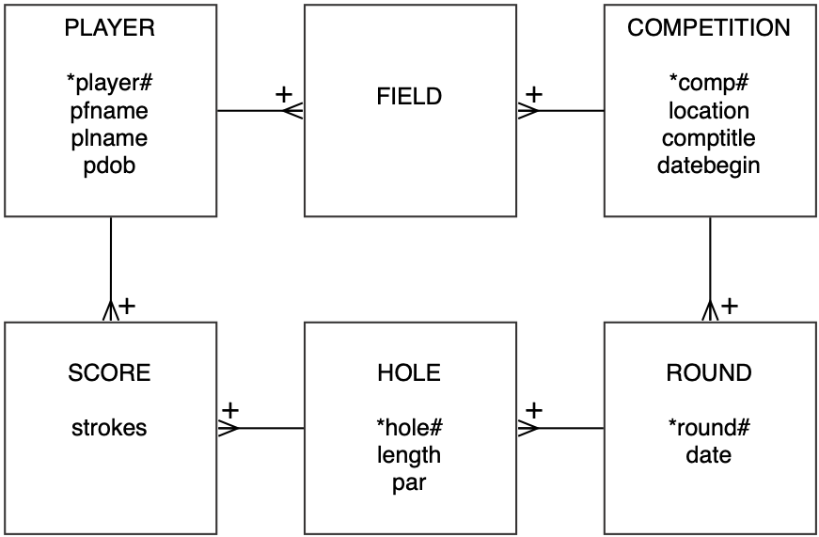

1. Write the following SQL queries for the database described in this chapter:
   1. List the names of items for which the quantity sold is greater than one for any sale.
   2. Compute the total value of sales for each item by date.
   3. Report all items of type “F” that have been sold.
   4. List all items of type “F” that have not been sold.
   5. Compute the total value of each sale.
2. Why do you have to create a third entity when you have an m:m relationship?
3. What does a plus sign near a relationship arc mean?
4. How does EXISTS differ from other clauses in an SQL statement?
5. Answer the following queries based on the described relational database.

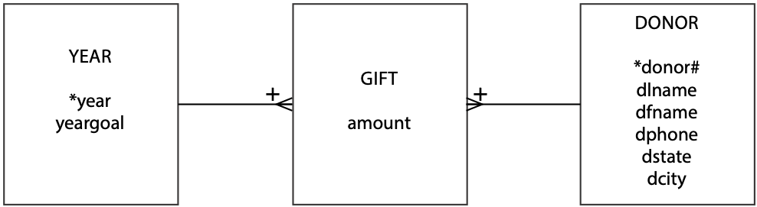

* 1. List the phone numbers of donors Hays and Jefts.
  2. How many donors are there in the donor table?
  3. How many people made donations in 1999?
  4. What is the name of the person who made the largest donation in 1999?
  5. What was the total amount donated in 2000?
  6. List the donors who have made a donation every year.
  7. List the donors whose average donation is more than twice the average donation of all donors.
  8. List the total amount given by each person across all years; sort the report by the donor’s name.
  9. Report the total donations in 2001 by state.
  10. In which years did the total donated exceed the goal for the year?

1. The following table records data found on the side of a breakfast cereal carton. Use these data as a guide to develop a data model to record nutrition facts for a meal. In this case, a meal is a cup of cereal and 1/2 cup of skim milk.

|  |  |  |
| --- | --- | --- |
| **Nutrition facts**  Serving size 1 cup (30g)  Servings per container about 17 | | |
| Amount per serving | Cereal | with 1/2 cup of skim milk |
| Calories | 110 | 150 |
| Calories from Fat | 10 | 10 |
|  |  | % Daily Value |
| Total Fat 1g | 1% | 2% |
| Saturated Fat 0g | 0% | 0% |
| Polyunsaturated Fat 0g |  |  |
| Monounsaturated Fat 0g |  |  |
| Cholesterol 0mg | 0% | 1% |
| Sodium 220mg | 9% | 12% |
| Potassium 105 mg | 3% | 9% |
| Total Carbohydrate 24g | 8% | 10% |
| Dietary Fiber 3g | 13% | 13% |
| Sugars 4g |  |  |
| Other Carbohydrate 17g |  |  |
| Protein 3g |  |  |
| Vitamin A | 10% | 15% |
| Vitamin C | 10% | 10% |
| Calcium | 2% | 15% |
| Iron | 45% | 45% |
| Vitamin D | 10% | 25% |
| Thiamin | 50% | 50% |
| Riboflavin | 50% | 50% |
| Niacin | 50% | 50% |
| Vitamin B12 | 50% | 60% |
| Phosphorus | 10% | 20% |
| Magnesium | 8% | 10% |
| Zinc | 50% | 50% |
| Copper | 4% | 4% |

## CD library case

After learning how to model m:m relationships, Ajay realized he could now model a number of situations that had bothered him. He had been puzzling over some relationships that he had recognized but was unsure how to model:

* A person can appear on many tracks, and a track can have many persons (e.g., *The Manhattan* *Transfer*, a quartet, has recorded many tracks).
* A person can compose many songs, and a song can have multiple composers (e.g., Rodgers and Hammerstein collaborated many times with Rodgers composing the music and Hammerstein writing the lyrics).
* An artist can release many CDs, and a CD can feature several artists (e.g., John Coltrane, who has many CDs, has a CD, *Miles & Coltrane,* with Miles Davis).

Ajay revised his data model to include the m:m relationships he had recognized. He wrestled with what to call the entity that stored details of people. Sometimes these people are musicians; other times singers, composers, and so forth. He decided that the most general approach was to call the entity PERSON. The extended data model is shown in the following figure.

CD library V3.0

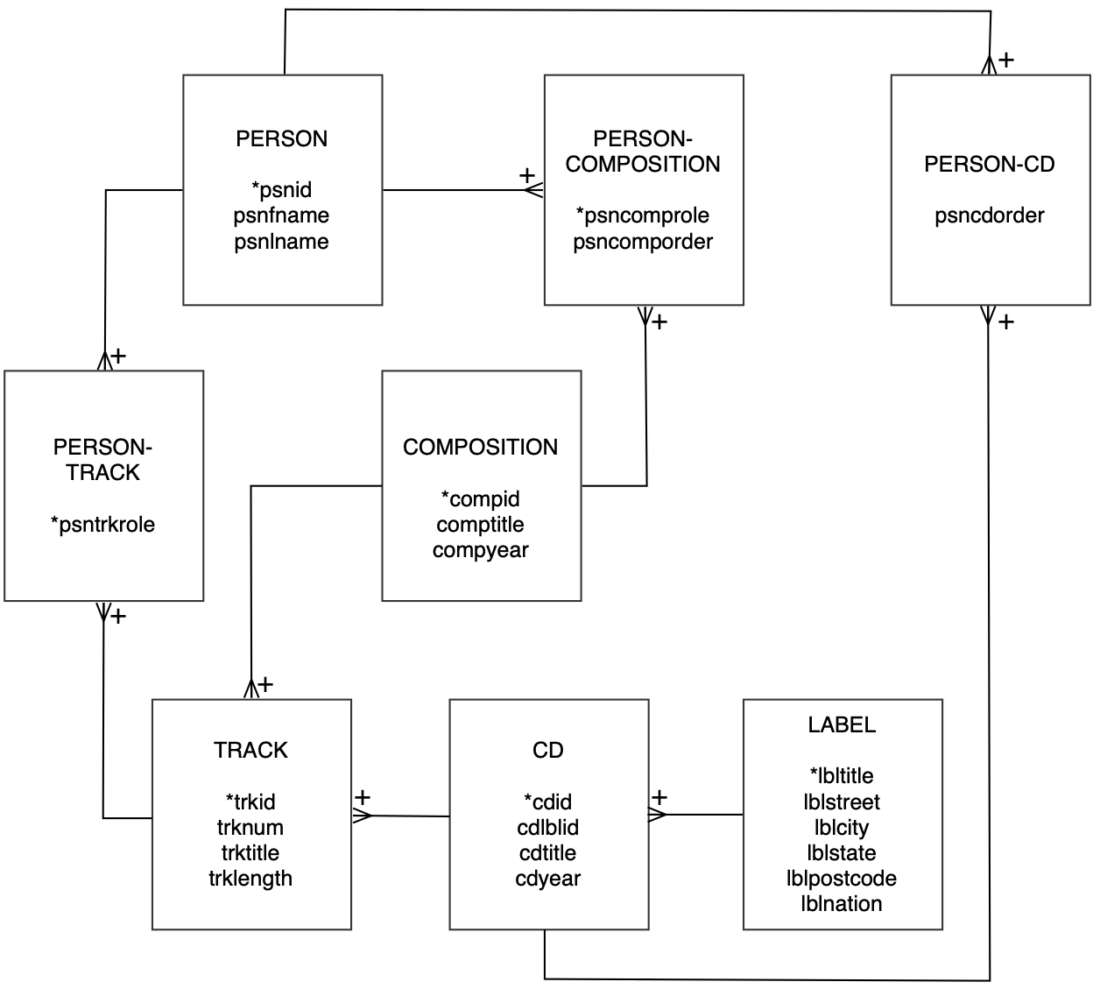

In version 3.0, Ajay introduced several new entities, including COMPOSITION to record details of a composition. He initially linked COMPOSITION to TRACK with a 1:m relationship. In other words, a composition can have many tracks, but a track is of one composition. This did not seem right.

After further thought, he realized there was a missing entity—RECORDING. A composition has many recordings (e.g., multiple recordings of John Coltrane’s composition “Giant Steps”), and a recording can appear as a track on different CDs (typically those whose title begins with The Best of … feature tracks on earlier CDs). Also, because a recording is a performance of a composition, it is a composition that has a title, not recording or track. So, he revised version 3.0 of the data model to produce version 4.0.

CD library V4.0

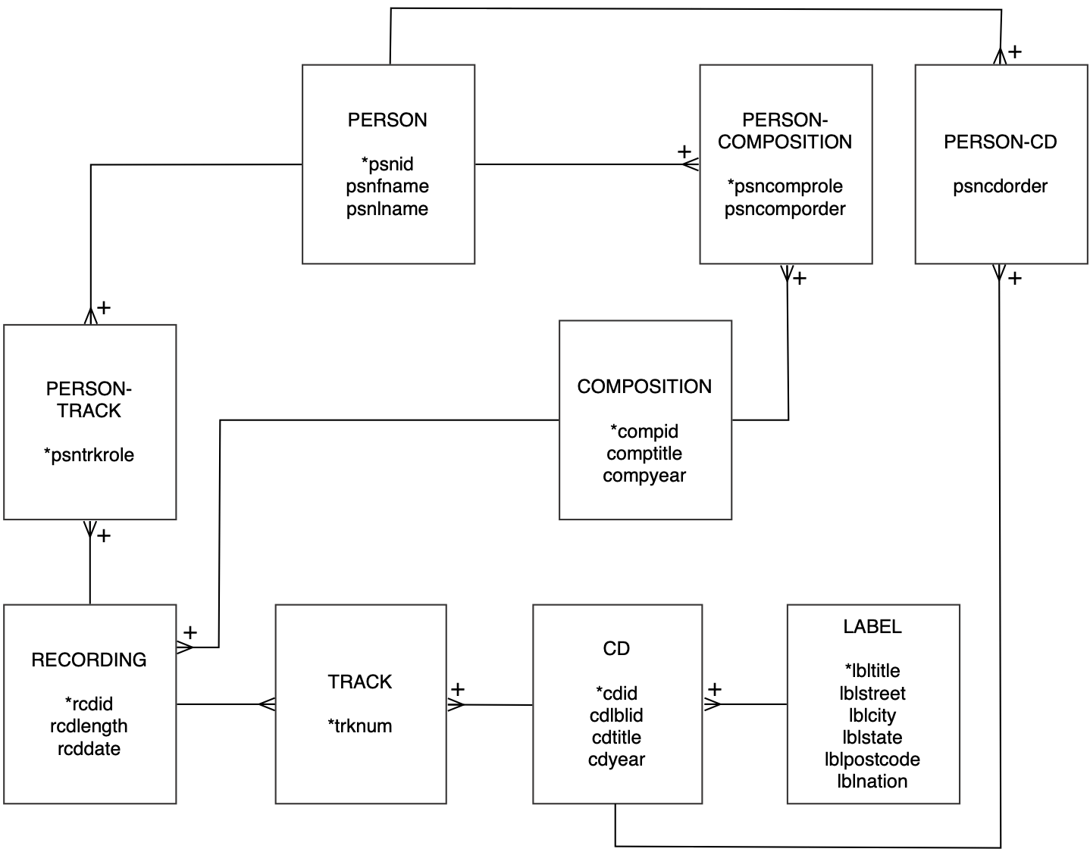

Version 4.0 of the model captures:

* the m:m between PERSON and RECORDING with the associative entity PERSON-RECORDING. The identifier for PERSON-RECORDING is a composite key (psnid, rcdid, psnrcdrole). The identifiers of PERSON and RECORDING are required to identify uniquely an instance of PERSON-RECORDING, which is why there are plus signs on the crow’s feet attached to PERSON-RECORDING. Also, because a person can have multiple roles on a recording, (e.g., play the piano and sing), then psnrcdrole is required to uniquely identify these situations.
* the m:m between PERSON and COMPOSITION with the associative entity PERSON-COMPOSITION. The identifier is a composite key (psnid, compid, psncomprole). The attribute psncomporder is for remembering the correct sequence in those cases where there are multiple people involved in a composition. That is, the database needs to record that it is Rodgers and Hammerstein, not Hammerstein and Rodgers.
* the m:m between PERSON and CD with the associative entity PERSON-CD. Again the identifier is a composite key (psnid, cdid) of the identifiers of entities in the m:m relationship, and there is an attribute (psncdorder) to record the order of the people featured on the CD.
* the 1:m between RECORDING and TRACK. A recording can appear on many tracks, but a track has only one recording.
* the 1:m between CD and TRACK. A CD can have many tracks, but a track appears on only one CD. You can also think of TRACK as the name for the associative entity of the m:m relationship between RECORDING and CD. A recording can appear on many CDs, and a CD has many recordings.

After creating the new tables, Ajay was ready to add some data. He decided first to correct the errors introduced by his initial, incorrect modeling of track by inserting data for recording and revising track. He realized that because recording contains a foreign key to record the 1:m relationship with composition, he needed to start by entering the data for composition. Note that some data are missing for the year of composition.

The table composition

| compid | comptitle | compyear |
| --- | --- | --- |
| 1 | Giant Steps |  |
| 2 | Cousin Mary |  |
| 3 | Countdown |  |
| 4 | Spiral |  |
| 5 | Syeeda’s Song Flute |  |
| 6 | Naima |  |
| 7 | Mr. P.C. |  |
| 8 | Stomp of King Porter | 1924 |
| 9 | Sing a Study in Brown | 1937 |
| 10 | Sing Moten’s Swing | 1997 |
| 11 | A-tisket, A-tasket | 1938 |
| 12 | I Know Why | 1941 |
| 13 | Sing You Sinners | 1930 |
| 14 | Java Jive | 1940 |
| 15 | Down South Camp Meetin’ | 1997 |
| 16 | Topsy | 1936 |
| 17 | Clouds |  |
| 18 | Skyliner | 1944 |
| 19 | It’s Good Enough to Keep | 1997 |
| 20 | Choo Choo Ch’ Boogie | 1945 |

Once composition was entered, Ajay moved on to the recording table. Again, some data are missing.

The table recording

| rcdid | compid | rcdlength | rcddate |
| --- | --- | --- | --- |
| 1 | 1 | 4.72 | 1959-May-04 |
| 2 | 2 | 5.75 | 1959-May-04 |
| 3 | 3 | 2.35 | 1959-May-04 |
| 4 | 4 | 5.93 | 1959-May-04 |
| 5 | 5 | 7 | 1959-May-04 |
| 6 | 6 | 4.35 | 1959-Dec-02 |
| 7 | 7 | 2.95 | 1959-May-04 |
| 8 | 1 | 5.93 | 1959-Apr-01 |
| 9 | 6 | 7 | 1959-Apr-01 |
| 10 | 2 | 6.95 | 1959-May-04 |
| 11 | 3 | 3.67 | 1959-May-04 |
| 12 | 2 | 4.45 | 1959-May-04 |
| 13 | 8 | 3.2 |  |
| 14 | 9 | 2.85 |  |
| 15 | 10 | 3.6 |  |
| 16 | 11 | 2.95 |  |
| 17 | 12 | 3.57 |  |
| 18 | 13 | 2.75 |  |
| 19 | 14 | 2.85 |  |
| 20 | 15 | 3.25 |  |
| 21 | 16 | 3.23 |  |
| 22 | 17 | 7.2 |  |
| 23 | 18 | 3.18 |  |
| 24 | 19 | 3.18 |  |
| 25 | 20 | 3 |  |

The last row of the recording table indicates a recording of the composition “Choo Choo Ch’ Boogie,” which has compid = 20.

Next, the data for track could be entered.

The table track

| cdid | trknum | rcdid |
| --- | --- | --- |
| 1 | 1 | 1 |
| 1 | 2 | 2 |
| 1 | 3 | 3 |
| 1 | 4 | 4 |
| 1 | 5 | 5 |
| 1 | 6 | 6 |
| 1 | 7 | 7 |
| 1 | 8 | 1 |
| 1 | 9 | 6 |
| 1 | 10 | 2 |
| 1 | 11 | 3 |
| 1 | 12 | 5 |
| 2 | 1 | 13 |
| 2 | 2 | 14 |
| 2 | 3 | 15 |
| 2 | 4 | 16 |
| 2 | 5 | 17 |
| 2 | 6 | 18 |
| 2 | 7 | 19 |
| 2 | 8 | 20 |
| 2 | 9 | 21 |
| 2 | 10 | 22 |
| 2 | 11 | 23 |
| 2 | 12 | 24 |
| 2 | 13 | 25 |

The last row of the track data indicates that track 13 of *Swing* (cdid = 2) is a recording of “Choo Choo Ch’ Boogie”(rcdid = 25 and compid = 20).

The table person-recording stores details of the people involved in each recording. Referring to the accompanying notes for the CD *Giant Steps*, Ajay learned that the composition *“*Giants Steps,” recorded on May 4, 1959, included the following personnel: John Coltrane on tenor sax, Tommy Flanagan on piano, Paul Chambers on bass, and Art Taylor on drums. Using the following data, he inserted four rows in the person table.

The table person

| psnid | psnfname | psnlname |
| --- | --- | --- |
| 1 | John | Coltrane |
| 2 | Tommy | Flanagan |
| 3 | Paul | Chamber |
| 4 | Art | Taylor |

Then, he linked these people to the particular recording of “Giant Steps” by entering the data in the table, person-recording.

The table person-recording

| psnid | rcdid | psncdrole |
| --- | --- | --- |
| 1 | 1 | tenor sax |
| 2 | 1 | piano |
| 3 | 1 | bass |
| 4 | 1 | drums |

Skill builder

1. What data will you enter in person-cd to relate John Coltrane to the *Giant Steps* CD?
2. Enter appropriate values in person-composition to relate John Coltrane to compositions with compid 1 through 7. You should indicate he wrote the music by entering a value of “music” for the person’s role in the composition.
3. Use SQL to solve the following queries:
   1. List the tracks on “Swing.”
   2. Who composed the music for “Spiral”?
   3. Who played which instruments for the May 4, 1959 recording of “Giant Steps”?
   4. List the composers who write music and play the tenor sax.
4. What is the data model missing?

6. One-to-One and Recursive Relationships

Self-reflection is the school of wisdom.

Baltasar Gracián, *The Art of Worldly Wisdom*, 1647

## Learning objectives

Students completing this chapter will be able to

* model one-to-one and recursive relationships;
* define a database with one-to-one and recursive relationships;
* write queries for a database with one-to-one and recursive relationships.

Alice was convinced that a database of business facts would speed up decision making. Her initial experience with the sales database had reinforced this conviction. She decided that employee data should be computerized next. When she arrived at The Expeditioner, she found the company lacked an organization chart and job descriptions for employees. One of her first tasks had been to draw an organization chart.

The Expeditioner’s organization chart

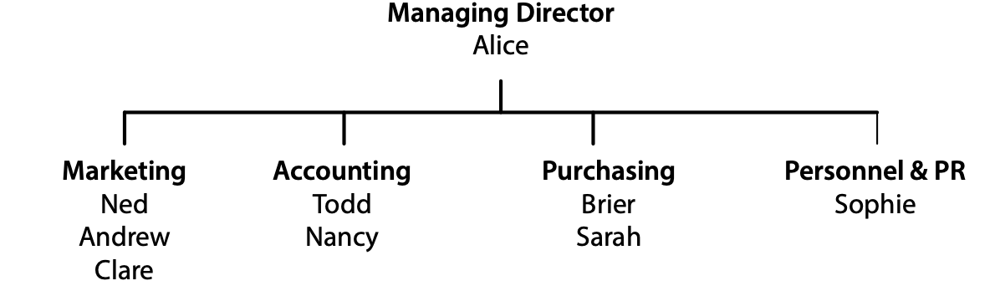

She divided the firm into four departments and appointed a boss for each department. The first person listed in each department was its boss; of course, Alice was paramount.

Ned had finished the sales database, so the time was right to create an employee database. Ned seemed to be enjoying his new role, though his dress standard had slipped. Maybe Alice would have to move him out of Marketing. In fact, he sometimes reminded her of fellows who used to hang around the computer lab all day playing weird games. She wasn’t quite ready to sound a “nerd alert,” but it was getting close.

# Modeling a one-to-one relationship

Initially, the organization chart appears to record two relationships. First***,*** a department has one or more employees, and an employee belongs to one department. Second, a department has one boss, and a person is boss of only one department. That is, boss is a 1:1 relationship between DEPT and EMP. The data model for this situation is shown.

A data model illustrating a 1:m and 1:1 relationship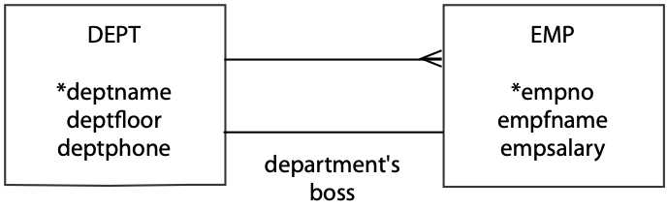

MySQL Workbench version of a 1:m and 1:1 relationship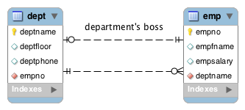

As a general rule, the 1:1 relationship is labeled to avoid confusion because the meaning of such a relationship cannot always be inferred. This label is called a relationship descriptor. The 1:m relationship between DEPT and EMP is not labeled because its meaning is readily understood by reading the model. Use a relationship descriptor when there is more than one relationship between entities or when the meaning of the relationship is not readily inferred from the model.

If we think about this problem, we realize there is more to boss than just a department. People also have a boss. Thus, Alice is the boss of all the other employees. In this case, we are mainly interested in who directly bosses someone else. So, Alice is the direct boss of Ned, Todd, Brier, and Sophie. We need to record the person-boss relationship as well as the department-boss relationship.

The person-boss relationship is arecursive 1:m relationship because it is a relationship between employees—an employee has one boss and a boss can have many employees. The data model is shown in the following figure.

A data model illustrating a recursive 1:m relationship

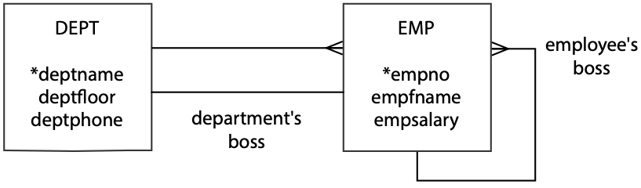

MySQL Workbench version of a recursive 1:m relationship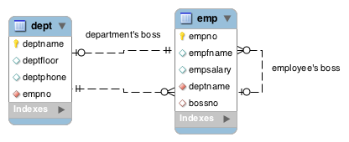

It is a good idea to label the recursive relationship, because its meaning is often not obvious from the data model.

# Mapping a one-to-one relationship

Since mapping a 1:1 relationship follows the same rules as for any other data model, the major consideration is where to place the foreign key(s). There are three alternatives:

1. Put the foreign key in dept.  
   Doing so means that every instance of dept will record the empno of the employee who is boss. Because it is mandatory that all departments, in this case have a boss, the foreign key will always be non-null.
2. Put the foreign key in emp.  
   Choosing this alternative means that every instance of emp should record deptname of the department this employee bosses. Since many employees are not bosses, the value of the foreign key column will generally be null.
3. Put a foreign key in both dept and emp.  
   The consequence of putting a foreign key in both tables in the 1:1 relationship is the combination of points 1 and 2.

The best approach is to put the foreign key in dept, because it is mandatory for each department to have a boss, and the foreign key will always be non-null

# Mapping a recursive one-to-many relationship

A recursive 1:m relationship is mapped like a standard 1:m relationship. An additional column, for the foreign key, is created for the entity at the “many” end of the relationship. Of course, in this case the “one” and “many” ends are the same entity, so an additional column is added to emp. This column contains the key empno of the “one” end of the relationship. Since empno is already used as a column name, a different name needs to be selected. In this case, it makes sense to call the foreign key column bossno because it stores the boss’s employee number.

The mapping of the data model is shown in the following table. Note that deptname becomes a column in emp, the “many” end of the 1:m relationship, and empno becomes a foreign key in dept, an end of the 1:1 relationship.

The tables dept and emp

| deptname | deptfloor | deptphone | empno |
| --- | --- | --- | --- |
| Management | 5 | 2001 | 1 |
| Marketing | 1 | 2002 | 2 |
| Accounting | 4 | 2003 | 5 |
| Purchasing | 4 | 2004 | 7 |
| Personnel & PR | 1 | 2005 | 9 |

| empno | empfname | empsalary | deptname | bossno |
| --- | --- | --- | --- | --- |
| 1 | Alice | 75000 | Management |  |
| 2 | Ned | 45000 | Marketing | 1 |
| 3 | Andrew | 25000 | Marketing | 2 |
| 4 | Clare | 22000 | Marketing | 2 |
| 5 | Todd | 38000 | Accounting | 1 |
| 6 | Nancy | 22000 | Accounting | 5 |
| 7 | Brier | 43000 | Purchasing | 1 |
| 8 | Sarah | 56000 | Purchasing | 7 |
| 9 | Sophie | 35000 | Personnel & PR | 1 |

If you examine emp, you will see that the boss of the employee with empno = 2 (Ned) has bossno = 1. You can then look up the row in emp with empno = 1 to find that Ned’s boss is Alice. This “double lookup” is frequently used when manually interrogating a table that represents a recursive relationship. Soon you will discover how this is handled with SQL.

Here is the SQL to create the two tables:

CREATE TABLE dept (

deptname VARCHAR(15),

deptfloor SMALLINT NOT NULL,

deptphone SMALLINT NOT NULL,

empno SMALLINT NOT NULL,

PRIMARY KEY(deptname));

CREATE TABLE emp (

empno SMALLINT,

empfname VARCHAR(10),

empsalary DECIMAL(7,0),

deptname VARCHAR(15),

bossno SMALLINT,

PRIMARY KEY(empno),

CONSTRAINT fk_belong_dept FOREIGN KEY(deptname)

REFERENCES dept(deptname),

CONSTRAINT fk_has_boss FOREIGN KEY(bossno)

REFERENCES emp(empno));

You will notice that there is no foreign key definition for empno in dept (the 1:1 department’s boss relationship). Why? Observe that deptname is a foreign key in emp. If we make empno a foreign key in dept, then we have a *deadly embrace*. A new department cannot be added to the dept table until there is a boss for that department (i.e., there is a person in the emp table with the empno of the boss); however, the other constraint states that an employee cannot be added to the emp table unless there is a department to which that person is assigned. If we have both foreign key constraints, we cannot add a new department until we have added a boss, and we cannot add a boss until we have added a department for that person. Nothing, under these circumstances, can happen if both foreign key constraints are in place. Thus, only one of them is specified.

In the case of the recursive employee relationship, we can create a constraint to ensure that bossno exists for each employee, except of course the person, Alice, who is top of the pyramid. This form of constraint is known as a self-referential foreign key. However, we must make certain that the first person inserted into emp is Alice. The following statements illustrate that we must always insert a person’s boss before we insert the person.

INSERT INTO emp (empno, empfname, empsalary, deptname)

VALUES (1,'Alice',75000,'Management');

INSERT INTO emp VALUES (2,'Ned',45000,'Marketing',1);

INSERT INTO emp VALUES (3,'Andrew',25000,'Marketing',2);

INSERT INTO emp VALUES (4,'Clare',22000,'Marketing',2);

INSERT INTO emp VALUES (5,'Todd',38000,'Accounting',1);

INSERT INTO emp VALUES (6,'Nancy',22000,'Accounting',5);

INSERT INTO emp VALUES (7,'Brier',43000,'Purchasing',1);

INSERT INTO emp VALUES (8,'Sarah',56000,'Purchasing',7);

INSERT INTO emp VALUES (9,'Sophie',35000,'Personnel',1);

In more complex modeling situations, such as when there are multiple relationships between a pair of entities, use of a FOREIGN KEY clause may result in a deadlock. Always consider the consequences of using a FOREIGN KEY clause before applying it.

Skill builder

A consulting company has assigned each of its employees to a specialist group (e.g., database management). Each specialist group has a team leader. When employees join the company, they are assigned a mentor for the first year. One person might mentor several employees, but an employee has at most one mentor.

# Querying a one-to-one relationship

Querying a 1:1 relationship presents no special difficulties but does allow us to see additional SQL features.

* List the salary of each department’s boss.

SELECT empfname, deptname, empsalary FROM emp

WHERE empno IN (SELECT empno FROM dept);

or

SELECT empfname, dept.deptname, empsalary

FROM emp JOIN dept

ON dept.empno = emp.empno;

| empfname | deptname | empsalary |
| --- | --- | --- |
| Alice | Management | 75000 |
| Ned | Marketing | 45000 |
| Todd | Accounting | 38000 |
| Brier | Purchasing | 43000 |
| Sophie | Personnel & PR | 35000 |

# Querying a recursive 1:m relationship

Querying a recursive relationship is puzzling until you realize that you can join a table to itself by creating two copies of the table. In SQL, you use the WITH clause, also known as the common table expression (CTE) to create a temporary copy, a **table alias.** First, use WITH to define two aliases, wrk and boss for emp. Table aliases are required so that SQL can distinguish which copy of the table is referenced. To demonstrate:

* Find the salary of Nancy’s boss.

First, use WITH to define two aliases, wrk and boss for emp.

WITH

wrk AS (SELECT * FROM emp),

boss AS (SELECT * FROM emp)

SELECT wrk.empfname, wrk.empsalary,boss.empfname, boss.empsalary

FROM wrk JOIN boss

ON wrk.bossno = boss.empno

WHERE wrk.empfname = 'Nancy';

Many queries are solved by getting all the data you need to answer the request in one row. In this case, the query is easy to answer once the data for Nancy and her boss are in the one row. Thus, think of this query as joining two copies of the table emp to get the worker and her boss’s data in one row. Notice that there is a qualifier (wrk and boss) for each copy of the table to distinguish between them. It helps to use a qualifier that makes sense. In this case, the wrk and boss qualifiers can be thought of as referring to the worker and boss tables, respectively. You can understand how the query works by examining the following table illustrating the self-join.

| wrk |  |  |  |  | boss |  |  |  |  |
| --- | --- | --- | --- | --- | --- | --- | --- | --- | --- |
| empno | empfname | empsalary | deptname | bossno | empno | empfname | empsalary | deptname | bossno |
| 2 | Ned | 45000 | Marketing | 1 | 1 | Alice | 75000 | Management |  |
| 3 | Andrew | 25000 | Marketing | 2 | 2 | Ned | 45000 | Marketing | 1 |
| 4 | Clare | 22000 | Marketing | 2 | 2 | Ned | 45000 | Marketing | 1 |
| 5 | Todd | 38000 | Accounting | 1 | 1 | Alice | 75000 | Management |  |
| 6 | Nancy | 22000 | Accounting | 5 | 5 | Todd | 38000 | Accounting | 1 |
| 7 | Brier | 43000 | Purchasing | 1 | 1 | Alice | 75000 | Management |  |
| 8 | Sarah | 56000 | Purchasing | 7 | 7 | Brier | 43000 | Purchasing | 1 |
| 9 | Sophie | 35000 | Personnel & PR | 1 | 1 | Alice | 75000 | Management |  |

The result of the SQL query is now quite clear once we apply the WHERE clause (see the highlighted row in the preceding table):

| wrk.empfname | wrk.empsalary | boss.empfname | boss.empsalary |
| --- | --- | --- | --- |
| Nancy | 22000 | Todd | 38000 |

* Find the names of employees who earn more than their boss.

WITH

wrk AS (SELECT * FROM emp),

boss AS (SELECT * FROM emp)

SELECT wrk.empfname FROM wrk JOIN boss

ON wrk.bossno = boss.empno

WHERE wrk.empsalary > boss.empsalary;

This would be very easy if the employee and boss data were in the same row. We could simply compare the salaries of the two people. To get the data in the one row, we repeat the self-join with a different WHERE condition. The result is as follows:

| empfname |
| --- |
| Sarah |

Skill builder

Find the name of Sophie’s boss.

Alice has found several histories of The Expeditioner from a variety of eras. Because many expeditions they outfitted were conducted under royal patronage, it was not uncommon for these histories to refer to British monarchs. Alice could remember very little about British history, let alone when various kings and queens reigned. This sounded like another database problem. She would ask Ned to create a database that recorded details of each monarch. She thought it also would be useful to record details of royal succession.

# Modeling a recursive one-to-one relationship

The British monarchy can be represented by a simple one-entity model. A monarch has one direct successor and one direct predecessor. The sequencing of monarchs can be modeled by a recursive 1:1relationship, shown in the following figure.

A data model illustrating a recursive 1:1 relationship

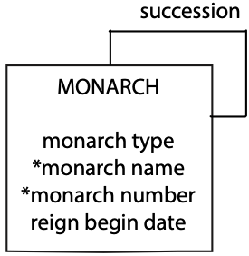

MySQL Workbench version of a recursive 1:1 relationship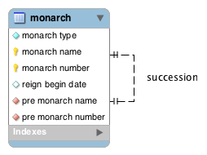

# Mapping a recursive one-to-one relationship

The recursive 1:1 relationship is mapped by adding a foreign key to monarch. You can add a foreign key to represent either the successor or predecessor relationship. In this case, for no particular reason, the preceding relationship is selected. Because each instance of a monarch is identified by a composite key, two columns are added to monarch for the foreign key. Data for recent monarchs are shown in the following table.

The table monarch

| montype | monname | monnum | rgnbeg | premonname | premonnum |
| --- | --- | --- | --- | --- | --- |
| King | William | IV | 1830/6/26 |  |  |
| Queen | Victoria | I | 1837/6/20 | William | IV |
| King | Edward | VII | 1901/1/22 | Victoria | I |
| King | George | V | 1910/5/6 | Edward | VII |
| King | Edward | VIII | 1936/1/20 | George | V |
| King | George | VI | 1936/12/11 | Edward | VIII |
| Queen | Elizabeth | II | 1952/02/06 | George | VI |

The SQL statements to create the table are very straightforward.

CREATE TABLE monarch (

montype CHAR(5) NOT NULL,

monname VARCHAR(15),

monnum VARCHAR(5),

rgnbeg DATE,

premonname VARCHAR(15),

premonnum VARCHAR(5),

PRIMARY KEY(monname,monnum),

CONSTRAINT fk_monarch FOREIGN KEY (premonname, premonnum)

REFERENCES monarch(monname, monnum);

Because the 1:1 relationship is recursive, you cannot insert Queen Victoria without first inserting King William IV. What you can do is first insert King William, without any reference to the preceding monarch (i.e., a null foreign key). The following code illustrates the order of record insertion so that the referential integrity constraint is obeyed.

INSERT INTO MONARCH (montype,monname, monnum,rgnbeg)

VALUES ('King','William','IV','1830-06-26');

INSERT INTO MONARCH

VALUES ('Queen','Victoria','I','1837-06-20','William','IV');

INSERT INTO MONARCH

VALUES ('King','Edward','VII','1901-01-22','Victoria','I');

INSERT INTO MONARCH

VALUES ('King','George','V','1910-05-06','Edward','VII');

INSERT INTO MONARCH

VALUES ('King','Edward','VIII','1936-01-20','George','V');

INSERT INTO MONARCH

VALUES('King','George','VI','1936-12-11','Edward','VIII');

INSERT INTO MONARCH

VALUES('Queen','Elizabeth','II','1952-02-06','George','VI');

Skill builder

In a competitive bridge competition, the same pair of players play together for the entire tournament. Draw a data model to record details of all the players and the pairs of players.

# Querying a recursive one-to-one relationship

Some queries on the monarch table demonstrate querying a recursive 1:1 relationship.

* Who preceded Elizabeth II?

SELECT premonname, premonnum FROM monarch

WHERE monname = 'Elizabeth' and monnum = 'II';

| premonname | premonnum |
| --- | --- |
| George | VI |

This is simple because all the data are in one row. A more complex query is:

* Was Elizabeth II’s predecessor a king or queen?

WITH

cur AS (SELECT * FROM monarch),

pre AS (SELECT * FROM monarch)

SELECT pre.montype FROM cur JOIN pre

ON cur.premonname = pre.monname AND cur.premonnum = pre.monnum

WHERE cur.monname = 'Elizabeth'

AND cur.monnum = 'II';

Notice in the preceding query how to specify the ON clause when you have a composite key.

| montype |
| --- |
| King |

This is very similar to the query to find the salary of Nancy’s boss. The monarch table is joined with itself to create a row that contains all the details to answer the query.

* List the kings and queens of England in ascending chronological order.

SELECT montype, monname, monnum, rgnbeg

FROM monarch ORDER BY rgnbeg;

| montype | monname | monnum | rgnbeg |
| --- | --- | --- | --- |
| Queen | Victoria | I | 1837-06-20 |
| King | Edward | VII | 1901-01-22 |
| King | George | V | 1910-05-06 |
| King | Edward | VIII | 1936-01-20 |
| King | George | VI | 1936-12-11 |
| Queen | Elizabeth | II | 1952-02-06 |

This is a simple query because rgnbeg is like a ranking column. It would not be enough to store just the year in rgnbeg, because two kings started their reigns in 1936; hence, the full date is required.

### Skill builder

Who succeeded Queen Victoria?

Of course, Alice soon had another project for Ned. The Expeditioner keeps a wide range of products that are sometimes assembled into kits to make other products. For example, the animal photography kit is made up of eight items that The Expeditioner also sells separately. In addition, some kits became part of much larger kits. The animal photography kit is included as one of 45 items in the East African Safari package. All of the various items are considered products, and each has its own product code. Ned was now required to create a product database that would keep track of all the items in The Expeditioner’s stock.

# Modeling a recursive many-to-many relationship

The assembly of products to create other products is very common in business. Manufacturing even has a special term to describe it: a bill of materials. The data model is relatively simple once you realize that a product can appear as part of many other products and can be composed of many other products; that is, we have a recursive many-to-many (m:m) relationship for product. As usual, we turn an m:m relationship into two one-to-many (1:m) relationships. Thus, we get the data model displayed in the following figure.

A data model illustrating a recursive m:m relationship

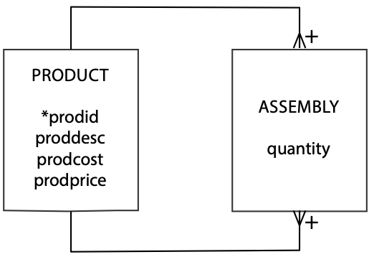

MySQL Workbench version of a recursive m:m relationship

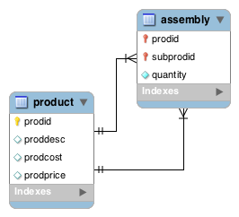

Tables product and assembly

| prodid | proddesc | prodcost | prodprice |
| --- | --- | --- | --- |
| 1000 | Animal photography kit |  | 725 |
| 101 | Camera | 150 | 300 |
| 102 | Camera case | 10 | 15 |
| 103 | 70-210 zoom lens | 125 | 200 |
| 104 | 28-85 zoom lens | 115 | 185 |
| 105 | Photographer’s vest | 25 | 40 |
| 106 | Lens cleaning cloth | 1 | 1.25 |
| 107 | Tripod | 35 | 45 |
| 108 | 16 GB SDHC memory card | 30 | 37 |

| quantity | *prodid* | *subprodid* |
| --- | --- | --- |
| 1 | 1000 | 101 |
| 1 | 1000 | 102 |
| 1 | 1000 | 103 |
| 1 | 1000 | 104 |
| 1 | 1000 | 105 |
| 2 | 1000 | 106 |
| 1 | 1000 | 107 |
| 10 | 1000 | 108 |

# Mapping a recursive many-to-many relationship

Mapping follows the same procedure described previously, producing the two tables shown below. The SQL statements to create the tables are shown next. Observe that assembly has a composite key, and there are two foreign key constraints.

CREATE TABLE product (

prodid INTEGER,

proddesc VARCHAR(30),

prodcost DECIMAL(9,2),

prodprice DECIMAL(9,2),

PRIMARY KEY(prodid));

CREATE TABLE assembly (

quantity INTEGER NOT NULL,

prodid INTEGER,

subprodid INTEGER,

PRIMARY KEY(prodid, subprodid),

CONSTRAINT fk_assembly_product FOREIGN KEY(prodid)

REFERENCES product(prodid),

CONSTRAINT fk_assembly_subproduct FOREIGN KEY(subprodid)

REFERENCES product(prodid));

Skill builder

An army is broken up into many administrative units (e.g., army, brigade, platoon). A unit can contain many other units (e.g., a regiment contains two or more battalions), and a unit can be part of a larger unit (e.g., a squad is a member of a platoon). Draw a data model for this situation.

# Querying a recursive many-to-many relationship

* List the product identifier of each component of the animal photography kit.

SELECT subprodid FROM product JOIN assembly

ON product.prodid = assembly.prodid

WHERE proddesc = 'Animal photography kit';

| subprodid |
| --- |
| 101 |
| 106 |
| 107 |
| 105 |
| 104 |
| 103 |
| 102 |
| 108 |

Why are the values for subprodid listed in no apparent order? Remember, there is no implied ordering of rows in a table, and it is quite possible, as this example illustrates, for the rows to have what appears to be an unusual ordering. If you want to order rows, use the ORDER BY clause.

* List the product description and cost of each component of the animal photography kit.

SELECT proddesc, prodcost FROM product

WHERE prodid IN

(SELECT subprodid FROM product JOIN assembly

ON product.prodid = assembly.prodid

WHERE proddesc = 'Animal photography kit');

In this case, first determine the prodid of those products in the animal photography kit (the inner query), and then report the description of these products. Alternatively, a three-way join can be done using two copies of product.

WITH

a AS (SELECT * FROM product),

b AS (SELECT * FROM product)

SELECT b.proddesc, b.prodcost FROM a JOIN assembly

ON a.prodid = assembly.prodid

JOIN b

ON assembly.subprodid = b.prodid

WHERE a.proddesc = 'Animal photography kit';

| proddesc | prodcost |
| --- | --- |
| Camera | 150 |
| Camera case | 10 |
| 70–210 zoom lens | 125 |
| 28–85 zoom lens | 115 |
| Photographer’s vest | 25 |
| Lens cleaning cloth | 1 |
| Tripod | 35 |
| 16 GB SDHC memory card | 0.85 |

Skill builder

How many lens cleaning cloths are there in the animal photography kit?

## Summary

Relationships can be one-to-one and recursive. A recursive relationship is within a single entity rather than between entities. Recursive relationships are mapped to the relational model in the same way as other relationships. A self-referential foreign key constraint permits a foreign key reference to a key within the same table. Resolution of queries involving recursive relationships often requires a table to be joined with itself. Recursive many-to-many relationships occur in business in the form of a bill of materials.

## Key terms and concepts

One-to-one (1:1) relationship

Recursive relationship

Recursive m:m relationship

Recursive 1:m relationship

Recursive 1:1 relationship

Relationship descriptor

Self-join

Self-referential foreign key

## Exercises

1. Draw data models for the following two problems:
   1. (i) A dairy farmer, who is also a part-time cartoonist, has several herds of cows. He has assigned each cow to a particular herd. In each herd, the farmer has one cow that is his favorite—often that cow is featured in a cartoon.  
      (ii) A few malcontents in each herd, mainly those who feel they should have appeared in the cartoon, disagree with the farmer’s choice of a favorite cow, whom they disparagingly refer to as the sacred cow. As a result, each herd now has elected a herd leader.
   2. The originator of a pyramid marketing scheme has a system for selling ethnic jewelry. The pyramid has three levels—gold, silver, and bronze. New associates join the pyramid at the bronze level. They contribute 30 percent of the revenue of their sales of jewelry to the silver chief in charge of their clan. In turn, silver chiefs contribute 30 percent of what they receive from bronze associates to the gold master in command of their tribe. Finally, gold masters pass on 30 percent of what they receive to the originator of the scheme.
   3. The legion, the basic combat unit of the ancient Roman army, contained 3,000 to 6,000 men, consisting primarily of heavy infantry (hoplites), supported by light infantry (velites), and sometimes by cavalry. The hoplites were drawn up in three lines. The hastati (youngest men) were in the first, the principes (seasoned troops) in the second, and the triarii (oldest men) behind them, reinforced by velites. Each line was divided into 10 maniples, consisting of two centuries (60 to 80 men per century) each. Each legion had a commander, and a century was commanded by a centurion. Julius Caesar, through one of his Californian channelers, has asked you to design a database to maintain details of soldiers. Of course, Julius is a little forgetful at times, and he has not supplied the titles of the officers who command maniples, lines, and hoplites, but he expects that you can handle this lack of fine detail.
   4. A travel agency is frequently asked questions about tourist destinations. For example, customers want to know details of the climate for a particular month, the population of the city, and other geographic facts. Sometimes they request the flying time and distance between two cities. The manager has asked you to create a database to maintain these facts.
   5. The Center for the Study of World Trade keeps track of trade treaties between nations. For each treaty, it records details of the countries signing the treaty and where and when it was signed.
   6. Design a database to store details about U.S. presidents and their terms in office. Also, record details of their date and place of birth, gender, and political party affiliation (e.g., Caluthumpian Progress Party). You are required to record the sequence of presidents so that the predecessor and successor of any president can be identified. How will you model the case of Grover Cleveland, who served nonconsecutive terms as president? Is it feasible that political party affiliation may change? If so, how will you handle it?
   7. The IS department of a large organization makes extensive use of software modules. New applications are built, where possible, from existing modules. Software modules can also contain other modules. The IS manager realizes that she now needs a database to keep track of which modules are used in which applications or other modules. (Hint: It is helpful to think of an application as a module.)
   8. Data modeling is finally getting to you. Last night you dreamed you were asked by Noah to design a database to store data about the animals on the ark. All you can remember from Sunday school is the bit about the animals entering the ark two-by-two, so you thought you should check the real thing.  
      Take with you seven pairs of every kind of clean animal, a male and its mate, and two of every kind of unclean animal, a male and its mate, and also seven pair of every kind of bird, male and female. Genesis 7:2  
      Next time Noah disturbs your sleep, you want to be ready. So, draw a data model and make certain you record the two-by-two relationship.
2. Write SQL to answer the following queries using the DEPT and EMP tables described in this chapter:
   1. Find the departments where all the employees earn less than their boss.
   2. Find the names of employees who are in the same department as their boss (as an employee).
   3. List the departments having an average salary greater than $25,000.
   4. List the departments where the average salary of the employees, excluding the boss, is greater than $25,000.
   5. List the names and manager of the employees of the Marketing department who have a salary greater than $25,000.
   6. List the names of the employees who earn more than any employee in the Marketing department.
3. Write SQL to answer the following queries using the monarch table described in this chapter:
   1. Who succeeded Victoria I?
   2. How many days did Victoria I reign?
   3. How many kings are there in the table?
   4. Which monarch had the shortest reign?
4. Write SQL to answer the following queries using the product and assembly tables:
5. How many different items are there in the animal photography kit?
6. What is the most expensive item in the animal photography kit?
7. What is the total cost of the components of the animal photography kit?
8. Compute the total quantity for each of the items required to assemble 15 animal photography kits.

## CD Library case

Ajay had some more time to work on this CD Library database. He picked up The Manhattan Transfer’s *Swing* CD to enter its data. Very quickly he recognized the need for yet another entity, if he were going to store details of the people in a group. A group can contain many people (there are four artists in The Manhattan Transfer), and also it is feasible that over time a person could be a member of multiple groups. So, there is an m:m between PERSON and GROUP. Building on his understanding of the relationship between PERSON and RECORDING and CD, Ajay realized there are two other required relationships: an m:m between GROUP and RECORDING, and between GROUP and CD. This led to version 5.0, shown in the following figure.

CD library V5.0

#### 

Skill builder

1. The group known as *Asleep at the Wheel* is featured on tracks 3, 4, and 7 of *Swing*. Record these data and write SQL to answer the following:
   1. What are the titles of the recordings on which Asleep at the Wheelappear?
   2. List all CDs that have any tracks featuring Asleep at the Wheel.

The members of *The Manhattan Transfer* are Cheryl Bentyne, Janis Siegel, Tim Hauser, and Alan Paul. Update the database with this information, and write SQL to answer the following:

Who are the members of *The Manhattan Transfer*?

What CDs have been released by *The Manhattan Transfer*?

What CDs feature Cheryl Bentyne as an individual or member of a group?

1. Record the following facts. The music of “*Sing a Song of Brown,”* composed in 1937, is by Count Basie and Larry Clinton and lyrics by Jon Hendricks. “*Sing Moten’s Swing,”* composed in 1932, features music by Buster and Benny Moten, and lyrics by Jon Hendricks. Write SQL to answer the following:
   1. For what songs has Jon Hendricks written the lyrics?
   2. Report all compositions and their composers where more than one person was involved in composing the music. Make certain you report them in the correct order.
2. Test your SQL skills with the following:
   1. List the tracks on which Alan Paul appears as an individual or as a member of The Manhattan Transfer.
   2. List all CDs featuring a group, and report the names of the group members.
   3. Report all tracks that feature more than one group.
   4. List the composers appearing on each CD.
3. How might you extend the data model?

7. Data Modeling

Man is a knot, a web, a mesh into which relationships are tied. Only those relationships matter.

Antoine de Saint-Exupéry in Flight to Arras

## Learning objectives

Students completing this chapter will be able to create a well-formed, high-fidelity data model.

# Modeling

Modeling is widely used within business to learn about organizational problems and design solutions. To understand where data modeling fits within the broader context, it is useful to review the full range of modeling activities. The types of modeling methods follow the 5W-H model of journalism.[15]

|  | | *Scope* | *Model* | *Technology* |
| --- | --- | --- | --- | --- |
| *Motivation* | Why | Goals | Business plan canvas | Groupware |
| *People* | Who | Business units | Organization chart | System interface |
| *Time* | When | Key events | PERT chart | Scheduling |
| *Data* | What | Key entities | Data model | Relational database |
| *Network* | Where | Locations | Logistics network | System architecture |
| *Function* | How | Key processes | Process model | Application software |

A broad perspective on modeling

Modeling occurs at multiple levels. At the highest level, an organization needs to determine the scope of its business by identifying the major elements of its environment, such as its goals, business units, where it operates, and critical events, entities, and processes. At the top level, textual models are frequently used. For example, an organization might list its major goals and business processes. A map will be typically used to display where the business operates.

Once senior managers have clarified the scope of a business, models can be constructed for each of the major elements. Goals will be converted into a business plan, business units will be shown on an organizational chart, and so on. The key elements, from an IS perspective, are data and process modeling, which are typically covered in the core courses of an IS program.

Technology, the final stage, converts models into operational systems to support the organization. Many organizations rely extensively on e-mail and Web technology for communicating business decisions. People connect to systems through an interface, such as a Web browser. Ensuring that events occur at the right time is managed by scheduling software. This could be implemented with operating system procedures that schedule the execution of applications. In some database management systems (DBMSs), triggers can be established. Atrigger is a database procedure that is automatically executed when some event is recognized. For example, U.S. banks are required to report all deposits exceeding USD 10,000, and a trigger could be coded for this event.

Data models are typically converted into relational databases, and process models become computer programs. Thus, you can see that data modeling is one element of a comprehensive modeling activity that is often required to design business systems. When a business undergoes a major change, such as a reengineering project, many dimensions can be altered, and it may be appropriate to rethink many elements of the business, starting with its goals. Because such major change is very disruptive and costly, it occurs less frequently. It is more likely that data modeling is conducted as a stand-alone activity or part of process modeling to create a new business application.

# Data modeling

You were introduced to the basic building blocks of data modeling in the earlier chapters of this section. Now it is time to learn how to assemble blocks to build a data model. Data modeling is a method for determining what data and relationships should be stored in the database. It is also a way of communicating a database design.

The goal of data modeling is to identify the facts that must be stored in a database. A data model is not concerned with how the data will be stored. This is the concern of those who implement the database. A data model is not concerned with how the data will be processed. This is the province of process modeling. The goal is to create a data model that is an accurate representation of data needs and real-world data relationships.

Building a data model is a partnership between a client, a representative of the eventual owners of the database, and a designer. Of course, there can be a team of clients and designers. For simplicity, we assume there is one client and one designer.

Drawing a data model is an iterative process of trial and revision. A data model is a working document that will change as you learn more about the client’s needs and world. Your early versions are likely to be quite different from the final product. Use a product such as MySQL Workbench for drawing and revising a data model.

# The building blocks

The purpose of a database is to store data about things, which can include facts (e.g., an exchange rate), plans (e.g., scheduled production of two-person tents for June), estimates (e.g., forecast of demand for smart phones), and a variety of other data. A data model describes these things and their relationships with other things using four components: entity, attribute, relationship, and identifier.

## Entity

The entity is the basic building block of a data model. an entity is a thing about which data should be stored, something we need to describe. Each entity in a data model has a unique name that we write in singular form. Why singular? Because we want to emphasize that an entity describes an instance of a thing. Thus, we previously used the word SHARE to define an entity because it describes each instance of a share rather than shares in general.

We have already introduced the convention that an entity is represented by a rectangle, and the name of the entity is shown in uppercase letters, as follows.

The entity SHARE

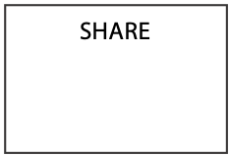

A large data model might contain over a 1,000 entities. A database can easily contain hundreds of millions of instances (rows) for any one entity (table). Imagine the number of instances in a national tax department’s database.

How do you begin to identify entities? One approach is to underline any nouns in the system proposal or provided documentation. Most nouns are possible entities, and underlining ensures that you do not overlook any potential entities. Start by selecting an entity that seems central to the problem. If you were designing a student database, you might start with the student. Once you have picked a central entity, describe it. Then move to the others.

## Attribute

An attribute describes an entity. When an entity has been identified, the next step is to determine its attributes, that is, the data that should be kept to describe fully the entity. An attribute name is singular and unique within the data model. You may need to use a modifier to make an attribute name unique (e.g., “hire date” and “sale date” rather than just “date”).

Our convention is that the name of an attribute is recorded in lowercase letters within the entity rectangle. The following figure illustrates that SHARE has attributes share code, share name, share price, share quantity, share dividend, and share PE. Notice the frequent use of the modifier “share”. It is possible that other entities in the database might also have a price and quantity, so we use a modifier to create unique attribute names. Note also that share code is the identifier.

The entity SHARE with its attributes

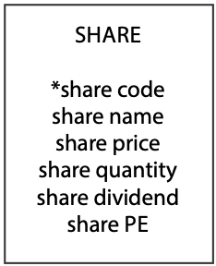

Defining attributes generally takes considerable discussion with the client. You should include any attribute that is likely to be required for present or future decision making, but don’t get carried away. Avoid storing unnecessary data. For example, to describe the entity STUDENT you usually record date of birth, but it is unlikely that you would store height. If you were describing an entity PATIENT, on the other hand, it might be necessary to record height, because that is sometimes relevant to medical decision making.

An attribute has a single value, which may be null. Multiple values are not allowed. If you need to store multiple values, it is a signal that you have a one-to-many (1:m) relationship and need to define another entity.

## Relationship

Entities are related to other entities. If there were no relationships between entities, there would be no need for a data model and no need for a relational database. A simple, flat file (a single-entity database) would be sufficient. A relationship is binary. It describes a linkage between two entities and is represented by a line between them.

Because a relationship is binary, strictly speaking it has two relationship descriptors, one for each entity. Each relationship descriptor has a degree stating how many instances of the other entity may be related to each instance of the described entity. Consider the entities STOCK and NATION and their 1:m relationship (see the following figure). We have two relationship descriptors: stocks of nation for NATION and nation of stock for STOCK. The relationship descriptor stocks of nation has a degree of m because a nation may have zero or more listed stocks. The relationship descriptor nation of stock has a degree of 1 because a stock is listed in at most one nation. To reduce data model clutter, where necessary for clarification, we will use a single label for the pair of relationship descriptors. Experience shows this approach captures the meaning of the relationship and improves readability.

A 1:m relationship between STOCK and NATION



Because the meaning of relationships frequently can be inferred, there is no need to label every one; however, each additional relationship between two entities should be labeled to clarify meaning. Also, it is a good idea to label one-to-one (1:1) relationships, because the meaning of the relationship is not always obvious.

Consider the fragment in the following figure. The descriptors of the 1:m relationship can be inferred as a firm has employees and an employee belongs to a firm. the 1:1 relationship is clarified by labeling the 1:1 relationship as firm’s boss.

Relationship labeling

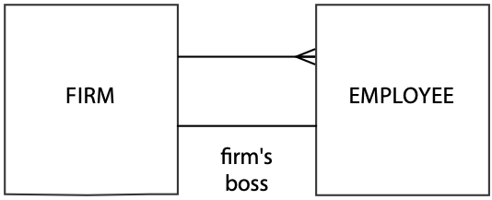

## Identifier

An identifier uniquely distinguishes an instance of an entity. An identifier can be one or more attributes and may include the identifier of a related entity. When a related entity’s identifier is part of an identifier, a plus sign is placed on the line closest to the entity being identified. In the following figure, an instance of the entity LINEITEM is identified by the composite of lineno and saleno, the identifier of SALE. The value lineno does not uniquely identify an instance of LINEITEM, because it is simply a number that appears on the sales form. Thus, the identifier must include saleno (the identifier of SALE). So, any instance of LINEITEM is uniquely identified by the composite saleno and lineno.

A related entity’s identifier as part of the identifier

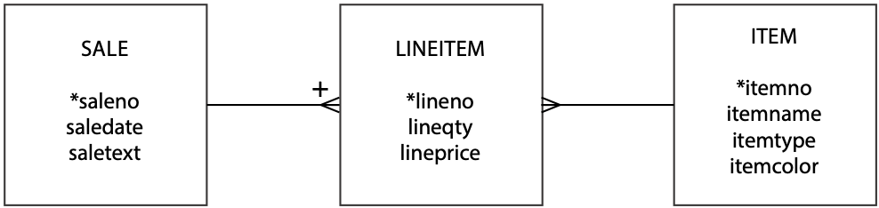

Occasionally, there will be several possible identifiers, and these are each given a different symbol. Our convention is to prefix an identifier with an asterisk (*). If there are multiple identifiers, use other symbols such as #, !, or &. Be careful: If you have too many possible identifiers, your model will look like comic book swearing. In most cases, you will have only one identifier.

No part of an identifier can be null. If this were permitted, there would be no guarantee that the other parts of the identifier were sufficiently unique to distinguish all instances in the database.

# Data model quality

There are two criteria for judging the quality of a data model. It must be well-formed and have high fidelity.

## A well-formed data model

A well-formed data model clearly communicates information to the client. Being well-formed means the construction rules have been obeyed. There is no ambiguity; all entities are named, and all entities have identifiers. If identifiers are missing, the client may make incorrect inferences about the data model. All relationships are recorded using the proper notation and labeled whenever there is a possibility of confusion.

Characteristics of a well-formed data model

|  |
| --- |
| All construction rules are obeyed. |
| There is no ambiguity. |
| All entities are named. |
| Every entity has an identifier. |
| All relationships are represented, using the correct notation. |
| Relationships are labeled to avoid misunderstanding. |
| All attributes of each entity are listed. |
| All attribute names are meaningful and unique. |

All the attributes of an entity are listed because missing attributes create two types of problems. First***,*** it is unclear what data will be stored about each instance. Second, the data model may be missing some relationships. Attributes that can have multiple values become entities. It is only by listing all of an entity’s attributes during data modeling that these additional entities are recognized.

In a well-formed data model, all attribute names are meaningful and unique. The names of entities, identifiers, attributes, and relationships must be meaningful to the client because they are describe the client’s world. Indeed, in nearly all cases they are the client’s everyday names. Take care in selecting words because they are critical to communicating meaning. The acid test for comprehension is to get the client to read the data model to other potential users. Names need to be unique to avoid confusion.

## A high-fidelity image

Music lovers aspire to own a high-fidelity stereo system—one that faithfully reproduces the original performance with minimal or no distortion. A data model is a high-fidelity image when it faithfully describes the world it is supposed to represent. All relationships are recorded and are of the correct degree. There are no compromises or distortions. If the real-world relationship is many-to-many (m:m), then so is the relationship shown in the data model. a well-formed, high-fidelity data model is complete, understandable, accurate, and syntactically correct.

# Quality improvement

A data model is an evolving representation. Each change should be an incremental improvement in quality. Occasionally, you will find a major quality problem at the data model’s core and have to change the model considerably.

## Detail and context

The quality of a data model can be determined only by understanding the context in which it will be used. Consider the data model (see the following figure) used in Chapter 4 to discuss the 1:m relationship. This fragment says a nation has many stocks. Is that really what we want to represent? Stocks are listed on a stock exchange, and a nation may have several stock exchanges. For example, the U.S. has the New York Stock Exchange and NASDAQ. Furthermore, some foreign stocks are listed on the New York Stock Exchange. If this is the world we have to describe, the data model is likely to differ from that shown in the figure. Try drawing the revised data model.

A 1:m relationship between STOCK and NATION



As you can see, the data model in the following figure is quite different from the initial data model of preceding figure. Which one is better? They both can be valid models; it just depends on the world you are trying to represent and possible future queries. In the first case, the purpose was to determine the value of a portfolio. There was no interest in on which exchange stocks were listed or their home exchange. So the first model has high fidelity for the described situation.

The second data model would be appropriate if the client needed to know the home exchange of stocks and their price on the various exchanges where they were listed. The second data model is an improvement on the first if it incorporates the additional facts and relationships required. If it does not, then the additional detail is not worth the extra cost.

Revised NATION-STOCK data model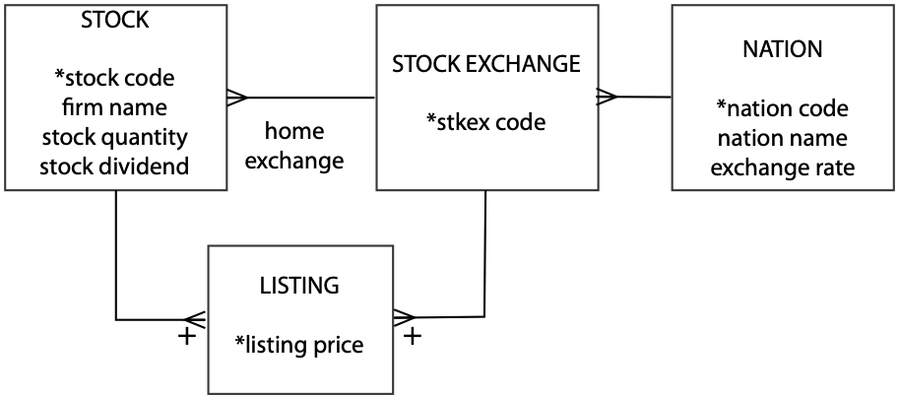

## A lesson in pure geography

A data model must be an accurate representation of the world you want to model. The data model must account for all the exceptions—there should be no impurities. Let’s say you want to establish a database to store details of the world’s cities. You might start with the data model depicted in the following figure.

A world’s cities data model

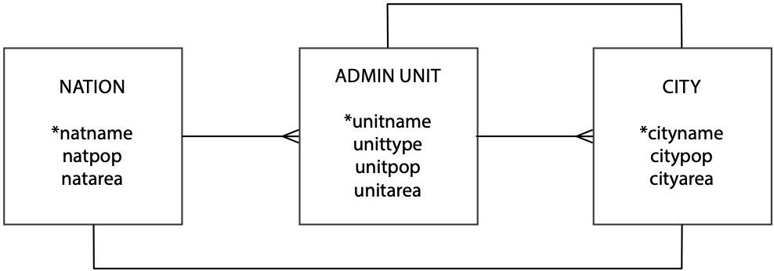

Before looking more closely at the data model, let’s clarify the meaning of unittype. Because most countries are divided into administrative units that are variously called states, provinces, territories, and so forth, unittype indicates the type of administrative unit (e.g., state). How many errors can you find in the initial data model?

Problems and solutions for the initial world’s cities data model

|  | *Problem* | *Solution* |
| --- | --- | --- |
| 1 | City names are not unique. There is an Athens in Greece and the U.S. has an Athens in Georgia, Alabama, Ohio, Pennsylvania, Tennessee, and Texas. | To identify a city uniquely, you need to specify its administrative unit and country. Add a plus sign to the crow’s feet between CITY and ADMIN UNIT and between ADMIN UNIT and NATION. |
| 2 | Administrative unit names are not necessarily unique. There used to be a Georgia in the old U.S.S.R., and there is a Georgia in the U.S. There is no guarantee that administrative unit names will always be unique. | To identify an administrative unit uniquely, you also need to know the country in which it is found. Add a plus sign to the crow’s foot between ADMIN UNIT and NATION. |
| 3 | There is an unlabeled 1:1 relationship between CITY and ADMIN UNIT and CITY and NATION. What do these mean? They are supposed to indicate that an administrative unit has a capital, and a nation has a capital. | Label relationships (e.g., national capital city). |
| 4 | The assumption is that a nation has only one capital, but there are exceptions. South Africa has three capitals: Cape Town (legislative), Pretoria (administrative), and Bloemfontein (judicial). You need only one exception to lower the fidelity of a data model significantly. | Change the relationship between NATION and CITY to 1:m. Add an attribute *natcaptype* to CITY to distinguish between types of capitals. |
| 5 | The assumption is that an administrative unit has only one capital, but there are exceptions. At one point, Chandigarh was the capital of two Indian states, Punjab and Haryana. The Indian state of Jammu & Kashmir has two capitals: Jammu (summer) and Srinagar (winter). | Change the relationship between ADMIN UNIT and CITY to m:m by creating an associative entity and include a distinguishing attribute of *unitcaptype*. |
| 6 | Some values can be derived. National population, *natpop*, and area, *natarea*, are the sum of the regional populations, *regpop*, and areas, *regarea*, respectively. The same rule does not apply to regions and cities because not everyone lives in a city. | Remove the attributes *natpop* and *natarea* from NATION. |

A revised world’s cities data model

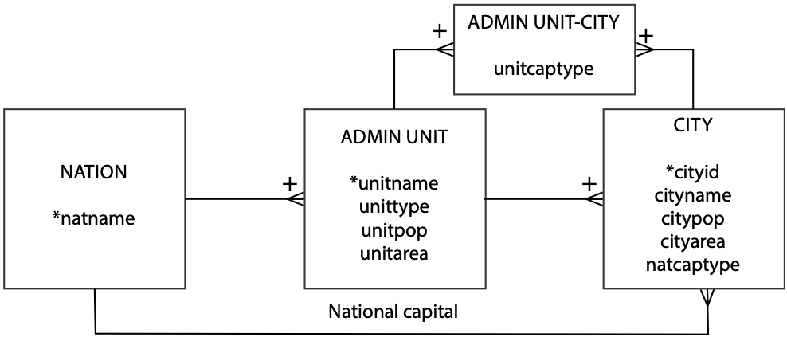

This geography lesson demonstrates how you often start with a simple model of low fidelity. By additional thinking about relationships and consideration of exceptions, you gradually create a high-fidelity data model.

Skill Builder

Write SQL to determine which administrative units have two capitals and which have a shared capital.

## Family matters

Families can be very complicated. It can be tricky to keep track of all those relations—maybe you need a relational database (this is the worst joke in the book; they improve after this). We start with a very limited view of marriage and gradually ease the restrictions to demonstrate how any and all aspects of a relationship can be modeled. An initial fragment of the data model is shown in the following figure. There are several things to notice about it.

A man-woman data model

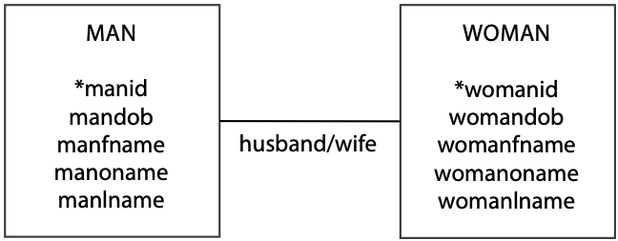

1. There is a 1:1 relationship between man and woman. The labels indicate that this relationship is marriage, but there is no indication of the marriage date. We are left to infer that the data model records the current marriage.
2. MAN and WOMAN have the same attributes. A prefix is used to make them unique. Both have an identifier (id, in the United States this would probably be a Social Security number), date of birth (dob), first name ( fname), other names (oname), and last name (name).
3. Other names (oname) looks like a multivalued attribute, which is not allowed. Should oname be single or multivalue? This is a tricky decision. It depends on how these data will be used. If queries such as “find all men whose other names include Herbert” are likely, then a person’s other names—kept as a separate entity that has a 1:m relationship for MAN and WOMAN—must be established. That is, a man or woman can have one or more other names. However, if you just want to store the data for completeness and retrieve it in its entirety, then oname is fine. It is just a text string. The key question to ask is, “What is the lowest level of detail possibly required for future queries?” Also, remember that SQL’s REGEXP clause can be used to search for values within a text string.

The use of a prefix to distinguish attribute names in different entities suggests you should consider combining the entities. In this case, we could combine the entities MAN and WOMAN to create an entity called PERSON. Usually when entities are combined, you have to create a new attribute to distinguish between the different types. In this example, the attribute gender is added. We can also generalize the relationship label to spouse. The revised data model appears in the following figure.

A PERSON data model

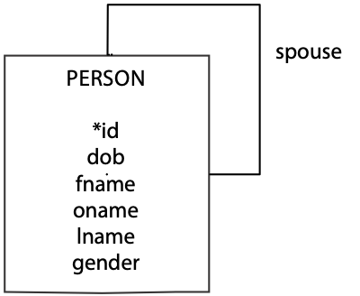

Now for a bit of marriage counseling. Marriage normally is a relationship between two people. Is that so? Well, some societies permit polygyny (one man can have many wives), others allow polyandry (one woman can have many husbands), and some permit same-sex marriages. So marriage, if we consider all the possibilities, is an m:m relationship between people, and partner might be a better choice than spouse for labeling the relationship Also, a person can be married more than once. To distinguish between different marriages, we really need to record the start and end date of each relationship and who was involved.

A marriage data model

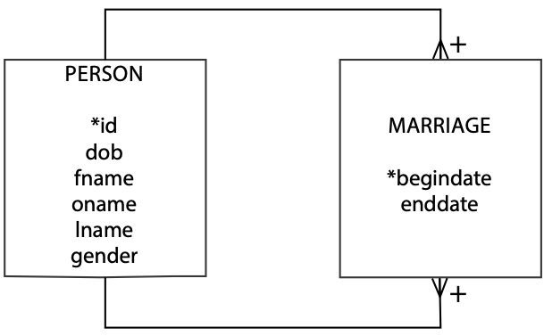

Marriage is an m:m relationship between two persons. It has attributes begindate and enddate. An instance of marriage is uniquely identified by a composite identifier: the two spouseidentifiers and begindate. This means any marriage is uniquely identified by the composite of two person identifiers and the beginning date of the marriage. We need begindate as part of the identifier because the same couple might have more than one marriage (e.g., get divorced and remarry each other later). Furthermore, we can safely assume that it is impossible for a couple to get married, divorced, and remarried all on the one day. Begindate and enddate can be used to determine the current state of a marriage. If enddate is null, the marriage is current; otherwise, the couple has divorced.

This data model assumes a couple goes through some formal process to get married or divorced, and there is an official date for both of these events. What happens if they just gradually drift into cohabitation, and there is no official beginning date? Think about it. (The data model problem, that is—not cohabitation!) Many countries recognize this situation as a common-law marriage, so the data model needs to recognize it. The present data model cannot handle this situation because begindate cannot be null—it is an identifier. Instead, a new identifier is needed, and begindate should become an attribute.

Two new attributes can handle a common-law marriage. Marriageno can count the number of times a couple has been married to each other. In the majority of cases, marriageno will be 1. Marriagestatus can record whether a marriage is current or ended. Now we have a data model that can also handle common-law marriages. This is also a high-quality data model in that the client does not have to remember to examine enddate to determine a marriage’s current status. It is easier to remember to examine marriagestatus to check status. Also, we can allow a couple to be married, divorced, and remarried as many times as they like on the one day—which means we can now use the database in Las Vegas.

A revised marriage data model

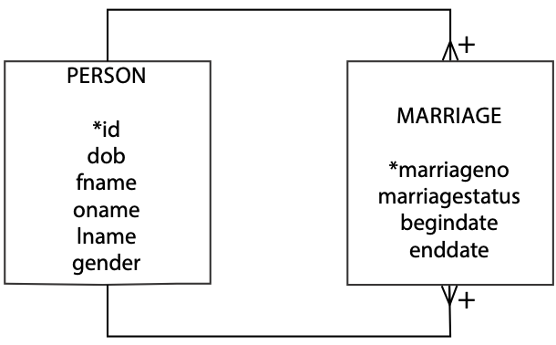

All right, now that we have the couple successfully married, we need to start thinking about children. A marriage has zero or more children, and let’s start with the assumption a child belongs to only one marriage. Therefore, we have a 1:m relationship between marriage and person to represent the children of a marriage.

A marriage with children data model

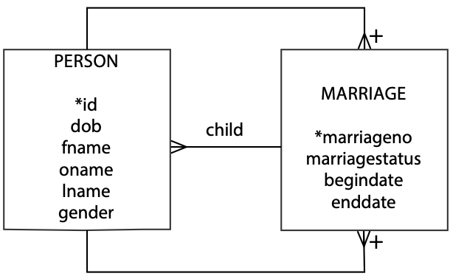

You might want to consider how the model would change to handle single-parent families, adopted children, and other aspects of human relationships.

Skill builder

The International Commission for Border Resolution Disputes requires a database to record details of which countries have common borders. Design the database. Incidentally, which country borders the most other countries?

## When’s a book not a book?

Sometimes we have to rethink our ideas of physical objects. Consider a data model for a library.

A library data model fragment

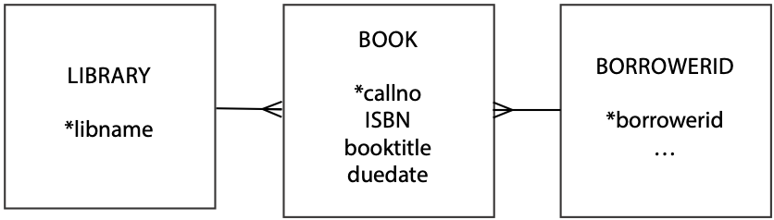

The preceding fragment assumes that a person borrows a book. What happens if the library has two copies of the book? Do we add an attribute to BOOK called copynumber? No, because we would introduce redundancy by repeating the same information for each book. What you need to recognize is that in the realm of data modeling, a book is not really a physical thing, but the copy is, because it is what you borrow.

A revised library data model fragment

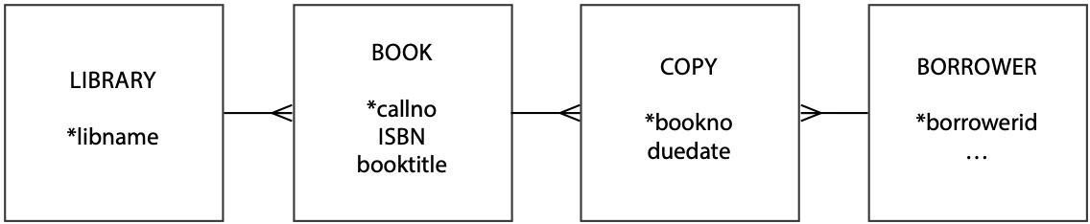As you can see, a book has many copies, and a copy is of one book. A book can be identified by callno, which is usually a Library of Congress number or Dewey number. A copy is identified by a bookno. This is a unique number allocated by the library to the copy of the book. If you look in a library book, you will generally find it pasted on the inside back cover and shown in numeric and bar code format. Notice that it is called book numberdespite the fact that it really identifies a copy of a book. This is because most people, including librarians, think of the copy as a book.

The International Standard Book Number (ISBN) uniquely identifies any instance of a book (not copy). Although it sounds like a potential identifier for BOOK, it is not. ISBNs were introduced in the second half of the twentieth century, and books published before then do not have an ISBN.

## A history lesson

Many organizations maintain historical data (e.g., a person’s job history or a student’s enrollment record). A data model can depict historical data relationships just as readily as current data relationships.

Consider the case of an employee who works for a firm that consists of divisions (e.g., production) and departments (e.g., quality control). The firm contains many departments, but a department belongs to only one division. At any one time, an employee belongs to only one department.

Employment history—take 1

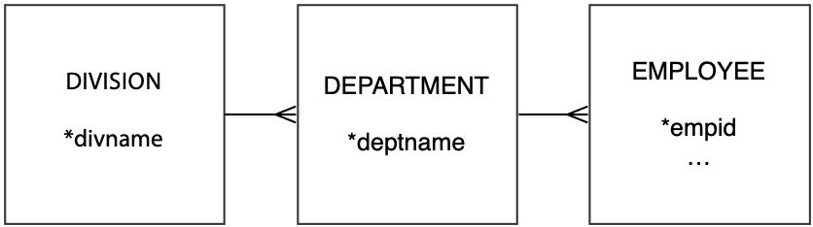

The fragment in the figure can be amended to keep track of the divisions and departments in which a person works. While employed with a firm, a person can work in more than one department. Since a department can have many employees, we have an m:m relationship between DEPARTMENT and EMPLOYEE. We might call the resulting associative entity POSITION.

Employment history—take 2

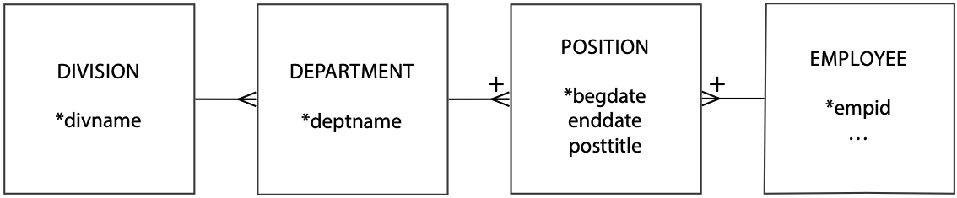The revised fragment records employee work history. Note that any instance of POSITION is identified by begdate and the identifiers for EMPLOYEE and DEPARTMENT. The fragment is typical of what happens when you move from just keeping current data to recording history. A 1:m becomes an m:m relationship to record history.

People who work get paid. How do we keep track of an employee’s pay data? An employee has many pay slips, but a pay slip belongs to one employee. When you look at a pay slip, you will find it contains many items: gross pay and a series of deductions for tax, medical insurance, and so on. Think of a pay slip as containing many lines, analogous to a sales form. Now look at the revised data model.

Employment history—take 3

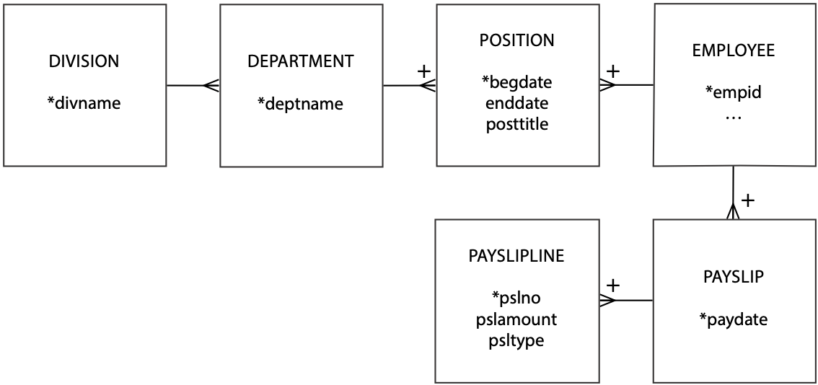Typically, an amount shown on a pay slip is identified by a short text field (e.g., gross pay). PAYSLIPLINE contains an attribute psltype to identify the text that should accompany an amount, but where is the text? When dealing with codes like psltype and their associated text, the fidelity of a data model is improved by creating a separate entity, PSLTEXT, for the code and its text.

Employment history—take 4

## 

## A ménage à trois for entities

Consider aircraft leasing. A plane is leased to an airline for a specific period. When a lease expires, the plane can be leased to another airline. So, an aircraft can be leased many times, and an airline can lease many aircraft. Furthermore, there is an agent responsible for handling each deal. An agent can lease many aircraft and deal with many airlines. Over time, an airline will deal with many agents. When an agent reaches a deal with an airline to lease a particular aircraft, you have a transaction. If you analyze the aircraft leasing business, you discover there are three m:m relationships. You might think of these as three separate relationships.

An aircraft-airline-agent data model

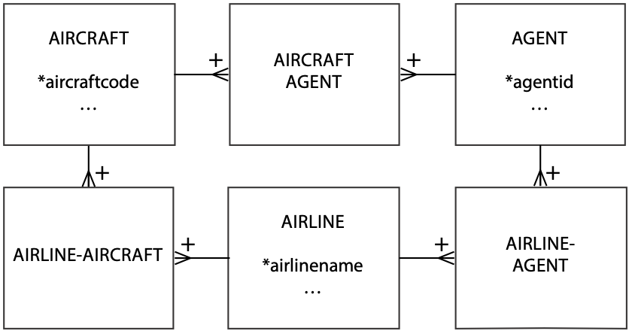

The problem with three separate m:m relationships is that it is unclear where to store data about the lease. Is it stored in AIRLINE-AIRCRAFT? If you store the information there, what do you do about recording the agent who closed the deal? After you read the fine print and do some more thinking, you discover that a lease is the association of these three entities in an m:m relationship.

A revised aircraft-airline-agent data model

### 

Skill builder

Horse racing is a popular sport in some parts of the world. A horse competes in at most one race on a course at a particular date. Over time, a horse can compete in many races on many courses. A horse’s rider is called a jockey, and a jockey can ride many horses and a horse can have many jockeys. Of course, there is only ever one jockey riding a horse at a particular time. Courses vary in their features, such as the length of the course and the type of surface (e.g., dirt or grass). Design a database to keep track of the results of horse races.

## Project management—planning and doing

Project management involves both planned and actual data. A project is divided into a number of activities that use resources. Planning includes estimation of the resources to be consumed. When a project is being executed, managers keep track of the resources used to monitor progress and keep the project on budget. Planning data may not be as detailed as actual data and is typically fairly broad, such as an estimate of the number of hours that an activity will take. Actual data will be more detailed because they are usually collected by getting those assigned to the project to log a daily account of how they spent their time. Also, resources used on a project are allocated to a particular activity. For the purposes of this data model, we will focus only on recording time and nothing else.

A project management data model

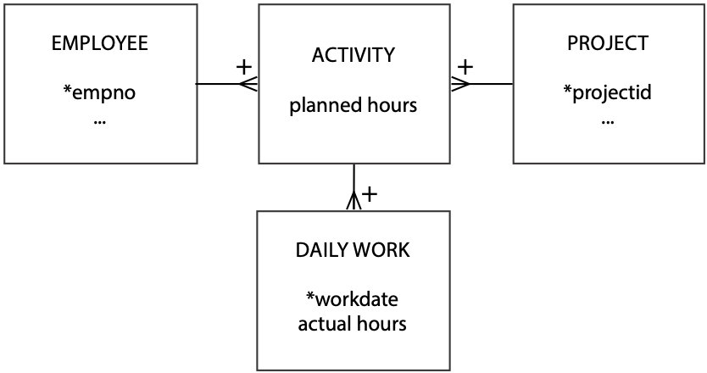

Notice that planned hours is an attribute of ACTIVITY, and actual hours is an attribute of DAILY WORK. The hours spent on an activity are derived by summing actual hours in the associated DAILY WORK entity. This is a high-fidelity data model if planning is done at the activity level and employees submit daily worksheets. Planning can be done in greater detail, however, if planners indicate how many hours of each day each employee should spend on a project.

A revised project management data model

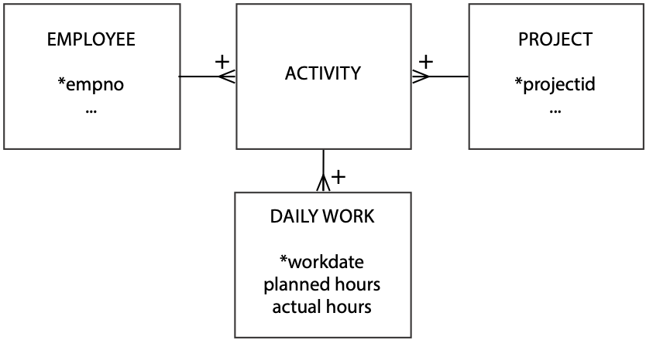

Now you see that planned hoursand actual hours are both attributes of DAILY WORK. The message of this example, therefore, is not to assume that planned and actual data have the same level of detail, but do not be surprised if they do.

## Cardinality

Some data modeling languages are quite precise in specifying the cardinality, or multiplicity, of a relationship. Thus, in a 1:m relationship, you might see additional information on the diagram. For example, the “many” end of the relationship might contain notation (such as 0,n) to indicate zero or more instances of the entity at the “many” end of the relationship.

Cardinality and modality options

| Cardinality | Modality | Meaning |
| --- | --- | --- |
| 0,1 | Optional | There can be zero or one instance of the entity relative to the other entity. |
| 0,n | There can be zero or many instances of the entity relative to the other entity. |
| 1,1 | Mandatory | There is exactly one instance of the entity relative to the other entity. |
| 1,n | The entity must have at least one and can have many instances relative to the other entity. |

The data modeling method of this text, as you now realize, has taken a broad approach to cardinality (is it 1:1 or 1:m?). We have not been concerned with greater precision (is it 0,1 or 1,1?), because the focus has been on acquiring basic data modeling skills. Once you know how to model, you can add more detail. When learning to model, too much detail and too much terminology can get in the way of mastering this difficult skill. Also, it is far easier to sketch models on a whiteboard or paper when you have less to draw. Once you switch to a data modeling tool, then adding cardinality precision is easier and appropriate.

## Modality

Modality, also known as optionality, specifies whether an instance of an entity must participate in a relationship. Cardinality indicates the range of instances of an entity participating in a relationship, while modality defines the minimum number of instances. Cardinality and modality are linked, as shown in the table above. If an entity is optional, the minimum cardinality will be 0, and if mandatory, the minimum cardinality is 1.

By asking the question, “Does an occurrence of this entity require an occurrence of the other entity?” you can assess whether an entity is mandatory. The usual practice is to use “O” for optional and place it near the entity that is optional. Mandatory relationships are often indicated by a short line (or bar) at right angles to the relationship between the entities.

In the following figure, it is mandatory for an instance of STOCK to have an instance of NATION, and optional for an instance of NATION to have an instance of STOCK, which means we can record details of a nation for which stocks have not yet been purchased. During conversion of the data model to a relational database, the mandatory requirement (i.e., each stock must have a nation) is enforced by the foreign key constraint.

1:m relationship showing modality

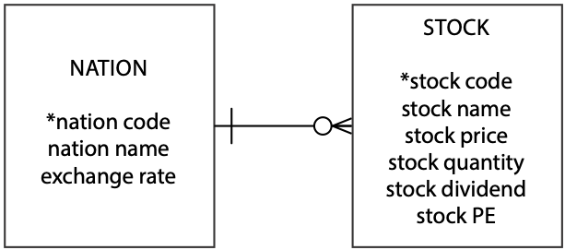

Now consider an example of an m:m relationship. A SALE can have many LINEITEMs, and a LINEITEM has only one SALE. An instance of LINEITEM must be related to an instance of SALE, otherwise it can’t exist. Similarly, it is mandatory for an instance of SALE to have an instance of LINEITEM, because it makes no sense to have a sale without any items being sold.

In a relational database, the foreign key constraint handles the mandatory relationship between instances of LINEITEM and SALE, The mandatory requirement between SALE and LINEITEM has to be built into the processing logic of the application that processes a sales transaction. Basic business logic requires that a sale include some items, so a sales transaction creates one instance of SALE and multiple instances of LINEITEM. It does not make sense to have a sale that does not sell something.

An m:m relationship showing modality

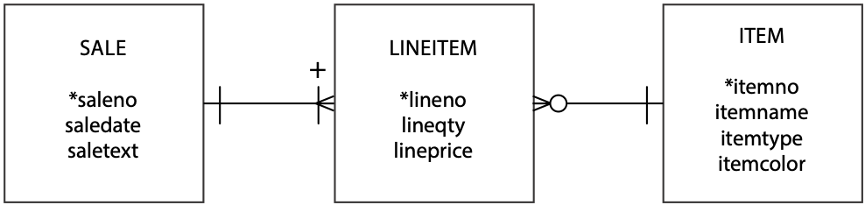

The relationship between ITEM and LINEITEM is similar in structure to that of NATION and STOCK, which we saw in the previous example. An instance of a LINEITEM has a mandatory requirement for an instance of ITEM. An instance of an ITEM can exist without the need for an instance of a LINEITEM (i.e., the items that have not been sold).

We gain further understanding of modality by considering a 1:1 relationship. We focus attention on the 1:1 because the 1:m relationship has been covered. The 1:1 implies that it is mandatory for an instance of DEPT to be related to one instance of EMP (i.e., a department must have a person who is the boss), and an instance of EMP is optionally related to one instance of DEPT (i.e., an employee can be a boss, but not all employees are departmental bosses).

A 1:1 relationship showing modality

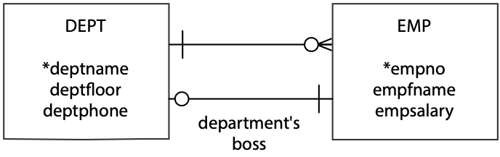

Earlier, when deciding where to store the foreign key for the 1:1 relationship, we settled on placing the foreign key in DEPT, because all departments have a boss. Now we have a rule. The foreign key goes with the entity for which the relationship is mandatory. When specifying the create statements, you will need to be aware of the chicken-and-egg connection between DEPT and EMP. We cannot insert an employee in EMP unless we know that person’s department, and we cannot insert a department unless we have already inserted the boss for that department in EMP. We can get around this problem by using a deferrable foreign key constraint, but at this point we don’t know enough about transaction processing to discuss this approach.

Let’s now consider recursive relationships. The following figure shows a recursive 1:m between employees, representing that one employee can be the boss of many other employees and a person has one boss. It is optional that a person is a boss, and optional that everyone has a boss, mainly because there has to be one person who is the boss of everyone. However, we can get around this one exception by inserting employees in a particular order. By inserting the biggest boss first, we effectively make it mandatory that all employees have a boss. Nevertheless, data models cover every situation and exception, so we still show the relationship as optional.

1:m recursive with modality

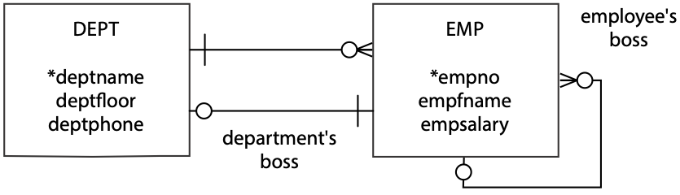

We rely again on the British monarchy. This time we use it to illustrate modality with a 1:1 recursive relationship. As the following figure shows, it is optional for a monarch to have a successor. We are not talking about the end of a monarchy, but rather how we address the data modeling issue of not knowing who succeeds the current monarch. Similarly, there must be a monarch who did not succeed someone (i.e., the first king or queen). Thus, both ends of the succession relationship have optional modality.

1:1 recursive with modality

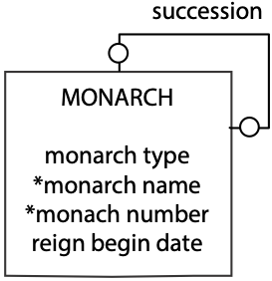

Finally, in our exploration of modality, we examine the m:m recursive. The model indicates that it is optional for a product to have components and optional for a product to be a component in other products. However, every assembly must have associated products.

m:m recursive with modality

### 

### Summary

Modality adds additional information to a data model, and once you have grasped the fundamental ideas of entities and relationships, it is quite straightforward to consider whether a relationship is optional or mandatory. When a relationship is mandatory, you need to consider what constraint you can add to a table’s definition to enforce the relationship. As we have seen, in some cases the foreign key constraint handles mandatory relationships. In other cases, the logic for enforcing a requirement will be built into the application.

## Entity types

A data model contains different kinds of entities, which are distinguished by the format of their identifiers. Labeling each of these entities by type will help you to determine what questions to ask.

### Independent entity

An independent entity is often central to a data model and foremost in the client’s mind. Independent entities are frequently the starting points of a data model. Remember that in the investment database, the independent entities are STOCK and NATION. Independent entities typically have clearly distinguishable names because they occur so frequently in the client’s world. In addition, they usually have a single identifier, such as stock code or nation code.

Independent entities are often connected to other independent entities in a 1:m or m:m relationship. The data model in the following figure shows two independent entities linked in a 1:m relationship.

NATION and STOCK—independent entities

### 

### Weak or dependent entity

A weak entity (also known as a dependent entity) relies on another entity for its existence and identification. It is recognized by a plus on the weak entity’s end of the relationship. CITY cannot exist without REGION. A CITY is uniquely identified by cityname and regname. If the composite identifier becomes unwieldy, creating an arbitrary identifier (e.g., cityno) will change the weak entity into an independent one.

CITY—a weak entity

### 

### Associative entity

Associative entities are by-products of m:m relationships. They are typically found between independent entities. Associative entities sometimes have obvious names because they occur in the real world. For instance, the associative entity for the m:m relationship between DEPARTMENT and EMPLOYEE is usually called POSITION. If the associative entity does not have a common name, the two entity names are generally hyphenated (e.g., DEPARTMENT-EMPLOYEE). Always search for the appropriate name, because it will improve the quality of the data model. Hyphenated names are a last resort.

POSITION is an associative entity

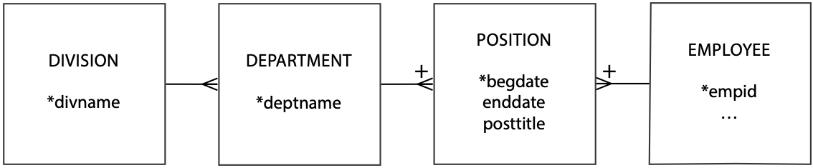

Associative entities can show either the current or the historic relationship between two entities. If an associative entity’s only identifiers are the two related entities’ identifiers, then it records the current relationship between the entities. If the associative entity has some time measure (e.g., date or hour) as a partial identifier, then it records the history of the relationship. Whenever you find an associative entity, ask the client whether the history of the relationship should be recorded.

Creating a single, arbitrary identifier for an associative entity will change it to an independent one. This is likely to happen if the associative entity becomes central to an application. For example, if a personnel department does a lot of work with POSITION, it may find it more expedient to give it a separate identifier (e.g., position number).

### Aggregate entity

An aggregate entity is created when several different entities have similar attributes that are distinguished by a preceding or following modifier to keep their names unique. For example, because components of an address might occur in several entities (e.g., CUSTOMER and SUPPLIER), an aggregate address entity can be created to store details of all addresses. Aggregate entities usually become independent entities. In this case, we could use address number to identify an instance of address uniquely.

### Subordinate entity

A subordinate entity stores data about an entity that can vary among instances. A subordinate entity is useful when an entity consists of mutually exclusive classes that have different descriptions. The farm animal database shown in the following figure indicates that the farmer requires different data for sheep and horses. Notice that each of the subordinate entities is identified by the related entity’s identifier. You could avoid subordinate entities by placing all the attributes in ANIMAL, but then you make it incumbent on the client to remember which attributes apply to horses and which to sheep. This becomes an important issue for null fields. For example, is the attribute hay consumption null because it does not apply to sheep, or is it null because the value is unknown?

SHEEP and HORSE are subordinate entities

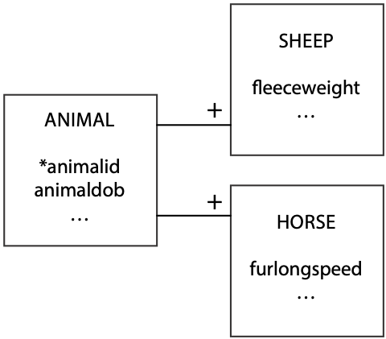

If a subordinate entity becomes important, it is likely to evolve into an independent entity. The framing of a problem often determines whether subordinate entities are created. Stating the problem as, “a farmer has many animals, and these animals can be horses or sheep,” might lead to the creation of subordinate entities. Alternatively, saying that “a farmer has many sheep and horses” might lead to setting up SHEEP and HORSE as independent entities.

## Generalization and aggregation

Generalization and aggregation are common ideas in many modeling languages, particularly object-oriented modeling languages such as the Unified Modeling Language (UML), which we will use in this section.

### Generalization

A generalization is a relationship between a more general element and a more specific element. In the following figure, the general element is animal, and the specific elements are sheep and horse. A horse is a subtype of animal. A generalization is often called an “is a” relationship because the subtype element is a member of the generalization.

A generalization is directly mapped to the relational model with one table for each entity. For each of the subtype entities (i.e., SHEEP and HORSE), the primary key is that of the supertype entity (i.e., ANIMAL). You must also make this column a foreign key so that a subtype cannot be inserted without the presence of the matching supertype. A generalization is represented by a series of 1:1 relationships to weak entities.

A generalization hierarchy in UML

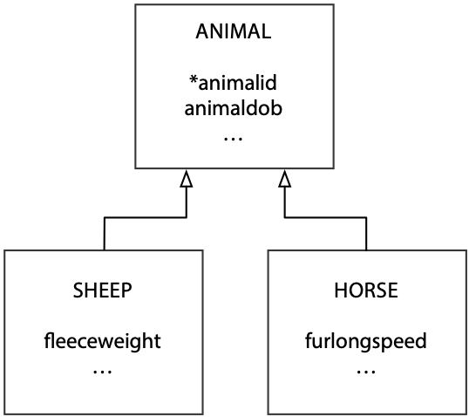

## Aggregation

Aggregation is a part-whole relationship between two entities. Common phrases used to describe an aggregation are “consists of,” “contains,” and “is part of.” The following figure shows an aggregation where a herd consists of many cows. Cows can be removed or added, but it is still a herd. An open diamond next to the whole denotes an aggregation. In data modeling terms, there is a 1:m relationship between herd and cow.

An aggregation in UML and data modeling

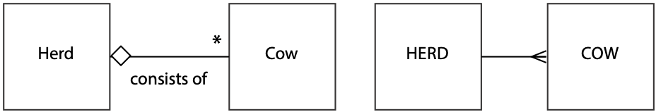

There are two special types of aggregation: shared and composition. With **shared aggregation**, one entity owns another entity, but other entities can own that entity as well. A sample shared aggregation is displayed in the following figure, which shows that a class has many students, and a student can be a member of many classes. Students, the parts in this case, can be part of many classes. An open diamond next to the whole denotes a shared aggregation, which we represent in data modeling as an m:m relationship.

Shared aggregation in UML and data modeling

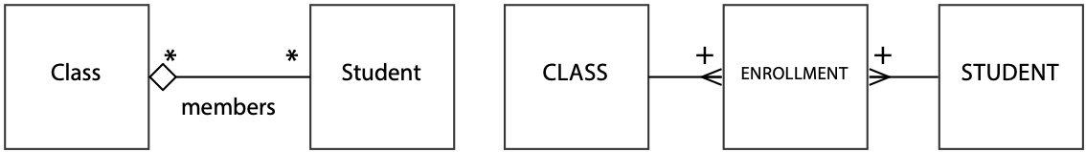In a **composition aggregation,** one entity exclusively owns the other entity. A solid diamond at the whole end of the relationship denotes composition aggregation. The appropriate data model is a weak entity, as shown in the following figure.

Composition aggregation in UML and data modeling

## 

## Data modeling hints

A high-fidelity data model takes time to develop. The client must explain the problem fully so that the database designer can understand the client’s requirements and translate them into a data model. Data modeling is like prototyping; the database designer gradually creates a model of the database as a result of interaction with the client. Some issues will frequently arise in this progressive creation, and the following hints should help you resolve many of the common problems you will encounter.

## The rise and fall of a data model

Expect your data model to both expand and contract. Your initial data model will expand as you extend the boundaries of the application. You will discover some attributes will evolve into entities, and some 1:m relationships will become m:m relationships. It will grow because you will add entities, attributes, and relationships to allow for exceptions. Your data model will grow because you are representing the complexity of the real world. Do not try to constrain growth. Let the data model be as large as is necessary. As a rough rule, expect your final data model to grow to about two to three times the number of entities of your initial data model.

Expect your data model to contract as you generalize structures. The following fragment is typical of the models produced by novice data modelers. It can be reduced by recognizing that PAINTING, SCULPTURE, and CERAMIC are all types of art. A more general entity, ART, could be used to represent the same data. Of course, it would need an additional attribute to distinguish the different types of art recordings.

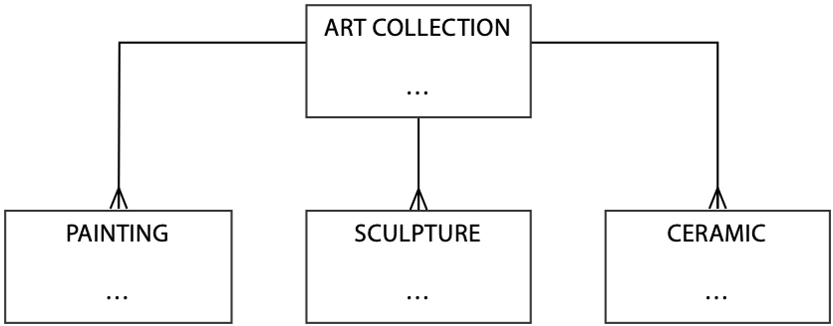

The shrunken data model

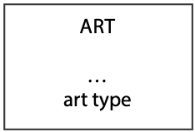

As you discover new entities, your data model will grow. As you generalize, your data model will shrink.

## Identifier

If there is no obvious simple identifier, invent one. The simplest is a meaningless code (e.g., person numberor order number). If you create an identifier, you can also guarantee its uniqueness.

Don’t overwork an identifier. The worst case we have seen is a 22-character product code used by a plastics company that supposedly not only uniquely identified an item but told you its color, its manufacturing process, and type of plastic used to make it! Color, manufacturing process, and type of plastic are all attributes. This product code was unwieldy. Data entry error rates were extremely high, and very few people could remember how to decipher the code.

An identifier has to do only one thing: uniquely identify every instance of the entity. Sometimes trying to make it do double, or even triple, duty only creates more work for the client.

## Position and order

There is no ordering in a data model. Entities can appear anywhere. You will usually find a central entity near the middle of the data model only because you tend to start with prominent entities (e.g., starting with STUDENT when modeling a student information system). What really matters is that you identify all relevant entities.

Attributes are in no order. You find that you will tend to list them as they are identified. For readability, it is a good idea to list some attributes sequentially. For example, first name, other names, and last name are usually together. This is not necessary, but it speeds up verification of a data model’s completeness.

Instances are also assumed to have no ordering. There is no first instance, next instance, or last instance. If you must recognize a particular order, create an attribute to record the order. For example, if ranking of potential investment projects must be recorded, include an attribute (projrank) to store this data. This does not mean the instances will be stored in projrank order, but it does allow you to use the ORDER BY clause of SQL to report the projects in rank order.

If you need to store details of a precedence relationship (i.e., there is an ordering of instances and a need to know the successor and predecessor of any instance), then use a 1:1 recursive relationship.

Using an attribute to record an ordering of instances

## 

## Attributes and consistency

Attributes must be consistent, retaining the same meaning for every instance. An example of an inconsistent attribute would be an attribute stock info that contains a stock’s PE ratio or its ROI (return on investment). Another attribute, say stock info code, is required to decipher which meaning applies to any particular instance. The code could be “1” for PE and “2” for ROI. If one attribute determines the meaning of another, you have inconsistency. Writing SQL queries will be extremely challenging because inconsistent data increases query complexity. It is better to create separate attributes for PE and ROI.

## Names and addresses

An attribute is the smallest piece of data that will conceivably form part of a query. If an attribute has segments (e.g., a person’s name), determine whether these could form part of a query. If so, then make them separate attributes and reapply the query test. When you apply the query test to person name, you will usually decide to create three attributes: ***f***irst name, other names, and last name.

What about titles? There are two sorts of modifier titles: preceding titles (e.g., Mr., Mrs., Ms., and Dr.) and following titles (e.g., Jr. and III). These should be separate attributes, especially if you have divided *name* into separate attributes.

Addresses seem to cause more concern than names because they are more variant. Business addresses tend to be the most complicated, and foreign addresses add a few more twists. The data model fragment in the following figure works in most cases.

Handling addresses

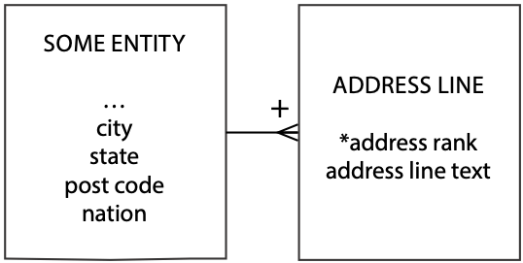

Common features of every address are city, state (province in Canada, county in Eire), postal code (ZIP code in the United States), and nation. Some of these can be null. For example, Singapore does not have any units corresponding to states. In the United States, city and state can be derived from the zip code, but this is not necessarily true for other countries. Furthermore, even if this were true for every nation, you would need a different derivation rule for each country, which is a complexity you might want to avoid. If there is a lifetime guarantee that every address in the database will be for one country, then examine the possibility of reducing redundancy by just storing post code.

Notice that the problem of multiple address lines is represented by a 1:m relationship. An address line is a text string that appears as one line of an address. There is often a set sequence in which these are displayed. The attribute address rank records this order.

How do you address students? First names may be all right for class, but it is not adequate enough for student records. Students typically have multiple addresses: a home address, a school address, and maybe a summer address. The following data model fragment shows how to handle this situation. Any instance of ADDRESS LINE is identified by the composite of studentid***,*** addresstype, and address rank.

Students with multiple addresses

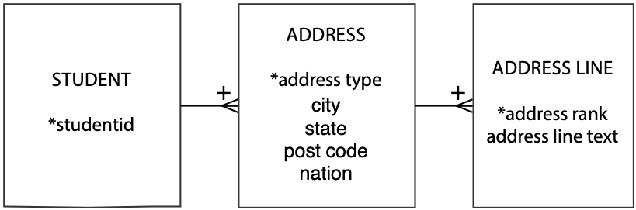

The identifier address type is used to distinguish among the different types of addresses. The same data model fragment works in situations where a business has different mailing and shipping addresses.

When data modeling, can you take a shortcut with names and addresses? It is time consuming to write out all the components of name and address. It creates clutter and does not add much fidelity. Our practical advice is to do two things. First***,*** create a policy for all names and addresses (e.g., all names will be stored as three parts: first name, other names, last name). Second, use shorthand forms of attributes for names and addresses when they obey the policy. So from now on, we will sometimes use name and address as attributes with the understanding that when the database is created, the parts will become separate columns.

## Single-instance entities

Do not be afraid of creating an entity with a single instance. Consider the data model fragment in the following figure which describes a single fast-food chain. Because the data model describes only one firm, the entity FIRM will have only one instance. The inclusion of this single instance entity permits facts about the firm to be maintained. Furthermore, it provides flexibility for expansion. If two fast-food chains combine, the data model needs no amendment.

FIRM—a single-instance entity

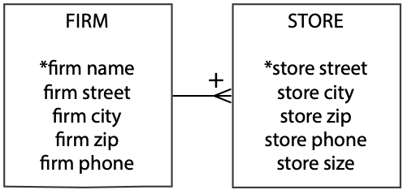

## Picking words

Words are very important. They are all we have to make ourselves understood. Let the client choose the words, because the data model belongs to the client and describes the client’s world. If you try to impose your words on the client, you are likely to create a misunderstanding.

## Synonyms

Synonyms are words that have the same meaning. For example, task, assignment, and project might all refer to the same real-world object. One of these terms, maybe the one in most common use, needs to be selected for naming the entity. Clients need to be told the official name for the entity and encouraged to adopt this term for describing it. Alternatively, create views that enable clients to use their own term. Synonyms are not a technical problem. It is a social problem of getting clients to agree on one word.

## Homonyms

Homonyms are words that sound the same but have different meanings. Homonyms can create real confusion. Sale date is a classic example. In business it can have several meanings. To the salespeople, it might be the day that the customer shakes hands and says, “We have a deal.” For the lawyers, it is could be the day when the contract is signed, and for production, it might be the day the customer takes delivery. In this case, the solution is reasonably obvious; redefine sale date to be separate terms for each area (e.g., sales date, contract date, and delivery date for sales, legal, and production departments, respectively).

Homonyms cause real confusion when clients do not realize that they are using the same word for different entities or attributes. Hunt down homonyms by asking lots of questions and querying a range of clients.

## Exception hunting

Go hunting for exceptions. Keep asking the client questions such as

* Is it always like this?
* Would there be any situations where this could be an m:m relationship?
* Have there ever been any exceptions?
* Are things likely to change in the future?

Always probe for exceptions and look for them in the examples the client uses. Redesigning the data model to handle exceptions increases fidelity.

## Relationship labeling

Relationship labeling clutters a data model. In most cases, labels can be correctly inferred, so use labels only when there is a possibility of ambiguity.

## Keeping the data model in shape

As you add to a data model, maintain fidelity. Do not add entities without also completing details of the identifier and attributes. By keeping the data model well formed, you avoid ambiguity, which frequently leads to miscommunication.

## Used entities

Would you buy a used data model? Certainly, because a used data model is more likely to have higher fidelity than a brand new one. A used data model has been subjected to much scrutiny and revision and should be a more accurate representation of the real world.

# Meaningful identifiers

An identifier is said to be meaningful when some attributes of the entity can be inferred from the identifier’s value (e.g., a code of B78 for an item informs a clerk that the item is black). The word “meaningful” in everyday speech usually connotes something desirable, but many data managers agree that meaningful identifiers or codes create problems. While avoiding meaningful identifiers is generally accepted as good data management practice, they are still widely used. After a short description of some examples of meaningful identifiers, this section discusses the pros and cons of meaningful identifiers.

The invoice number “12dec0001” is a meaningful identifier. The first five positions indicate in which period the invoice was generated. The last four digits of the invoice number have a meaning. The 0001 indicates it was the first invoice sent in December. In addition, e-mail addresses, like [mvdpas@bizzo.nl](mailto:mvdpas@bizzo.nl), have a meaning.

When coding a person’s gender, some systems use the codes “m” and “f” and others “1” and “2.” The pair (m, f) is meaningful, but (1, 2) is not and puts the onus on the user to remember the meaning. The codes “m” and “f’” are derived from the reality that they represent. They are the first letters of the words male and female. The “1” and “2” are not abstracted from reality, and therefore they do not have an intuitive meaning.

However, if you want to set an international standard suitable for many languages, then you need to revert to numeric codes, because “m” and “f” are not the first letters in all languages for male and female, respectively. Thus the English version of the International Organization for Standardization (ISO) information interchange standard for the representation of human sexes (ISO 5218) states:

No significance is to be placed on the fact that “Male” is coded “1” and “Female” is coded “2.” This standard was developed based upon predominant practices of the countries involved and does not convey any meaning of importance, ranking or any other basis that could imply discrimination.

In determining whether an identifier is meaningful, one can look at the way new values of that identifier are generated. If the creation takes place on the basis of characteristics that appear in reality, the identifier is meaningful. That is why the identifier of the invoice “12dec0002,” which is the identifier assigned to the second invoice generated in December 2012, is meaningful. It is also why the e-mail address [rwatson@terry.uga.edu](mailto:rwatson@terry.uga.edu) is meaningful.

Meaningful identifiers clearly have some advantages and disadvantages, and these are now considered. Advantages and disadvantages of meaningful identifiers

| Advantages | Disadvantages |
| --- | --- |
| Recognizable and rememberable  Administrative simplicity | Identifier exhaustion  Reality changes  Loss of meaningfulness |

## Advantages of meaningful identifiers

### Recognizable and rememberable

People can often recognize and remember the significance of meaningful identifiers. If, for example, someone receives an e-mail from [rwatson@terry.uga.edu](mailto:rwatson@terry.uga.edu), this person can probably deduce the sender’s name and workplace. If a manufacturer, for instance, uses the last two digits of its furniture code to indicate the color (e.g., 08 = beech), employees can then quickly determine the color of a packed piece of furniture. Of course, the firm could also show the color of the furniture on the label, in which case customers, who are most unlikely to know the coding scheme, can quickly determine the color of the enclosed product.

### Administrative simplicity

By using meaningful identifiers, administration can be relatively easily decentralized. Administering e-mail addresses, for instance, can be handled at the domain level. This way, one can avoid the process of synchronizing with other domains whenever a new e-mail address is created.

A second example is the EAN (European article number), the bar code on European products. Issuing EANs can be administered per country, since each country has a unique number in the EAN. When issuing a new number, a country need only issue a code that is not yet in use in that country. The method of contacting all countries to ask whether an EAN has already been issued is time consuming and open to error. On the other hand, creating a central database of issued EAN codes is an option. If every issuer of EAN codes can access such a database, alignment among countries is created and duplicates are prevented.

## Disadvantages of meaningful identifiers

### Identifier exhaustion

Suppose a company with a six-digit item identifier decides to use the first three digits to specify the product group (e.g., stationery) uniquely. Within this group, the remaining three digits are used to define the item (e.g., yellow lined pad). As a consequence, only one thousand items can be specified per product group. This problem remains even when some numbers in a specific product group, or even when entire product groups, are not used.

Consider the case when product group “010” is exhausted and is supplemented by the still unused product group code “940.” What seems to be a simple quick fix causes problems, because a particular product group is not uniquely identified by a single identifier. Clients have to remember there is an exception.

A real-world example of identifier exhaustion is a holding company that identifies its subsidiaries by using a code, where the first character is the first letter of the subsidiary’s name. When the holding company acquired its seventh subsidiary, the meaningfulness of the coding system failed. The newly acquired subsidiary name started with the same letter as one of the existing subsidiaries. The system had already run out of identifiers.

When existing identifiers have to be converted because of exhaustion, printed codes on labels, packages, shelves, and catalogs will have to be redone. Recoding is an expensive process and should be avoided.

Exhaustion is not only a problem with meaningful identifiers. It can happen with non-meaningful identifiers. The problem is that meaningful identifier systems tend to exhaust sooner. To avoid identifier exhaustion and maintain meaningful identifiers, some designers increase identifier lengths (e.g., four digits for product group).

### Reality changes

The second problem of meaningful identifiers is that the reality they record changes. For example, a company changes its name. The College of Business at the University of Georgia was renamed the Terry College of Business. E-mail addresses changed (e.g., [rwatson@cba.uga.edu](mailto:rwatson@cba.uga.edu) became [rwatson@terry.uga.edu](mailto:rwatson@terry.uga.edu)). An identifier can remain meaningful over a long period only if the meaningful part rarely or never changes.

Non-meaningful identifiers avoid reality changes. Consider the case of most telephone billing systems, which use an account ID to identify a customer rather than a telephone number. This means a customer can change telephone numbers without causing any coding problems because telephone number is not the unique identifier of each customer.

### A meaningful identifier can lose its meaningfulness

Consider the problems that can occur with the identifier that records both the color and the material of an article. Chipboard with a beech wood veneer is coded BW. A black product, on the other hand, is coded BL. Problems arise whenever there is an overlap between these characteristics. What happens with a product that is finished with a black veneer on beech wood? Should the code be BW or BL? What about a black-painted product that is made out of beech wood? Maybe a new code, BB for black beech wood, is required. There will always be employees and customers who do not know the meaning of these not-so-meaningful identifiers and attribute the wrong meaning to them.

## The solution—non-meaningful identifiers

Most people are initially inclined to try to make identifiers meaningful. There is a sense that something is lost by using a simple numeric to identify a product or customer. Nothing, however, is lost and much is gained. Non-meaningful identifiers serve their sole purpose well—to identify an entity uniquely. Attributes are used to describe the characteristics of the entity (e.g., color, type of wood). A clear distinction between the role of identifiers and attributes creates fewer data management problems now and in the future.

## Vehicle identification

In most countries, every road vehicle is uniquely identified. The Vehicle Identification Number (VIN) was originally described in ISO Standard 3779 in February 1977 and last revised in 1983. It is designed to identify motor vehicles, trailers, motorcycles, and mopeds. A VIN is 17 characters, A through Z and 0 through 9.

The European Union and the United States have different implementations of the standard. The U.S. VIN is divided into four parts

* World Manufacturer's Identification (WMI) - three characters
* Vehicle Description Section (VDS) - five characters
* Check digit
* Vehicle Identification Section (VIS) - eight characters

When decoded, a VIN specifies the country and year of manufacture; make, model, and serial number; assembly plant; and even some equipment specifications.

VINs are normally located in several locations on a car, but the most common places are in the door frame of the front doors, on the engine itself, around the steering wheel, or on the dash near the window.

What do you think of the VIN as a method of vehicle identification? How do you reconcile it with the recommendation to use meaningless identifiers? If you were consulted on a new VIN system, what would advise?

# The seven habits of highly effective data modelers

There is often a large gap between the performance of average and expert data modelers. An insight into the characteristics that make some data modelers more skillful than others should improve your data modeling capabilities.

## Immerse

Find out what the client wants by immersing yourself in the task environment. Spend some time following the client around and participate in daily business. Firsthand experience of the problem will give you a greater understanding of the client’s requirements. Observe, ask questions, reflect, and talk to a wide variety of people (e.g., managers, operations personnel, customers, and suppliers). The more you learn about the problem, the better equipped you are to create a high-fidelity data model.

## Challenge

Challenge existing assumptions; dig out the exceptions. Test the boundaries of the data model. Try to think about the business problem from different perspectives (e.g., how might the industry leader tackle this problem?). Run a brainstorming session with the client to stimulate the search for breakthrough solutions.

## Generalize

Reduce the number of entities whenever possible by using generalized structures (remember the Art Collection model) to simplify the data model. Simpler data models are usually easier to understand and less costly to implement. Expert data modelers can see beyond surface differences to discern the underlying similarities of seemingly different entities.

## Test

Test the data model by reading it to yourself and several people intimately familiar with the problem. Test both directions of every relationship (e.g., a farmer has many cows and a cow belongs to only one farmer). Build a prototype so that the client can experiment and learn with a concrete model. Testing is very important because it costs very little to fix a data model but a great deal to repair a system based on an incorrect data model.

## Limit

Set reasonable limits to the time and scope of data modeling. Don’t let the data modeling phase continue forever. Discover the boundaries early in the project and stick to these unless there are compelling reasons to extend the project. Too many projects are allowed to expand because it is easier to say yes than no. In the long run, however, you do the client a disservice by promising too much and extending the life of the project. Determine the core entities and attributes that will solve most of the problems, and confine the data model to this core. Keep sight of the time and budget constraints of the project.

## Integrate

Step back and reflect on how your project fits with the organization’s information architecture. Integrate with existing systems where feasible and avoid duplication. How does your data model fit with the corporate data model and those of other projects? Can you use part of an existing data model? A skilled data modeler has to see both the fine-grained detail of a project data model and the big picture of the corporate data resource.

## Complete

Good data modelers don’t leave data models ill-defined. All entities, attributes, and relationships are carefully defined, ambiguities are resolved, and exceptions are handled. Because the full value of a data model is realized only when the system is complete, the data modeler should stay involved with the project until the system is implemented. The data modeler, who generally gets involved in the project from its earliest days, can provide continuity through the various phases and ensure the system solves the problem.

## Summary

Data modeling is both a technique for modeling data and its relationships and a graphical representation of a database. It communicates a database’s design. The goal is to identify the facts that must be stored in a database. Building a data model is a partnership between a client, a representative of the eventual owners of the database, and a designer. The building blocks are an entity, attribute, identifier, and relationship. A well-formed data model, which means the construction rules have been obeyed, clearly communicates information to the client. A high-fidelity data model faithfully describes the world it represents.

A data model is an evolving representation. Each change should be an incremental improvement in quality. The quality of a data model can be determined only by understanding the context in which it will be used. A data model can model historical data relationships just as readily as current ones. Cardinality specifies the precise multiplicity of a relationship. Modality indicates whether a relationship is optional or mandatory. The five different types of entities are independent, dependent, associative, aggregate, and subordinate. Expect a data model to expand and contract. A data model has no ordering. Introduce an attribute if ordering is required. An attribute must have the same meaning for every instance. An attribute is the smallest piece of data that will conceivably form part of a query. Synonyms are words that have the same meaning; homonyms are words that sound the same but have different meanings. Identifiers should generally have no meaning. Highly effective data modelers immerse, challenge, generalize, test, limit, integrate, and complete.

## Key terms and concepts

Aggregate entity

Aggregation

Associative entity

Attribute

Cardinality

Composite aggregation

Data model

Data model quality

Dependent entity

Determinant

Domain

Entity

Generalization

High-fidelity image

Homonym

Identifier

Independent entity

Instance

Mandatory

Modality

Modeling

Optional

Relationship

Relationship descriptor

Relationship label

Shared aggregation

Synonym

## References and additional readings

Carlis, J. V. 1991. *Logical data structures*. Minneapolis, MN: University of Minnesota.

Hammer, M. 1990. Reengineering work: Don’t automate, obliterate. *Harvard Business Review* 68 (4):104–112.

## Exercises

### Short answers

1. What is data modeling?
2. What is a useful technique for identifying entities in a written description of a data modeling problem?
3. When do you label relationships?
4. When is a data model well formed, and when is it high-fidelity?
5. How do you handle exceptions when data modeling?
6. Describe the different types of entities.
7. Why might a data model grow?
8. Why might a data model contract?
9. How do you indicate ordering of instances in a data model?
10. What is the difference between a synonym and a homonym?

### Data modeling

Create a data model from the following narratives, which are sometimes intentionally incomplete. You will have to make some assumptions. Make certain you state these alongside your data model. Define the identifier(s) and attributes of each entity.

1. The president of a book wholesaler has told you that she wants information about publishers, authors, and books.
2. A university has many subject areas (e.g., MIS, Romance languages). Professors teach in only one subject area, but the same subject area can have many professors. Professors can teach many different courses in their subject area. An offering of a course (e.g., Data Management 457, French 101) is taught by only one professor at a particular time.
3. Kids’n’Vans retails minivans for a number of manufacturers. Each manufacturer offers several models of its minivan (e.g., SE, LE, GT). Each model comes with a standard set of equipment (e.g., the Acme SE comes with wheels, seats, and an engine). Minivans can have a variety of additional equipment or accessories (radio, air-conditioning, automatic transmission, airbag, etc.), but not all accessories are available for all minivans (e.g., not all manufacturers offer a driver’s side airbag). Some sets of accessories are sold as packages (e.g., the luxury package might include stereo, six speakers, cocktail bar, and twin overhead foxtails).
4. Steve operates a cinema chain and has given you the following information:  
   “I have many cinemas. Each cinema can have multiple theaters. Movies are shown throughout the day starting at 11 a.m. and finishing at 1 a.m. Each movie is given a two-hour time slot. We never show a movie in more than one theater at a time, but we do shift movies among theaters because seating capacity varies. I am interested in knowing how many people, classified by adults and children, attended each showing of a movie. I vary ticket prices by movie and time slot. For instance, Lassie Get Lost is 50 cents for everyone at 11 a.m. but is 75 cents at 11 p.m.”
5. A university gymnastics team can have as many as 10 gymnasts. The team competes many times during the season. A meet can have one or more opponents and consists of four events: vault, uneven bars, beam, and floor routine. A gymnast can participate in all or some of these events though the team is limited to five participants in any event.
6. A famous Greek shipping magnate, Stell, owns many container ships. Containers are collected at one port and delivered to another port. Customers pay a negotiated fee for the delivery of each container. Each ship has a sailing schedule that lists the ports the ship will visit over the next six months. The schedule shows the expected arrival and departure dates. The daily charge for use of each port is also recorded.
7. A medical center employs several physicians. A physician can see many patients, and a patient can be seen by many physicians, though not always on the one visit. On any particular visit, a patient may be diagnosed to have one or more illnesses.
8. A telephone company offers a 10 percent discount to any customer who phones another person who is also a customer of the company. To be eligible for the discount, the pairing of the two phone numbers must be registered with the telephone company. Furthermore, for billing purposes, the company records both phone numbers, start time, end time, and date of call.
9. Global Trading (GT), Inc. is a conglomerate. It buys and sells businesses frequently and has difficulty keeping track of what strategic business units (SBUs) it owns, in what nations it operates, and what markets it serves. For example, the CEO was recently surprised to find that GT owns 25 percent of Dundee’s Wild Adventures, headquartered in Zaire, that has subsidiaries operating tours of Australia, Zaire, and New York. You have been commissioned to design a database to keep track of GT’s businesses. The CEO has provided you with the following information:  
     
   SBUs are headquartered in one country, not necessarily the United States. Each SBU has subsidiaries or foreign agents, depending on local legal requirements, in a number of countries. Each subsidiary or foreign agent operates in only one country but can operate in more than one market. GT uses the standard industrial code (SIC) to identify a market (e.g., newspaper publishing). The SIC is a unique four-digit code.  
     
   While foreign agents operate as separate legal entities, GT needs to know in what countries and markets they operate. On the other hand, subsidiaries are fully or partly owned by GT, and it is important for GT to know who are the other owners of any subsidiary and what percentage of the subsidiary they own. It is not unusual for a corporation to have shares in several of GT’s subsidiary companies and for several corporations to own a portion of a subsidiary. Multiple ownership can also occur at the SBU level.
10. A real estate investment company owns many shopping malls. Each mall contains many shops. To encourage rental of its shops, the company gives a negotiated discount to retailers who have shops in more than one mall. Each shop generates an income stream that can vary from month to month because rental is based on a flat rental charge and a negotiated percentage of sales revenue. Also, each shop has monthly expenses for scheduled and unscheduled maintenance. The company uses the data to compute its monthly net income per square meter for each shop and for ad hoc querying.
11. Draw a data model for the following table taken from a magazine that evaluates consumer goods. The reports follow a standard fashion of listing a brand and model, price, overall score, and then an evaluation of a series of attributes, which can vary with the product. For example, the sample table evaluates stereo systems. A table for evaluating microwave ovens would have a similar layout, but different features would be reported (e.g., cooking quality).

| Brand and model | Price | Overall score | Sound quality | Taping quality | FM tuning | CD handling | Ease  of use |
| --- | --- | --- | --- | --- | --- | --- | --- |
| Phillips SC-AK103 | 140 | 62 | Very good | Good | Very good | Excellent | Fair |
| Panasonic MC-50 | 215 | 55 | Good | Good | Very good | Very good | Good |
| Rio G300 | 165 | 38 | Good | Good | Fair | Very good | Poor |

1. Draw a data model for the following freight table taken from a mail order catalog.

| Merchandise  subtotals | Regular delivery  7–10 days | Rush delivery  4–5 business days | Express delivery  1–2 business days |
| --- | --- | --- | --- |
| Up to $30.00 | $4.95 | $9.95 | $12.45 |
| $30.01–$65.00 | $6.95 | $11.95 | $15.45 |
| $65.01–$125.00 | $8.95 | $13.95 | $20.45 |
| $125.01+ | $9.95 | $15.95 | $25.45 |

Reference 1: Basic Structures

Few things are harder to put up with than the annoyance of a good example.

Mark Twain, Pudd’nhead Wilson, 1894

Every data model is composed of the same basic structures. This is a major advantage because you can focus on a small part of a full data model without being concerned about the rest of it. As a result, translation to a relational database is very easy because you systematically translate each basic structure. This section describes each of the basic structures and shows how they are mapped to a relational database. Because the mapping is shown as a diagram and SQL CREATE statements, you might use this section frequently when first learning data modeling.

# One entity

## No relationships

The unrelated entity was introduced in Chapter 3. This is simply a flat file, and the mapping is very simple. Although it is unlikely that you will have a data model with a single entity, it is covered for completeness.

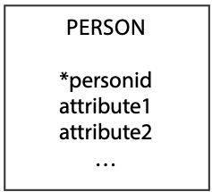

CREATE TABLE person (

personid INTEGER,

attribute1 … ,

attribute2 … ,

…

PRIMARY KEY(personid));

## A 1:1 recursive relationship

A recursive one-to-one (1:1) relationship is used to describe situations like current marriage. In most countries, a person can legally have zero or one current spouse. The relationship should be labeled to avoid misunderstandings. Mapping to the relational database requires that the identifier of the one end of the relationship becomes a foreign key. It does not matter which one you select. Notice that when personid is used as a foreign key, it must be given a different column name—in this case partner—because two columns in the same table cannot have the same name. The foreign key constraint is not defined, because this constraint cannot refer to the table being created.

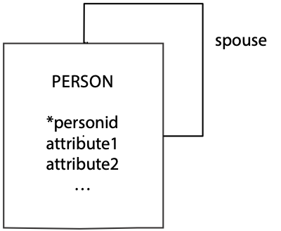

CREATE TABLE person (

personid INTEGER,

attribute1 … ,

attribute2 … ,

…

partner INTEGER,

PRIMARY KEY(personid));

## A recursive 1:m relationship

A recursive one-to-many (1:m) relationship describes situations like fatherhood or motherhood. The following figure maps fatherhood. A father may have many biological children, but a child has only one biological father. The relationship is mapped like any other 1:m relationship. The identifier of the one end becomes a foreign key in the many end. Again, we must rename the identifier when it becomes a foreign key in the same table. Also, again the foreign key constraint is not defined because it cannot refer to the table being created.

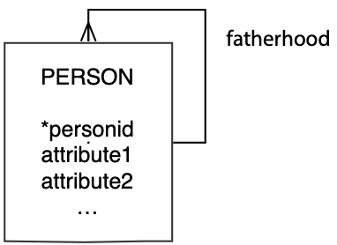

CREATE TABLE person (

personid INTEGER,

Attribute1 … ,

Attribute2 … ,

…

father INTEGER,

PRIMARY KEY(personid));

It is possible to have more than one 1:m recursive relationship. For example, details of a mother-child relationship would be represented in the same manner and result in the data model having a second 1:m recursive relationship. The mapping to the relational model would result in an additional column to contain a foreign key mother, the personid of a person’s mother.

## A recursive m:m relationship

A recursive many-to-many (m:m) relationship can describe a situation such as friendship. A person can have many friends and be a friend to many persons. As with m:m relationships between a pair of entities, we convert this relationship to two 1:m relationships and create an associative entity.

The resulting entity friendship has a composite primary key based on the identifier of person, which in effect means the two components are based on *personid*. To distinguish between them, the columns are called personid1 and personid2, so you can think of friendship as a pair of *personids*. You will see the same pattern occurring with other m:m recursive relationships. Notice both person identifiers are independent foreign keys, because they are used to map the two 1:m relationships between person and friendship.

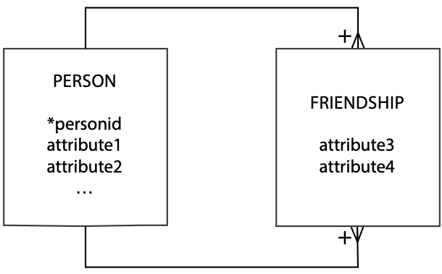

CREATE TABLE person (

personid INTEGER,

Attribute1 … ,

attribute2 … ,

…

PRIMARY KEY(personid));

CREATE TABLE friendship (

personid1 INTEGER,

personid2 INTEGER,

attribute3 … ,

attribute4 … ,

…

PRIMARY KEY(personid1,personid2),

CONSTRAINT fk_friendship_person1

FOREIGN KEY(personid1) REFERENCES person(personid),

CONSTRAINT fk_friendship_person2

FOREIGN KEY(personid2) REFERENCES person(personid));

A single entity can have multiple m:m recursive relationships. Relationships such as enmity (not enemyship) and siblinghood are m:m recursive on person. The approach to recording these relationships is the same as that outlined previously.

# Two entities

## No relationship

When there is no relationship between two entities, the client has decided there is no need to record a relationship between the two entities. When you are reading the data model with the client, be sure that you check whether this assumption is correct both now and for the foreseeable future. When there is no relationship between two entities, map them each as you would a single entity with no relationships.

## A 1:1 relationship

A 1:1 relationship sometimes occurs in parallel with a 1:m relationship between two entities. It signifies some instances of an entity that have an additional role. For example, a department has many employees (the 1:m relationship), and a department has one boss (the 1:1). The data model fragment shown in the following figure represents the 1:1 relationship.

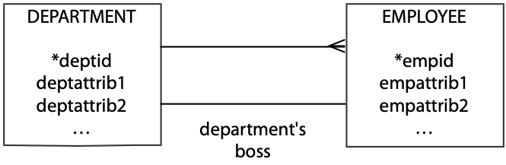

The guideline, as explained in Chapter 6, is to map the relationship to the relational model by placing the foreign key at the mandatory relationship side of the relationship. In this case, we place the foreign key in department because each department must have an employee who is the boss.

CREATE TABLE employee (

empid INTEGER,

empattrib1 … ,

empattrib2 … ,

…

PRIMARY KEY(empid));

CREATE TABLE department (

deptid CHAR(3),

deptattrib1 … ,

deptattrib2 … ,

…

bossid INTEGER,

PRIMARY KEY(deptid),

CONSTRAINT fk_department_employee

FOREIGN KEY(bossid) REFERENCES employee(empid));

## A 1:m relationship

The 1:m relationship is possibly the easiest to understand and map. The mapping to the relational model is very simple. The primary key of the “one” end becomes a foreign key in the “many” end.



CREATE TABLE nation (

natcode CHAR(3),

natname VARCHAR(20),

exchrate DECIMAL(9,5),

PRIMARY KEY(natcode));

CREATE TABLE stock (

stkcode CHAR(3),

stkfirm VARCHAR(20),

stkprice DECIMAL(6,2),

stkqty DECIMAL(8),

stkdiv DECIMAL(5,2),

stkpe DECIMAL(5),

natcode CHAR(3),

PRIMARY KEY(stkcode),

CONSTRAINT fk_stock_nation

FOREIGN KEY(natcode) REFERENCES nation(natcode));

## An m:m relationship

An m:m relationship is transformed into two 1:m relationships. The mapping is then a twofold application of the 1:m rule.

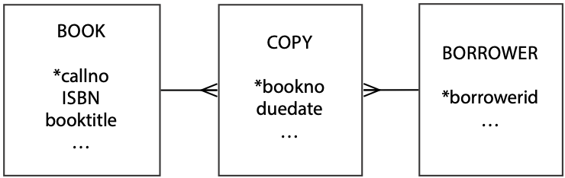

The book and borrower tables must be created first because copy contains foreign key constraints that refer to book and borrower. The column borrowerid can be null because a book need not be borrowed; if it’s sitting on the shelf, there is no borrower.

CREATE TABLE book (

callno VARCHAR(12),

isbn … ,

booktitle … ,

…

PRIMARY KEY(callno));

CREATE TABLE borrower (

borrowerid INTEGER,

…

PRIMARY KEY(borrowerid));

CREATE TABLE copy (

bookno INTEGER,

duedate DATE,

…

callno VARCHAR(12),

borrowerid INTEGER,

PRIMARY KEY(bookno),

CONSTRAINT fk_copy_book

FOREIGN KEY(callno) REFERENCES book(callno),

CONSTRAINT fk_copy_borrower

FOREIGN KEY (borrowerid) REFERENCES borrower(borrowerid));

# Another entity’s identifier as part of the identifier

Using one entity’s identifier as part of another entity’s identifier tends to cause the most problems for novice data modelers. (One entity’s identifier is part of another identifier when there is a plus sign on an arc. The plus is almost always at the crow’s foot end of a 1:m relationship.) Tables are formed by applying the following rule: The primary key of the table at the other end of the relationship becomes both a foreign key and part of the primary key in the table at the plus end. The application of this rule is shown for several common data model fragments.

## A weak or dependent entity

In the following figure, *regname* is part of the identifier (signified by the plus near the crow’s foot) and a foreign key of city (because of the 1:m between region and city).

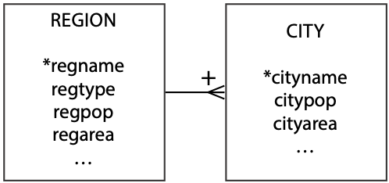

CREATE TABLE region (

regname VARCHAR(20),

regtype …,

regpop …,

regarea …,

…

PRIMARY KEY(regname));

CREATE TABLE city (

cityname VARCHAR(20),

citypop … ,

cityarea … ,

…

regname VARCHAR(20),

PRIMARY KEY(cityname,regname),

CONSTRAINT fk_city_region

FOREIGN KEY(regname) REFERENCES region(regname));

## An associative entity

In the following figure, observe that cityname and firmname are both part of the primary key (signified by the plus near the crow’s foot) and foreign keys (because of the two 1:m relationships) of store.

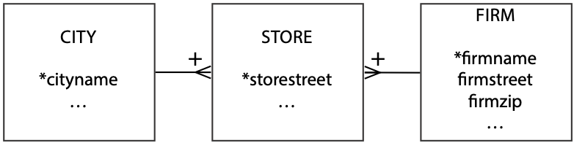

CREATE TABLE city (

cityname VARCHAR(20),

…

PRIMARY KEY(cityname));

CREATE TABLE firm

firmname VARCHAR(15),

firmstreet … ,

firmzip … ,

…

PRIMARY KEY(firmname));

CREATE TABLE store (

storestreet VARCHAR(30),

storezip … ,

…

cityname VARCHAR(20),

firmname VARCHAR(15),

PRIMARY KEY(storestreet,cityname,firmname),

CONSTRAINT fk_store_city

FOREIGN KEY(cityname) REFERENCES city(cityname),

CONSTRAINT fk_store_firm

FOREIGN KEY(firmname) REFERENCES firm(firmname));

## A tree structure

The interesting feature of the following figure is the primary key. Notice that the primary key of a lower level of the tree is a composite of its partial identifier and the primary key of the immediate higher level. The primary key of department is a composite of deptname, divname, and firmname. Novice modelers often forget to make this translation.

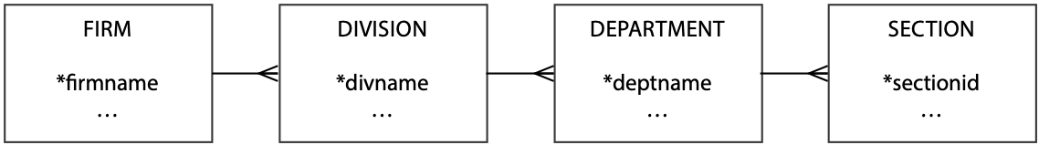

CREATE TABLE firm (

firmname VARCHAR(15),

…

PRIMARY KEY(firmname));

CREATE TABLE division (

divname VARCHAR(15),

…

firmname VARCHAR(15),

PRIMARY KEY(firmname,divname),

CONSTRAINT fk_division_firm

FOREIGN KEY(firmname) REFERENCES firm(firmname));

CREATE TABLE department (

deptname VARCHAR(15),

…

divname VARCHAR(15),

firmname VARCHAR(15),

PRIMARY KEY(firmname,divname,deptname),

CONSTRAINT fk_department_division

FOREIGN KEY (firmname,divname)

REFERENCES division(firmname,divname));

CREATE TABLE section (

sectionid VARCHAR(15),

…

divname VARCHAR(15),

firmname VARCHAR(15),

deptname VARCHAR(15),

PRIMARY KEY(firmname,divname,deptname,sectionid),

CONSTRAINT fk_department_department

FOREIGN KEY (firmname,divname,deptname)

REFERENCES department(firmname,divname,deptname));

### Another approach to a tree structure

A more general approach to modeling a tree structure is to recognize that it is a series of 1:m recursive relationships. Thus, it can be modeled as follows. This model is identical in structure to that of recursive 1:m reviewed earlier in this chapter and converted to a table in the same manner. Notice that we label the relationship superunit, and this would be a good choice of name for the foreign key.

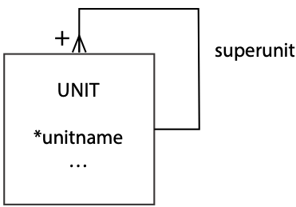

## Exercises

Write the SQL CREATE statements for the following data models.

1. 
2. 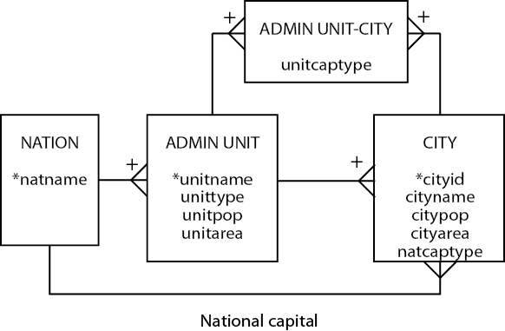
3. 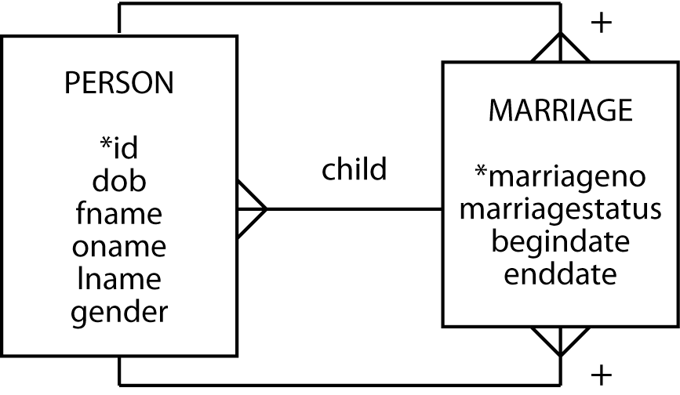
4. 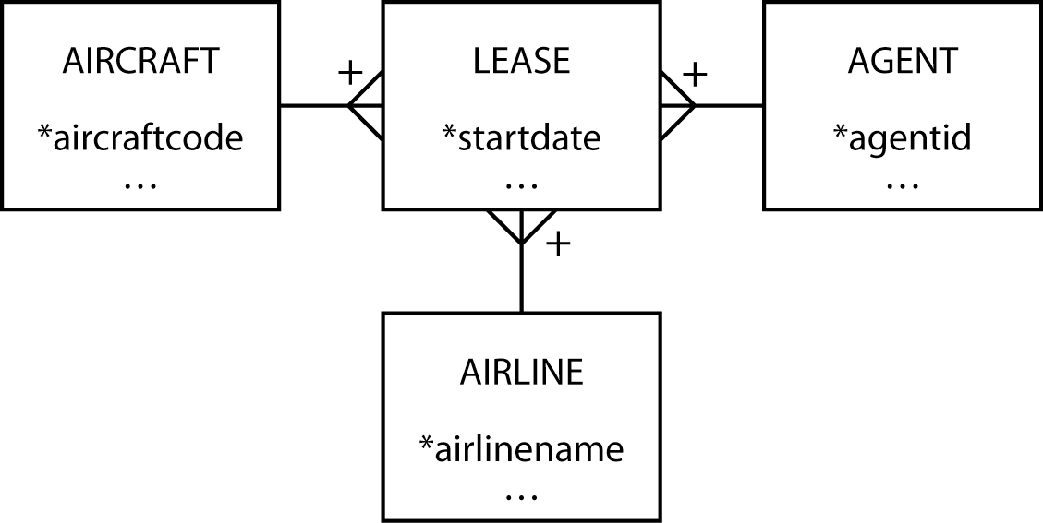
5. Under what circumstances might you use choose a fixed tree over a 1:m recursive data model?

8. Normalization and Other Data Modeling Methods

There are many paths to the top of the mountain, but the view is always the same.

Chinese Proverb

## Learning objectives

Students completing this chapter will

* understand the process of normalization;
* be able to distinguish between different normal forms;
* recognize that different data modeling approaches, while they differ in representation methods, are essentially identical.

## Introduction

There are often many ways to solve a problem, and different methods frequently produce essentially the same solution. When this is the case, the goal is to find the most efficient path. We believe that data modeling, as you have learned in the preceding chapters, is an efficient and easily learned approach to database design. There are, however, other paths to consider. One of these methods, normalization, was the initial approach to database design. It was developed as part of the theoretical foundation of the relational data model. It is useful to understand the key concepts of normalization because they advance your understanding of the relational model. Experience and research indicate, however, that normalization is more difficult to master than data modeling.

Data modeling first emerged as entity-relationship (E-R) modeling in a paper by Peter Pin-Shan Chen. He introduced two key database design concepts:

* Identify entities and the relationships between them.
* A graphical representation improves design communication.

Chen’s core concepts spawned many species of data modeling. To give you an appreciation of the variation in data modeling approaches, we briefly review, later in this chapter, Chen’s E-R approach and IDEF1X, an approach used by the Department of Defense.

# Normalization

Normalization is a method for increasing the quality of database design. It is also a theoretical base for defining the properties of relations. The theory gradually developed to create an understanding of the desirable properties of a relation. The goal of normalization is identical to that of data modeling—a high-fidelity design. The need for normalization seems to have arisen from the conversion of prior file systems into database format. Often, analysts started with the old file design and used normalization to design the new database. Now, designers are more likely to start with a clean slate and use data modeling.

Normal forms can be arrived at in several ways. The recommended approach is data modeling, as experience strongly indicates people find it is an easier path to high quality database design. If the principles of data modeling are followed faithfully, then the outcome should be a high-fidelity model and a normalized database. In other words, if you model data correctly, you create a normalized design. Nevertheless, modeling mistakes can occur, and normalization is a useful crosscheck for ensuring the soundness of a data model. Normalization also provides a theoretical underpinning to data modeling.

Normalization gradually converts a file design into normal form by the successive application of rules to move the design from first to fifth normal form. Before we look at these steps, it is useful to learn about functional dependency.

## Functional dependency

A functional dependency is a relationship between attributes in an entity. It simply means that one or more attributes determine the value of another. For example, given a stock’s code, you can determine its current PE ratio. In other words, PE ratio is functionally dependent on stock code. In addition, stock name, stock price, stock quantity, and stock dividend are functionally dependent on stock code. The notation for indicating that stock code functionally determines stock name is

stock code ® stock name

An identifier functionally determines all the attributes in an entity. That is, if we know the value of stock code, then we can determine the value of stock name, stock price, and so on.

Formulae, such as yield = stock dividend/stock price*100, are a form of functional dependency. In this case, we have

(stock dividend, stock price) ® yield

This is an example of full functional dependency because yield can be determined only from both attributes.

An attribute, or set of attributes, that fully functionally determines another attribute is called a determinant. Thus, stock code is a determinant because it fully functionally determines stock PE. An identifier, usually called a key when discussing normalization, is a determinant. Unlike a key, a determinant need not be unique. For example, a university could have a simple fee structure where undergraduate courses are $5000 and graduate courses are $7500. Thus, course type ® fee. Since there are many undergraduate and graduate courses, course type is not unique for all records.

There are situations where a given value determines multiple values. This multidetermination property is denoted as A ® ® B and reads “A multidetermines B.” For instance, a department multidetermines a course. If you know the department, you can determine the set of courses it offers. Multivalued dependencymeans that functional dependencies are multivalued.

Functional dependency is a property of a relation’s data. We cannot determine functional dependency from the names of attributes or the current values. Sometimes, examination of a relation’s data will indicate that a functional dependency does not exist, but it is by understanding the relationships between data elements we can determine functional dependency.

Functional dependency is a theoretical avenue for understanding relationships between attributes. If we have two attributes, say A and B, then three relations are possible, as shown in the following table.

Functional dependencies of two attributes

| *Relationship* | *Functional dependency* | *Relationship* |
| --- | --- | --- |
| They determine each other | A → B and B → A | 1:1 |
| One determines the other | A → B | 1:m |
| They do not determine each other | A not→ B and B not→A | m:m |

### One-to-one attribute relationship

Consider two attributes that determine each other (A ® B and B ® A), for instance a country’s code and its name. Using the example of Switzerland, there is a one-to-one (1:1) relationship between CH and Switzerland: CH ® Switzerland and Switzerland ® CH. When two attributes have a 1:1 relationship, they must occur together in at least one table in a database so that their equivalence is a recorded fact.

### One-to-many attribute relationship

Examine the situation where one attribute determines another (i.e., A® B), but the reverse is not true (i.e., A not® B), as is the case with country name and its currency unit. If you know a country’s name, you can determine its currency, but if you know the currency unit (e.g., the euro), you cannot always determine the country (e.g., both Italy and Portugal use the euro). As a result, if A and B occur in the same table, then A must be the key. In our example, country name would be the key, and currency unit would be a nonkey column.

### Many-to-many attribute relationship

The final case to investigate is when neither attribute determines the other (i.e., A not® B and B not®A). The relationship between country name and language is many-to-many (m:m). For example, Belgium has two languages (French and Flemish), and French is spoken in many countries. To record the m:m relationship between these attributes, a table containing both attributes as a composite key is required. This is essentially the associative entity created during data modeling, when there is an m:m relationship between entities.

As you can understand from the preceding discussion, functional dependency is an explicit form of presenting some of the ideas you gained implicitly in earlier chapters on data modeling. The next step is to delve into another theoretical concept underlying the relational model: normal forms.

## Normal forms

Normal forms describe a classification of relations. Initial work by Codd identified first (1NF), second (2NF), and third (3NF) normal forms. Later researchers added Boyce-Codd (BCNF), fourth (4NF), and fifth (5NF) normal forms. Normal forms are nested like a set of Russian dolls, with the innermost doll, 1NF, contained within all other normal forms. The hierarchy of normal forms is 5NF, 4NF, BCNF, 3NF, 2NF, and 1NF. Thus, 5NF is the outermost doll.

A new normal form, domain-key normal form (DK/NF), appeared in 1981. When a relation is in DK/NF, there are no modification anomalies. Conversely, any relation that is free of anomalies must be in DK/NF. The difficult part is discovering how to convert a relation to DK/NF.

## First normal form

A relation is in first normal form if and only if all columns are single-valued. In other words, 1NF states that all occurrences of a row must have the same number of columns. In data modeling terms, this means that an attribute must have a single value. An attribute that can have multiple values must be represented as a one-to-many (1:m) relationship. At a minimum, a data model will be in 1NF, because all attributes of an entity are required to be single-valued.

## Second normal form

Second normal form is violated when a nonkey column is dependent on only a component of the primary key. This can also be stated as a relation is in second normal form if and only if it is in first normal form, and all nonkey columns are dependent on the key***.***

Consider the following table. The primary key of order is a composite of itemno and customerid. The problem is that customer-credit is a fact about customerid (part of the composite key) rather than the full key (itemno+customerid), or in other words, it is not fully functionally dependent on the primary key. An insert anomaly arises when you try to add a new customer to order. You cannot add a customer until that person places an order, because until then you have no value for item number, and part of the primary key will be null. Clearly, this is neither an acceptable business practice nor an acceptable data management procedure.

Analyzing this problem, you realize an item can be in many orders, and a customer can order many items—an m:m relationship. By drawing the data model in the following figure, you realize that customer-credit is an attribute of customer, and you get the correct relational mapping.

Second normal form violation

| itemno | customerid | quantity | customer-credit |
| --- | --- | --- | --- |
| 12 | 57 | 25 | OK |
| 34 | 679 | 3 | POOR |

Resolving second normal form violation

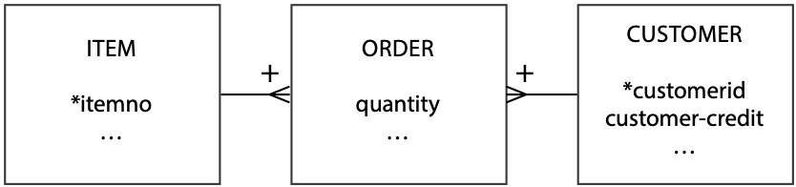

## Third normal form

Third normal form is violated when a nonkey column is a fact about another nonkey column. Alternatively, a relation is in third normal form if and only if it is in second normal form and has no transitive dependencies.

The problem in the following table is that exchange rate is a fact about nation, a nonkey field. In the language of functional dependency, exchange rate is not fully functionally dependent on stockcode, the primary key.

The functional dependencies are stockcode → nation → exchange rate. In other words, exchange rate is transitively dependent on stock, since exchange rate is dependent on nation, and nation is dependent on stockcode. The fundamental problem becomes very apparent when you try to add a new nation to the stock table. Until you buy at least one stock for that nation, you cannot insert the nation, because you do not have a primary key. Similarly, if you delete MG from the stock table, details of the USA exchange rate are lost. There are modification anomalies.

When you think about the data relationships, you realize that a nation has many stocks and a stock belongs to only one nation. Now the data model and relational map can be created readily .

Third normal form violation

| stockcode | nation | exchange rate |
| --- | --- | --- |
| MG | USA | 0.67 |
| IR | AUS | 0.46 |

Resolving third normal form violation



Skill builder

You have been given a spreadsheet that contains details of invoices. The column headers for the spreadsheet are *date*, *invoice number*, *invoice amount*, *invoice tax*, *invoice total*, *cust number*, *cust name*, *cust street*, *cust city*, *cust state*, *cust postal code*, *cust nation*, *product code*, *product price*, *product quantity*, *salesrep number*, *salesrep first name*, *salesrep last name*, *salesrep district*, *district name*, and *district size*. Normalize this spreadsheet so that it can be converted to a high-fidelity relational database.

## Boyce-Codd normal form

The original definition of 3NF did not cover a situation that, although rare, can occur. So Boyce-Codd normal form, a stronger version of 3NF, was developed. BCNF is necessary because 3NF does not cover the cases when

* A relation has multiple candidate keys.
* Those candidate keys are composite.
* The candidate keys overlap because they have at least one column in common.

Before considering an example, candidate key needs to be defined. Earlier we introduced the idea that an entity could have more than one potential unique identifier. These identifiers become candidate keys when the data model is mapped to a relational database. One of these candidates is selected as the primary key.

Consider the following case from a management consulting firm. A client can have many types of problems (e.g., finance, personnel), and the same problem type can be an issue for many clients. Consultants specialize and advise on only one problem type, but several consultants can advise on one problem type. A consultant advises a client. Furthermore, for each problem type, the client is advised by only one consultant. If you did not use data modeling, you might be tempted to create the following table.

Boyce-Codd normal form violation

| client | probtype | consultant |
| --- | --- | --- |
| Alpha | Marketing | Gomez |
| Alpha | Production | Raginiski |

The column client cannot be the primary key because a client can have several problem types; however, a client is advised by only one consultant for a specific problem type, so the composite key client+probtype determines consultant. Also, because a consultant handles only one type of problem, the composite key client+consultant determines probtype. So, both of these composites are candidate keys. Either one can be selected as the primary key, and in this case client+probtype was selected. Notice that all the previously stated conditions are satisfied—there are multiple, composite candidate keys that overlap. This means the table is 3NF, but not BCNF. This can be easily verified by considering what happens if the firm adds a new consultant. A new consultant cannot be added until there is a client—an insertion anomaly. The problem is that consultant is a determinant, consultant→probtype, but is not a candidate key. In terms of the phrasing used earlier, the problem is that part of the key column is a fact about a nonkey column. The precise definition is a relation is in Boyce-Codd normal form if and only if every determinant is a candidate key.

This problem is avoided by creating the correct data model and then mapping to a relational model.

Resolving Boyce-Codd normal form violation

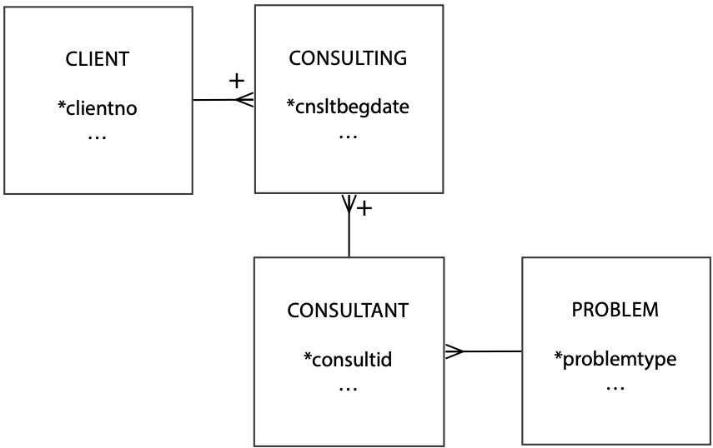

## Fourth normal form

Fourth normal form requires that a row should not contain two or more independent multivalued facts about an entity. This requirement is more readily understood after investigating an example.

Consider students who play sports and study subjects. One way of representing this information is shown in the following table. Consider the consequence of trying to insert a student who did not play a sport. Sport would be null, and this is not permissible because part of the composite primary key would then be null—a violation of the entity integrity rule. You cannot add a new student until you know her sport and her subject. Modification anomalies are very apparent.

Fourth normal form violation

| studentid | sport | subject | ... |
| --- | --- | --- | --- |
| 50 | Football | English | ... |
| 50 | Football | Music | ... |
| 50 | Tennis | Botany | ... |
| 50 | Karate | Botany | ... |

This table is not in 4NF because sport and subject are independent multivalued facts about a student. There is no relationship between sport and subject. There is an indirect connection because sport and subject are associated with a student. In other words, a student can play many sports, and the same sport can be played by many students—a many-to-many (m:m) relationship between student and sport. Similarly, there is an m:m relationship between student and subject. It makes no sense to store information about a student’s sports and subjects in the same table because sport and subject are not related. The problem arises because sport and subject are multivalued dependencies of student. The solution is to convert multivalued dependencies to functional dependencies. More formally, a relation is in fourth normal form if it is in Boyce-Codd normal form and all multivalued dependencies on the relation are functional dependencies.A data model sorts out this problem, and note that the correct relational mapping requires five tables.

Resolving fourth normal form violation

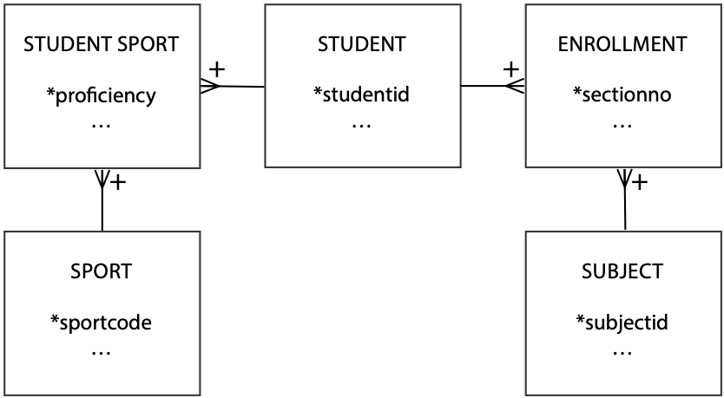

## Fifth normal form

Fifth normal form deals with the case where a table can be reconstructed from other tables. The reconstruction approach is preferred, because it means less redundancy and fewer maintenance problems.

A consultants, firms, and skills problem is used to illustrate the concept of 5NF. The problem is that consultants provide skills to one or more firms and firms can use many consultants; a consultant has many skills and a skill can be used by many firms; and a firm can have a need for many skills and the same skill can be required by many firms. The data model for this problem has the ménage-à-trois structure which was introduced in Chapter 7.

The CONSULTANT-FIRM-SKILL data model without a rule

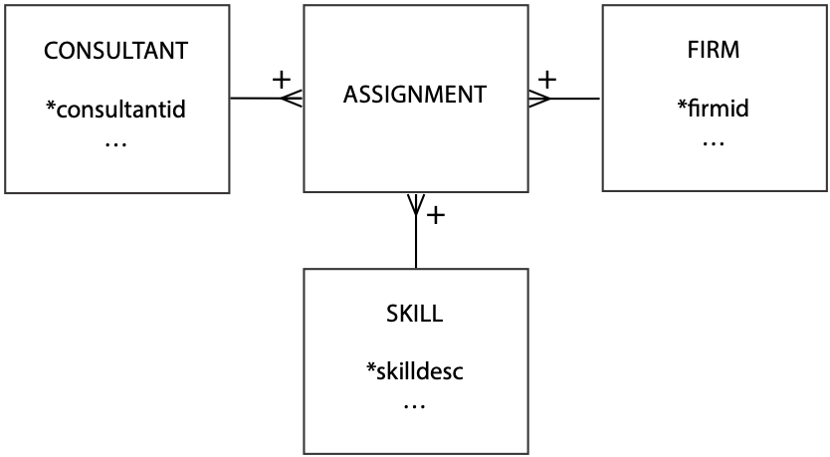

The relational mapping of the three-way relationships results in four tables, with the associative entity ASSIGNMENT mapping shown in the following table.

Relation table assignment

| consultid | firmid | skilldesc |
| --- | --- | --- |
| Tan | IBM | Database |
| Tan | Apple | Data comm |

The table is in 5NF because the combination of all three columns is required to identify which consultants supply which firms with which skills. For example, we see that Tan advises IBM on database and Apple on data communications. The data in this table cannot be reconstructed from other tables.

The preceding table is not in 5NF if there is a rule of the following form: If a consultant has a certain skill (e.g., database) and has a contract with a firm that requires that skill (e.g., IBM), then the consultant advises that firm on that skill (i.e., he advises IBM on database). Notice that this rule means we can infer a relationship, and we no longer need the combination of the three columns. As a result, we break the single three-entity m:m relationship into three two-entity m:m relationships. Revised data model after the introduction of the rule

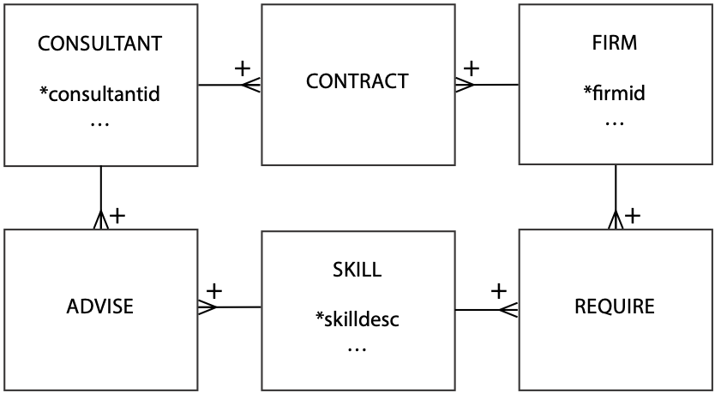

Further understanding of 5NF is gained by examining the relational tables resulting from these three associative entities. Notice the names given to each of the associative entities. The table contract records data about the firms a consultant advises; advise describes the skills a consultant has; and require stores data about the types of skills each firm requires. To help understand this problem, examine the three tables below.

Relational table contract

| consultid | firmid |
| --- | --- |
| Gonzales | Apple |
| Gonzales | IBM |
| Gonzales | NEC |
| Tan | IBM |
| Tan | NEC |
| Wood | Apple |

Relational table advise

| consultid | skilldesc |
| --- | --- |
| Gonzales | Database |
| Gonzales | Data comm |
| Gonzales | Groupware |
| Tan | Database |
| Tan | Data comm |
| Wood | Data comm |

Relational table require

|  |  |
| --- | --- |
| firmid | skilldesc |
| IBM | Data comm |
| IBM | Groupware |
| NEC | Data comm |
| NEC | Database |
| NEC | Groupware |
| Apple | Data comm |

Consider joining contract and advise, the result of which we call could advise because it lists skills the consultant could provide if the firm required them. For example, Tan has skills in database and data communications, and Tan has a contract with IBM. If IBM requires database skills, Tan can handle it. We need to look at require to determine whether IBM requires advice on database; it does not.

Relational table could advise

| consultid | firmid | skilldesc |
| --- | --- | --- |
| Gonzales | Apple | Database |
| Gonzales | Apple | Data comm |
| Gonzales | Apple | Groupware |
| Gonzales | IBM | Database |
| Gonzales | IBM | Data comm |
| Gonzales | IBM | Groupware |
| Gonzales | NEC | Database |
| Gonzales | NEC | Data comm |
| Gonzales | NEC | Groupware |
| Tan | IBM | Database |
| Tan | IBM | Data comm |
| Tan | NEC | Database |
| Tan | NEC | Data comm |
| Wood | Apple | Data comm |

Relational table can advise

The join of could advise with require gives details of a firm’s skill needs that a consultant can provide. The table can advise is constructed by directly joining contract, advise, and require. Because we can construct can advise from three other tables, the data are in 5NF.

| consultid | firmid | skilldesc |
| --- | --- | --- |
| Gonzales | IBM | Data comm |
| Gonzales | IBM | Groupware |
| Gonzales | NEC | Database |
| Gonzales | NEC | Data comm |
| Gonzales | NEC | Groupware |
| Tan | IBM | Data comm |
| Tan | NEC | Database |
| Tan | NEC | Data comm |
| Wood | Apple | Data comm |

Since data are stored in three separate tables, updating is easier. Consider the case where IBM requires database skills. We only need to add one row to require to record this fact. In the case of can advise, we would have to add two rows, one for Gonzales and one for Tan.

Now we can give 5NF a more precise definition: A relation is in fifth normal form if and only if every join dependency of the relation is a consequence of the candidate keys of the relation.

Up to this point, data modeling has enabled you to easily avoid normalization problems. Fifth normal form introduces a complication, however. How can you tell when to use a single three-way associative entity or three two-way associative entities? If there is a constraint or rule that is applied to the relationships between entities, consider the possibility of three two-way associative entities. Question the client carefully whenever you find a ménage-à-trois. Check to see that there are no rules or special conditions.

## Domain-key normal form

The definition of DK/NF builds on three terms: key, constraint, and domain. You already know a key is a unique identifier. A **constraint** is a rule governing attribute values. It must be sufficiently well-defined so that its truth can be readily evaluated. Referential integrity constraints, functional dependencies, and data validation rules are examples of constraints. A **domain** is a set of all values of the same data type. With the help of these terms, the concept of DK/NF is easily stated.A relation is in domain-key normal form if and only if every constraint on the relation is a logical consequence of the domain constraints and the key constraints that apply to the relation.

Note that DK/NF does not involve ideas of dependency; it just relies on the concepts of key, constraint, and domain. The problem with DK/NF is that while it is conceptually simple, no algorithm has been developed for converting relations to DK/NF. Hence, database designers must rely on their skills to create relations that are in DK/NF.

## Conclusion

Normalization provides designers with a theoretical basis for understanding what they are doing when modeling data. It also alerts them to be aware of problems that they might not ordinarily detect when modeling. For example, 5NF cautions designers to investigate situations carefully (i.e., look for special rules), when their data model contains a ménage-à-trois.

# Other data modeling methods

As mentioned previously, there are many species of data modeling. Here we consider two methods.

## The E-R model

One of the most widely known data modeling methods is the E-R model developed by Chen. There is no standard for the E-R model, and it has been extended and modified in a number of ways.

As the following figure shows, an E-R model looks like the data models with which you are now familiar. Entities are shown by rectangles, and relationships are depicted by diamonds within which the cardinality of the relationship is indicated (e.g., there is a 1:m relationship between NATION and STOCK EXCHANGE). Cardinality can be 1:1, 1:m (conventionally shown as 1:N in E-R diagrams), and m:m (shown as M:N). Recursive relationships are also readily modeled. One important difference is that an m:m relationship is not shown as an associative entity; thus the database designer must convert this relationship to a table.

An E-R diagram

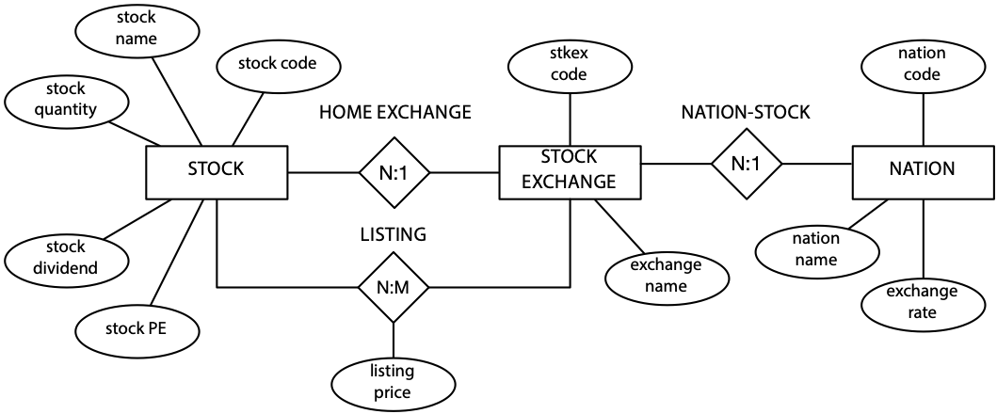

Attributes are shown as ellipses connected to the entity or relationship to which they belong (e.g., stock name is an attribute of STOCK). Relationships are named, and the name is shown above or below the relationship symbol. For example, LISTING is the name of the m:m relationship between STOCK and STOCK EXCHANGE. The method of recording attributes consumes space, particularly for large data models. It is more efficient to record attributes within an entity rectangle, as in the data modeling method you have learned.

## IDEF1X

IDEF1X (Integrated DEFinition 1X) was conceived in the late 1970s and refined in the early 1980s. It is based on the work of Codd and Chen. A quick look at some of the fundamental ideas of IDEF1X will show you how similar it is to the method you have learned. Entities are represented in a similar manner, as the following figure shows. The representation is a little different (e.g., the name of the entity is in a separate box within a rectangle), but the information is the same.

IDEF1X adds additional notation to an attribute to indicate whether it is an alternate key or inversion entry. An alternate key is a possible primary key (identifier) that was not selected as the primary key. Stock name, assuming it is unique, is an alternate key. An inversion entry indicates a likely frequent way of accessing the entity, so it should become an index. For instance, the entity may be accessed frequently via stock name. Alternate keys are shown as AK1, AK2,... and inversion entries as IE1, IE2, .... Thus, stock name is both an alternate key and an inversion entry.

The representation of relationships is also similar. A dot is used rather than a crow’s foot. Also, notice that relationships are described, whereas you learned to describe only relationships when they are not readily inferred.

An IDEF1X relationship

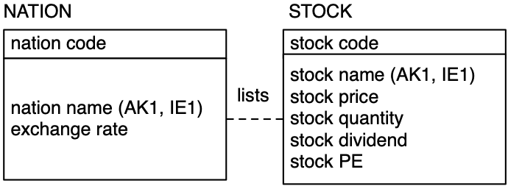

Skill builder

Ken is a tour guide for trips that can last several weeks. He has requested a database that will enable him to keep track of the people who have been on the various tours he has led. He wants to be able to record his comments about some of his clients to remind him of extra attention he might need to pay to them on a future trip  (e.g., Bill tends to get lost, Daisy has problems getting along with others). Some times people travel with a partner, and Ken wants to record this in his database.

Design a database using MySQL Workbench. Experiment with Object Notation and Relationship Notation (options of the Model tab) to get a feel for different forms of representing data models.

## Conclusion

The underlying concepts of different data modeling methods are very similar. They all have the same goal: improving the quality of database design. They share common concepts, such as entity and relationship mapping. We have adopted an approach that is simple and effective. The method can be learned rapidly, novice users can create high-quality models, and it is similar to the representation style of MySQL Workbench. Also, if you have learned one data modeling method, you can quickly adapt to the nuances of other methods.

## Summary

Normalization gradually converts a file design into normal form by successive application of rules to move the design from first to fifth normal form. Functional dependency means that one or more attributes determine the value of another. An attribute, or set of attributes, that fully functionally determines another attribute is called a determinant. First normal form states that all occurrences of a row must have the same number of columns. Second normal form is violated when a nonkey column is a fact about a component of the prime key. Third normal form is violated when a nonkey column is a fact about another nonkey column. Boyce-Codd normal form is a stronger version of third normal form. Fourth normal form requires that a row should not contain two or more independent multivalued facts about an entity. Fifth normal form deals with the case where a table can be reconstructed from data in other tables. Fifth normal form arises when there are special rules or conditions. A high-fidelity data model will be of high normal form.

One of the most widely known methods of data modeling is the E-R model. The basic concepts of most data modeling methods are very similar. All aim to improve database design.

## Key terms and concepts

Alternate key

Boyce-Codd normal form (BCNF)

Constraint

Data model

Determinant

Domain

Domain-key normal form (DK/NF)

Entity

Entity-relationship (E-R) model

Fifth normal form (5NF)

First normal form (1NF)

Fourth normal form (1NF)

Full functional dependency

Functional dependency

Generalization hierarchy

IDEF1X

Inversion entry

Many-to-many attribute relationship

Multidetermination

Multivalued dependency

Normalization

One-to-many attribute relationship

One-to-one attribute relationship

Relationship

Second normal form (2NF)

Third normal form (3NF)

## References and additional readings

Chen, P. 1976. The entity-relationship model—toward a unified view of data. *ACM Transactions on Database Systems* 1 (1):9–36.

Kent, W. 1983. A simple guide to five normal forms in relational database theory. *Communications of the ACM 26 (2): 120-125.*

## Exercises

### Short answers

1. What is normalization, and what is its goal?
2. How does DK/NF differ from earlier normal forms?
3. How do E-R and IDEF1X differ from the data modeling method of this text?

### Normalization and data modeling

Using normalization, E-R, or IDEF1X, create data models from the following narratives, which are sometimes intentionally incomplete. You will have to make some assumptions. Make certain you state these assumptions alongside your data model. Define the identifier(s) and attributes of each entity.

1. The president of a book wholesaler has told you that she wants information about publishers, authors, and books.
2. A university has many subject areas (e.g., MIS, Romance languages). Professors teach in only one subject area, but the same subject area can have many professors. Professors can teach many different courses in their subject area. An offering of a course (e.g., Data Management 457, French 101) is taught by only one professor at a particular time.
3. Kids’n’Vans retails minivans for a number of manufacturers. Each manufacturer offers several models of its minivan (e.g., SE, LE, GT). Each model comes with a standard set of equipment (e.g., the Acme SE comes with wheels, seats, and an engine). Minivans can have a variety of additional equipment or accessories (radio, air conditioning, automatic transmission, airbag, etc.), but not all accessories are available for all minivans (e.g., not all manufacturers offer a driver’s side airbag). Some sets of accessories are sold as packages (e.g., the luxury package might include stereo, six speakers, cocktail bar, and twin overhead foxtails).
4. Steve operates a cinema chain and has given you the following information:  
   “I have many cinemas. Each cinema can have multiple theaters. Movies are shown throughout the day starting at 11 a.m. and finishing at 1 a.m. Each movie is given a two-hour time slot. We never show a movie in more than one theater at a time, but we do shift movies among theaters because seating capacity varies. I am interested in knowing how many people, classified by adults and children, attended each showing of a movie. I vary ticket prices by movie and time slot. For instance, Lassie Get Lost is 50 cents for everyone at 11 a.m. but is 75 cents at 11 p.m.”
5. A telephone company offers a 10 percent discount to any customer who phones another person who is also a customer of the company. To be eligible for the discount, the pairing of the two phone numbers must be registered with the telephone company. Furthermore, for billing purposes, the company records both phone numbers, start time, end time, and date of call.

9. The Relational Model and Relational Algebra

Nothing is so practical as a good theory.

K. Lewin, 1945

## Learning objectives

Students completing this chapter will

* know the structures of the relational model;
* understand relational algebra commands;
* be able to determine whether a DBMS is completely relational.

## Background

The relational model, developed as a result of recognized shortcomings of hierarchical and network DBMSs, was introduced by Codd in 1970.As the major developer, Codd believed that a sound theoretical model would solve most practical problems that could potentially arise.

In another article, Codd expounds the case for adopting the relational over earlier database models. There is a threefold thrust to his argument. First***,*** earlier models force the programmer to code at a low level of structural detail. As a result, application programs are more complex and take longer to write and debug. Second, no commands are provided for processing multiple records at one time. Earlier models do not provide the set-processing capability of the relational model. The set-processing feature means that queries can be more concisely expressed. Third, the relational model, through a query language such as structured query language (SQL), recognizes the clients’ need to make ad hoc queries. The relational model and SQL permits an IS department to respond rapidly to unanticipated requests. It can also mean that analysts can write their own queries. Thus, Codd’s assertion that the relational model is a practical tool for increasing the productivity of IS departments is well founded.

The productivity increase arises from three of the objectives that drove Codd’s research. The first was to provide a clearly delineated boundary between the logical and physical aspects of database management. Programming should be divorced from considerations of the physical representation of data. Codd labels this the data independence objective. The second objective was to create a simple model that is readily understood by a wide range of analysts and programmers. This communicability objective promotes effective and efficient communication between clients and IS personnel. The third objective was to increase processing capabilities from record-at-a-time to multiple-records-at-a-time—the set-processing objective. Achievement of these objectives means fewer lines of code are required to write an application program, and there is less ambiguity in client-analyst communication.

The relational model has three major components:

* Data structures
* Integrity rules
* Operators used to retrieve, derive, or modify data

# Data structures

Like most theories, the relational model is based on some key structures or concepts. We need to understand these in order to understand the theory.

## Domain

A domain is a set of values all of the same data type. For example, the domain of nation name is the set of all possible nation names. The domain of all stock prices is the set of all currency values in, say, the range $0 to $10,000,000. You can think of a domain as all the legal values of an attribute.

In specifying a domain, you need to think about the smallest unit of data for an attribute defined on that domain. In Chapter  8, we discussed how a candidate attribute should be examined to see whether it should be segmented (e.g., we divide name into first name, other name, and last name, and maybe more). While it is unlikely that name will be a domain, it is likely that there will be a domain for first name, last name, and so on. Thus, a domain contains values that are in their atomic state; they cannot be decomposed further.

The practical value of a domain is to define what comparisons are permissible. Only attributes drawn from the same domain should be compared; otherwise it is a bit like comparing bananas and strawberries. For example, it makes no sense to compare a stock’s PE ratio to its price. They do not measure the same thing; they belong to different domains. Although the domain concept is useful, it is rarely supported by relational model implementations.

## Relations

A relation is a table of n columns (or attributes) and m rows (or tuples). Each column has a unique name, and all the values in a column are drawn from the same domain. Each row of the relation is uniquely identified. The order of columns and rows is immaterial.

The cardinality of a relation is its number of rows. The degree of a relation is the number of columns. For example, the relation nation (see the following figure) is of degree 3 and has a cardinality of 4. Because the cardinality of a relation changes every time a row is added or deleted, you can expect cardinality to change frequently. The degree changes if a column is added to a relation, but in terms of relational theory, it is considered to be a new relation. So, only a relation’s cardinality changes.

A relational database with tables nation and stock

| natcode | natname | exchrate |  |
| --- | --- | --- | --- |
| AUS | Australia | 0.46 |  |
| IND | India | 0.0228 |  |
| UK | United Kingdom | 1 |  |
| USA | United States | 0.67 | → |

| stkcode | stkfirm | stkprice | stkqty | stkdiv | stkpe | natcode |  |
| --- | --- | --- | --- | --- | --- | --- | --- |
| FC | Freedonia Copper | 27.5 | 10,529 | 1.84 | 16 | UK |  |
| PT | Patagonian Tea | 55.25 | 12,635 | 2.5 | 10 | UK |  |
| AR | Abyssinian Ruby | 31.82 | 22,010 | 1.32 | 13 | UK |  |
| SLG | Sri Lankan Gold | 50.37 | 32,868 | 2.68 | 16 | UK |  |
| ILZ | Indian Lead & Zinc | 37.75 | 6,390 | 3 | 12 | UK |  |
| BE | Burmese Elephant | 0.07 | 154,713 | 0.01 | 3 | UK |  |
| BS | Bolivian Sheep | 12.75 | 231,678 | 1.78 | 11 | UK |  |
| NG | Nigerian Geese | 35 | 12,323 | 1.68 | 10 | UK |  |
| CS | Canadian Sugar | 52.78 | 4,716 | 2.5 | 15 | UK |  |
| ROF | Royal Ostrich Farms | 33.75 | 1,234,923 | 3 | 6 | UK |  |
| MG | Minnesota Gold | 53.87 | 816,122 | 1 | 25 | USA | ← |
| GP | Georgia Peach | 2.35 | 387,333 | 0.2 | 5 | USA | ← |
| NE | Narembeen Emu | 12.34 | 45,619 | 1 | 8 | AUS |  |
| QD | Queensland Diamond | 6.73 | 89,251 | 0.5 | 7 | AUS |  |
| IR | Indooroopilly Ruby | 15.92 | 56,147 | 0.5 | 20 | AUS |  |
| BD | Bombay Duck | 25.55 | 167,382 | 1 | 12 | IN |  |

## Relational database

A relational database is a collection of relations or tables. The distinguishing feature of the relational model, when compared to the hierarchical and network models, is that there are no explicit linkages between tables. Tables are linked by common columns drawn on the same domain; thus, the portfolio database (see the preceding tables) consists of tables stock and nation. The 1:m relationship between the two tables is represented by the column natcode that is common to both tables. Note that the two columns need not have the same name, but they must be drawn on the same domain so that comparison is possible. In the case of an m:m relationship, while a new table must be created to represent the relationship, the principle of linking tables through common columns on the same domain remains in force.

## Primary key

A relation’s primary key is its unique identifier; for example, the primary key of nation is natcode. As you already know, a primary key can be a composite of several columns. The primary key guarantees that each row of a relation can be uniquely addressed.

## Candidate key

In some situations, there may be several attributes, known as candidate keys, that are potential primary keys. Column natcode is unique in the nation relation, for example. We also can be fairly certain that two nations will not have the same name. Therefore, nation has multiple candidate keys: natcode and natname.

## Alternate key

When there are multiple candidate keys, one is chosen as the primary key, and the remainder are known as alternate keys. In this case, we selected natcode as the primary key, and natname is an alternate key.

## Foreign key

The foreign key is an important concept of the relational model. It is the way relationships are represented and can be thought of as the glue that holds a set of tables together to form a relational database. A foreign key is an attribute (possibly composite) of a relation that is also a primary key of a relation. The foreign key and primary key may be in different relations or the same relation, but both keys must be drawn from the same domain.

# Integrity rules

The integrity section of the relational model consists of two rules. The entity integrity rule ensures that each instance of an entity described by a relation is identifiable in some way. Its implementation means that each row in a relation can be uniquely distinguished. The rule is

No component of the primary key of a relation may be null.

Null in this case means that the component cannot be undefined or unknown; it must have a value. Notice that the rule says “component of a primary key.” This means every part of the primary key must be known. If a part cannot be defined, it implies that the particular entity it describes cannot be defined. In practical terms, it means you cannot add a nation to nation unless you also define a value for natcode.

The definition of a foreign key implies that there is a corresponding primary key. The referential integrity rule ensures that this is the case. It states

A database must not contain any unmatched foreign key values.

Simply, this rule means that you cannot define a foreign key without first defining its matching primary key. In practical terms, it would mean you could not add a Canadian stock to the stock relation without first creating a row in nation for Canada.

Notice that the concepts of foreign key and referential integrity are intertwined. There is not much sense in having foreign keys without having the referential integrity rule. Permitting a foreign key without a corresponding primary key means the relationship cannot be determined. Note that the referential integrity rule does not imply a foreign key cannot be null. There can be circumstances where a relationship does not exist for a particular instance, in which case the foreign key is null.

# Manipulation languages

There are four approaches to manipulating relational tables, and you are already familiar with SQL. Query-by-example (QBE), which describes a general class of graphical interfaces to a relational database to make it easier to write queries, is also commonly used. Less widely used manipulation languages are relational algebra and relational calculus. These languages are briefly discussed, with some attention given to relational algebra in the next section and SQL in the following chapter.

Query-by-example (QBE) is not a standard, and each vendor implements the idea differently. The general principle is to enable those with limited SQL skills to interrogate a relational database. Thus, the analyst might select tables and columns using drag and drop or by clicking a button. The following screen shot shows the QBE interface to LibreOffice, which is very similar to that of MS Access. It shows selection of the stock table and two of its columns, as well as a criterion for stkqty. QBE commands are translated to SQL prior to execution, and many systems allow you to view the generated SQL. This can be handy. You can use QBE to generate a portion of the SQL for a complex query and then edit the generated code to fine-tune the query.

Query-by-example with LibreOffice

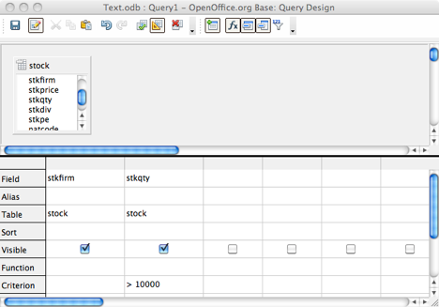

**Relational algebra** has a set of operations similar to traditional algebra (e.g., add and multiply) for manipulating tables. Although relational algebra can be used to resolve queries, it is seldom employed, because it requires you to specify both what you want and how to get it. That is, you have to specify the operations on each table. This makes relational algebra more difficult to use than SQL, where the focus is on specifying what is wanted.

Relational calculus overcomes some of the shortcomings of relational algebra by concentrating on what is required. In other words, there is less need to specify how the query will operate. Relational calculus is classified as a nonprocedural language, because you do not have to be overly concerned with the procedures by which a result is determined.

Unfortunately, relational calculus can be difficult to learn, and as a result, language designers developed SQL and QBE, which are nonprocedural and more readily mastered. You have already gained some skills in SQL. Although QBE is generally easier to use than SQL, IS professionals need to master SQL for two reasons. First***,*** SQL is frequently embedded in other programming languages, a feature not available with QBE. Second, it is very difficult, or impossible, to express some queries in QBE (e.g., divide). Because SQL is important, it is the focus of the next chapter.

## Relational algebra

The relational model includes a set of operations, known as relational algebra, for manipulating relations. Relational algebra is a standard for judging data retrieval languages. If a retrieval language, such as SQL, can be used to express every relational algebra operator, it is said to be relationally complete.

Relational algebra operators

| Operator | Description |
| --- | --- |
| Restrict | Creates a new table from specified rows of an existing table |
| Project | Creates a new table from specified columns of an existing table |
| Product | Creates a new table from all the possible combinations of rows of two existing tables |
| Union | Creates a new table containing rows appearing in one or both tables of two existing tables |
| Intersect | Creates a new table containing rows appearing in both tables of two existing tables |
| Difference | Creates a new table containing rows appearing in one table but not in the other of two existing tables |
| Join | Creates a new table containing all possible combinations of rows of two existing tables satisfying the join condition |
| Divide | Creates a new table containing *xi* such that the pair (*x*i, *y*i) exists in the first table for every *yi* in the second table |

There are eight relational algebra operations that can be used with either one or two relations to create a new relation. The assignment operator (:=) indicates the name of the new relation. The relational algebra statement to create relation A, the union of relations B and C, is expressed as

A := B UNION C

Before we begin our discussion of each of the eight operators, note that the first two, restrict and project, operate on a single relation and the rest require two relations.

## Restrict

Restrict extracts specified rows from a single relation. As the shaded rows in the following figure depict, restrict takes a horizontal slice through a relation.

Relational operation restrict—a horizontal slice

| W | X | Y | Z |
| --- | --- | --- | --- |
|  |  |  |  |
|  |  |  |  |
|  |  |  |  |
|  |  |  |  |
|  |  |  |  |

The relational algebra command to create the new relation using restrict is

tablename WHERE column1 theta column2

or

tablename WHERE column1 theta literal

where theta can be =, <>, >, >=, <, or <=.

For example, the following relational algebra command creates a new table from stock containing all rows with a nation code of 'US':

usstock := stock WHERE natcode = 'US'

## Project

Project extracts specified columns from a table. As the following figure shows, project takes a vertical slice through a table.

Relational operator project—a vertical slice

| W | X | Y | Z |
| --- | --- | --- | --- |
|  |  |  |  |
|  |  |  |  |
|  |  |  |  |
|  |  |  |  |
|  |  |  |  |

The relational algebra command to create the new relation using project is

tablename [columnname, …]

So, in order to create a new table from nation that contains the nation’s name and its exchange rate, for example, you would use this relational algebra command:

rates := nation[natname, exchrate]

## Product

Product creates a new relation from all possible combinations of rows in two other relations. It is sometimes called TIMES or MULTIPLY. The relational command to create the product of two tables is

tablename1 TIMES tablename2

The operation of product is illustrated in the following figure, which shows the result of A TIMES B.

Relational operator product

|  |  |  |  |  |  |
| --- | --- | --- | --- | --- | --- |
| A |  |  | B |  |  |
| V | W |  | X | Y | Z |
| v1 | w1 |  | x1 | y1 | z1 |
| v2 | w2 |  | x2 | y2 | z2 |
| v3 | w3 |  |  |  |  |
|  |  |  |  |  |  |
| A TIMES B |  |  |  |  |  |
| V | W | X | Y | Z |  |
| v1 | w1 | x1 | y1 | z1 |  |
| v1 | w1 | x2 | y2 | z2 |  |
| v2 | w2 | x1 | y1 | z1 |  |
| v2 | w2 | x2 | y2 | z2 |  |
| v3 | w3 | x1 | y1 | z1 |  |
| v3 | w3 | x2 | y2 | z2 |  |

## Union

The union of two relations is a new relation containing all rows appearing in one or both relations. The two relations must be union compatible**,** which means they have the same column names, in the same order, and drawn on the same domains. Duplicate rows are automatically eliminated—they must be, or the relational model is no longer satisfied. The relational command to create the union of two tables is

tablename1 UNION tablename2

Union is illustrated in the following figure. Notice that corresponding columns in tables A and B have the same names. While the sum of the number of rows in relations A and B is five, the union contains four rows, because one row (x2, y2 ) is common to both relations.

Relational operator union

|  |  |  |  |  |
| --- | --- | --- | --- | --- |
| A |  |  | B |  |
| X | Y |  | X | Y |
| x1 | y1 |  | x2 | y2 |
| x2 | y2 |  | x4 | y4 |
| x3 | y3 |  |  |  |
|  |  |  |  |  |
| A UNION B |  |  |  |  |
| X | Y |  |  |  |
| x1 | y1 |  |  |  |
| x2 | y2 |  |  |  |
| x3 | y3 |  |  |  |
| x4 | y4 |  |  |  |

## Intersect

The intersection of two relations is a new relation containing all rows appearing in both relations. The two relations must be union compatible. The relational command to create the intersection of two tables is

tablename1 INTERSECT tablename2

The result of A INTERSECT B is one row, because only one row (x2, y2) is common to both relations A and B.

Relational operator intersect

|  |  |  |  |  |
| --- | --- | --- | --- | --- |
| A |  |  | B |  |
| X | Y |  | X | Y |
| x1 | y1 |  | x2 | y2 |
| x2 | y2 |  | x4 | y4 |
| x3 | y3 |  |  |  |

|  |  |
| --- | --- |
| A INTERSECT B |  |
| X | Y |
| x2 | y2 |

## Difference

The difference between two relations is a new relation containing all rows appearing in the first relation but not in the second. The two relations must be union compatible. The relational command to create the difference between two tables is

tablename1 MINUS tablename2

The result of A MINUS B is two rows (see the following figure). Both of these rows are in relation A but not in relation B. The row containing (x1, y2) appears in both A and B and thus is not in A MINUS B.

Relational operator difference

|  |  |  |  |  |
| --- | --- | --- | --- | --- |
| A |  |  | B |  |
| X | Y |  | X | Y |
| x1 | y1 |  | x2 | y2 |
| x2 | y2 |  | x4 | y4 |
| x3 | y3 |  |  |  |
|  |  |  |  |  |
| A MINUS B |  |  |  |  |
| X | Y |  |  |  |
| x1 | y1 |  |  |  |
| x3 | y3 |  |  |  |

## Join

Join creates a new relation from two relations for all combinations of rows satisfying the join condition. The general format of join is

tablename1 JOIN tablename2 WHERE tablename1.columnname1 theta

tablename2.columnname2

where theta can be =, <>, >, >=, <, or <=.

The following figure illustrates A JOIN B WHERE W = Z, which is an equijoin because theta is an equals sign. Tables A and B are matched when values in columns W and Z in each relation are equal. The matching columns should be drawn from the same domain. You can also think of join as a product followed by restrict on the resulting relation. So the join can be written

(A TIMES B) WHERE W theta Z

Relational operator join

|  |  |  |  |  |  |
| --- | --- | --- | --- | --- | --- |
| A |  |  | B |  |  |
| V | W |  | X | Y | Z |
| v1 | wz1 |  | x1 | y1 | wz1 |
| v2 | wz2 |  | x2 | y2 | wz2 |
| v3 | wz3 |  |  |  |  |

|  |  |  |  |  |
| --- | --- | --- | --- | --- |
| A EQUIJOIN B |  |  |  |  |
| V | W | X | Y | Z |
| v1 | wz1 | x1 | y1 | wz1 |
| v3 | wz3 | x2 | y2 | wz3 |

## Divide

Divide is the hardest relational operator to understand. Divide requires that A and B have a set of attributes, in this case Y, that are common to both relations. Conceptually, A divided by B asks the question, “Is there a value in the X column of A (e.g., x1) that has a value in the Y column of A for every value of y in the Y column of B?” Look first at B, where the Y column has values y1 and y2. When you examine the X column of A, you find there are rows (x1, y1) and (x1, y2). That is, for x1, there is a value in the Y column of A for every value of y in the Y column of B. Thus, the result of the division is a new relation with a single row and column containing the value x1.

Relational operator divide

|  |  |  |  |
| --- | --- | --- | --- |
| A |  |  | B |
| X | Y |  | Y |
| x1 | y1 |  | y1 |
| x1 | y3 |  | y2 |
| x1 | y2 |  |  |
| x2 | y1 |  |  |
| x3 | y3 |  |  |
|  |  |  |  |
| A DIVIDE B |  |  |  |
| X |  |  |  |
| x1 |  |  |  |

## Querying with relational algebra

A few queries will give you a taste of how you might use relational algebra. To assist in understanding these queries, the answer is expressed, side-by-side, in both relational algebra (on the left) and SQL (on the right).

* List all data in share.

A very simple report of all columns in the table share.

|  |  |
| --- | --- |
| share | SELECT * FROM share |

* Report a firm’s name and price-earnings ratio.

A projection of two columns from share.

|  |  |
| --- | --- |
| share [shrfirm, shrpe] | SELECT shrfirm, shrpe FROM share |

* Get all shares with a price-earnings ratio less than 12.

A restriction of share on column shrpe.

|  |  |
| --- | --- |
| share WHERE shrpe < 12 | SELECT * FROM share  WHERE shrpe < 12 |

* List details of firms where the share holding is at least 100,000.

A restriction and projection combined. Notice that the restriction is expressed within parentheses.

|  |  |
| --- | --- |
| (share WHERE shrqty >= 100000)  [shrfirm, shrprice, shrqty, shrdiv] | SELECT shrfirm, shrprice,  shrqty, shrdiv FROM share  WHERE shrqty >= 100000 |

* Find all shares where the PE is 12 or higher and the share holding is less than 10,000.

Intersect is used with two restrictions to identify shares satisfying both conditions.

|  |  |
| --- | --- |
| (share WHERE shrpe >= 12)  INTERSECT  (share WHERE shrqty < 10000) | SELECT * FROM share  WHERE shrpe >= 12  AND shrqty < 10000 |

* Report all shares other than those with the code CS or PT.

Difference is used to subtract those shares with the specified codes. Notice the use of union to identify shares satisfying either condition.

|  |  |
| --- | --- |
| share MINUS  ((share WHERE shrcode = 'CS')  UNION  (share WHERE shrcode = 'PT')) | SELECT * FROM share WHERE shrcode NOT IN ('CS', 'PT') |

* Report the value of each stock holding in UK pounds.

A join of stock and nation and projection of specified attributes.

|  |  |
| --- | --- |
| (stock JOIN nation  WHERE stock.natcode =  nation.natcode )  [natname, stkfirm,  stkprice, stkqty, exchrate,  stkprice*stkqty*exchrate] | SELECT natname, stkfirm,  stkprice, stkqty, exchrate,  stkprice*stkqty*exchrate  FROM stock JOIN nation  ON stock.natcode =  nation.natcode |

* Find the items that have appeared in all sales.

Divide reports the item numbers of items appearing in all sales, and this result is then joined with item to report these items.

|  |  |
| --- | --- |
| ((lineitem[itemno, saleno]  DIVIDEBY sale[saleno])  JOIN item) [itemno, itemname] | SELECT itemno, itemname FROM item  WHERE NOT EXISTS  (SELECT * FROM sale  WHERE NOT EXISTS  (SELECT * FROM lineitem  WHERE lineitem.itemno =  item.itemno  AND lineitem.saleno =  sale.saleno)) |

Skill builder

Write relational algebra statements for the following queries:

Report a firm’s name and dividend.

Find the names of firms where the holding is greater than 10,000.

# A primitive set of relational operators

The full set of eight relational operators is not required. As you have already seen, JOIN can be defined in terms of product and restrict. Intersection and divide can also be defined in terms of other commands. Indeed, only five operators are required: restrict, project, product, union, and difference. These five are known as primitives because these are the minimal set of relational operators. None of the primitive operators can be defined in terms of the other operators. The following table illustrates how each primitive can be expressed as an SQL command, which implies that SQL is relationally complete.

Comparison of relational algebra primitive operators and SQL

| *Operator* | *Relational algebra* | *SQL* |
| --- | --- | --- |
| Restrict | A WHERE condition | SELECT * FROM A WHERE condition |
| Project | A [X] | SELECT X FROM A |
| Product | A TIMES B | SELECT * from A, B |
| Union | A UNION B | SELECT * FROM A UNION SELECT * FROM B |
| Difference | A MINUS B | SELECT * FROM A  WHERE NOT EXISTS  (SELECT * FROM B WHERE  A.X = B.X AND A.Y = B.Y AND …* |
| * Essentially where all columns of A are equal to all columns of B | | |

# A fully relational database

The three components of a relational database system are structures (domains and relations), integrity rules (primary and foreign keys), and a manipulation language (relational algebra). A fullyrelationaldatabase system provides complete support for each of these components. Many commercial systems support SQL but do not provide support for domains. Such systems are not fully relational but are relationally complete.

In 1985, Codd established the 12 commandments of relational database systems (see the following table). In addition to providing some insights into Codd’s thinking about the management of data, these rules can also be used to judge how well a database fits the relational model. The major impetus for these rules was uncertainty in the marketplace about the meaning of “relational DBMS.” Codd’s rules are a checklist for establishing the completeness of a relational DBMS. They also provide a short summary of the major features of the relational DBMS.

Codd’s rules for a relational DBMS

| Rules |
| --- |
| The information rule |
| The guaranteed access rule |
| Systematic treatment of null values |
| Active online catalog of the relational model |
| The comprehensive data sublanguage rule |
| The view updating rule |
| High-level insert, update, and delete |
| Physical data independence |
| Logical data independence |
| Integrity independence |
| Distribution independence |
| The nonsubversion rule |

## The information rule

There is only one logical representation of data in a database. All data must appear to be stored as values in a table.

## The guaranteed access rule

Every value in a database must be addressable by specifying its table name, column name, and the primary key of the row in which it is stored.

## Systematic treatment of null values

There must be a distinct representation for unknown or inappropriate data. This must be unique and independent of data type. The DBMS should handle null data in a systematic way. For example, a zero or a blank cannot be used to represent a null. This is one of the more troublesome areas because null can have several meanings (e.g., missing or inappropriate).

## Active online catalog of the relational model

There should be an online catalog that describes the relational model. Authorized users should be able to access this catalog using the DBMS’s query language (e.g., SQL).

## The comprehensive data sublanguage rule

There must be a relational language that supports data definition, data manipulation, security and integrity constraints, and transaction processing operations. Furthermore, this language must support both interactive querying and application programming and be expressible in text format. SQL fits these requirements.

## The view updating rule

The DBMS must be able to update any view that is theoretically updatable.

## High-level insert, update, and delete

The system must support set-at-a-time operations. For example, multiple rows must be updatable with a single command.

## Physical data independence

Changes to storage representation or access methods will not affect application programs. For example, application programs should remain unimpaired even if a database is moved to a different storage device or an index is created for a table.

## Logical data independence

Information-preserving changes to base tables will not affect application programs. For instance, no applications should be affected when a new table is added to a database.

## Integrity independence

Integrity constraints should be part of a database’s definition rather than embedded within application programs. It must be possible to change these constraints without affecting any existing application programs.

## Distribution independence

Introduction of a distributed DBMS or redistribution of existing distributed data should have no impact on existing applications.

## The nonsubversion rule

It must not be possible to use a record-at-a-time interface to subvert security or integrity constraints. You should not be able, for example, to write a Java program with embedded SQL commands to bypass security features.

Codd issued an additional higher-level rule, rule 0, which states that a relational DBMS must be able to manage databases entirely through its relational capacities. In other words, a DBMS is either totally relational or it is not relational.

## Summary

The relational model developed as a result of recognized shortcomings of hierarchical and network DBMSs. Codd created a strong theoretical base for the relational model. Three objectives drove relational database research: data independence, communicability, and set processing. The relational model has domain structures, integrity rules, and operators used to retrieve, derive, or modify data. A domain is a set of values all of the same data type. The practical value of a domain is to define what comparisons are permissible. A relation is a table of n columns and m rows. The cardinality of a relation is its number of rows. The degree of a relation is the number of columns.

A relational database is a collection of relations. The distinguishing feature of the relational model is that there are no explicit linkages between tables. A relation’s primary key is its unique identifier. When there are multiple candidates for the primary key, one is chosen as the primary key and the remainder are known as alternate keys. The foreign key is the way relationships are represented and can be thought of as the glue that binds a set of tables together to form a relational database. The purpose of the entity integrity rule is to ensure that each entity described by a relation is identifiable in some way. The referential integrity rule ensures that you cannot define a foreign key without first defining its matching primary key.

The relational model includes a set of operations, known as relational algebra, for manipulating relations. There are eight operations that can be used with either one or two relations to create a new relation. These operations are restrict, project, product, union, intersect, difference, join, and divide. Only five operators, known as primitives, are required to define all eight relational operations. An SQL statement can be translated to relational algebra and vice versa. If a retrieval language can be used to express every relational algebra operator, it is said to be relationally complete. A fully relational database system provides complete support for domains, integrity rules, and a manipulation language. Codd set forth 12 rules that can be used to judge how well a database fits the relational model. He also added rule 0—a DBMS is either totally relational or it is not relational.

## Key terms and concepts

Alternate key

Candidate key

Cardinality

Catalog

Communicability objective

Data independence

Data structures

Data sublanguage rule

Degree

Difference

Distribution independence

Divide

Domain

Entity integrity

Foreign key

Fully relational database

Guaranteed access rule

Information rule

Integrity independence

Integrity rules

Intersect

Join

Logical data independence

Nonsubversion rule

Null

Operators

Physical data independence

Primary key

Product

Project

Query-by-example (QBE)

Referential integrity

Relational algebra

Relational calculus

Relational database

Relational model

Relationally complete

Relations

Restrict

Set processing objective

Union

View updating rule

## References and additional readings

Codd, E. F. 1982. Relational database: A practical foundation for productivity. Communications of the ACM 25 (2):109–117.

## Exercises

1. What reasons does Codd give for adopting the relational model?
2. What are the major components of the relational model?
3. What is a domain? Why is it useful?
4. What are the meanings of cardinality and degree?
5. What is a simple relational database?
6. What is the difference between a primary key and an alternate key?
7. Why do we need an entity integrity rule and a referential integrity rule?
8. What is the meaning of “union compatible”? Which relational operations require union compatibility?
9. What is meant by the term “a primitive set of operations”?
10. What is a fully relational database?
11. How well does OpenOffice’s database satisfy Codd’s rules.
12. Use relational algebra with the given data model to solve the following queries:

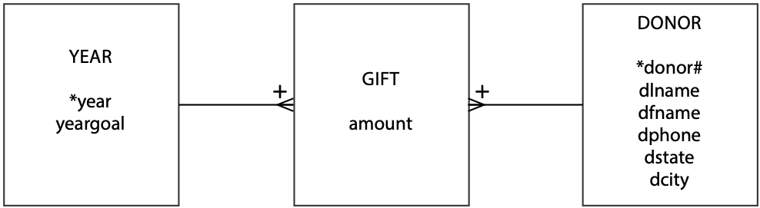

1. List all donors.
2. List the first and last names of all donors.
3. List the phone numbers of donors Hays and Jefts.
4. List the amount given by each donor for each year.
5. List the donors who have made a donation every year.
6. List the names of donors who live in Georgia or North Carolina.
7. List the names of donors whose last name is Watson and who live in Athens, GA.

10. SQL

The questing beast.

Sir Thomas Malory, Le Morte D’Arthur, 1470

## Learning objectives

Students completing this chapter will have a detailed knowledge of SQL.

## Introduction

Structured query language (SQL) is widely used as a relational database language, and SQL skills are essential for data management in a world that is increasingly reliant on relational technology. SQL originated in the IBM Research Laboratory in San Jose, California. Versions have since been implemented by commercial database vendors and open source teams for a wide range of operating systems. Both the American National Standards Institute (ANSI) and the International Organization for Standardization (ISO) have designated SQL as a standard language for relational database systems.

SQL is a **complete database language**. It is used for defining a relational database, creating views, and specifying queries. In addition, it allows for rows to be inserted, updated, and deleted. In database terminology, it is both adata definition language (DDL), a data manipulation language (DML), and a data control language (DCL). SQL, however, is not a complete programming language like PHP and Java. Because SQL statements can be embedded into general-purpose programming languages, SQL is often used in conjunction with such languages to create application programs. The embedded SQL statements handle the database processing, and the statements in the general-purpose language perform the necessary tasks to complete the application.

SQL is a declarative language, because you declare the desired results. Languages such as Java are procedural languages, because the programmer specifies each step the computer must execute. The SQL programmer can focus on defining what is required rather than detailing the process to achieve what is required. Thus, SQL programs are much shorter than their procedural equivalents.

You were introduced to SQL in Chapters 3 through 6. This chapter provides an integrated coverage of the language, pulling together the various pieces presented previously.

# Data definition

The DDL part of SQL encompasses statements to operate on tables, views, and indexes. Before we proceed, however, the term “base table” must be defined. A base table is an autonomous, named table. It is autonomous because it exists in its own right; it is physically stored within the database. In contrast, a view is not autonomous because it is derived from one or more base tables and does not exist independently. A view is a virtual table. A base table has a name by which it can be referenced. This name is chosen when the base table is generated using the CREATE statement. Short-lived temporary tables, such as those formed as the result of a query, are not named.

## Keys

The concept of a key occurs several times within SQL. In general, a key is one or more columns identified as such in the description of a table, an index, or a referential constraint. The same column can be part of more than one key. For example, it can be part of a primary key and a foreign key. A composite key is an ordered set of columns of the same table. In other words, the primary key of lineitem is always the composite of (lineno, saleno) in that order, which cannot be changed.

Comparing composite keys actually means that corresponding components of the keys are compared. Thus, application of the referential integrity rule—the value of a foreign key must be equal to a value of the primary key—means that each component of the foreign key must be equal to the corresponding component of the composite primary key.

So far, you have met primary and foreign keys. A unique key is another type of key. Its purpose is to ensure that no two values of a given column are equal. This constraint is enforced by the DBMS during the execution of INSERT and UPDATE statements. A unique key is part of the index mechanism.

## Indexes

Indexes are used to accelerate data access and ensure uniqueness. An index is an ordered set of pointers to rows of a base table. Think of an index as a table that contains two columns. The first column contains values for the index key, and the second contains a list of addresses of rows in the table. Since the values in the first column are ordered (i.e., in ascending or descending sequence), the index table can be searched quickly. Once the required key has been found in the table, the row’s address in the second column can be used to retrieve the data quickly. An index can be specified as being unique, in which case the DBMS ensures that the corresponding table does not have rows with identical index keys.

An example of an index

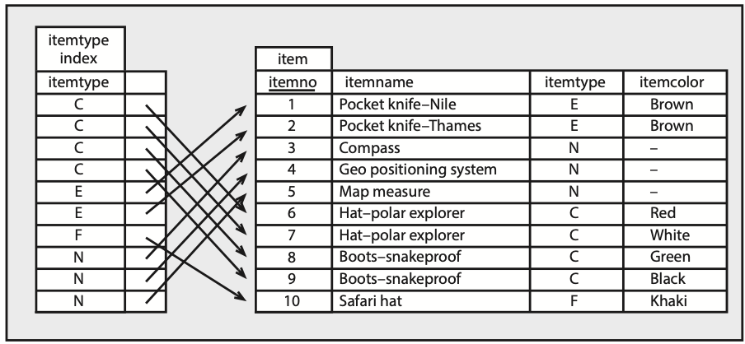

## Notation

A short primer on notation is required before we examine SQL commands.

1. Text in uppercase is required as is.
2. Text in lowercase denotes values to be selected by the query writer.
3. Statements enclosed within square brackets are optional.
4. | indicates a choice.
5. An ellipsis (…) indicates that the immediate syntactic unit may be repeated optionally more than once.

## Creating a table

CREATE TABLE is used to define a new base table, either interactively or by embedding the statement in a host language. The statement specifies a table’s name, provides details of its columns, and provides integrity checks. The syntax of the command is

CREATE TABLE base-table

column-definition-block

[primary-key-block]

[referential-constraint-block]

[unique-block];

### Column definition

The column definition block defines the columns in a table. Each column definition consists of a column name, data type, and optionally the specification that the column cannot contain null values. The general form is

(column-definition [, …])

where column-definition is of the form

column-name data-type [NOT NULL]

The NOT NULL clause specifies that the particular column must have a value whenever a new row is inserted.

## Constraints

A constraint is a rule defined as part of CREATE TABLE that defines valid sets of values for a base table by placing limits on INSERT, UPDATE, and DELETE operations. Constraints can be named (e.g., fk_stock_nation) so that they can be turned on or off and modified. The four constraint variations apply to primary key, foreign key, unique values, and range checks.

### Primary key constraint

The primary key constraint block specifies a set of columns that constitute the primary key. Once a primary key is defined, the system enforces its uniqueness by checking that the primary key of any new row does not already exist in the table. A table can have only one primary key. While it is not mandatory to define a primary key, it is good practice always to define a table’s primary key, though it is not that common to name the constraint. The general form of the constraint is

[primary-key-name] PRIMARY KEY(column-name [asc|desc] [, …])

The optional ASC or DESC clause specifies whether the values from this key are arranged in ascending or descending order, respectively.

For example:

pk_stock PRIMARY KEY(stkcode)

### Foreign key constraint

The referential constraint block defines a foreign key, which consists of one or more columns in the table that together must match a primary key of the specified table (or else be null). A foreign key value is null when any one of the columns in the row constituting the foreign key is null. Once the foreign key constraint is defined, the DBMS will check every insert and update to ensure that the constraint is observed. The general form is

CONSTRAINT constraint-name FOREIGN KEY(column-name [,…])

REFERENCES table-name(column-name [,…])

[on delete (restrict | cascade | set null)]

The constraint-name defines a referential constraint. You cannot use the same constraint-name more than once in the same table. Column-name identifies the column or columns that comprise the foreign key. The data type and length of foreign key columns must match exactly the data type and length of the primary key columns. The clause REFERENCES table-name specifies the name of an existing table, and its primary key, that contains the primary key, which cannot be the name of the table being created.

The ON DELETE clause defines the action taken when a row is deleted from the table containing the primary key. There are three options:

1. RESTRICT prevents deletion of the primary key row until all corresponding rows in the related table, the one containing the foreign key, have been deleted. RESTRICT is the default and the cautious approach for preserving data integrity.
2. CASCADE causes all the corresponding rows in the related table also to be deleted.
3. SET NULLS sets the foreign key to null for all corresponding rows in the related table.

For example:

CONSTRAINT fk_stock_nation FOREIGN KEY(natcode)

REFERENCES nation(natcode)

### Unique constraint

A unique constraint creates a unique index for the specified column or columns. A unique key is constrained so that no two of its values are equal. Columns appearing in a unique constraint must be defined as NOT NULL. Also, these columns should not be the same as those of the table’s primary key, which is guaranteed uniqueness by its primary key definition. The constraint is enforced by the DBMS during execution of INSERT and UPDATE statements. The general format is

UNIQUE constraint-name (column-name [ASC|DESC] [, …])

An example follows:

CONSTRAINT unq_stock_stkname UNIQUE(stkname)

### Check constraint

A check constraint defines a set of valid values and comes in three forms: table, column, or domain constraint.

Table constraints are defined in CREATE TABLE and ALTER TABLE statements. They can be set for one or more columns. A table constraint, for example, might limit itemcode to values less than 500.

CREATE TABLE item (

itemcode integer,

CONSTRAINT chk_item_itemcode check(itemcode <500));

A column constraint is defined in a CREATE TABLE statement and must be for a single column. Once created, a column constraint is, in effect, a table constraint. The following example shows that there is little difference between defining a table and column constraint. In the following case, itemcode is again limited to values less than 500.

CREATE TABLE item (

itemcode INTEGER CONSTRAINT chk_item_itemcode CHECK(itemcode <500),

itemcolor VARCHAR(10));

A domain constraint defines the legal values for a type of object (e.g., an item’s color) that can be defined in one or more tables. The following example sets legal values of color.

CREATE domain valid_color AS char(10)

CONSTRAINT chk_qitem_color check(

IN ('Bamboo','Black','Brown','Green','Khaki','White'));

In a CREATE TABLE statement, instead of defining a column’s data type, you specify the domain on which the column is defined. The following example shows that itemcolor is defined on the domain valid_color.

CREATE table item (

itemcode INTEGER,

itemcolor valid_color);

## Data types

Some of the variety of data types that can be used are depicted in the following figure and described in more detail in the following pages.

### BOOLEAN

Boolean data types can have the values true, false, or unknown.

### SMALLINT and INTEGER

Most commercial computers have a 32-bit word, where a word is a unit of storage. An integer can be stored in a full word or half a word. If it is stored in a full word (INTEGER), then it can be 31 binary digits in length. If half-word storage is used (SMALLINT), then it can be 15 binary digits long. In each case, one bit is used for the sign of the number. A column defined as INTEGER can store a number in the range –231 to 231-1 or –2,147,483,648 to 2,147,483,647. A column defined as SMALLINT can store a number in the range –215 to 215-1 or –32,768 to 32,767. Just remember that INTEGER is good for ±2 billion and SMALLINT for ±32,000.

### FLOAT

Scientists often deal with numbers that are very large (e.g., Avogadro’s number is 6.02252 × 1023) or very small (e.g., Planck’s constant is 6.6262 × 10–34 joule sec). The FLOAT data type is used for storing such numbers, often referred to as floating-point numbers. A single-precision floating-point number requires 32 bits and can represent numbers in the range –7.2 × 1075 to –5.4 × 10–79, 0, 5.4 × 10–79 to 7.2 × 10 75 with a precision of about 7 decimal digits. A double-precision floating-point number requires 64 bits. The range is the same as for a single-precision floating-point number. The extra 32 bits are used to increase precision to about 15 decimal digits.

In the specification FLOAT(n), if n is between 1 and 21 inclusive, single-precision floating-point is selected. If n is between 22 and 53 inclusive, the storage format is double-precision floating-point. If n is not specified, double-precision floating-point is assumed.

### DECIMAL

Binary is the most convenient form of storing data from a computer’s perspective. People, however, work with a decimal number system. The DECIMAL data type is convenient for business applications because data storage requirements are defined in terms of the maximum number of places to the left and right of the decimal point. To store the current value of an ounce of gold, you would possibly use DECIMAL(6,2) because this would permit a maximum value of $9,999.99. Notice that the general form is DECIMAL(p,q), where p is the total number of digits in the column, and q is the number of digits to the right of the decimal point.

Data types

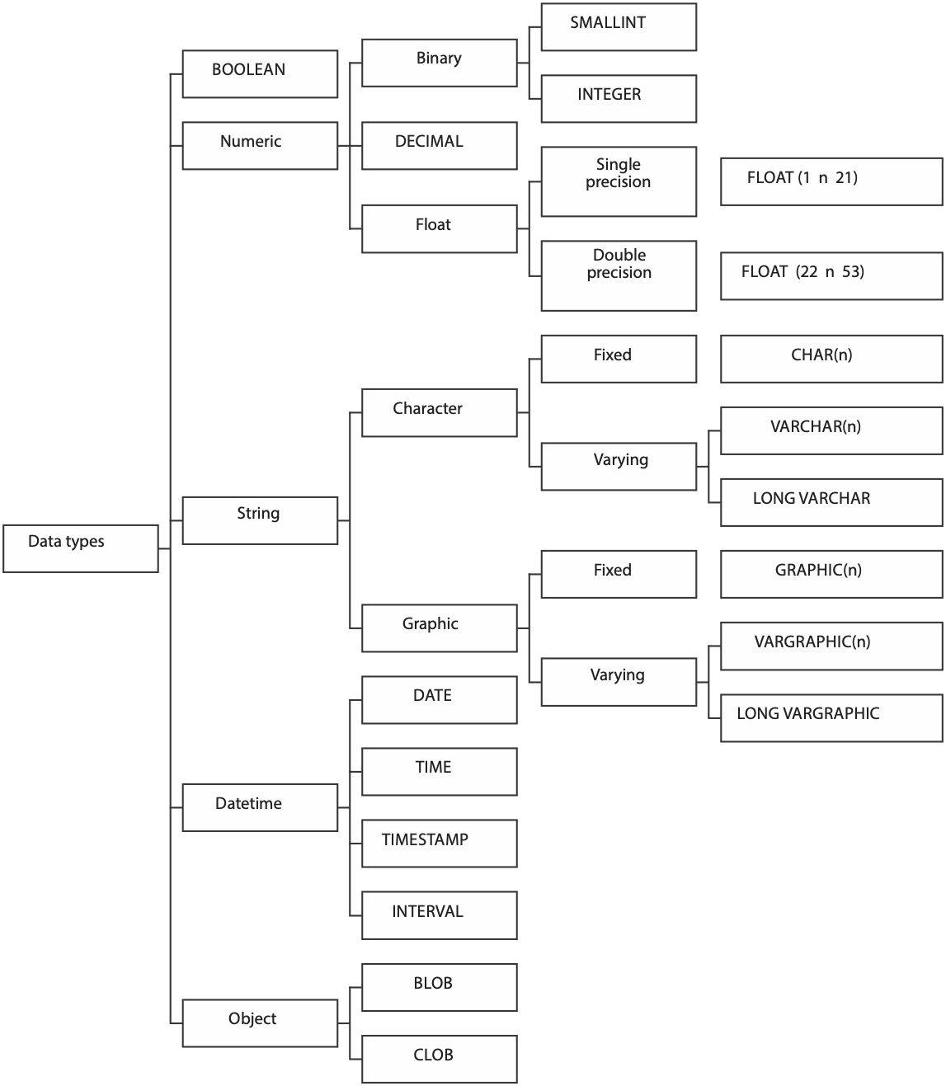

### CHAR and VARCHAR

Nonnumeric columns are stored as character strings. A person’s family name is an example of a column that is stored as a character string. CHAR(n) defines a column that has a fixed length of n characters, where n can be a maximum of 255.

When a column’s length can vary greatly, it makes sense to define the field as VARCHAR. A column defined as VARCHAR consists of two parts: a header indicating the length of the character string and the string. If a table contains a column that occasionally stores a long string of text (e.g., a message field), then defining it as VARCHAR makes sense. VARCHAR can store strings up to 65,535 characters long.

Why not store all character columns as VARCHAR and save space? There is a price for using VARCHAR with some relational systems. First***,*** additional space is required for the header to indicate the length of the string. Second, additional processing time is required to handle a variable-length string compared to a fixed-length string. Depending on the DBMS and processor speed, these might be important considerations, and some systems will automatically make an appropriate choice. For example, if you use both data types in the same table, MySQL will automatically change CHAR into VARCHAR for compatibility reasons.

There are some columns where there is no trade-off decision because all possible entries are always the same length. Canadian postal codes, for instance, are always six characters (e.g., the postal code for Ottawa is K1A0A1).

Data compression is another approach to the space wars problem. A database can be defined with generous allowances for fixed-length character columns so that few values are truncated. Data compression can be used to compress the file to remove wasted space. Data compression, however, is slow and will increase the time to process queries. You save space at the cost of time, and save time at the cost of space. When dealing with character fields, the database designer has to decide whether time or space is more important.

### Times and dates

Columns that have a data type of DATE are stored as yyyymmdd (e.g., 2012-11-04 for November 4, 2012). There are two reasons for this format. *First,* it is convenient for sorting in chronological order. The common American way of writing dates (mmddyy) requires processing before chronological sorting. *Second*, the full form of the year should be recorded for exactness.

For similar reasons, it makes sense to store times in the form hhmmss with the understanding that this is 24-hour time (also known as European time and military time). This is the format used for data type TIME.

Some applications require precise recording of events. For example, transaction processing systems typically record the time a transaction was processed by the system. Because computers operate at high speed, the TIMESTAMP data type records date and time with microsecond accuracy. A timestamp has seven parts—year, month, day, hour, minute, second, and microsecond. Date and time are defined as previously described (i.e., yyyymmdd and hhmmss, respectively). The range of the microsecond part is 000000 to 999999.

Although times and dates are stored in a particular format, the formatting facilities that generally come with a DBMS usually allow tailoring of time and date output to suit local standards. Thus for a U.S. firm, date might appear on a report in the form mm/dd/yy; for a European firm following the ISO standard, date would appear as yyyy-mm-dd.

SQL-99 introduced the INTERVAL data type, which is a single value expressed in some unit or units of time (e.g., 6 years, 5 days, 7 hours).

### BLOB (binary large object)

BLOB is a large-object data type that stores any kind of binary data. Binary data typically consists of a saved spreadsheet, graph, audio file, satellite image, voice pattern, or any digitized data. The BLOB data type has no maximum size.

### CLOB (character large object)

CLOB is a large-object data type that stores any kind of character data. Text data typically consists of reports, correspondence, chapters of a manual, or contracts. The CLOB data type has no maximum size.

Skill builder

What data types would you recommend for the following?

1. A book’s ISBN
2. A photo of a product
3. The speed of light (2.9979 × 108 meters per second)
4. A short description of an animal’s habitat
5. The title of a Japanese book
6. A legal contract
7. The status of an electrical switch
8. The date and time a reservation was made
9. An item’s value in euros
10. The number of children in a family

# Collation sequence

A DBMS will typically support many character sets. so it can handle text in different languages. While many European languages are based on an alphabet, they do not all use the same alphabet. For example, Norwegian has some additional characters (e.g., æ ,ø, å) compared to English, and French accents some letters (e.g., é, ü, and ȃ), which do not occur in English. Alphabet based languages have a collating sequence, which defines how to sort individual characters in a particular language. For English, it is the familiar A B C … X Y Z. Norwegian’s collating sequence includes three additional symbols, and the sequence is A B C … X Y Z Æ Ø Å. When you define a database you need to define its collating sequence. Thus, a database being set up for exclusive use in Chile would opt for a Spanish collating sequence. You can specify a collation sequence at the database, table, and, column level. The usual practice is to specify at the database level.

CREATE DATABASE ClassicModels COLLATE latin1_general_cs;

The latin1_general character set is suitable for Western European languages. The cs suffix indicates that comparisons are case sensitive. In other words, a query will see the two strings ‘abc’ and ‘Abc’ as different, whereas if case sensitivity is turned off, the strings are considered identical. Case sensitivity is usually the right choice to ensure precision of querying.

## Scalar functions

Most implementations of SQL include functions that can be used in arithmetic expressions, and for data conversion or data extraction. The following sampling of these functions will give you an idea of what is available. You will need to consult the documentation for your version of SQL to determine the functions it supports. For example, Microsoft SQL Server has more than 100 additional functions.

Some examples of SQL’s built-in scalar functions

| Function | Description |
| --- | --- |
| CURRENT_DATE() | Retrieves the current date |
| EXTRACT(date_time_part FROM expression) | Retrieves part of a time or date (e.g., YEAR, MONTH, DAY, HOUR, MINUTE, or SECOND) |
| SUBSTRING(str, pos, len) | Retrieves a string of length *len* starting at position pos from string *str* |

Some examples:

SELECT extract(day FROM CURRENT_DATE());

SELECT SUBSTRING(`person first`, 1,1), `person last` FROM person;

A vendor’s additional functions can be very useful. Remember, though, that use of a vendor’s extensions might limit portability.

* How many days’ sales are stored in the sale table?

This sounds like a simple query, but you have to do a self-join and also know that there is a function, DATEDIFF, to determine the number of days between any two dates. Consult your DBMS manual to learn about other functions for dealing with dates and times.

WITH

late AS (SELECT * FROM sale),

early AS (SELECT * FROM sale)

SELECT DISTINCT DATEDIFF(late.saledate,early.saledate) AS Difference

FROM late JOIN early

ON late.saledate =

(SELECT MAX(saledate) FROM sale)

AND early.saledate =

(SELECT MIN(saledate) FROM sale);

| Difference |
| --- |
| 1 |

The preceding query is based on the idea of joining sale with a copy of itself. The matching column from late is the latest sale’s date (or MAX), and the matching column from early is the earliest sale’s date (or MIN). As a result of the join, each row of the new table has both the earliest and latest dates.

## Formatting

You will likely have noticed that some queries report numeric values with a varying number of decimal places. The FORMAT function gives you control over the number of decimal places reported, as illustrated in the following example where yield is reported with two decimal places.

SELECT shrfirm, shrprice, shrqty, FORMAT(shrdiv/shrprice*100,2) AS yield

FROM share;

When you use format you create a string, but you often want to sort on the numeric value of the formatted field. The following example illustrates how to do this.

SELECT shrfirm, shrprice, shrqty, FORMAT(shrdiv/shrprice*100,2) AS yield FROM SHARE

ORDER BY shrdiv/shrprice*100 DESC

To see the difference, run the following code

SELECT shrfirm, shrprice, shrqty, FORMAT(shrdiv/shrprice*100,2) AS yield FROM SHARE

ORDER BY yield DESC

## Altering a table

The ALTER TABLE statement has two purposes. First*,* it can add a single column to an existing table. Second, it can add, drop, activate, or deactivate primary and foreign key constraints. A base table can be altered by adding one new column, which appears to the right of existing columns. The format of the command is

ALTER TABLE base-table ADD column data-type;

Notice that there is no optional NOT NULL clause for column-definition with ALTER TABLE. It is not allowed because the ALTER TABLE statement automatically fills the additional column with null in every case. If you want to add multiple columns, you repeat the command. ALTER TABLE does not permit changing the width of a column or amending a column’s data type. It can be used for deleting an unwanted column.

ALTER TABLE stock ADD stkrating CHAR(3);

ALTER TABLE is also used to change the status of referential constraints. You can deactivate constraints on a table’s primary key or any of its foreign keys. Deactivation also makes the relevant tables unavailable to all users except the table’s owner or someone possessing database management authority. After the data are loaded, referential constraints must be reactivated before they can be automatically enforced again. Activating the constraints enables the DBMS to validate the references in the data.

## Dropping a table

A base table can be deleted at any time by using the DROP statement. The format is

DROP TABLE base-table;

The table is deleted, and any views or indexes defined on the table are also deleted.

## Creating a view

A view is a virtual table. It has no physical counterpart but appears to the client as if it really exists. A view is defined in terms of other tables that exist in the database. The syntax is

CREATE VIEW view [column [,column] …)]

AS subquery;

There are several reasons for creating a view. First***,*** a view can be used to restrict access to certain rows or columns. This is particularly important for sensitive data. An organization’s person table can contain both private data (e.g., annual salary) and public data (e.g., office phone number). A view consisting of public data (e.g., person’s name, department, and office telephone number) might be provided to many people. Access to all columns in the table, however, might be confined to a small number of people. Here is a sample view that restricts access to a table.

CREATE VIEW stklist

AS SELECT stkfirm, stkprice FROM stock;

Handling derived data is a second reason for creating a view. A column that can be computed from one or more other columns should always be defined by a view. Thus, a stock’s yield would be computed by a view rather than defined as a column in a base table.

CREATE VIEW stk

(stkfirm, stkprice, stkqty, stkyield)

AS SELECT stkfirm, stkprice, stkqty, stkdiv/stkprice*100

FROM stock;

A third reason for defining a view is to avoid writing common SQL queries. For example, there may be some joins that are frequently part of an SQL query. Productivity can be increased by defining these joins as views. Here is an example:

CREATE VIEW stkvalue

(nation, firm, price, qty, value)

AS SELECT natname, stkfirm, stkprice*exchrate, stkqty,  
 stkprice*exchrate*stkqty FROM stock JOIN nation

ON stock.natcode = nation.natcode;

The preceding example demonstrates how CREATE VIEW can be used to rename columns, create new columns, and involve more than one table. The column nation corresponds to natname, firm to stkfirm, and so forth. A new column, price, is created that converts all share prices from the local currency to British pounds.

Data conversion is a fourth useful reason for a view. The United States is one of the few countries that does not use the metric system, and reports for American managers often display weights and measures in pounds and feet, respectively. The database of an international company could record all measurements in metric format (e.g., weight in kilograms) and use a view to convert these measures for American reports.

When a CREATE VIEW statement is executed, the definition of the view is entered in the systems catalog. The subquery following AS, the view definition, is executed only when the view is referenced in an SQL command. For example, the following command would enable the subquery to be executed and the view created:

SELECT * FROM stkvalue WHERE price > 10;

In effect, the following query is executed:

SELECT natname, stkfirm, stkprice*exchrate, stkqty, stkprice*exchrate*stkqty

FROM stock JOIN nation

ON stock.natcode = nation.natcode

WHERE stkprice*exchrate > 10;

Any table that can be defined with a SELECT statement is a potential view. Thus, it is possible to have a view that is defined by another view.

## Dropping a view

DROP VIEW is used to delete a view from the system catalog. A view might be dropped because it needs to be redefined or is no longer used. It must be dropped first before a revised version of the view is created. The syntax is

DROP VIEW view;

Remember, if a base table is dropped, all views based on that table are also dropped.

## Creating an index

An index helps speed up retrieval (a more detailed discussion of indexing is covered later in this book). A column that is frequently referred to in a WHERE clause is a possible candidate for indexing. For example, if data on stocks were frequently retrieved using stkfirm, then this column should be considered for an index. The format for CREATE INDEX is

CREATE [UNIQUE] INDEX indexname

ON base-table (column [order] [,column, [order]] …)

[CLUSTER];

This next example illustrates use of CREATE INDEX.

CREATE UNIQUE INDEX stkfirmindx ON stock(stkfirm);

In the preceding example, an index called stkfirmindx is created for the table stock. Index entries are ordered by ascending (the default order) values of stkfirm. The optional clause UNIQUE specifies that no two rows in the base table can have the same value for stkfirm, the indexed column. Specifying UNIQUE means that the DBMS will reject any insert or update operation that would create a duplicate value for stkfirm.

A composite index can be created from several columns, which is often necessary for an associative entity. The following example illustrates the creation of a composite index.

CREATE INDEX lineitemindx ON lineitem (lineno, saleno);

## Dropping an index

Indexes can be dropped at any time by using the DROP INDEX statement. The general form of this statement is

DROP INDEX index;

# Data manipulation

SQL supports four DML statements—SELECT, INSERT, UPDATE, and DELETE. Each of these will be discussed in turn, with most attention focusing on SELECT because of the variety of ways in which it can be used. First, we need to understand why we must qualify column names and temporary names.

## Qualifying column names

Ambiguous references to column names are avoided by qualifying a column name with its table name, especially when the same column name is used in several tables. Clarity is maintained by prefixing the column name with the table name. The following example demonstrates qualification of the natcode, which appears in both stock and nation.

SELECT stkfirm, stkprice FROM stock JOIN nation

ON stock.natcode = nation.natcode;

## Temporary names

Using the WITH clause, a table or view can be given a temporary name, or alias, that remains current for a query. Temporary names are used in a self-join to distinguish the copies of the table.

WITH

wrk AS (SELECT * FROM emp),

boss AS (SELECT * FROM emp)

SELECT wrk.empfname

FROM wrk JOIN boss

ON wrk.bossno = boss.empno;

A temporary name also can be used as a shortened form of a long table name. For example, l might be used merely to avoid having to enter lineitem more than once. If a temporary name is specified for a table or view, any qualified reference to a column of the table or view must also use that temporary name.

## SELECT

The SELECT statement is by far the most interesting and challenging of the four DML statements. It reveals a major benefit of the relational model—powerful interrogation capabilities. It is challenging because mastering the power of SELECT requires considerable practice with a wide range of queries. The major varieties of SELECT are presented in this section. The SQL Playbook, which follows this chapter, reveals the full power of the command.

The general format of SELECT is

SELECT [DISTINCT] item(s) FROM table(s)

[WHERE condition]

[GROUP BY column(s)] [HAVING condition]

[ORDER BY column(s)];

Alternatively, we can diagram the structure of SELECT.

Structure of SELECT

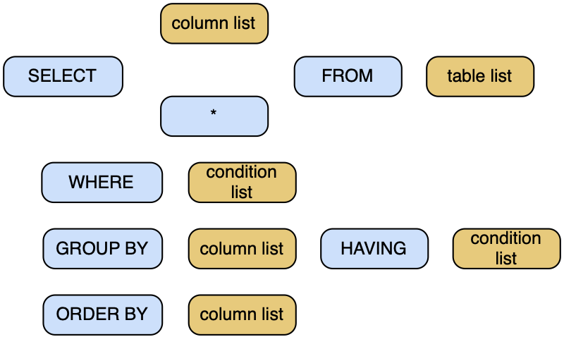

### Product

Product, or more strictly Cartesian product, is a fundamental operation of relational algebra. It is rarely used by itself in a query; however, understanding its effect helps in comprehending join. The product of two tables is a new table consisting of all rows of the first table concatenated with all possible rows of the second table. For example:

* Form the product of stock and nation.

SELECT * FROM stock, nation;

The new table contains 64 rows (16*4), where stock has 16 rows and nation has 4 rows. It has 10 columns (7 + 3), where stock has 7 columns and nation has 3 columns. The result of the operation is shown in the following table. Note that each row in stock is concatenated with each row in nation.

Product of stock and nation

| stkcode | stkfirm | stkprice | stkqty | stkdiv | stkpe | natcode | natcode | natname | exchrate |
| --- | --- | --- | --- | --- | --- | --- | --- | --- | --- |
| FC | Freedonia Copper | 27.5 | 10529 | 1.84 | 16 | UK | UK | United Kingdom | 1.0000 |
| FC | Freedonia Copper | 27.5 | 10529 | 1.84 | 16 | UK | US | United States | 0.6700 |
| FC | Freedonia Copper | 27.5 | 10529 | 1.84 | 16 | UK | AUS | Australia | 0.4600 |
| FC | Freedonia Copper | 27.5 | 10529 | 1.84 | 16 | UK | IND | India | 0.0228 |
| PT | Patagonian Tea | 55.25 | 12635 | 2.5 | 10 | UK | UK | United Kingdom | 1.0000 |
| PT | Patagonian Tea | 55.25 | 12635 | 2.5 | 10 | UK | US | United States | 0.6700 |
| PT | Patagonian Tea | 55.25 | 12635 | 2.5 | 10 | UK | AUS | Australia | 0.4600 |
| PT | Patagonian Tea | 55.25 | 12635 | 2.5 | 10 | UK | IND | India | 0.0228 |
| AR | Abyssinian Ruby | 31.82 | 22010 | 1.32 | 13 | UK | UK | United Kingdom | 1.0000 |
| AR | Abyssinian Ruby | 31.82 | 22010 | 1.32 | 13 | UK | US | United States | 0.6700 |
| AR | Abyssinian Ruby | 31.82 | 22010 | 1.32 | 13 | UK | AUS | Australia | 0.4600 |
| AR | Abyssinian Ruby | 31.82 | 22010 | 1.32 | 13 | UK | IND | India | 0.0228 |
| SLG | Sri Lankan Gold | 50.37 | 32868 | 2.68 | 16 | UK | UK | United Kingdom | 1.0000 |
| SLG | Sri Lankan Gold | 50.37 | 32868 | 2.68 | 16 | UK | US | United States | 0.6700 |
| SLG | Sri Lankan Gold | 50.37 | 32868 | 2.68 | 16 | UK | AUS | Australia | 0.4600 |
| SLG | Sri Lankan Gold | 50.37 | 32868 | 2.68 | 16 | UK | IND | India | 0.0228 |
| ILZ | Indian Lead & Zinc | 37.75 | 6390 | 3 | 12 | UK | UK | United Kingdom | 1.0000 |
| ILZ | Indian Lead & Zinc | 37.75 | 6390 | 3 | 12 | UK | US | United States | 0.6700 |
| ILZ | Indian Lead & Zinc | 37.75 | 6390 | 3 | 12 | UK | AUS | Australia | 0.4600 |
| ILZ | Indian Lead & Zinc | 37.75 | 6390 | 3 | 12 | UK | IND | India | 0.0228 |
| BE | Burmese Elephant | 0.07 | 154713 | 0.01 | 3 | UK | UK | United Kingdom | 1.0000 |
| BE | Burmese Elephant | 0.07 | 154713 | 0.01 | 3 | UK | US | United States | 0.6700 |
| BE | Burmese Elephant | 0.07 | 154713 | 0.01 | 3 | UK | AUS | Australia | 0.4600 |
| BE | Burmese Elephant | 0.07 | 154713 | 0.01 | 3 | UK | IND | India | 0.0228 |
| BS | Bolivian Sheep | 12.75 | 231678 | 1.78 | 11 | UK | UK | United Kingdom | 1.0000 |
| BS | Bolivian Sheep | 12.75 | 231678 | 1.78 | 11 | UK | US | United States | 0.6700 |
| BS | Bolivian Sheep | 12.75 | 231678 | 1.78 | 11 | UK | AUS | Australia | 0.4600 |
| BS | Bolivian Sheep | 12.75 | 231678 | 1.78 | 11 | UK | IND | India | 0.0228 |
| NG | Nigerian Geese | 35 | 12323 | 1.68 | 10 | UK | UK | United Kingdom | 1.0000 |
| NG | Nigerian Geese | 35 | 12323 | 1.68 | 10 | UK | US | United States | 0.6700 |
| NG | Nigerian Geese | 35 | 12323 | 1.68 | 10 | UK | AUS | Australia | 0.4600 |
| NG | Nigerian Geese | 35 | 12323 | 1.68 | 10 | UK | IND | India | 0.0228 |
| CS | Canadian Sugar | 52.78 | 4716 | 2.5 | 15 | UK | UK | United Kingdom | 1.0000 |
| CS | Canadian Sugar | 52.78 | 4716 | 2.5 | 15 | UK | US | United States | 0.6700 |
| CS | Canadian Sugar | 52.78 | 4716 | 2.5 | 15 | UK | AUS | Australia | 0.4600 |
| CS | Canadian Sugar | 52.78 | 4716 | 2.5 | 15 | UK | IND | India | 0.0228 |
| ROF | Royal Ostrich Farms | 33.75 | 1234923 | 3 | 6 | UK | UK | United Kingdom | 1.0000 |
| ROF | Royal Ostrich Farms | 33.75 | 1234923 | 3 | 6 | UK | US | United States | 0.6700 |
| ROF | Royal Ostrich Farms | 33.75 | 1234923 | 3 | 6 | UK | AUS | Australia | 0.4600 |
| ROF | Royal Ostrich Farms | 33.75 | 1234923 | 3 | 6 | UK | IND | India | 0.0228 |
| MG | Minnesota Gold | 53.87 | 816122 | 1 | 25 | US | UK | United Kingdom | 1.0000 |
| MG | Minnesota Gold | 53.87 | 816122 | 1 | 25 | US | US | United States | 0.6700 |
| MG | Minnesota Gold | 53.87 | 816122 | 1 | 25 | US | AUS | Australia | 0.4600 |
| MG | Minnesota Gold | 53.87 | 816122 | 1 | 25 | US | IND | India | 0.0228 |
| GP | Georgia Peach | 2.35 | 387333 | 0.2 | 5 | US | UK | United Kingdom | 1.0000 |
| GP | Georgia Peach | 2.35 | 387333 | 0.2 | 5 | US | US | United States | 0.6700 |
| GP | Georgia Peach | 2.35 | 387333 | 0.2 | 5 | US | AUS | Australia | 0.4600 |
| GP | Georgia Peach | 2.35 | 387333 | 0.2 | 5 | US | IND | India | 0.0228 |
| NE | Narembeen Emu | 12.34 | 45619 | 1 | 8 | AUS | UK | United Kingdom | 1.0000 |
| NE | Narembeen Emu | 12.34 | 45619 | 1 | 8 | AUS | US | United States | 0.6700 |
| NE | Narembeen Emu | 12.34 | 45619 | 1 | 8 | AUS | AUS | Australia | 0.4600 |
| NE | Narembeen Emu | 12.34 | 45619 | 1 | 8 | AUS | IND | India | 0.0228 |
| QD | Queensland Diamond | 6.73 | 89251 | 0.5 | 7 | AUS | UK | United Kingdom | 1.0000 |
| QD | Queensland Diamond | 6.73 | 89251 | 0.5 | 7 | AUS | US | United States | 0.6700 |
| QD | Queensland Diamond | 6.73 | 89251 | 0.5 | 7 | AUS | AUS | Australia | 0.4600 |
| QD | Queensland Diamond | 6.73 | 89251 | 0.5 | 7 | AUS | IND | India | 0.0228 |
| IR | Indooroopilly Ruby | 15.92 | 56147 | 0.5 | 20 | AUS | UK | United Kingdom | 1.0000 |
| IR | Indooroopilly Ruby | 15.92 | 56147 | 0.5 | 20 | AUS | US | United States | 0.6700 |
| IR | Indooroopilly Ruby | 15.92 | 56147 | 0.5 | 20 | AUS | AUS | Australia | 0.4600 |
| IR | Indooroopilly Ruby | 15.92 | 56147 | 0.5 | 20 | AUS | IND | India | 0.0228 |
| BD | Bombay Duck | 25.55 | 167382 | 1 | 12 | IND | UK | United Kingdom | 1.0000 |
| BD | Bombay Duck | 25.55 | 167382 | 1 | 12 | IND | US | United States | 0.6700 |
| BD | Bombay Duck | 25.55 | 167382 | 1 | 12 | IND | AUS | Australia | 0.4600 |
| BD | Bombay Duck | 25.55 | 167382 | 1 | 12 | IND | IND | India | 0.0228 |

* Find the percentage of Australian stocks in the portfolio.

To answer this query, you need to count the number of Australian stocks, count the total number of stocks in the portfolio, and then compute the percentage. Computing each of the totals is a straightforward application of count. If we save the results of the two counts as views, then we have the necessary data to compute the percentage. The two views each consist of a single-cell table (i.e., one row and one column). We create the product of these two views to get the data needed for computing the percentage in one row. The SQL is

CREATE VIEW austotal (auscount) AS

SELECT COUNT(*) FROM nation JOIN stock

ON natname = 'Australia'

WHERE nation.natcode = stock.natcode;

CREATE VIEW total (totalcount) AS

SELECT COUNT(*) FROM stock;

SELECT auscount/totalcount*100

AS percentage FROM austotal, total;

CREATE VIEW total (totalcount) AS

SELECT COUNT(*) FROM stock;

SELECT auscount*100/totalcount as Percentage

FROM austotal, total;

The result of a COUNT is always an integer, and SQL will typically create an integer data type in which to store the results. When two variables have a data type of integer, SQL will likely use integer arithmetic for all computations, and all results will be integer. To get around the issue of integer arithmetic, we first multiply the number of Australian stocks by 100 before dividing by the total number of stocks. Because of integer arithmetic, you might get a different answer if you used the following SQL.

SELECT auscount/totalcount*100 as Percentage

FROM austotal, total;

The preceding example was used to show when you might find product useful. You can also write the query as

SELECT (SELECT COUNT(*) FROM stock WHERE natcode = 'AUS')*100/

(SELECT COUNT(*) FROM stock) as Percentage;

### Inner join

Inner join, often referred to as join, is a powerful and frequently used operation. It creates a new table from two existing tables by matching on a column common to both tables. An equijoin is the simplest form of join; in this case, columns are matched on equality.

SELECT * FROM stock JOIN nation

ON stock.natcode = nation.natcode;

There are other ways of expressing join that are more concise. For example, we can write

SELECT * FROM stock INNER JOIN nation USING (natcode);

The preceding syntax implicitly recognizes the frequent use of the same column name for matching primary and foreign keys.

A further simplification is to rely on the primary and foreign key definitions to determine the join condition, so we can write

SELECT * FROM stock NATURAL JOIN nation;

An equijoin creates a new table that contains two identical columns. If one of these is dropped, then the remaining table is called a natural join.

As you now realize, join can be thought of as a product with a condition clause. There is no reason why this condition needs to be restricted to equality. There could easily be another comparison operator between the two columns. This general version is called a theta-join because theta is a variable that can take any value from the set [=, <>, >, >=, <, <=].

As you discovered earlier, there are occasions when you need to join a table to itself. To do this, make two copies of the table first and give each of these copies a unique name.

* Find the names of employees who earn more than their boss.

SELECT wrk.empfname

FROM emp wrk JOIN emp boss

ON wrk.bossno = boss.empno

WHERE wrk.empsalary > boss.empsalary;

### Outer join

An inner join reports those rows where the primary and foreign keys match. There are also situations where you might want an outer join, which comes in three flavors as shown in the following figure.

Types of joins

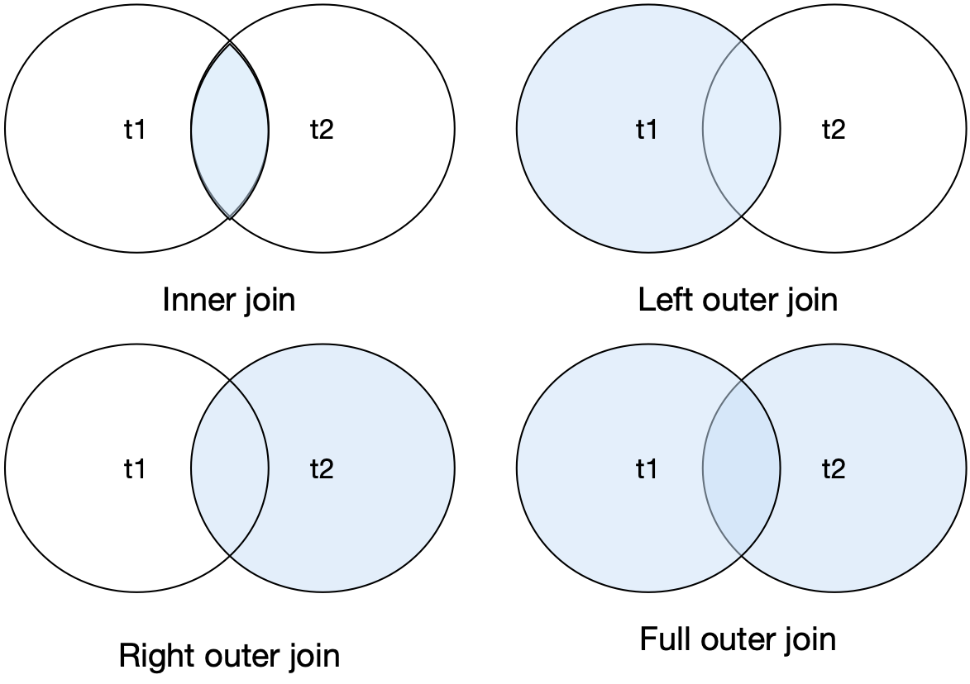

An outer join reports these matching rows and others depending on which form is used, as the following examples illustrate for a sample pair of tables.

| t1 |  |  | t2 |  |
| --- | --- | --- | --- | --- |
| id | col1 |  | id | col2 |
| 1 | a |  | 1 | x |
| 2 | b |  | 3 | y |
| 3 | c |  | 5 | z |

A left outer join is an inner join plus those rows from t1 not included in the inner join.

SELECT id, col1, col2 FROM t1 LEFT JOIN t2 USING (id)

| id | col1 | col2 |
| --- | --- | --- |
| 1 | a | x |
| 2 | b | null |
| 3 | c | y |

Here is an example to illustrate the use of a left join.

* For all brown items, report each sale. Include in the report those brown items that have appeared in no sales.

SELECT itemname, saleno, lineqty FROM item

LEFT JOIN lineitem USING (itemno)

WHERE itemcolor = 'Brown'

ORDER BY itemname;

| itemname | saleno | lineqty |
| --- | --- | --- |
| Map case | null | null |
| Pocket knife - Avon | 1 | 1 |
| Pocket knife - Avon | 3 | 1 |
| Pocket knife - Avon | 2 | 1 |
| Pocket knife - Avon | 5 | 1 |
| Pocket knife - Avon | 4 | 1 |
| Pocket knife - Nile | null | null |
| Stetson | null | null |

A right outer join is an inner join plus those rows from t2 not included in the inner join.

SELECT id, col1, col2 FROM t1 RIGHT JOIN t2 USING (id);

| Id | col1 | col2 |
| --- | --- | --- |
| 1 | a | x |
| 3 | c | y |
| 5 | null | z |

A full outer join is an inner join plus those rows from t1 and t2 not included in the inner join.

SELECT id, col1, col2 FROM t1 FULL JOIN t2 USING (id);

| id | col1 | col2 |
| --- | --- | --- |
| 1 | a | x |
| 2 | b | null |
| 3 | c | y |
| 5 | null | z |

MySQL does not support a full outer join, rather you must use a union of a left and right outer joins.

SELECT id, col1, col2 FROM t1 LEFT JOIN t2 USING (id)

UNION

SELECT id, col1, col2 FROM t1 RIGHT JOIN t2 USING (id);

### Simple subquery

A subquery is a query within a query. There is a SELECT statement nested inside another SELECT statement. Simple subqueries were used extensively in earlier chapters. For reference, here is a simple subquery used earlier:

SELECT stkfirm FROM stock

WHERE natcode IN

(SELECT natcode FROM nation

WHERE natname = 'Australia');

### Correlated subquery

A correlated subquery differs from a simple subquery in that the inner query must be evaluated more than once. Consider the following example described previously:

* Find those stocks where the quantity is greater than the average for that country.

SELECT natname, stkfirm, stkqty FROM stock JOIN nation

ON stock.natcode = nation.natcode

WHERE stkqty >

(SELECT AVG(stkqty) FROM stock

WHERE stock.natcode = nation.natcode);

The requirement to compare a column against a function (e.g., average or count) of some column of specified rows of is usually a clue that you need to write a correlated subquery. In the preceding example, the stock quantity for each row is compared with the average stock quantity for that row’s country.

### Aggregate functions

SQL’s aggregate functions increase its retrieval power. These functions were covered earlier and are only mentioned briefly here for completeness. The five aggregate functions are shown in the following table. Nulls in the column are ignored in the case of SUM, AVG, MAX, and MIN. COUNT(*) does not distinguish between null and non-null values in a column. Use COUNT(columnname) to exclude a null value in columnname.

Aggregate functions

| Function | Description |
| --- | --- |
| COUNT | Counts the number of values in a column |
| SUM | Sums the values in a column |
| AVG | Determines the average of the values in a column |
| MAX | Determines the largest value in a column |
| MIN | Determines the smallest value in a column |

### GROUP BY and HAVING

The GROUP BY clause is an elementary form of control break reporting and supports grouping of rows that have the same value for a specified column and produces one row for each different value of the grouping column. For example,

* Report by nation the total value of stockholdings.

SELECT natname, SUM(stkprice*stkqty*exchrate) AS total

FROM stock JOIN nation ON stock.natcode = nation.natcode

GROUP BY natname;

gives the following results:

| natname | total |
| --- | --- |
| Australia | 946430.65 |
| India | 97506.71 |
| United Kingdom | 48908364.25 |
| United States | 30066065.54 |

The HAVING clause is often associated with GROUP BY. It can be thought of as the WHERE clause of GROUP BY because it is used to eliminate rows for a GROUP BY condition. Both GROUP BY and HAVING are dealt with in-depth in Chapter 4.

### REGEXP

The REGEXP clause supports pattern matching to find a defined set of strings in a character column (CHAR or VARCHAR). Refer to Chapters 3 and 4 for more details.

## INSERT

There are two formats for INSERT. The first format is used to insert one row into a table.

### Inserting a single record

The general form is

INSERT INTO table [(column [,column] …)]

VALUES (literal [,literal] …);

For example,

INSERT INTO stock

(stkcode,stkfirm,stkprice,stkqty,stkdiv,stkpe)

VALUES ('FC','Freedonia Copper',27.5,10529,1.84,16);

In this example, stkcode is given the value “FC,” stkfirm is “Freedonia Copper,” and so on. In general, the nth column in the table is the nth value in the list.

When the value list refers to all field names in the left-to-right order in which they appear in the table, then the columns list can be omitted. So, it is possible to write the following:

INSERT INTO stock

VALUES ('FC','Freedonia Copper',27.5,10529,1.84,16);

If some values are unknown, then the INSERT can omit these from the list. Undefined columns will have nulls. For example, if a new stock is to be added for which the price, dividend, and PE ratio is 5, the following INSERT statement would be used:

INSERT INTO stock

(stkcode, stkfirm, stkqty)

VALUES ('EE','Elysian Emeralds',5);

### Inserting multiple records using a query

The second form of INSERT operates in conjunction with a subquery. The resulting rows are then inserted into a table. Imagine the situation where stock price information is downloaded from an information service into a table. This table could contain information about all stocks and may contain additional columns that are not required for the stock table. The following INSERT statement could be used:

INSERT INTO stock

(stkcode, stkfirm, stkprice, stkdiv, stkpe)

SELECT code, firm, price, div, pe

FROM download WHERE code IN

('FC','PT','AR','SLG','ILZ','BE','BS','NG','CS','ROF');

Think of INSERT with a subquery as a way of copying a table. You can select the rows and columns of a particular table that you want to copy into an existing or new table.

## UPDATE

The UPDATE command is used to modify values in a table. The general format is

UPDATE table

SET column = scalar expression

[, column = scalar expression] …

[WHERE condition];

Permissible scalar expressions involve columns, scalar functions (see the section on scalar functions in this chapter), or constants. No aggregate functions are allowable.

### Updating a single row

UPDATE can be used to modify a single row in a table. Suppose you need to revise your data after 200,000 shares of Minnesota Gold are sold. You would code the following:

UPDATE stock

SET stkqty = stkqty - 200000

WHERE stkcode = 'MG';

### Updating multiple rows

Multiple rows in a table can be updated as well. Imagine the situation where several stocks change their dividend to £2.50. Then the following statement could be used:

UPDATE stock

SET stkdiv = 2.50

WHERE stkcode IN ('FC','BS','NG');

### Updating all rows

All rows in a table can be updated by simply omitting the WHERE clause. To give everyone at The Expeditioner a 5 percent raise, use

UPDATE emp

SET empsalary = empsalary*1.05;

### Updating with a subquery

A subquery can also be used to specify which rows should be changed. Consider the following example. The employees in the departments on the fourth floor of The Expeditioner have won a productivity improvement bonus of 10 percent. The following SQL statement would update their salaries:

UPDATE emp

SET empsalary = empsalary*1.10

WHERE deptname IN

(SELECT deptname FROM dept WHERE deptfloor = 4);

## DELETE

The DELETE statement erases one or more rows in a table. The general format is

DELETE FROM table

[WHERE condition];

### Delete a single record

If all stocks with stkcode equal to “BE” were sold, then this row can be deleted using

DELETE FROM stock WHERE stkcode = 'BE';

### Delete multiple records

If all Australian stocks were liquidated, then the following command would delete all the relevant rows:

DELETE FROM stock

WHERE natcode in

(SELECT natcode FROM nation WHERE natname = 'Australia');

### Delete all records

All records in a table can be deleted by omitting the WHERE clause. The following statement would delete all rows if the entire portfolio were sold:

DELETE FROM stock;

This command is not the same as DROP TABLE because, although the table is empty, it still exists.

### Delete with a subquery

Despite their sterling efforts in the recent productivity drive, all the employees on the fourth floor of The Expeditioner have been fired (the rumor is that they were fiddling the tea money). Their records can be deleted using

DELETE FROM emp

WHERE deptname IN

(SELECT deptname FROM dept WHERE deptfloor = 4);

# SQL routines

SQL provides two types of routines—functions and procedures—that are created, altered, and dropped using standard SQL. Routines add flexibility, improve programmer productivity, and facilitate the enforcement of business rules and standard operating procedures across applications.

## SQL function

A function is SQL code that returns a value when invoked within an SQL statement. It is used in a similar fashion to SQL’s built-in functions. Consider the case of an Austrian firm with a database in which all measurements are in SI units (e.g., meters). Because its U.S. staff is not familiar with SI,[16] it decides to implement a series of user-defined functions to handle the conversion. Here is the function for converting from kilometers to miles.

CREATE FUNCTION km_to_miles(km REAL)

RETURNS REAL

RETURN 0.6213712*km;

The preceding function can be used within any SQL statement to make the conversion. For example:

SELECT km_to_miles(100);

Skill builder

Create a table containing the average daily temperature in Tromsø, Norway, then write a function to convert Celsius to Fahrenheit (F = C*1.8 + 32), and test the function by reporting temperatures in C and F.

| Month | Jan | Feb | Mar | Apr | May | Jun | Jul | Aug | Sep | Oct | Nov | Dec |
| --- | --- | --- | --- | --- | --- | --- | --- | --- | --- | --- | --- | --- |
| ºC | -4.7 | -4.1 | -1.9 | 1.1 | 5.6 | 10.1 | 12.7 | 11.8 | 7.7 | 2.9 | -1.5 | -3.7 |

## SQL procedure

A procedure is SQL code that is dynamically loaded and executed by a CALL statement, usually within a database application. We use an accounting system to demonstrate the features of a stored procedure, in which a single accounting transaction results in two entries (one debit and one credit). In other words, a transaction has multiple entries, but an entry is related to only one transaction. An account (e.g., your bank account) has multiple entries, but an entry is for only one account. Considering this situation results in the following data model.

A simple accounting system

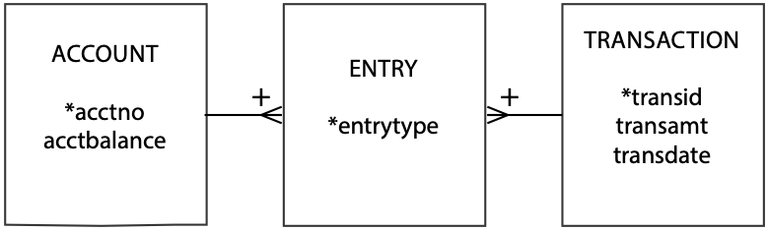

The following are a set of steps for processing a transaction (e.g., transferring money from a checking account to a money market account):

1. Write the transaction to the transaction table so you have a record of the transaction.
2. Update the account to be credited by incrementing its balance in the account table.
3. Insert a row in the entry table to record the credit.
4. Update the account to be debited by decrementing its balance in the account table.
5. Insert a row in the entry table to record the debit.

Here is the code for a stored procedure to execute these steps. Note that the first line sets the delimiter to // because the default delimiter for SQL is a semicolon (;), which we need to use to delimit the multiple SQL commands in the procedure. The last statement in the procedure is thus END // to indicate the end of the procedure.

DELIMITER //

CREATE PROCEDURE transfer (

IN `Credit account` INTEGER,

IN `Debit account` INTEGER,

IN Amount DECIMAL(9,2),

IN `Transaction ID` INTEGER)

LANGUAGE SQL

DETERMINISTIC

BEGIN

INSERT INTO transaction VALUES (`Transaction ID`, Amount, CURRENT_DATE);

UPDATE account

SET acctbalance = acctbalance + Amount

WHERE acctno = `Credit account`;

INSERT INTO entry VALUES (`Transaction ID`, `Credit account`, 'cr');

UPDATE account

SET acctbalance = acctbalance - Amount

WHERE acctno = `Debit account`;

INSERT INTO entry VALUES (`Transaction ID`, `Debit account`, 'db');

END//

A CALL statement executes a stored procedure. The generic CALL statement for the preceding procedure is

CALL transfer(cracct, dbacct, amt, transno);

Thus, imagine that transaction 1005 transfers $100 to account 1 (the credit account) from account 2 (the debit account). The specific call is

CALL transfer(1,2,100,1005);

Alternatively, you can use an automatically generated pop-up window to run the procedure by clicking on the rightmost icon for the procedure under the Stored Procedures header.

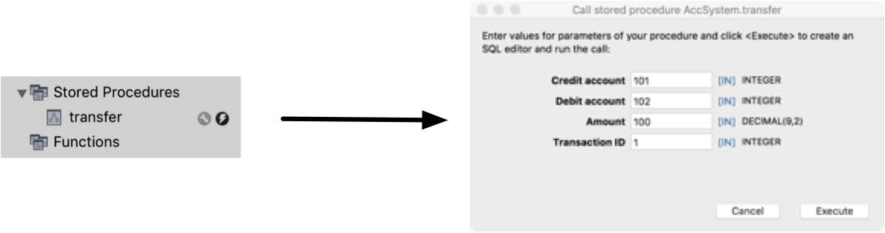

Skill builder

1. After verifying that the system you use for learning SQL supports stored procedures, create the tables for the preceding data model and enter the code for the stored procedure. Now, test the stored procedure and query the tables to verify that the procedure has worked.
2. Write a stored procedure to add details of a gift to the donation database (see exercises in Chapter 5).

## Trigger

A trigger is a form of stored procedure that executes automatically when a table’s rows are modified. Triggers can be defined to execute either before or after rows are inserted into a table, when rows are deleted from a table, and when columns are updated in the rows of a table. Triggers can include virtual tables that reflect the row image before and after the operation, as appropriate. Triggers can be used to enforce business rules or requirements, integrity checking, and automatic transaction logging.

Consider the case of recording all updates to the stock table (see Chapter 4). First, you must define a table in which to record details of the change.

CREATE TABLE stock_log (

stkcode CHAR(3),

old_stkprice DECIMAL(6,2),

new_stkprice DECIMAL(6,2),

old_stkqty DECIMAL(8),

new_stkqty DECIMAL(8),

update_stktime TIMESTAMP NOT NULL,

PRIMARY KEY(update_stktime));

The trigger writes a record to stock_log every time an update is made to stock. Use is made of two virtual tables (old and new) to access the prior and current values of stock price (old.stkprice and new.stkprice and stock quantity (old.stkprice and new.stkprice). The INSERT statement also writes the stock’s identifying code and the time of the transaction.

CREATE TRIGGER stock_update

AFTER UPDATE ON stock

FOR EACH ROW BEGIN

INSERT INTO stock_log VALUES

  (old.stkcode, old.stkprice, new.stkprice, old.stkqty, new.stkqty, CURRENT_TIMESTAMP);

END

Skill builder

Why is the primary key of stock_log not the same as that of stock?

# Nulls—much ado about missing information

Nulls are overworked in SQL because they can represent several situations. Null can represent unknown information. For example, you might add a new stock to the database, but lacking details of its latest dividend, you leave the field null. Null can be used to represent a value that is inapplicable. For instance, the employee table contains a null value in bossno for Alice because she has no boss. The value is not unknown; it is not applicable for that field. In other cases, null might mean “no value supplied” or “value undefined.” Because null can have multiple meanings, the client must infer which meaning is appropriate to the circumstances.

Do not confuse null with blank or zero, which are values. In fact, null is a marker that specifies that the value for the particular column is null. Thus, null represents no value.

The well-known database expert Chris Date has been outspoken in his concern about the confusion caused by nulls. His advice is that nulls should be explicitly avoided by specifying NOT NULL for all columns and by using codes to make the meaning of a value clear (e.g., “U” means “unknown,” “I” means “inapplicable,” “N” means “not supplied”).

# Security

Data are a valuable resource for nearly every organization. Just as an organization takes measures to protect its physical assets, it also needs to safeguard its electronic assets—its organizational memory, including databases. Furthermore, it often wants to limit the access of authorized users to particular parts of a database and restrict their actions to particular operations.

Two SQL features are used to administer security procedures. A view, discussed earlier in this chapter, can restrict a client’s access to specified columns or rows in a table, and authorization commands can establish a user’s privileges.

The authorization subsystem is based on the concept of a privilege—the authority to perform an operation. For example, a person cannot update a table unless she has been granted the appropriate update privilege. The database administrator (DBA) is a master of the universe and has the highest privilege. The DBA can perform any legal operation. The creator of an object, say a base table, has full privileges for that object. Those with privileges can then use GRANT and REVOKE, commands included in SQL’s data control language (DCL) to extend privileges to or rescind them from other users.

## GRANT

The GRANT command defines a client’s privileges. The general format of the statement is

GRANT privileges ON object TO users [WITH GRANT OPTION];

where “privileges” can be a list of privileges or the keyword ALL PRIVILEGES, and “users” is a list of user identifiers or the keyword PUBLIC. An “object” can be a base table or a view.

The following privileges can be granted for tables and views: SELECT, UPDATE, DELETE, and INSERT.

The UPDATE privilege specifies the particular columns in a base table or view that may be updated. Some privileges apply only to base tables. These are ALTER and INDEX.

The following examples illustrate the use of GRANT:

* Give Alice all rights to the stock table.

GRANT ALL PRIVILEGES ON stock TO alice;

* Permit the accounting staff, Todd and Nancy, to update the price of a stock.

GRANT UPDATE (stkprice) ON stock TO todd, nancy;

* Give all staff the privilege to select rows from item.

GRANT SELECT ON item TO PUBLIC;

* Give Alice all rights to view stk.

GRANT SELECT, UPDATE, DELETE, INSERT ON stk TO alice;

### The WITH GRANT OPTION clause

The WITH GRANT OPTION command allows a client to transfer his privileges to another client, as this next example illustrates:

* Give Ned all privileges for the item table and permit him to grant any of these to other staff members who may need to work with item.

GRANT ALL PRIVILEGES ON item TO ned WITH GRANT OPTION;

This means that Ned can now use the GRANT command to give other staff privileges. To give Andrew permission for select and insert on item, for example, Ned would enter

GRANT SELECT, INSERT ON item TO andrew;

## REVOKE

What GRANT granteth, REVOKE revoketh. Privileges are removed using the REVOKE statement. The general format of this statement is

REVOKE privileges ON object FROM users;

These examples illustrate the use of REVOKE.

* Remove Sophie’s ability to select from item.

REVOKE SELECT ON item FROM sophie;

* Nancy is no longer permitted to update stock prices.

REVOKE UPDATE ON stock FROM nancy;

### Cascading revoke

When a REVOKE statement removes a privilege, it can result in more than one revocation. An earlier example illustrated how Ned used his WITH GRANT OPTION right to authorize Andrew to select and insert rows on item. The following REVOKE command

REVOKE INSERT ON item FROM ned;

automatically revokes Andrew’s insert privilege.

## The system catalog

The system catalog describes a relational database. It contains the definitions of base tables, views, indexes, and so on. The catalog itself is a relational database and can be interrogated using SQL. Tables in the catalog are called system tables to distinguish them from base tables, though conceptually these tables are the same. In MySQL, the system catalog is called information_schema. Some important system tables in this schema are tables, and columns, and these are used in the following examples. Note that the names of the system catalog tables vary with DBMS implementations, so while the following examples illustrate use of system catalog tables, it is likely that you will have to change the table names for other DBMSs.

The table TABLES contains details of all tables in the database. There is one row for each table in the database.

* Find the table(s) with the most columns.

SELECT table_name, table_rows

FROM information_schema.tables

WHERE table_rows = (SELECT MAX(table_rows)

FROM information_schema.tables);

The COLUMN table stores details about each column in the database.

* What columns in what tables store dates?

SELECT table_name, column_name

FROM information_schema.columns

WHERE DATA_TYPE = 'date'

ORDER BY table_name, column_name;

As you can see, querying the catalog is the same as querying a database. This is a useful feature because you can use SQL queries on the catalog to find out more about a database.

# Natural language processing

Infrequent inquirers of a relational database may be reluctant to use SQL because they don’t use it often enough to remain familiar with the language. While the QBE approach can make querying easier, a more natural approach is to use standard English. In this case, natural language processing (NLP) is used to convert ordinary English into SQL so the query can be passed to the relational database. The example in the table below shows the successful translation of a query to SQL. A natural language processor must translate a request to SQL and request clarification where necessary.

An example of natural language processing

| English | SQL generated for MS Access |
| --- | --- |
| Which movies have won best foreign film sorted by year? | SELECT DISTINCT [Year], [Title] FROM [Awards] INNER JOIN [Movies] ON [Movies].[Movie ID] = [Awards].[Movie ID] WHERE [Category]='Best Foreign Film' and [Status]='Winner' ORDER BY [Year] ASC; |

# Connectivity and ODBC

Over time and because of differing needs, an organization is likely to purchase DBMS software from a variety of vendors. Also, in some situations, mergers and acquisitions can create a multivendor DBMS environment. Consequently, the SQL Access Group developed SQL Call-Level Interface (CLI), a unified standard for remote database access. The intention of CLI is to provide programmers with a generic approach for writing software that accesses a database. With the appropriate CLI database driver, any DBMS server can provide access to client programs that use the CLI. On the server side, the DBMS CLI driver is responsible for translating the CLI call into the server’s access language. On the client side, there must be a CLI driver for each database to which it connects. CLI is not a query language but a way of wrapping SQL so it can be understood by a DBMS. In 1996, CLI was adopted as an international standard and renamed X/Open CLI.

## Open database connectivity (ODBC)

The de facto standard for database connectivity isOpen Database Connectivity (ODBC), an extended implementation of CLI developed by Microsoft. This application programming interface (API) is cross-platform and can be used to access any DBMS that has an ODBC driver. This enables a software developer to build and distribute an application without targeting a specific DBMS. Database drivers are then added to link the application to the client’s choice of DBMS. For example, a microcomputer running under Windows can use ODBC to access an Oracle DBMS running on a Unix box.

There is considerable support for ODBC. Application vendors like it because they do not have to write and maintain code for each DBMS; they can write one API. DBMS vendors support ODBC because they do not have to convince application vendors to support their product. For database systems managers, ODBC provides vendor and platform independence. Although the ODBC API was originally developed to provide database access from MS Windows products, many ODBC driver vendors support Linux and Macintosh clients.

Most vendors also have their own SQL APIs. The problem is that most vendors, as a means of differentiating their DBMS, have a more extensive native API protocol and also add extensions to standard ODBC. The developer who is tempted to use these extensions threatens the portability of the database.

ODBC introduces greater complexity and a processing overhead because it adds two layers of software. As the following figure illustrates, an ODBC-compliant application has additional layers for the ODBC API and ODBC driver. As a result, ODBC APIs can never be as fast as native APIs.

ODBC layers

| Application |
| --- |
| ODBC API |
| ODBC driver manager |
| Service provider API |
| Driver for DBMS server |
| DBMS server |

# Embedded SQL

SQL can be used in two modes. First*,* SQL is an interactive query language and database programming language. SELECT defines queries; INSERT, UPDATE, and DELETE maintain a database. Second, any interactive SQL statement can be embedded in an application program.

This dual-mode principle is a very useful feature. It means that programmers need to learn only one database query language, because the same SQL statements apply for both interactive queries and application statements. Programmers can also interactively examine SQL commands before embedding them in a program, a feature that can substantially reduce the time to write an application program.

Because SQL is not a complete programming language, however, it must be used with a traditional programming language to create applications. Common complete programming languages, such as PHP and Java, support embedded SQL. If you are need to write application programs using embedded SQL, you will need training in both the application language and the details of how it communicates with SQL.

# User-defined types

Versions of SQL prior to the SQL-99 specification had predefined data types, and programmers were limited to selecting the data type and defining the length of character strings. One of the basic ideas behind the object extensions of the SQL standard is that, in addition to the normal built-in data types defined by SQL, user-defined data types (UDTs) are available. A UDT is used like a predefined type, but it must be set up before it can be used.

# The future of SQL

Since 1986, developers of database applications have benefited from an SQL standard, one of the most successful standardization stories in the software industry. Although most database vendors have implemented proprietary extensions of SQL, standardization has kept the language consistent, and SQL code is highly portable. Standardization was relatively easy when focused on the storage and retrieval of numbers and characters. Objects have made standardization more difficult.

## Summary

Structured Query Language (SQL), a widely used relational database language, has been adopted as a standard by ANSI and ISO. It is a data definition language (DDL), data manipulation language (DML), and data control language (DCL). A base table is an autonomous, named table. A view is a virtual table. A key is one or more columns identified as such in the description of a table, an index, or a referential constraint. SQL supports primary, foreign, and unique keys. Indexes accelerate data access and ensure uniqueness. CREATE TABLE defines a new base table and specifies primary, foreign, and unique key constraints. Numeric, string, date, or graphic data can be stored in a column. BLOB and CLOB are data types for large fields. ALTER TABLE adds one new column to a table or changes the status of a constraint. DROP TABLE removes a table from a database. CREATE VIEW defines a view, which can be used to restrict access to data, report derived data, store commonly executed queries, and convert data. A view is created dynamically. DROP VIEW deletes a view. CREATE INDEX defines an index, and DROP INDEX deletes one.

Ambiguous references to column names are avoided by qualifying a column name with its table name. A table or view can be given a temporary name that remains current for a query. SQL has four data manipulation statements—SELECT, INSERT, UPDATE, and DELETE. INSERT adds one or more rows to a table. UPDATE modifies a table by changing one or more rows. DELETE removes one or more rows from a table. SELECT provides powerful interrogation facilities. The product of two tables is a new table consisting of all rows of the first table concatenated with all possible rows of the second table. Join creates a new table from two existing tables by matching on a column common to both tables. A subquery is a query within a query. A correlated subquery differs from a simple subquery in that the inner query is evaluated multiple times rather than once.

SQL’s aggregate functions increase its retrieval power. GROUP BY supports grouping of rows that have the same value for a specified column. The REXEXP clause supports pattern matching. SQL includes scalar functions that can be used in arithmetic expressions, data conversion, or data extraction. Nulls cause problems because they can represent several situations—unknown information, inapplicable information, no value supplied, or value undefined. Remember, a null is not a blank or zero. The SQL commands, GRANT and REVOKE, support data security. GRANT authorizes a user to perform certain SQL operations, and REVOKE removes a user’s authority. The system catalog, which describes a relational database, can be queried using SELECT. SQL can be used as an interactive query language and as embedded commands within an application programming language. Natural language processing (NLP) and open database connectivity (ODBC) are extensions to relational technology that enhance its usefulness.

## Key terms and concepts

Aggregate functions

ALTER TABLE

ANSI

Base table

Complete database language

Complete programming language

Composite key

Connectivity

Correlated subquery

CREATE FUNCTION

CREATE INDEX

CREATE PROCEDURE

CREATE TABLE

CREATE TRIGGER

CREATE VIEW

Cursor

Data control language (DCL)

Data definition language (DDL)

Data manipulation language (DML)

Data types

DELETE

DROP INDEX

DROP TABLE

DROP VIEW

Embedded SQL

Foreign key

GRANT

GROUP BY

Index

INSERT

ISO

Join

Key

Natural language processing (NLP)

Null

Open database connectivity (ODBC)

Primary key

Product

Qualified name

Referential integrity rule

REVOKE

Routine

Scalar functions

Security

SELECT

Special registers

SQL

Subquery

Synonym

System catalog

Temporary names

Unique key

UPDATE

View

## References and additional readings

Date, C. J. 2003. An introduction to database systems. 8th ed. Reading, MA: Addison-Wesley.

## Exercises

1. Why is it important that SQL was adopted as a standard by ANSI and ISO?
2. What does it mean to say “SQL is a complete database language”?
3. Is SQL a complete programming language? What are the implications of your answer?
4. List some operational advantages of a DBMS.
5. What is the difference between a base table and a view?
6. What is the difference between a primary key and a unique key?
7. What is the purpose of an index?
8. Consider the three choices for the ON DELETE clause associated with the foreign key constraint. What are the pros and cons of each option?
9. Specify the data type (e.g., DECIMAL(6,2)) you would use for the following columns:
   1. The selling price of a house
   2. A telephone number with area code
   3. Hourly temperatures in Antarctica
   4. A numeric customer code
   5. A credit card number
   6. The distance between two cities
   7. A sentence using Chinese characters
   8. The number of kilometers from the Earth to a given star
   9. The text of an advertisement in the classified section of a newspaper
   10. A basketball score
   11. The title of a CD
   12. The X-ray of a patient
   13. A U.S. zip code
   14. A British or Canadian postal code
   15. The photo of a customer
   16. The date a person purchased a car
   17. The time of arrival of an e-mail message
   18. The number of full-time employees in a small business
   19. The text of a speech
   20. The thickness of a layer on a silicon chip
10. What is the difference between DROP TABLE and deleting all the rows in a table?
11. Give some reasons for creating a view.
12. When is a view created?
13. Write SQL codes to create a unique index on firm name for the share table defined in Chapter 3. Would it make sense to create a unique index for PE ratio in the same table?
14. What is the difference between product and join?
15. What is the difference between an equijoin and a natural join?
16. You have a choice between executing two queries that will both give the same result. One is written as a simple subquery and the other as a correlated subquery. Which one would you use and why?
17. What function would you use for the following situations?
    1. Computing the total value of a column
    2. Finding the minimum value of a column
    3. Counting the number of customers in the customer table
    4. Displaying a number with specified precision
    5. Reporting the month part of a date
    6. Displaying the second part of a time
    7. Retrieving the first five characters of a city’s name
    8. Reporting the distance to the sun in feet
18. Write SQL statements for the following:
    1. Let Hui-Tze query and add to the nation table.
    2. Give Lana permission to update the phone number column in the customer table.
    3. Remove all of William’s privileges.
    4. Give Chris permission to grant other users authority to select from the address table.
    5. Find the name of all tables that include the word sale.
    6. List all the tables created last year.
    7. What is the maximum length of the column city in the ClassicModels database? Why do you get two rows in the response?
    8. Find all columns that have a data type of SMALLINT.
19. What are the two modes in which you can use SQL?
20. Using the Classic Models database, write an SQL procedure to change the credit limit of all customers in a specified country by a specified amount. Provide before and after queries to show your procedure works.
21. How do procedural programming languages and SQL differ in the way they process data? How is this difference handled in an application program? What is embedded SQL?
22. Using the Classic Models database, write an SQL procedure to change the MSRP of all products in a product line by a specified percentage. Provide before and after queries to show your procedure works.

Reference 2: SQL Playbook

This section has been moved to the book’s web site.

See [http://www.richardtwatson.com/dm6e/Reader/sql/playbook.pdf](http://richardtwatson.com/dm6e/Reader/sql/playbook.pdf)

1. Officially pronounced as “S-Q-L,” but often also pronounced as “sequel.”
2. Attributes are shown in italics.
3. Now would be a good time to install the MySQL Community server < [www.mysql.com/downloads/mysql/](http://www.mysql.com/downloads/mysql/) >on your computer, unless your instructor has set up a class server.
4. SQL keywords are shown in uppercase
5. Table and column names are shown in red.
6. [wb.mysql.com](http://wb.mysql.com)/
7. [dev.mysql.com/doc/workbench/en/wb-getting-started-tutorial-creating-a-model.html](http://dev.mysql.com/doc/workbench/en/wb-getting-started-tutorial-creating-a-model.html)
8. Preferences > Diagram > Show Column Types
9. [dev.mysql.com/doc/workbench/en/wb-getting-started-tutorial-adding-data.html](http://dev.mysql.com/doc/workbench/en/wb-getting-started-tutorial-adding-data.html)
10. I acknowledge the problem is a bit dated, but the data modeling issues are still relevant.
11. Database > Forward Engineer…
12. <http://regexlib.com>
13. “Two women share a name, birthday, and S.S. number!” Athens [Georgia] Daily News, January 29 1990, 7A. Also, see [wnyt.com/article/stories/S1589778.shtml?cat=10114](http://wnyt.com/article/stories/S1589778.shtml?cat=10114)
14. MySQL does not support INTERSECT. Use another AND in the WHERE statement.
15. Roberto Franzosi, “On Quantitative Narrative Analysis,” in Varieties of Narrative Analysis, ed. James A. Holstein and Jaber F. Gubrium (SAGE Publications, Inc., 2012), 75–96.
16. The international system of units of measurement. SI is the from French Système International.