SE Research Hub
Design documentation
Wireframes, site map, use cases, data flow, threat model and interaction sequences
Module: Web Technologies (55-709700)
Live site: https://chrisgoodings-dev.github.io/research-companion-/
Generated: 2026-10-04
Contents
1. Wireframes
2. Site map and navigation
3. Use cases
4. Data flow and data model
5. Threat model
6. Interaction sequence diagrams
These documents describe the application as built. The diagrams are also provided as vector (SVG) and high-resolution (PNG) files in docs/design/diagrams and docs/design/wireframes, which are easier to read at full size than the page-fitted copies in this document.

Wireframes
Low-fidelity, annotated wireframes for every page and overlay. Each shows the desktop and tablet layout (768px and wider, with the sidebar) beside the phone layout (320px, with the bottom bar), so the responsive behaviour is visible at a glance. Numbered red markers on a wireframe are explained in the Annotations underneath it, including the accessibility behaviour.
They document the interface as built: the layout, content and behaviour match the running app at https://chrisgoodings-dev.github.io/research-companion-/ and its source in index.html, css/ and js/views/. Wireframes are deliberately grey: they show structure, hierarchy and behaviour, not colour or typography (see css/tokens.css for the Teal Graphite design tokens).

How to read them
Convention | Meaning
Dark rectangle on the left (desktop) | The persistent sidebar navigation; the current page is highlighted
Dark bar at the bottom (phone) | The fixed bottom navigation: Dashboard, Discover, Library, Menu
Rounded box | A card (a grouped region of content)
Dashed red outline | A warning or destructive area (delete zone, error or failure notice)
Filled dark button | The primary action; outlined button: a secondary action; red outline: destructive
Underlined text | A link
Pill-shaped label | A badge or chip. Status is always carried by its text (and a symbol), never by colour
⚠ before red text | A validation error (always icon plus words)
Red numbered circle | An annotation, explained below the wireframe

Responsive behaviour
 | Phone (under 48rem) | Tablet and desktop (48rem and wider)
Navigation | Fixed bottom bar with three destinations and a Menu button that opens a sheet with the rest | Persistent left sidebar with all seven destinations and Backup and export in the footer
Page layout | One column; cards stack | Two columns where it helps (a main column and a side column)
Card grids | Two columns (statistics) | Up to four columns, adapting to the available width
Forms | Fields stack one per row | Related fields sit side by side (for example the two year fields and the sort)
Wide table (matrix) | Scrolls sideways inside its own region with the paper column kept in view; the page never scrolls sideways | Fits the width
Dialogs | Centred, fitted to the screen | Centred
Touch targets | At least 40 to 44px tall | Same

The layout is written mobile first: the base CSS is the phone layout and min-width media queries add the sidebar and extra columns.

1. Dashboard
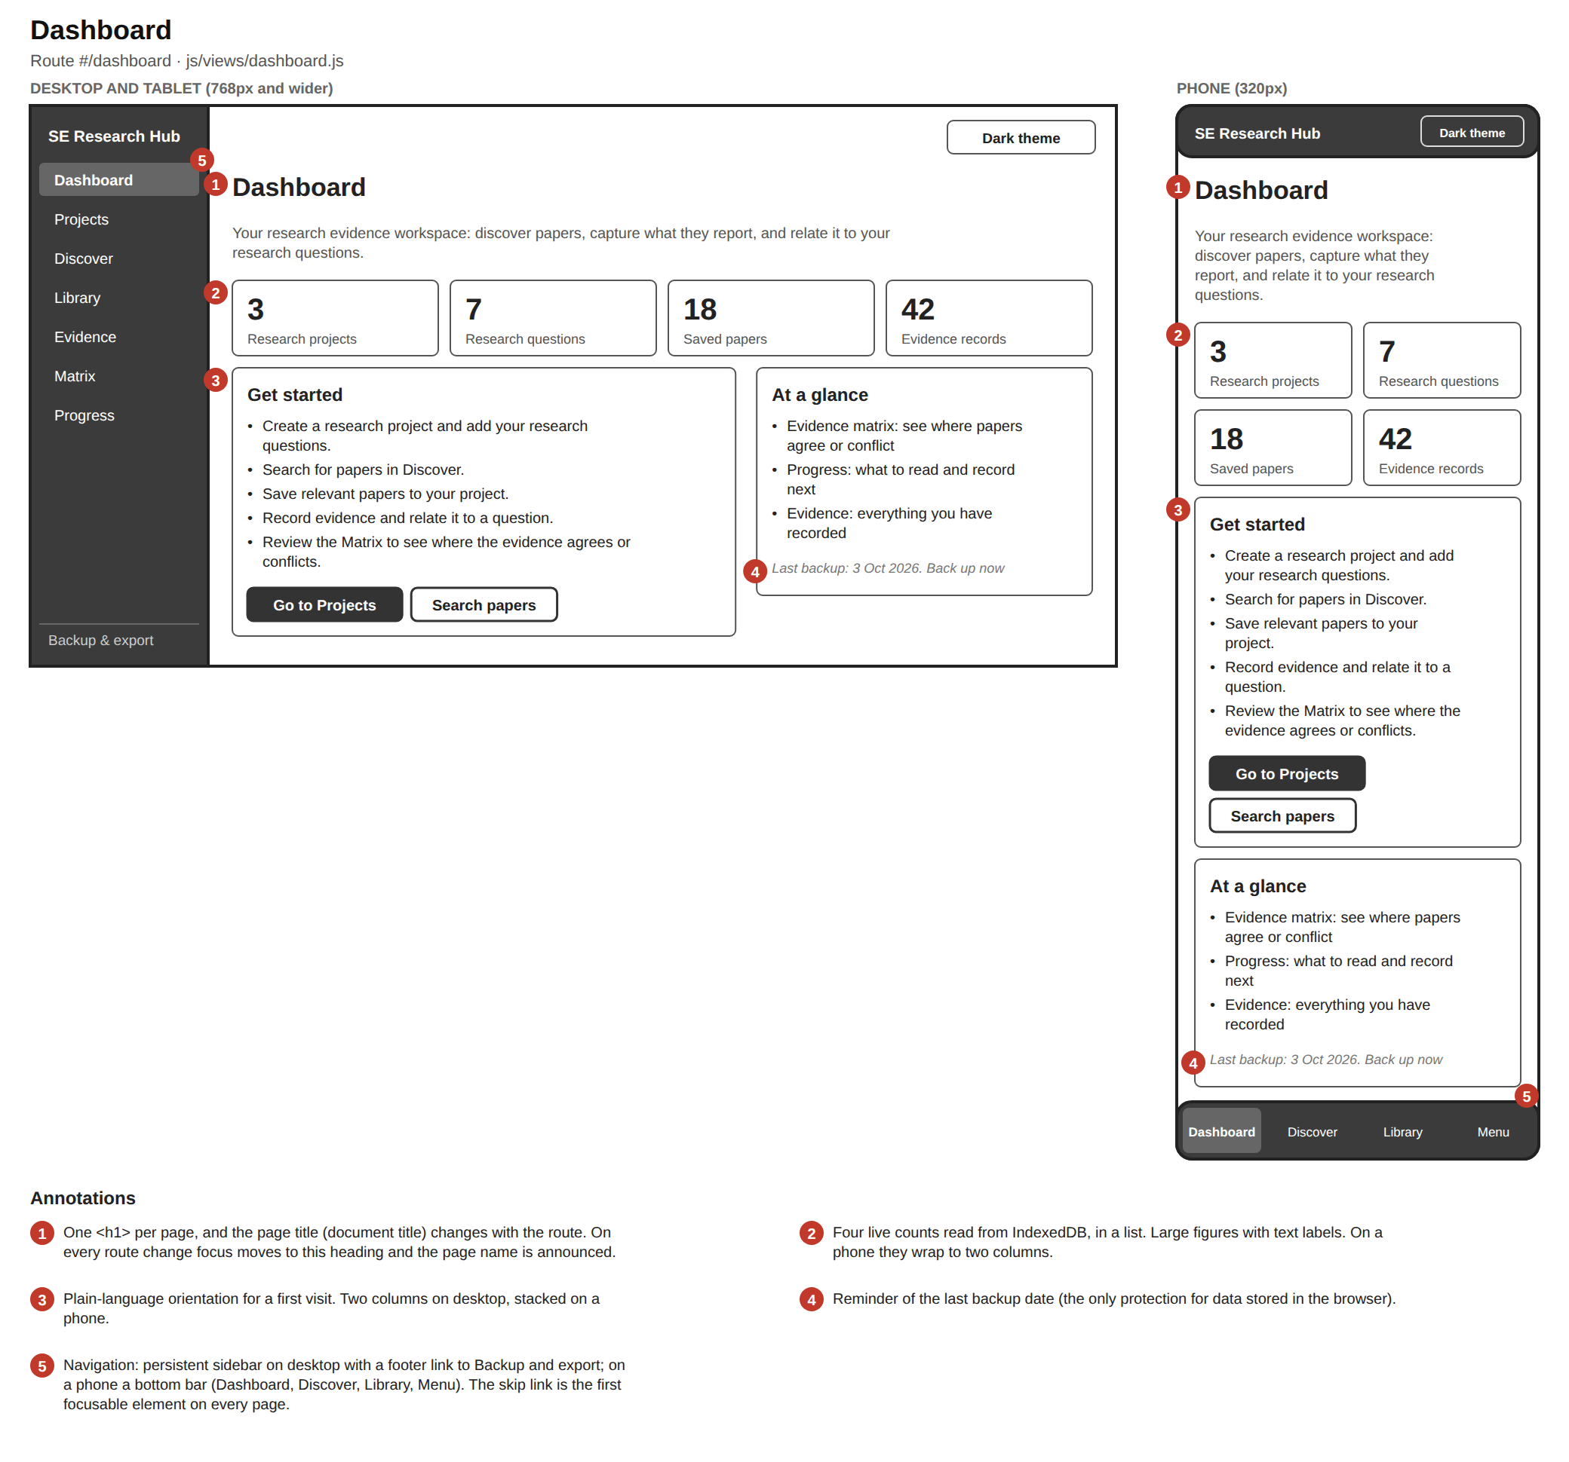
Dashboard wireframe: four statistic cards, a getting-started card and an at-a-glance card, with sidebar on desktop and bottom bar on phone

2. Projects
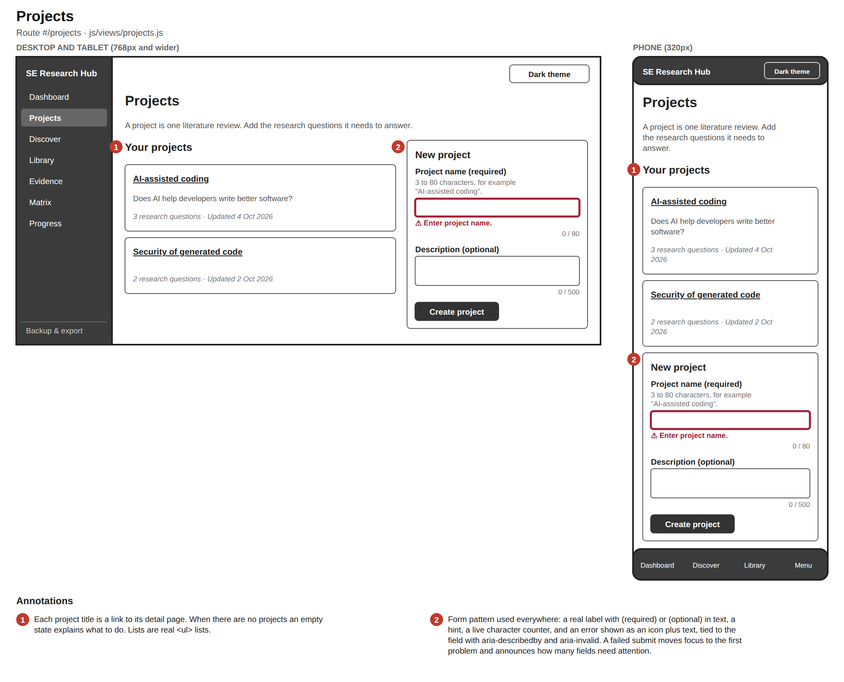
Projects wireframe: a list of project cards and a New project form with an inline validation error

3. Project detail
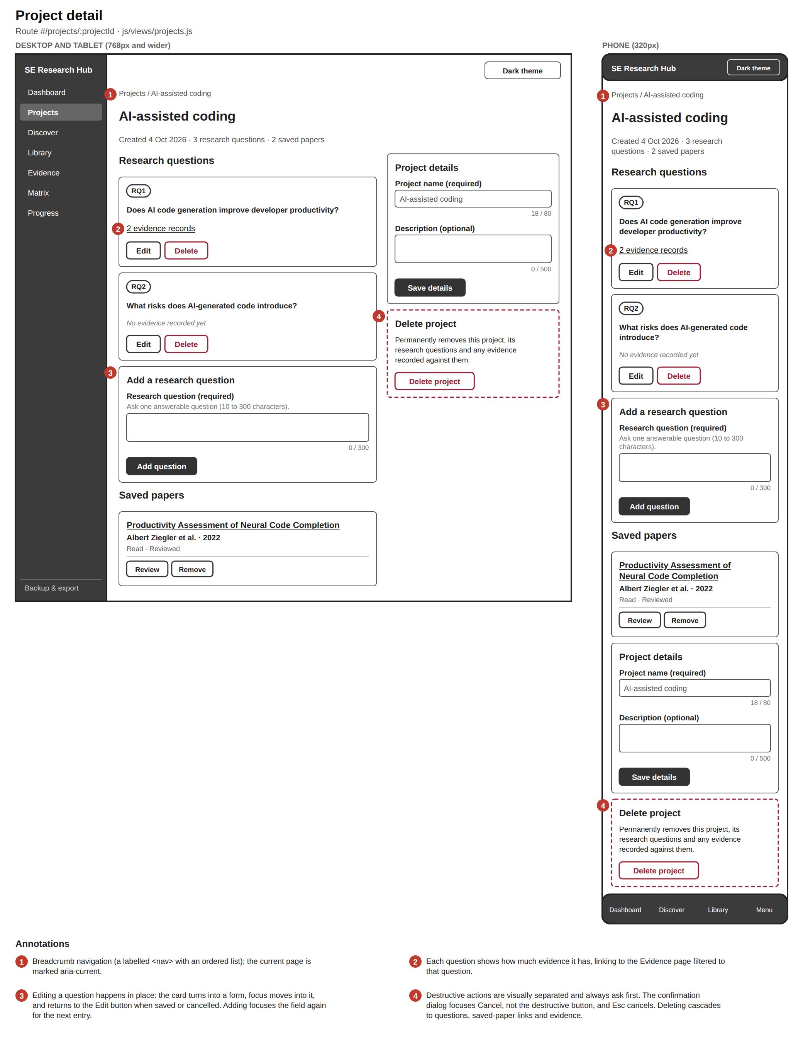
Project detail wireframe: breadcrumb, research questions with evidence counts, add-question form, saved papers, project details and a delete zone

4. Discover: search form
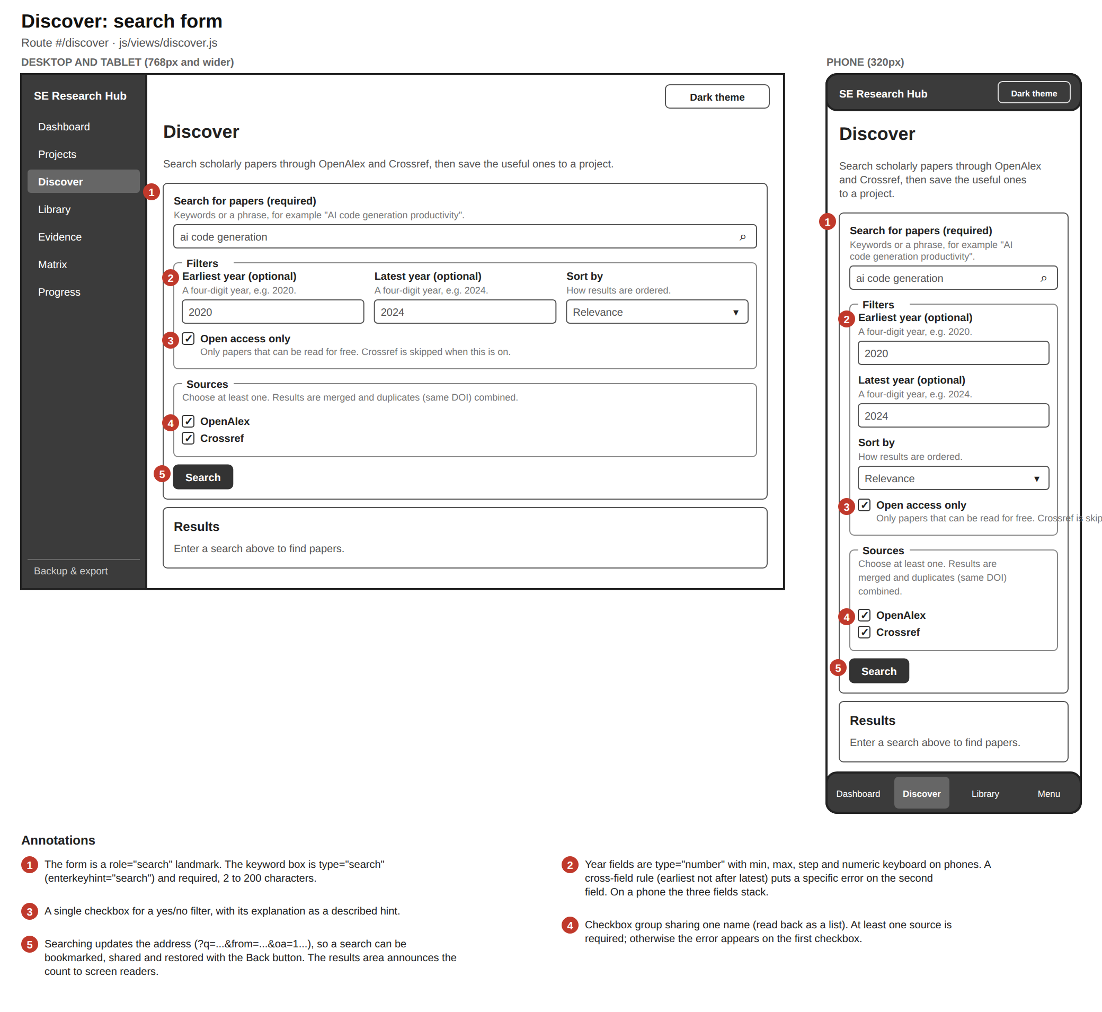
Discover wireframe showing the search form: keyword search, year filters, sort, open access checkbox, sources checkboxes

5. Discover: results
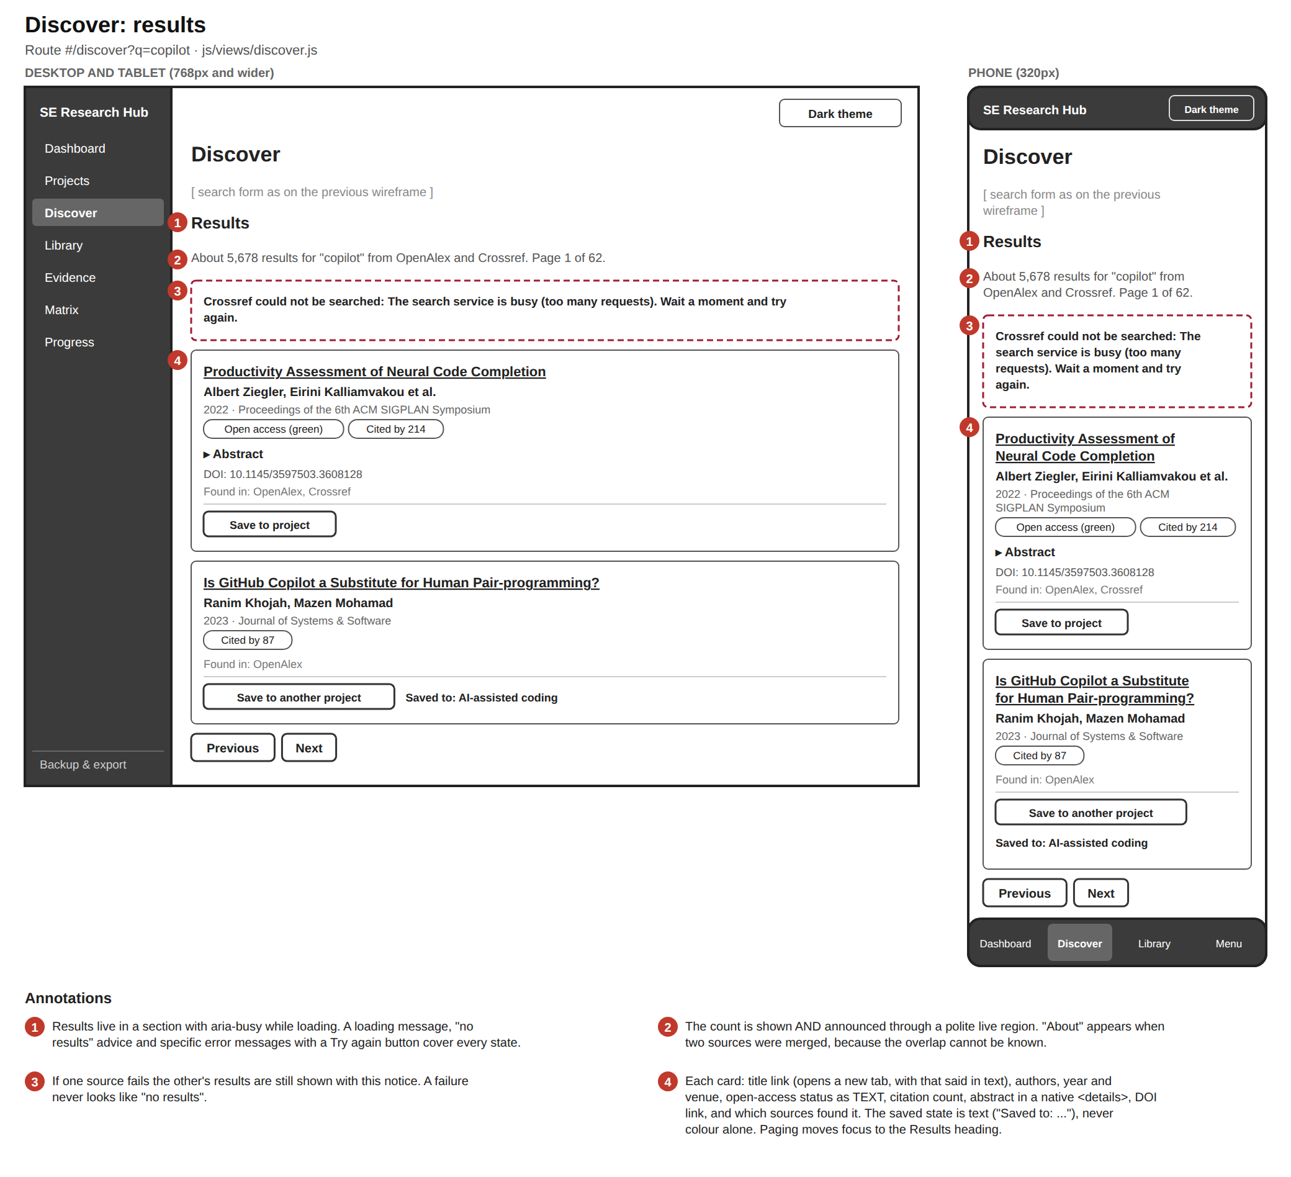
Discover results wireframe: result count, a source notice, paper cards with save buttons, and paging

6. Library
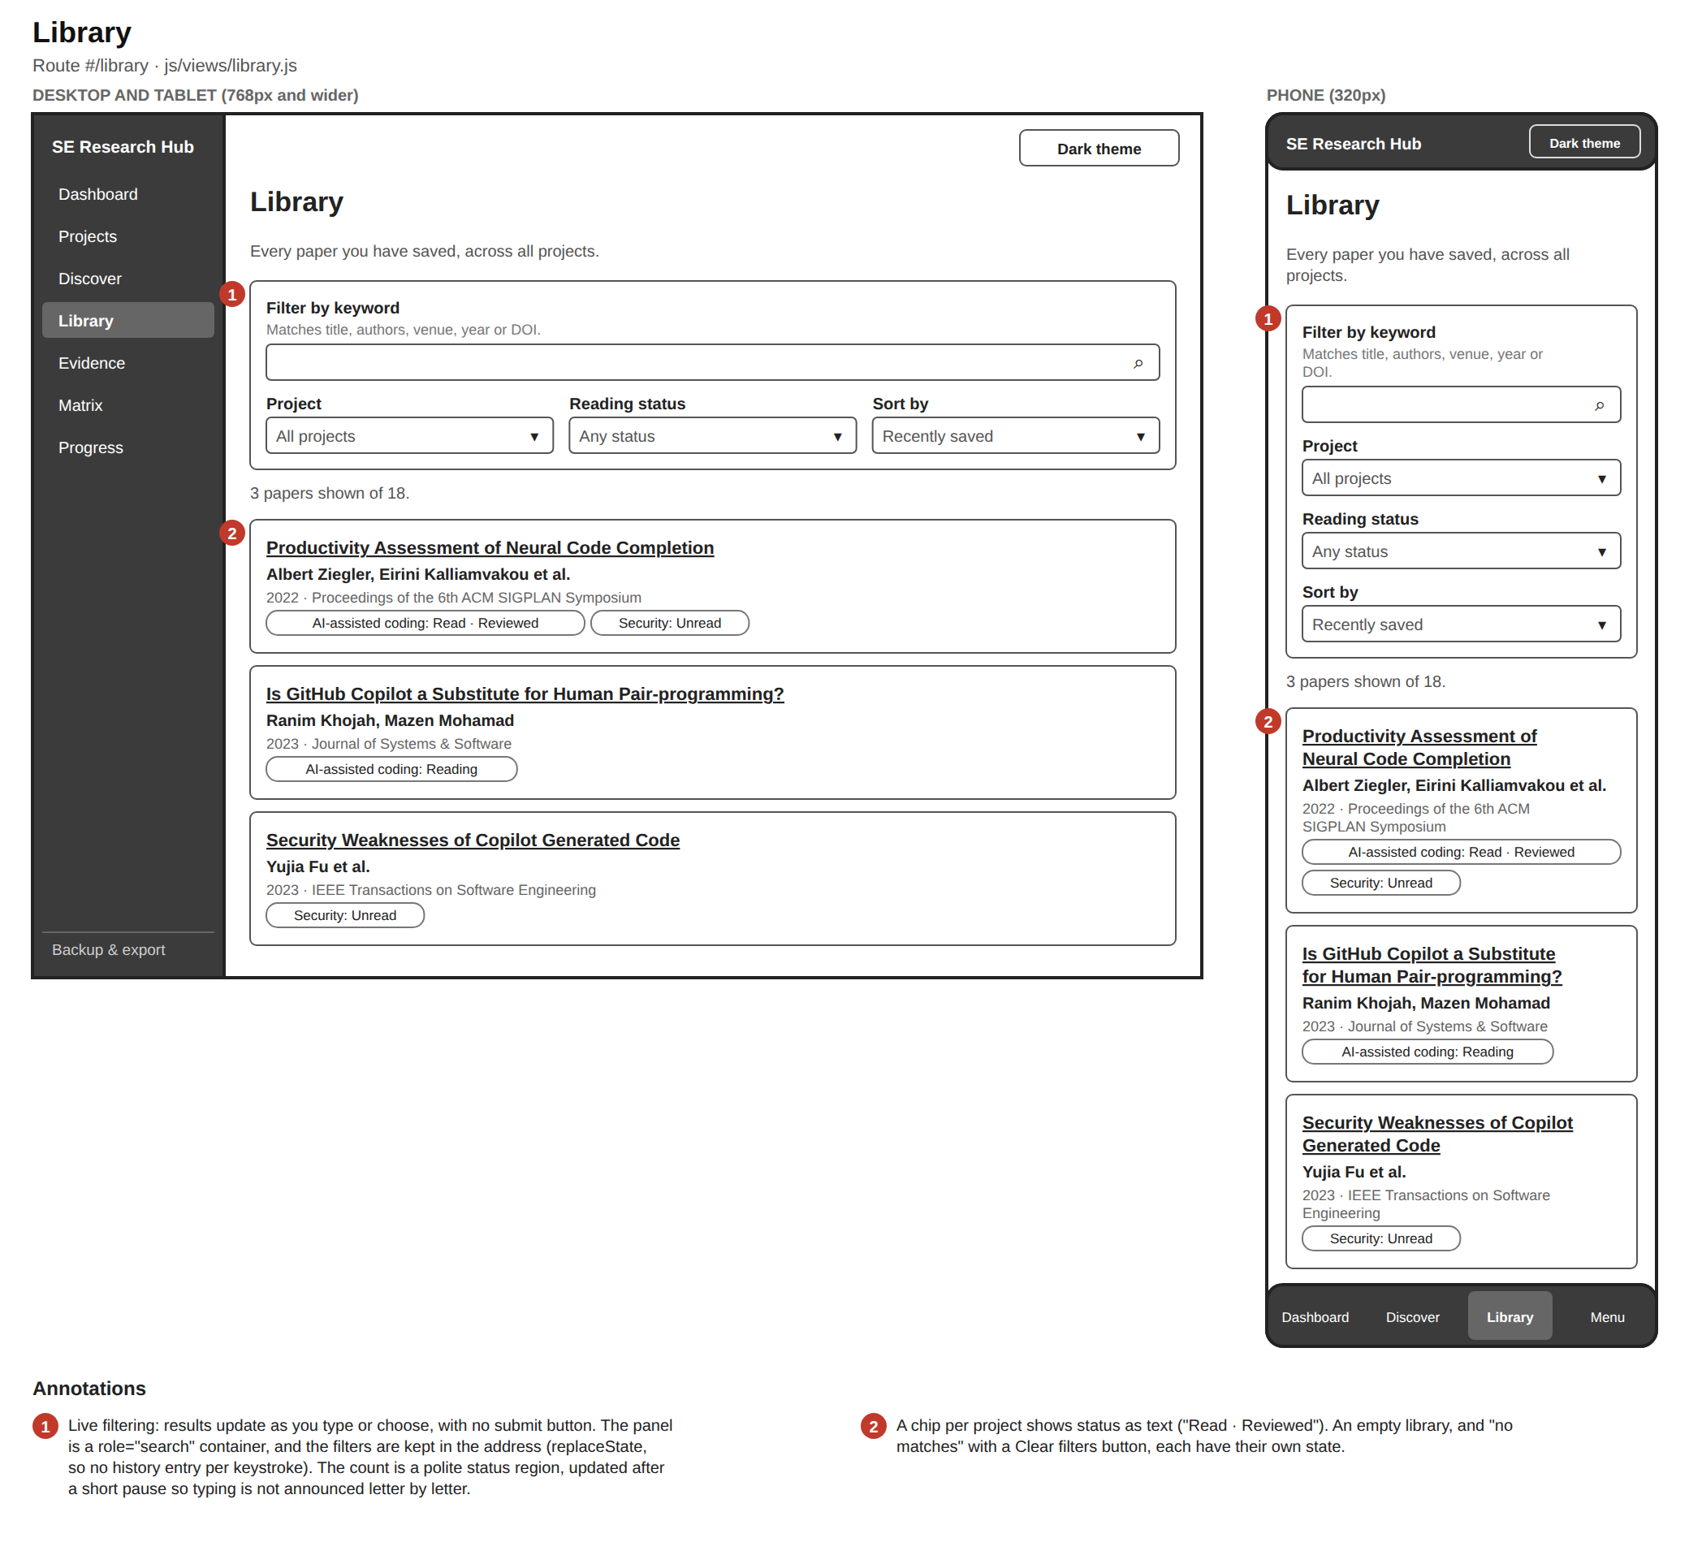
Library wireframe: filter panel and paper cards with project status chips

7. Paper detail: Overview tab
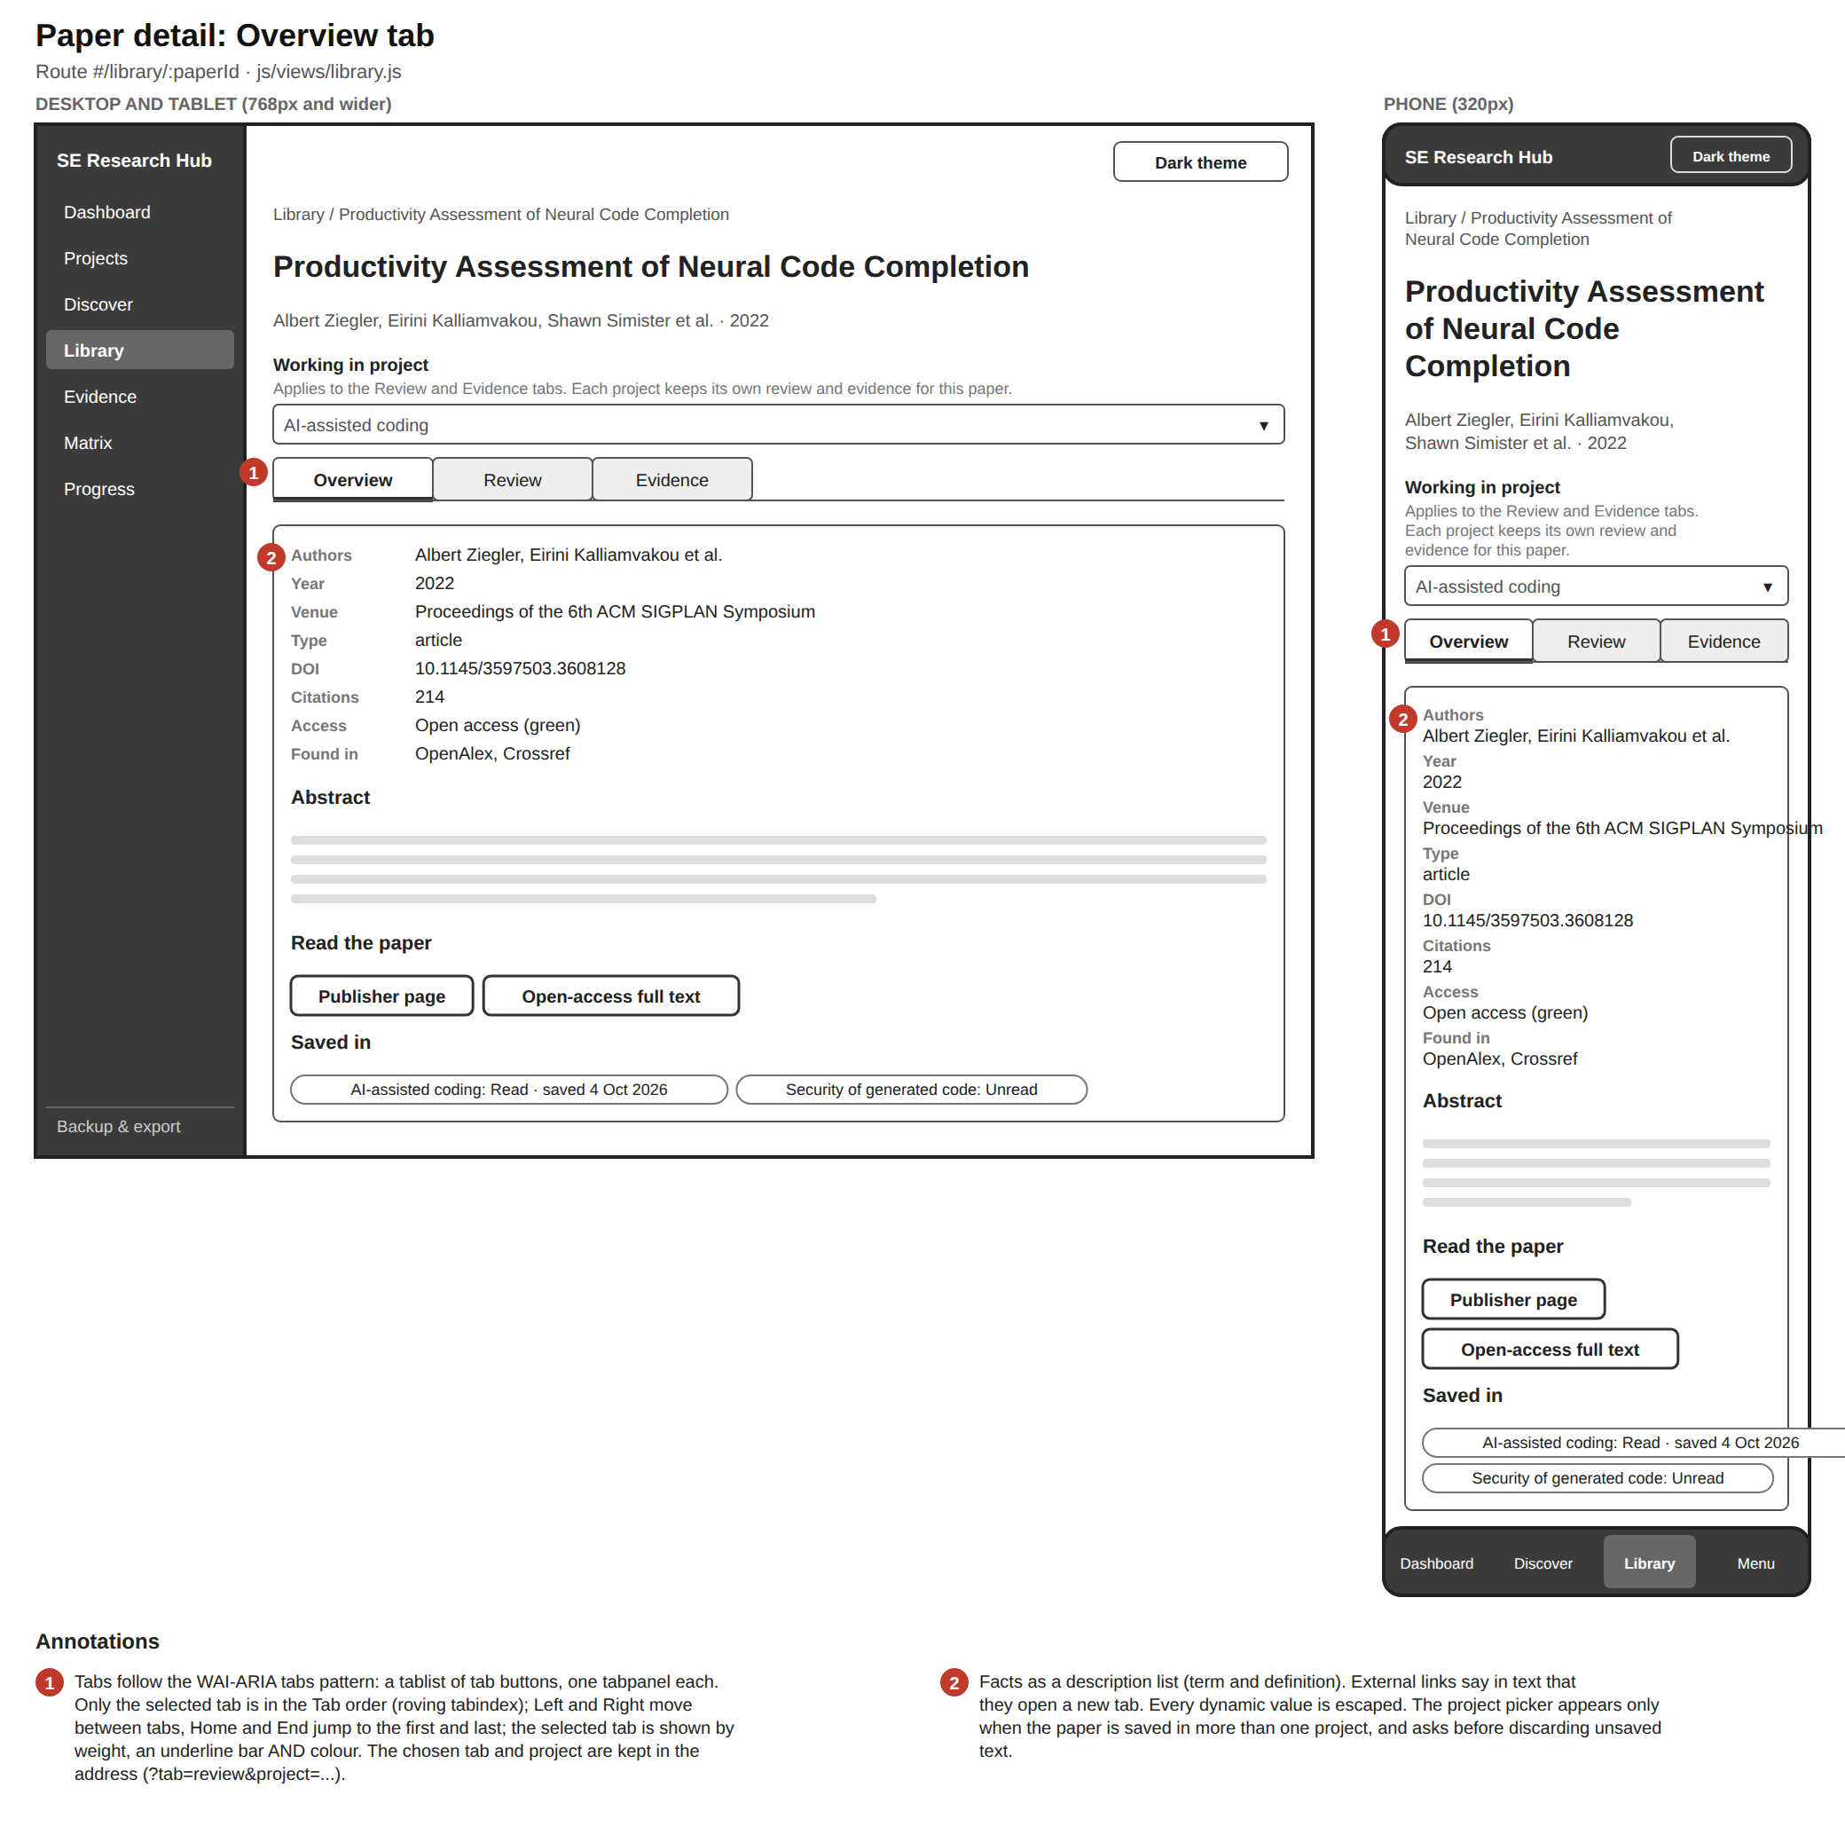
Paper detail overview wireframe: project picker, tabs, facts, abstract, links and the projects the paper is saved in

8. Paper detail: Review tab
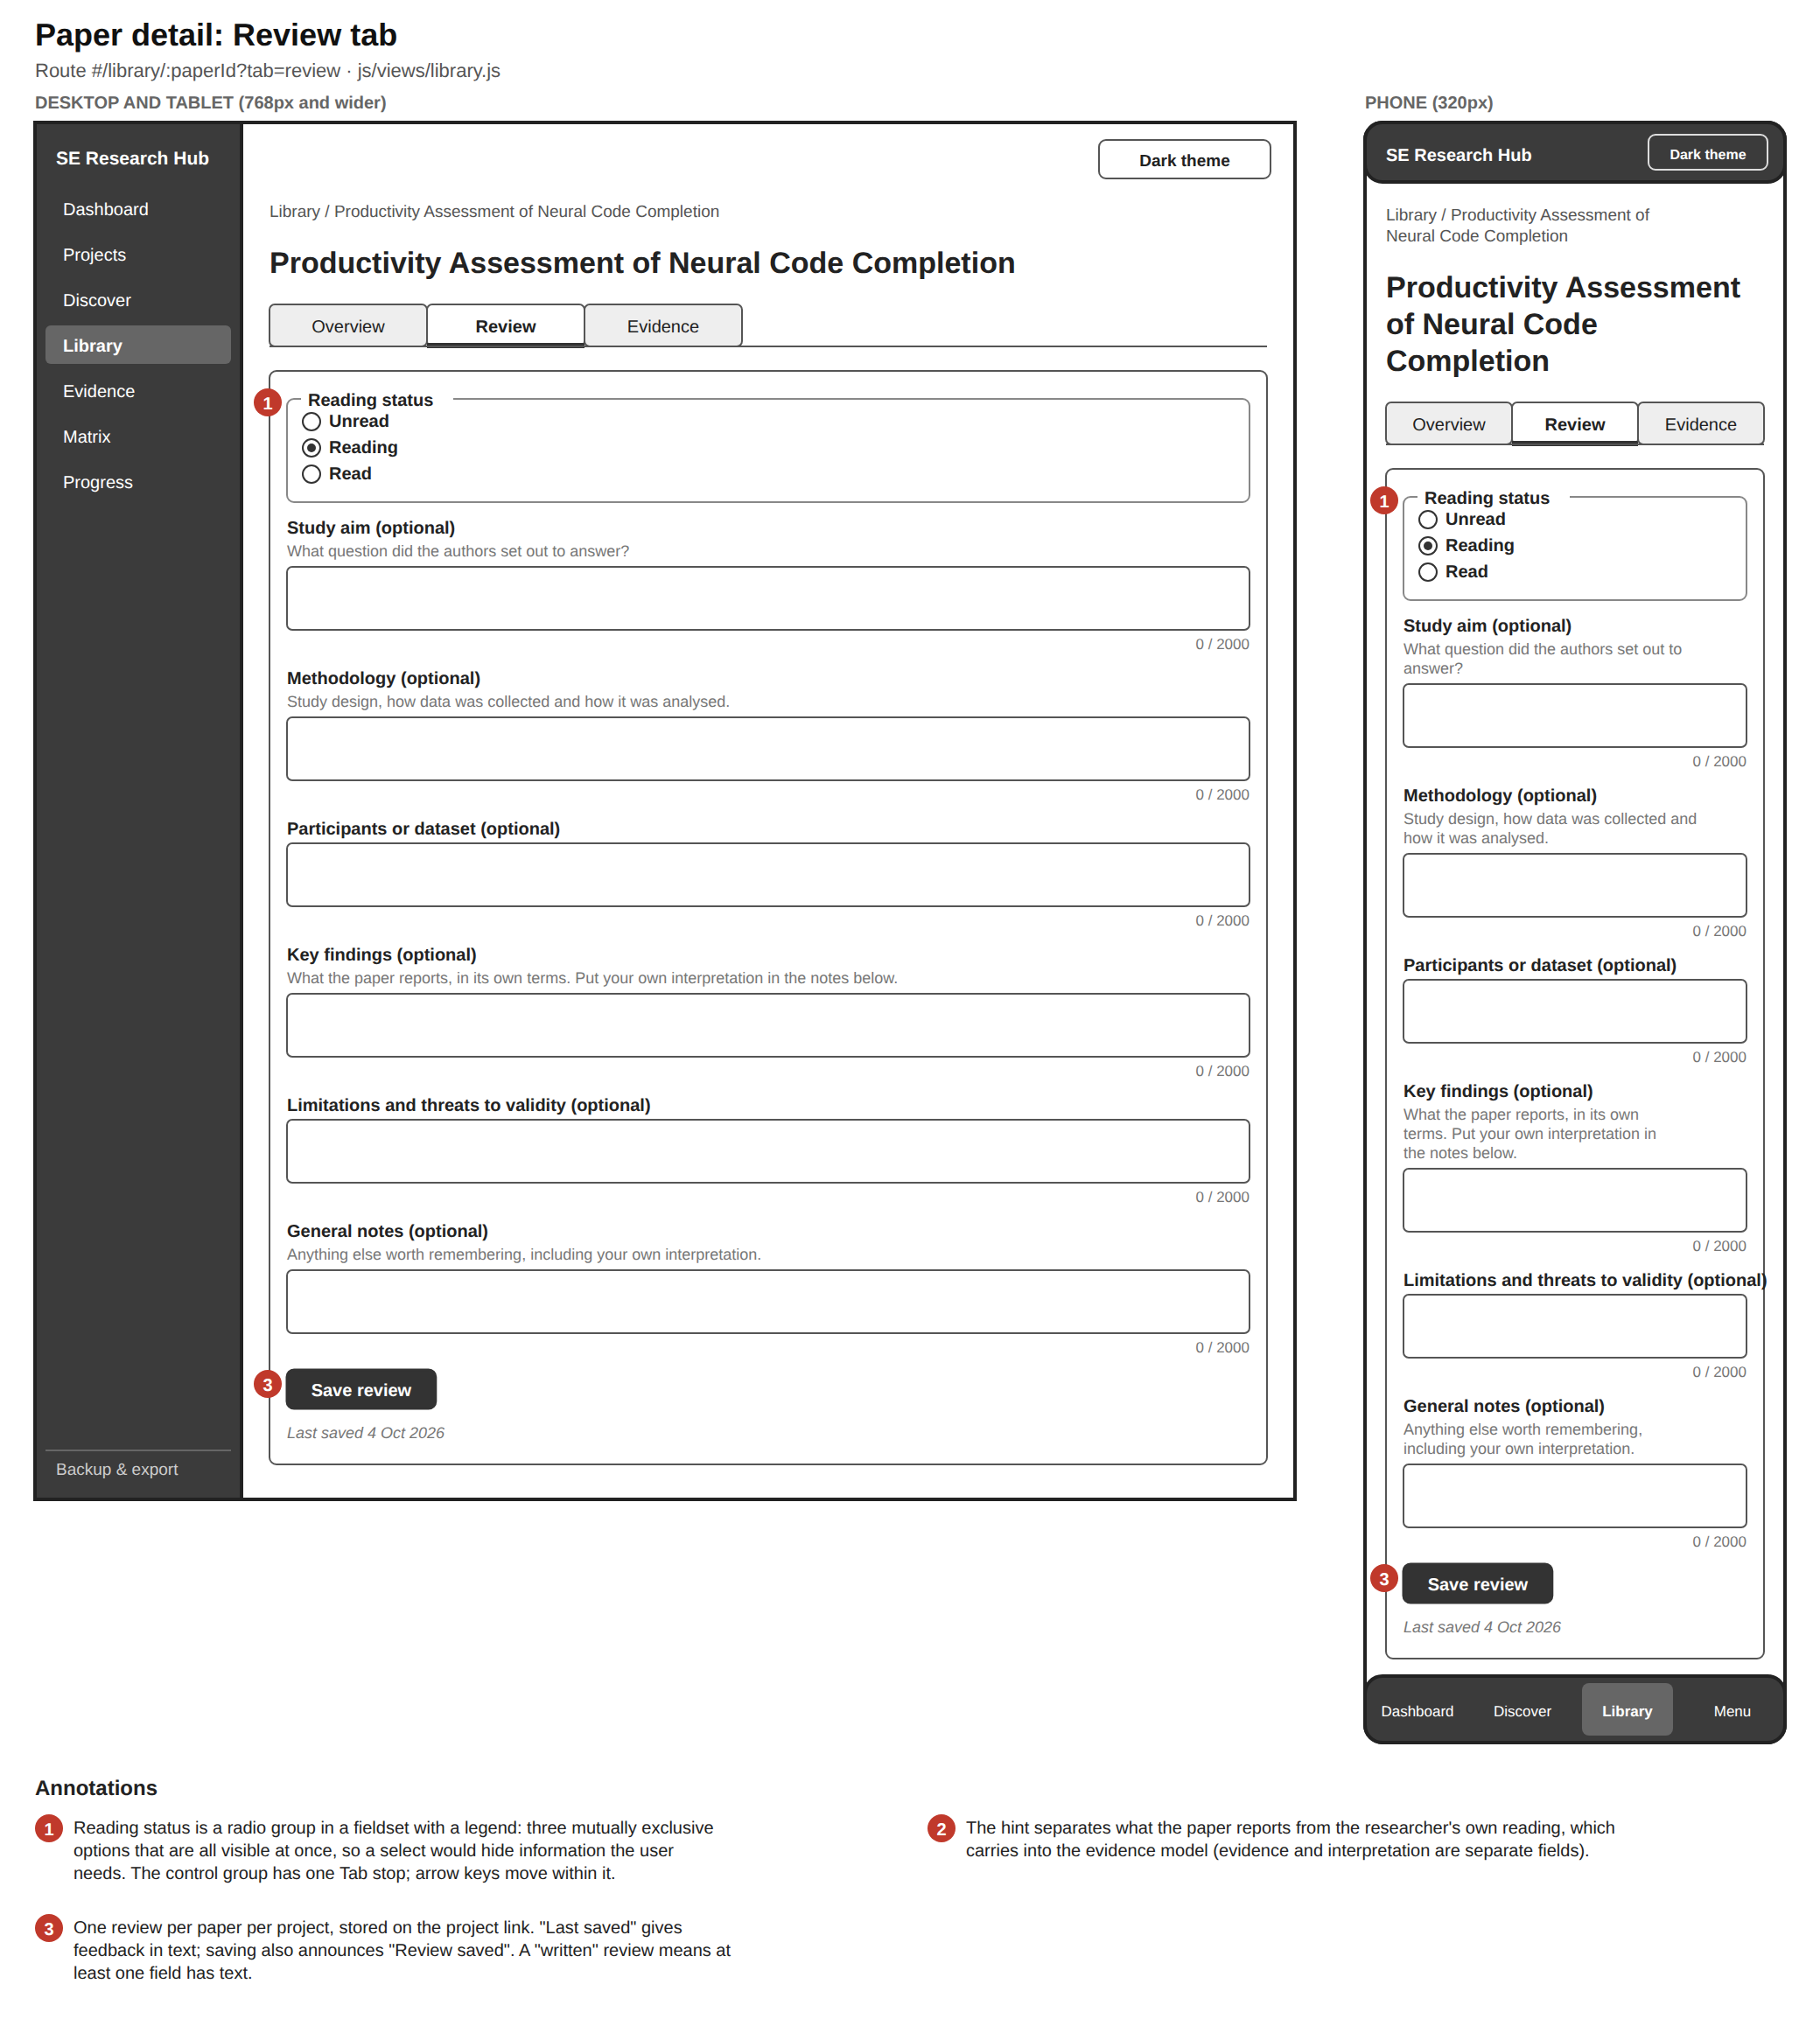
Paper detail review wireframe: reading status radio group and six structured review fields

9. Paper detail: Evidence tab
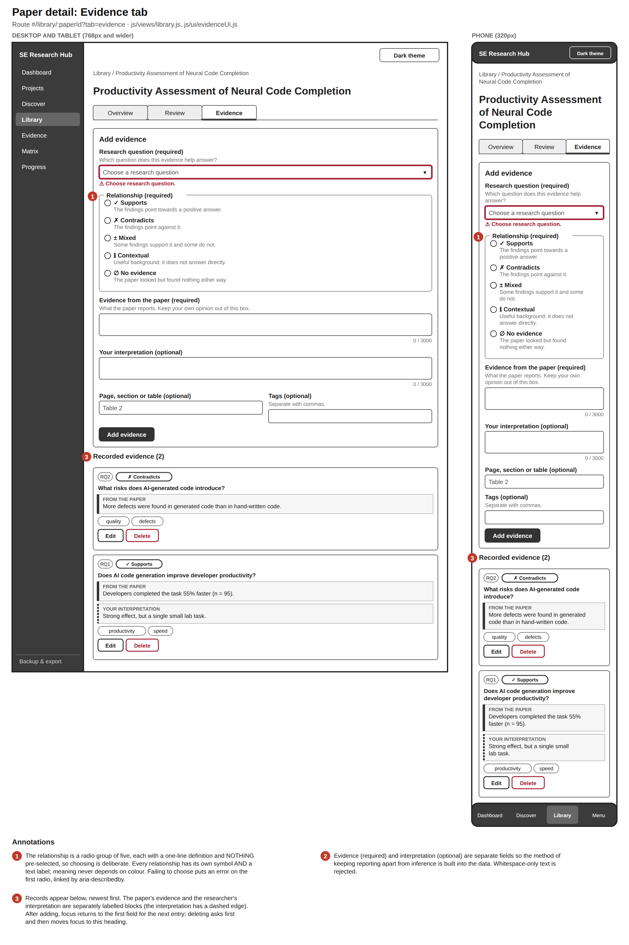
Paper detail evidence wireframe: add-evidence form with relationship radio group, and recorded evidence cards separating what the paper reports from the researcher's interpretation

10. Evidence
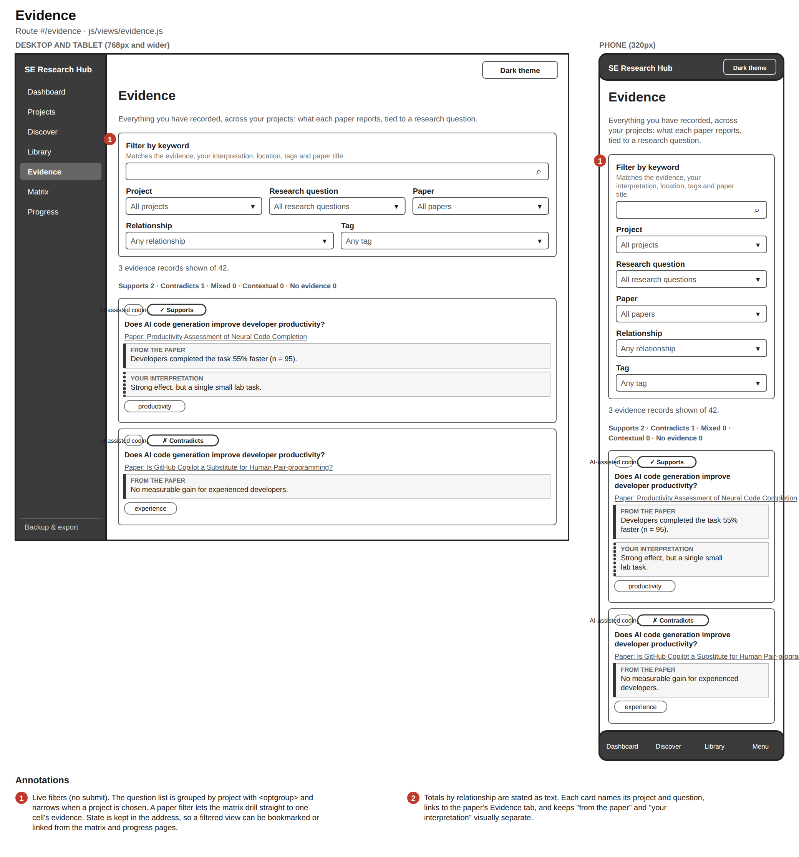
Evidence page wireframe: filter panel, relationship totals and evidence cards across projects

11. Evidence matrix
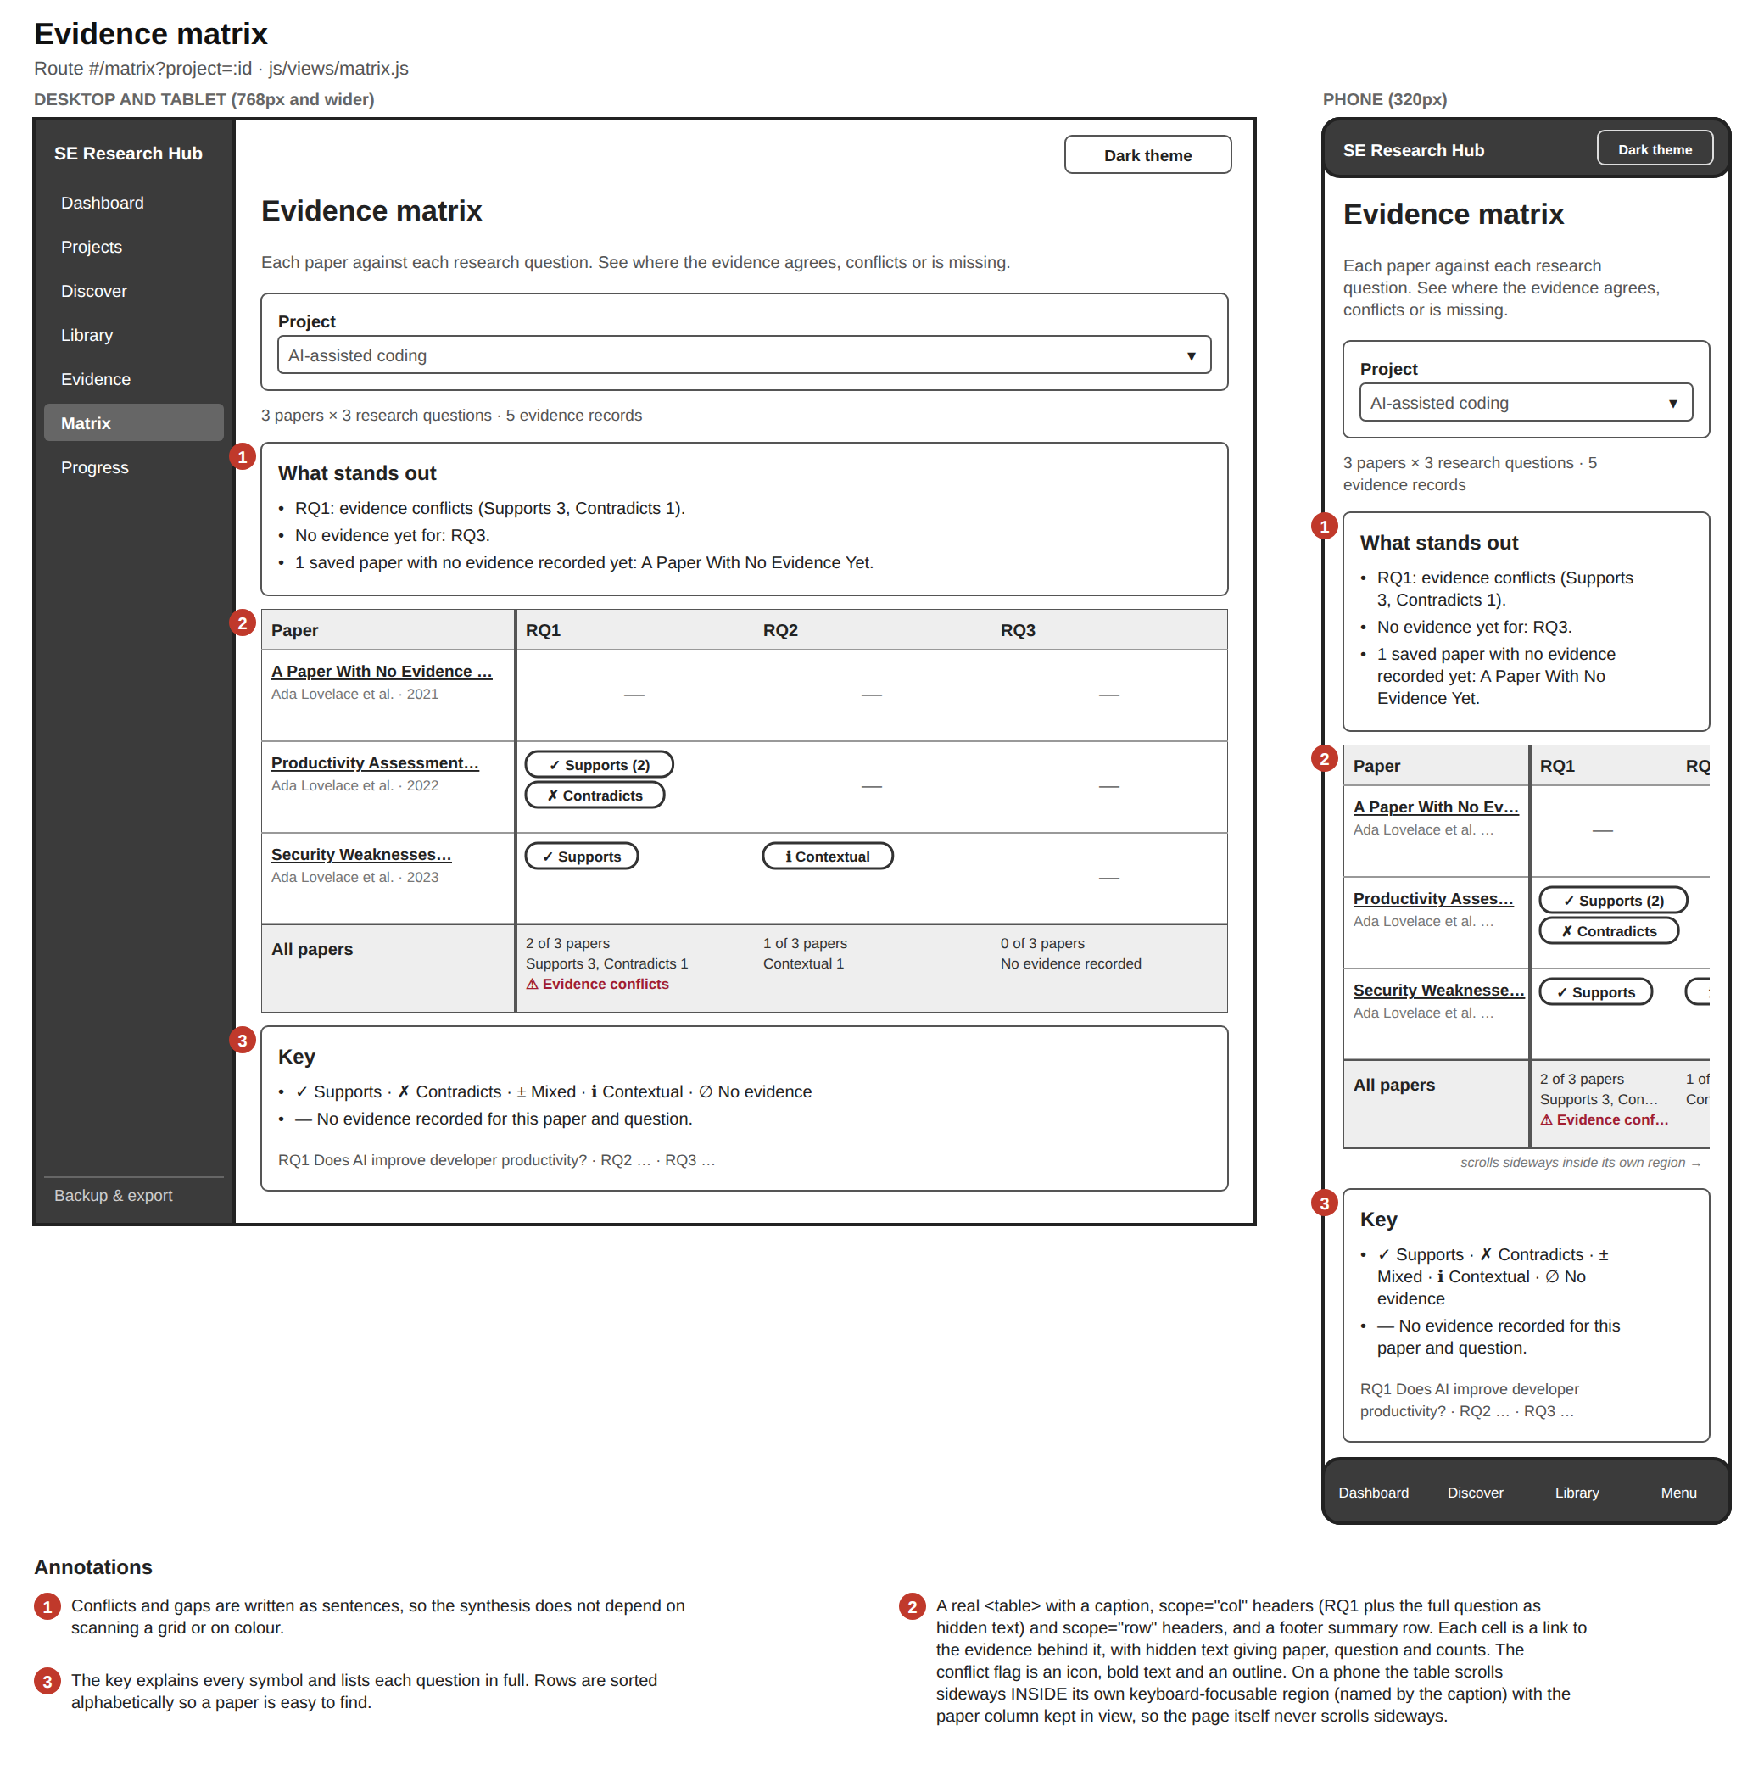
Evidence matrix wireframe: what stands out, papers by research questions table with relationship badges and a summary row, and a key

12. Progress
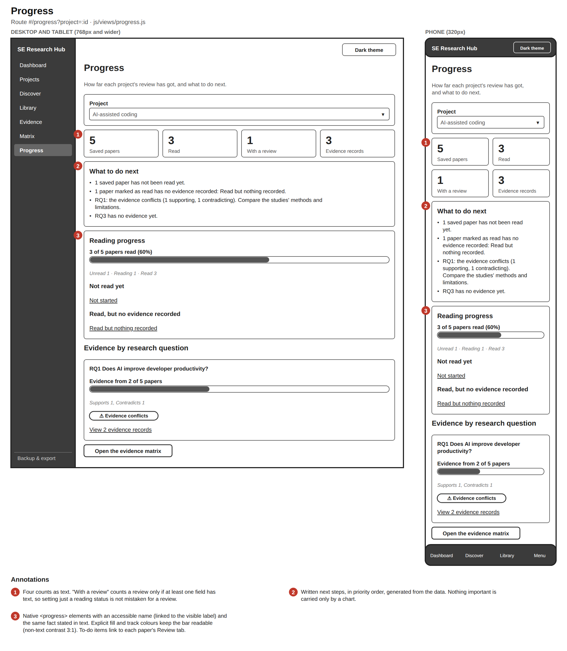
Progress wireframe: summary counts, what to do next, reading progress bar and evidence coverage per research question

13. Backup and export
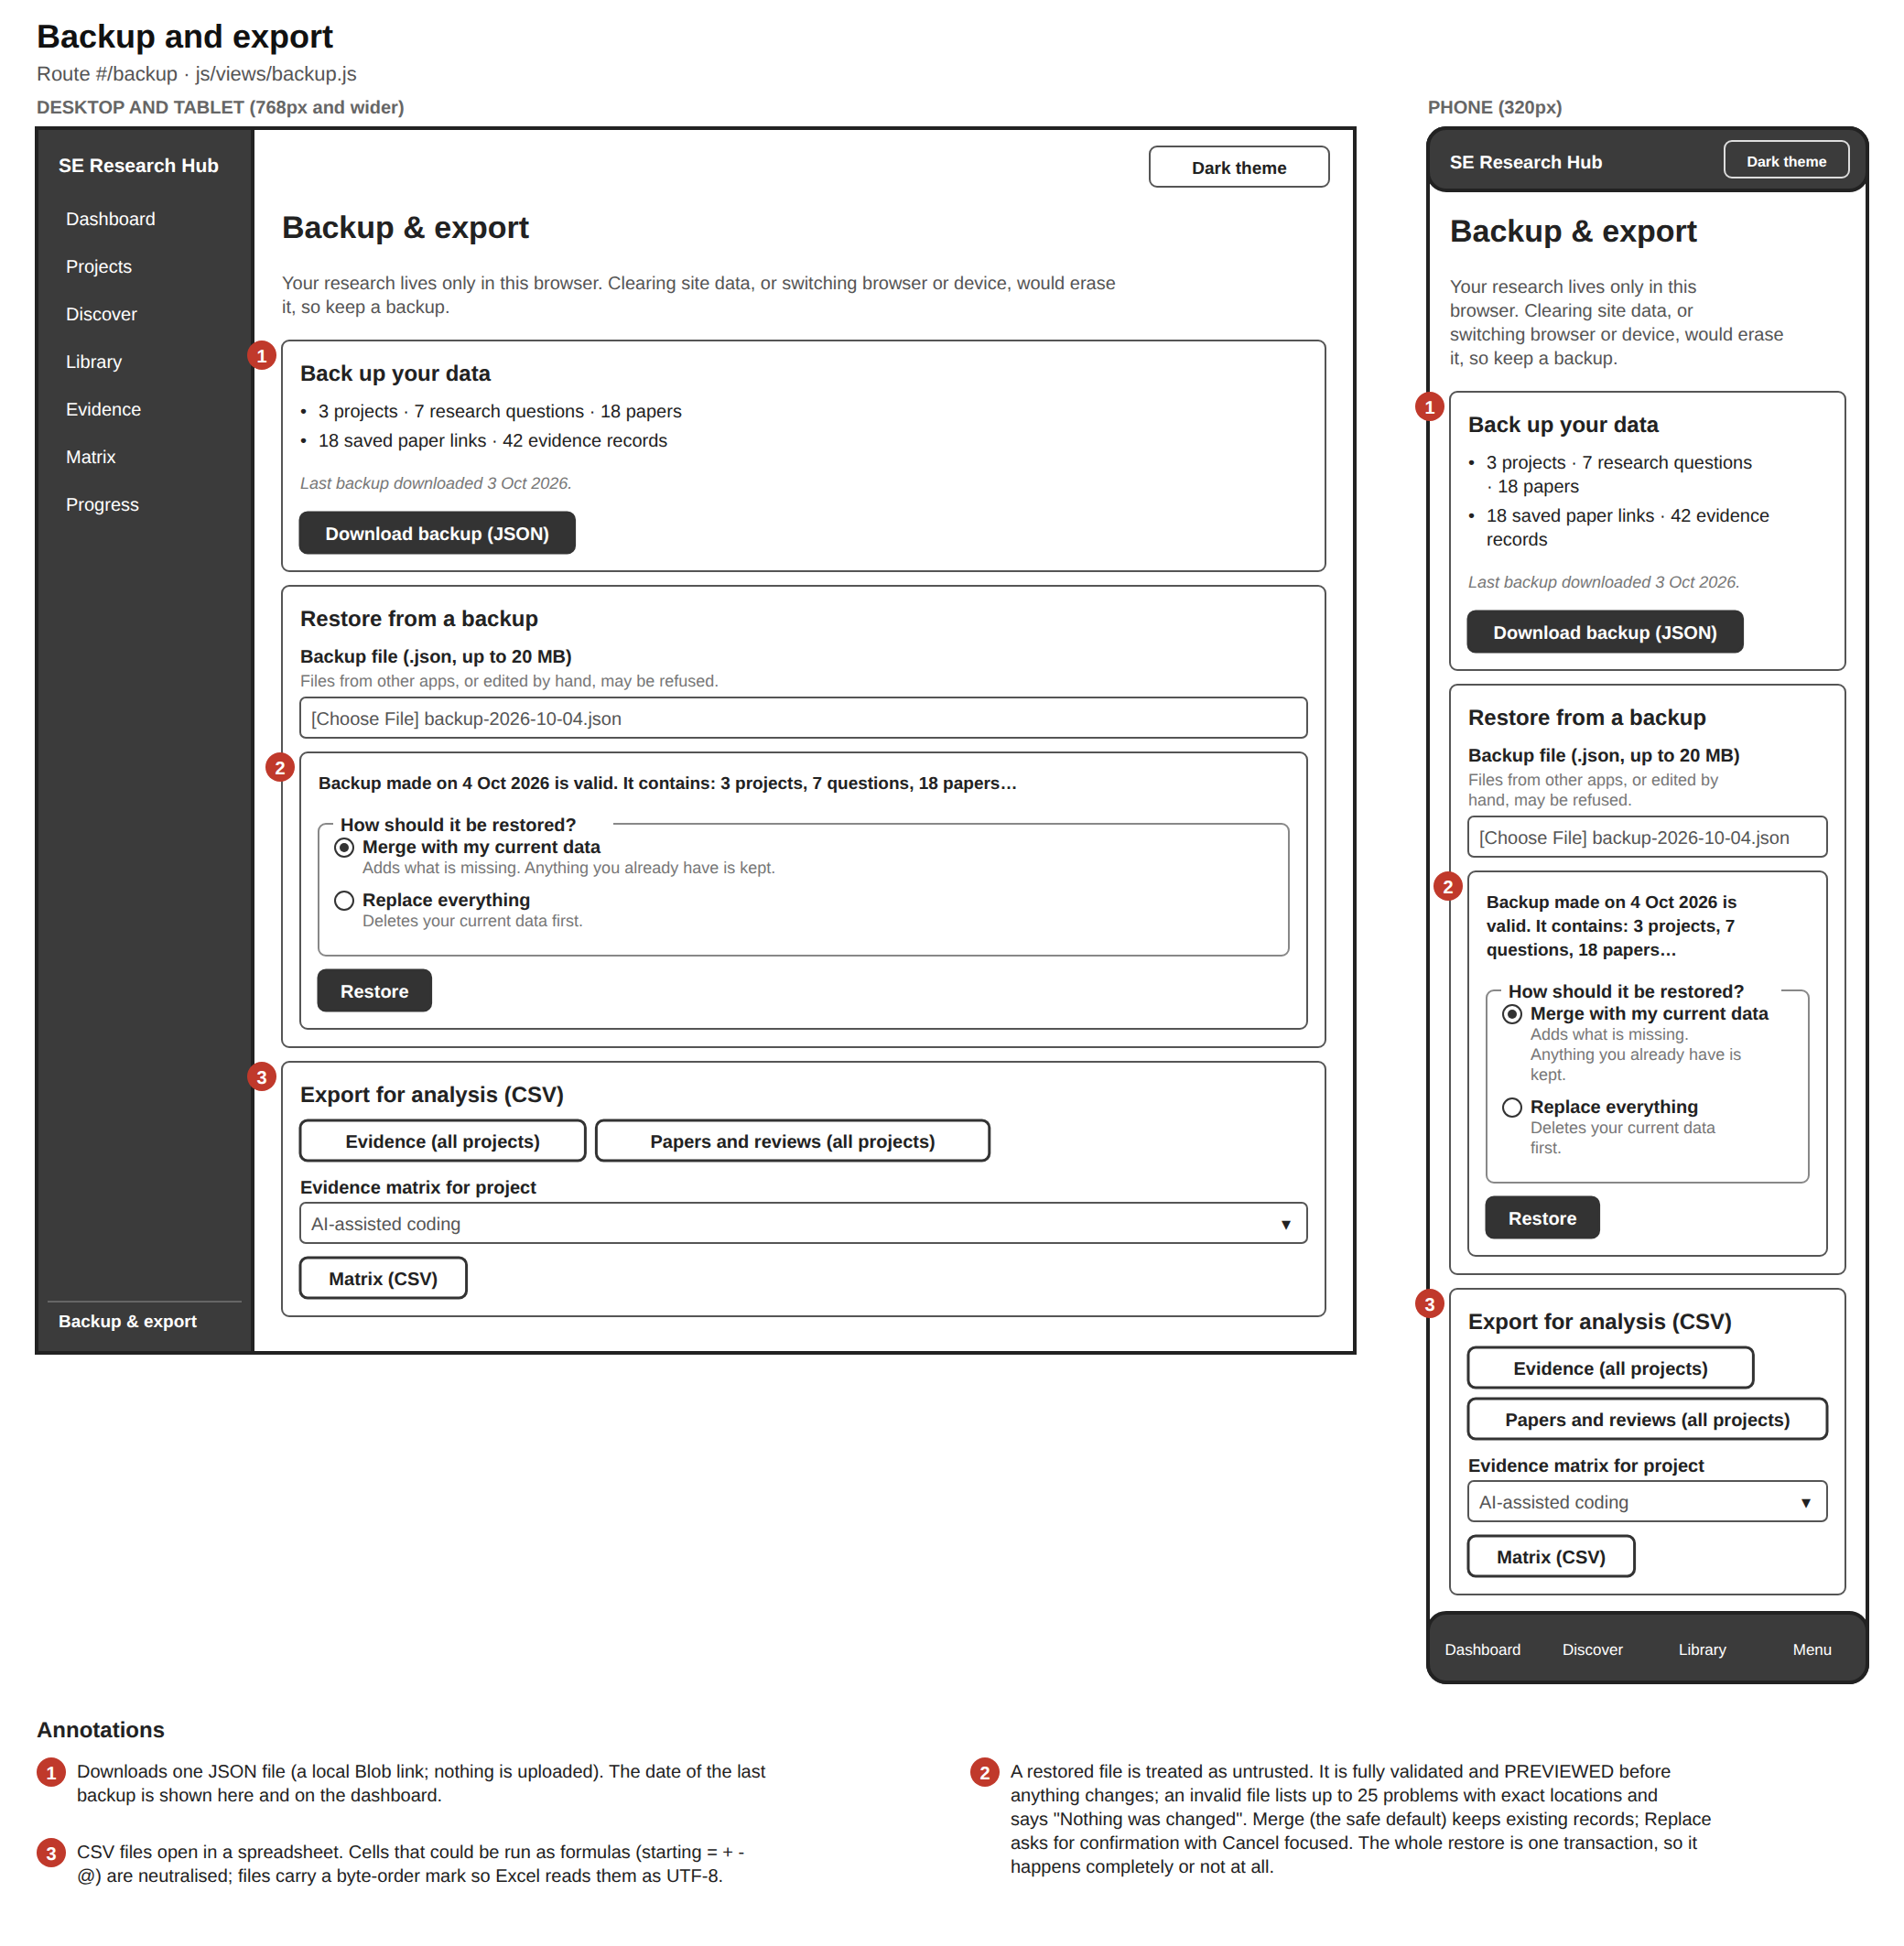
Backup and export wireframe: download backup, restore with preview and Merge or Replace, and CSV export

14. Not found, empty and error states
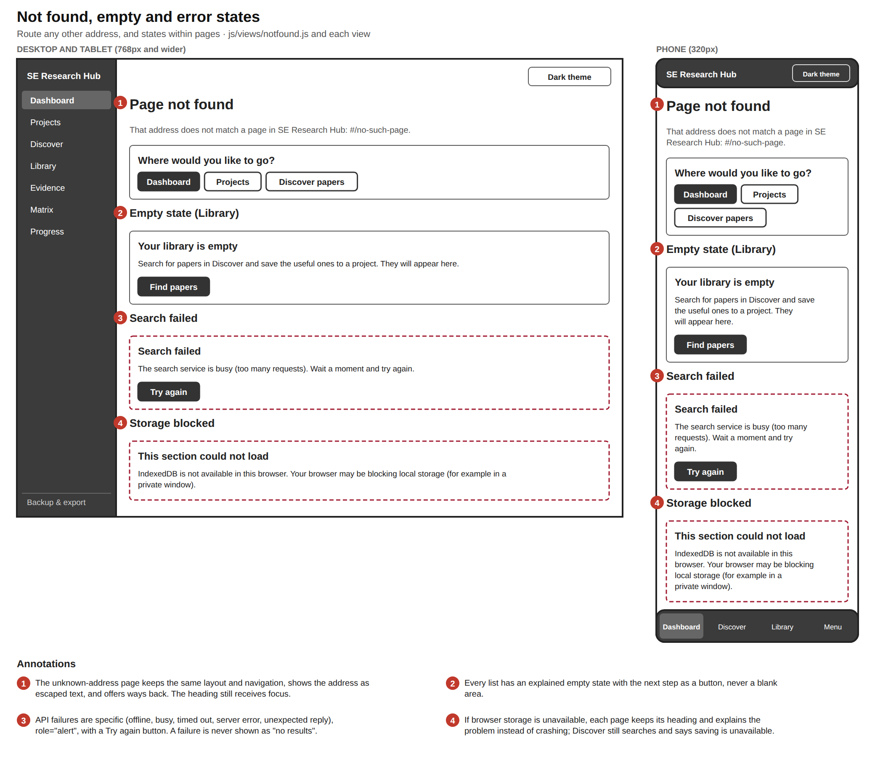
States wireframe: page not found, an empty library, a failed search and a storage-blocked message

15. Overlays: dialogs, menu sheet and toasts
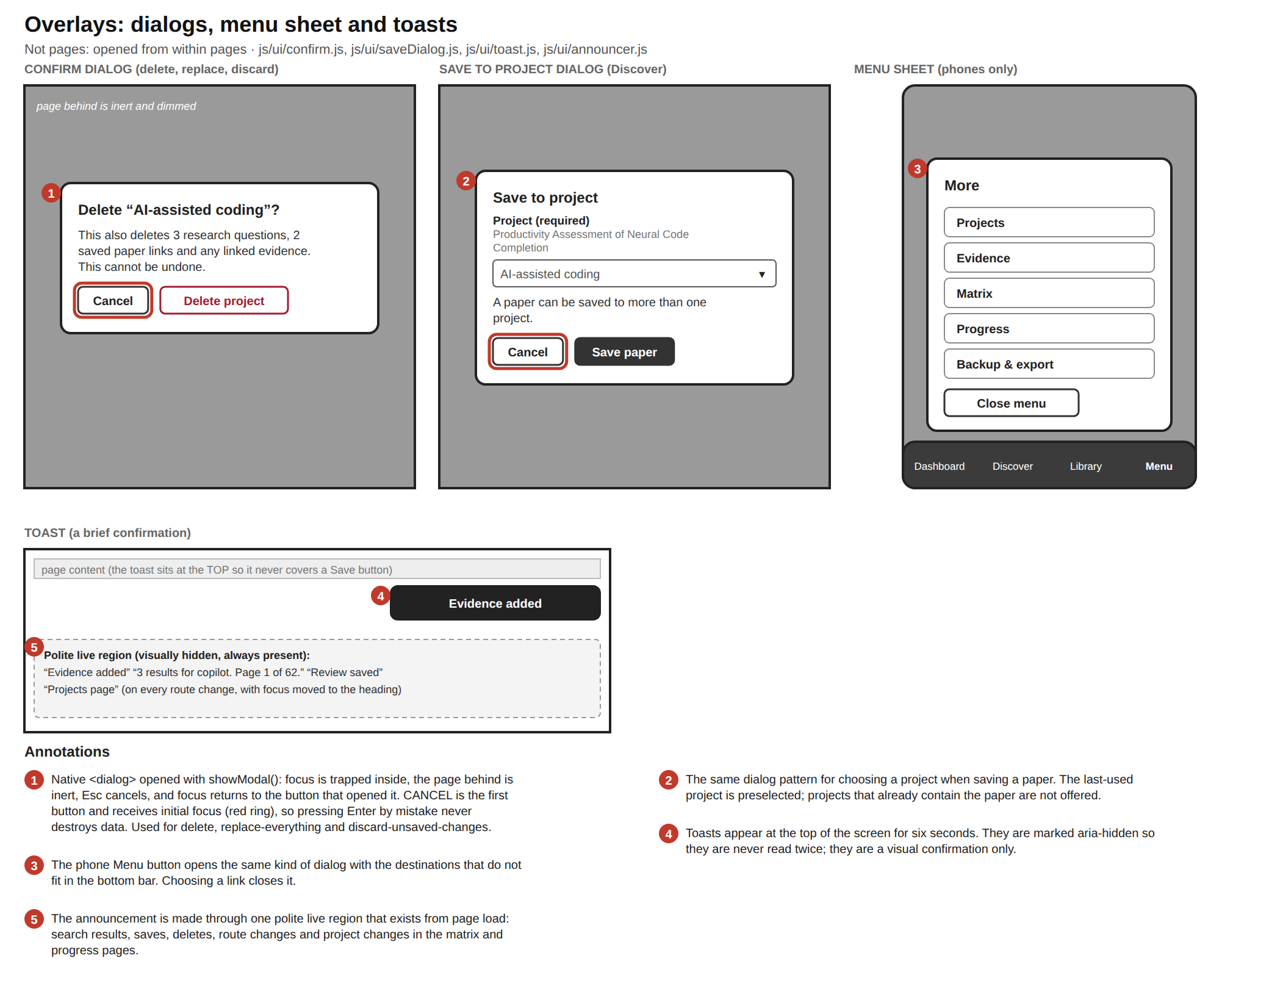
Overlays wireframe: confirm dialog with Cancel focused, save-to-project dialog, phone menu sheet, a toast and the live region

Shared components and rules
These patterns repeat on every page, so they are specified once.
Component | Rules | Implemented in
Page heading | One <h1> per page; focus moves to it after every route change and the page name is announced | js/router.js
Form field | Real <label>; "(required)" or "(optional)" written in the label; a hint; a live character counter where there is a limit; an error shown as ⚠ plus text, tied to the field with aria-describedby and aria-invalid | js/ui/fields.js, js/ui/forms.js
Failed submit | Focus moves to the first problem; the number of problems is announced | js/ui/forms.js
Buttons | Primary (filled), secondary (outlined), destructive (red outline); minimum height 40px | css/components.css
Destructive action | Always confirmed in a dialog whose first button, Cancel, has focus | js/ui/confirm.js
Status | Reading status, relationship, open-access status and saved state are written as text, with a symbol where useful; colour is never the only signal | js/ui/evidenceUi.js, views
Tabs | WAI-ARIA tabs: arrow keys, Home and End; selected tab marked by weight, underline and colour; the tab is kept in the address | js/ui/tabs.js
Data table | <caption>, scope headers, a keyboard-focusable named scroll region | js/views/matrix.js
Progress | Native <progress> with a name, plus the same fact as text | js/views/progress.js
Empty and error states | Every list and failure has an explanation and a next step, never a blank area | each view
Live announcements | One polite live region for results, saves, deletes, route and project changes | js/ui/announcer.js

Regenerating
The wireframes are generated from page descriptions in scripts/wireframe-pages.mjs (and wireframe-overlays.mjs) by a small drawing toolkit (scripts/wireframe-lib.mjs):
npm run wireframes # writes docs/design/wireframes/*.svg and *.png
npm run design # diagrams and wireframes together

SVG files are vector (sharp at any size); PNG files are 2x resolution for pasting into Word or slides.

Site map and navigation
SE Research Hub is a single-page application: one HTML file, with the visible page chosen by the address after the # (hash routing). That keeps it deployable on any static host with no server rules, and makes every page, filter and paper linkable and bookmarkable.

1. Site map

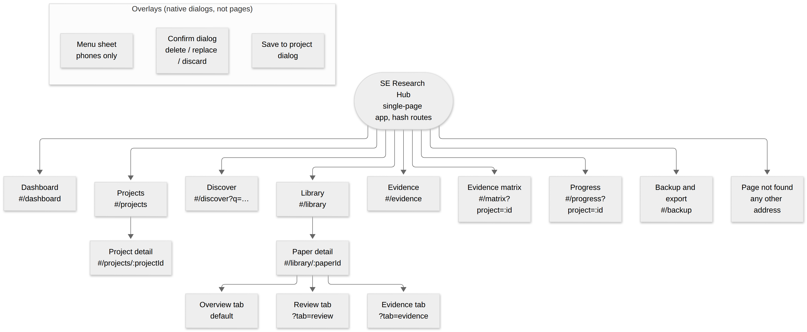

Overlays are opened from several pages: the Save to project dialog from Discover; the Confirm dialog from Projects, Paper detail (evidence, project switching) and Backup (replace); the Menu sheet from the phone navigation bar.

2. Page inventory
# | Page | Route | Purpose | Main content
1 | Dashboard | #/dashboard | Orientation and quick access | Four counts (projects, questions, saved papers, evidence), getting-started steps, shortcuts, last-backup note
2 | Projects | #/projects | List and create literature reviews | Project cards, "New project" form
3 | Project detail | #/projects/:projectId | Everything about one project | Research questions (with evidence counts), add-question form, saved papers, project details form, delete
4 | Discover | #/discover | Find papers | Search form (keywords, years, sort, open access, sources), merged results, paging, save buttons
5 | Library | #/library | All saved papers | Keyword, project, status and sort filters; paper cards with project chips
6 | Paper detail | #/library/:paperId | Read, review and extract evidence from one paper | Project picker; tabs: Overview, Review, Evidence
7 | Evidence | #/evidence | Everything recorded, across projects | Filters (keyword, project, question, paper, relationship, tag), relationship totals, evidence cards
8 | Evidence matrix | #/matrix | Synthesis: where papers agree, conflict or are silent | Papers × questions table, summary row, "What stands out", key
9 | Progress | #/progress | What to do next | Reading progress, coverage per question, to-do lists
10 | Backup and export | #/backup | Protect and reuse data | JSON backup, validated restore (merge or replace), CSV exports
11 | Page not found | any other address | Recover from a bad link | Links back to Dashboard, Projects, Discover

3. URL scheme (state lives in the address)
Route | Parameters | Example
#/projects/:projectId | project id (UUID) | #/projects/6f1c…
#/discover | q search text, from, to years, oa=1 open access only, sort = newest/cited, src = openalex,crossref, page | #/discover?q=copilot&from=2020&oa=1&sort=cited&page=2
#/library | q, project, status, sort | #/library?status=unread&sort=year
#/library/:paperId | tab = review/evidence; project (which project's review/evidence) | #/library/doi%3A10.1145%2F3597503.3608128?tab=evidence&project=6f1c…
#/evidence | q, project, rq (question id), paper, rel, tag | #/evidence?project=6f1c…&rq=a2b9…&rel=contradicts
#/matrix, #/progress | project | #/matrix?project=6f1c…

Notes: paper ids contain / and : (for example doi:10.1145/3597503.3608128), so they are URL-encoded in the address. Filters change the address with history.replaceState (no history entry per keystroke); a new search uses pushState, so Back returns to the previous search.

4. Navigation structure by screen size
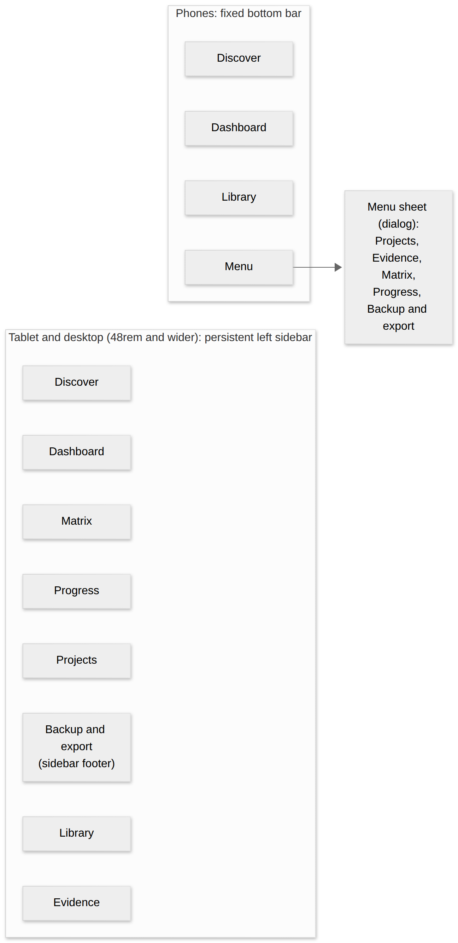
Both layouts share a skip link (first focusable element), a top bar with the theme toggle, and the same landmarks (header, nav, main). The current page is marked with aria-current="page". The order and labels of the navigation never change between pages (WCAG 3.2.3).

5. Typical journey and cross-links

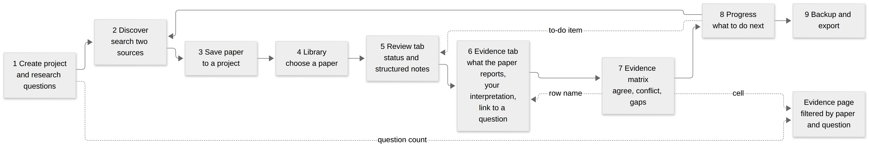

From | Link | To
Matrix cell | evidence for this paper and question | Evidence page filtered by project, question and paper
Matrix summary cell | all evidence for the question | Evidence page filtered by project and question
Matrix row heading | the paper | Paper detail, Evidence tab
Progress to-do item | unread, or read with no evidence | Paper detail, Review tab
Progress question card | "View n evidence records" | Evidence page filtered by question
Project page, question | "n evidence records" | Evidence page filtered by question
Project page, saved paper | Review | Paper detail, Review tab
Evidence card | paper title | Paper detail, Evidence tab
Library card | paper title | Paper detail
Dashboard | shortcuts | Matrix, Progress, Evidence, Projects, Discover

6. Design rationale
- Hash routing, not path routing. Static hosts (GitHub Pages) have no rewrite rules, so /projects/123 would 404 on reload. A hash route needs none, and the app works from any sub-path.
- Seven main destinations, one footer link. The research workflow (Discover, Library, Evidence, Matrix, Progress) and its containers (Dashboard, Projects) are the daily destinations; Backup is occasional, so it sits in the sidebar footer and the phone menu.
- Phone bar holds three, plus Menu. Thumb reach: the three most-used places are one tap away; the rest are one tap further (the Menu sheet).
- Paper and tab state in the address. A researcher can bookmark "this paper's evidence tab in that project", and the Back button behaves predictably.

Use cases

1. Actors
Actor | Type | Role
Researcher | Primary | The only human user: a student or researcher running a literature review. There are no accounts, roles or other users.
OpenAlex API | Secondary (external system) | Scholarly metadata service queried when the Researcher searches.
Crossref API | Secondary (external system) | Second scholarly metadata service, queried in parallel.

Browser storage (IndexedDB) and the file system are part of the Researcher's own browser and device, so they appear in the data-flow diagrams rather than as actors.

2. Use case diagram
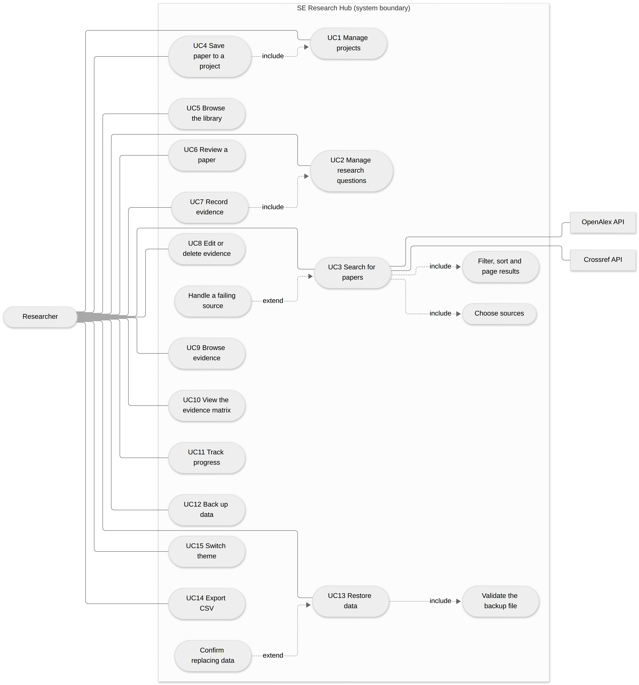
Notation: solid line = association between an actor and a use case; dashed arrow = include (the base use case always uses the other) or extend (optional behaviour added to the base use case; the arrow points at the base). "UC4 includes UC1" and "UC7 includes UC2" express a precondition: saving a paper needs a project, and recording evidence needs a research question, so the interface offers to create one.

3. Use case list
ID | Use case | Goal | Where | Key rules
UC1 | Manage projects | Create, rename, describe and delete literature reviews | Projects, Project detail | Name 3 to 80 characters; deleting removes its questions, saved-paper links and evidence
UC2 | Manage research questions | Add, edit, delete and order the questions a project must answer | Project detail | 10 to 300 characters; numbered RQ1, RQ2… by position; deleting removes evidence recorded against it
UC3 | Search for papers | Find candidate papers from two sources | Discover | Keywords 2 to 200 characters; years 1900 to next year, earliest ≤ latest; at least one source
UC4 | Save paper to a project | Keep a paper for review | Discover (Save button, dialog) | A paper is stored once and linked to each project; saving twice to one project does nothing
UC5 | Browse the library | Find a saved paper again | Library | Filters: keyword, project, reading status; four sorts
UC6 | Review a paper | Record status and structured notes | Paper detail, Review tab | One review per paper per project; every note ≤ 2,000 characters
UC7 | Record evidence | Capture what a paper reports about a question | Paper detail, Evidence tab | Evidence (required) is kept apart from interpretation; relationship chosen deliberately; the question must belong to the same project
UC8 | Edit or delete evidence | Correct or remove a record | Paper detail, Evidence tab | Cannot move a record to another paper or project; delete asks first
UC9 | Browse evidence | See everything recorded across projects | Evidence | Filters: keyword, project, question, paper, relationship, tag
UC10 | View the evidence matrix | See agreement, conflict and gaps | Matrix | Conflict = both Supports and Contradicts for a question; gaps stated in words
UC11 | Track progress | Decide what to do next | Progress | Written suggestions; "reviewed" means at least one review field has text
UC12 | Back up data | Protect against browser data loss | Backup and export | One JSON file containing all five data sets
UC13 | Restore data | Recover or move data | Backup and export | Merge keeps existing records; Replace deletes first (confirmation); all-or-nothing
UC14 | Export CSV | Analyse outside the app | Backup and export | Evidence, papers and reviews, or one project's matrix; formula-safe
UC15 | Switch theme | Comfortable reading | Top bar | Light or dark; follows the operating system until chosen; saved

4. Use case specifications (key flows)

UC3 Search for papers
Primary actor | Researcher
Secondary actors | OpenAlex API, Crossref API
Preconditions | The Researcher is online. (Saving needs browser storage but searching does not.)
Trigger | Submits the search form, or opens a link such as #/discover?q=copilot.
Main flow | 1. The Researcher enters keywords and optional filters. 2. The system validates the form (focus moves to the first problem if invalid). 3. The system records the search in the address. 4. It queries every chosen source in parallel. 5. Each response is checked, cleaned and converted to one common paper shape. 6. Results are merged: the same DOI becomes one paper. 7. The system shows the total, the sources used and the papers, and announces the result count to screen readers.
Alternative flows | A1 One source fails (timeout, rate limit, server error, offline): the other source's results are shown with a visible notice. A2 All sources fail, or a failure would look like "no results": an error with a specific explanation and a Try again button. A3 Open access only is on: Crossref is skipped (it does not report open access) with a notice. A4 No results: advice to widen the search. A5 The Researcher searches again before results arrive: the earlier request is cancelled and its late reply ignored.
Postconditions | Nothing is stored. The search is in the browser's history.
Quality rules | Every value from an API is untrusted: tags stripped, text escaped when displayed, links limited to http/https.
Tests | tests/unit/openalex.test.js, crossref.test.js, merge.test.js; tests/e2e/discover.mjs, save.mjs, security.mjs

UC4 Save paper to a project
Preconditions | A search has results; at least one project exists (otherwise the card offers "Create a project").
Trigger | Presses Save to project on a result.
Main flow | 1. A dialog asks which project (last used is preselected; projects that already have the paper are not offered). 2. The Researcher confirms. 3. The system validates the paper (field whitelist), then stores the paper once and a link to the project in one transaction. 4. The card shows "Saved to: …"; focus stays on the card; a confirmation is announced.
Alternatives | Cancel or Esc: nothing changes and focus returns to the button. Storage blocked: the card says saving is unavailable.
Postconditions | The paper appears in the Library and the project. Reading status "Unread".

UC7 Record evidence
Preconditions | The paper is saved in the project; the project has at least one research question.
Trigger | Submits the Evidence form on the paper's Evidence tab.
Main flow | 1. The Researcher picks a research question and a relationship (Supports, Contradicts, Mixed, Contextual or No evidence; nothing is pre-selected). 2. Writes what the paper reports; optionally their interpretation, a page or table, and tags. 3. The form validates (required fields, lengths, tag count) and shows specific messages. 4. The system checks integrity (the paper is saved in this project; the question belongs to this project) and stores the record. 5. The list updates, focus returns to the form for the next entry, and "Evidence added" is announced.
Alternatives | Invalid: focus moves to the first problem and the count of problems is announced. No questions in the project: the tab explains and links to the project page.
Postconditions | The record counts in the matrix, Evidence page, progress and dashboard.

UC10 View the evidence matrix
Preconditions | A project with research questions and saved papers.
Main flow | 1. The Researcher chooses a project. 2. The system builds a papers × questions table: each cell shows the relationships recorded (with counts). 3. A summary row totals each question and flags conflicts. 4. "What stands out" lists conflicts and gaps as sentences. 5. Choosing a cell opens the evidence behind it.
Alternatives | No questions or no papers: the page explains what is needed and links to it.

UC13 Restore data
Trigger | Chooses a backup file on the Backup page.
Main flow | 1. The system reads the file and validates all of it before changing anything: envelope, size, counts, every field, references between records. 2. It previews what the file contains. 3. The Researcher chooses Merge (default) or Replace. 4. For Replace, a confirmation says current data will be deleted and cannot be recovered. 5. The system applies everything in one transaction. 6. The result (records added and skipped) is shown.
Alternatives | Invalid file: up to 25 problems listed with exact locations (for example evidenceNotes[0].researchQuestionId) and "Nothing was changed". Failure part-way: the transaction is aborted and nothing changes.

Data flow and data model
Notation (Yourdon/DeMarco style): rectangles are external entities, circles are processes (numbered), cylinders are data stores (D1…), arrows are labelled data flows. Dashed borders mark data that comes from outside the trust boundary (untrusted until checked).

1. Context diagram (level 0)

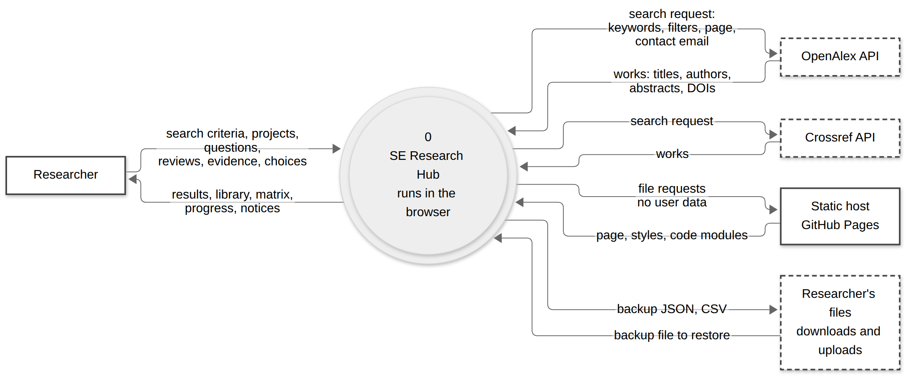

What never leaves the browser: the Researcher's projects, questions, reviews and evidence. Only the search request is sent to a third party (the two scholarly APIs), plus the contact email set in js/config.js. The static host sees only requests for the app's own files.

2. Level 1: main processes and data stores
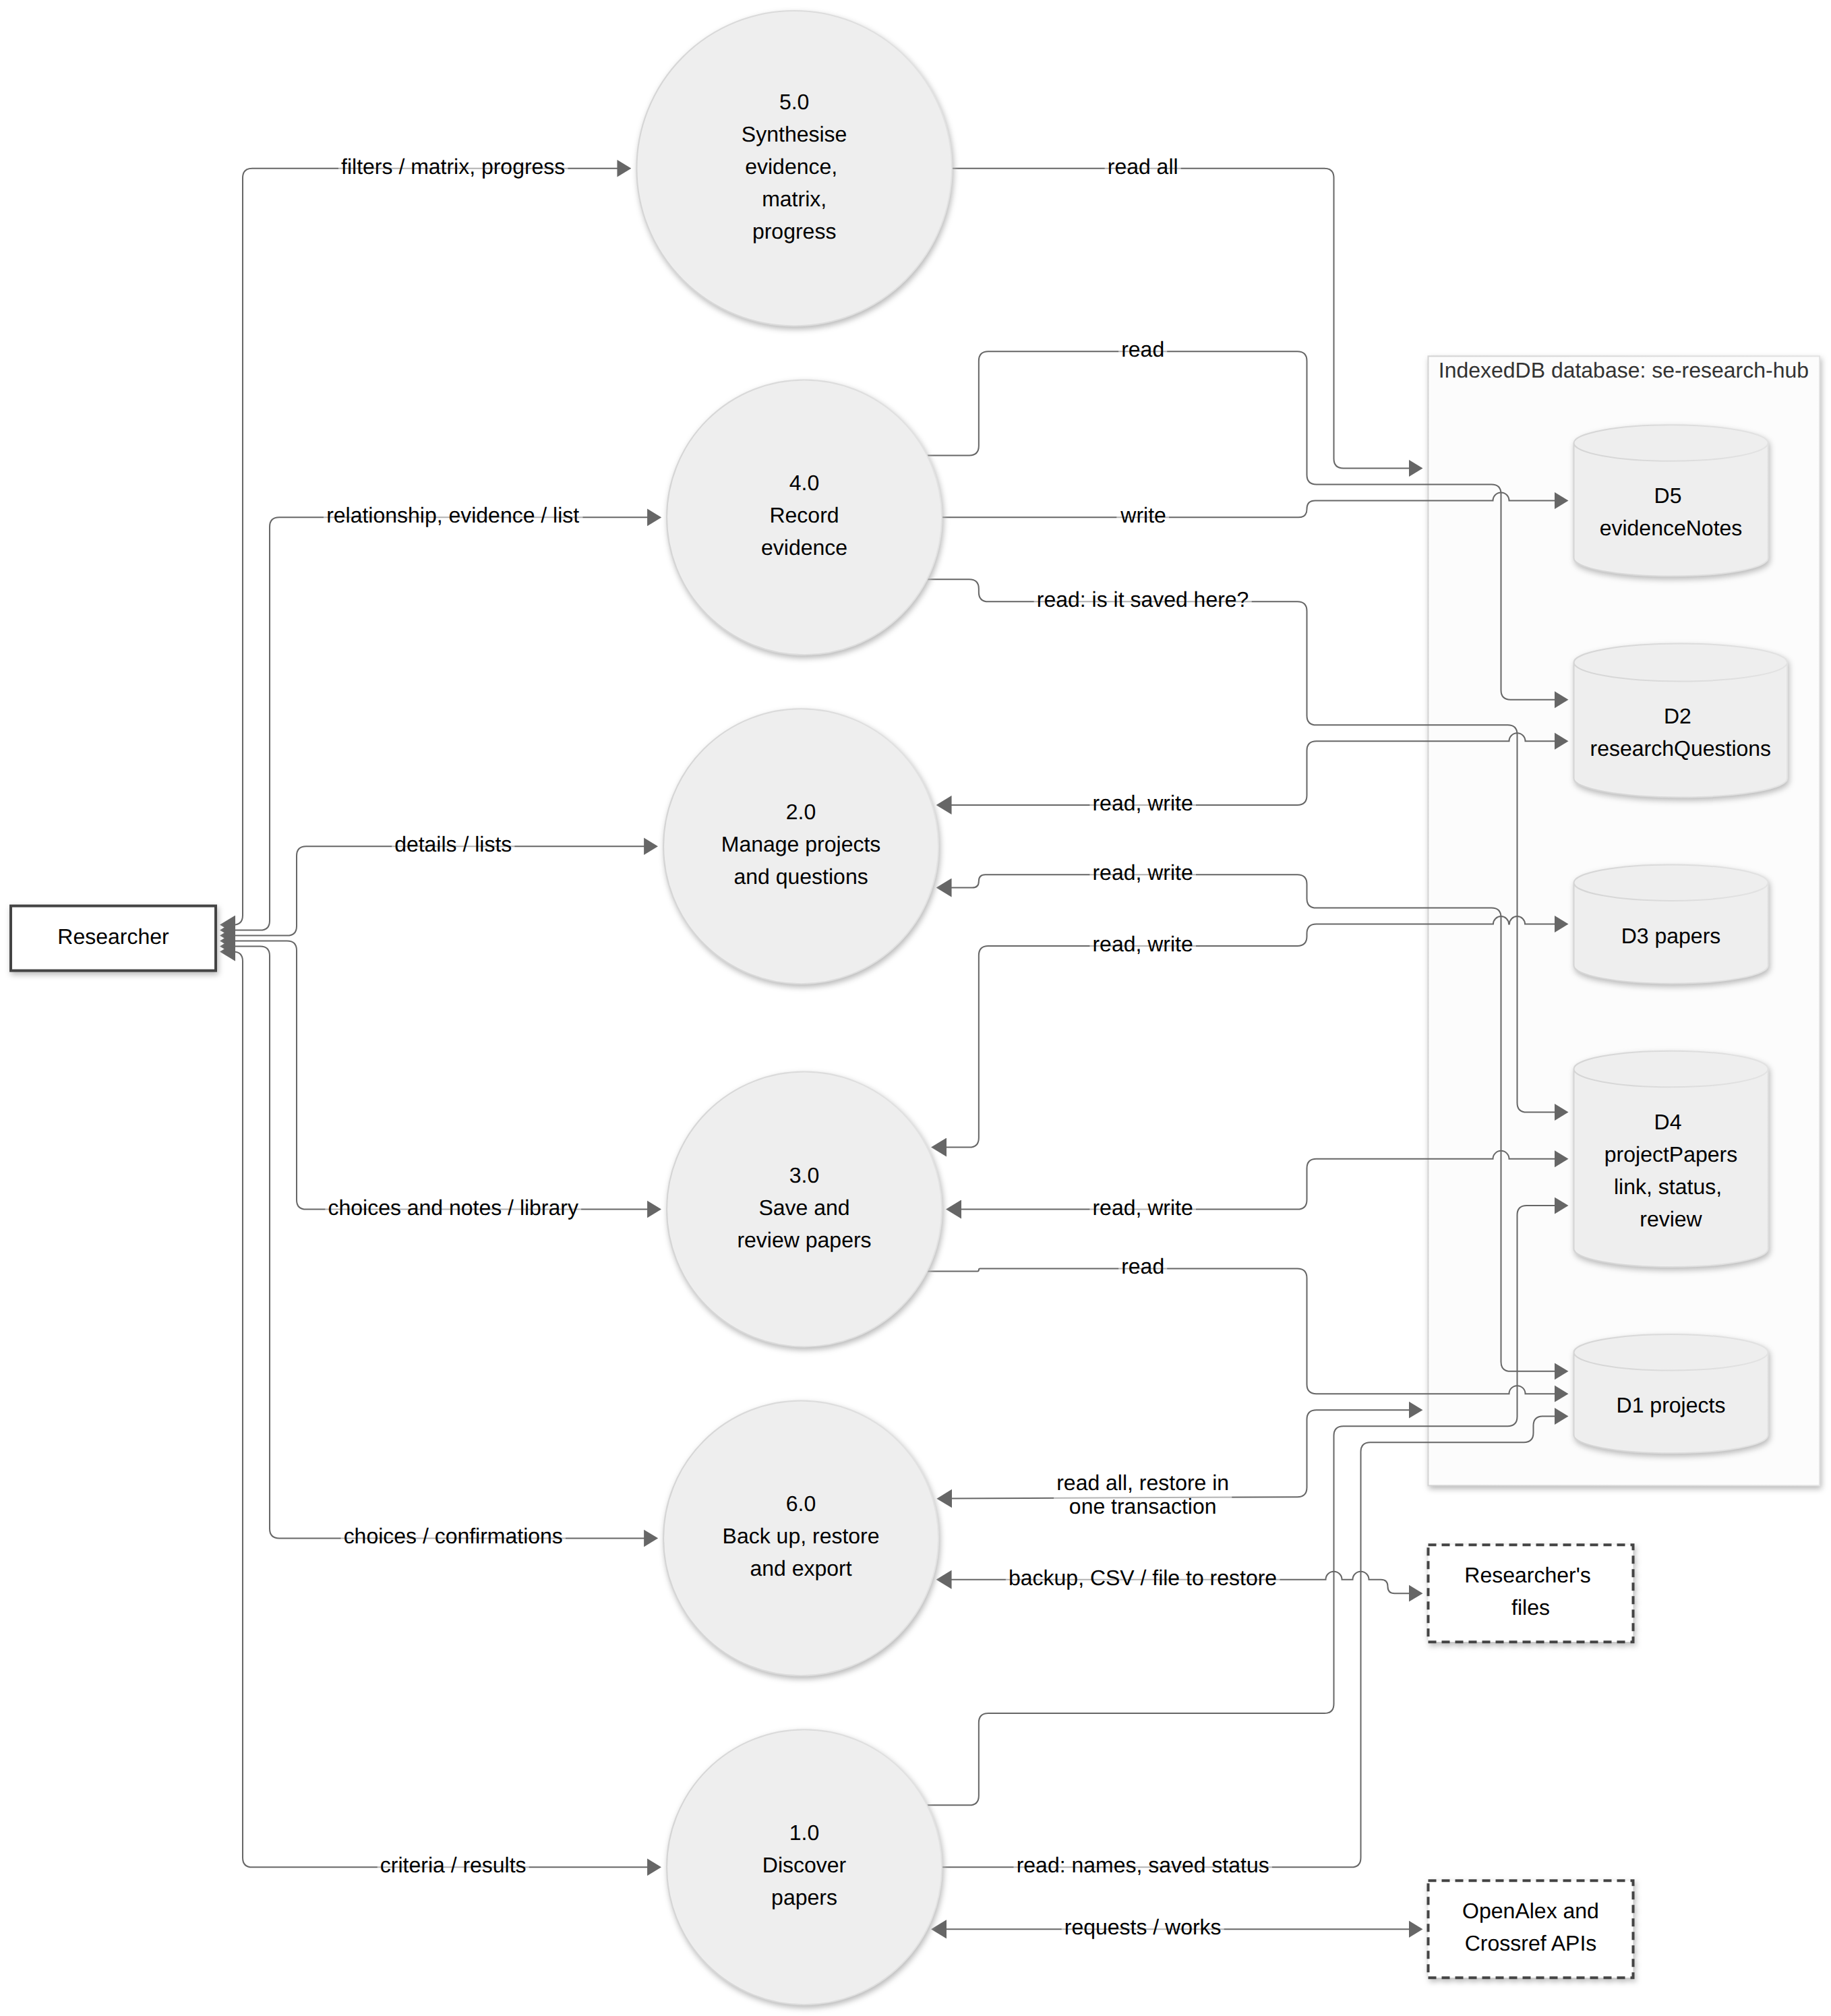
A double-headed line is one flow in each direction (the labels read "in / out"). Arrows into a store are writes, arrows out of a store are reads; a double-headed line to a store is both. D6 preferences (localStorage: theme, last project, last backup date) is used by the page shell and by 3.0 and 6.0 and is left off the diagram for clarity.

Flow dictionary (level 1)
Process | Inputs | Outputs | Reads | Writes
1.0 Discover papers | Keywords, years, sort, open-access flag, chosen sources | Merged results, source notices, "saved to" status | D1 (project names), D4 (what is saved) | none
2.0 Manage projects and questions | Project name and description; question text | Project and question lists, counts | D1, D2 | D1, D2
3.0 Save and review papers | Chosen paper and project; reading status; structured review text | Library, paper pages | D1, D3, D4 | D3 (paper), D4 (link, status, review)
4.0 Record evidence | Question, relationship, evidence, interpretation, location, tags | Evidence list for the paper | D2, D4 (integrity checks) | D5
5.0 Synthesise | Filters; project choice | Evidence page, matrix, progress | D1 to D5 | none
6.0 Back up, restore and export | Choice of export; a backup file; confirmation | Backup JSON, CSV files; restore result | D1 to D5 | D1 to D5 (restore only, all-or-nothing)

3. Level 2: process 1.0 Discover papers
This is where untrusted data first enters. Every step between the API reply and the screen exists to make it safe and consistent.
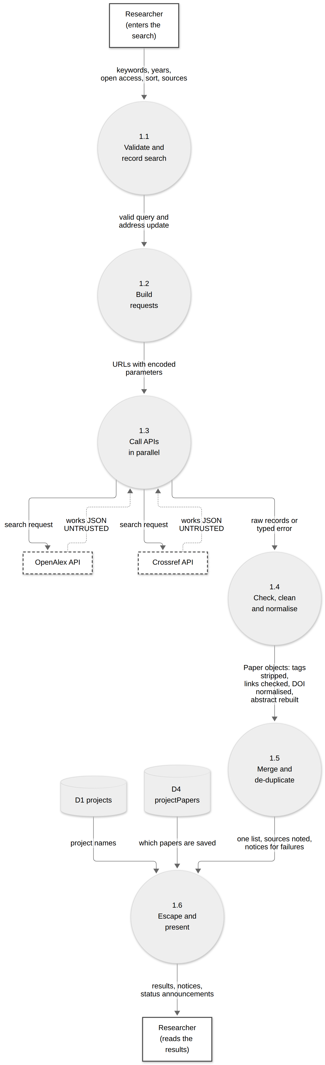
Step | What it does | Code
1.1 | Accessible validation (keywords 2 to 200, years, at least one source); search stored in the address with pushState | js/ui/forms.js, js/views/discover.js
1.2 | Builds each provider's URL (filters, sort, paging, contact email) with URLSearchParams, so text is always encoded | js/api/openalex.js, js/api/crossref.js (buildSearchUrl)
1.3 | Runs both requests together; 15 s timeout; cancellable; maps failures to typed errors | js/api/search.js (searchAll)
1.4 | Checks the response shape; strips markup from titles; decodes entities; accepts only http(s) links; normalises DOIs; rebuilds OpenAlex's inverted-index abstract; cleans Crossref's JATS XML | js/api/paper.js, normaliseWork, normaliseItem
1.5 | Same DOI (or same title and year) becomes one paper; the preferred source wins conflicts and gaps are filled | js/api/merge.js
1.6 | Everything is HTML-escaped when drawn; the result count is announced to screen readers | js/ui/dom.js (esc), js/ui/announcer.js

4. Data model
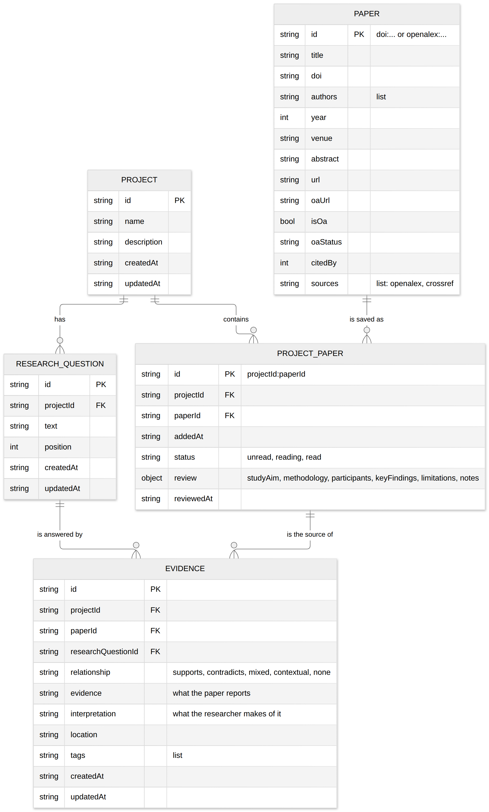

Data stores
Store | Key | Indexes | Notes
D1 projects | id (UUID) |  | Deleting a project removes its D2, D4 and D5 rows, then any D3 paper nothing links to
D2 researchQuestions | id | projectId | Numbered by position (RQ1, RQ2…); deleting removes its D5 rows
D3 papers | id (doi:…, or openalex:… when there is no DOI) | doi | One shared record per paper, however many projects use it
D4 projectPapers | projectId:paperId | projectId, paperId | Holds the per-project reading status and structured review, so the same paper can be read differently in two projects; the composite key makes duplicate saves impossible
D5 evidenceNotes | id | projectId, paperId, researchQuestionId | Integrity: the paper must be saved in the project and the question must belong to it; removing the paper link removes this project's evidence for that paper only
D6 preferences | n/a (localStorage) |  | seh-theme, seh-last-project, seh-last-backup: small conveniences only, never research data

Why this shape
- Evidence and interpretation are separate fields so the method (report versus infer) is built into the data, and exports keep them apart.
- Review and status live on the link (D4), not on the paper (D3), because they belong to a paper in a project.
- One paper record, many links avoids duplicated metadata and lets a paper be refreshed once.
- IndexedDB, not `localStorage`: structured records, indexes for lookups, much larger quota, and transactions (used for atomic restore and cascade deletes).

5. Data flow rules that matter for safety
Rule | Where enforced
Nothing from an API reaches D3 without passing step 1.4, then the field whitelist validatePaper | js/api/*, js/validation.js
Nothing from a backup file reaches any store without full validation and a field-by-field copy | js/backup.js
Writes that span stores happen in one transaction (restore, project delete, remove-paper) | js/db/repository.js
Untrusted text is escaped at the moment it is drawn, never stored pre-escaped | esc() in every view
Exported CSV cells that look like formulas are neutralised | js/export.js (csvCell)

Threat model
Method: STRIDE per element on the data-flow diagrams, then misuse cases and attack trees for the highest-impact threats. Each threat names its mitigation in the code and the test that proves it. Residual risk is stated, including the risks that are not fully solved.

1. Scope, assets and assumptions
Asset | Why it matters
A1 Research data (projects, questions, reviews, evidence) | The user's real work; only copy is in the browser
A2 Researcher's privacy | Search terms, and the contact email sent with them
A3 Integrity of the app code | If the code is altered, everything the app does is untrustworthy
A4 Trust in displayed paper metadata | Research conclusions rest on it

Assumptions. One user per browser profile; no accounts, passwords, payments or personal data beyond the optional contact email; hosted as static files over HTTPS; the user's device and browser are not already compromised.
Out of scope. Attacks needing control of the user's device or browser profile; the security of OpenAlex, Crossref or GitHub themselves (treated as untrusted data sources or trusted hosts as shown below).

Threat agents
ID | Agent | Capability
TA1 | Compromised or malicious data source, or an on-path attacker | Controls the content of an API reply
TA2 | Author of a malicious backup file | Gets the user to restore a crafted file (shared by email or drive)
TA3 | Another web page | Frames the app, or runs on the same origin
TA4 | Supply-chain attacker | Compromises a dependency, action or hosting account
TA5 | Curious third party | Reads network traffic or API logs
TA6 | The user, by accident | Deletes or overwrites data, or loses the browser profile

2. Trust boundaries

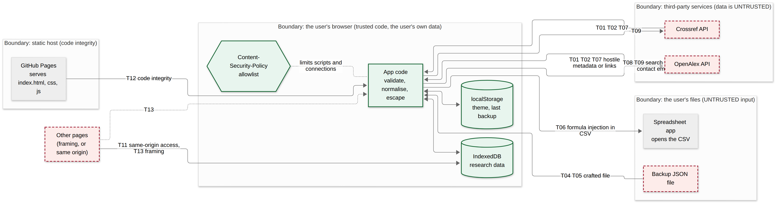

Every arrow that crosses into the browser from outside carries data that is checked before use. The only data that leaves the browser is the search request (and CSV files the user chooses to save).

3. Defence in depth for untrusted data
No single layer is trusted to be perfect: layers 3, 4 and 6 are the primary protections; layers 1 and 7 mean that if one of them ever had a flaw, the browser would still block the most harmful outcomes.

4. Misuse cases
Read each row left to right: a threat agent (red) performs a misuse case (heavy red outline) that threatens a legitimate use case (white). A mitigation (green) is aimed at the misuse case; an amber box means the app has no mitigation of its own and the risk is handled outside it.
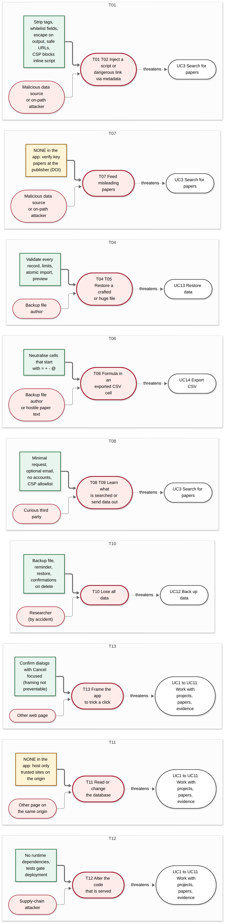
Misuse cases without a green mitigation are the honest gaps: T07 (misleading data cannot be detected by the app), T11 (same-origin pages) and, partly, T13 (framing). They are discussed in section 7.

5. Attack trees

5.1 Goal: run attacker script inside the app (and so read or change all research data)
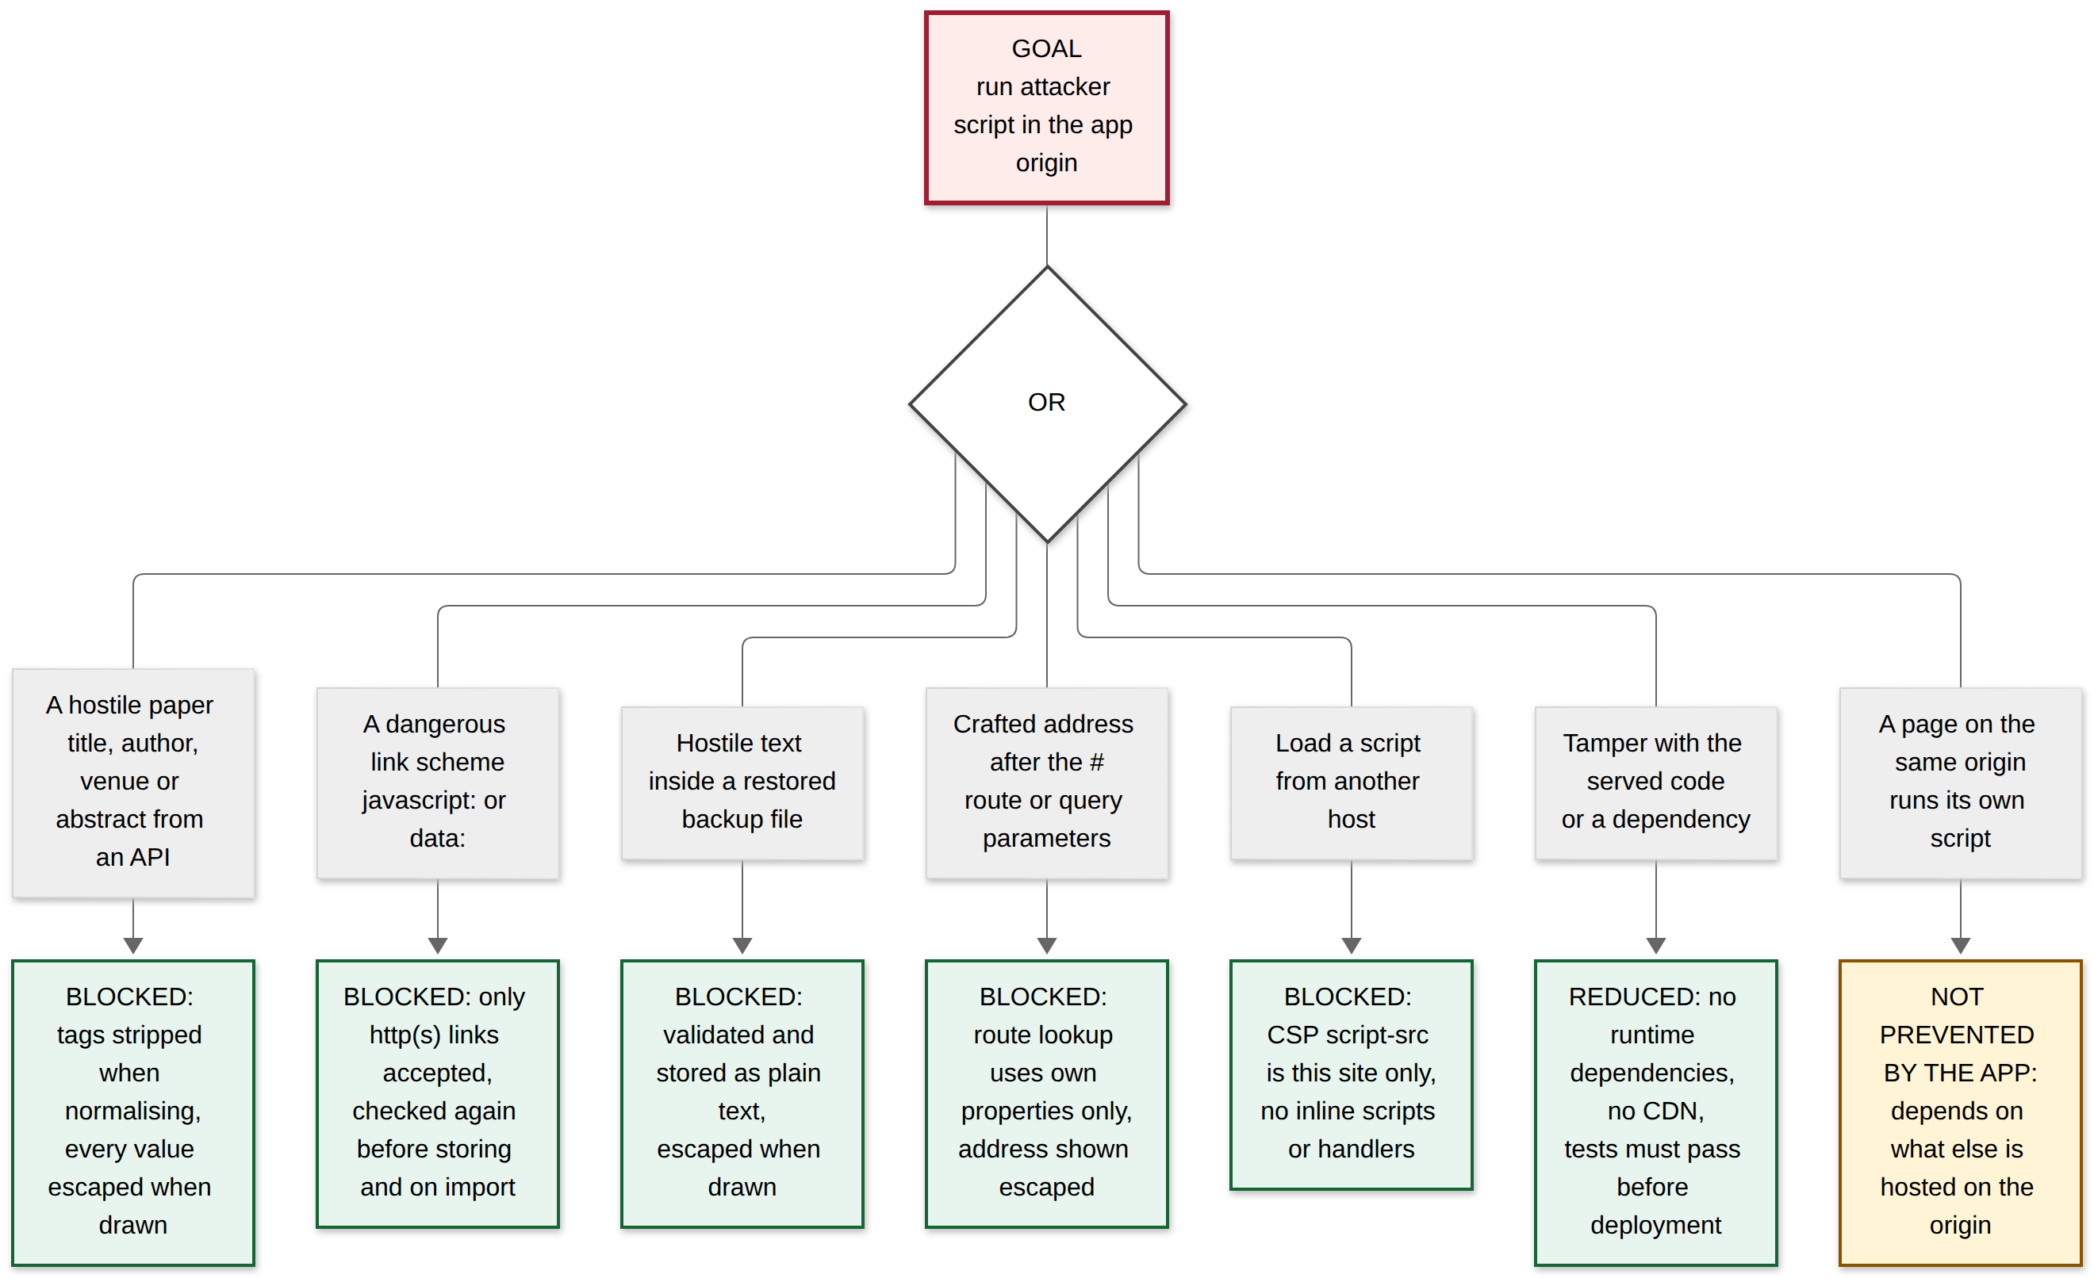

5.2 Goal: corrupt or take over the user's data through a restore
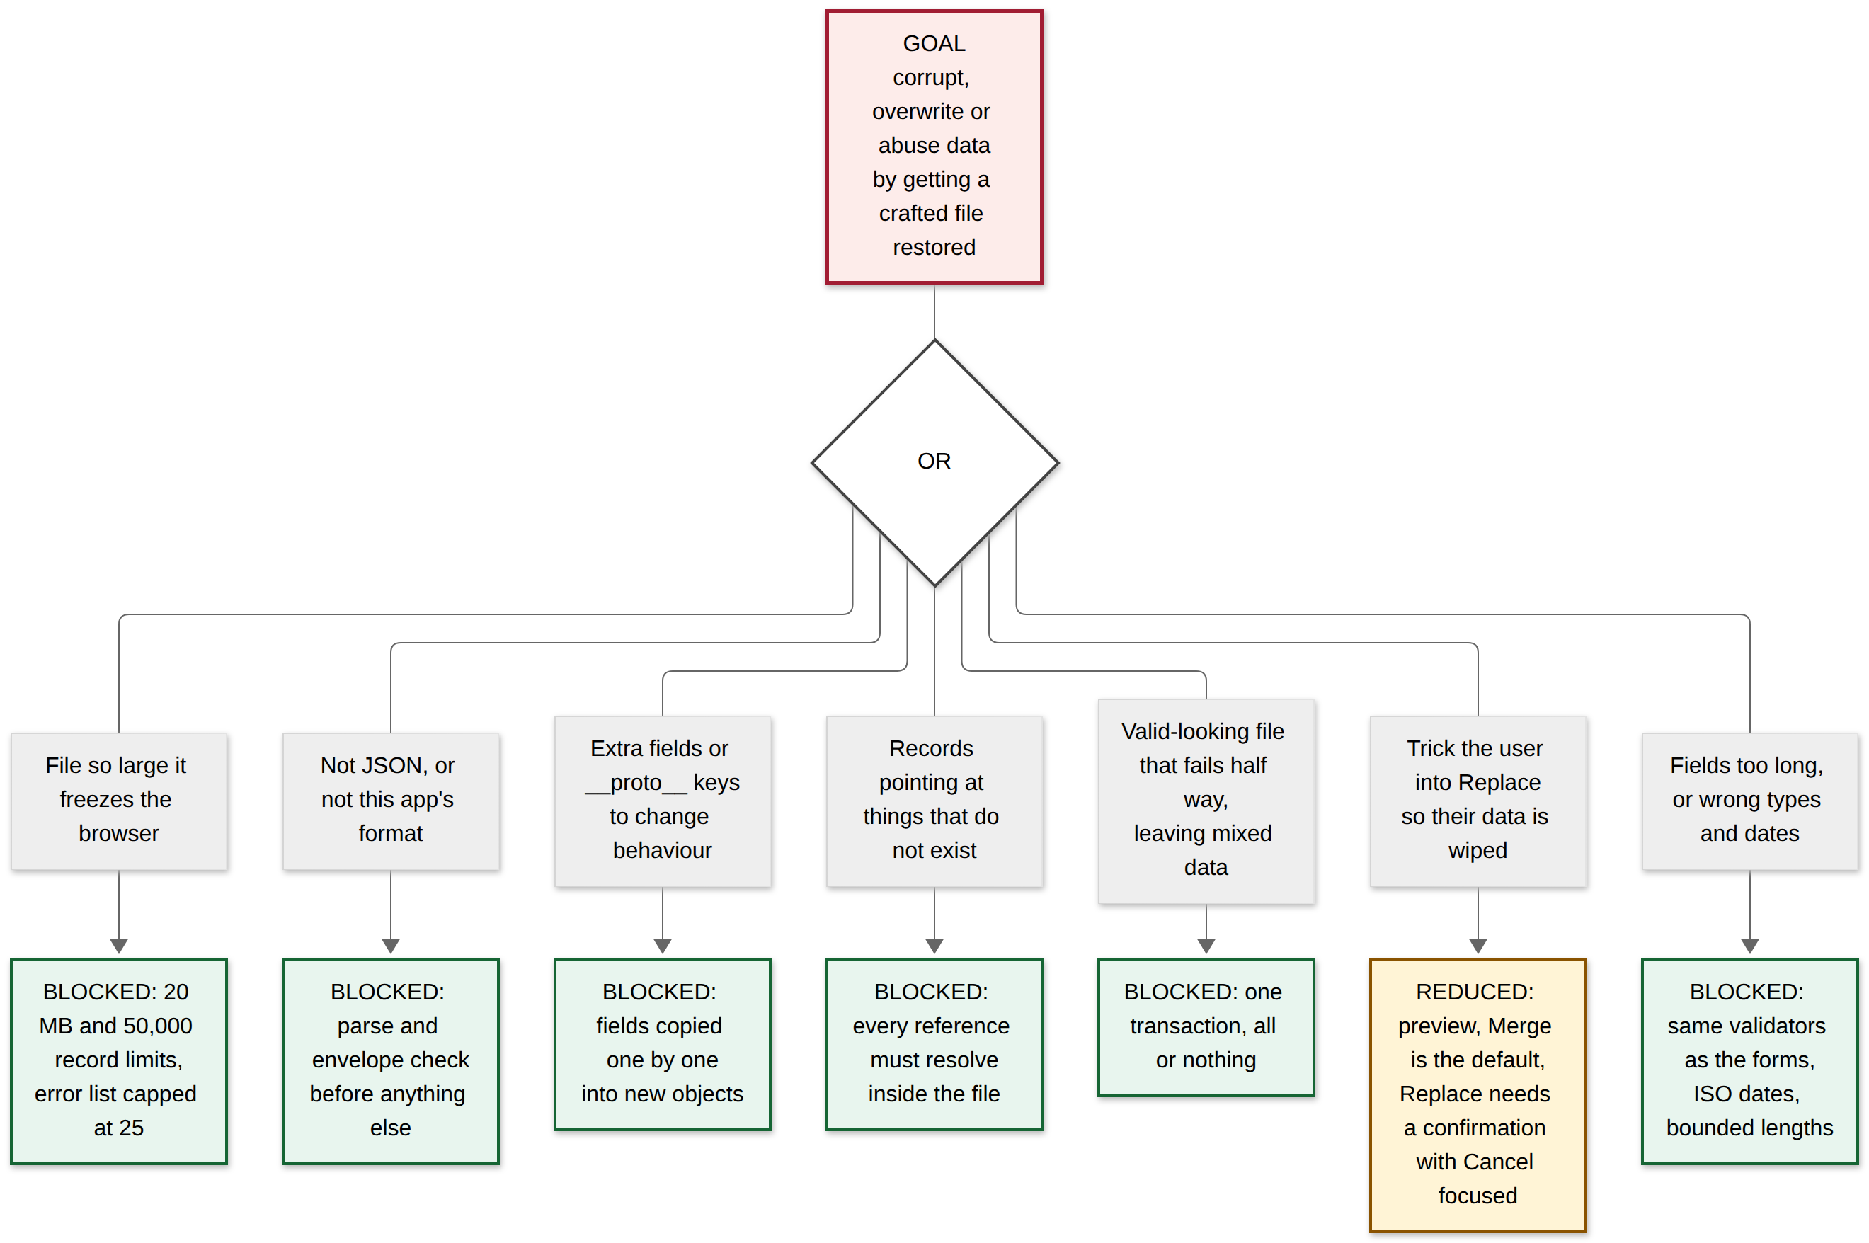

6. Threat register (STRIDE)
Likelihood (L) and impact (I): Low, Medium, High. Residual is the risk after the mitigations listed.
ID | STRIDE | Threat | L | I | Mitigation (where) | Evidence | Residual
T01 | Tampering, Elevation | Script injection through paper metadata (titles, authors, venue, abstract) from an API | M | H | Tags stripped on normalising (js/api/paper.js); all dynamic values escaped (esc in every view); project names set with textContent; CSP forbids inline scripts and handlers | tests/unit/openalex.test.js, crossref.test.js; tests/e2e/discover.mjs (hostile author <img onerror>; fails when escaping is removed); security.mjs | Low
T02 | Elevation | javascript: or data: links in a paper's URL fields | M | H | safeUrl allows only http(s) at normalisation, again in validatePaper, and on import; CSP | openalex.test.js; discover.mjs; backup.test.js (mutation-checked) | Low
T03 | Info disclosure, Tampering | Reverse tabnabbing or referrer leakage through external links | M | M | target="_blank" always with rel="noopener noreferrer"; link text says it opens a new tab | security.mjs | Low
T04 | Tampering, Elevation | Crafted backup file: extra fields, __proto__, dangling references, wrong types | M | H | Strict validator copies field by field, enforces references, ISO dates, bounded text (js/backup.js); atomic import (js/db/repository.js); preview before applying | tests/unit/backup.test.js (hostile files, round trip, atomic failure; mutation-checked); tests/e2e/backup.mjs | Low
T05 | Denial of service | Huge or record-heavy backup file | L | M | 20 MB and 50,000-record limits; error list capped at 25 | backup.test.js | Low
T06 | Tampering (on the user's spreadsheet) | Formula injection through exported CSV cells (=HYPERLINK(...)) | M | M | Cells starting = + - @ tab or CR are prefixed with an apostrophe; RFC 4180 escaping (js/export.js) | backup.test.js, backup.mjs (mutation-checked) | Low
T07 | Tampering | On-path attacker or compromised API returns misleading papers | L | M | HTTPS only (CSP lists only https API hosts; GitHub Pages enforces HTTPS); response shape checks; treated as untrusted for T01 | openalex.test.js (bad shapes), security.mjs | Medium: the app cannot tell true metadata from false. Verify key papers at the publisher via their DOI.
T08 | Info disclosure | Research data sent to a third party (analytics, injected request) | L | H | No third-party scripts or analytics; CSP connect-src allows only the two APIs | security.mjs (a fetch to another origin is blocked and reported) | Low
T09 | Info disclosure | Search terms and the contact email visible to API operators, network tools and (if public) the source | H | L | Only the search request and an optional contact address are sent; no cookies, accounts or identifiers; address is a single config value and may be blank | docs/deployment.md warns before deploying | Medium-Low: accepted. Use a dedicated address, not a personal one.
T10 | Denial of service (availability), accident | Loss of all data (clear site data, browser eviction, new device, mistaken delete or replace) | H | H | JSON backup and tested restore; dashboard shows last backup; destructive actions confirm with Cancel focused; deletes and imports are transactional | backup.mjs, projects.mjs, library.mjs | Medium: the user must actually make backups.
T11 | Spoofing, Tampering, Info disclosure | Another page on the same origin reads or changes the IndexedDB database. On GitHub Pages every project site of one account shares <user>.github.io, and storage is per origin, not per path | L | H | None in the app. Keep only trusted sites on that origin; use a custom domain or a separate account to isolate; store no secrets (the app has none) | None (an environment risk) | Medium (depends on hosting)
T12 | Tampering | Compromised dependency, GitHub Action or hosting account alters the served code | L | H | Zero runtime dependencies and no CDN: all served code is first-party; dev dependencies run only locally and in CI; lockfile committed; deployment is gated on the full test suite | npm audit: 0 vulnerabilities; npm ls --omit=dev empty | Low-Medium: Actions are pinned to major tags, not commit hashes.
T13 | Spoofing, Tampering | Clickjacking: a hostile page frames the app to trick a click | L | M | Static hosting cannot send X-Frame-Options or frame-ancestors (the <meta> form ignores it). Destructive actions need an explicit confirmation | None automated | Low-Medium
T14 | Denial of service | API throttling or outage; a slow search blocks the user | M | L | 15 s timeout; partial results; specific messages; no automatic retries; superseded searches cancelled; polite-pool identification | discover.mjs, save.mjs, openalex.test.js | Low
T15 | Tampering | Abuse of the address: #/__proto__, malformed % escapes, markup in the hash | M | L | Route lookup with Object.hasOwn; URLSearchParams; safe decoding; the address is escaped when shown | tests/unit/router.test.js, polish.mjs | Low
T16 | Tampering, Info disclosure | Someone with the user's browser profile or DevTools reads or edits stored data | L | M | Out of scope: there is no login to protect, and the data is the user's own. Use the device's own login and profile separation | n/a | Accepted
T17 | Repudiation | No audit trail of changes | L | L | Single-user local data; every record carries created and updated times | n/a | Accepted

STRIDE coverage
Category | Threats
Spoofing | T11, T13
Tampering | T01, T02, T03, T04, T06, T07, T11, T12, T13, T15, T16
Repudiation | T17
Information disclosure | T03, T08, T09, T11, T16
Denial of service | T05, T10, T14
Elevation of privilege | T01, T02, T04

7. Residual risks and recommended next steps
Honest summary: the data-handling risks (T01, T02, T04, T05, T06, T08, T14, T15) are mitigated and tested. The remaining risks are mostly about where and how it is hosted, and user behaviour:
- T11 same-origin sharing (Medium). The live site is at https://<user>.github.io/research-companion-/. Any other Pages site on the same account shares its origin and could read the database. Keep only trusted sites there, or move to a custom domain or a dedicated account for isolation.
- T10 data loss (Medium). Back up regularly. Possible improvement: ask the browser for persistent storage (navigator.storage.persist()) and warn when a backup is old.
- T07 data truthfulness (Medium). Treat search results as leads, and check key papers at the publisher through their DOI link.
- T09 contact email (Medium-Low). The address is visible to anyone using the site. Use a dedicated address, or leave it blank.
- T12 pipeline (Low-Medium). Pin GitHub Actions to full commit hashes and enable Dependabot alerts.
- T13 framing (Low-Medium). If the site moves to Cloudflare Pages, add a _headers file with X-Frame-Options: DENY and a frame-ancestors 'none' policy, and move the policy from the <meta> tag into a real header.
- Not tested by anyone yet: a professional penetration test or a live-site scan. The automated tests prove the controls work as designed, not that no other flaw exists.

8. Security tests at a glance
Control | Test
Hostile metadata is inert | discover.mjs (hostile author), openalex.test.js, crossref.test.js, security.mjs
Unsafe URLs removed | openalex.test.js, discover.mjs, backup.test.js
Backup validation and atomic restore | backup.test.js (15+ hostile and broken cases), backup.mjs
CSV formula safety | backup.test.js, backup.mjs
CSP present, no violations in normal use, injections blocked | security.mjs
External links safe | security.mjs
Route and address abuse | router.test.js, polish.mjs
Failure handling for APIs | discover.mjs, save.mjs, openalex.test.js, merge.test.js
Dependencies | npm audit (0 vulnerabilities), zero runtime dependencies

Several of these were mutation-checked: the protection was temporarily removed and the tests were shown to fail, so a passing result is meaningful.

Interaction sequence diagrams
Each diagram shows who talks to whom, in order, with the actual requests the app makes. Solid arrows are calls or requests; dashed arrows are replies.
Participants used throughout:
Participant | Meaning
Researcher | The person using the app
Page | The view in the browser (HTML, CSS and the view's JavaScript)
Router | js/router.js, which shows the page for the address after #
Search | js/api/search.js, which runs the sources in parallel and merges
OpenAlex / Crossref clients | js/api/openalex.js, js/api/crossref.js
Repo | js/db/repository.js, the only code that touches IndexedDB
IndexedDB | The browser's database (se-research-hub)
GitHub Pages | The static host that serves the app's own files

1. Loading the app and opening a page
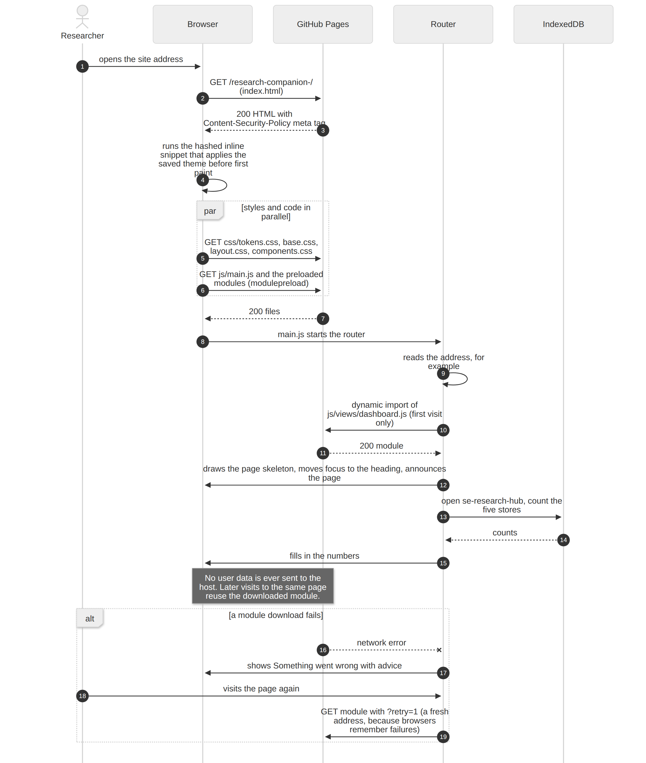

2. Searching: the API calls
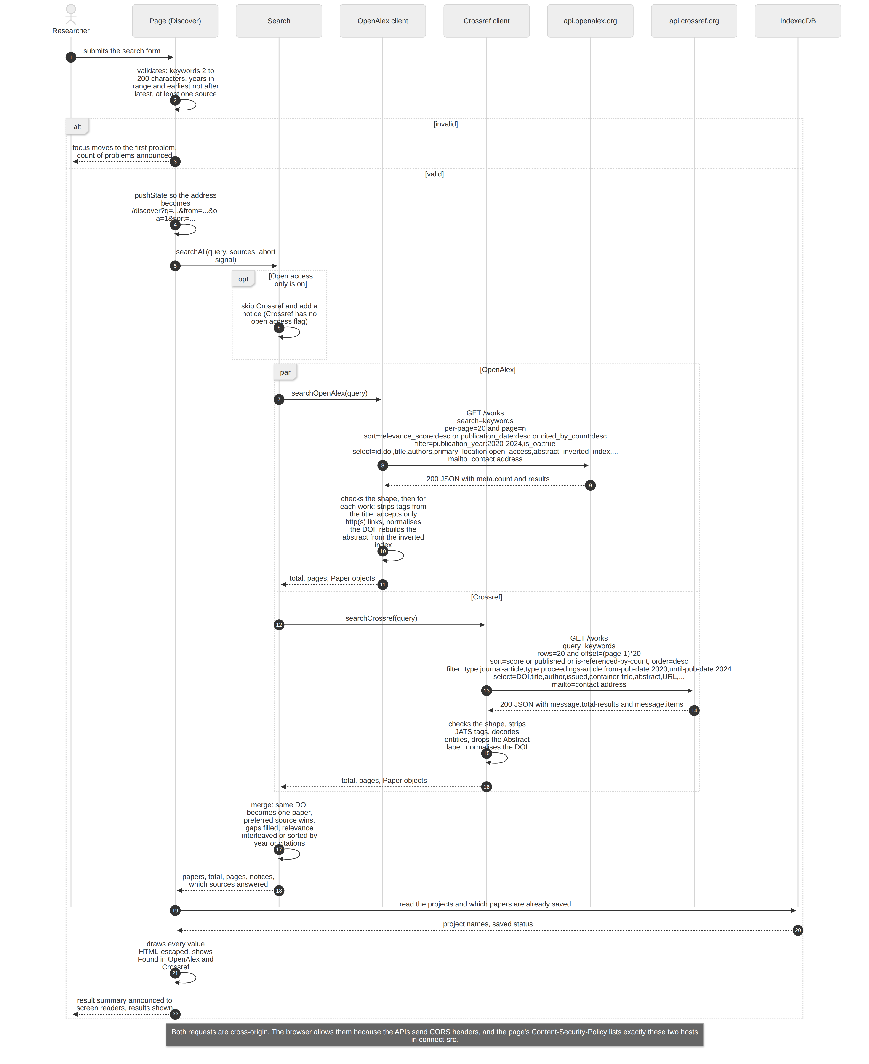

3. Searching: when something goes wrong
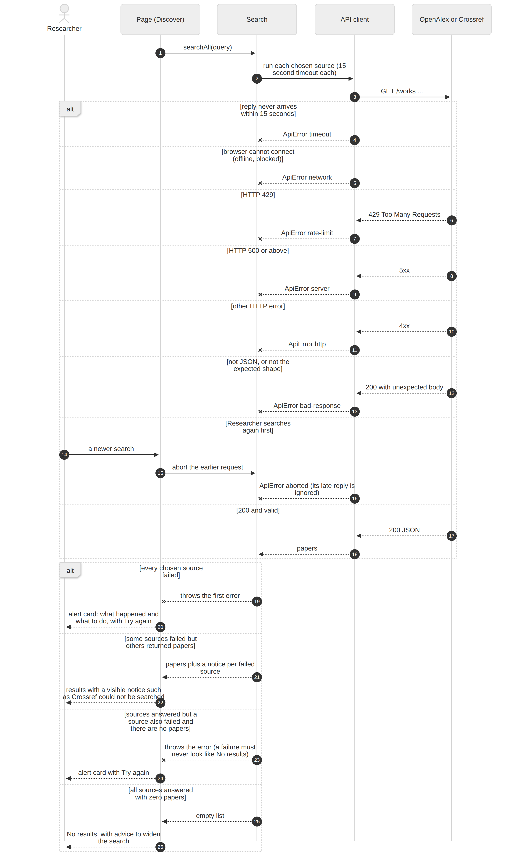

4. Saving a paper to a project
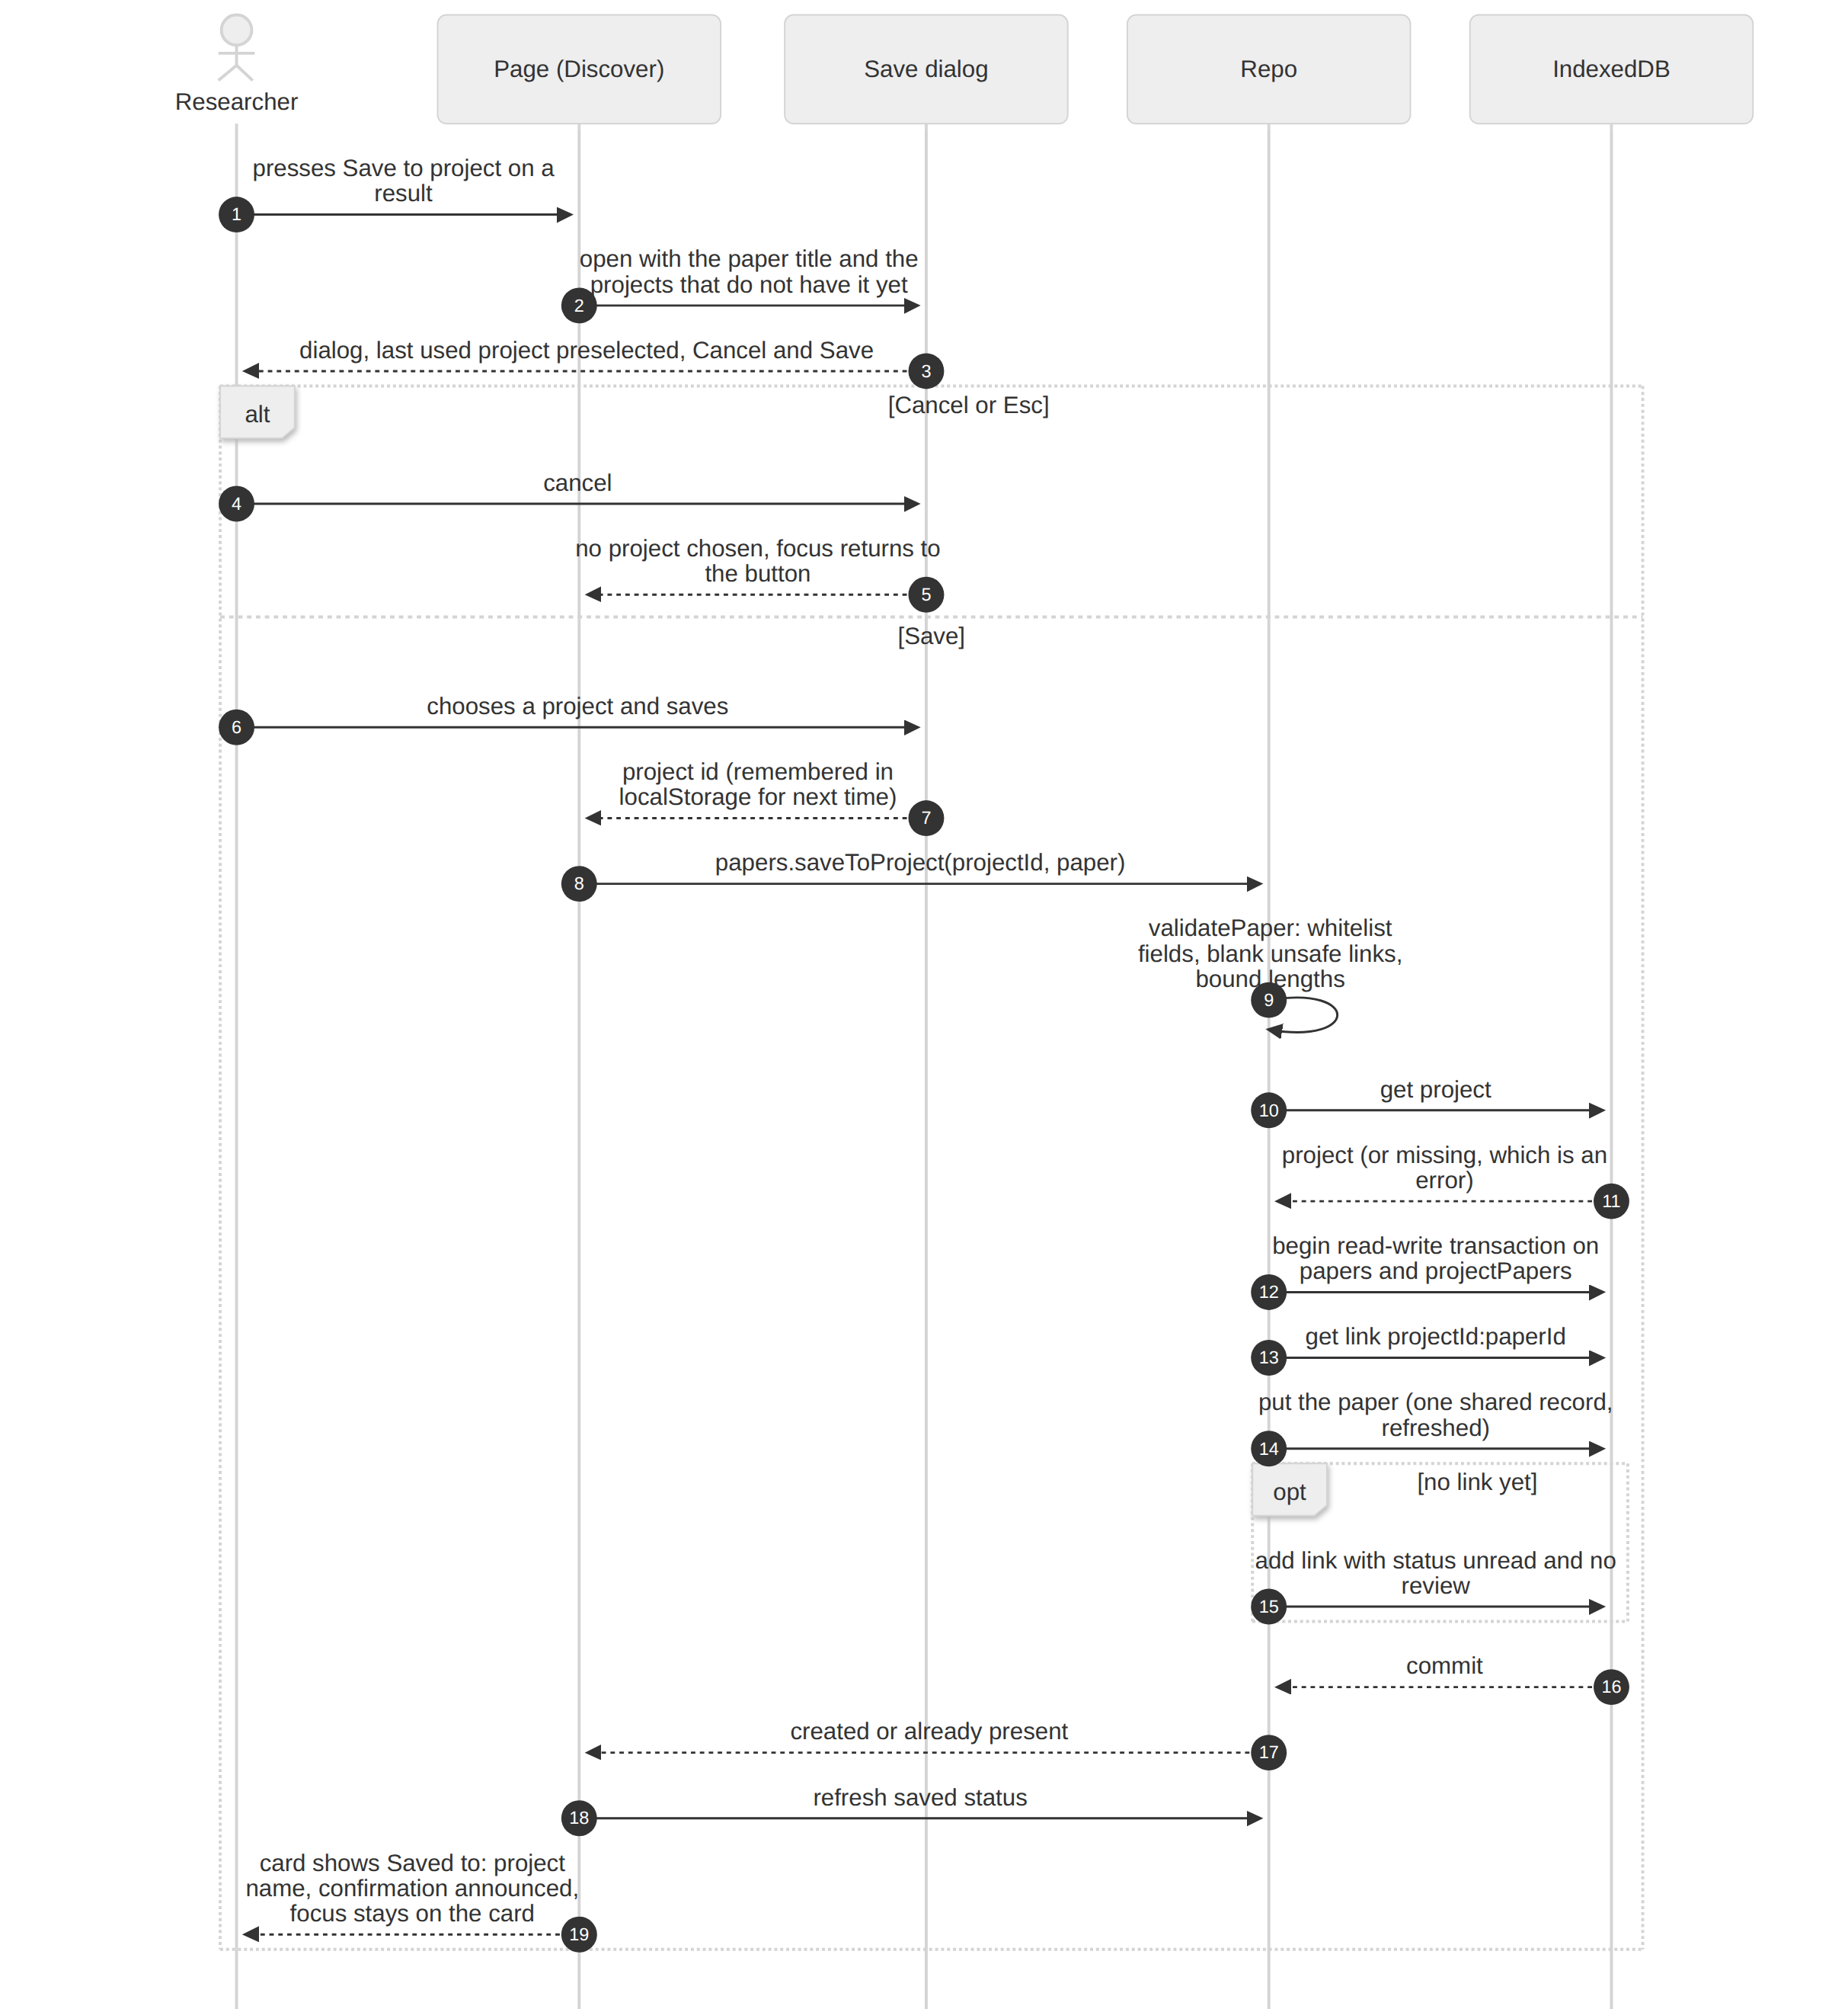

5. Recording evidence
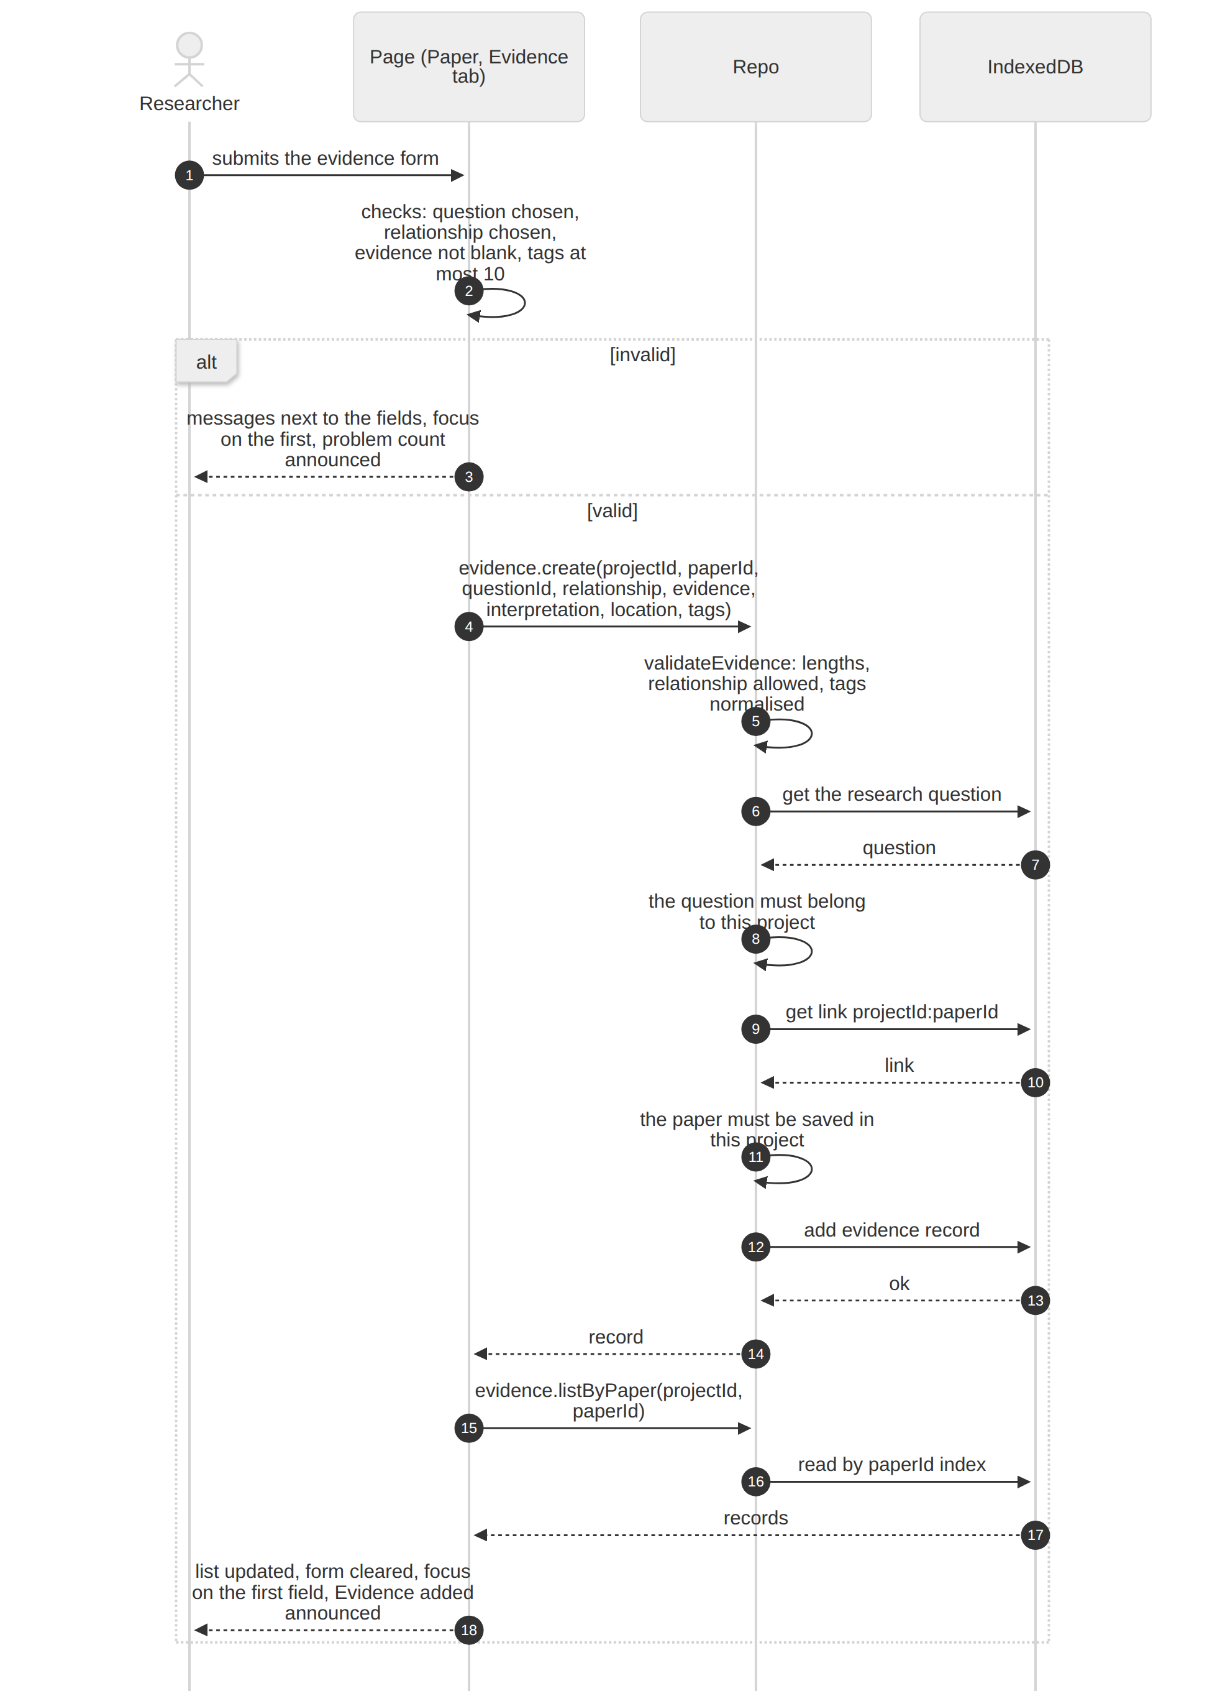

6. Viewing the evidence matrix
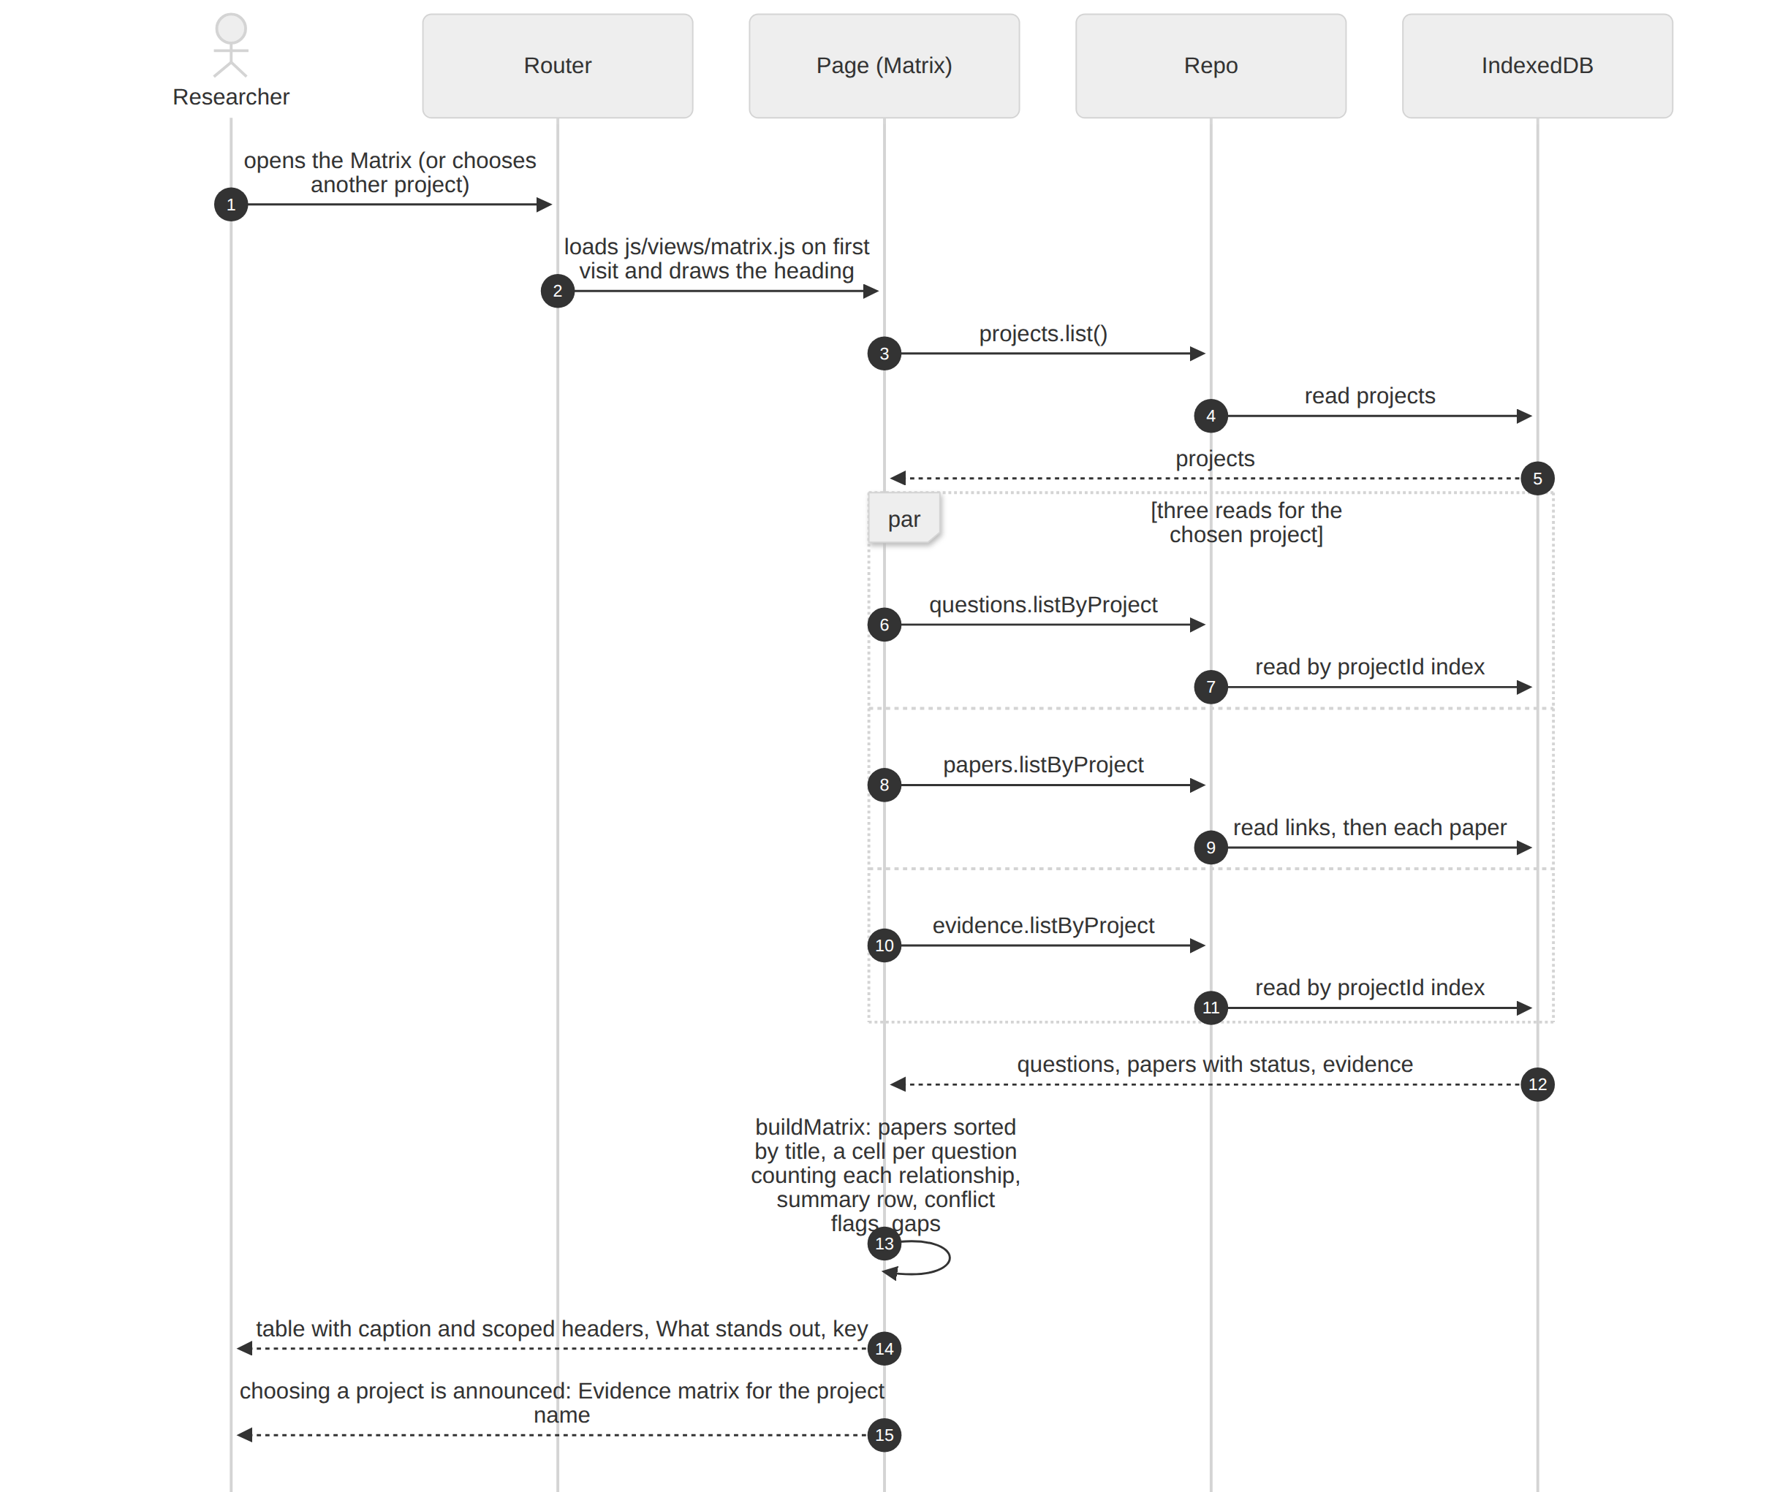

7. Backing up and restoring data

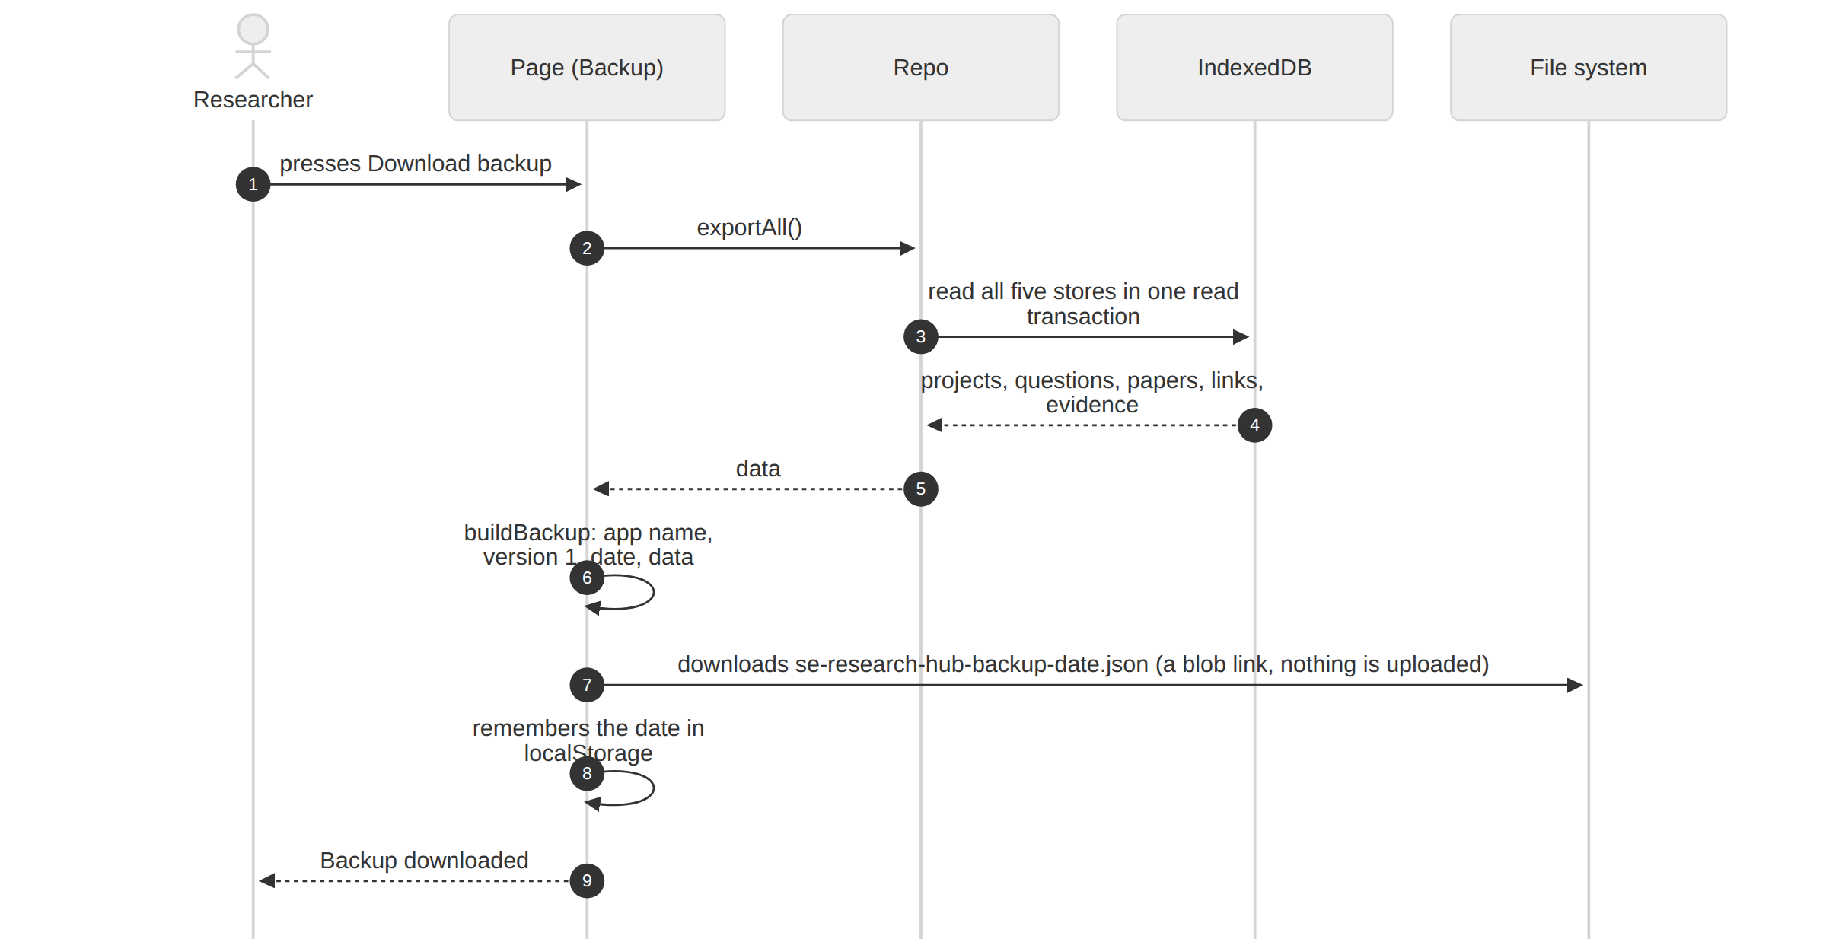

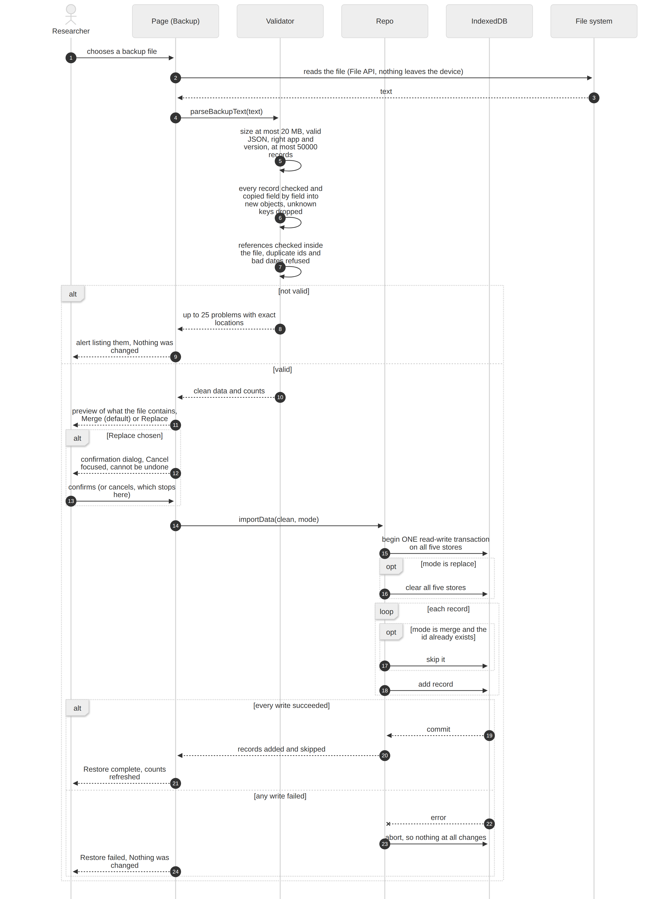

8. API contract summary
 | OpenAlex | Crossref
Endpoint | GET https://api.openalex.org/works | GET https://api.crossref.org/works
Search text | search | query
Paging | per-page=20, page=n (the app stops at 10,000 results, 500 pages) | rows=20, offset=(n-1)*20 (same cap)
Sort | sort=relevance_score:desc, publication_date:desc, cited_by_count:desc | sort=score, published, is-referenced-by-count with order=desc
Year filter | filter=publication_year:2020-2024 (or >2019, <2025) | filter=from-pub-date:2020,until-pub-date:2024
Open access | filter=is_oa:true | not supported, so the source is skipped when requested
Types | all | filter=type:journal-article,type:proceedings-article
Fields requested | select=id,doi,title,display_name,publication_year,type,cited_by_count,authorships,primary_location,open_access,abstract_inverted_index | select=DOI,title,author,issued,container-title,abstract,URL,is-referenced-by-count,type
Identification | mailto=<contact address> (polite pool) | mailto=<contact address> (polite pool)
Response shape the app requires | { meta: { count }, results: [...] } | { message: { "total-results", items: [...] } }
Abstract | an inverted index (word: [positions]) rebuilt into text | JATS XML text, tags removed, entities decoded
Credentials | none | none
Failure handling | timeout 15 s, network, 429, 5xx, other HTTP, bad response, cancelled (see diagram 3) | same

Notes
- The formats above are the providers' documented ones. The app's tests use recorded sample responses, and the author confirmed on the live site that real searches return results.
- No API keys exist anywhere in the app, so there is nothing secret to leak. The only identifying value sent is the optional contact address.
- Nothing is retried automatically. A rate-limited or failed search shows what happened and a Try again button, so the app never hammers a struggling service.
- The static host is the only other server contacted, and only for the app's own files (diagram 1).

