Chris Gorham

Bellevue University

WEB 335 – Introduction to NoSQL

Professor Krasso

Week 1

3/19/2023

Assignment 1.4 - Business Rules

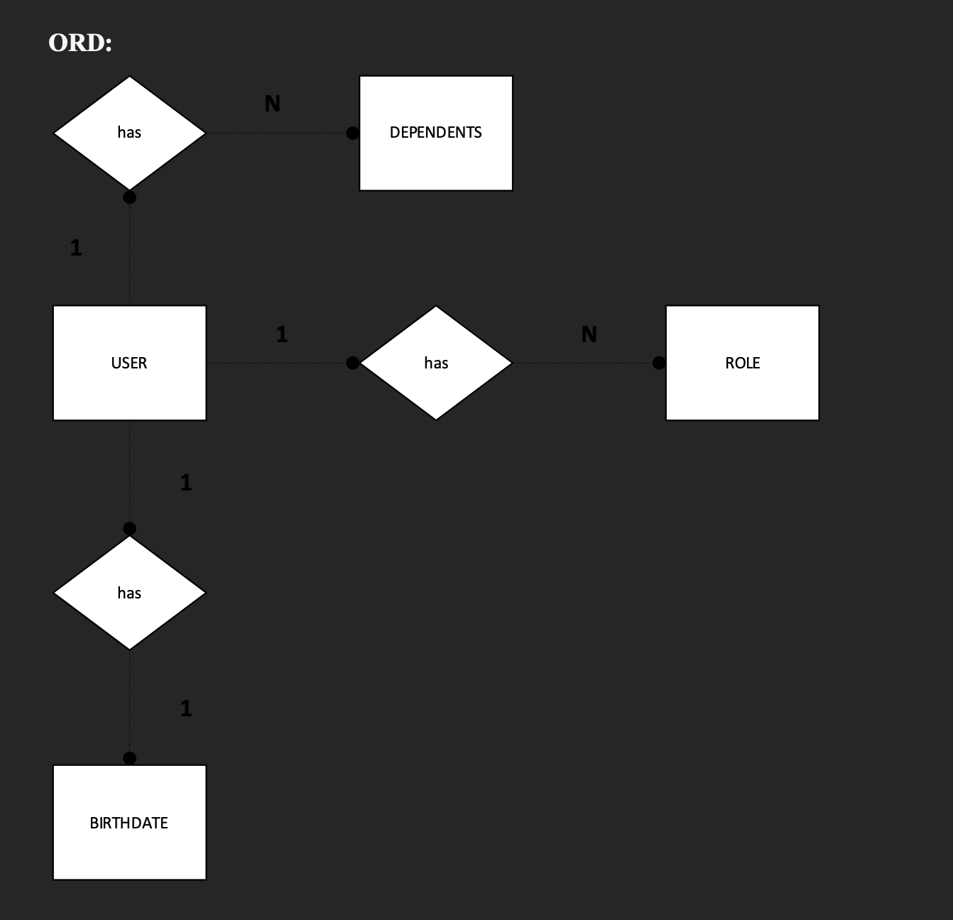

Business Rules:

A USER has many DEPENDENTS.

A USER has many ROLEs

A USER has one BIRTHDATE