Chris Gorham

Bellevue University

WEB 335 – Introduction to NoSQL

Professor Krasso

Week 3

3/30/2023

Assignment 3.2 - 2NF

NodeSecurity

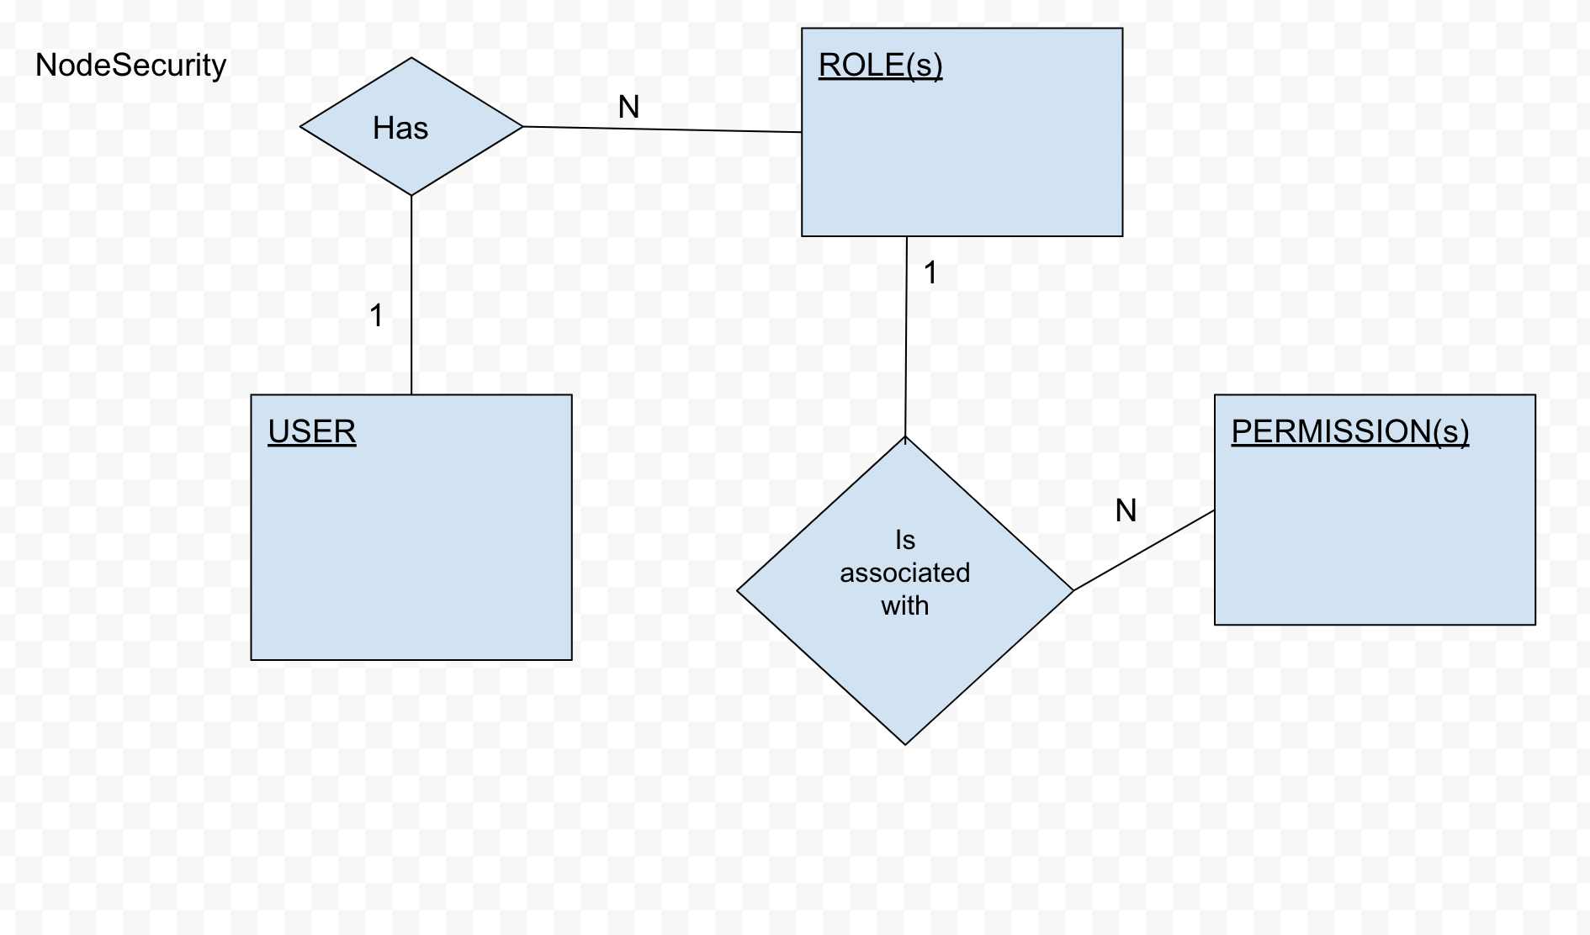

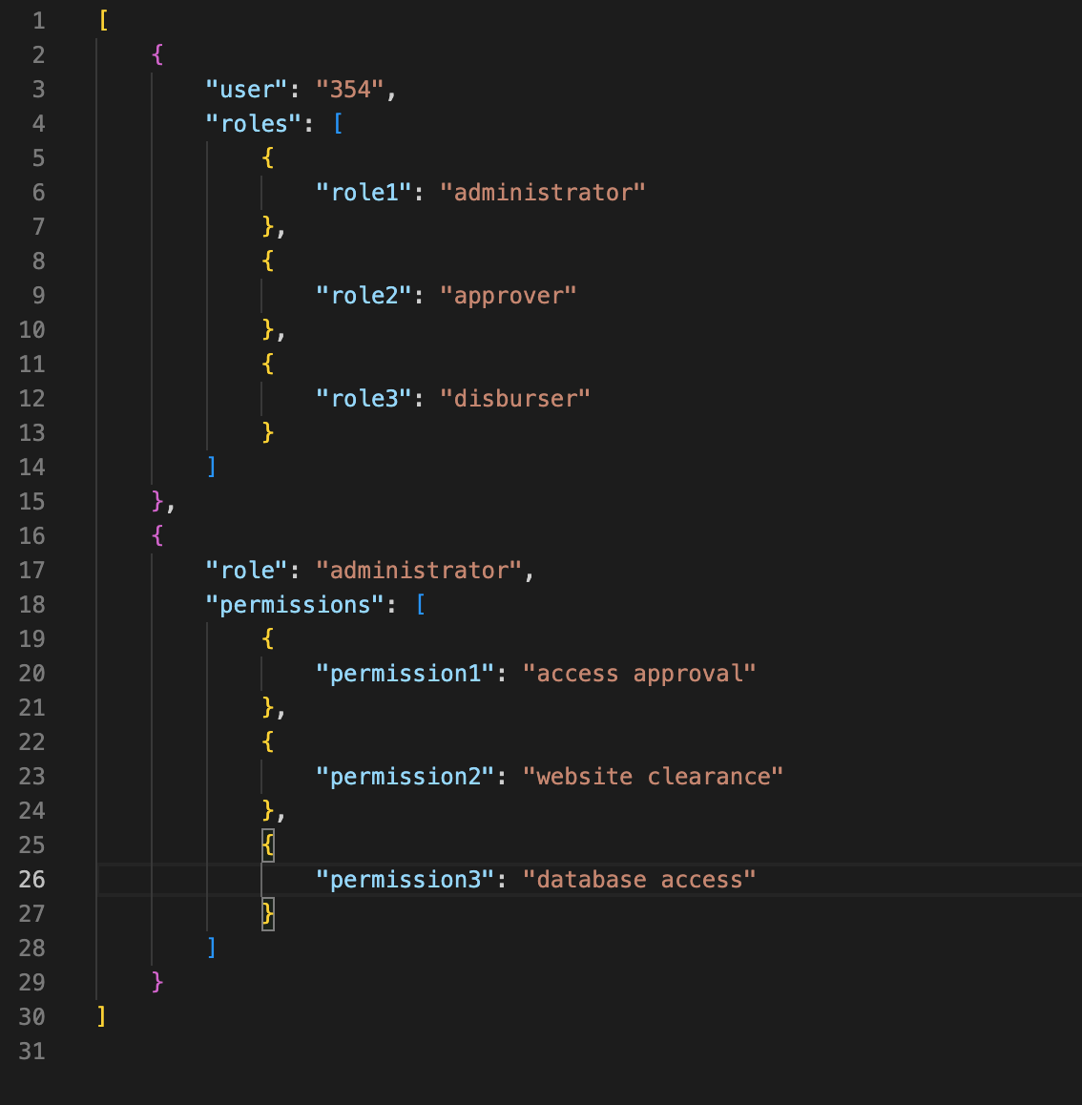

2NF Tables for Node Security

|  |  |  |
| --- | --- | --- |
| publisher_name | author_last_name | book_name |
| Bright Publishing | Johnson | All Around Town |
| Fine Tuned | Bridges | A Day in the Life |
| Bright Publishing | Dawkins | Above All Else |
| Fine Tuned | Bridges | Beginning To End |

|  |  |  |
| --- | --- | --- |
| publisher_name | publisher_code | publisher_address |
| Bright Publishing | 0934903 | 6 Alicia Street Somersworth NH 03878 |
| Fine Tuned | 0234920 | 446 Babbling Brook Dr Virginia Beach VA 23462 |
| Bright Publishing | 0934903 | 6 Alicia Street Somersworth NH 03878 |

|  |  |  |
| --- | --- | --- |
| book_name | book_isbn | book_price |
| All Around Town | 29842984929 | $29.99 |
| A Day in the Life | 20490202 | $19.99 |
| Above All Else | 29382993829 | $49.99 |
| Beginning To End | 20492020209 | $29.99 |

|  |  |  |  |
| --- | --- | --- | --- |
| author_last_name | author_first_name | author_phone | author_email |
| Johnson | Arthur | 413-312-1492 | Johnsona@yahoo.com |
| Bridges | Danny | 603-692-4437 | Bridgesd@gmail.com |
| Dawkins | Andrew | 333-333-1882 | Andrewdawkins@outlook.com |

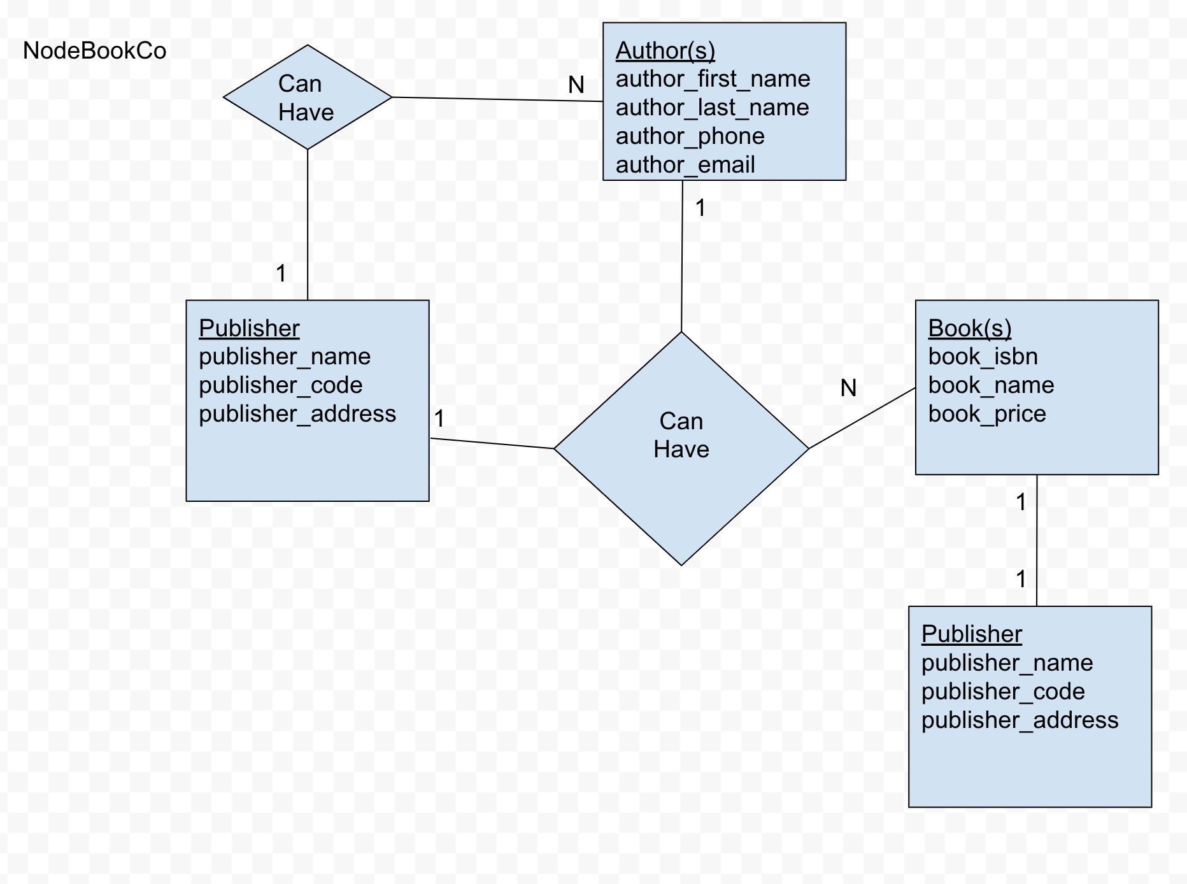

A publisher can have many authors

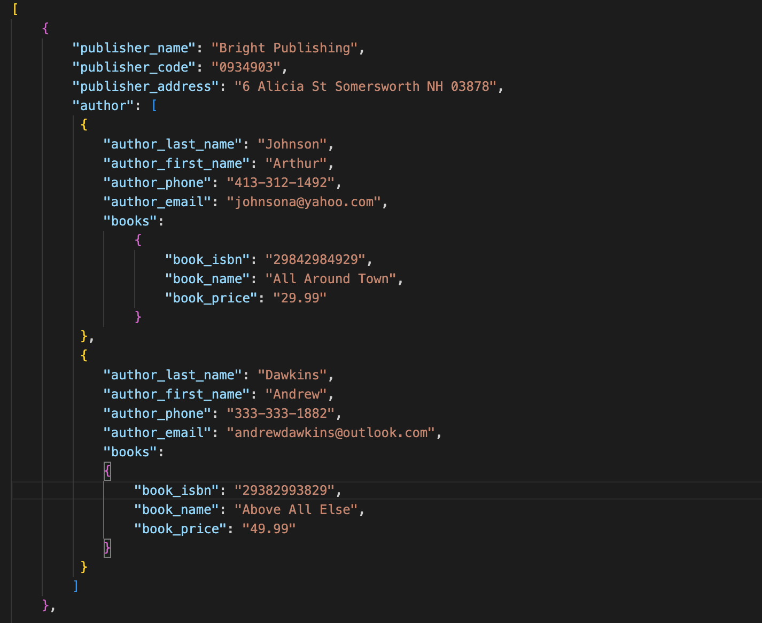

Authors can have many books

