Chris Gorham

Bellevue University

WEB 335 – Introduction to NoSQL

Professor Krasso

Week 2

3/20/2023

Exercise 2.3 - Python

Screenshot of opening command palette in VS Code to access the Python Interpreter settings:

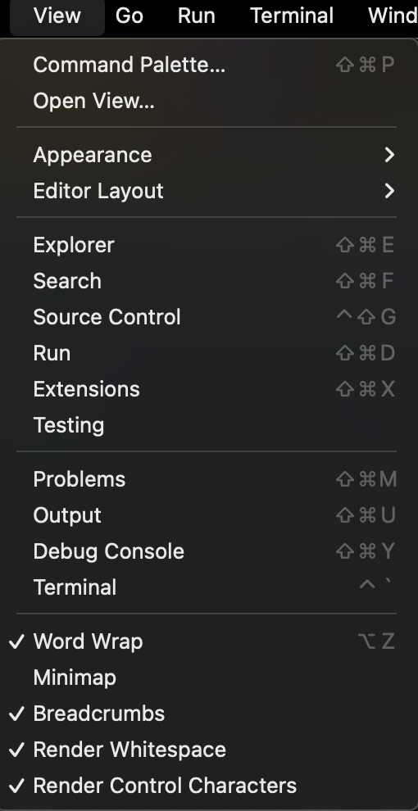

Screenshot of typing >Python: Select Interpreter into the VS Code Command Palette and selecting the correct Python interpreter:

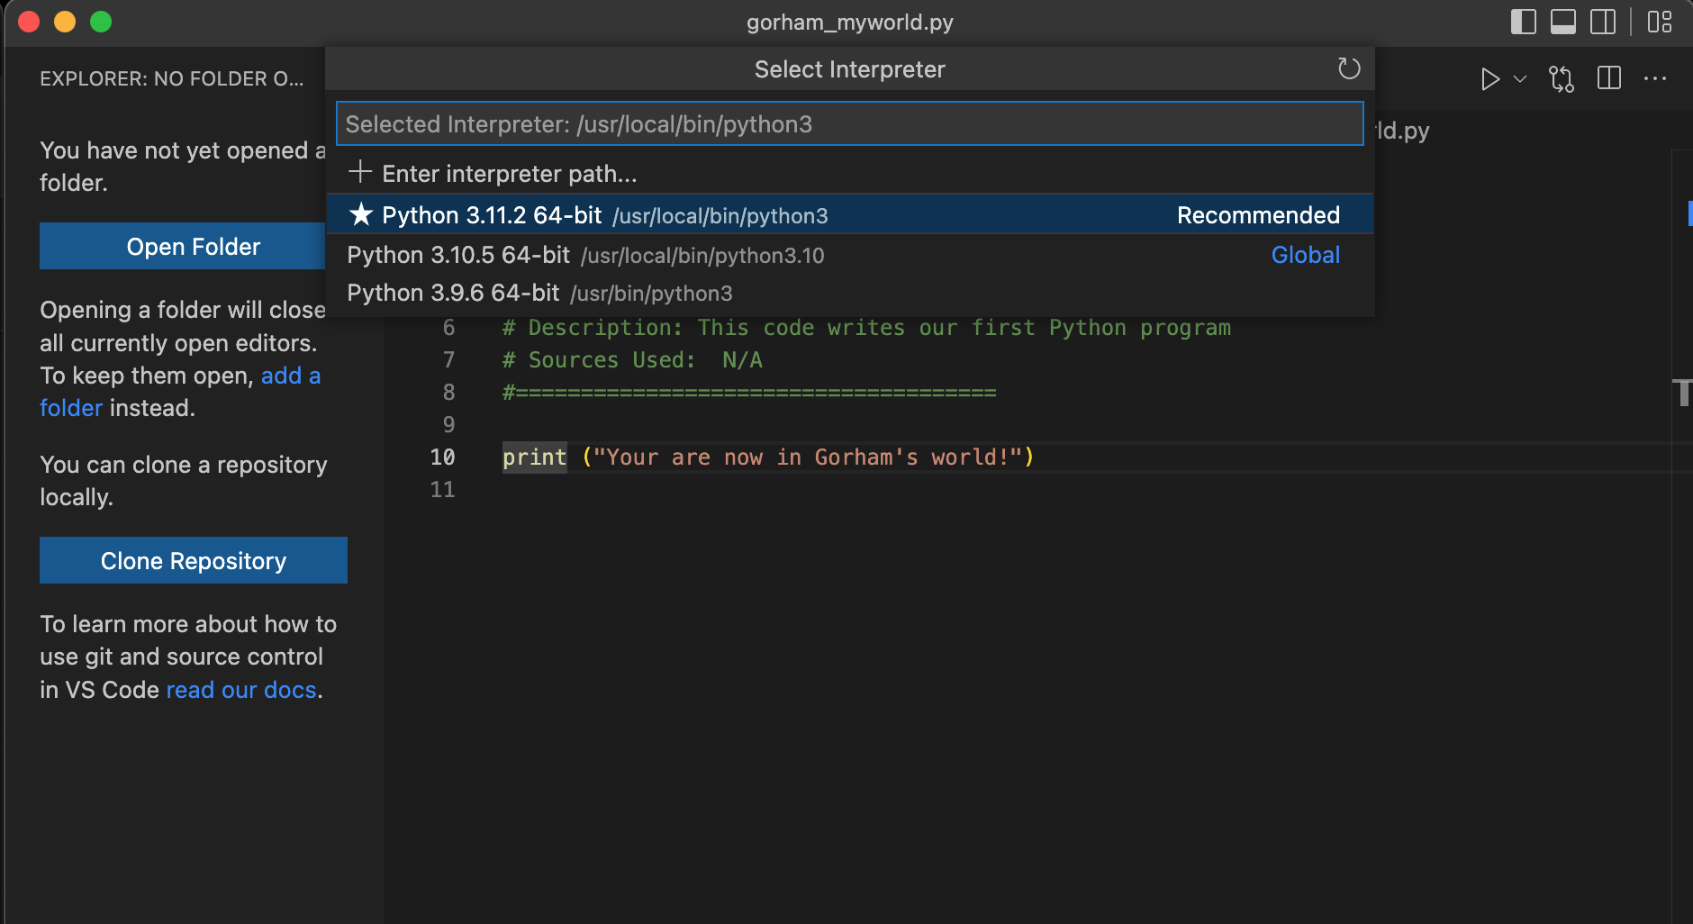

Screenshot of executing my first python program in the terminal in VS Code:

