Software Requirements Specification

eTimely

Version 1.2

February 21, 2022

Team: Matt Korte, Caleb Obi, Chris Gumieny, Samia Chowdhury

# Revision History

|  |  |  |  |
| --- | --- | --- | --- |
| **Date** | **Description** | **Author** | **Comments** |
| 2/15/22 | Version 1.0 | Matthew Korte,  Caleb Obi,  Chris Gumieny,  Samia Chowdhury | First Draft |
| 2/16/22 | Version 1.1 | Matthew Korte,  Caleb Obi,  Chris Gumieny,  Samia Chowdhury | Feedback from first day of presentations |
| 2/21/22 | Version 1.2 | Matthew Korte,  Caleb Obi,  Chris Gumieny,  Samia Chowdhury | Feedback from our presentation and from Darla. |

# Document Approval

The following Software Requirements Specification has been accepted and approved by the following:

|  |  |  |  |
| --- | --- | --- | --- |
| **Signature** | **Printed Name** | **Title** | **Date** |
|  | Matthew Korte | Team Lead | 2/21/22 |
|  | Caleb Obi | Backend Lead / QA Lead | 2/21/22 |
|  | Chris Gumieny | Frontend Lead | 2/21/22 |
|  | Samia Chowdhury | Presentation Lead / Documentation Lead | 2/21/22 |

**Table of Contents**

Revision History i

Document Approval i

1. Introduction 1

1.1 Purpose 1

1.2 Scope 1

1.3 Definitions, Acronyms, and Abbreviations 1

1.4 References 2

1.5 Overview 2

2. General Description 4

2.1 Product Perspective 4

2.2 Product Functions 4

2.3 User Characteristics 5

2.4 General Constraints 5

2.5 Assumptions and Dependencies 6

3. Specific Requirements 7

3.1 External Interface Requirements 7

3.1.1 User Interfaces 7

3.1.1.1 Default View 7

3.1.1.1.1 Home Page 7

3.1.1.1.2 Login Page 8

3.1.1.1.3 Password Recovery Page 9

3.1.1.1.4 Contact Us Window 10

3.1.1.2 Staff View 11

3.1.1.2.1 Create Staff Account Page 11

3.1.1.2.2 Staff Dashboard View 12

3.1.1.2.3 Staff Schedule Tab 13

3.1.1.2.4 Staff Availability Tab 14

3.1.1.2.5 Staff Availability Window 15

3.1.1.2.6 Staff Announcements Tab 16

3.1.1.2.7 Staff Messages Tab 17

3.1.1.2.8 New Message Window 18

3.1.1.2.9 Staff Settings Tab 19

3.1.1.3 Business View 20

3.1.1.3.1 Create Business Account Page 20

3.1.1.3.2 Business Dashboard View 21

3.1.1.3.3 Business Approval Window 22

3.1.1.3.4 Business Schedules Tab 23

3.1.1.3.5 Business Team Tab 24

3.1.1.3.6 Business Messages Tab 25

3.1.1.3.7 Business Announcements Tab 27

3.1.1.3.8 Business Settings Tab 27

3.1.2 Hardware Interfaces 28

3.1.3 Software Interfaces 28

3.1.4 Communications Interfaces 28

3.2 Functional Requirements 29

ID: FR3.2.1 29

ID: FR3.2.2 29

ID: FR3.2.3 30

ID: FR3.2.4 31

ID: FR3.2.5 32

ID: FR3.2.6 33

ID: FR3.2.7 34

ID: FR3.2.8 35

ID: FR3.2.9 36

ID: FR3.2.10 37

ID: FR3.2.11 38

ID: FR3.2.12 39

ID: FR3.2.13 40

ID: FR3.2.14 41

ID: FR3.2.15 42

ID: FR3.2.16 43

ID: FR3.2.17 44

ID: FR3.2.18 45

ID: FR3.2.19 46

ID: FR3.2.20 47

ID: FR3.2.21 48

ID: FR3.2.22 49

ID: FR3.2.23 50

ID: FR3.2.24 51

ID: FR3.2.25 52

ID: FR3.2.26 53

3.3 Non-Functional Requirements 54

3.3.1 Performance 54

ID: NFR 3.3.1.1 54

ID: NFR 3.3.1.2 54

ID: NFR 3.3.1.3 54

3.3.2 Reliability 54

ID: NFR 3.3.2.1 54

3.3.3 Availability 55

ID: NFR 3.3.2.1 55

ID: NFR 3.3.2.2 55

3.3.4 Security 55

ID: NFR 3.3.4.1 55

ID: NFR 3.3.4.2 56

3.3.5 Maintainability 56

ID: NFR 3.3.5.1 56

ID: NFR 3.3.5.2 56

ID: NFR 3.3.6.1 56

ID: NFR 3.3.6.2 57

3.4 Design Constraints 57

3.4.1 Deployment Constraints 57

ID: LDR 3.4.1.1 57

3.4.2 Database Constraints 57

ID: LDR 3.4.2.1 57

ID: LDR 3.4.2.2 58

ID: LDR 3.4.2.3 58

ID: LDR 3.4.2.4 58

ID: LDR 3.4.2.5 59

3.5 Logical Database Requirements 59

3.5.1 Business User Collection 59

3.5.2 Staff User Collection 60

3.6 Stretch Goals 62

ID: SG3.5.1 62

ID: SG3.5.2 63

ID: SG3.5.3 64

ID: SG3.5.4 65

ID: SG3.5.5 66

ID: SG3.5.6 67

4. Analysis Models 68

4.1 Data Flow Diagrams (DFD) 68

4.1.1 Business Web Application Data Flow Diagrams 68

4.1.2 Staff Web Application Data Flow Diagram 69

# 1. Introduction

This section describes the purpose of this document, provides any necessary definition, and elaborates on what is found in each subsequent section.

## 1.1 Purpose

This document is being written to outline the requirements for the small business scheduling web application, eTimely. Here we will explain the purpose and features of the system, as well as how it will and will not respond to end user interaction. Additionally, this is being written for stakeholders to clarify what exactly eTimely will and will not be able to do, as well as serve as a point of reference for the development team while constructing the system.

## 1.2 Scope

eTimely is a shift management and communication application for small companies and their staff. The primary goal of eTimely is to allow a business to create and manage shift schedules for their entire staff using availability information provided by the staff themselves.

Employees will have the ability to enter information about when they can and cannot work into their “staff” account. This information will be shared with their place of work’s “business” account (created by ownership or management) so that management may utilize it to develop a schedule that satisfies everyone's demands.

It is our hope that eTimely will help small companies of approximately 100 people or less communicate more effectively, particularly in the context of scheduling and shift planning.

## 1.3 Definitions, Acronyms, and Abbreviations

|  |  |
| --- | --- |
| **Term** | **Definition** |
| Availability | The specified times and days of the week an employee is willing to be scheduled. |
| Business | A company that has sign up for and who is using eTimely. |
| Employee | A singular person who works at the business who is using eTimely. |
| Organization | A business account and all associated staff accounts. |
| Role | Specific job title assigned by a business to a staff user. |
| Staff | All employees of a business. |
| User | Any person using the application, generally someone using a business or staff account |

**Figure 1.3.1**

## 1.4 References

[1] Google, “Firebase Quotas and Limits” <https://cloud.google.com/firestore/quotas>

[2] Google, “Firebase Firestore Collection Structure” <https://firebase.google.com/docs/firestore/manage-data/structure-data>

## 1.5 Overview

The rest of this document is composed of three more major sections. The next section will explain the project’s functionalities in general terms. It will also elaborate on how the users interact with the system, as well as how the different components of the system interact. This section will also clarify an assumption and constraints of the development of the system.

The third section will be where detailed descriptions of the many different functional requirements, nonfunctional requirements, and interfaces of the system will be found. These requirements are going to be used to outline what exactly is expected of the system for all stakeholders, in addition to guiding the development team.

Finally, the document ends with two data flow diagrams, one for the flow of data for both user types. These will show what information the application will take in, as well as what data each user type will be able to view when signed in.

# 2. General Description

This section will give an overview of the system. Here will be where the different user types will be defined, as well as what functionalities they will have access to. This will be followed up with any constraints the system will have placed upon it. Lastly, there will be a description of any assumptions being made during the creation of requirements found in the next section.

## 2.1 Product Perspective

The business account type is intended to be created and accessed by someone in a position of relative authority in the workplace, such as ownership or management. It is from this account that this individual (or individuals) will add or remove staff members from the organization, approve any kind of shift request, create schedules, as well as moderate the message board in case anyone posts something that is deemed inappropriate.

Meanwhile, the staff accounts are meant for the average employee of a business that is using eTimely. This is where they will enter their weekly availability, request days off, and request shift trades. Additionally, employees will be able to view a schedule when it has been posted by management as well as any announcements made on the message board.

## 2.2 Product Functions

To use the system, a user will make one of two account types, “business” or “staff.” As the names suggest, the business will make a business account and each employee of that business will make their own staff account.

Once a user logs into a staff account, they will be able to enter and update information on their availability for each day of the week. Additionally, they will also be able to request specific dates off work as well as shift trades with other employees with the same role. Once this information is submitted, it will be submitted to the associated business account for approval.

After the business user approves any kind of availability changes, the new schedule will be saved and available to see by the business user to assist in creating schedules for all employees. When creating a schedule, the business user will be able to filter staff users by their assigned role (or roles) to help narrow down the list of employees. Upon publishing, this schedule will be sent out for all associated staff users to view.

There will also be several features that both account types can access. This includes updating account information such as name, password, or profile pictures. Additionally, both users will be able to view, create, and reply to posts on a company message board (with the business user given the additional privileges to moderate it.

## 2.3 User Characteristics

As was touched on before, the two main user types will be business and their staff, both with different uses and requirements to make the application work.

Businesses who feel as though creating a shift schedule and communicating with their team is difficult and want a solution would be the ones creating a business account. Once the account is made, it will be access and used by someone at the business such as ownership or management that is usually in charge of shift planning and communicating with staff. Generally, these types of people are educated and technically literate. This means that they can be expected to be able to navigate, use, and understand the more complex functionalities of the system (compared to those of the staff user). Regardless however, focusing on making the system as simple to use and navigate should be a high priority, as we cannot predict the technical skills of all potential business users.

As for staff users, those will be the average employee of the business. This is someone like a server at restaurant, or a warehouse worker at a retail store. Generally, these types of roles can be filled by someone with limited knowledge of and experience with using computers and smartphones. This will require the application to be built with ease of use and simple user interface design in mind.

## 2.4 General Constraints

With data capacity limits as well as any limits to the number of reads and writes to it in a given time, the database could become a large constraint for the system. If the user volume or traffic gets too high, the performance of the database could go down quickly. Additional information on the constraints that Firebase brings, see section 3.4.2.

Finally, the internet will also constrain the system. Since the user’s device will need to be connected to the internet to be able to read or write from the database, any network errors can cause major issues for the system. As of right now, we believe that there is not any minimum internet speed the end user needs to reach. As long as they have some sort of internet connection, the application is expected to work, just at differing load times.

## 2.5 Assumptions and Dependencies

The only dependency of this project is on the database, Firestore from Firebase. For this application to function as expected, Firestore needs to be up and running without issue to ensure users can sign in and access any information from eTimely once they are.



# 3. Specific Requirements

## 3.1 External Interface Requirements

### 3.1.1 User Interfaces

This application is going to have distinct groups of user interfaces. The group of user interfaces that will be shown depends on whether the user is logged in. A user that is not logged in will only be able to navigate through the application’s Default View. If a user is logged in, the group of user interfaces presented to the user will depend on which type of account the user is logged in to. This is where the user will be able to take advantage of the functionalities of the application. These functionalities are highlighted by employees inputting availability and requesting schedule changes as well as the business user creating and publishing schedules, and making decisions on schedule change requests.

#### 3.1.1.1 Default View

A user that is not logged in will be presented with the default view of the application. The primary functions of this perspective are to inform the user of the application’s uses as well as lead the user towards logging in or creating an account.

#### 3.1.1.1.1 Home Page

The Home Page will contain a navigation bar, a “Get Started” button, and a footer. The navigation bar will consist of multiple links including but not limited to “Home”, “About Us” and "Sign In”. The “Get Started” button will lead the user to the account selection page. The footer will consist of multiple links including a link to “Icons8” (the website from which we got our icon assets) and the terms and conditions for the application.

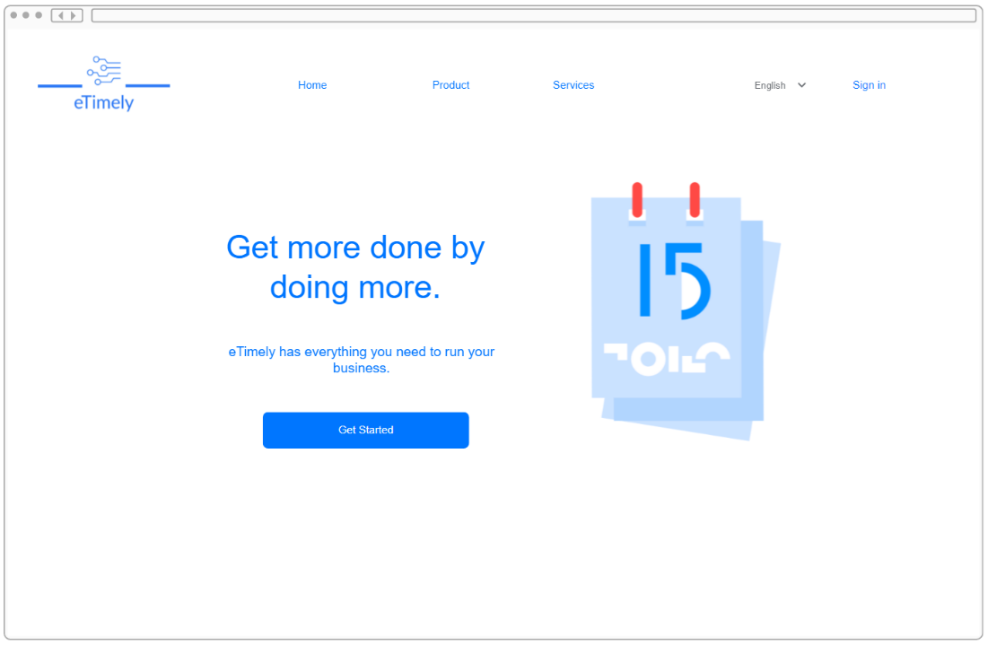**Figure 3.1.1.1.1**



#### 3.1.1.1.2 Login Page

The Login Page will allow the user to enter a previously registered email and password in order to log into an account. Both staff and business accounts will be able to login through this page. The Login Page will link the user to the business account creation page if an account needs to be created. It will also link the user to the password recovery page if the user forgets the password to their account.

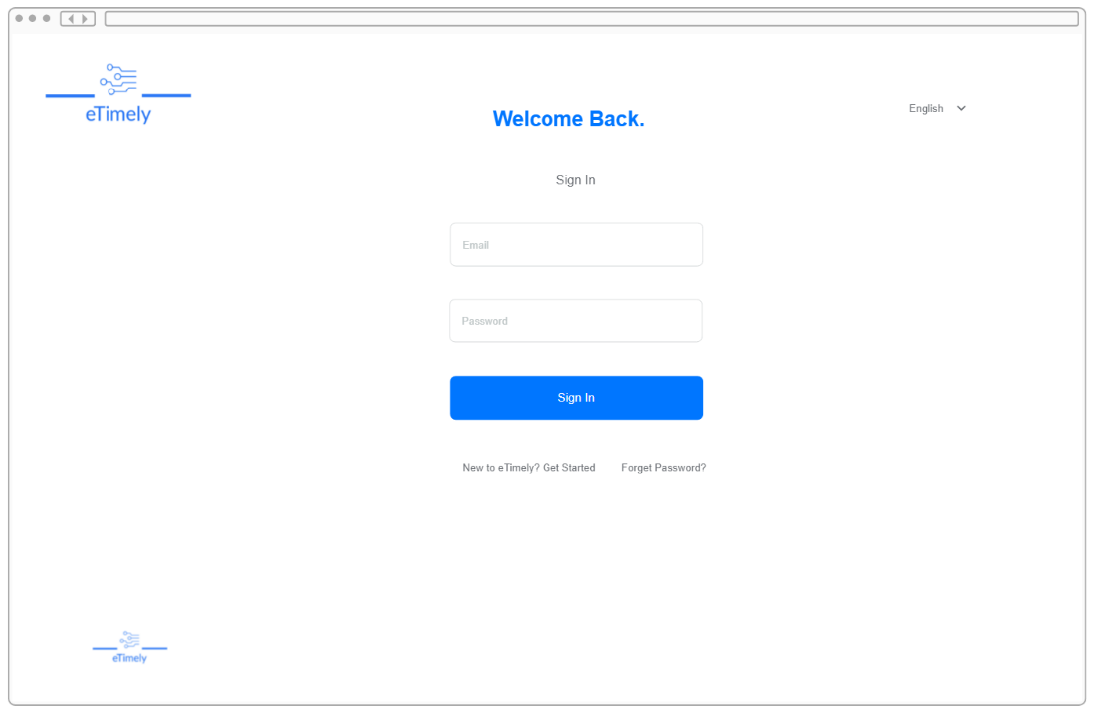**Figure 3.1.1.1.2**



#### 3.1.1.1.3 Password Recovery Page

The Password Recovery Page is where the user will be able to enter an email to change a forgotten password. Upon hitting the “Forgot Password” button, the user will be sent an email that will include a link that will direct the user to the screen shown below to update the account’s password.

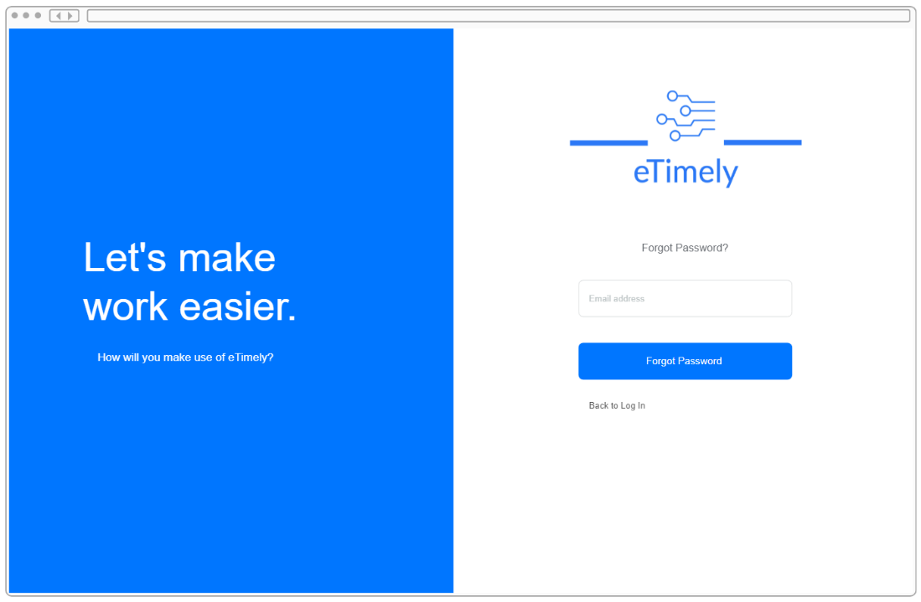**Figure 3.1.1.1.3**

#### 3.1.1.1.4 Contact Us Window

The Contact Us Window will be accessed from the home page and will be a pop-up window. In this window, the user will be able to enter an email and a message that will be sent directly to the team behind eTimely. This will be able to be achieved without being logged in.

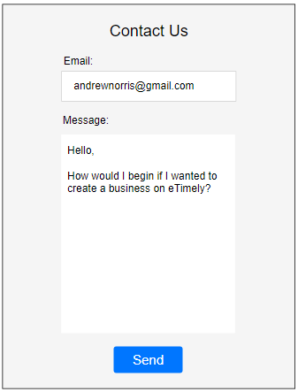

**Figure 3.1.1.1.4**

### 3.1.1.2 Staff View

The Staff View will be the perspective of any logged in staff account. The functionalities of this view will include the ability to input an availability as well as request other types of scheduling changes. The possible scheduling changes will include days off, shift trading, and vacation time.

#### 3.1.1.2.1 Create Staff Account Page

The Create Staff Account Page will allow a user to create a staff account by their first name, last name, email address, and password. A user will be directed here from an invitation sent by email from the business account. Creating an account will allow the user to make use of the features of the staff account.

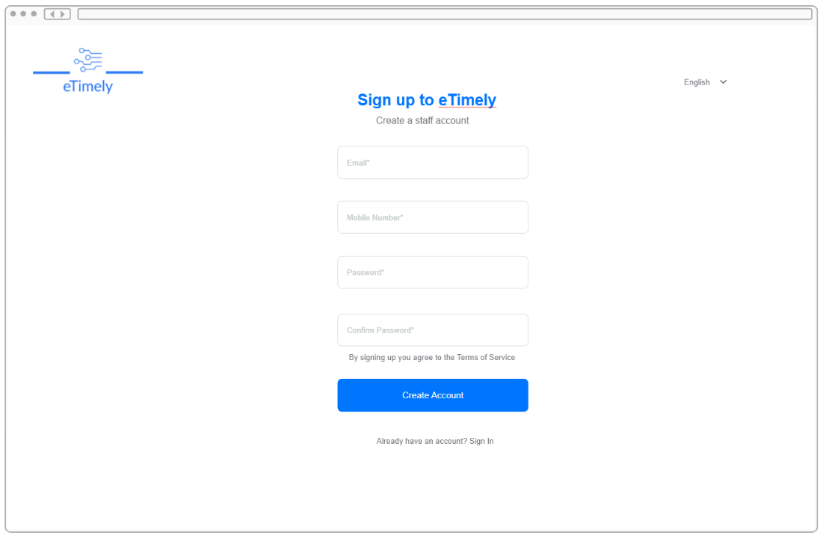**Figure 3.1.1.2.1**



#### 3.1.1.2.2 Staff Dashboard View

The Staff Dashboard view will be where a staff account is taken after a successful login. The Staff Dashboard will show the user the next shift, and upcoming workdays. The Staff Dashboard will also show important notifications which may include schedule request updates and business announcements. This page will also allow the user to navigate to any other tabs within the staff dashboard.

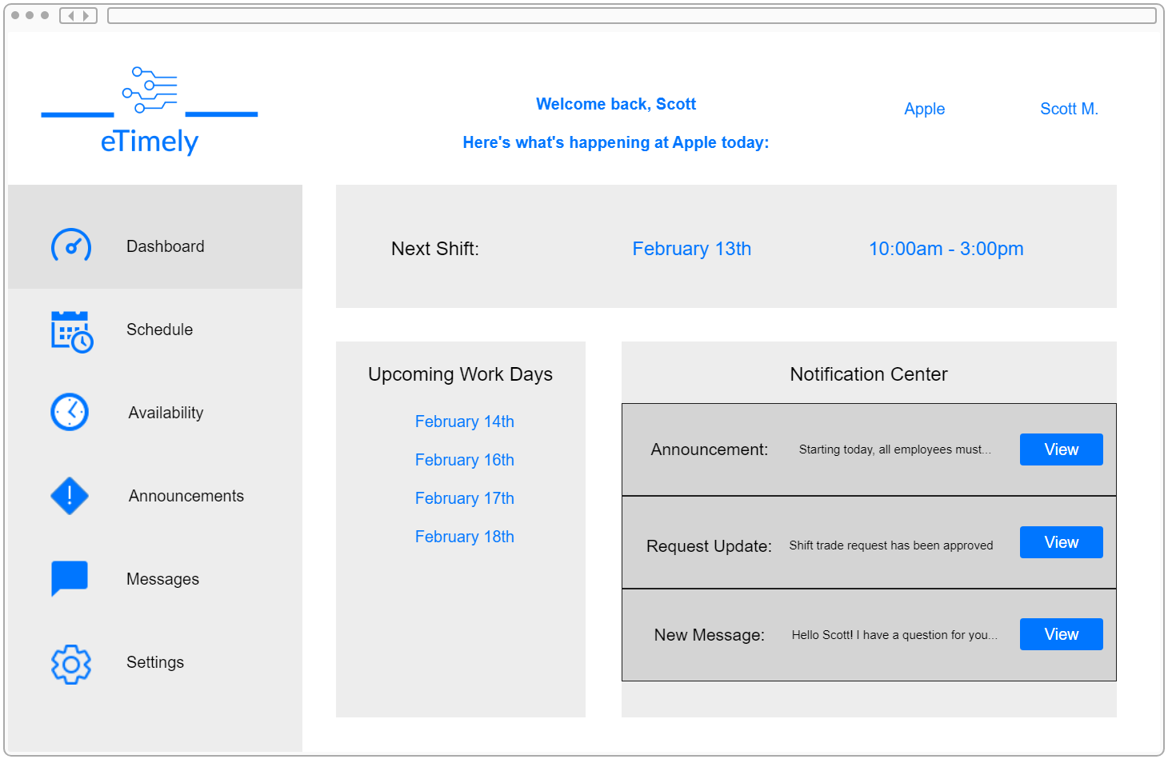**Figure 3.1.1.2.2**

#### 3.1.1.2.3 Staff Schedule Tab

The Staff Schedule Tab will allow the user to see an upcoming shift schedule that was created by the business that the staff account is currently linked to. This schedule will only list the times that the corresponding employee must work.

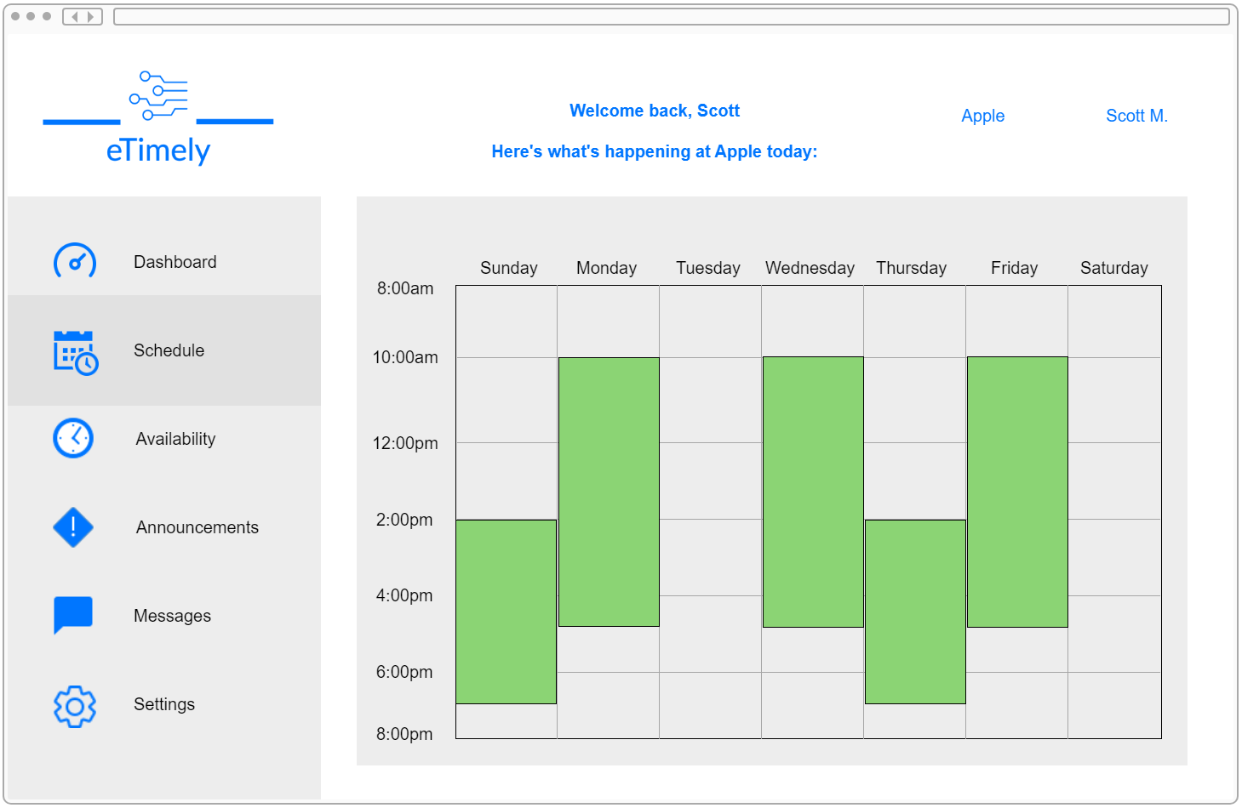**Figure 3.1.1.2.3**

#### 3.1.1.2.4 Staff Availability Tab

The Staff Availability Tab will allow a user to add, edit and view an availability for each day of the week. The changes that are made to a user’s availability will be used by the corresponding business account to create a schedule for that employee. The user will also be able to request days off and ask for approval to trade shifts with another employee. The “Add” buttons will open a pop-up window for the user to enter an availability for the corresponding day.

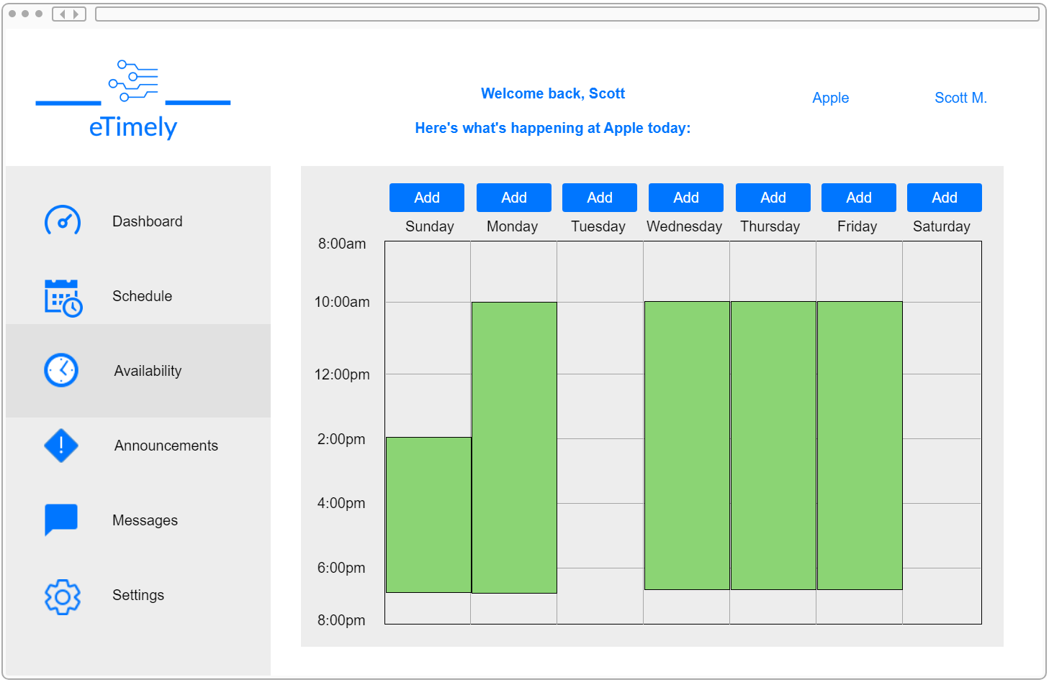**Figure 3.1.1.2.4**

#### 3.1.1.2.5 Staff Availability Window

The Staff Availability Window will allow the user to input times for availability. To add an availability window to an account, the user will have to enter a start time and an end time for that availability. The user will then select either “Available” or “Unavailable” from a drop down before they can click the “Confirm” button to add schedule updates to the user’s account. By default, the entire schedule will be marked as unavailable until the user specifies otherwise.

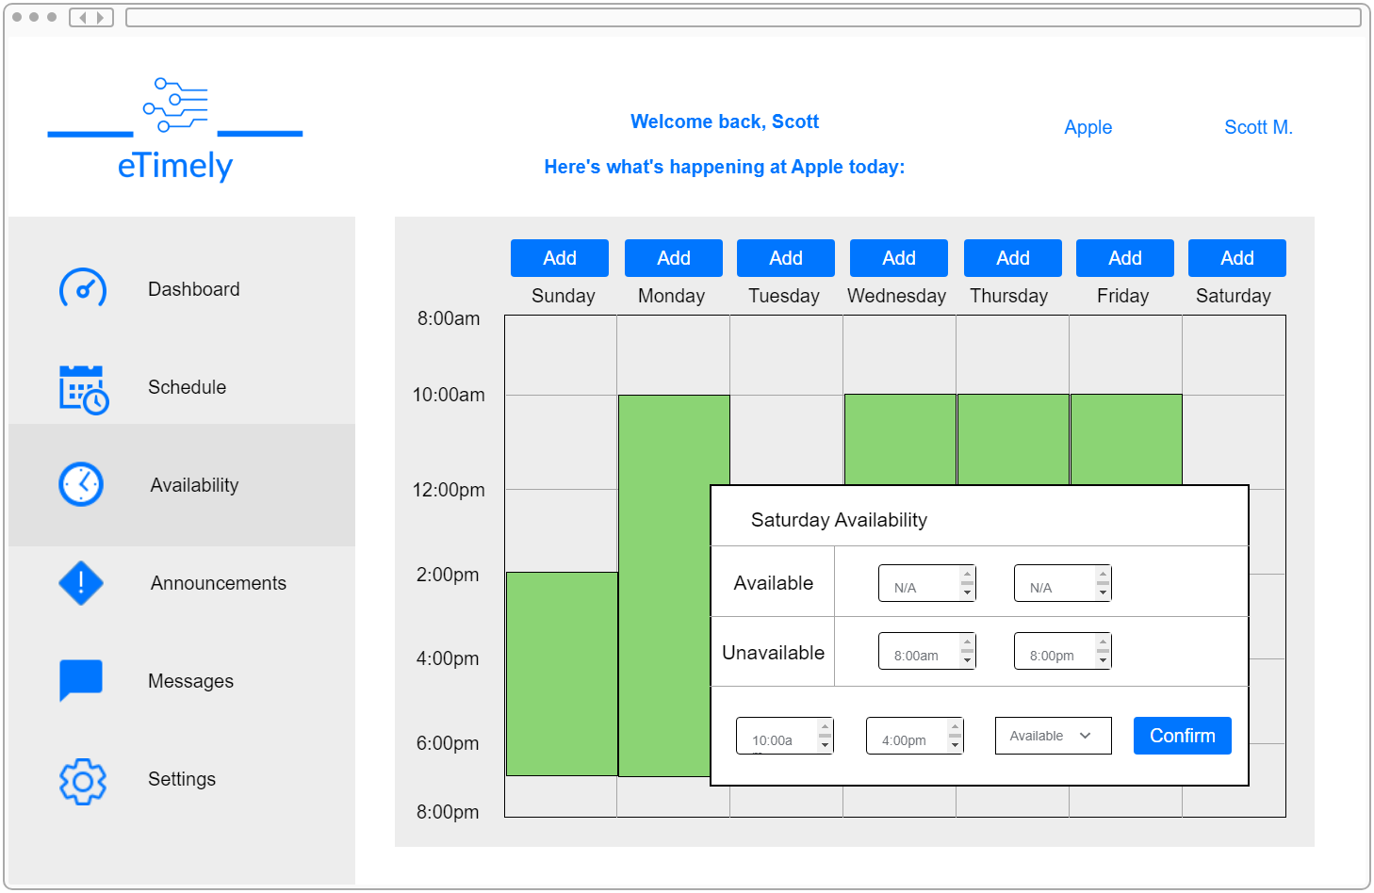**Figure 3.1.1.2.5**

#### 3.1.1.2.6 Staff Announcements Tab

The Staff Announcements Tab will be where the user is able to read any announcements made by the business. The announcements will be in a list format and the user will be able to scroll through any past announcements.

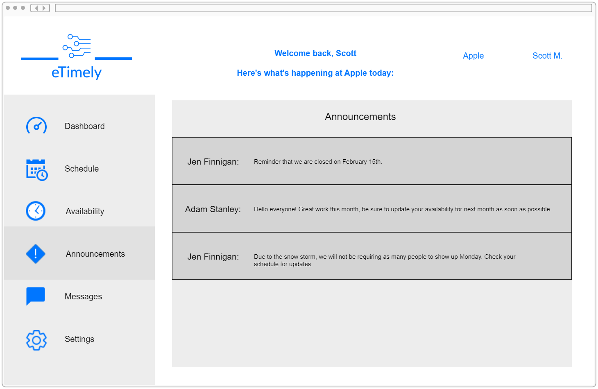**Figure 3.1.1.2.6**

#### 3.1.1.2.7 Staff Messages Tab

The Staff Messages Tab will be where the user will send and receive messages from other employees and the business. The user will be able to directly send a message to one account or will be able to post on a message board that is able to be viewed by all employees and the business. Any direct message can be opened by clicking the “Open” button. A message can be sent by clicking the “New Message” button which will present the user with a pop-up window.

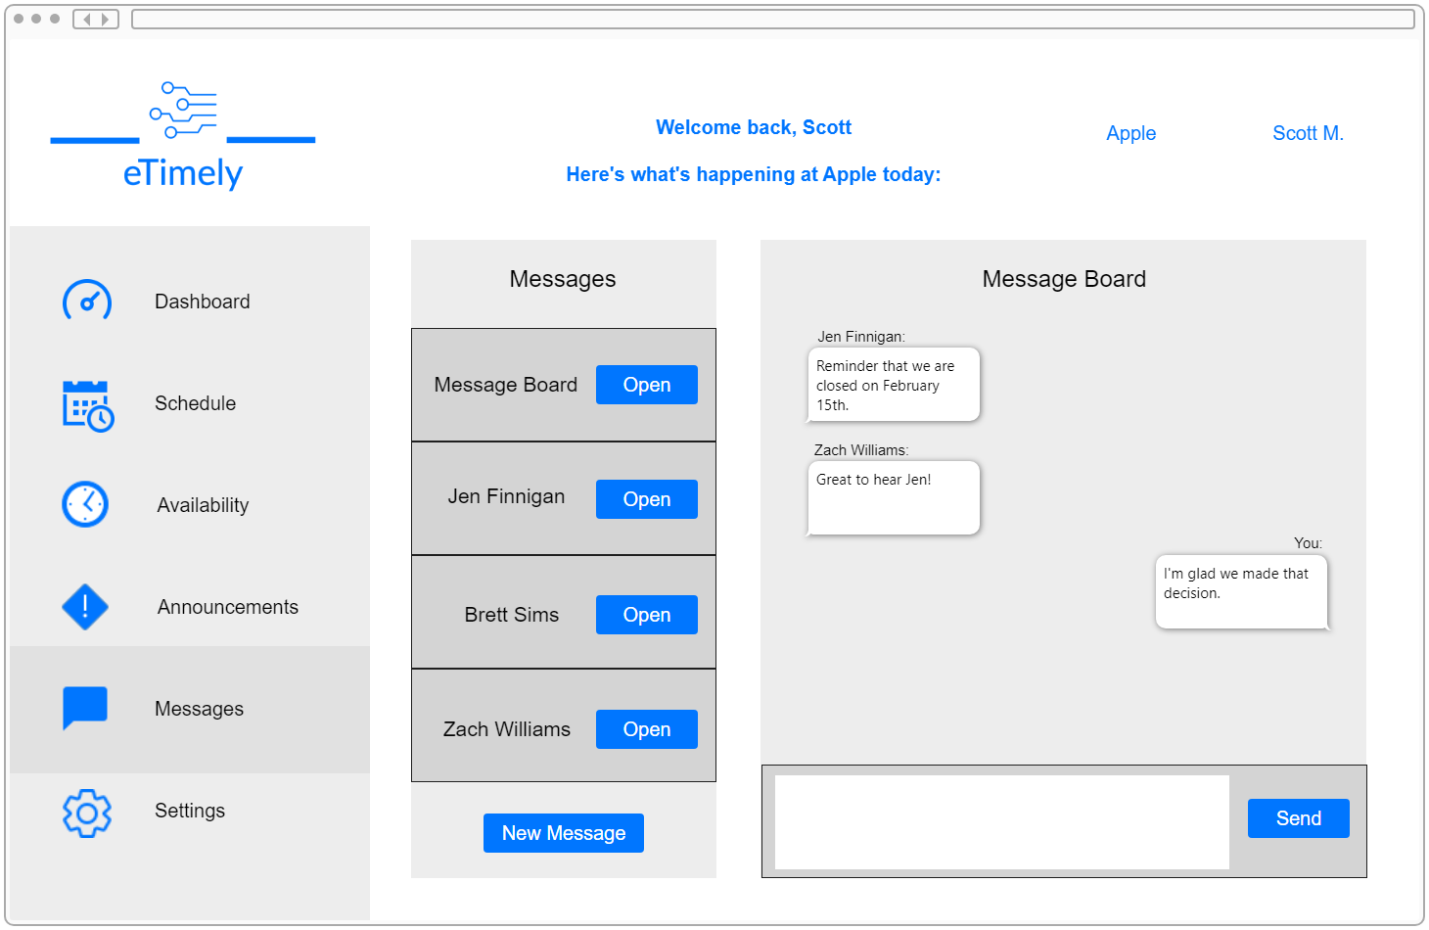**Figure 3.1.1.2.7**

#### 3.1.1.2.8 New Message Window

The New Message Window opens when a user clicks the “New Message” button in the respective account’s Messages Tab. The user will be able to select a recipient and enter a message in order to start a direct message with someone else. A message can be sent by clicking the "Send” button.

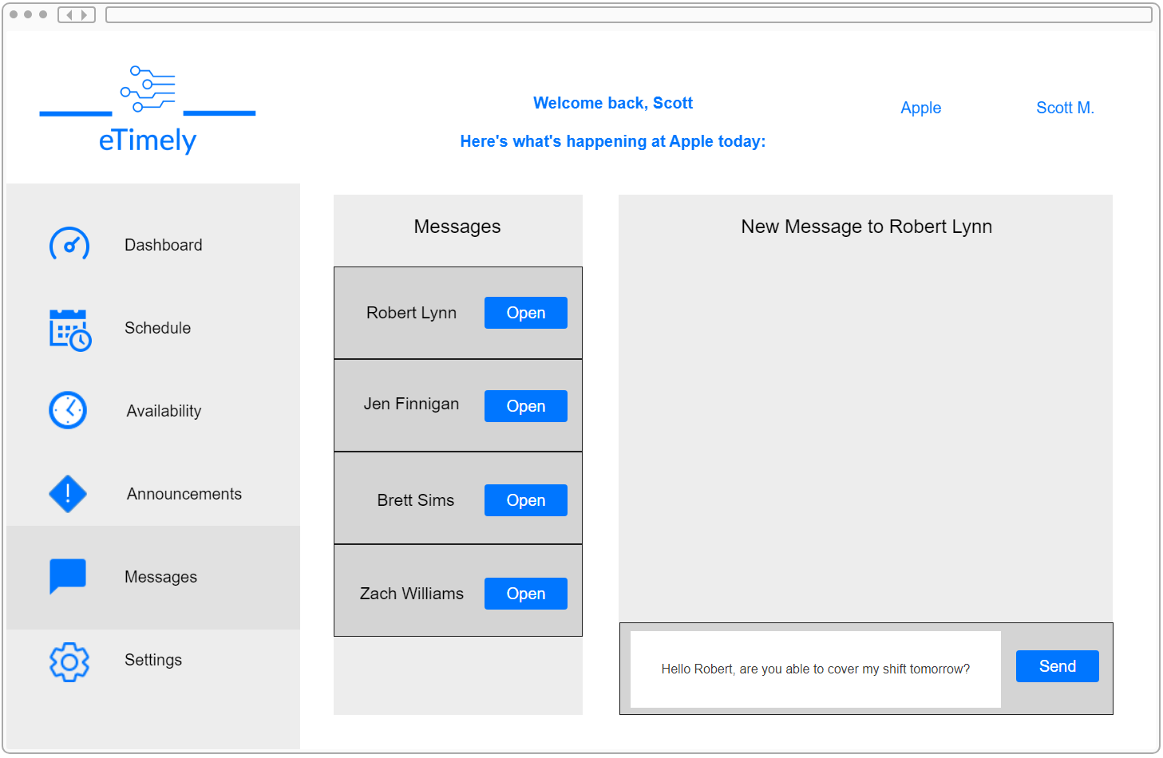**Figure 3.1.1.2.8**

#### 3.1.1.2.9 Staff Settings Tab

The Staff Settings Tab is where the user will be able to change certain aspects of the account. The user will be able to add a profile picture, update the account’s password and edit email notification settings. The user will also be able to log out from this tab.

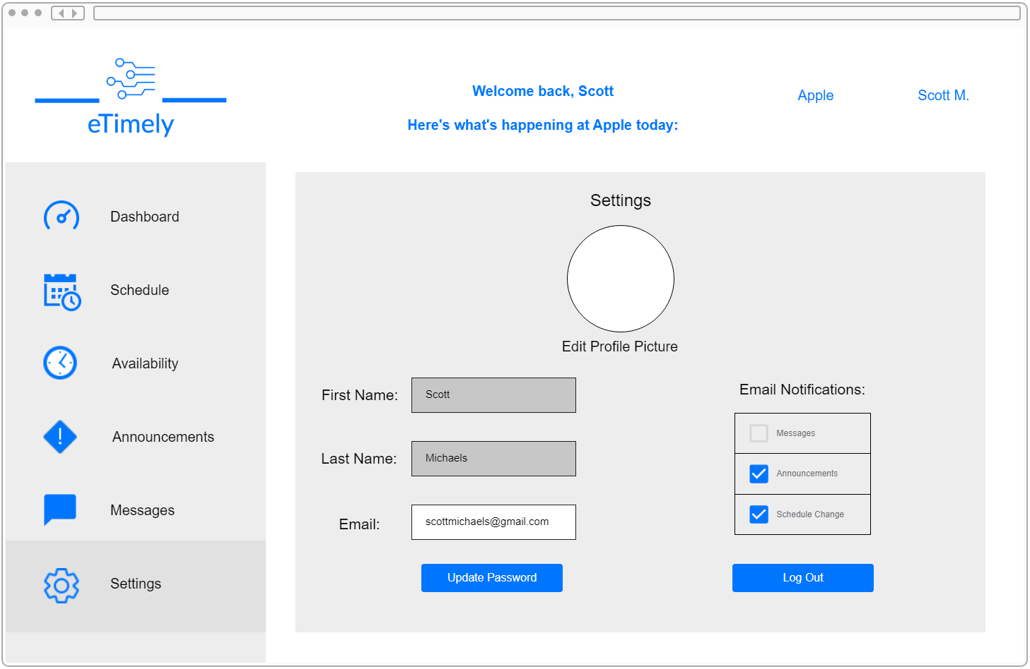**Figure 3.1.1.2.9**

### 3.1.1.3 Business View

The Business View will be the perspective of any logged in business account. The business account will have a lot of responsibilities including creating and maintaining a schedule, managing employees, and sending announcements to those employees.

#### 3.1.1.3.1 Create Business Account Page

The Create Business Account Page will allow a user to create a business account by entering valid information into the fields. Creating an account will allow the user to make use of the features of the business account.

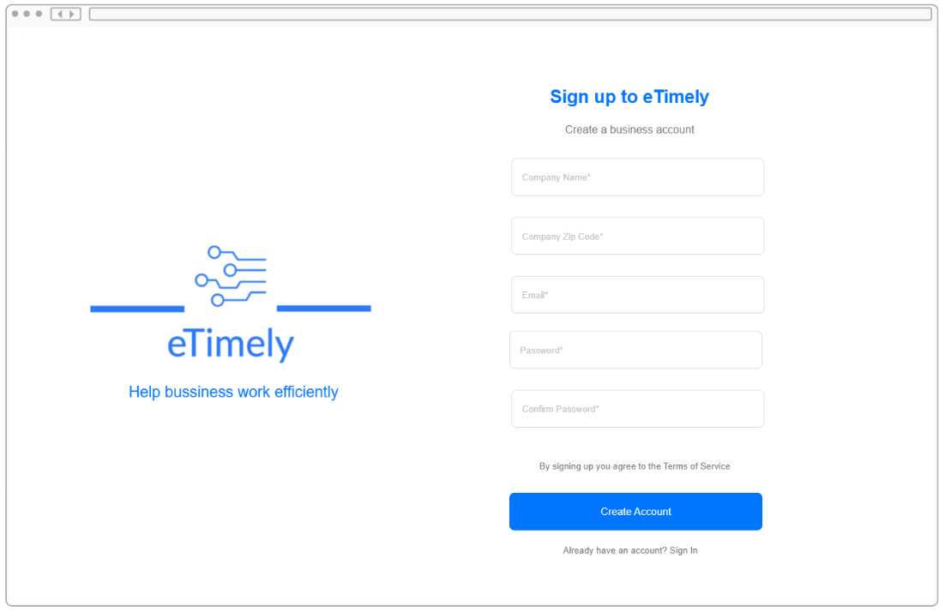**Figure 3.1.1.3.1**

#### 3.1.1.3.2 Business Dashboard View

The Business Dashboard Tab is where the user is taken after a successful login with business account credentials. This dashboard will show the employees that are due to work for the current day, an area for the business to approve or deny availability changes, and a place for the business to post an announcement to all employees. In the pending approval section of the dashboard, there will be a list of names. To approve or deny a request, the "View" button must be clicked to lead the user to a pop-up window that includes more information on the employee’s request. On the top of the dashboard, the business will be able to quickly create and send an announcement to all employees by typing in the input box and clicking the “Announce” button. This page will also allow the user to navigate to any of the tabs within the business dashboard.

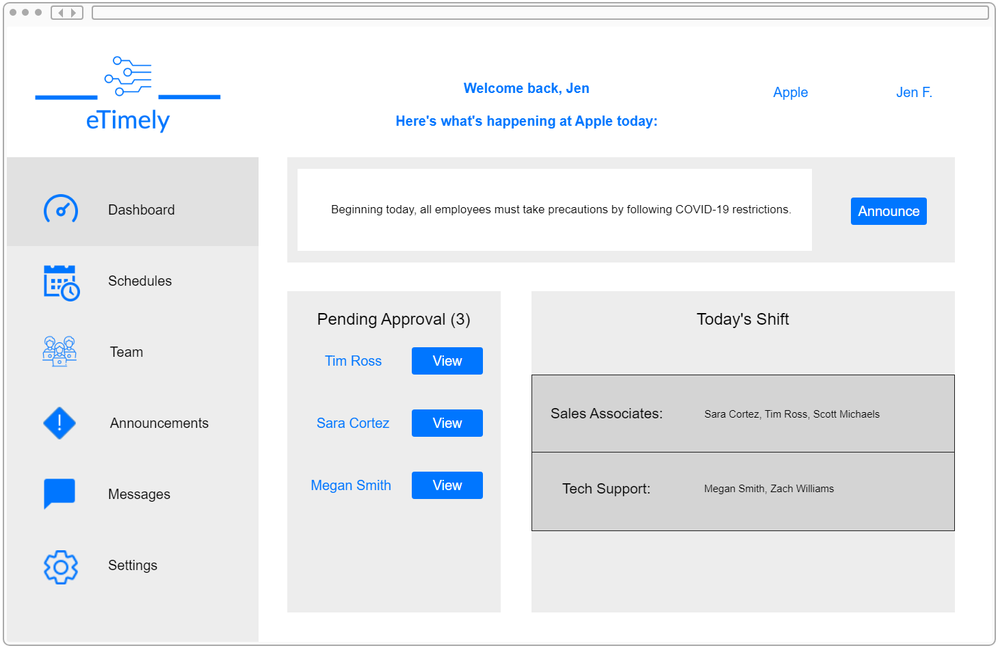**Figure 3.1.1.3.2**

#### 3.1.1.3.3 Business Approval Window

The Business Approval Window is the pop-up window that is presented when the user clicks the “View” button. This window will show details of an employee’s schedule request to the business.

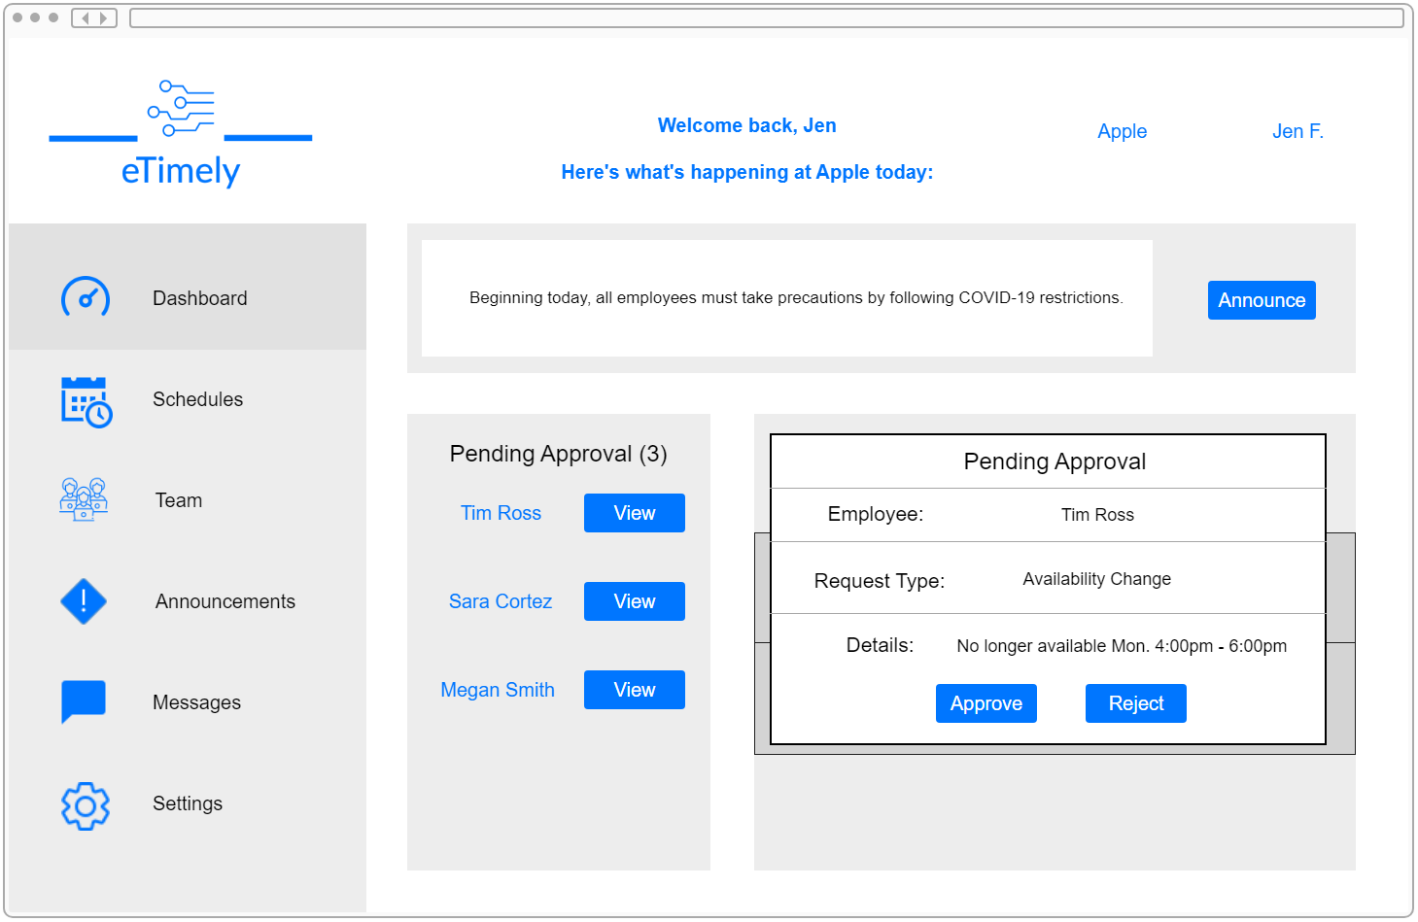**Figure 3.1.1.3.3**

#### 3.1.1.3.4 Business Schedules Tab

The Business Schedules Tab is where the user will have the ability to create a schedule based on the availability of employees. Two dropdowns will be added in to allow the user to view a schedule for each day and for each role. The user will be able to add a shift to an employee by clicking the “Add” button. This will allow the user to select a start time and an end time for that employee’s shift. Once a schedule is created, the business account will be able to hit the “Publish” button to send out the schedule to all employees that are included in it.

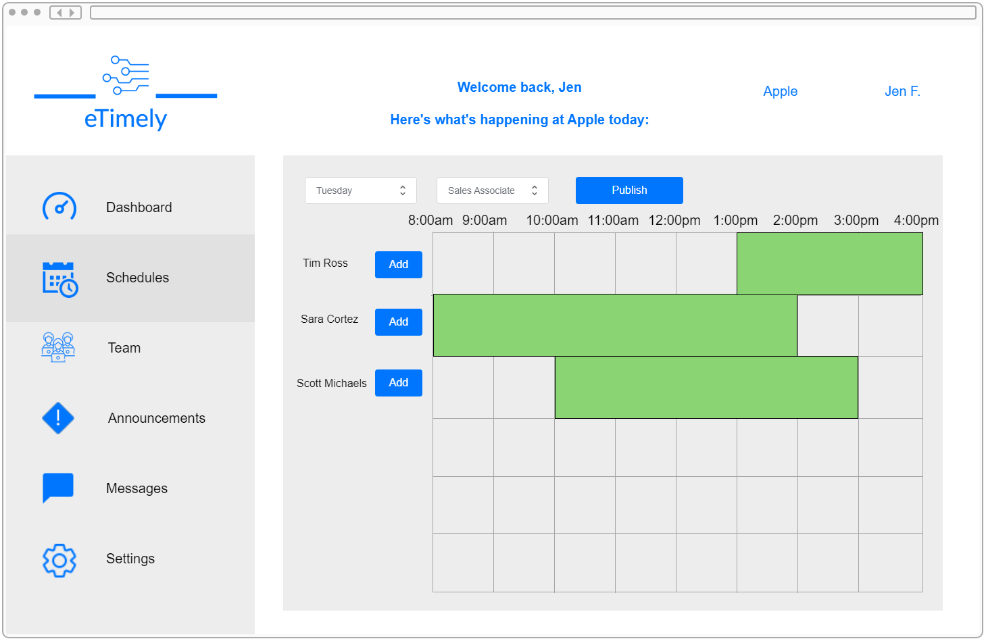**Figure 3.1.1.3.4**

#### 3.1.1.3.5 Business Team Tab

The Business Team Tab is where the user will be able to see all employees linked to that business. In this view, the user will be able to invite and remove employees from the list. This view will also allow the ability to designate a job title for each employee as well as search and filter through the team. The “Edit” button will allow the user to edit an employee’s attributes, whereas the “Delete” button remove the corresponding employee from the business. The “Invite an Employee” button will allow the user to invite someone to the business via email.

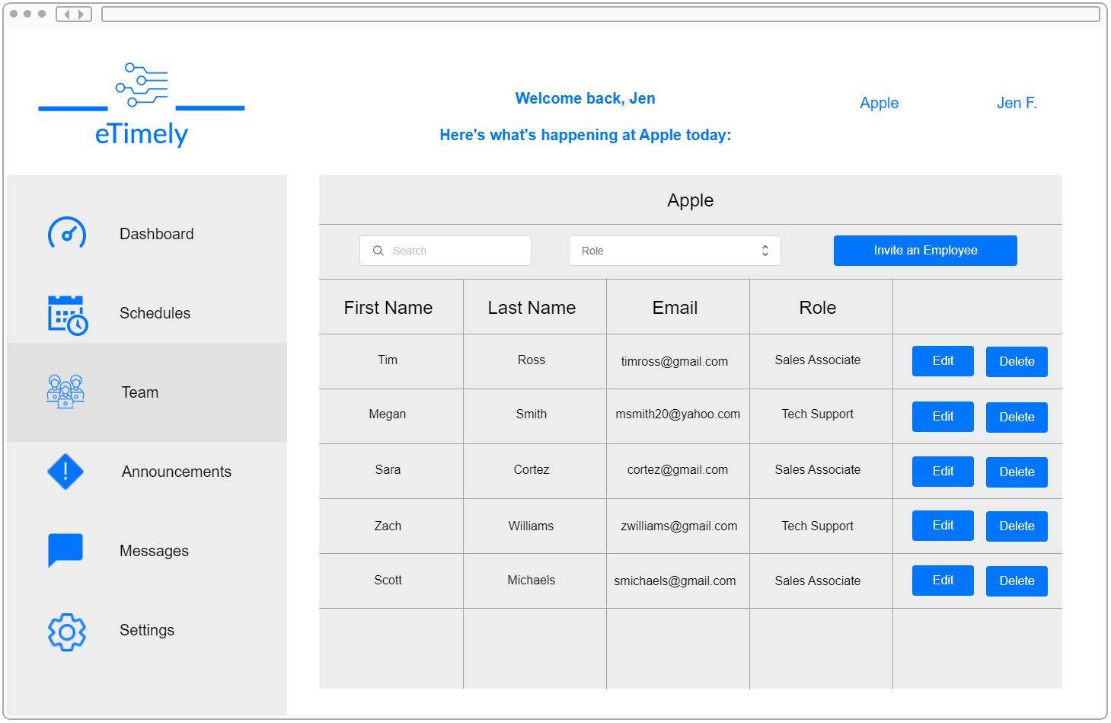**Figure 3.1.1.3.5**

#### 3.1.1.3.6 Business Messages Tab

The Business Messages Tab will allow the user to view any messages that were sent directly to the business account from an employee. The user will also be able to view and will have administrative rights to the message board. When the “Open” button is clicked, the window will be identical to what is shown in Figure 3.1.1.2.8.

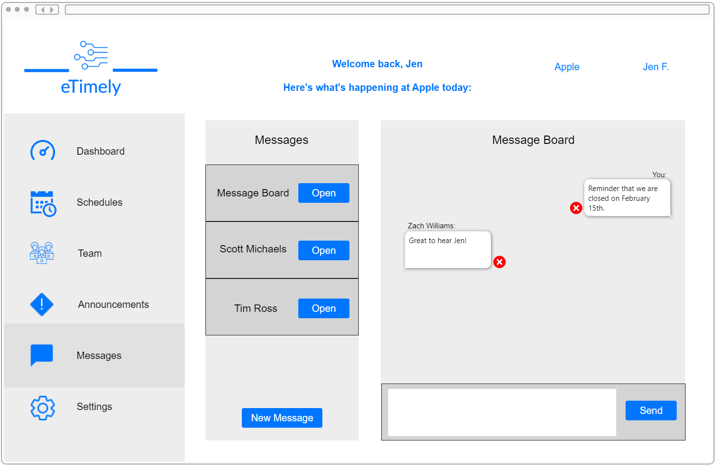**Figure 3.1.1.3.6**

#### 3.1.1.3.7 Business Announcements Tab

The Business Announcements Tab will be a more detailed version of the announcements section in the business dashboard. In this tab, the user will be able to view past announcements, create announcements and choose which roles will receive an announcement.

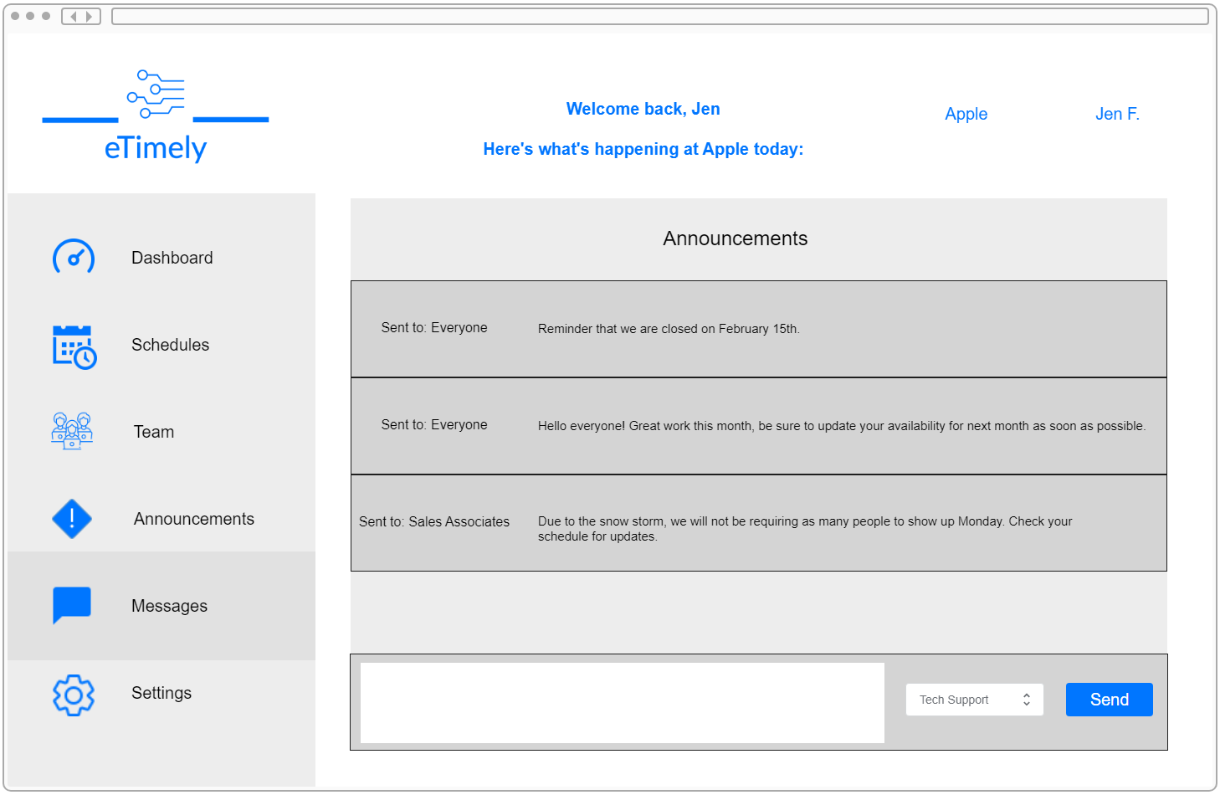**Figure 3.1.1.3.7**

#### 3.1.1.3.8 Business Settings Tab

The Business Settings Tab will be where certain aspects of the business account can be edited. These changes will include adding a profile picture, updating the account’s password, and editing notification settings. The settings tab will also allow the user to add, edit and remove roles from the business.

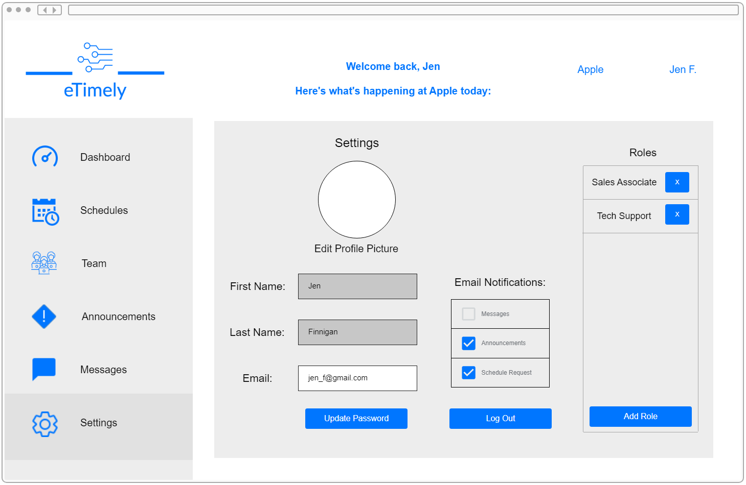**Figure 3.1.1.3.8**

### 3.1.2 Hardware Interfaces

eTimely is to be developed in such a way that it may be used on a computer or a mobile to access the web application. The application will also be responsive, allowing it to be easily navigated on a variety of screen sizes.

### 3.1.3 Software Interfaces

Our server-side interactions will be implemented with NodeJS and expressJS, and our user interface will be developed with React and JavaScript. To store all our application data, we'll use Firebase Firestore as our database. We will also use an external software package called nodemailer to send emails to users in this application.

### 3.1.4 Communications Interfaces

This application will use REST APIs to communicate with the backend servers and Firestore database. JSON Web Tokens will also be used to validate and authorize users in this application.

## 3.2 Functional Requirements

|  |  |  |
| --- | --- | --- |
| ID: FR3.2.1 | **Title**: Landing Page | |
| **Description:** Create the initial page that a user will be presented with. This page will direct them to create an account, sign in, and use the contact us page to contact the eTimely developers. | | |
| **Inputs:** N/A | | **Outputs:** N/A |
| **Processing:** N/A | | |
| **Error Handling:** N/A | | |
| **Priority:** High | **Dependencies:** FR3.2.2: About Us Page,  FR3.2.3: Contact Us Window  FR3.2.4: Business User Account Registration | |

|  |  |  |
| --- | --- | --- |
| ID: FR3.2.2 | **Title**: About Us Page | |
| **Description:** Create a webpage that describes what services eTimely provides, motivation for its creation, and other related information. | | |
| **Inputs:** N/A | | **Outputs:** N/A |
| **Processing:** N/A | | |
| **Error Handling:** N/A | | |
| **Priority:** Medium | **Dependencies:** FR3.2.1: Landing Page | |

|  |  |  |
| --- | --- | --- |
| ID: FR3.2.3 | **Title**: Contact Us Window | |
| **Description:** A Contact Us window will be found at the footer of the landing page. This window will allow a user to enter an email as well as a message. The email will be where the developer’s response will be sent to, and the message is what will be sent to the development team. | | |
| **Inputs:** A user’s email address, and the message to the development team. | | **Outputs:** An email message sent directly to the development team. |
| **Processing:** The user’s email address will be saved so that the user may receive a response from the development team. The message written by the user will be directed to the development team and will not be stored anywhere else. | | |
| **Error Handling:** In the case that a user is attempting to send a message and uses the wrong email, an error will be shown to inform the user to use an acceptable email. Also, in the case that a user attempts to send a message with an empty message field, the system will also prompt the user to create a message. | | |
| **Priority:** High | **Dependencies:** FR3.2.1: Landing Page | |

|  |  |  |
| --- | --- | --- |
| ID: FR3.2.4 | **Title**: Business User Account Registration | |
| **Description:** A user will be able to create a business account by entering a company name, email address, and password. This page can be directly accessed from the landing page. Once the business account is registered, the user will have to verify the registered email before they can log in. | | |
| **Inputs:** Company name, company email, password and a user’s agreement to the terms and conditions. | | **Outputs:** If the registration is successful, the user will be shown a “success” message and will be taken to the business dashboard. If the registration is not successful, the user will be shown an error message. |
| **Processing:** The business’s company name, email address and password will be saved in a database. This data will be able to be viewed by the business account on the staff roster management page as well as in the business account settings. | | |
| **Error Handling:** If the user is attempting to register with invalid credentials, or credentials already associated with an existing account, an error message will be shown, and the user will be unable to create an account with that information. | | |
| **Priority:** High | **Dependencies:**  FR3.2.1: Landing Page,  FR3.2.8: Email Account Confirmation Link,  FR3.2.9: Credential Validation on Sign Up,  FR3.2.10: Password Complexity,  FR3.2.15: Business Account Settings | |

|  |  |  |
| --- | --- | --- |
| ID: FR3.2.5 | **Title**: Staff User Account Registration | |
| **Description:** A user will be able to create a staff account by entering the staff member’s first name, last name, email address, and password. This page will be accessed from an invite link generated from a business account. Once the staff account is registered, the user will have to verify the registered email before they can log in. | | |
| **Inputs:** Staff member’s first and last name, email, password and a user’s agreement to the terms and conditions. | | **Outputs:** If the registration is successful, the user will be shown a “success” message and will be taken to the staff dashboard. If the registration is not successful, the user will be shown an error message. |
| **Processing:** The staff member’s first name, last name, email address and password will be saved in a database. This data will be able to be viewed by the business account on the staff roster management page as well as by the corresponding staff user in the staff account settings. | | |
| **Error Handling:** If the user is attempting to register with invalid credentials, or credentials already associated with an existing account, an error message will be shown, and the user will be unable to create an account with that information. | | |
| **Priority:** High | **Dependencies:**  FR3.2.4: Business User Account Registration,  FR3.2.8: Email Account Confirmation Link,  FR3.2.9: Credential Validation on Sign Up,  FR3.2.10: Password Complexity,  FR3.2.11: Business Invites for Staff,  FR3.2.16: Staff Account Settings | |

|  |  |  |
| --- | --- | --- |
| ID: FR3.2.6 | **Title**: User Login | |
| **Description:** If the user has registered for either a business or a staff account and has verified their email address, they will be able to log into the application. Once the user is logged in, the features of the type of account that the user logged into will be made available to them. | | |
| **Inputs:** Email address and password | | **Outputs:** The user will be shown a “success” message and will be taken to the account’s respective dashboard. |
| **Processing:** The email address and password that the user attempts to sign in with will be compared to the existing accounts in the database. If a match is found, the user will be signed in. | | |
| **Error Handling:** If the user is attempting to sign into the application with an email that doesn’t exist in the database, an error message will be shown, and the user will be prompted to create a new account. Also, in the case that the user tries to sign into the application with an existing email but an incorrect password, an error message will be shown, and the user will be able to use a correct password or reset their password. | | |
| **Priority:** High | **Dependencies:**  FR3.2.1: Landing Page,  FR3.2.4: Business User Account Registration,  FR3.2.5: Staff User Account Registration  FR3.2.8: Email Account Confirmation Link | |

|  |  |  |
| --- | --- | --- |
| ID: FR3.2.7 | **Title**: Password Reset | |
| **Description:** A user will be able to reset their password by following a link given at the login page. Once the “Reset” password is clicked, the user will be taken to the reset password page. On this page, the user must enter the email for their account. Once it is submitted, a link will be sent to that email that will take the user to the update password page where they can change the password for their account. | | |
| **Inputs:** Email address | | **Outputs:** A reset password link is sent to the user’s email address to update their password. |
| **Processing:** The entered email address will be compared to the existing emails in the database to send the user a password reset link that words for the designated account. Once the user submits the update password form, the account’s password will be updated to the updated password that the user submitted. | | |
| **Error Handling:** If the user is attempting to reset their password with an email that doesn’t exist, an error message will be shown, and the user will be prompted to use a correct email. | | |
| **Priority:** High | **Dependencies:**  FR3.2.4: Business User Account Registration,  FR3.2.5: Staff User Account Registration,  FR3.2.6: User Login | |

|  |  |  |
| --- | --- | --- |
| ID: FR3.2.8 | **Title**: Email Account Confirmation Link | |
| **Description:** Once a user makes a new account, the system will send a confirmation email to the email address supplied by the user. This is to ensure that a user is using a valid email address when creating an account. The user will not be able to log in until the email address is verified. | | |
| **Inputs:** Email address | | **Outputs:** Email sent to user to verify their email address. |
| **Processing:** The information that a user used to create a new account will be held in the database but will be flagged as unverified. Once the email is confirmed, the data associated with that account will be set to verified. | | |
| **Error Handling:** If the user attempting to use the application hasn’t confirmed their email address, we will prompt the user by displaying an error message alerting the user that their account is not verified and prompt them to check their email address and verify their email be clicking on the confirmation link sent to their emails. | | |
| **Priority:** Medium | **Dependencies:**  FR3.2.4: Business User Account Registration,  FR3.2.5: Staff User Account Registration,  FR3.2.6: User Login | |

|  |  |  |
| --- | --- | --- |
| ID: FR3.2.9 | **Title**: Credential Validation on Sign Up | |
| **Description:** If a user is in the process of creating an account, all information entered by the user will be checked to make sure it is accurate. The system will check to make sure that all required fields are filled. During staff account creation, this will include staff member’s first name, last name, email and password, and agreement to the terms and conditions. During business account creation, this will include company name, email, password, and agreement to the terms and conditions. The system will also make sure that the email input is formatted as an email address and does not already exist under an existing account in the database. Finally, the system will require the user to enter their password twice in order to validate it and confirm that the user is aware of the password that they entered. | | |
| **Inputs:** Email address and password. Company name for a business account or first and last name for a staff account. | | **Outputs:** An account is created for the user with the data that the user entered. This data is saved in the database so that the user can log in. |
| **Processing:** The entered email address will be compared to existing emails in the database to make sure that no existing accounts were made with that email. | | |
| **Error Handling:** If the user is attempting to sign up with invalid credentials or credentials that don’t satisfy the requirement listed above, an error message will be displayed on the form and users won’t be able to sign up with those credentials till they have satisfied the form requirements. | | |
| **Priority:** High | **Dependencies:**  FR3.2.4: Business User Account Registration,  FR3.2.5: Staff User Account Registration | |

|  |  |  |
| --- | --- | --- |
| ID: FR3.2.10 | **Title**: Password Complexity | |
| **Description:** Upon creation of a business or staff account, we will ensure that the user’s password fulfills the complexity requirements (at least 8 characters in length, upper and lowercase letters, and numbers), to ensure that the user is creating a secure password. | | |
| **Inputs:** Password | | **Outputs:** Error message |
| **Processing:** N/A | | |
| **Error Handling:** If the user is attempting to sign up using a password that does not satisfy the password complexity requirement, an email will be displayed to the user prompting them to create a complex password with the requirement mentioned above. | | |
| **Priority:** High | **Dependencies:**  FR3.2.4: Business User Account Registration,  FR3.2.5: Staff User Account Registration,  FR3.2.9: Credential Validation on Sign Up | |

|  |  |  |
| --- | --- | --- |
| ID: FR3.2.11 | **Title**: Business Invites for Staff | |
| **Description:** For a staff member to create an account and join an organization, the business account must send them an invite link that will automatically make the staff user part of the organization after signing up. A business user will be able to create an invite link for a staff member on the staff roster management page. | | |
| **Inputs:** N/A | | **Outputs:** Invite link to send to a staff member |
| **Processing:** When a staff member creates a staff account from the invite link, the staff account will automatically be linked to the business in the database. | | |
| **Error Handling:** If a business is attempting to send an invite email to a staff that doesn’t have an email account set up or an email account that doesn’t exist. An error message will be displayed to the business user alerting them that the email is not active or invalid. | | |
| **Priority:** High | **Dependencies:**  FR3.2.4: Business User Account Registration,  FR3.2.5: Staff User Account Registration,  FR3.2.6: User Login,  FR3.2.17: Staff Roster Management | |

|  |  |  |
| --- | --- | --- |
| ID: FR3.2.12 | **Title**: Navigation Menu | |
| **Description:** After logging into the application, both the business and staff user will see a navigation menu, allowing them to navigate to different pages. The business user will be able to visit the business dashboard, schedule creation page, staff roster management page, announcements board, message board and profile settings. The staff user will be able to visit the staff dashboard, schedule page, availability page, announcements board, message board and profile settings. | | |
| **Inputs:** N/A | | **Outputs:** N/A |
| **Processing:** N/A | | |
| **Error Handling:** In the case that users who are logged into the application are having difficulty accessing the navigation menu, an error and timeout error will be shown alerting the users that the page is currently down and not responding. | | |
| **Priority:** High | **Dependencies:**  FR3.2.6: User Login,  FR3.2.13: Business Dashboard,  FR3.2.14: Staff Dashboard,  FR3.2.15: Business Account Settings,  FR3.2.16: Staff Account Settings,  FR3.2.17: Staff Roster Management,  FR3.2.18: Announcement Board,  FR3.2.20: Business Approval,  FR3.2.21: Schedule Creation,  FR3.2.23: View Schedule,  FR3.2.24: Staff Availability Input,  FR3.2.26: Message Board | |

|  |  |  |
| --- | --- | --- |
| ID: FR3.2.13 | **Title**: Business Dashboard | |
| **Description:** Upon logging into the application, business users will be greeted by a dashboard that will show basic information such as pending staff requests, and staff currently scheduled. From this page, the business will be able to quickly make an announcement to the whole organization. The business will also be able to approve or reject pending staff requests. | | |
| **Inputs:** Announcement message and the business user’s decision on a pending staff request. | | **Outputs:** Announcement sent to the entire organization. Approval decisions will be sent to the staff members affected. |
| **Processing:** When a business user creates a schedule, the data behind that schedule will be stored so that when a business user opens the business dashboard, the page will use that data to show the business user which employees are scheduled to work at that current time. | | |
| **Error Handling:** N/A | | |
| **Priority:** High | **Dependencies:**  FR3.2.4 Business User Account Registration,  FR3.2.6 User Login,  FR3.2.12: Navigation Menu,  FR3.2.18: Announcement Board,  FR3.2.20: Business Approval | |

|  |  |  |
| --- | --- | --- |
| ID: FR3.2.14 | **Title**: Staff Dashboard | |
| **Description:** Upon logging into the application, staff users will be greeted by a dashboard that will show basic information on upcoming shifts, new announcements, pending requests, and messages. Unlike the business dashboard, the staff dashboard will not accept any input from the staff user. | | |
| **Inputs:** N/A | | **Outputs:** A staff user’s next scheduled shift, as well as recent announcements, request updates and new messages. |
| **Processing:** When a schedule is created by the business user, data is saved in the database that includes all information on scheduled shifts for all employees. When a staff user opens the staff dashboard, this information will be shown. The page will show upcoming days, as well as a start and end time for each shift that the staff user is scheduled to work in upcoming days. | | |
| **Error Handling:** If a schedule is not created for the current day, the dashboard will present the message, “No employees scheduled at this time.” If the page is unable to load the schedule data, then a message will be presented that says, “Unable to load schedule.” | | |
| **Priority:** High | **Dependencies:**  FR3.2.5: Staff User Account Registration,  FR3.2.6: User Login,  FR3.2.12: Navigation Menu,  FR3.2.18: Announcement Board*,*  FR3.2.25: Staff Requests for Days Off,  FR3.2.26: Message Board | |

|  |  |  |
| --- | --- | --- |
| ID: FR3.2.15 | **Title**: Business Account Settings | |
| **Description:** The business account settings will allow a business user to manage their account settings such as profile picture, email, and password. The business user will be able to add, remove and edit roles from this page. The business user will also be able to log out of the account from this page. | | |
| **Inputs:** Email, password and newly created role names. The user will also have the option to upload a picture for a profile picture. The system will accept common image file types, but the picture must have a 1:1 aspect ratio. | | **Outputs:** UI elements that hold the user’s account information. |
| **Processing:** The corresponding account’s information will be pulled from the database and displayed on this screen. Any updates that the user makes in this view will be updated in the database. | | |
| **Error Handling:** If the user is attempting to update their profile information like email and password with invalid credentials, already existing address, or password that doesn’t meet the password complexity requirement, an error message will be displayed, and user will not be allowed to update their profile till they use valid credentials. | | |
| **Priority:** Medium | **Dependencies:**  FR3.2.4: Business User Account Registration,  FR3.2.6: User Login,  FR3.2.12: Navigation Menu,  FR3.2.19: Role Assignment | |

|  |  |  |
| --- | --- | --- |
| ID: FR3.2.16 | **Title**: Staff Account Settings | |
| **Description:** The staff account settings will allow a staff user to manage their account settings such as profile picture, first name, last name, email, and password. The staff user will also be able to log out of their account from this page. | | |
| **Inputs:** First name, last name, email and password. The user will also have the option to upload a picture for a profile picture. The system will accept common image file types, but the picture must have a 1:1 aspect ratio. | | **Outputs:** UI elements that hold the user’s account information. |
| **Processing:** The corresponding account’s information will be pulled from the database and displayed on this screen. Any updates that the user makes in this view will be updated in the database. | | |
| **Error Handling:** If the user is attempting to update their profile information like email and password with invalid credentials, already existing address, or password that doesn’t meet the password complexity requirement, an error message will be displayed, and user will not be allowed to update their profile till they use valid credentials. | | |
| **Priority:** Medium | **Dependencies:**  FR3.2.5: Staff User Account Registration  FR3.2.6: User Login,  FR3.2.12: Navigation Menu | |

|  |  |  |
| --- | --- | --- |
| ID: FR3.2.17 | **Title**: Staff Roster Management | |
| **Description:** The business user will be able to navigate to a page that allows them to manage the staff roster. This includes viewing a staff member’s information, changing job roles, and removing users from the organization. The staff roster will be able to be searched and filtered through. From this view, the business user will also be able to create an invite link for a staff member so that they can create an account within the organization. | | |
| **Inputs:** N/A | | **Outputs:** Updated roles for each staff member. |
| **Processing:** All basic account information for any user in the organization will be displayed in this view. If a business user removes a user from the organization, that account’s data will be removed from the organization and from the database. Any roles that the business previously created will be able to be assigned to any staff members. | | |
| **Error Handling:** In the case that a business is unable to add, edit or delete staff information, an error message will be displayed to the user. | | |
| **Priority:** Medium | **Dependencies:**  FR3.2.4: Business User Account Registration,  FR3.2.6: User Login,  FR3.2.11: Business Invites for Staff,  FR3.2.12: Navigation Menu,  FR3.2.19: Role Assignment, | |

|  |  |  |
| --- | --- | --- |
| ID: FR3.2.18 | **Title**: Announcement Board | |
| **Description:** The business user will have the ability to write and post announcements to an announcement board. By default, an announcement will be sent to all users within an organization, but the business user will be able to send out announcements to specific roles. | | |
| **Inputs:** A typed out message by the business user to be send as an announcement. | | **Outputs:** Announcement box with message contents sent to the specified users. |
| **Processing:** A list of previous announcements will be displayed on this page. If a business user makes an announcement, that announcement will be added to the announcement list. | | |
| **Error Handling:** If the business user attempts to send a duplicate announcement, an error message will be displayed to the user informing them that a similar announcement has already been made. | | |
| **Priority:** Medium | **Dependencies:**  FR3.2.6: User Login,  FR3.2.12: Navigation Menu,  FR3.2.19: Role Assignment | |

|  |  |  |
| --- | --- | --- |
| ID: FR3.2.19 | **Title**: Role Assignment | |
| **Description:** The business user will be able to assign each staff member one or more roles corresponding to their job title(s). A business user will assign roles on the staff roster management page. The roles that can be assigned will be created by the business user in the business account settings. | | |
| **Inputs:** New role types | | **Outputs:** Newly entered role type added list of roles |
| **Processing:** The business user will be able to assign roles to any staff member in the organization. The roles that can be assigned will be roles that were created by the business user in the business account settings. | | |
| **Error Handling:** If a business is attempting to create a role that already exists, an error message will be shown, and the user will be able to know if the role already exists. | | |
| **Priority:** Medium | **Dependencies:**  FR3.2.4: Business User Account Registration,  FR3.2.6: User Login,  FR3.2.15: Business Account Settings,  FR3.2.17: Staff Roster Management | |

|  |  |  |
| --- | --- | --- |
| ID: FR3.2.20 | **Title**: Business Approval | |
| **Description:** The business user will have the ability to approve or deny requests from staff members regarding availability changes and requests for days off. The requests will be approved or denied on the business user’s dashboard. | | |
| **Inputs:** Staff users will input a shift request. Business users will input their decision on the staff user’s shift request. | | **Outputs:** Staff will receive an approval/denial notification |
| **Processing:** Availability changes and day off requests made by staff members will be sent to the business for approval. If a business user approves those requests, any required schedule updates will be automatically made and sent out to the staff members. | | |
| **Error Handling:** N/A | | |
| **Priority:** Medium | **Dependencies:**  FR3.2.4: Business User Account Registration,  FR3.2.6: User Login,  FR3.2.13: Business Dashboard,  FR3.2.22: Show Employee Availability,  FR3.2.24: Staff Availability Input,  FR3.2.25: Staff Requests for Days Off | |

|  |  |  |
| --- | --- | --- |
| ID: FR3.2.21 | **Title**: Schedule Creation | |
| **Description:** The business user will be able to create a schedule for the employees that can then be viewed by the entire organization. A schedule will be made for each day separately, and employees will be able to be filtered by role. The business user will be able to add a shift for each employee based on their availability. When the schedule is complete, the business user will click the “Publish” button in order to send the schedule to all employees. | | |
| **Inputs:** Employee shifts to be added to the new schedule | | **Outputs:** Newly published schedule |
| **Processing:** Stored data containing employee availabilities will be used to allow the business user to create a schedule for all employees. The created schedule will also be stored and sent out to all employees that are included in the schedule. | | |
| **Error Handling:** If the business user attempts to schedule an employee for a timeslot that the employee is not available for, there will be an error message and the business user will not be able to add that shift to the employee and must select a time where the employee is available. | | |
| **Priority:** High | **Dependencies:**  FR3.2.4: Business User Account Registration,  FR3.2.6: User Login,  FR3.2.12 Navigation Menu,  FR3.2.19: Role Assignment,  FR3.2.22: Show Employee Availability,  FR3.2.24: Staff Availability Input,  FR3.2.25: Staff Requests for Days Off | |

|  |  |  |
| --- | --- | --- |
| ID: FR3.2.22 | **Title**: Show Employee Availability | |
| **Description:** On the schedule creation page, the business user will be able to see each employee’s availability. Additionally, they will be warned when trying to schedule an employee during a time that they are unavailable. | | |
| **Inputs:** N/A | | **Outputs:** Time that each employee is available. An error message if a business user attempts to schedule an employee at an unavailable time. |
| **Processing:** Any availabilities submitted by any staff members will be shown to the business. The business will be able to use this data in order to create a schedule for the organization. | | |
| **Error Handling:** If the business is attempting to create a schedule for an employee that is unavailable at that time, a warning email will be displayed to inform the business that the staff isn’t available. | | |
| **Priority:** High | **Dependencies:**  FR3.2.4: Business User Account Registration,  FR3.2.6: User Login,  FR3.2.12: Navigation Menu,  FR3.2.21: Schedule Creation,  FR3.2.24: Staff Availability Input | |

|  |  |  |
| --- | --- | --- |
| ID: FR3.2.23 | **Title**: View Schedule | |
| **Description:** Staff users will be able to view the two most recently published schedules by the business based on role type. While viewing the schedule, the staff user will be able to see all the times that they are required to work. This will be shown on the schedule by the blocks of time required for work being colored green. | | |
| **Inputs:** N/A | | **Outputs:** N/A |
| **Processing:** The schedule that the business user creates will be sent to all employees in the organization. For each employee, the times that they are scheduled to work will be shown on the schedule. | | |
| **Error Handling:** If a user attempts to view a schedule that has not yet been published, then there will be an error message letting the user know that a scheduled has not been published. Until a schedule is published, the schedule view will simply be an empty schedule. | | |
| **Priority:** High | **Dependencies:**  FR3.2.5: Staff User Account Registration,  FR3.2.6: User Login,  FR3.2.12: Navigation Menu,  FR3.2.19: Role Assignment,  FR3.2.21: Schedule Creation | |

|  |  |  |
| --- | --- | --- |
| ID: FR3.2.24 | **Title**: Staff Availability Input | |
| **Description:** Staff users will be able to add and update the times that they are available to work by each day of the week. Any times that the staff user does not designate as “available” will be listed as unavailable by default. In order to list a time as available, the staff user must select a start time and an end time for the block of time they are available on that day. | | |
| **Inputs:** Available work times | | **Outputs:** Visual representation of available time |
| **Processing:** The times that a staff member designates as “available” will be stored and will be made available for the business account to view and use for schedule creation. | | |
| **Error Handling:** If a staff user attempts to input a time block that is invalid, then the user will be given an error message and will not be able to submit the new availability until a valid time block is entered. | | |
| **Priority:** High | **Dependencies:**  FR3.2.5: Staff User Account Registration,  FR3.2.6: User Login,  FR3.2.12: Navigation Menu,  FR3.2.21: Schedule Creation,  FR3.2.22: Show Employee Availability | |
|  |  |  |

|  |  |  |
| --- | --- | --- |
| ID: FR3.2.25 | **Title**: Staff Requests for Days Off | |
| **Description:** Staff users will be able to send requests for specific dates off work. The staff user will be able to input dates to request off in the staff availability window. When a request for a day off gets accepted by the business account, the staff user will be notified on their dashboard. | | |
| **Inputs:** Dates that staff user requests to have off work | | **Outputs:** Approval request sent to business account |
| **Processing:** The date that a staff member submits as a day off request will be sent directly to the business account for approval. If the request is approved, a notification will be sent to the staff member and any schedule updates will be made automatically. | | |
| **Error Handling:** If a staff user attempts to input a time block that is invalid, then the user will be given an error message and will not be able to submit the new availability until a valid time block is entered. | | |
| **Priority:** High | **Dependencies:**  FR3.2.5: Staff User Account Registration,  FR3.2.6: User Login,  FR3.2.20: Business Approval,  FR3.2.21: Schedule Creation Page | |

|  |  |  |
| --- | --- | --- |
| ID: FR3.2.26 | **Title**: Message Board | |
| **Description:** Business and staff users will be able to access the message board in order to view and post messages to everyone in the organization. All messages on the message board will be able to be viewed by anyone in the organization. A business user will be able to delete any messages from the message board. | | |
| **Inputs:** User entered message | | **Outputs:** Message post with post contents, creators name, and profile picture |
| **Processing:** A message sent by someone in the organization will be stored unless the business account deletes that message. Past messages will be viewable whenever a user opens the message board. | | |
| **Error Handling:** N/A | | |
| **Priority:** Low | **Dependencies:**  FR3.2.6: User Login,  FR3.2.12: Navigation Menu | |

## 3.3 Non-Functional Requirements

### 3.3.1 Performance

|  |  |
| --- | --- |
| ID: NFR 3.3.1.1 | **Title**: API Request Performance: Staff API – Restful Server Application |
| **Description:** All Rest API’s requests used in allowing staff to communicate with the application will be processed within 3 seconds. | |

|  |  |
| --- | --- |
| ID: NFR 3.3.1.2 | **Title**: API Request Performance: Business API – Restful Server Application |
| **Description:** All Rest API’s requests used in allowing businesses to communicate with the application will be processed within 3 seconds. | |

|  |  |
| --- | --- |
| ID: NFR 3.3.1.3 | **Title**: API Performance – Restful Server Application |
| **Description:** All Rest APIs must be capable of handling concurrent communications with at least 100 or more concurrent users. | |

### 3.3.2 Reliability

|  |  |
| --- | --- |
| ID: NFR 3.3.2.1 | **Title**: Database Server Error Handling |
| **Description:** In the case that there are any failed database reads, writes, or deletions. It should return an error message to the user. | |

### 3.3.3 Availability

|  |  |
| --- | --- |
| ID: NFR 3.3.2.1 | **Title**: Website Maintenance Time |
| **Description:** During high volume operating times, changes to the website or database will not be deployed to the server. | |

|  |  |
| --- | --- |
| ID: NFR 3.3.2.2 | **Title**: Website Availability |
| **Description:** The website will be up and running correctly 98% of the time | |

### 3.3.4 Security

|  |  |
| --- | --- |
| **ID: NFR 3.3.4.1** | **Title**: User’s Password Hashing |
| **Description:** All passwords that are saved in the database will be hashed with SHA-2 256 algorithm to ensure we are securely saving users password. | |

|  |  |
| --- | --- |
| ID: NFR 3.3.4.2 | **Title**: User’s Personal Information Security |
| **Description:** Personal information given by the user such as email address, phone number, and shift information won’t be shared with anyone other than users within the same organization. | |

### 3.3.5 Maintainability

|  |  |
| --- | --- |
| ID: NFR 3.3.5.1 | **Title**: Application Testability |
| **Description:** The application should be organized and structured in a way that accommodates  Testing of each component and functions used in the development of this application. | |

|  |  |
| --- | --- |
| ID: NFR 3.3.5.2 | **Title:** Extensibility of the Application |
| **Description:** The application should be easy to extend. The code should be written and structured in a way that accommodates the implementation of new features. | |

**3.3.6 Portability**

|  |  |
| --- | --- |
| ID: NFR 3.3.6.1 | **Title:** Targeted Browsers |
| **Description:** The website should function properly on any modern browser (Chrome, Firefox, and Safari) the client is using to access our application. | |

|  |  |
| --- | --- |
| ID: NFR 3.3.6.2 | **Title:** Website Responsiveness |
| **Description:** The website should be totally responsive and adaptable to any view the users are using to access the application, which could include a smartphone, tablet, or web view. | |

## 3.4 Design Constraints

### 3.4.1 Deployment Constraints

|  |  |
| --- | --- |
| ID: LDR 3.4.1.1 | **Title:** Rest API needs deployment |
| **Description**: As we intend to use Rest APIs as a communication mechanism for our frontend and backend, we will need to deploy all Rest APIs developed for our application on firebase. | |
| **Origin**: Firebase Firestore research | |

### 3.4.2 Database Constraints

|  |  |
| --- | --- |
| ID: LDR 3.4.2.1 | **Title:** Stored data limitation on database |
| **Description**: The current Firebase plan can only store 1 GB of data because it is a free plan. As a result, if the amount of data kept on Firestore exceeds 1 GB, no additional data can be stored. | |
| **Origin**: Firebase Firestore research | |

|  |  |
| --- | --- |
| ID: LDR 3.4.2.2 | **Title:** Read requests limitation on database |
| **Description**: Because the current Firebase plan is free, the Firestore database can only handle 50,000 read requests per day. As a result, if the application receives more than 50,000 read requests per day, it will be unable to access any additional data. | |
| **Origin**: Firebase Firestore research | |

|  |  |
| --- | --- |
| ID: LDR 3.4.2.3 | **Title:** Writes requests limitation on database |
| **Description**: Because the current Firebase plan is free, the Firestore database can only handle 20,000 writes requests per day. As a result, if the application receives more than 20,000 writes requests per day, it will be unable to add any additional data. | |
| **Origin**: Firebase Firestore research | |

|  |  |
| --- | --- |
| ID: LDR 3.4.2.4 | **Title:** Delete requests limitation on database |
| **Description**: Because the current Firebase plan is free, the Firestore database can only handle 20,000 deletes requests per day. As a result, if the application receives more than 20,000 deletes requests per day, it will be unable to delete any additional data. | |
| **Origin**: Firebase Firestore research | |

|  |  |
| --- | --- |
| ID: LDR 3.4.2.5 | **Title:** Connections limitation on database |
| **Description**: At any given time, a Firebase Firestore database can support 1,000,000 concurrent connections. This restricts the number of concurrent users who can access the application | |
| **Origin**: Firebase Firestore research | |

## 3.5 Logical Database Requirements

The application will use the Firebase Firestore database to store all data used in the application, interaction between the database, client and backend server will rely on Rest API’s HTTP requests to send, retrieve, update, delete and access information stored in the database.

As we intend to have two types of users withing the application, we aim to structure our database in a way that will allow data to flow consistently and efficiently. Our Firestore database will be grouped into two collections, a collection for a business user and a staff user. However, documents in each collection will be implemented using the following data structure hierarchy:

* Documents.
* Multiple collections within a document.
* Subcollection within documents.

Here is how data will be structured for each collection:

### 3.5.1 Business User Collection

* Each business user will be associated with a unique id on the database
* Each business user collection will have the following fields:
  + Company email address: This will be a valid company email address
  + Company name: This will be the name of the business
  + Company phone number: This will be the phone number of a business
  + Role types: This will be a nested data document field that will allow a business to create and maintain several types of roles within an organization that they can assign to staff members.
  + Password: This will be hashed created by a business account when creating an account
  + Company staff: This will be a subcollection of users associated with that business. This hierarchy will look like this:

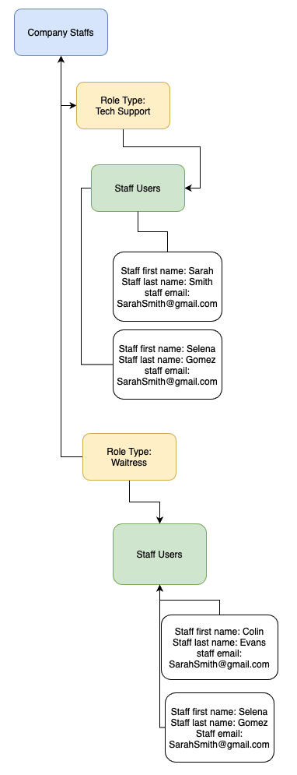

* + Announcements: This will be an array of all announcements created by a business
  + Schedules: Schedules will also be a list of schedules that have been created by a business.
  + Messages: This will also be a subcollection of messages that will follow a similar hierarchy shown above.

### 3.5.2 Staff User Collection

* Each staff user will also be associated with a unique id on the database
* Each staff user will have the following fields:
  + Staff email: This will be a valid staff email address
  + Staff First name: This will be the first name of the staff
  + Staff Last name: This will be the last name of the staff
  + Password: This will be hashed created by a business account when creating an account.
  + Role: This will be a role type assigned to a staff by a business
  + Schedule: This will be a list of schedules assigned by a business to a user
  + Availability:
  + Messages: This will be a root-level collection hierarchy that will contain all messages a staff member has sent or received. For example, in the case of a direct messaging feature, this hierarchy will look like this:

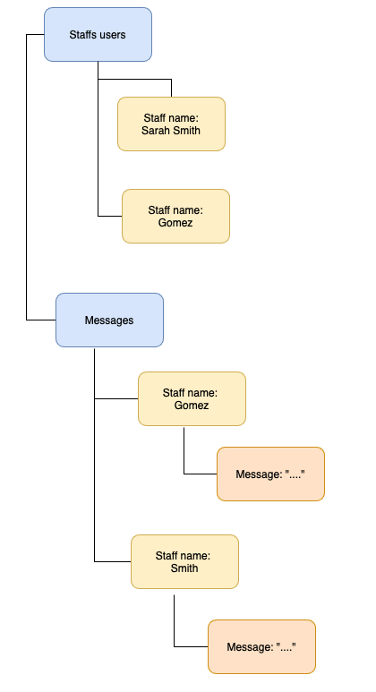

## 3.6 Stretch Goals

This section holds all the additional goals that the team would like to reach later in development but were of lower priority to complete given the limited amount of time to develop the project. If development goes faster than expected, or continues longer currently expect, these will be features that will be added.

|  |  |  |
| --- | --- | --- |
| ID: SG3.5.1 | **Title**: Direct Messaging | |
| **Description:** Users will have the ability to message each other directly and privately. This will be located on the same page as the message board. | | |
| **Inputs:** User entered string for the message | | **Outputs:** Messages from other users |
| **Processing:** A direct message sent by someone in the organization will be stored. Past messages will be viewable whenever a user opens a corresponding direct message. | | |
| **Error Handling:** If a message is unable to be sent due to a slow connection, an error message will be shown and the message will not be sent. | | |
| **Priority:** Low | **Dependencies:**  FR3.2.6: User Login,  FR3.2.26: Message Board | |

|  |  |  |
| --- | --- | --- |
| ID: SG3.5.2 | **Title**: View Available Shift Trades | |
| **Description:** Both management and employees will be able to view the shifts that are up for trade. | | |
| **Inputs:** N/A | | **Outputs:** Available shifts to be traded from other users |
| **Processing:** Any shifts that are designated for trade will be stored as data and will be able to be viewed by anyone in the organization. | | |
| **Error Handling:** If there are no available shift trades, then a message will be shown indicating this. | | |
| **Priority:** Low | **Dependencies:**  FR3.2.6: User Login,  SG3.5.3: Shift Trade Requests | |

|  |  |  |
| --- | --- | --- |
| ID: SG3.5.3 | **Title**: Shift Trade Requests | |
| **Description:** Employees will be able to enter requests to trade shifts with other employees to be sent to management for approval. | | |
| **Inputs:** Available shifts to be traded from other users | | **Outputs:** N/A |
| **Processing:** The times for the shifts that are being traded as well as the employees involved in the shift trade will be sent to the business account for approval. If approved, the employees will get a notification and the schedule will be automatically updated with the new data. | | |
| **Error Handling:** An employee will not be able to request a shift trade if the selected shift is not available for trade. If an employee attempts to request an invalid shift trade, an error message will be shown, and the request will not be submitted. | | |
| **Priority:** Low | **Dependencies:**  FR3.2.5: Staff User Account Registration,  FR3.2.6: User Login,  SG3.5.2: View Available Shift Trades,  SG3.5.4: Shift Trade Notification,  SG3.5.5: Shift Trade Approval,  SG3.5.6: Shift Trade Schedule Update | |

|  |  |  |
| --- | --- | --- |
| ID: SG3.5.4 | **Title**: Shift Trade Notification | |
| **Description:** Employees will receive notification of available shift trades. | | |
| **Inputs:** N/A | | **Outputs:** Available shifts to be traded from other users |
| **Processing:** Any available shift trades with data on the employee that wants to trade as well as the times for that shift will be made viewable by anyone in the organization. | | |
| **Error Handling:** N/A | | |
| **Priority:** Low | **Dependencies:**  FR3.2.5: Staff User Account Registration  FR3.2.6: User Login,  SG3.5.2: View Available Shift Trades,  SG3.5.3: Shift Trade Requests | |

|  |  |  |
| --- | --- | --- |
| ID: SG3.5.5 | **Title**: Shift Trade Approval | |
| **Description:** The business user will be able to approve shift trades made by employees. | | |
| **Inputs:** Shift trade selection to be approved | | **Outputs:** Notification of shift trade approval to affected employees. |
| **Processing:** If a shift trade is approved, the data will be updated so that the employees are now listed to work for their new shifts. The schedule will be updated automatically once a shift trade is approved. | | |
| **Error Handling:** If the schedule is not able to be updated automatically, then the shift trade approval will not be processed. The approval will only succeed if the schedule can also be updated automatically. | | |
| **Priority:** Low | **Dependencies:**  FR3.2.4: Business User Account Registration,  FR3.2.6: User Login,  SG3.5.3: Shift Trade Requests,  SG3.5.6: Shift Trade Schedule Update | |

|  |  |  |
| --- | --- | --- |
| ID: SG3.5.6 | **Title**: Shift Trade Schedule Update | |
| **Description:** When a shift trade is approved, the schedule view will change to reflect that. | | |
| **Inputs:** Approved shift trades | | **Outputs:** New schedule with changes due to shift trades |
| **Processing:** The corresponding data behind an accepted shift trade will be used in order to automatically update the organization’s schedule. Any affected employees will have their schedule view updated in order to show the change in schedule. | | |
| **Error Handling:** If the schedule is not able to be updated automatically, then the shift trade approval will not be processed. The approval will only succeed if the schedule can also be updated automatically. | | |
| **Priority:** Low | **Dependencies:**  F3.2.23: View Schedule  SG3.5.2: Shift Trade Requests,  SG3.5.5: Shift Trade Approval | |

# 4. Analysis Models

## 4.1 Data Flow Diagrams (DFD)

### 4.1.1 Business Web Application Data Flow Diagrams

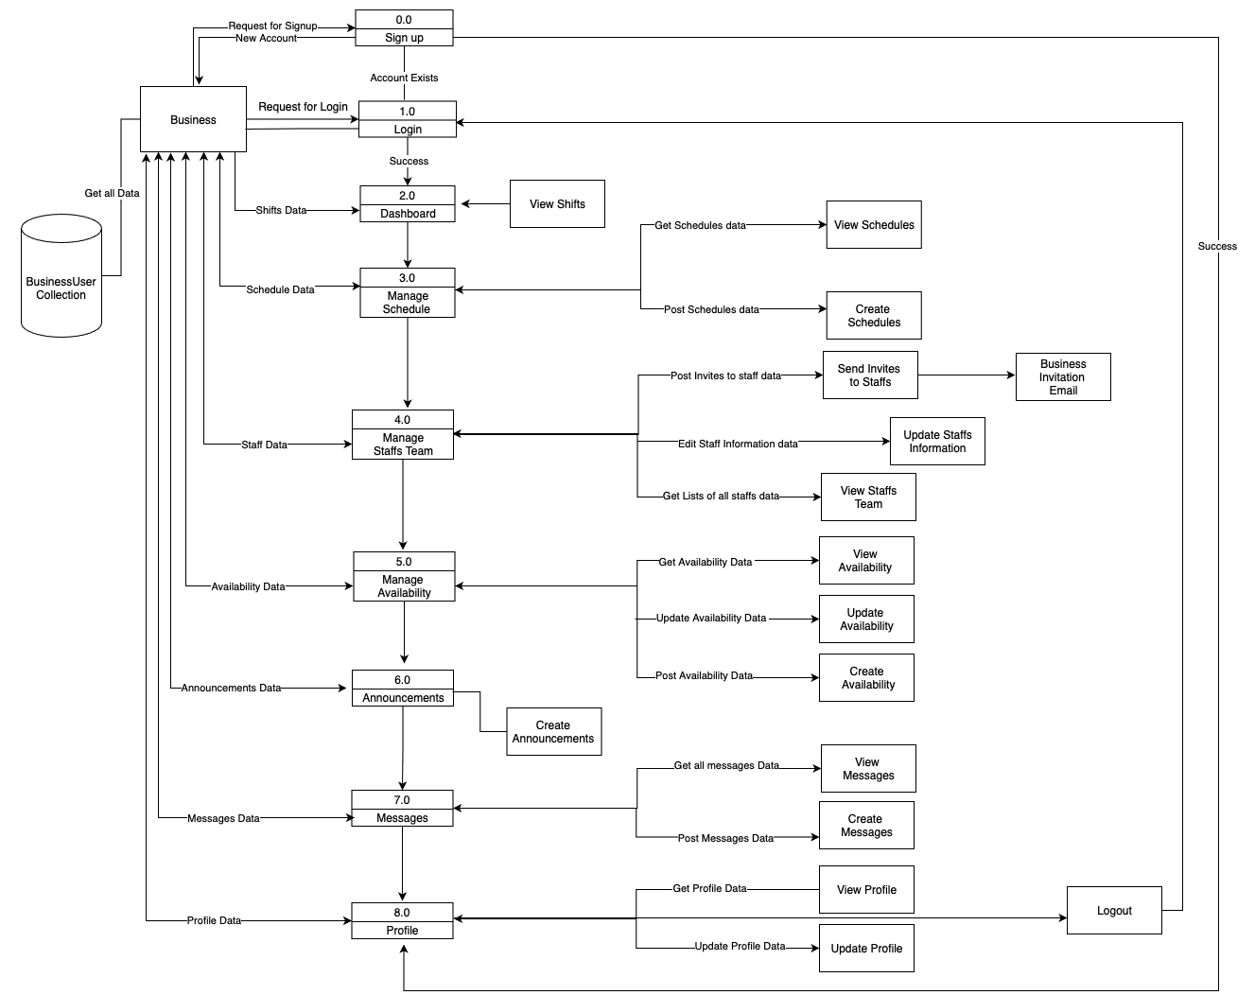

### 4.1.2 Staff Web Application Data Flow Diagram

