GBD2020 Trainings – Clinical Data
Claims Overview ~ Inpatient overview is also present in this thread(review accordingly)
=====================================================================
Maternal Bundle Reports: "J:\WORK\12_bundle\maternal\ClinInfo_BundleReports_Jan2020\MaternalBundleReports_ClinInfo_Jan2020"
=====================================================================
Hi Mae, Jenny,
For the maternal data landscaping I’m doing, Mae had told me to ask Erin Hamilton from Clinical Informatics about “ bundle reports”. Erin sent those to me last week – they’re from Jan 2020. For future reference, I placed those in J:\WORK\12_bundle\maternal\ClinInfo_BundleReports_Jan2020. I also put in that directory a Jan 6, 2020 email she forwarded between her, Nick K, and Ira about the bundle reports. If Jenny ever needs to look at these, there was a training in Jan 2020; link to slides & video is here: https://hub.ihme.washington.edu/display/GBD2020/GBD+2020+Trainings I doubt there’s been an update since on that training.
As an fyi, in her reply, Erin Hamilton of Clinical Informatics mentioned the following (I had asked whether they had any further information on a Kenya source Mae and I had discussed).:
“I forwarded on the bundle reports we created in 2020. The Kenya source pre-dates my time at IHME, so I do not know more about that source. Mohsen may know.
We're doing a review of our hospital data sources that are frequently outliered in clinical data, so we may be excluding sources like these in our estimates moving forward. That decision has not been made formally yet though. “
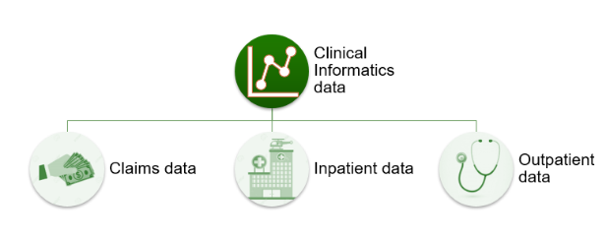
=====================================================================================
=====================================================================================
Clinical Mapping Process
• Clinical data is processed at a more detailed level in your pipelines (ICGs and bundles)
- 60,000 ICD-9 and -10 codes reduce to ~1300 ICG codes which reduce to ~300 bundle codes
- ICD and ICG codes are mutually exclusive and collectively exhaustive while bundle code are not.
- All ICD map to one ICG
- Not all ICGs map to bundle ~(50%)
- Single ICD code can map to multiple bundles
- Some sources do not have ICD coding, so they require a special map
• What is an ICG?
- ICD Cause Group – a grouping of ICD codes (on average, about 11 ICD codes per ICG)
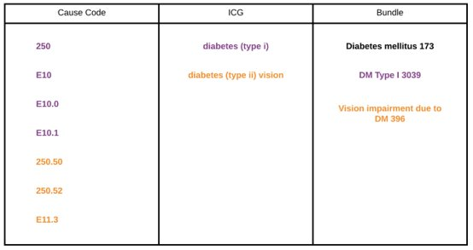
Claims Data Overview
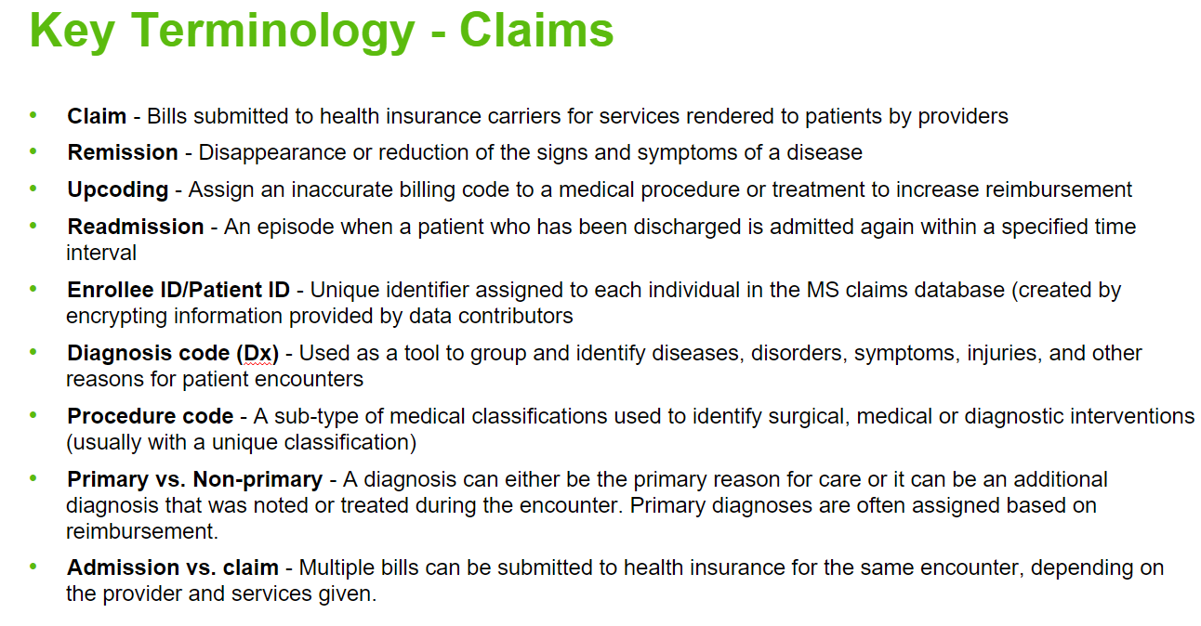
• Used to track reimbursements for care
• Must include information on diagnosis and procedures
• Enrollee IDs allow us to associate claims with an individual
- Allows for tracking patient over space and time
- Requirements for identifying readmissions and outpatient care
• Main pipeline generally refers to Marketscan – other sources are processed similarly, but separately.
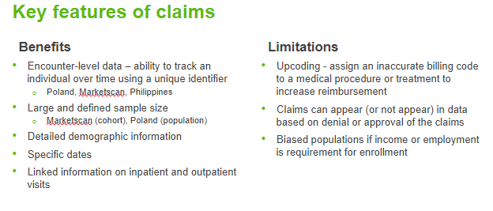
• What is Claims data used for in GBD?
- One of three main clinical data types/outputs
- Claims bundle estimates
- All diagnoses, individuals, inpatient data
- All diagnoses, individuals, inpatient and outpatient data
- Correction factor input data
- Used to correct known issues in inpatient and outpatient data
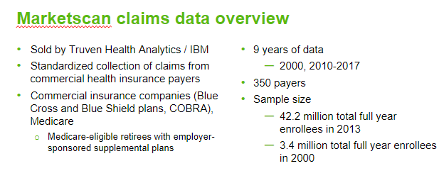
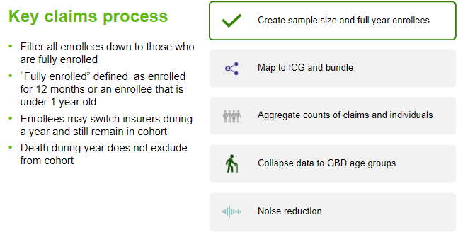
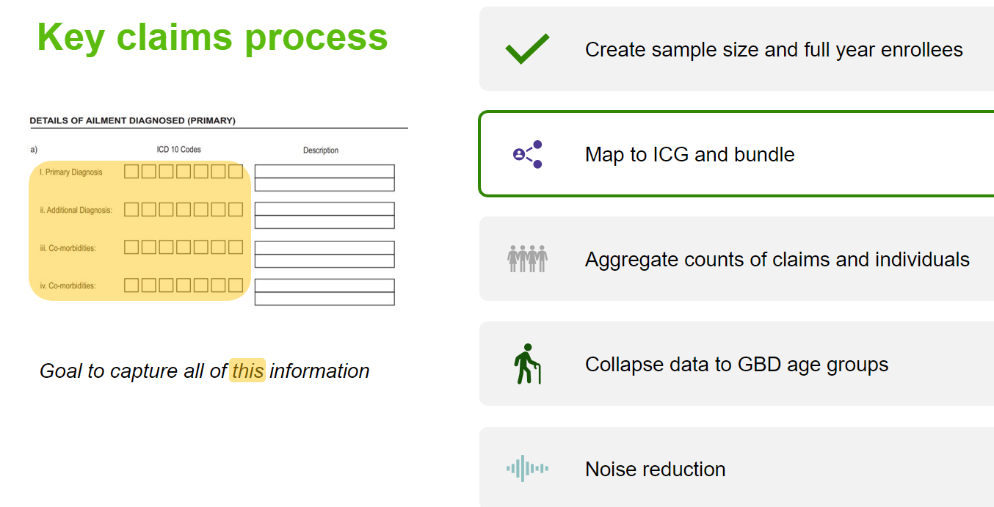
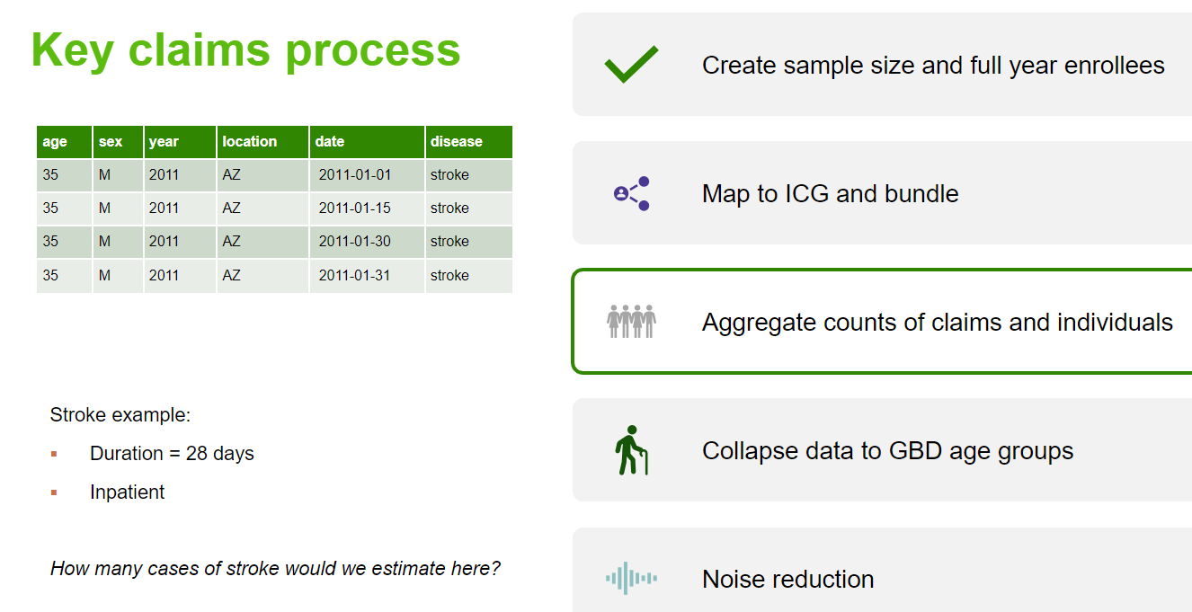
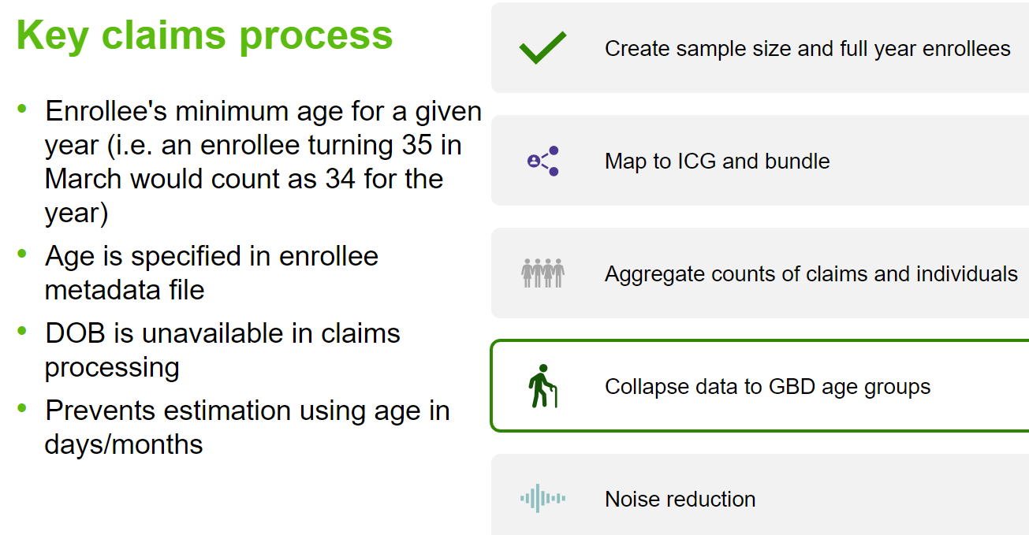
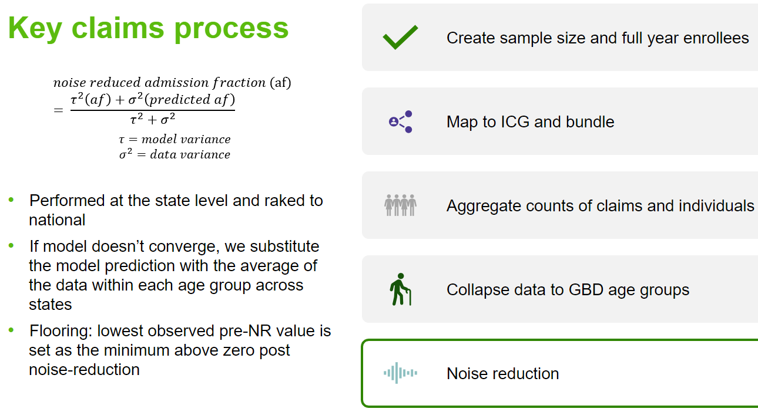
Inpatient Data Overview
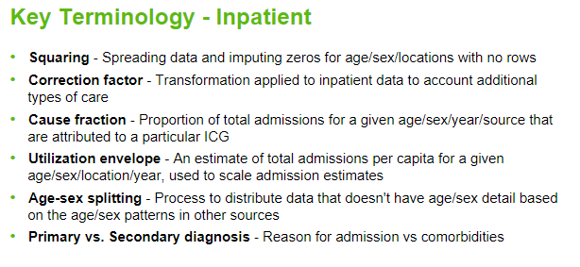
• Inpatient care is defined as overnight admission to a hospital
• Usually more serious conditions that require a higher level of care than outpatient
- Expect to see appendicitis as indication for an admission, but not aczema
- These designations may need to be revisited as modes of care evolve
• Criteria for inpatient data inclusion
- General hospital and specialty clinics (need both or only general)
- Includes demographic information
- Diagnosis classification (ICD-9/10) or tabulated list that can be mapped to GBD causes)
• General goal is to create population-level disease and injury encounter rates or proportions, not just cause estimates for primary inpatient admissions.
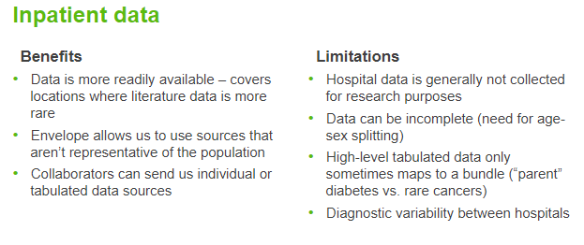
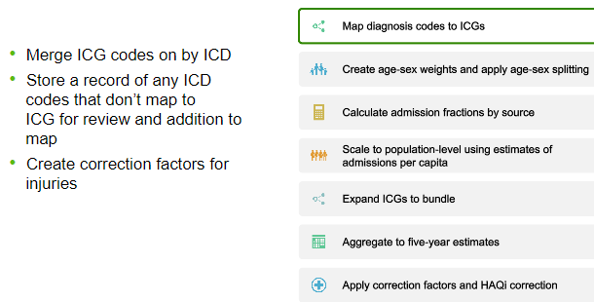
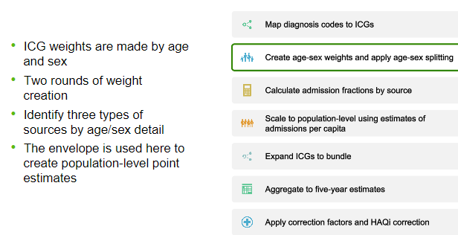
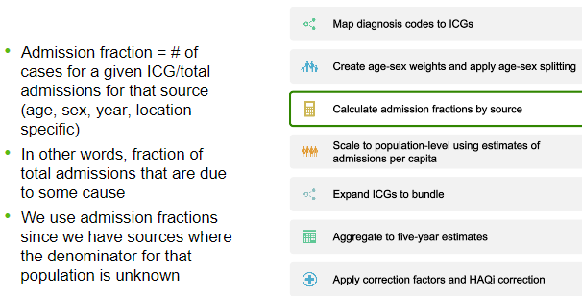
Example: cvd, ischemic, angina
• Cause Fraction = ICG admissions / Total admissions
• Denominator = Total admissions
• Numerator = ICG admissions
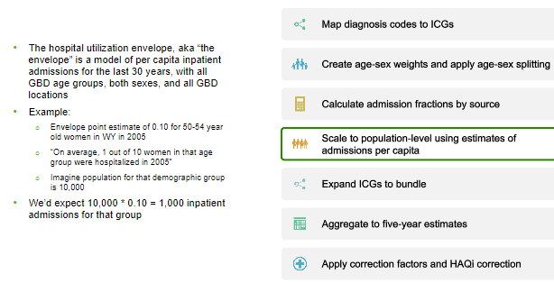
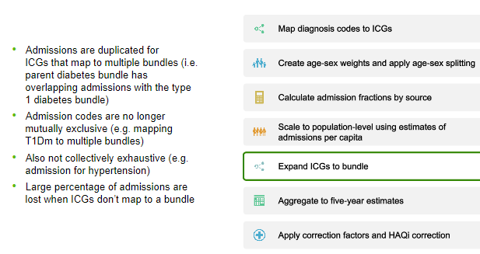
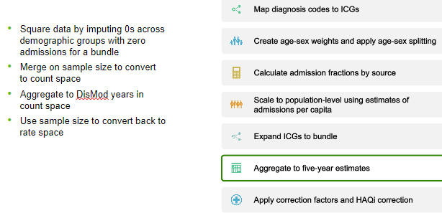
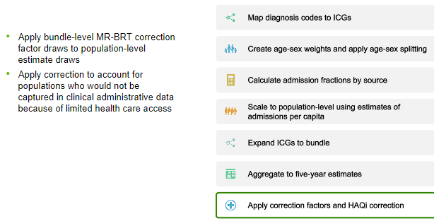
• Transformations/adjustments to inpatient data aimed at better approximating population – level incidence or prevalence.
