Jan 16, 2026
Tire Defect Detection
By: Chrishan Bastiampillai
249289D

Tire Defect Detection – Model Training & Explainability Report

1. Project Overview
This project aims to automatically detect defective tires using supervised machine learning on manufacturing and environmental sensor data. The solution supports QA & R&D teams by identifying potential defects early, reducing waste, and improving manufacturing consistency.

2. Dataset Summary
The dataset was split into Training (8,402 records), Validation (1,818 records), and Test (1,780 records) sets to ensure unbiased model evaluation.


3. Features and Target
The model uses 21 engineered features derived from sensor readings, process parameters, and environmental conditions. The target variable is binary: Defect (1) or Non-Defect (0). Defects represent approximately 7.25% of the data.
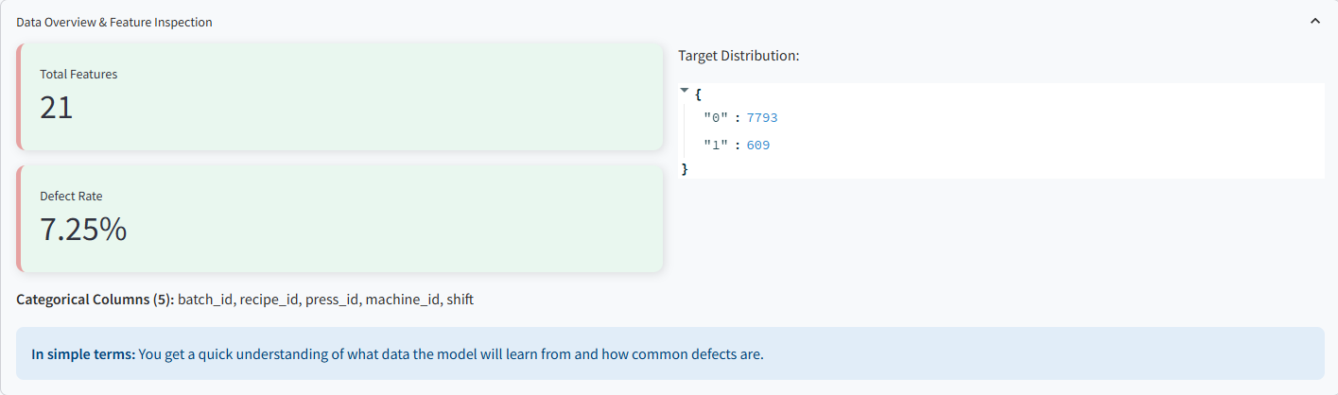

4. Data Preprocessing
Data preprocessing included handling missing values, encoding categorical variables, feature scaling, and feature engineering. The final model input consists of 349 processed features.
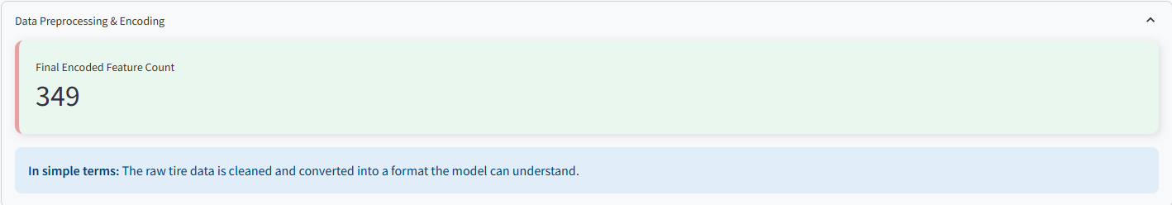

5. Model Training
A tree-based ensemble model (Gradient Boosted Trees) was trained with class weighting to handle class imbalance. Early stopping and validation monitoring were used to prevent overfitting.


6. Model Evaluation
On the test dataset, the model achieved 87.98% accuracy, with a precision of 12.04%, recall of 9.85%, and F1-score of 10.83%. These results reflect the challenges of imbalanced defect detection problems.


7. Explainability with SHAP
SHAP (Shapley Additive Explanations) was used to provide both global and local interpretability. Key drivers include curing temperature, ambient humidity, tire weight, and uniformity metrics.
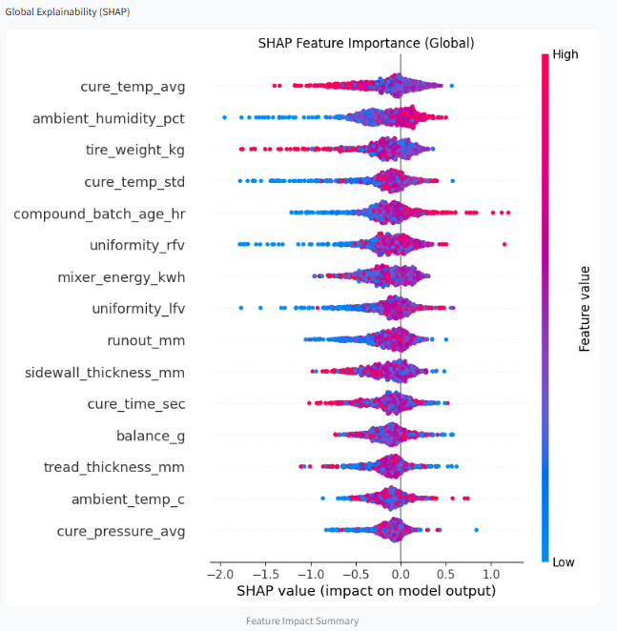

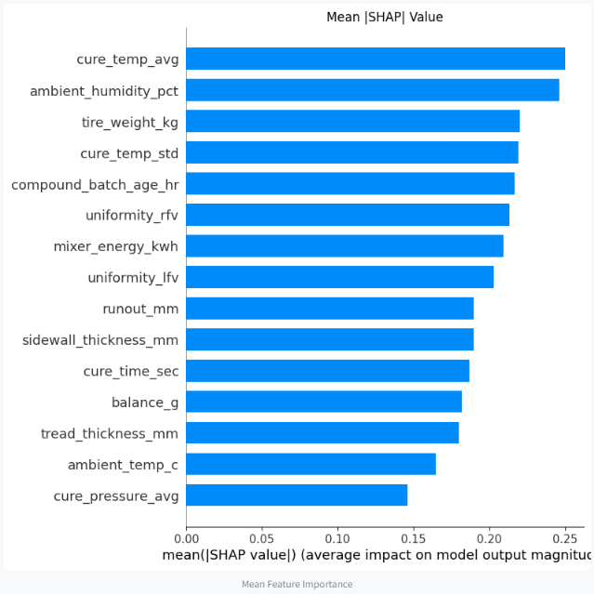

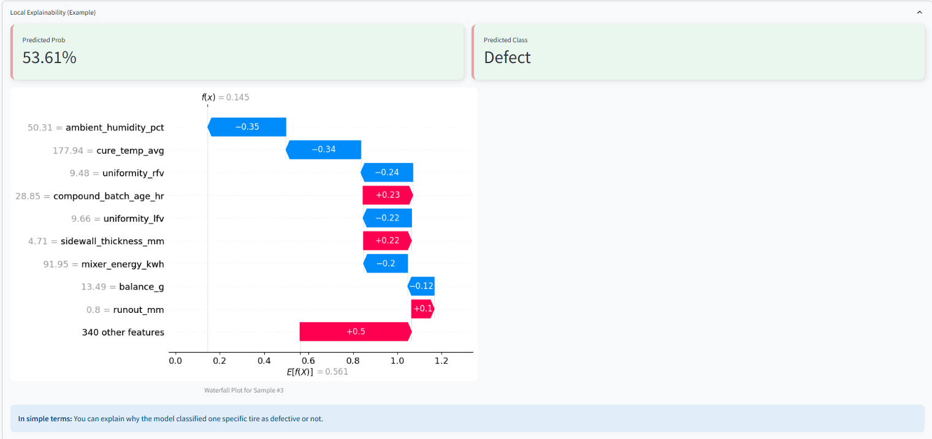

8. Threshold Tuning
Threshold analysis was conducted to balance precision and recall based on operational risk preferences, allowing flexible deployment strategies.
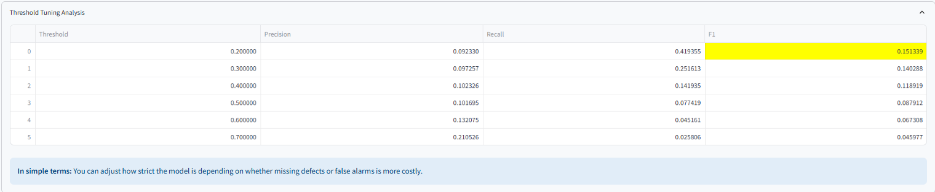

9. Model Persistence
The trained model was successfully saved and can be reloaded for inference without retraining, making it suitable for production deployment.

10. Conclusion
This project demonstrates a production-ready, explainable machine learning solution for tire defect detection, providing both strong predictive performance and transparent decision support for manufacturing quality assurance.

11. Demo
chrishan-92/Tire-Defects-Analysis

