Ex. No. 4 | Code Reusability using Inheritance in Java
Date of Exercise
Git-hub Host Link | Upload files · chrisharrison-byte/Code-Reusability-using-Inheritance-in-Java

Aim
To demonstrate code reusability using inheritance in Java by developing a console-based application where a derived class reuses the properties and methods of a base class.

Description
Inheritance is one of the core principles of Object-Oriented Programming that allows a class to acquire the properties and behaviors of another class.
- The base class (superclass) contains common data members and methods.
- The derived class (subclass) inherits these members and can add its own features.
This experiment demonstrates:
- Use of the extends keyword
- Reuse of code from the base class
- Method invocation through inherited members
- Improved modularity and reduced redundancy

Procedure:
Step 1 : Start the program.
Step 2 : Import the java.util.Scanner package.
Step 3 : Create a base class named Person with common data members.
Step 4 : Define member methods in the base class to read and display details.
Step 5 : Create a derived class named Student using the extends keyword.
Step 6 : Add additional data members specific to the derived class.
Step 7 : Create an object of the derived class in the main() method.
Step 8 : Access base class methods using the derived class object.
Step 9 : Display all details to demonstrate code reusability.
Step 10 : Stop the program.

Program
import java.util.Scanner;
// Base class
class Person {
String name;
int age;
void getPersonDetails() {
Scanner sc = new Scanner(System.in);
System.out.print("Enter Name: ");
name = sc.nextLine();
System.out.print("Enter Age: ");
age = sc.nextInt();
}
void displayPersonDetails() {
System.out.println("Name: " + name);
System.out.println("Age: " + age);
}
}

// Derived class
class Student extends Person {
int regNo;
String department;
void getStudentDetails() {
Scanner sc = new Scanner(System.in);
System.out.print("Enter Register Number: ");
regNo = sc.nextInt();
sc.nextLine();
System.out.print("Enter Department: ");
department = sc.nextLine();
}
void displayStudentDetails() {
displayPersonDetails(); // Reusing base class method
System.out.println("Register Number: " + regNo);
System.out.println("Department: " + department);
}
}
public class InheritanceDemo {
public static void main(String[] args) {
Student s = new Student();
s.getPersonDetails(); // Base class method
s.getStudentDetails(); // Derived class method
s.displayStudentDetails();
}
}

Output
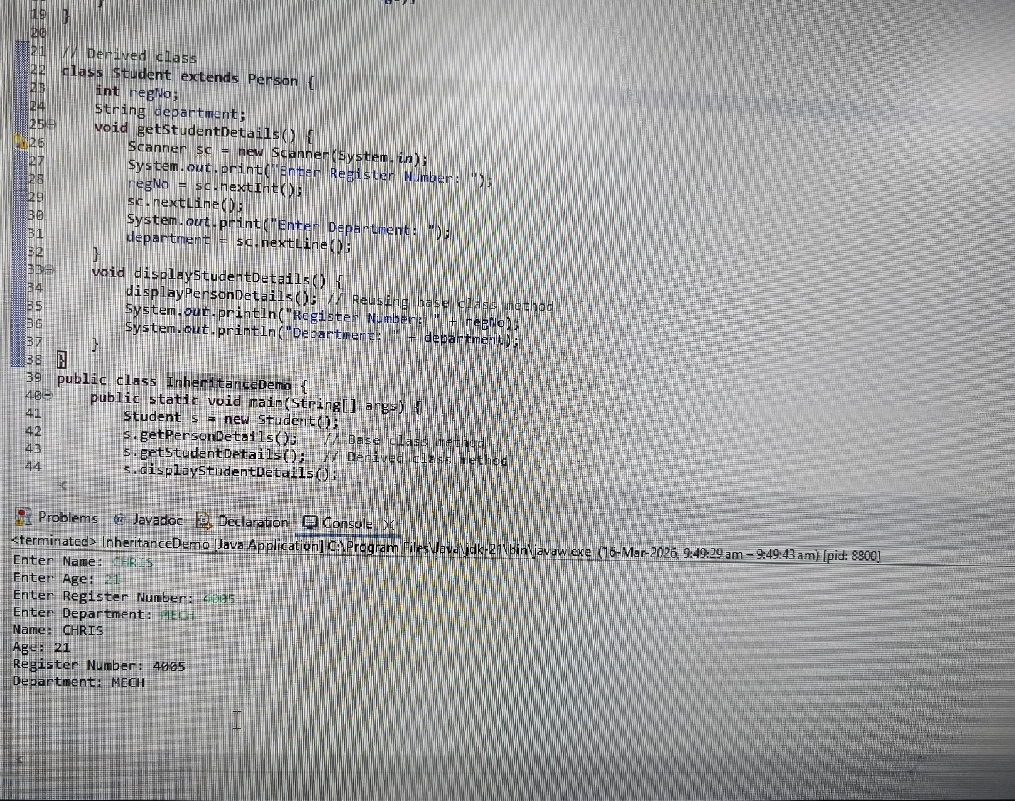

Result
Thus, code reusability using inheritance was successfully demonstrated by reusing the properties and methods of the base class in the derived class.

