Ex. No. 9 | Data management using File handling
Date of Exercise | 16-03-2026
Git-hub Host Link

Aim
To demonstrate data management using file handling in Java by creating, writing, and reading data from a file.

Description
File handling in Java allows programs to store and retrieve data from files permanently. It is commonly used for data storage, logging, and record management.
Java provides classes in the java.io package to perform file operations such as:
- Creating a file
- Writing data into a file
- Reading data from a file
This experiment demonstrates the use of:
- FileWriter for writing data to a file
- FileReader and BufferedReader for reading data from a file
File handling is widely used in applications like student record systems, banking systems, and data processing applications.

Procedure:
Step 1 : Start the program.
Step 2 : Import the java.io package for file handling operations.
Step 3 : Create a file object to represent the file.
Step 4 : Use FileWriter to write data into the file.
Step 5 : Close the file after writing the data.
Step 6 : Use FileReader and BufferedReader to read data from the file.
Step 7 : Read the contents of the file line by line.
Step 8 : Display the file contents on the console.
Step 9 : Close the file reader object.
Step 10 : Stop the program.

Program
import java.io.*;
public class FileHandlingDemo {
public static void main(String[] args) {
try {
// Writing data to file
FileWriter writer = new FileWriter("student.txt");
writer.write("Name: Tilak\n");
writer.write("Department: CSE\n");
writer.write("University: Karunya Institute\n");
writer.close();
System.out.println("Data written to file successfully.\n");
// Reading data from file
FileReader reader = new FileReader("student.txt");
BufferedReader br = new BufferedReader(reader);
String line;
System.out.println("Reading data from file:");
while ((line = br.readLine()) != null) {
System.out.println(line);
}
br.close();
}
catch (IOException e) {
System.out.println("An error occurred.");
}
}
}

Output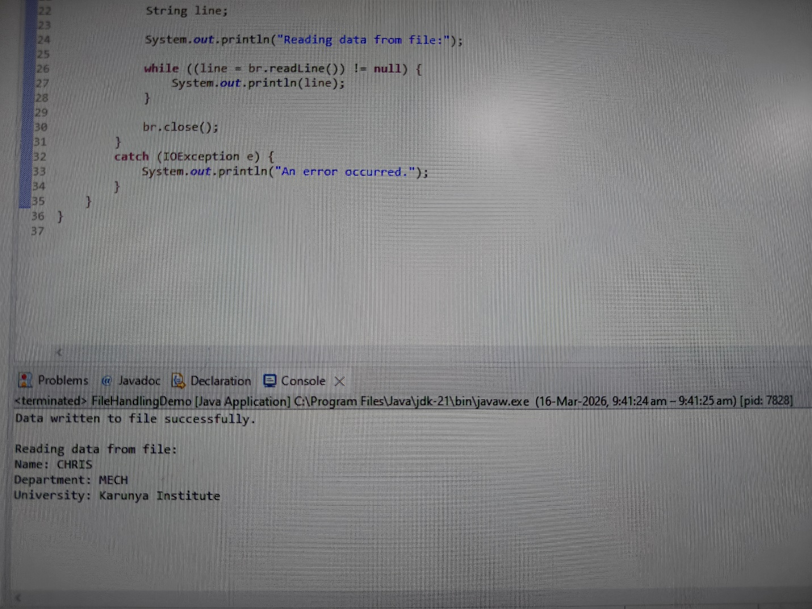
Result
Thus, data management using file handling was successfully implemented by writing data to a file and reading the stored data using Java file handling classes.

