Empirical Workshop 1

Filip Mellgren

2019-04-02

library(rio)  
library(tidyverse)  
library(AER)  
library(ggthemes)  
library(stargazer)

df <- import("dutch_coffee.dta")

df %>% head()

## maand year month qu cprice tprice incom q1 q2 q3 q4 bprice wprice  
## 1 29 1990 1 0.55 12.12 18.6 1640.87 1 0 0 0 3.47 28.15  
## 2 22 1990 2 0.65 12.12 18.6 1538.60 1 0 0 0 3.40 28.15  
## 3 50 1990 3 0.66 12.12 18.6 1680.93 1 0 0 0 3.26 28.33  
## 4 1 1990 4 0.66 12.12 18.6 1656.20 0 1 0 0 3.46 28.49  
## 5 57 1990 5 0.64 12.12 18.6 1700.80 0 1 0 0 3.47 28.55  
## 6 43 1990 6 0.65 12.12 18.6 1732.67 0 1 0 0 3.68 28.55  
## oprice  
## 1 1  
## 2 1  
## 3 1  
## 4 1  
## 5 1  
## 6 1

# Create time variable  
df <- df %>% mutate(time = year + month/12)

## Summary statistics

Present and discuss summary statistics of the data. Show and describe the following relationships: (a) per capita consumption of roasted coffee and the price of roasted coffee, (b) consumption of roasted coffee and price of tea, (c) price of roasted coffee and price of labor, (d) price of roasted coffee and price of tea. Comment if you observe any clear time trends.

### Summary Table

#summary(df$cprice)  
sapply(select(df, cprice, tprice, wprice, qu), summary)

## cprice tprice wprice qu  
## Min. 11.00917 16.38983 28.15000 0.5200000  
## 1st Qu. 11.45455 17.29825 28.97850 0.6300000  
## Median 12.12000 17.56278 29.19489 0.6600000  
## Mean 12.82877 17.64858 29.18545 0.6815476  
## 3rd Qu. 13.50216 17.93442 29.43054 0.7400000  
## Max. 17.69912 18.60396 30.08333 1.0400000

### Per capita consumption of roasted coffe and price of roasted coffee

# descriptives are important!  
# Plot all the time series in separate graphs  
# a) per capita consumption of roasted coffee and price of roasted coffee  
df %>% ggplot(aes(x = time, y = qu)) +  
 geom_line() +  
 labs(y = "Quantity", x = "Year", title = "Per capita consumption of roasted coffee")

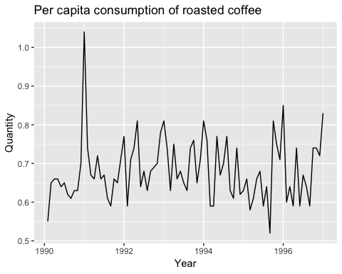

df %>% ggplot(aes(x = time, y = cprice)) +  
 geom_line() +  
 theme_economist() + scale_colour_economist() +  
 labs(y = "Price", x = "Year", title = "Price of roasted coffee")

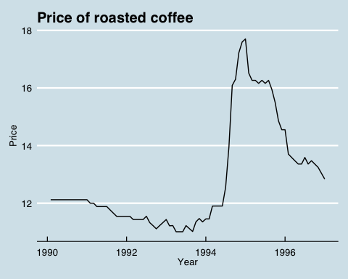

# Coffee and tea and quantity indexed  
df <- df %>% mutate("price roasted coffee" = cprice/cprice[1]*100,  
 "price tea" = tprice/tprice[1]*100,  
 "pc roasted coffee consumption" = qu/qu[1]*100,  
 "price coffee beans" = bprice/bprice[1]*100)   
  
df %>% gather(`price roasted coffee`, `price tea`, `pc roasted coffee consumption`, key = "index", value = "price") %>%   
 ggplot(aes(x = time, y = price, color = index )) +  
 geom_line() +  
 theme_economist() + scale_colour_economist() +  
 labs(y = "Indexed price and consumption", x = "Year", title = "No obvious correlations")

## Warning: attributes are not identical across measure variables;  
## they will be dropped

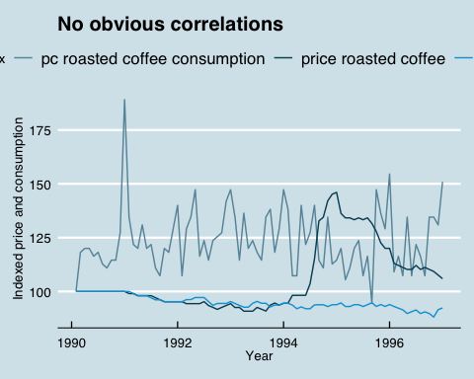

# Calculate correlations  
cor(df$cprice, df$tprice)

## [1] -0.3161684

cor(df$cprice, df$qu)

## [1] -0.186854

cor(df$tprice, df$qu)

## [1] -0.01671327

df %>% gather(`price roasted coffee`, `price coffee beans`, key = "index", value = "price") %>%   
 ggplot(aes(x = time, y = price, color = index )) +  
 geom_line() +  
 theme_economist() + scale_colour_economist() +  
 labs(y = "Indexed price", x = "Year", title = "Roasted coffee prices depend heavily on bean prices")

## Warning: attributes are not identical across measure variables;  
## they will be dropped

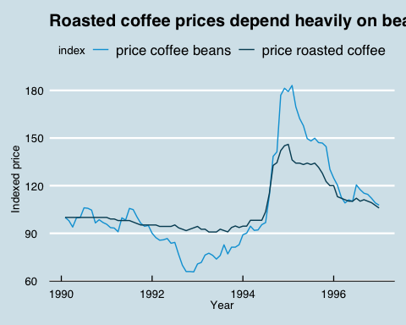

### Consumption of roasted coffee and price of tea

# consumption of roasted coffee and price of tea  
df %>% ggplot(aes(x = time, y = tprice)) +  
 geom_line() +  
 labs(y = "Price", x = "Year", title = "Price of tea")

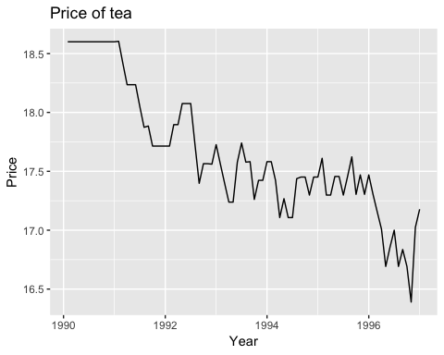

### c and d

df <- df %>% mutate("roasted coffee" = cprice/cprice[1]*100,  
 tea = tprice/tprice[1]*100,  
 wages = wprice/wprice[1]*100)   
  
df %>% gather(`roasted coffee`, tea, wages, key = "Index", value = "price") %>%   
 ggplot(aes(x = time, y = price, color = Index)) +  
 geom_line() +  
 theme_economist() + scale_colour_economist() +   
 labs(y = "Indexed price", x = "Year",   
 title = "Coffee price jitters: wages and tea prices unaffected")

## Warning: attributes are not identical across measure variables;  
## they will be dropped

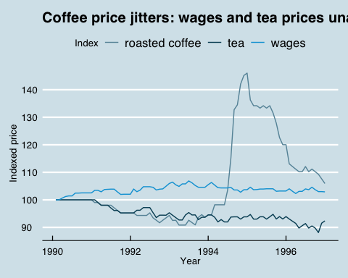

# price of roasted coffee and price of labor  
df %>% ggplot(aes(x = time, y = wprice)) +  
 geom_line() +  
 labs(y = "Price", x = "Year", title = "Wages over time")

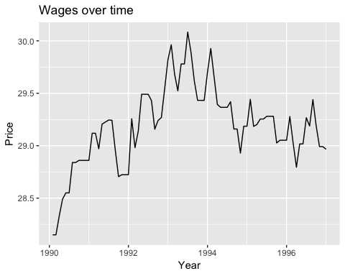

# price of roasted coffee and price of tea

## Regress

df <- df %>% mutate(cprice = cprice / oprice,  
 wprice = wprice / oprice,  
 tprice = tprice / oprice)  
  
no_controls <- lm(log(qu) ~ log(cprice), data = df)  
quarter_controls <- lm(log(qu) ~ log(cprice) + q1 + q2 + q3, data = df)

stargazer(no_controls, quarter_controls, header = FALSE)

## Supply and demand shifts

Start from the data that we have.

Valid instrument, corr(zx) > 0, E(z epsilon) = 0. How to find instruments?

Supply shift: wages, prices of beans

Demand shift:

## Log linear demand estimation

$log(Q)=β_{0}+β_{1}log(P)+ε$

$Q=e^{β_{0}+β_{1}log(P)+ε}$

$\beta_1 = \frac{dQ}{dP}\frac{P}$

tea_control <- lm(log(qu) ~log(cprice) + q1 + q2 + q3 + log(tprice), data = df)  
income_control <- lm(log(qu) ~log(cprice) + q1 + q2 + q3 + log(tprice) +  
 log(incom), data = df)  
  
# seasonal controls summary  
stargazer(no_controls, quarter_controls, tea_control, income_control,   
 header = FALSE, type = "text")

##   
## ==========================================================================================================  
## Dependent variable:   
## --------------------------------------------------------------------------------------  
## log(qu)   
## (1) (2) (3) (4)   
## ----------------------------------------------------------------------------------------------------------  
## log(cprice) -0.238** -0.254*** -0.255*** -0.270***   
## (0.104) (0.094) (0.095) (0.095)   
##   
## q1 -0.127*** -0.127*** -0.111***   
## (0.030) (0.031) (0.033)   
##   
## q2 -0.092*** -0.092*** -0.092***   
## (0.030) (0.031) (0.030)   
##   
## q3 -0.118*** -0.118*** -0.106***   
## (0.030) (0.030) (0.031)   
##   
## log(tprice) -0.015 0.200   
## (0.133) (0.205)   
##   
## log(incom) 0.513   
## (0.374)   
##   
## Constant 0.196 0.319 0.365 -4.051   
## (0.257) (0.234) (0.458) (3.246)   
##   
## ----------------------------------------------------------------------------------------------------------  
## Observations 84 84 84 84   
## R2 0.060 0.265 0.265 0.282   
## Adjusted R2 0.048 0.228 0.218 0.227   
## Residual Std. Error 0.109 (df = 82) 0.098 (df = 79) 0.099 (df = 78) 0.098 (df = 77)   
## F Statistic 5.219** (df = 1; 82) 7.112*** (df = 4; 79) 5.621*** (df = 5; 78) 5.052*** (df = 6; 77)  
## ==========================================================================================================  
## Note: *p<0.1; **p<0.05; ***p<0.01

## One major concern

ivreg

IV_spec <- ivreg(log(qu) ~ log(cprice) + q1 + q2 + q3 + log(tprice) +  
 log(incom) | q1 + q2 + q3 + log(tprice) +  
 log(incom) + log(bprice) + log(wprice), data = df)  
  
stargazer(IV_spec, income_control, header = FALSE, type = "text")

##   
## ================================================================  
## Dependent variable:   
## ----------------------------------  
## log(qu)   
## instrumental OLS   
## variable   
## (1) (2)   
## ----------------------------------------------------------------  
## log(cprice) -0.288*** -0.270***   
## (0.101) (0.095)   
##   
## q1 -0.111*** -0.111***   
## (0.033) (0.033)   
##   
## q2 -0.093*** -0.092***   
## (0.030) (0.030)   
##   
## q3 -0.106*** -0.106***   
## (0.031) (0.031)   
##   
## log(tprice) 0.201 0.200   
## (0.205) (0.205)   
##   
## log(incom) 0.521 0.513   
## (0.374) (0.374)   
##   
## Constant -4.067 -4.051   
## (3.247) (3.246)   
##   
## ----------------------------------------------------------------  
## Observations 84 84   
## R2 0.282 0.282   
## Adjusted R2 0.226 0.227   
## Residual Std. Error (df = 77) 0.098 0.098   
## F Statistic 5.052*** (df = 6; 77)  
## ================================================================  
## Note: *p<0.1; **p<0.05; ***p<0.01

summary(IV_spec, diagnostics = TRUE)

##   
## Call:  
## ivreg(formula = log(qu) ~ log(cprice) + q1 + q2 + q3 + log(tprice) +   
## log(incom) | q1 + q2 + q3 + log(tprice) + log(incom) + log(bprice) +   
## log(wprice), data = df)  
##   
## Residuals:  
## Min 1Q Median 3Q Max   
## -0.190660 -0.074534 -0.007248 0.060874 0.329964   
##   
## Coefficients:  
## Estimate Std. Error t value Pr(>|t|)   
## (Intercept) -4.06707 3.24656 -1.253 0.21409   
## log(cprice) -0.28771 0.10053 -2.862 0.00542 **  
## q1 -0.11077 0.03262 -3.396 0.00108 **  
## q2 -0.09255 0.03046 -3.038 0.00325 **  
## q3 -0.10600 0.03148 -3.367 0.00119 **  
## log(tprice) 0.20076 0.20530 0.978 0.33121   
## log(incom) 0.52098 0.37386 1.394 0.16747   
##   
## Diagnostic tests:  
## df1 df2 statistic p-value   
## Weak instruments 2 76 345.070 <2e-16 ***  
## Wu-Hausman 1 76 0.314 0.577   
## Sargan 1 NA 0.141 0.707   
## ---  
## Signif. codes: 0 '***' 0.001 '**' 0.01 '*' 0.05 '.' 0.1 ' ' 1  
##   
## Residual standard error: 0.09823 on 77 degrees of freedom  
## Multiple R-Squared: 0.2821, Adjusted R-squared: 0.2262   
## Wald test: 5.081 on 6 and 77 DF, p-value: 0.0001933

## Degree of competition in the Dutch coffee market

c0 = 4  
h = 1.19  
df <- df %>% mutate(c = c0 + h*bprice) # we know the cost already

### Lerner index

$L=\frac{P−c}{P}$

df <- df %>% mutate(L = (cprice - c)/cprice)

### Adjusted Lerner index

$L_{η}=\frac{P−c}{P}\overset{^}{η}$

eta = -0.27737 # The price elastsicity of demand from the IV  
df <- df %>% mutate(L_adj = -eta * L)

# Summary statistics for both and seasonal variation (plot)  
  
df %>% gather(L, L_adj, key = Type, value = Lerner_index) %>%  
 ggplot(aes(x = time, y = Lerner_index, color = Type)) +  
 geom_line() +  
 theme_economist() + scale_colour_economist() +  
 labs(title = "Firms have a mark up, yet the market is rather competitive",  
 y = "Lerner index", x = "Year")

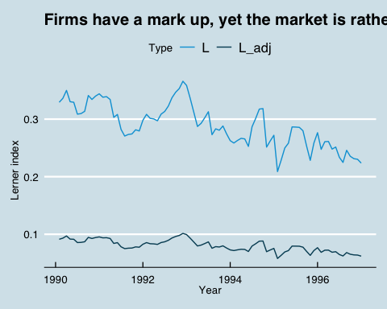

quarterly_table <- df %>% group_by(q1, q2, q3, q4) %>%   
 summarize("mean unadjusted" = mean(L),  
 "mean adjusted" = mean(L_adj),  
 "std unadjusted" = sqrt(var(L)),  
 "std adjusted" = sqrt(var(L_adj))) %>%  
 mutate(quarter = case_when(  
 q1 == 1 ~ "Q1",  
 q2 == 1 ~ "Q2",  
 q3 == 1 ~ "Q3",  
 q4 == 1 ~ "Q4")) %>%  
 as_tibble()  
  
quarterly_table %>% select(-q1, -q2, -q3, -q4) %>%  
 select(quarter, everything()) %>%  
 arrange(quarter)

## # A tibble: 4 x 5  
## quarter `mean unadjusted` `mean adjusted` `std unadjusted` `std adjusted`  
## <chr> <dbl> <dbl> <dbl> <dbl>  
## 1 Q1 0.291 0.0808 0.0417 0.0116   
## 2 Q2 0.288 0.0800 0.0275 0.00762  
## 3 Q3 0.290 0.0804 0.0344 0.00955  
## 4 Q4 0.286 0.0794 0.0457 0.0127

## Conduct parameter

Estimate for the entire period $P=\frac{ηc}{η−λ}$ $P=b*c$, estimate $\overset{^}{b}$ from a regression and solve for lambda:

$\overset{^}{b}=\frac{η}{η−\overset{^}{λ}}$

We estimate the following regression: $P_{coffee}=b*cost+β′Q$ where $Q$ is a vector of four quarterly dummies (including all four because we don’t include any intercept).

no_dummies <- lm(cprice ~ c + 0, data = df) # plus 0 for no intercept?  
q_dummies <- lm(cprice ~ c + 0 + q1 + q2 + q3 + q4, data = df) # add controls  
# obtain estimate of b  
b <- q_dummies$coefficients[1]

We obtain the following estimate for $b$: 1.11 which we use to plug into the following formula: $λ=\frac{\overset{^}{η}(\overset{^}{b}−1)}{\overset{^}{b}}$

lambda = eta * (b-1)/b

We estimate $λ$ to be equal to -0.03 $λ$ is a measure of number of identical firms.