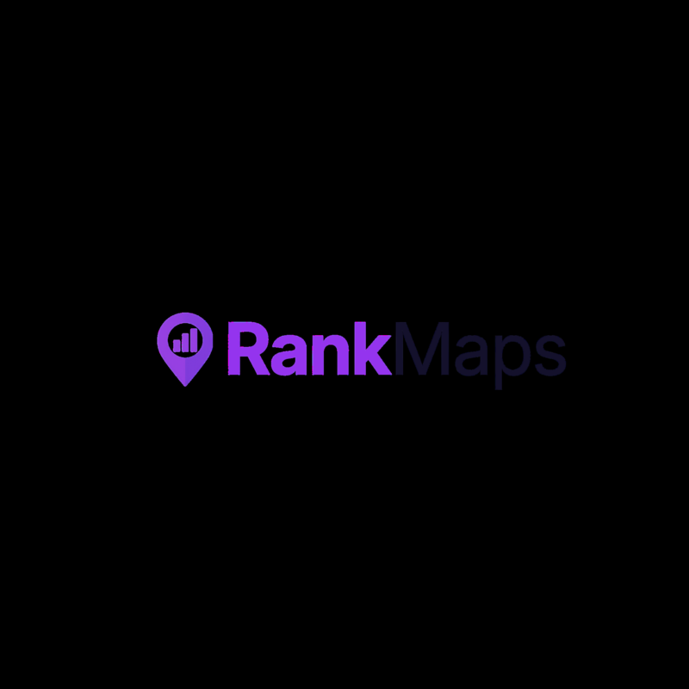

RANKMAPS.IO
Brand Guidelines

AI-Powered Local SEO Management
www.rankmaps.io
hello@rankmaps.io | Provo, Utah

Version 1.0 | March 2026

1. Brand Overview

Who We Are
Rankmaps.io is an AI-powered local SEO platform built to manage and optimize Google Business Profiles at scale. Founded with the belief that local businesses deserve enterprise-grade tools without the enterprise complexity, Rankmaps.io puts the power of AI to work so business owners can focus on what they do best.
We are not just another SEO tool. We are an intelligent agent that actively manages, optimizes, and monitors your Google Business Profile—delivering measurable results with minimal effort on your part.

Mission Statement
To empower local service businesses with AI-driven tools that automate and optimize their Google Business Profile presence, driving real, measurable growth and directly impacting their bottom line.

Brand Promise
We put your local SEO on autopilot. Smarter optimization, better rankings, more customers—powered by AI.

Key Differentiators
- AI-powered automation—your GBP is managed 24/7 by intelligent agents
- Hands-off optimization: posts, Q&A, review responses, and category tuning handled automatically
- Data-driven insights and recommendations powered by real-time ranking data
- Built for local businesses—not bloated enterprise software repurposed for SMBs
- Transparent results: ROI-focused reporting, not vanity metrics

2. Color Palette
Our color palette is anchored by a vibrant purple that conveys confidence, creativity, and premium quality. It is paired with clean neutrals for readability and professionalism.

Swatch | Name | HEX | RGB | Usage
 | Primary Purple | #8F63E9 | 143, 99, 233 | CTAs, accents, highlights
 | Dark Charcoal | #1D2025 | 29, 32, 37 | Headings, body text
 | Medium Gray | #6B7280 | 107, 114, 128 | Secondary text, captions
 | Light Gray | #F1F2F4 | 241, 242, 244 | Backgrounds, dividers
 | White | #FFFFFF | 255, 255, 255 | Primary background
 | Purple Light | #E8DEFA | 232, 222, 250 | Accent backgrounds, tags

Color Usage Rules
- Primary Purple (#8F63E9) is used for CTAs, links, accent text, and the logo. It should always have strong contrast against its background.
- Dark Charcoal (#1D2025) is the default for all headings and body copy. Never use pure black (#000000).
- Purple Light (#E8DEFA) is used sparingly for highlight backgrounds, tags, and feature callout boxes.
- White is the default page/slide background. Avoid colored full-page backgrounds.

3. Typography
Poppins is our sole typeface across all brand materials. It is a geometric sans-serif that is modern, clean, and highly readable at all sizes. It is available for free via Google Fonts.

Poppins Bold — Primary Headings
Poppins SemiBold — Subheadings
Poppins Regular — Body copy, descriptions, and general content
Poppins Regular — Captions, footnotes, and metadata

Element | Size | Weight | Color | Line Height
Display / Hero | 48–60pt | Bold | #8F63E9 | 1.1
H1 / Page Title | 28–36pt | Bold | #8F63E9 | 1.2
H2 / Section Title | 22–28pt | Bold | #1D2025 | 1.3
H3 / Subsection | 18–22pt | SemiBold | #1D2025 | 1.3
Body | 10–12pt | Regular | #1D2025 | 1.5
Caption / Small | 8–9pt | Regular | #6B7280 | 1.4
Accent / CTA Text | 10–14pt | SemiBold | #FFFFFF on Purple | 1.2

Typography Rules
- Always use Poppins. Fallback: system-ui, sans-serif.
- Use purple (#8F63E9) for H1/display headings. Use dark charcoal (#1D2025) for H2 and below.
- Bold keywords or phrases in purple to create emphasis (e.g., “AI-powered,” “automated optimization”).
- Do not use decorative, serif, or script fonts in any brand material.

4. Logo
The Rankmaps.io logo consists of a purple map pin icon containing a rising bar chart, paired with the wordmark “RankMaps” where “Rank” is set in purple and “Maps” in dark charcoal.
The logo is available in multiple formats (SVG, PNG, JPG) and color variants for use across all media.

Primary Logo (Full Color)
The primary full-color logo on a white background. This is the default logo for most use cases.


Logo Mark (Icon Only)
The standalone map pin icon for use as favicons, app icons, social media avatars, and other small-format applications.

Logo Type (Wordmark Only)
The wordmark without the icon. Use when the icon mark is already displayed separately or when horizontal space is limited.

Available File Formats
Variant | SVG | PNG | JPG
Full Logo (Color) | logo.svg | logo.png | logo.jpg
Full Logo (Black) | logo_black.svg | logo_black.png | logo_black.jpg
Full Logo (White) | logo_white.svg | logo_white.png | logo_white.jpg
Logo Mark (Icon) | logo-mark.svg | logo-mark.png | logo-mark.jpg
Logo Type (Wordmark) | logo-type.svg | logo-type.png | logo-type.jpg

Logo Usage Rules
- Minimum clear space around the logo should equal the height of the map pin icon on all sides.
- The logo should always appear on a white or very light background. For dark backgrounds, use the white-reversed version.
- Never stretch, rotate, recolor, or add effects (drop shadow, glow, etc.) to the logo.
- Minimum size: 120px wide for digital, 1 inch wide for print.
- The icon may be used standalone (without the wordmark) as a favicon or app icon only.

5. Brand Voice & Tone
Rankmaps.io’s brand voice is confident, direct, and results-oriented. We speak plainly, back claims with data, and position ourselves as the smart, automated solution for local SEO. Our tone is professional but never corporate; approachable but never soft.

Voice Attributes
Attribute | We Are | We Are Not
Confident | Bold claims backed by data | Arrogant or dismissive
Direct | Clear, no-nonsense language | Blunt or rude
Results-Driven | Focused on ROI and revenue | Obsessed with vanity metrics
Intelligent | AI-first, smart automation | Hype-driven or buzzword-heavy
Approachable | Easy to understand, friendly | Jargon-heavy or inaccessible
Authentic | Honest, transparent, real | Overly polished or corporate

Key Brand Phrases
- “AI-Powered Local SEO Management”
- “Your Google Business Profile on autopilot.”
- “Smarter optimization, better rankings, more customers.”
- “We’re not just a tool. We’re your AI SEO agent.”
- “ROI-driven local SEO, powered by AI.”

Terminology Guide
Use “users” or “customers” instead of “subscribers”
Use “AI agent” or “intelligent platform” instead of “tool” or “software”
Use “rankings” and “visibility” instead of just “traffic”
Use “automated optimization” to reinforce the AI-first approach
Use “measurable results” instead of generic “great results”

6. UI & Design Elements

Buttons & CTAs
Primary CTA: Purple (#8F63E9) background, white text, Poppins SemiBold, 12px border radius
Secondary CTA: Purple (#8F63E9) outlined border, purple text, transparent background, 12px border radius
Button text: Action-oriented verbs like “Get Started,” “Optimize Now,” always in Poppins SemiBold

Cards & Containers
Border: 1px solid light gray (#DDDDDD) or subtle shadow
Border radius: 12–16px for modern, rounded feel
Background: White (#FFFFFF), with optional light gray (#F1F2F4) section backgrounds
Highlight tags: Light purple (#E8DEFA) background with purple text for feature callouts

Spacing & Layout
Grid: Clean, centered layout with generous whitespace
Section padding: Generous vertical padding between content sections
Content width: Max content width of approximately 1200px for readability
Alignment: Center-aligned for hero/headline content; left-aligned for body text

Photography & Media
- Use clean product screenshots showcasing the platform UI. Avoid generic stock photos.
- Data visualizations and analytics dashboards should use dark backgrounds to convey credibility.
- Feature demo GIFs and short video walkthroughs are key brand assets. Display them with rounded corners.

7. Document & Presentation Standards
When creating branded documents (Word, PowerPoint, PDF), follow these specifications for consistency.

Word Documents (.docx)
Font: Poppins for all text (headings and body)
Heading 1: 28–36pt Poppins Bold, #8F63E9 (purple)
Heading 2: 22–28pt Poppins Bold, #1D2025 (dark charcoal)
Body text: 10–12pt Poppins Regular, #1D2025
Page margins: 1 inch on all sides (US Letter)
Header: “RANKMAPS.IO | [Document Title]” in small purple text
Footer: Page number, “Confidential | Rankmaps.io”

Presentations (.pptx)
Slide size: Widescreen 16:9
Title slides: Purple (#8F63E9) heading, centered, white background
Body slides: Dark charcoal headings, left-aligned body text
Accent elements: Purple divider lines, purple highlight boxes
Slide footer: “RANKMAPS.IO” logo mark, small, bottom-left

Emails & External Communications
Tone: Direct, confident, personalized. Avoid filler or fluff.
Sign-off: First name, title, Rankmaps.io. Include website URL.
Email: hello@rankmaps.io

8. Quick Reference Card
Use this at-a-glance reference when creating any Rankmaps.io branded material.

Primary Color | #8F63E9 (Purple) — rgb(143, 99, 233)
Dark Text | #1D2025 (Charcoal) — rgb(29, 32, 37)
Secondary Text | #6B7280 (Gray) — rgb(107, 114, 128)
Light Background | #F1F2F4 (Light Gray) — rgb(241, 242, 244)
Accent Background | #E8DEFA (Light Purple) — rgb(232, 222, 250)
Font | Poppins (Google Fonts) — all weights
Button Radius | 12px
Page Background | White (#FFFFFF)
Tagline | AI-Powered Local SEO Management
Website | www.rankmaps.io
Contact Email | hello@rankmaps.io
Location | Provo, Utah

RANKMAPS.IO
AI-Powered Local SEO Management
www.rankmaps.io | hello@rankmaps.io | Provo, UT

