

**Table of Contents**

1. Description
2. NavBar
3. Colours
4. Wireframe

**Description**

This site is intended to be a personal portfolio site for myself. It features Home, About Me, Projects, Services, GitHub, and Contact Me pages. It was intended to have several other extra features, but due to my frustration at HTML and CSS, I stuck to the basics. The home page features a slider containing images of several recent projects that I’ve worked on. I opted for a simplistic design to avoid the hang-ups that are all too common when I attempt HTML and CSS, but I’m pleased overall at the result.

**NavBar**

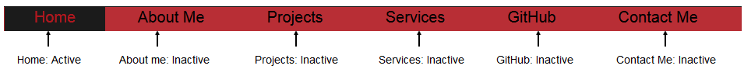

**Colors**

|  |  |
| --- | --- |
| **Swatch** | **RGB or Hex** |
|  | RGB(27,27,27) |
|  | RGB(176.23.31) |
|  | #FFFFFF |
|  | #808080 |

**Wireframe**

