Awesome Rmarkdown Word report with programmatically inserted headings, outputs and cross-references

Thomas de Marchin

17MAR2021

# Introduction

The aim of this document is to introduce a way to generate word reports from R using Rmarkdown with programmatically inserted headings, outputs and Word cross-references. See <https://towardsdatascience.com/awesome-r-markdown-word-report-with-programmatically-inserted-headings-outputs-and-19ad0de29a22> to understand the context of this example.

# Data

We will use the built-in iris dataset as an example. This dataset consists in Petal and Sepal width and length measurements for three iris species. Table shows summary statistics.

Table : Summary table for the iris dataset

| **Attribute** | **Species** | **n** | **mean** | **sd** | **min** | **max** |
| --- | --- | --- | --- | --- | --- | --- |
| Petal.Length | setosa | 50 | 1.46 | 0.17 | 1.0 | 1.9 |
| versicolor | 50 | 4.26 | 0.47 | 3.0 | 5.1 |
| virginica | 50 | 5.55 | 0.55 | 4.5 | 6.9 |
| Petal.Width | setosa | 50 | 0.25 | 0.11 | 0.1 | 0.6 |
| versicolor | 50 | 1.33 | 0.20 | 1.0 | 1.8 |
| virginica | 50 | 2.03 | 0.27 | 1.4 | 2.5 |
| Sepal.Length | setosa | 50 | 5.01 | 0.35 | 4.3 | 5.8 |
| versicolor | 50 | 5.94 | 0.52 | 4.9 | 7.0 |
| virginica | 50 | 6.59 | 0.64 | 4.9 | 7.9 |
| Sepal.Width | setosa | 50 | 3.43 | 0.38 | 2.3 | 4.4 |
| versicolor | 50 | 2.77 | 0.31 | 2.0 | 3.4 |
| virginica | 50 | 2.97 | 0.32 | 2.2 | 3.8 |

# Analysis

## setosa

Figure shows the relation between Sepal width and length.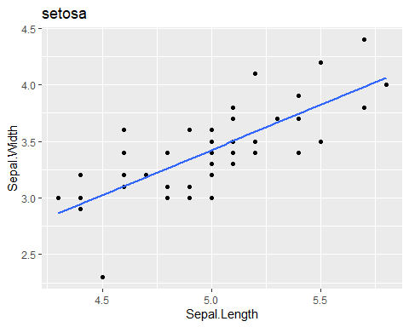

Figure : Scatter plot of Sepal Width vs Sepal Length for setosa. Blue line is a linear regression.

A linear regression was performed using Sepal.Length as the response and Sepal.Width as the explanatory variable. Table shows the parameters estimates and 95% Confidence intervals.

Table : Parameters estimates of the fit for setosa

| **term** | **estimate** | **std.error** | **statistic** | **p.value** | **2.5 %** | **97.5 %** |
| --- | --- | --- | --- | --- | --- | --- |
| (Intercept) | 2.6390012 | 0.31001431 | 8.512514 | 0.00000000003742438 | 2.0156757 | 3.2623268 |
| Sepal.Width | 0.6904897 | 0.08989888 | 7.680738 | 0.00000000067098430 | 0.5097359 | 0.8712435 |

## versicolor

Figure shows the relation between Sepal width and length.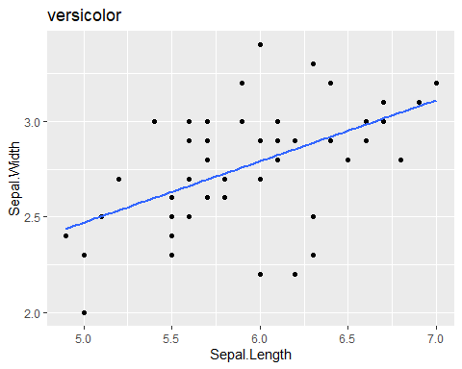

Figure : Scatter plot of Sepal Width vs Sepal Length for versicolor. Blue line is a linear regression.

A linear regression was performed using Sepal.Length as the response and Sepal.Width as the explanatory variable. Table shows the parameters estimates and 95% Confidence intervals.

Table : Parameters estimates of the fit for versicolor

| **term** | **estimate** | **std.error** | **statistic** | **p.value** | **2.5 %** | **97.5 %** |
| --- | --- | --- | --- | --- | --- | --- |
| (Intercept) | 3.5397347 | 0.5628736 | 6.288685 | 0.00000009069049 | 2.408002 | 4.671468 |
| Sepal.Width | 0.8650777 | 0.2019376 | 4.283887 | 0.00008771860012 | 0.459055 | 1.271100 |

## virginica

Figure shows the relation between Sepal width and length.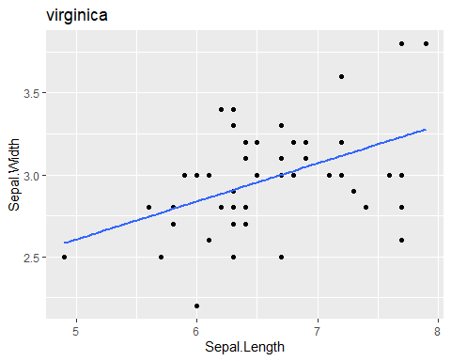

Figure : Scatter plot of Sepal Width vs Sepal Length for virginica. Blue line is a linear regression.

A linear regression was performed using Sepal.Length as the response and Sepal.Width as the explanatory variable. Table shows the parameters estimates and 95% Confidence intervals.

Table : Parameters estimates of the fit for virginica

| **term** | **estimate** | **std.error** | **statistic** | **p.value** | **2.5 %** | **97.5 %** |
| --- | --- | --- | --- | --- | --- | --- |
| (Intercept) | 3.9068365 | 0.7570605 | 5.160534 | 0.000004656345 | 2.3846642 | 5.429009 |
| Sepal.Width | 0.9015345 | 0.2531055 | 3.561892 | 0.000843462472 | 0.3926317 | 1.410437 |

# Conclusion

**Congratulations!**

