Data Model Modifications

________________________________________________________________________________________________________

EMBL-EBI Kim Henrick, Wim Vranken, Anne Pajon
University of Cambridge Rasmus Fogh, Wayne Boucher, Tim Stevens
Daresbury Laboratory Chris Morris
Diamond Alun Ashton
University of York Susy Griffiths
OPPF Jon Diprose
CNRS Gif/Yvette Anne Poupon, Eric Oeuillet
Dundee Geoff Barton geoff@compbio.dundee.ac.uk
Manchester Steve Prince steve.prince@umist.ac.uk
NRC Montreal Mirek Cygler, Stéphane Raymond, Xueli Li
Weizmann Institute Jaime Prilusky
EMBL Grenoble HTP Crystallisation: Jose A. Marquez, Martin Roewer, Jacques Chung
HTP Expression: Darren Hart, Franck Tarendeau, Benjamin Corbex
________________________________________________________________________________________________________

Table of Contents

UNITS 2
PACKAGE PROTOCOL 3
PACKAGE EXPERIMENT 5
PACKAGE ANNOTATION 7
PACKAGE EXPBLUEPRINT 8
PACKAGE REFCONTAINER 9
PACKAGE REFSAMPLECOMPONENT 10
PACKAGE SAMPLE 11
PACKAGE LOCATION 12
PACKAGE PEOPLE 13
PACKAGE METHOD 14
PACKAGE INSTRUMENT 15

UNITS
All values are floats and they are going to be stored in a fixed SI unit. Because the user is going to enter these values in different unit, a displayUnit will be added.

For concentration where three different types of value can be stored, three attributes are going to be created (concPerMol, concPerMass, concPerVolume) with fixed SI unit.
Rasmus suggested to keep the attrs concentration and concentrationUnit with a closed enumeration attached to it [kg/m3 (mass density), mol/m3 (amount-of-substance concentration), m3/m3 (volume fraction), mol/mol (amount of substance fraction), kg/kg (mass fraction)] because there are more than three different types of concentration to store.

For amount where three different types of value can be stored, three attributes are going to be created (mass, volume, number) with fixed SI unit.
Rasmus suggested to have the attrs amount and amountUnit with a closed enumeration attached to it [kg (mass), m3 (volume), ? (number)].

? What do you think? If we adopt the attributes concentrationUnit and amountUnit with a closed enumeration, it will be easier to increase the number of units in future for these two values.

? Which unit should be used for the amount value expressed in number?

PACKAGE PROTOCOL

new class Protocol
- Add open enumeration: protocolType = {Pcr, DnaPurification, Digest,...}

? I'm not sure about the class name, since a "protocol" to a scientist seems to mean a recipe for a whole series of planned experiments. Can it be ExperimentMethod?

new class FlowStep (subtype of Step)
- Add open enumeration: flowStepType = {fixed volume, one solution flow, 2 solutions gradient, ...}

? How are solutionA and solutionB defined?

new class CentrifugationStep
- Add attr centrifugeModel ???
- Add attr distFromAxis ???
- Add attr numOfG ???

? Should we add more attributes like the one listed above for CentrifugationStep?

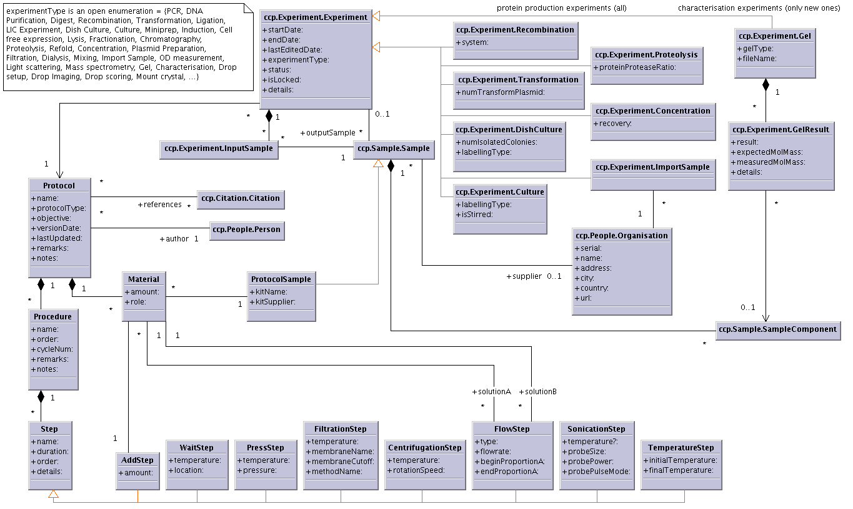

PACKAGE EXPERIMENT

class ccp.api.Experiment.DishCulture & ccp.api.Experiment.Culture
- Add attr labellingType = {SelenoMet, SelenoCys, C13, N15, C13-N15,...}

new class ccp.api.Experiment.Gel
- Add attr gelType = {agarose 1%, SDS-PAGE 14%, ...}

new class ccp.api.Experiment.GelResult
- Add attr result = {band at expected weight, band at unexpected weight, no band}

class ccp.api.Experiment.Experiment
- Add a link to the class Annotation
- Remove attr isModel (old isTemplate)
- Remove attr protocolDetails
- Modify link between Experiment and Instrument: derived link from Method
- Add link between Experiment and Method
- Modify attr experimentType = {PCR, DNA purification, ...}. The open enumeration will carry the experiment type, and all experiment subtypes that can be fully described by the protocol class will be removed like PCR, DNA Purification, ...

class ccp.api.Experiment.InputSample
- Remove attr sampleIoType
- Add attr amountUnit as closed enum = [kg (mass), m3 (volume), ? (number)]
- Add attr displayUnit

A generic way of handling any type of parameters for experiment will be to add two new classes:
new class ccp.api.Experiment.Parameter attrs [name | type | unit | description]
new class ccp.api.Experiment.ExperimentHasParameter attrs [value]
This will give the possibility to store any kind of experiments.

new class ccp.api.Experiment.LightScatResult attrs [ intensity | expectedMolMass | measuredMolMass ]
class ccp.api.Experiment.LightScaterring attrs [ proteinTreatement | radiusSize | polydispersity ]

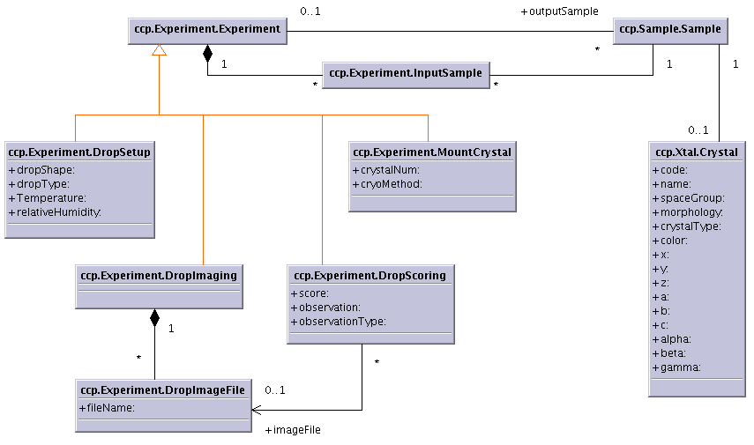

PACKAGE ANNOTATION

class ccp.api.Annotation.MolFeature
- Add derived attr position (derived from MolResidue.seqId)
- Add method getPosition()

new class ccp.api.Annotation.Annotation (Mole bug 263)
- Add attr description
- Add derived attr fileName from memops.api.Implementation.DataLocation.path
- Add derived attr url from memops.api.Implementation.DataLocation.url
- Add attr date
- Add attr details
- Add a link to memops.api.Implementation.DataLocation
- Add a link to Person (+author)

NB: Change all the attr fileName to a link to memops.api.Implementation.DataLocation and derived the attr fileName

PACKAGE EXPBLUEPRINT

class aap.api.ExpBlueprint.ExpBlueprint
- Add a link to ccp.api.People.Person called owner

PACKAGE REFCONTAINER

class ccp.api.RefContainer.RefHolder
- Add attr numColumn e.g. 12
- Add attr columnName e.g. 8
- Add attr columnSpacing
- Add attr numRow e.g. 1,2,3,4,5,6,7,8,9,10,11,12
- Add attr rowName e.g. A,B,C,D,E,F,G,H
- Add attr rowSpacing
- Change attr numSubunits -> capacity
- Remove attr vendorName
- Add link to ccp.api.People.Organisation called supplier
- Add attr catalogNum

class ccp.api.RefContainer.RefContainer
- Add attr length
- Add attr wireWidth
- Remove attr vendorName
- Add link to ccp.api.People.Organisation called supplier
- Add attr catalogNum

? Should we create a subclass of RefContainer for the crystal mounting specific attributes?

PACKAGE REFSAMPLECOMPONENT

class ccp.api.RefSampleComponent.AbstractComponent
- componentType enum: lower case as molType in Molecule
- Remove attr vendorName
- Add link to ccp.api.People.Organisation called supplier
- Add attr catalogNum

class ccp.api.RefSampleComponent.Substance (Mole bug 266)
- Add attr pH. This would mean having different Substance objects for phosphate buffers at different pHs.
- componentType enum: add chemShiftRef (should be an open enum)
The substance class is used to store not only mixtures but also components for which you do not want to create a molecule for.
Detergent (NonPolyMolComp or Substance?): Critical Micelle Concentration in pure water is an important parameter

class ccp.api.RefSampleComponent.RestrictionEnzyme
- Change class name RestrictionEnzyme to Enzyme

class ccp.api.RefSampleComponent.Construct
- Add attr constructType = {empty, with target, bac, cosmid, ...}

class ccp.api.RefSampleComponent.MolComponent
- Add attr empiricalFormula
- Add attr expectedMolMass (not derived if descriptor not frozen)
- Add attr measuredMolMass
- Remove attr molecularMass

class ccp.api.RefSampleComponent.MolCompFeature
- Add derived attr length
- Add method getLength = endSeqId – starSeqId
- Add attr status: {cut, uncut, ...}

PACKAGE SAMPLE

class ccp.api.Sample.Sample
- Add link to ccp.api.People.Organisation called supplier or used the experiment import with a link to Organisation ???
- Attr derived attr creator from Experiment.creator
- Add attr catalogNum
- Add attr initialAmountUnit as closed enum = [kg (mass), m3 (volume), ? (number)]
- Add attr currentAmountUnit as closed enum = [kg (mass), m3 (volume), ? (number)]
- Add attr displayUnit

class ccp.api.Sample.SampleComponent
- Move attr isotopicLabelling to class SampleComponent.PolyMolComp
- Change attr isotopicLabelling to labellingType, and add an open enumeration {SelenoMethionine, SelenoCysteine, N15, C13, N15+C13, ...} (look at BioMagResBank labelling)
- Add attr concentrationUnit closed enum = [kg/m3 (mass density), mol/m3 (amount-of-substance concentration), m3/m3 (volume fraction), mol/mol (amount of substance fraction), kg/kg (mass fraction)]
- Add attr displayUnit

class ccp.api.Sample.AnomalousScatterer
- Add assessmentMethod as link name to ccp.api.Method.Method
- change attr count -> numberOfInstances or numInstances

class ccp.api.Sample.SampleLocation/HolderLocation
- Check location validity for samples when they are part of an holder and this holder has a particular location

PACKAGE LOCATION

class ccp.api.Location.Location
- Add attr room
- Add link to Laboratory or Organisation ?

PACKAGE PEOPLE

new class ccp.api.People.ContactData
- Add attr deliveryAddress
- Add attr phoneNumber2

class ccp.api.People.Person
- Remove attrs position, addresses and phone/fax numbers because they depend on the laboratory which this person is affilated with.

class ccp.api.People.Laboratory
- Change class name Laboratory to Group

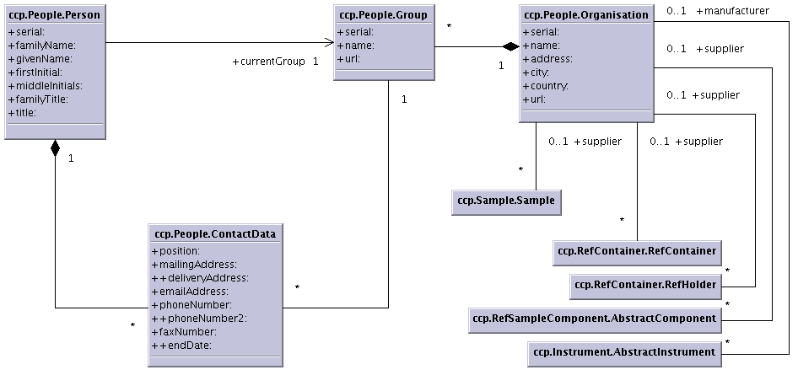

PACKAGE METHOD

class ccp.api.Method.Method
- Add attr name

class ccp.api.Method.Parameter
- Add attr unit ???

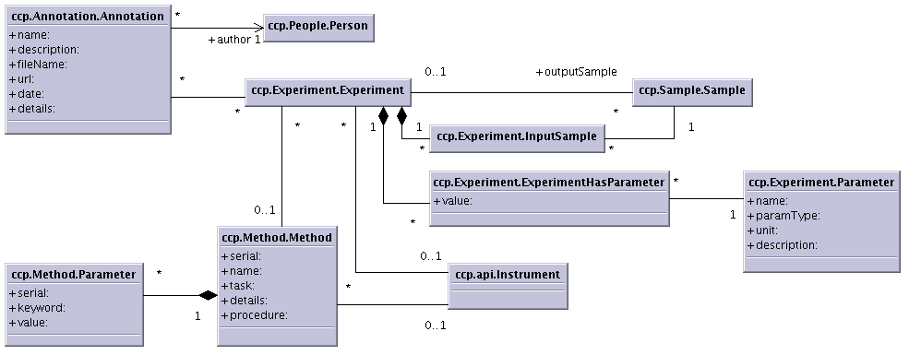

PACKAGE INSTRUMENT

class ccp.api.Instrument.AbstractIntrument
- Remove attr manufacturer
- Add link to ccp.api.People.Organisation called manufacturer

class ccp.api.Instrument.Intrument
- Add link to Method

new class ccp.api.Instrument.Column (subtype of Instrument)
- Add attr columnType
- Add attr volume
- Add link to ccp.api.Method.Method called loadingMethod

