Old DM diagram
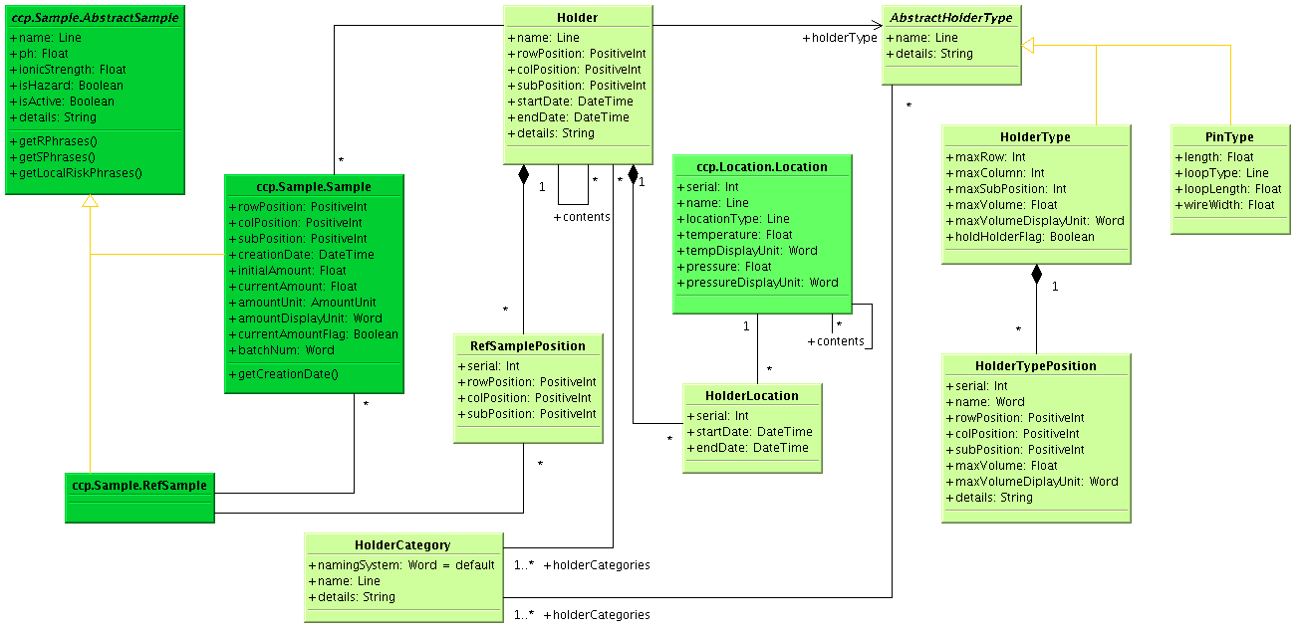
New DM diagram

+Name
+Details
+RowPosition
+ColPosition
+SubPosition

AbstractHolder
+StartDate
+EndDate

Holder
RefHolder
Sample
*
HolderLocation
*
1
HolderCatergory
AbstractHolder
Type
*
1-*
*
1-*
*
RefSample
Position
Type
*
1
RefSample
1
*
HolderType
PinType
+ResSubPosition
CryHolderType
RefHolder
Offset
1
1
*
*
contents
1
*
RefSample
Source
Organisation
*
1
1
1
*
*
1

Summary of Changes:
- Split Holder to Holder and RefHolder which extended from AbstractHolder
  - Put previous Holder’s name, details, abstractHolderType and HolderCatergories into AbstractHolder.
  - Keep previous Holder’s start/endDate, samples and holderlocations in Holder
  - Move previous Holder’s refSamplePosition to RefHolder
The new Holder represents a real holder and RefHolder represents an idea holder which contains refSamples through RefSamplePosition.

- Add RefHolderOffset to link Holder and RefHolder
- Move previous Holder’s row/col/sub to SubHolderOffset ‘s row/col/sub offset
Through RefHolderOffset, a Holder can be confirmed to a set of sub-Holders at position defined in RefHolderOffset

- Add CryHolderType which extends HolderType
- Add ResSubPosition for CryHolderType
This will allow a crystallization holder know where is the reservoir

API level data checks:
- When Holder contain sub-RefHolder, its sample should be confirmed to refHolder’s refSample in the same position
- RefHolder should not contain holder and holder should not contain refHolder (generated API changed manually)
- AbstractHolder’s size ( in AbstractHolderType) should >= sub-holder’s (offset+ size) and sub-holders should have no overlap (refholder can overlap with holder)

Other Changes:
1) Storing screen manufacturer information:
1.1) Extend RefSampleSource with two additional attributes:
- productGroupName
- productName
Both strings, restricted length (255 maybe), whitespace allowed. These attibutes to map Condition.manufacturerScreenName and Condition.manufacturerCode respectively.

1.2) Extend RefSampleSource with an additional Role:
- RefHolder
This class to map Screen.manufacturerName.

2) Storing component information
2.1) Extend SampleComponent with additional attribute:
- pH
Float, To use to record the use of a buffer of defined pH as a component of the condition. This attribute to map component.pH.

2.2) Extend MolComponent with additional attribute:
- volatile
Boolean. This attribute to map component.volatileComponent.
DM change 30:
- Score
- Add String Column color
- Drop Column Serial
- DropAnnotation
- Drop not-null constraint for Annotator
- Drop column Serial

DM change 31:
  - Add “operator” person for experiment

