Vancouver End-to-End Housing Insights
TRANSFORMATIONS FOR DATA ANALYTICS (CPSC 4810) —
Final Project
Date: April 12, 2026
Repository: github.com/chrisho251/vancouver-end-to-end-housing-insights

Chris Ho
Yetkin Celik
Samuel Molina
Alejandra Quintero

Table of Contents
- Part I — Problem Statement
- Part II — Data Collection
- Part III — Data Cleaning & Transformation
- Part IV — Exploratory Data Analysis (EDA)
- Part V — Data Transformation & Feature Engineering
- Part VI — Machine Learning Model
- Part VII — Dashboard
- Part VIII — Key Insights & Business Recommendations
- Part IX — Git VCS Usage
- Part X — Final Report

Part I — Problem Statement Definition
Introduction
Vancouver's real estate market is one of the most expensive in North America. This project aims to analyze publicly available datasets, including property tax reports, business licenses, crime data, and local area boundaries—to better understand the key factors influencing housing prices and to predict future trends using machine learning techniques.
According to Statistics Canada, housing affordability in major metropolitan areas such as Vancouver has significantly declined over the past decade, driven by increasing demand and limited supply.
Motivation & Background
- Metro Vancouver has one of the least affordable housing markets in Canada.
- Housing prices are influenced by multiple factors, including location, land value, and economic activity.
- Real-world housing analysis requires the integration of multiple heterogeneous datasets.

In this project, we combine:

- Property tax data
- Business licence data
- Geographic boundary data
- Crime data
Recent studies highlight that homeownership rates among younger populations remain relatively low, reflecting affordability challenges in urban centers (Statistics Canada, 2022).

Business Problem
What is the specific problem we are trying to solve?
Analyze and predict housing value patterns in Metro Vancouver to identify key price drivers and detect high-value or potential bubble areas.
Scope of the Project
- Data: Property values, neighborhood characteristics, business activity, and crime rates
- Analysis: Exploratory Data Analysis (EDA), feature engineering, and predictive modeling
Goal:
To understand how different factors influence housing prices across locations and improve prediction accuracy.
Key Drivers (Causes)
- Supply and demand imbalance
- Location premium (neighborhood effects)
- Concentration of business and economic activity
- Limited land availability
Implications
- Housing affordability challenges
- Inequality across neighborhoods
- Risk of housing bubbles
- Need for improved urban planning and policy decisions

Part II — Data Collection
Datasets Used
- We used four integrated datasets to support house price prediction:
  - Property Tax
  - Business Licences
  - Local Areas
  - Crime
- The datasets include a mix of:
  - Numerical variables for valuation and counts
  - Categorical variables for neighborhood and type classifications
  - Geographic information for spatial analysis
- The property tax dataset is the core source for the target variable, while the other datasets provide contextual predictors.
Dataset | Source | Landing Path
Business Licences | City of Vancouver Open Data Portal | data/landing/business_licences/
Crime Data | Vancouver Police Department Open Data | data/landing/crime/
Local Areas | City of Vancouver Open Data Portal | data/landing/local_areas/
Property Tax Report | BC Assessment / City of Vancouver | data/landing/property_tax_report/

Dataset source:
- Local Area Boundary: https://opendata.vancouver.ca/explore/dataset/local-area-boundary/
- Property Tax Report: https://opendata.vancouver.ca/explore/dataset/property-tax-report/
- Business Licences: https://opendata.vancouver.ca/explore/dataset/business-licences/
- Crime Statistics: https://geodash.vpd.ca/opendata/

Part III — Data Cleaning & Transformation
The transformation layer is implemented as Python modules in src/transformation/. Each script handles ingestion, cleaning, and staging for a specific dataset.
Summary transformations.

transform_business_licences.py
The Business Licences dataset was loaded from the landing layer and prepared for transformation into the staging layer.
Column names were standardized:
- All columns were converted to lowercase.
- Inconsistent or concatenated names were reformatted using underscores for clarity, e.g.:
- businessname → business_name
- postalcode → postal_code
- issueddate → issued_date.
Non-essential audit columns were removed to improve data usability:
- created_by
- ingested_dt.
Text fields were cleaned to ensure data consistency:
- Newline characters were removed to prevent CSV formatting issues.
Invalid or placeholder values such as "nan", "None", and empty strings were standardized to proper missing values (NA).
Duplicate records were identified and removed to avoid redundancy and bias in downstream analysis.
Missing values were reviewed and standardized in key business and location-related fields, including:
- business_trade_name
- business_sub_type
- unit
- unit_type
- house
- street
- postal_code.

Geographic data was prepared by transforming the geo_point_2d field:
- Latitude and longitude were extracted.
Multiple input formats (JSON and comma-separated strings) were handled to ensure robustness.
Logging was implemented to track the transformation process, including the number of duplicate records removed.
The cleaned dataset was saved to the staging layer with a dynamically generated filename including the execution date, ensuring traceability and version control.

transform_crime.py
The Vancouver Police Department (VPD) Crime dataset was loaded from the landing layer and prepared for transformation into the staging layer.
Column names were standardized by converting all variables to lowercase to ensure consistency across the dataset.
Non-essential audit columns were removed, including:
- created_by
- ingested_dt.
Duplicate records were identified and removed to improve data quality and avoid redundancy in later analysis.
Missing or anonymized coordinate values were handled:
- Records with coordinates equal to 0.0, 0.0 were treated as invalid/anonymized values and replaced with missing values (NA).
- This step is especially relevant for offences where exact locations are intentionally masked.
Separate date and time components were merged into a single timestamp variable:
- year
- month
- day
- hour
- minute
Missing hour and minute values were filled with 0 before creating the new timestamp field.
After aggregation, the original time-related columns were removed.
Crime location coordinates were reprojected into a more usable geographic format:
- Original x and y coordinates in UTM (EPSG:26910) were transformed into:
  - latitude
  - longitude
- The new coordinates were stored in WGS84 (EPSG:4326) format, which is more suitable for mapping and spatial analysis.
- The original x and y columns were dropped after transformation.
Logging was used throughout the process to document key cleaning steps, such as duplicate removal, anonymized coordinate handling, and timestamp creation.
The transformed crime dataset was then saved to the staging layer with a filename that includes the execution date for traceability and version control.

transform_local_areas.py
- The Vancouver Local Area Boundaries dataset was loaded from the landing layer and prepared for transformation into the staging layer.
- Column names were standardized by converting all variables to lowercase to ensure consistency across the dataset.
- Non-essential audit columns were removed, including:
  - created_by
  - ingested_dt.
- Duplicate records were identified and removed to ensure data integrity and avoid redundancy.
- The geom column, containing GeoJSON data, was cleaned and transformed:
  - Extra or malformed quotation marks were corrected to ensure valid JSON formatting.
  - GeoJSON strings were parsed into structured geometry objects using Shapely.
  - The dataset was converted into a GeoDataFrame to enable geospatial operations.
  - The original geom column was removed after transformation.
- Geographic center point coordinates were extracted from the geo_point_2d field:
  - The field was split into:
    - center_lat
    - center_lon
  - Values were converted to numeric format, handling potential parsing errors.
  - The original geo_point_2d column was dropped after extraction.
- Logging was implemented to track key transformation steps, including duplicate removal and successful parsing of geospatial data.
- The cleaned and transformed dataset was saved to the staging layer with a dynamically generated filename that includes the execution date, ensuring traceability and version control.

transform_property_tax.py
The Vancouver Property Tax Report dataset was loaded from the landing layer and prepared for transformation into the staging layer.
Column names were standardized by converting all variables to lowercase to ensure consistency across the dataset.
Non-essential audit columns were removed, including:
- created_by
- ingested_dt.
Duplicate records were identified and removed to ensure data quality and avoid redundancy.
Property identifiers (pid) were standardized:
- Dashes were removed to ensure a consistent and comparable format across records.
Empty or blank string values were standardized to proper missing values (NA) in key location-related fields, including:
- block
- plan
- district_lot
- from_civic_number.
Multiple narrative legal description fields were consolidated:
- Columns containing narrative_legal_line were combined into a single field:
  - full_legal_description
- Missing values were handled to ensure proper concatenation.
- Extra whitespace was removed for cleaner text formatting.
- Original fragmented columns were dropped after consolidation.
Financial variables were converted to appropriate numeric data types:
- current_land_value
- current_improvement_value
- previous_land_value
- previous_improvement_value
This ensures accurate quantitative analysis and modeling.
The tax_assessment_year variable was converted into a numeric integer format to support time-based analysis.
Logging was implemented to track key transformation steps, including duplicate removal and field standardization.
The cleaned dataset was saved to the staging layer with a dynamically generated filename including the execution date, ensuring traceability and version control.

transform_utils.py
A set of shared utility functions was implemented to standardize and support the data transformation pipeline across all datasets.
Data Loading (Landing Layer)
- Data ingestion from the landing layer was handled through a unified loading function:
  - All JSON files within a specified directory were automatically detected and loaded.
  - A validation step ensures data completeness by checking the presence of a _SUCCESS flag file.
  - If the flag is missing, the process stops to prevent using incomplete data.
- Multiple JSON files were combined:
  - Each file was read into a temporary DataFrame.
  - All parts were concatenated into a single unified DataFrame.
  - This ensures scalability when handling partitioned or chunked datasets.
- Logging was used to track:
  - Number of files detected
  - Total number of records loaded
Data Saving (Staging Layer)
- Transformed datasets were saved into the staging layer using a standardized function:
  - Output directories were automatically created if they did not exist.
  - Data was exported in CSV format without index columns to ensure compatibility.
- Logging was implemented to confirm:
  - Successful data export
  - Number of records saved
  - Output file location

Part IV — Exploratory Data Analysis (EDA)
The following notebooks perform exploratory analysis on each dataset, including descriptive statistics, visualizations, and correlation analysis.

EDA: Eda Business Licences

Exploratory Data Analysis: Business Licences
This notebook explores the business licences dataset.We will look at descriptive statistics, distributions, and time-series trends
The transformed Business Licences dataset was loaded from the staging layer for exploratory data analysis (EDA).
Initial data inspection was performed:
- The first rows of the dataset were displayed to understand structure, variable types, and data consistency.
- A warning (DtypeWarning) indicated mixed data types in at least one column, suggesting potential data quality issues that may require further type standardization.
Descriptive Statistics
- Key numeric variables were selected for analysis:
  - numberofemployees
  - fee_paid
- Summary statistics were computed, including:
  - count
  - mean
  - standard deviation
  - minimum and maximum values
  - quartiles (25%, 50%, 75%)
- Key insights:
  - The median number of employees is 1, indicating that most businesses are small-scale operations.
  - The mean number of employees (~10.7) is significantly higher than the median, suggesting a right-skewed distribution with outliers.
  - The maximum number of employees (5,876) confirms the presence of extreme values.

Distribution Analysis
- Histograms were generated for key numeric variables:
  - numberofemployees
  - fee_paid
- Observations from distributions:
  - Both variables exhibit highly skewed distributions.
  - A large concentration of observations is clustered at lower values.
  - Long right tails indicate the presence of outliers and high-value observations.

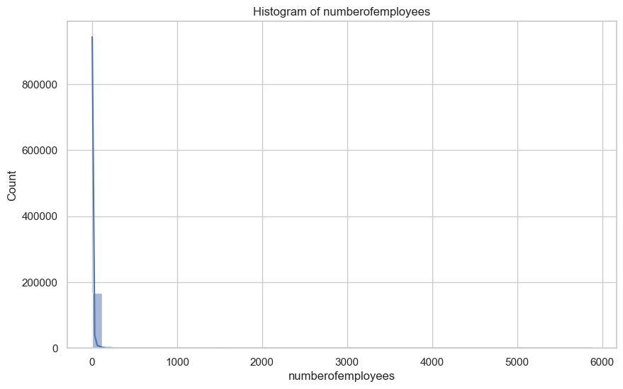
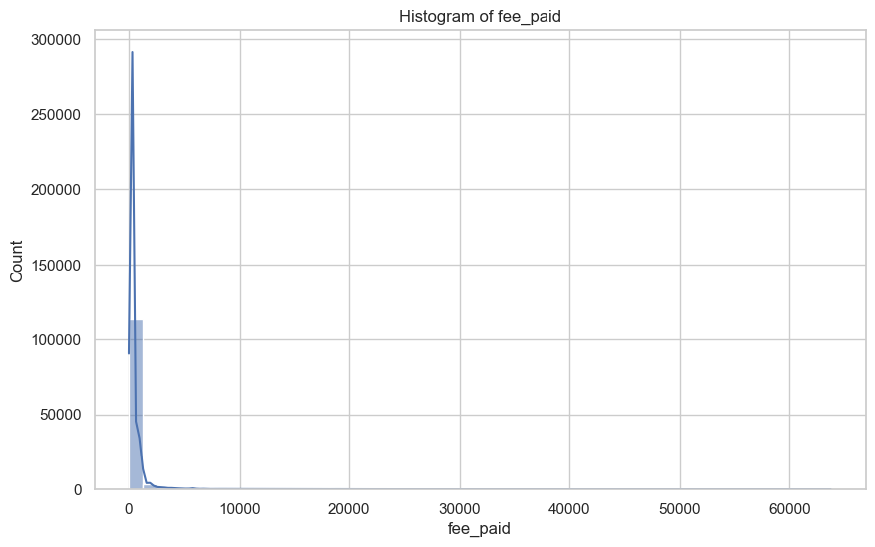

Data Quality Observations
- Presence of missing values:
  - fee_paid has a significant number of missing entries.
- Mixed data types warning suggests:
  - Potential inconsistencies in data formatting.
  - Need for further validation or type enforcement in preprocessing.

Outlier Detection – Business Licences Dataset
- Boxplots were generated for key numeric variables to identify potential outliers:
  - numberofemployees
  - fee_paid
- This visualization allows for:
  - Detection of extreme values
  - Identification of distribution spread and skewness
  - Comparison between median and interquartile range (IQR)

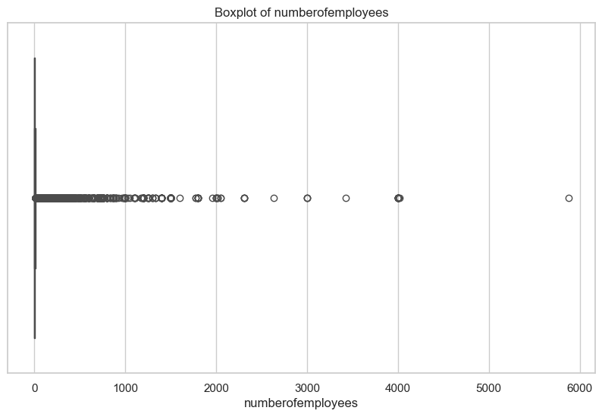
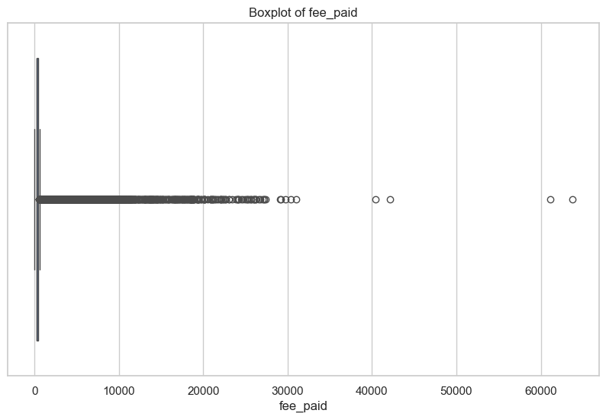
Key Observations
- Both variables exhibit a high number of outliers, particularly in the upper range.
- For numberofemployees:
  - The majority of observations are concentrated at very low values.
  - A small number of businesses show extremely high employee counts, creating a long upper tail.
- For fee_paid:
  - Most values are clustered in lower ranges.
  - Several high-value outliers indicate that a subset of businesses pays significantly higher fees.
- The boxplots confirm that both variables are right-skewed, reinforcing findings from the histogram analysis.

Time-Series Analysis – Business Licences Dataset
- A time-series analysis was conducted to examine trends in business licence issuance over time.
Data Preparation
- The issued_date variable was converted to a datetime format:
  - Invalid or improperly formatted values were handled using coercion (errors='coerce'), ensuring robustness.
- A new time-based feature was created:
  - issued_year_month, representing the year and month of issuance.
  - This allowed aggregation at a monthly level for trend analysis.
Trend Analysis
- The number of business licences issued per month was calculated by grouping the data by issued_year_month.
- A time-series line plot was generated to visualize:
  - Monthly trends
  - Temporal patterns in business activity

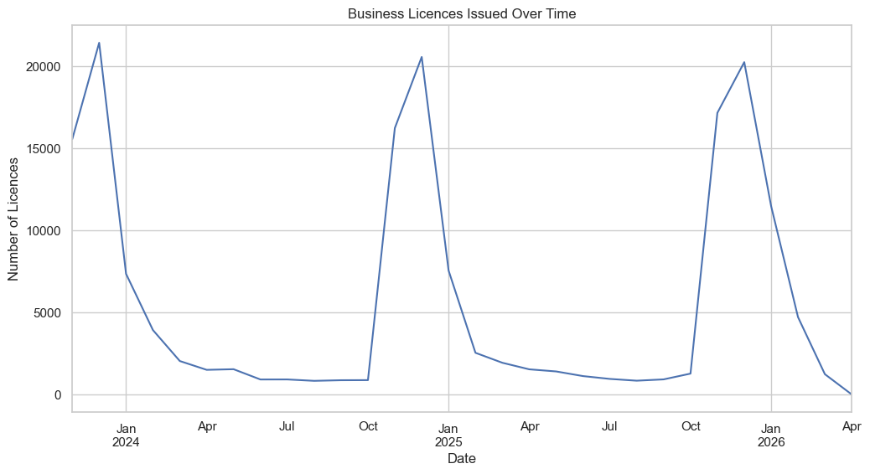
Key Observations
- The time-series plot reveals fluctuations in the number of licences issued over time, indicating variability in business activity.
- Potential patterns that may be observed:
  - Seasonal trends (e.g., increases during certain months)
  - Periods of growth or decline in business registrations
  - External influences such as economic conditions or policy changes
Correlation Analysis – Business Licences Dataset
- A correlation analysis was conducted to examine relationships between key numeric variables in the dataset.
Methodology
- A correlation matrix was computed using the following variables:
  - numberofemployees
  - fee_paid
  - latitude
  - longitude
- A heatmap visualization was generated to:
  - Display pairwise correlation coefficients
  - Identify the strength and direction of relationships between variables

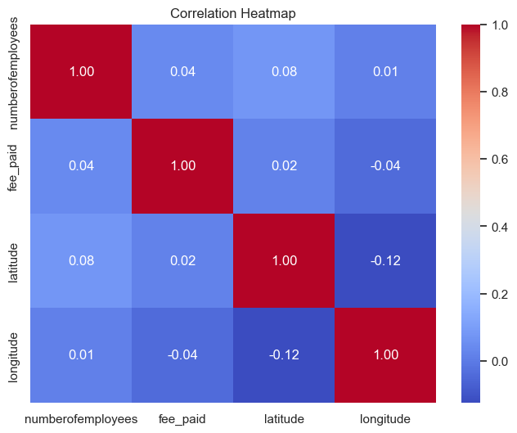
Key Observations
- The correlation values between variables are generally low to moderate, indicating weak linear relationships.
- numberofemployees and fee_paid:
  - May show a slight positive correlation, suggesting that larger businesses tend to pay higher fees.
- Geographic variables (latitude, longitude):
  - Typically show low correlation with business size and fees, indicating that location alone does not directly explain these variables in a linear sense.
- The absence of strong correlations suggests:
  - Relationships may be non-linear
  - Or influenced by additional contextual variables (e.g., neighborhood characteristics, zoning, economic clusters)

EDA: Eda Crime

Exploratory Data Analysis: Crime Data
This notebook explores the crime dataset.
We will look at frequencies of different crime types, geographic distribution by neighborhood, and time-series trends.
Initial Data Exploration – Crime Dataset
- The transformed Crime dataset was loaded from the staging layer for analysis.
- The timestamp variable was converted to datetime format:
  - Invalid values were handled using coercion to ensure consistency.
- An initial inspection (df.head()) was performed to:
  - Understand the data structure
  - Verify key variables such as time, location, and crime attributes

type hundred_block neighbourhood timestamp latitude \
0 Mischief 64XX CHURCHILL ST Kerrisdale 2009-03-28 20:00:00 49.227802
1 Mischief 64XX CHURCHILL ST Kerrisdale 2013-11-01 08:28:00 49.227904
2 Mischief 64XX COLLINGWOOD ST Kerrisdale 2011-04-20 15:00:00 49.227752
3 Mischief 64XX COLLINGWOOD ST Kerrisdale 2006-04-06 12:00:00 49.227599
4 Mischief 64XX COLUMBIA ST Oakridge 2004-11-19 18:00:00 49.226839
longitude
0 -123.141545
1 -123.141541
2 -123.182211
3 -123.182094
4 -123.110708

Basic Summary – Crime Dataset
- The total number of records was calculated to understand dataset size.
- The time range of the data was identified:
- From the earliest (min) to the latest (max) timestamp
- This provides context on the coverage period of crime data.
- Missing values were analyzed across all variables:
- This helps identify data quality issues
- Highlights fields that may require further cleaning or imputation
Number of records: 875675
Time range:
Start: 2003-01-01 00:00:00
End: 2026-03-12 21:27:00
Missing values:
type 0
hundred_block 12
neighbourhood 92
timestamp 16666
latitude 47561
longitude 47561
dtype: int64

Crime Type Distribution
- A bar chart was created to analyze the frequency of different crime types.
- Crime categories were sorted by frequency to highlight the most common offences.
- Key observations:
  - Theft-related crimes (e.g., Theft from Vehicle and Other Theft) are the most frequent.
  - Mid-level categories include:
    - Mischief
    - Break and Enter (Residential/Commercial)
  - Severe crimes (e.g., homicide, fatal collisions) occur at significantly lower frequencies.

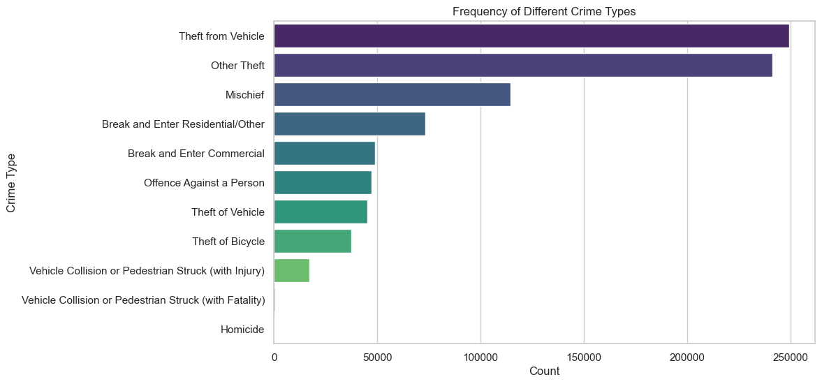

Crime Distribution by Neighborhood
- A bar chart was created to analyze the top 20 neighborhoods with the highest number of crimes.
- Neighborhoods were ranked based on total crime counts to identify high-activity areas.

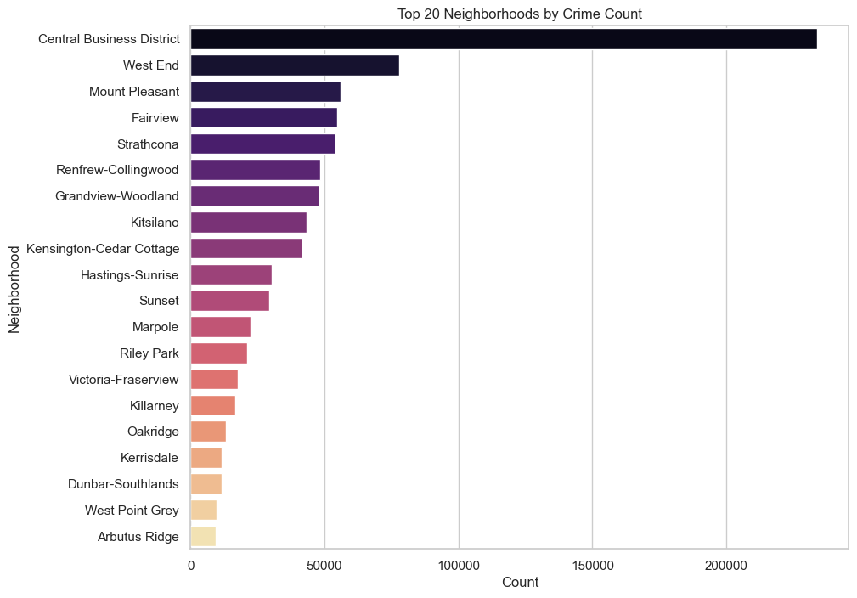

Time-Series Analysis – Crime Trends
- A time-series analysis was conducted to examine monthly crime trends over time.
- A new variable (year_month) was created from the timestamp to aggregate data at a monthly level.
- The number of crimes per month was calculated and visualized using a line chart.
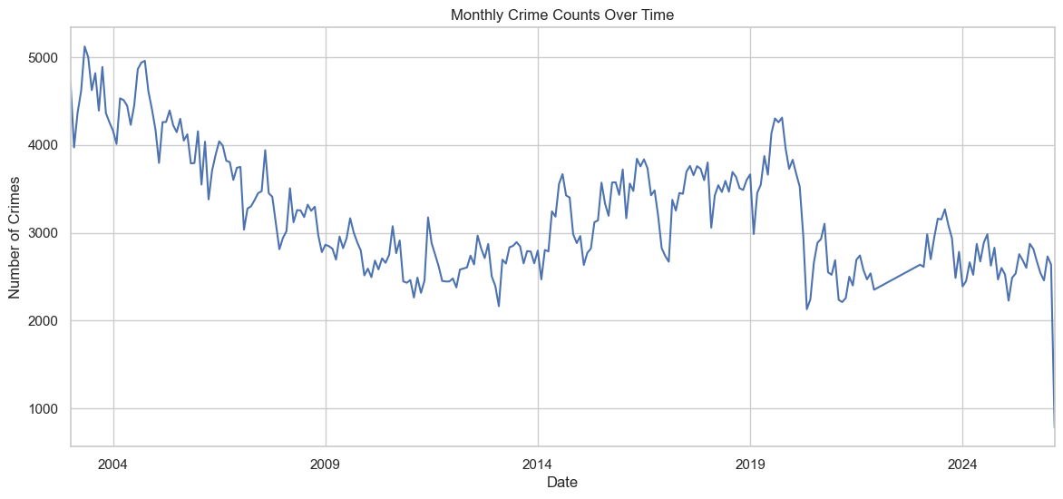
Key Observations
- Crime levels show clear temporal variation over time.
- Early years exhibit higher crime levels, followed by a gradual decline.
- There are noticeable fluctuations, indicating:
  - Possible seasonal patterns
  - Periods of increase and decrease
- A sharp drop in the most recent period may indicate:
  - Incomplete data
  - Or reporting delays

Temporal Patterns – Crime by Day and Hour
- A heatmap was created to analyze crime frequency by day of the week and hour of the day.
- Time-based features were extracted from the timestamp:
  - hour (0–23)
  - day_of_week (Monday–Sunday)
- Data was aggregated to count the number of crimes for each combination of day and hour.

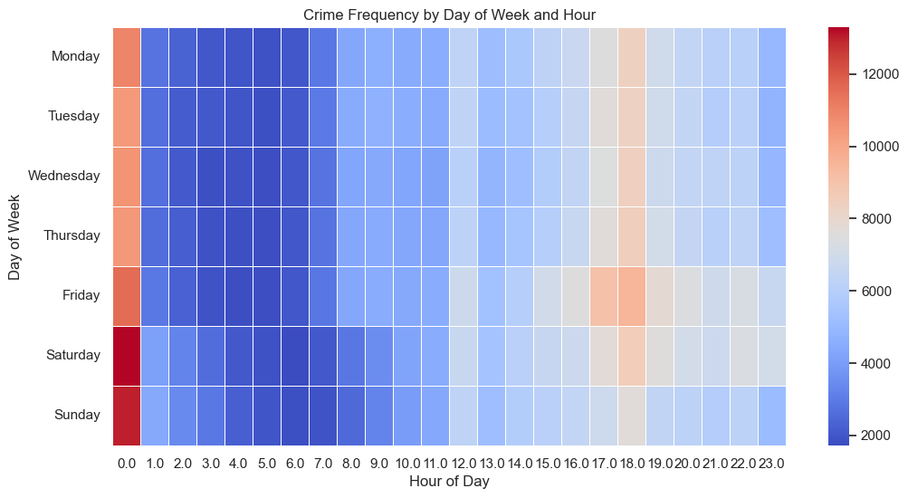
Key Observations
- Crime activity varies significantly across both days and hours.
- Higher crime concentrations are typically observed:
  - During evening and nighttime hours
  - Toward the end of the week (Friday–Sunday)
- Lower activity is generally seen:
  - During early morning hours
  - On weekdays during working hours
Descriptive Statistics – Spatial Variables (Crime Dataset)
- Descriptive statistics were computed for geographic variables:
  - latitude
  - longitude
- Key metrics analyzed include:
  - mean
  - standard deviation
  - minimum and maximum values
  - quartiles (25%, 50%, 75%)
latitude longitude
count 828114.000000 828114.000000
mean 49.264492 -123.107023
std 0.021939 0.035946
min 49.108175 -124.549757
25% 49.254122 -123.127450
50% 49.271088 -123.113140
75% 49.281577 -123.087237
max 49.755319 -122.835318
Median values:
latitude 49.271088
longitude -123.113140
dtype: float64

Key Observations
- Latitude and longitude values fall within a consistent geographic range, confirming that the data corresponds to the Vancouver area.
- The relatively small variation in coordinates indicates:
- A localized spatial distribution of crime events within the city.
- Median values provide a central reference point for crime locations, useful for spatial analysis.

Outlier Detection – Spatial Variables (Crime Dataset)
- Histograms and boxplots were generated to analyze the distribution of:
  - latitude
  - longitude
- These visualizations were used to:
  - Assess distribution shape
  - Detect potential outliers
  - Validate geographic consistency

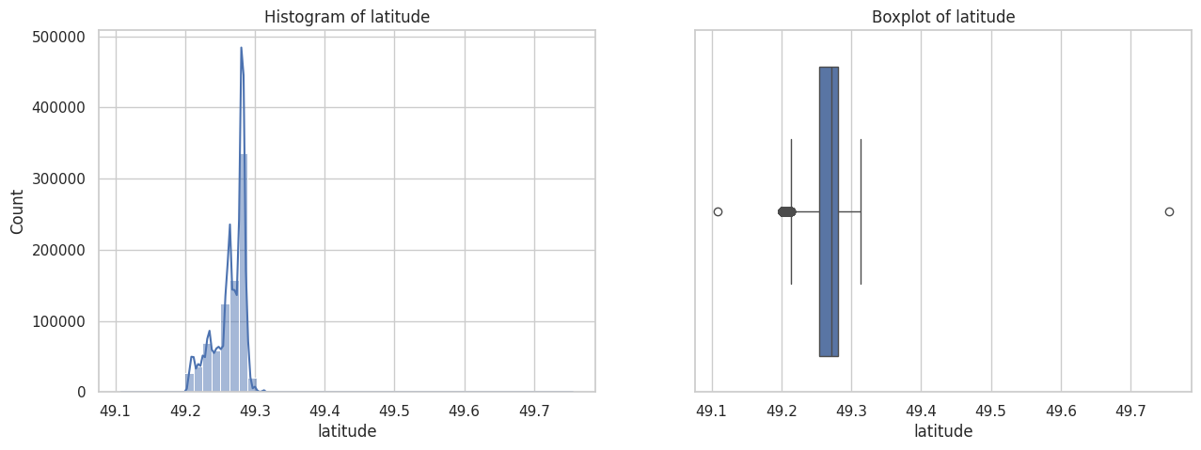
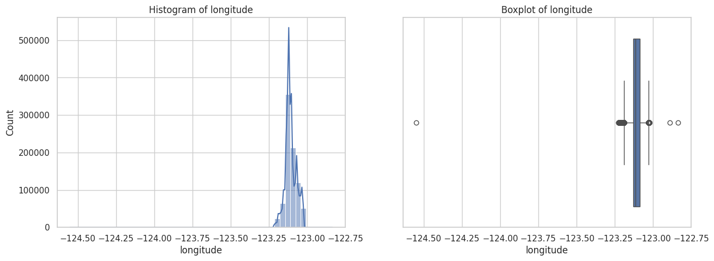
Key Observations
- Both latitude and longitude show highly concentrated distributions, indicating that most crime events occur within a geographic area.
- The distributions are:
  - Narrow and centered, consistent with a single city (Vancouver)
  - Slightly skewed but largely stable
- A small number of outliers are present:
  - These may represent:
    - Data entry errors
    - Boundary or projection issues
    - Events recorded outside the main study area
Correlation Analysis – Spatial Variables (Crime Dataset)
- A correlation heatmap was generated to analyze the relationship between:
  - latitude
  - longitude

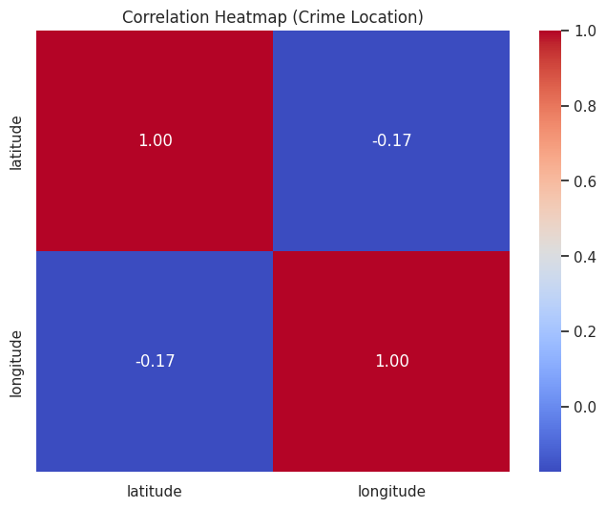
Key Observations
- The correlation between latitude and longitude is weak and slightly negative (~ -0.17).
- This indicates:
  - No strong linear relationship between the two variables
  - Expected behavior for geographic coordinates

EDA: Eda External Features

Complementary EDA: Advanced Insights
This section extends the initial exploratory analysis by integrating external datasets, including property tax and crime data.
The objective is to better understand the key drivers of housing prices in Vancouver and prepare the dataset for predictive modeling.
This analysis focuses on:
- Feature engineering from raw data
- Understanding distributions and skewness
- Exploring relationships between variables
- Segmenting the housing market
- Integrating external factors such as crime

1. Data Preparation
We load the most recent processed datasets from the staging layer.

Preview of datasets
pid legal_type folio land_coordinate zoning_district \
0 28194781.0 STRATA 638097940001 63809794 C-3A
1 13915452.0 LAND 708292100000 70829210 RS-1
2 9281401.0 LAND 598196510000 59819651 RT-3
3 26347245.0 STRATA 148606030099 14860603 DD
4 26239086.0 STRATA 618129450058 61812945 CD-1 (366)
zoning_classification lot plan block district_lot ... \
0 Commercial 1 BCS3790 NaN 526 ...
1 One-Family Dwelling 2 VAP2299 4 THSL ...
2 Two-Family Dwelling 22 VAP196 90 196 ...
3 Comprehensive Development 99 BCS1399 NaN 541 ...
4 Comprehensive Development 58 BCS1219 NaN NaN ...
tax_assessment_year previous_land_value previous_improvement_value \
0 2022.0 1249000.0 479000.0
1 2022.0 1181000.0 266000.0
2 2022.0 1492000.0 203000.0
3 2022.0 595000.0 271000.0
4 2022.0 933000.0 392000.0
year_built big_improvement_year tax_levy neighbourhood_code report_year \
0 2010.0 2010.0 17429.70 2 2022
1 1997.0 1997.0 6863.45 22 2022
2 1905.0 1989.0 7118.12 13 2022
3 2005.0 2005.0 2394.01 29 2022
4 2005.0 2005.0 3444.27 30 2022
note full_legal_description
0 NaN LOT 1 PLAN BCS3790 DISTRICT LOT 5 26 NWD GROUP...
1 NaN LOT 2 BLOCK 4 SECTION 49 PLAN VA P2299 DISTRIC...
2 NaN LOT 22 BLOCK 90 PLAN VAP196 DIST RICT LOT 196 ...
3 NaN LOT 99 PLAN BCS1399 DISTRICT LOT 541 NEW WESTM...
4 NaN LOT 58 PLAN BCS1219 NEW WESTMINST ER DISTRICT ...
[5 rows x 26 columns]
df_tax.head()
pid legal_type folio land_coordinate zoning_district \
0 28194781.0 STRATA 638097940001 63809794 C-3A
1 13915452.0 LAND 708292100000 70829210 RS-1
2 9281401.0 LAND 598196510000 59819651 RT-3
3 26347245.0 STRATA 148606030099 14860603 DD
4 26239086.0 STRATA 618129450058 61812945 CD-1 (366)
zoning_classification lot plan block district_lot ... \
0 Commercial 1 BCS3790 NaN 526 ...
1 One-Family Dwelling 2 VAP2299 4 THSL ...
2 Two-Family Dwelling 22 VAP196 90 196 ...
3 Comprehensive Development 99 BCS1399 NaN 541 ...
4 Comprehensive Development 58 BCS1219 NaN NaN ...
tax_assessment_year previous_land_value previous_improvement_value \
0 2022.0 1249000.0 479000.0
1 2022.0 1181000.0 266000.0
2 2022.0 1492000.0 203000.0
3 2022.0 595000.0 271000.0
4 2022.0 933000.0 392000.0
year_built big_improvement_year tax_levy neighbourhood_code report_year \
0 2010.0 2010.0 17429.70 2 2022
1 1997.0 1997.0 6863.45 22 2022
2 1905.0 1989.0 7118.12 13 2022
3 2005.0 2005.0 2394.01 29 2022
4 2005.0 2005.0 3444.27 30 2022
note full_legal_description
0 NaN LOT 1 PLAN BCS3790 DISTRICT LOT 5 26 NWD GROUP...
1 NaN LOT 2 BLOCK 4 SECTION 49 PLAN VA P2299 DISTRIC...
2 NaN LOT 22 BLOCK 90 PLAN VAP196 DIST RICT LOT 196 ...
3 NaN LOT 99 PLAN BCS1399 DISTRICT LOT 541 NEW WESTM...
4 NaN LOT 58 PLAN BCS1219 NEW WESTMINST ER DISTRICT ...
[5 rows x 26 columns]

Integrated Housing Insights
The previous sections explored the property tax and crime datasets separately.
This complementary section connects both analyses to the project objective: supporting house price prediction and housing analytics.
Consistent with Metro Vancouver housing studies, three ideas are especially relevant for this project:
1. Property value can be represented using a derived variable built from land value and improvement value.
2. Location-related factors appear to play a major role in housing prices.
3. Real-world housing analytics depends heavily on data integration, preprocessing, and feature construction.
These additional analyses strengthen the transition from EDA to feature engineering.

2. Feature Engineering
We construct a key variable representing total property value:
total_value = land value + improvement value
We also apply log transformations to reduce skewness and improve model readiness.

Derived Property Value
A derived variable called `total_value` is used as a proxy for property value:
`total_value = current_land_value + current_improvement_value`
This follows a logic commonly used in Vancouver housing analysis, where total assessed property value is represented by the combined contribution of land and improvements.
total_value current_land_value current_improvement_value \
mean 2.198675e+06 1.726532e+06 4.721432e+05
median 1.256000e+06 1.015000e+06 1.970000e+05
std 1.239683e+07 9.718579e+06 5.054232e+06
year_built
mean 1984.814568
median 1994.000000
std 29.789092

The summary statistics confirm substantial variability in property values.
This supports the visual evidence that the housing data is right-skewed and contains high-value outliers, which is common in real estate datasets.

A comparative distribution analysis was conducted for key property value components:
- log_land_value
- log_improvement_value
- log_total_value
Variables were transformed into log scale to:
- Reduce skewness
- Improve distribution symmetry
- Prepare data for modeling
The data was reshaped into a long format to enable comparison across variables in a single visualization.

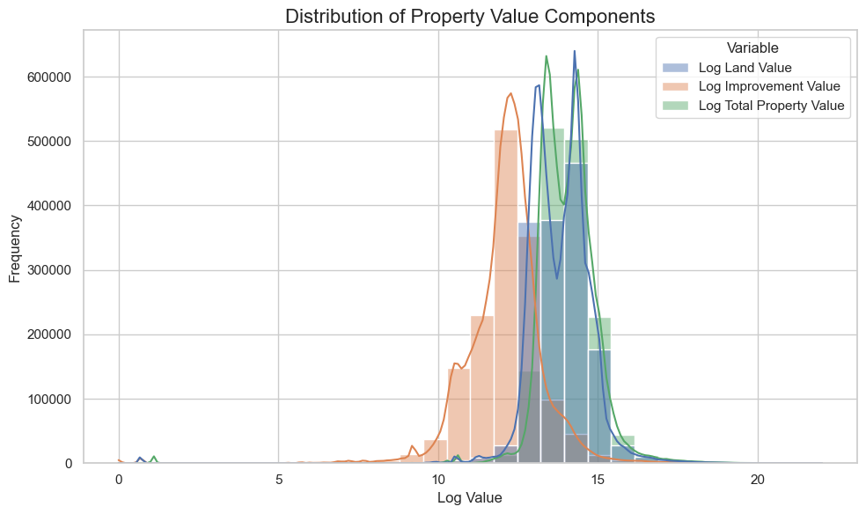

Distribution of Property Value Components (Log Scale)
The figure compares the distributions of land value, improvement value, and total property value after applying a log transformation.
Several key insights emerge:
- **Total property value closely follows land value**, indicating that land value is the primary driver of overall property valuation.
- **Improvement value is generally lower and more dispersed**, suggesting that building value contributes less consistently across properties.
- All three variables exhibit a **right-skewed distribution in their original form**, which becomes more symmetric after the log transformation.
- The log scale allows for a clearer comparison by reducing the impact of extreme high-value properties (outliers).
Overall, this visualization supports the decision to define `total_value` as the sum of land and improvement values and justifies the use of log transformations for further analysis and modeling.

4. Relationship Analysis

Figure 3: Land Value vs Improvement Value
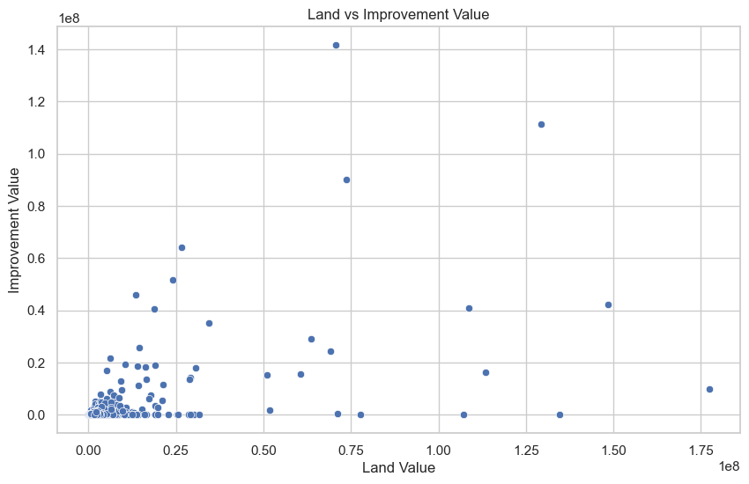

Interpretation
Land value appears to dominate total property value, especially at higher price levels.
### Implication
Location is likely a key driver of housing prices.

Location-Related Importance
One of the main insights from Metro Vancouver housing analysis is that location strongly influences price patterns.
In this dataset, land value acts as a location-related proxy, and it appears to be more influential than improvement value in explaining total property value.
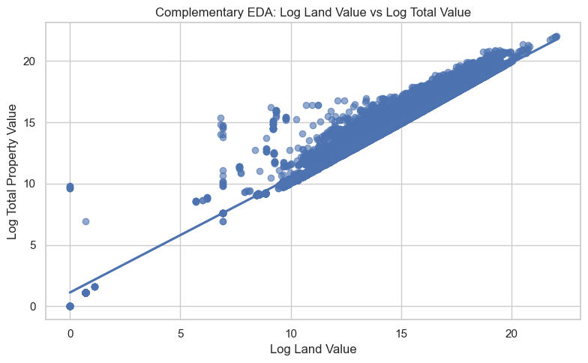
The plot shows a strong positive linear relationship between land value and total property value.
This suggests that location-related components are central to housing valuation and may be more important than building-related components alone.
Improvement value also has a positive relationship with total property value, but the association is weaker and more dispersed than the relationship observed for land value.
This indicates that structural components matter, but they do not appear to dominate pricing as strongly as land-related factors.

5. Market Segmentation

Market Segmentation Perspective
To better understand variation in the housing market, property values can also be grouped into segments.
This helps reveal whether high-value properties behave differently from low- and medium-value properties.
The categories are clearly separated, and the median property value increases from Low to Medium to High.
This supports the usefulness of segmentation and suggests that high-value properties may represent a more heterogeneous market segment.

Summary Statistics by Segment
total_value current_land_value current_improvement_value \
price_segment
Low 589206.34 433578.02 155628.32
Medium 1265934.76 1041601.10 224333.66
High 4743078.64 3706148.57 1036930.08
property_age
price_segment
Low 26.47
Medium 39.30
High 51.37

Figure 4: Property Value by Segment
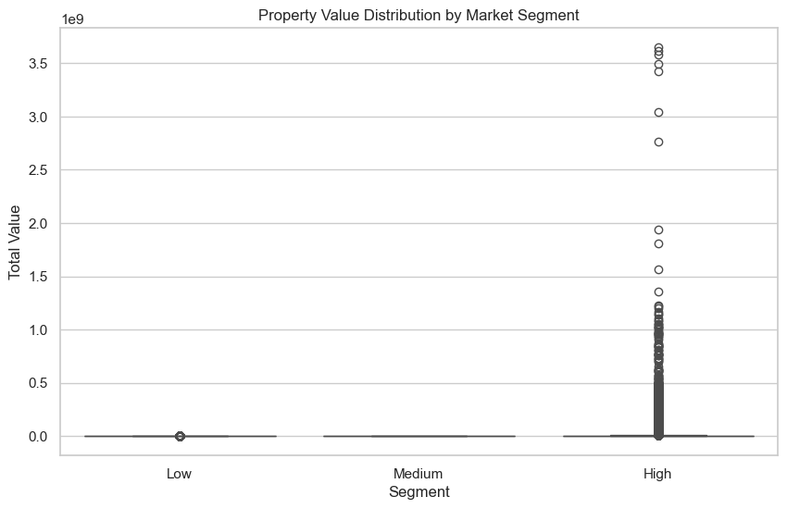

Interpretation
The High-value segment shows significantly higher values and greater variability.
Land value increases disproportionately in higher segments.
Implication
The housing market is heterogeneous and high-value properties behave differently.
Next Step
We evaluate external influences such as crime.

6. Crime Data Integration
Figure X: Crime Distribution Across Neighbourhoods
neighbourhood crime_count
1 Central Business District 234279
22 West End 77892
11 Mount Pleasant 55963
3 Fairview 54603
19 Strathcona 54161
14 Renfrew-Collingwood 48355
4 Grandview-Woodland 48203
9 Kitsilano 43444
6 Kensington-Cedar Cottage 41939
5 Hastings-Sunrise 30270
Figure X: Crime Distribution Across Neighbourhoods

Crime concentration (top vs rest)
Top 10 neighbourhoods account for 78.64% of total crime incidents.
Figure Z: Crime Variability
count 24.000000
mean 36510.041667
std 46833.338014
min 979.000000
25% 11118.250000
50% 21731.500000
75% 48241.000000
max 234279.000000
Name: crime_count, dtype: float64

7. Summary Statistics
total_value current_land_value current_improvement_value
count 1.482050e+06 1.482050e+06 1.482050e+06
mean 2.198675e+06 1.726532e+06 4.721432e+05
std 1.239683e+07 9.718579e+06 5.054232e+06
min 0.000000e+00 0.000000e+00 0.000000e+00
25% 7.030000e+05 5.150000e+05 1.050000e+05
50% 1.256000e+06 1.015000e+06 1.970000e+05
75% 2.065400e+06 1.769000e+06 3.270000e+05
max 3.648569e+09 3.637869e+09 1.136633e+09

Interpretation
Large differences between mean and median confirm skewness and outliers.
### Implication
Transformations and robust models are necessary.

Market Segmentation Insight
Properties were grouped into low-, medium-, and high-value segments using quantiles of total property value.
This segmentation helps compare whether higher-value properties differ in terms of land value, improvement value, and property age.
If the High segment shows clearly higher land values and more variability, this suggests that premium properties behave differently from the rest of the market.
total_value current_land_value \
mean median mean
price_segment
Low 589525.71 611000.0 433545.43
Medium 1265818.99 1256500.0 1037997.78
High 4876069.61 2601000.0 3834576.41
current_improvement_value property_age
mean mean
price_segment
Low 155980.28 28.46
Medium 227821.21 41.30
High 1041493.20 53.38
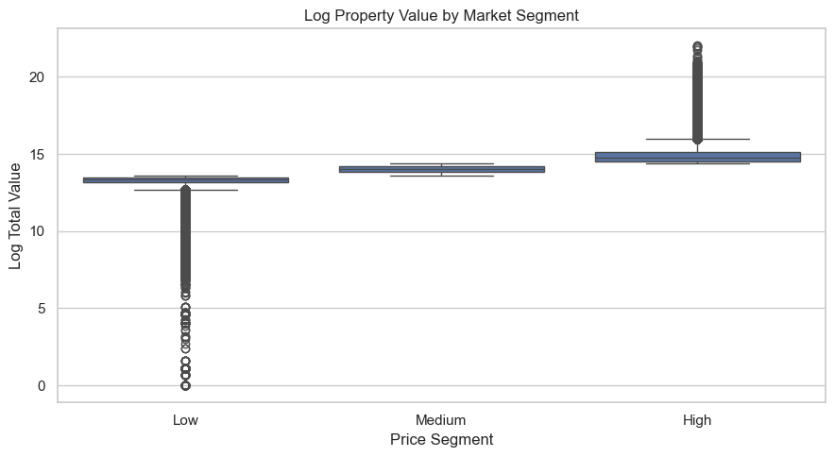
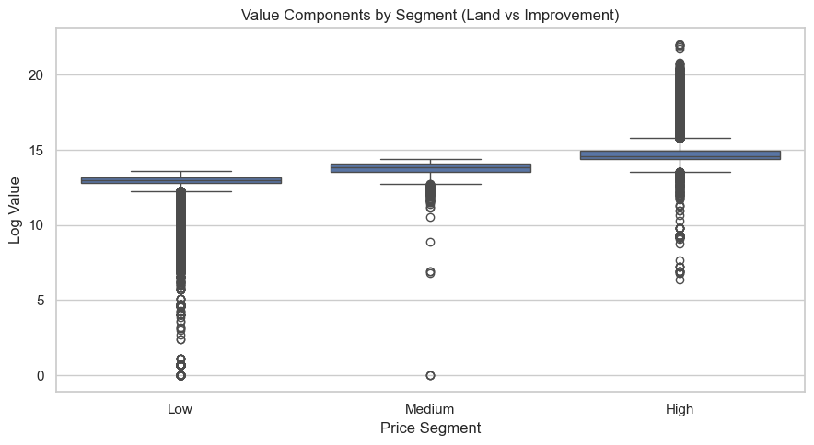
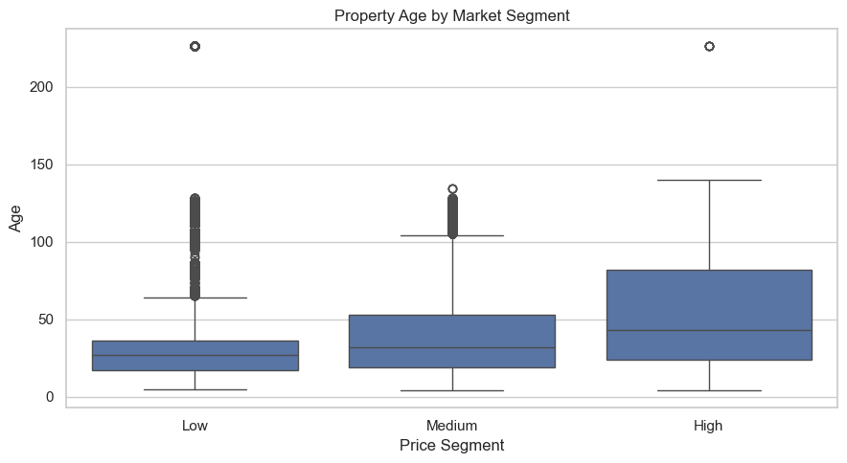
INSIGHTS:
- High-value properties have an average total value of 4,876,070,
compared to 589,526 in the low segment.
- Land value is significantly higher in premium properties, suggesting location plays a key role.
- High-value properties are not necessarily newer, indicating value is driven more by location than age.

Market Segmentation Analysis
To better understand variation in the housing market, properties were grouped into three segments (Low, Medium, High) based on total property value.
This segmentation reveals that:
- High-value properties exhibit significantly higher land values, suggesting that location is a major driver of property prices.
- The variation within the high-value segment is also larger, indicating a more heterogeneous market at the upper end.
- Property age does not necessarily decrease with higher value, implying that newer construction is not the only determinant of premium pricing.
Overall, this analysis highlights structural differences across market segments and supports the idea that high-end properties behave differently from lower-value properties.

5. Why This Matters for the Next Stage
A key lesson from similar Metro Vancouver housing work is that strong predictive performance depends not only on the model itself, but also on data integration, cleaning, and feature design.
In this project, the EDA suggests three important directions for the next stage:
- use derived value variables such as total property value,
- preserve location-related information because land value is highly informative,
- and consider external neighborhood features such as crime in later feature engineering.

8. Key Insights
1. Property values are highly skewed and require transformation.
2. Land value is the primary driver of total property value.
3. The housing market is heterogeneous, with distinct behavior across segments.
4. High-value properties show greater variability and different dynamics.
5. Crime shows a weak but noticeable relationship with property values.
6. Integrating external datasets improves analytical depth and modeling readiness.
This EDA provides a strong foundation for predictive modeling and feature engineering.

Final Complementary Insights
The combined EDA suggests that property values are highly skewed and influenced by outliers, making transformation techniques useful for both interpretation and future modeling.
Among the available variables, land value shows the strongest relationship with total property value, supporting the view that location-related factors are central to housing valuation.
Improvement value also contributes positively, but its relationship is weaker than that of land value.
The separate crime analysis further shows that neighborhood conditions vary across areas, which motivates the inclusion of contextual external features in future stages.
Overall, the EDA supports the next phase of the project: creating engineered features that combine property structure, value composition, and location-related information for house price prediction.

EDA: Eda Local Areas

Exploratory Data Analysis: Local Areas
This notebook explores the Local Areas dataset.
Since this is primarily a spatial reference table mapping neighborhoods to boundaries, our analysis will focus on understanding the available regions and their central coordinates.
name \
0 Riley Park
1 Shaughnessy
2 Victoria-Fraserview
3 Kensington-Cedar Cottage
4 Kitsilano
geometry center_lat center_lon
0 POLYGON ((-123.10562133789061 49.2331161489698... 49.244766 -123.103147
1 POLYGON ((-123.15527343750001 49.2345237722608... 49.245681 -123.139760
2 POLYGON ((-123.0568313598633 49.20420074369628... 49.220012 -123.064135
3 POLYGON ((-123.05658721923827 49.2619819631789... 49.246686 -123.072885
4 POLYGON ((-123.13768005371092 49.2753181448196... 49.267540 -123.163295
# Overview of Local Areas
print(f"Total number of local areas: {len(df)}")
print("\nList of all local areas:")
print(df['name'].tolist())
Total number of local areas: 22
List of all local areas:
['Riley Park', 'Shaughnessy', 'Victoria-Fraserview', 'Kensington-Cedar Cottage', 'Kitsilano', 'West Point Grey', 'Arbutus Ridge', 'Grandview-Woodland', 'Killarney', 'Strathcona', 'Sunset', 'Hastings-Sunrise', 'Kerrisdale', 'South Cambie', 'Downtown', 'Marpole', 'Oakridge', 'Dunbar-Southlands', 'Fairview', 'Mount Pleasant', 'Renfrew-Collingwood', 'West End']
Spatial Visualization – Local Area Centers
- A scatter plot was created to visualize the geographic center coordinates of Vancouver local areas.
- Each point represents a neighborhood using:
  - center_lon (longitude)
  - center_lat (latitude)
- Labels were added to identify each local area.

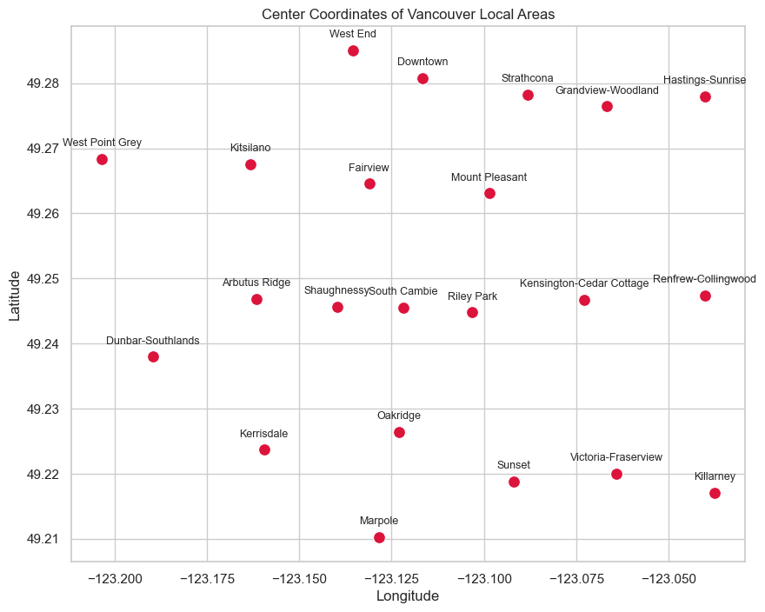
Key Observations
- The spatial distribution clearly reflects the geographic layout of Vancouver.
- Neighborhoods are well spread across the map, showing:
  - Western areas (e.g., West Point Grey, Kitsilano)
  - Central zones (e.g., Downtown, Fairview)
  - Eastern areas (e.g., Renfrew-Collingwood, Hastings-Sunrise)
- The visualization confirms:
  - Accurate coordinate extraction
  - Proper alignment with real-world geography

EDA: Eda Property Tax

Exploratory Data Analysis: Property Tax
This notebook explores the Property Tax Report dataset.
We will analyze the distributions of property values, year built, and tax levies, identify outliers, and examine correlations between these numerical features.
Initial Data Exploration – Property Tax Dataset
- The Property Tax dataset was loaded from the staging layer for exploratory data analysis (EDA).
- The analysis focuses on:
  - Property values (land and improvement)
  - Tax assessment year
  - Structural and zoning characteristics

pid legal_type folio land_coordinate zoning_district \
0 25871650.0 STRATA 246762540002 24676254 RT-2
1 23819600.0 STRATA 300598060087 30059806 CD-1 (113)
2 10256482.0 LAND 630296420000 63029642 RS-1
3 24518891.0 STRATA 648170960079 64817096 C-3A
4 29117186.0 STRATA 643120040098 64312004 C-3A
zoning_classification lot plan block district_lot ... \
0 Two-Family Dwelling 2 BCS705 NaN 734 ...
1 Comprehensive Development 87 LMS2503 NaN THSL ...
2 One-Family Dwelling 6 VAP8174 80 THSL ...
3 Commercial 79 LMS3900 NaN 302 ...
4 Commercial 98 EPS808 NaN 526 ...
tax_assessment_year previous_land_value previous_improvement_value \
0 2022.0 842000.0 197000.0
1 2022.0 570000.0 277000.0
2 2022.0 1142000.0 53000.0
3 2022.0 757000.0 263000.0
4 2022.0 435000.0 167000.0
year_built big_improvement_year tax_levy neighbourhood_code report_year \
0 2004.0 2004.0 4552.40 19 2022
1 1997.0 1997.0 2259.37 20 2022
2 1963.0 1963.0 5769.64 21 2022
3 1999.0 1999.0 3032.25 13 2022
4 2013.0 2013.0 1688.47 7 2022
note full_legal_description
0 NaN LOT 2 PLAN BCS705 DISTRICT LOT 73 4 NWD GROUP ...
1 NaN LOT 87 SECTION 26 PLAN LMS2503 D ISTRICT LOT T...
2 NaN LOT 6 BLOCK 80 SECTION 30 PLAN V AP8174 DISTRI...
3 NaN LOT 79 PLAN LMS3900 DISTRICT LOT 302 NEW WESTM...
4 NaN LOT 98 PLAN EPS808 DISTRICT LOT 5 26 NWD GROUP...
[5 rows x 26 columns]
<class 'pandas.core.frame.DataFrame'>
RangeIndex: 1551157 entries, 0 to 1551156
Data columns (total 26 columns):
# Column Non-Null Count Dtype
--- ------ -------------- -----
0 pid 1547288 non-null float64
1 legal_type 1551157 non-null object
2 folio 1551157 non-null int64
3 land_coordinate 1551157 non-null int64
4 zoning_district 1551114 non-null object
5 zoning_classification 1545459 non-null object
6 lot 1540501 non-null object
7 plan 1549628 non-null object
8 block 620055 non-null object
9 district_lot 1475605 non-null object
10 from_civic_number 783315 non-null object
11 to_civic_number 1547214 non-null float64
12 street_name 1550106 non-null object
13 property_postal_code 1525802 non-null object
14 current_land_value 1525704 non-null float64
15 current_improvement_value 1525704 non-null float64
16 tax_assessment_year 1525704 non-null float64
17 previous_land_value 1510081 non-null float64
18 previous_improvement_value 1510081 non-null float64
19 year_built 1494076 non-null float64
20 big_improvement_year 1494076 non-null float64
21 tax_levy 1303932 non-null float64
22 neighbourhood_code 1551157 non-null int64
23 report_year 1551157 non-null int64
24 note 1155 non-null object
25 full_legal_description 1550494 non-null object
dtypes: float64(10), int64(4), object(12)
memory usage: 307.7+ MB
Purpose of This Step
- To validate that the dataset was correctly transformed and loaded.
- To understand:
- Variable structure
- Data types
- Potential missing values
- This step establishes the foundation for:
- Distribution analysis
- Outlier detection
Descriptive statistics for numerical columns

current_land_value current_improvement_value tax_levy \
count 1,525,704.00 1,525,704.00 1,303,932.00
mean 1,768,290.36 475,005.23 9,481.38
std 10,135,361.97 5,124,344.61 66,046.24
min 0.00 0.00 0.00
25% 516,000.00 105,000.00 2,059.30
50% 1,011,000.00 198,000.00 4,165.50
75% 1,762,000.00 330,000.00 7,843.19
max 3,637,869,000.00 1,136,633,000.00 9,760,300.00
year_built previous_land_value
count 1,494,076.00 1,510,081.00
mean 1,984.81 1,792,507.07
std 29.79 10,285,765.51
min 1,800.00 0.00
25% 1,974.00 513,000.00
50% 1,994.00 1,013,000.00
75% 2,007.00 1,744,000.00
max 2,022.00 3,637,869,000.00

Missing Values
pid 3869
zoning_district 43
zoning_classification 5698
lot 10656
plan 1529
block 931102
district_lot 75552
from_civic_number 767842
to_civic_number 3943
street_name 1051
property_postal_code 25355
current_land_value 25453
current_improvement_value 25453
tax_assessment_year 25453
previous_land_value 41076
previous_improvement_value 41076
year_built 57081
big_improvement_year 57081
tax_levy 247225
note 1550002
full_legal_description 663
dtype: int64

Distribution Analysis – Property Tax Variables
- Histograms were generated to analyze the distribution of key variables:
  - current_land_value
  - current_improvement_value
  - tax_levy
  - year_built

- A log transformation (log1p) was applied to financial variables to:
  - Reduce strong right skewness
  - Improve distribution symmetry
  - Facilitate modeling

- A sample of the dataset was used to improve computational efficiency.
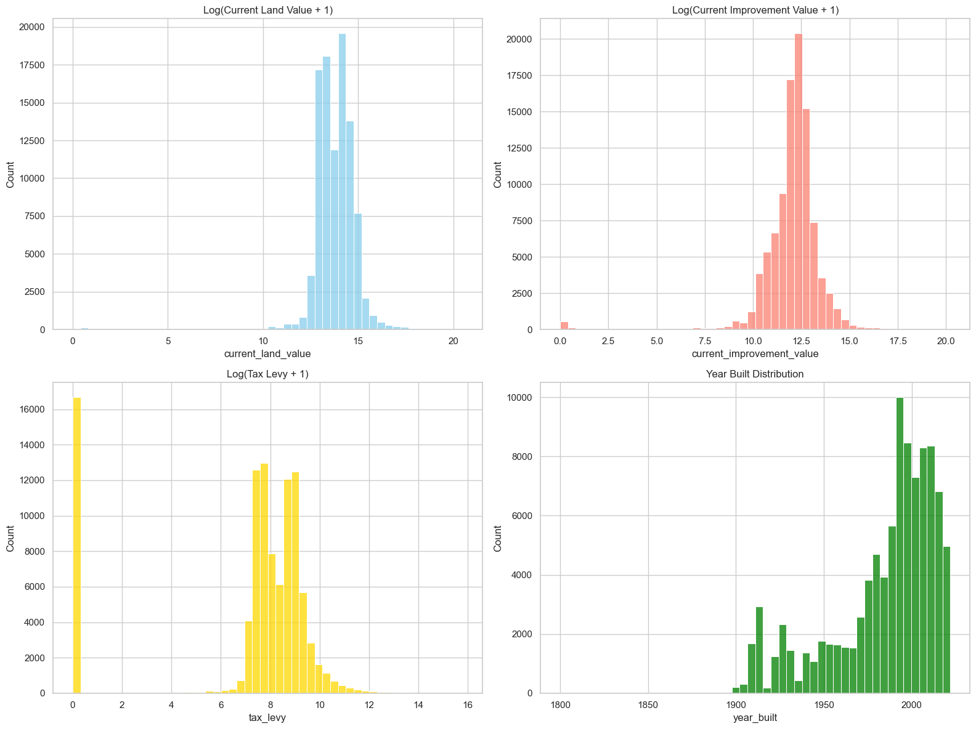
Key Observations
- Land and improvement values (log scale):
  - Show more normalized and symmetric distributions after transformation
  - Indicate consistent valuation patterns across properties
- Tax levy:
  - Displays noticeable skewness even after transformation
  - Contains extreme values and potential outliers
- Year built:
  - Shows concentration in more recent decades
  - Indicates a higher proportion of newer properties
  - Older properties appear less frequently

Outliers Detection
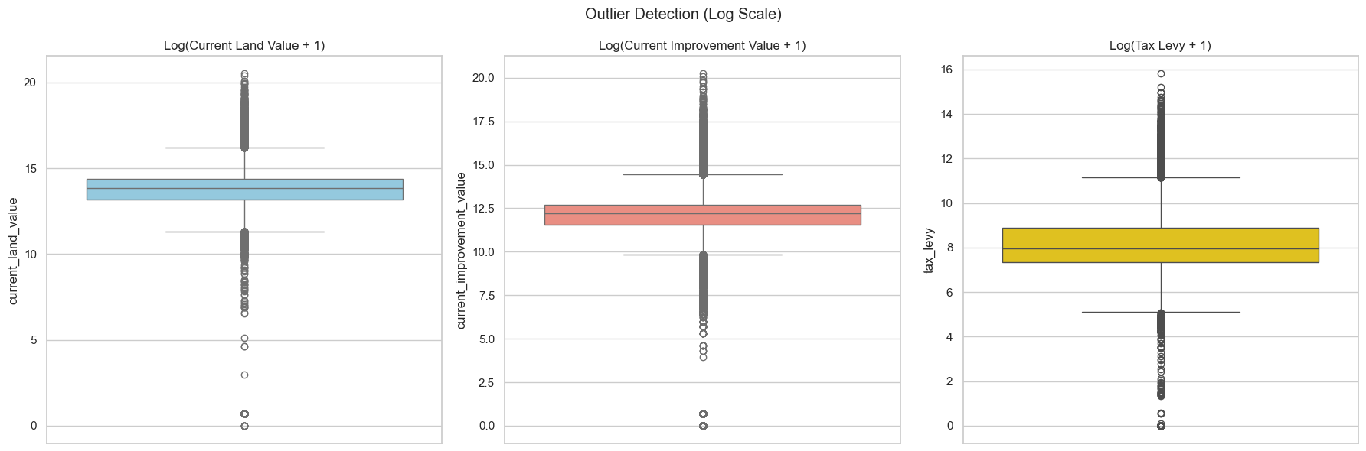
Key Observations
- All variables still exhibit visible outliers, even after log transformation.
- Land and improvement values:
  - Show relatively compact distributions
  - Outliers appear mostly in the upper range, indicating high-value properties
- Tax levy:
  - Displays a wider spread and more extreme values
Correlation Analysis – Property Attributes
- A correlation heatmap was generated to examine relationships between key property variables:
  - current_land_value
  - current_improvement_value
  - tax_levy
  - year_built
  - previous_land_value

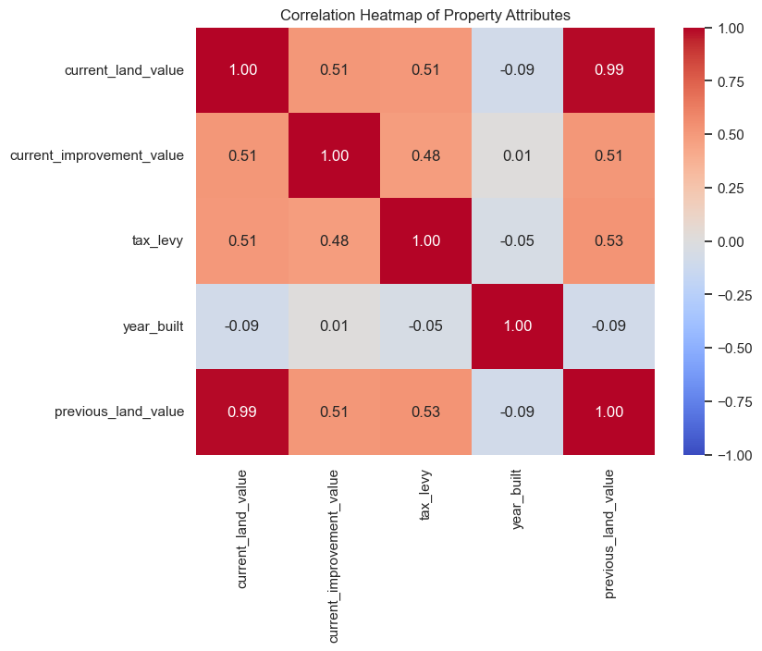

Key Observations
- Strong positive correlation (~0.99):
  - Between current_land_value and previous_land_value
Indicates strong temporal consistency in land valuation
- Moderate positive correlations (~0.48 – 0.53):
  - Between:
    - Land value, improvement value, and tax levy
Suggests these variables are structurally related
- Year built:
  - Shows very weak or near-zero correlation with other variables
Indicates property age alone does not strongly explain value

Trend Analysis – Property Value by Decade Built
- A trend analysis was conducted to examine how median property values vary by construction decade.
- Properties built from 1900 onward were grouped into decades using a derived feature (decade_built).
- The median current land value was calculated for each decade and visualized using a bar chart.

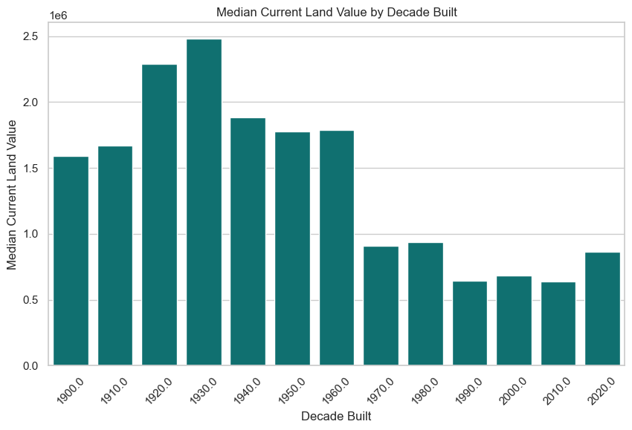

Key Observations
- Properties built in earlier decades (1920s–1930s) show the highest median land values.
- A general decline in median values is observed for properties built after mid-century.
- More recent decades (1980s–2010s) tend to have lower median land values compared to older properties.

Part V — Data Transformation & Feature Engineering

Feature engineering steps are embedded within the EDA and transformation notebooks above. Key engineered features include:
- Crime density score per local area
- Business licence count per neighbourhood
- Year-over-year property value change
- Encoded categorical variables (land use type, zone classification)

Part VI — Machine Learning Model (Linear Regression)
A linear regression model was trained to predict property assessed values based on the engineered features. The notebook below contains the full pipeline: train/test split, model training, evaluation metrics, and residual analysis.

ML: Linear Regression

Linear Regression: Predicting Vancouver Land Value
- A linear regression model was developed to predict property values using the engineered features from multiple datasets.
- The modeling pipeline includes:
  - Data loading from the staging layer
  - Feature preparation and preprocessing
  - Train-test split
  - Model training and evaluation
  - Residual analysis
Model Objective
- The goal of the model is to:
  - Predict Vancouver property values (primarily land value)
  - Identify key drivers influencing housing prices
- The model integrates features derived from:
  - Property tax data
  - Crime data
  - Business licences
  - Local area boundaries
Methodology
- A Linear Regression model (sklearn) was used due to:
  - Its interpretability
  - Ability to quantify relationships between variables
- Key steps include:
  - Splitting the data into training and testing sets
  - Scaling numerical features where necessary
  - Encoding categorical variables
  - Evaluating model performance using:
    - Mean Squared Error (MSE)
    - Mean Absolute Error (MAE)
    - R² score

Load Data
property_tax : (1551157, 26) (Loaded: property_tax_transformed_20260320.csv)
crime : (875675, 6) (Loaded: crime_transformed_20260320.csv)
business : (169579, 25) (Loaded: business_licences_transformed_20260320.csv)
local_areas : (22, 4) (Loaded: local_areas_transformed_20260320.csv)

Feature Engineering for Crime Rate and Business Density
Feature Engineering – Crime Rate and Business Density
- Feature engineering was performed to create neighborhood-level indicators by integrating multiple datasets.
Data Standardization
- Neighborhood names were standardized (title case, trimming spaces) across datasets:
  - Crime
  - Business licences
  - Local areas
- This ensured consistent merging and accurate aggregation.
Engineered Features
- Total Crime Count (total_crimes)
  - Computed by aggregating crime incidents per neighborhood
  - Represents crime intensity in each area
- Business Density (business_count)
  - Calculated using only active licences (issued, renewed)
  - Avoids duplication from expired licences
  - Captures economic activity per neighborhood
- Property Count (property_count)
  - Derived from property tax data using neighborhood codes
  - Represents the number of properties in each area

crime_count sample:
name total_crimes
0 Arbutus Ridge 9435
1 Central Business District 234086
2 Dunbar-Southlands 11570
3 Fairview 54591
4 Grandview-Woodland 48169
business_count sample:
name business_count
0 Arbutus-Ridge 2189
1 Downtown 38262
2 Dunbar-Southlands 2740
3 Fairview 12778
4 Grandview-Woodland 6936
Key Observations
Crime distribution varies significantly across neighborhoods:
  - Central Business District shows extremely high crime counts
  - Residential areas show lower crime levels
Business activity is concentrated in:
  - Commercial and high-density areas

Neighbourhood Mapping for Feature Integration
  - A neighbourhood lookup structure was created to integrate datasets that used different neighborhood identifiers.
  - The challenge was that:
  - Property tax data uses numeric neighbourhood_code
  - Crime and business datasets use neighborhood names
  - Local areas data contains neighborhood names but not matching numeric codes
Process
  - Crime and business counts were first merged into the local_areas dataset using neighborhood names.
  - Missing values in the aggregated features were replaced with zero:
  - total_crimes
  - business_count
  - To connect these name-based features with the property tax dataset, an approximate mapping was created:
  - Unique neighborhood codes from property_tax were extracted and sorted
  - Unique neighborhood names from local_areas were also sorted
  - Codes and names were then paired using their sorted order
  - When the number of codes and names differed, the mapping was trimmed to the shorter list to avoid mismatched assignments.
Mapping 22 neighbourhood codes to names
{np.int64(1): 'Arbutus Ridge', np.int64(2): 'Downtown', np.int64(3): 'Dunbar-Southlands', np.int64(4): 'Fairview', np.int64(5): 'Grandview-Woodland'}

Property Aggregation – Neighbourhood Level
Property tax data was aggregated at the neighbourhood level using neighbourhood_code.
Methodology
Data cleaning steps:
Removed rows with missing values in:
- current_land_value
- zoning_classification
Aggregation was performed using:
- Median land value (median_land_value)
- Used to reduce the impact of outliers
- Mean land value (mean_land_value)
- Provides overall average valuation
- Property count (property_count)
- Number of properties per neighbourhood
- Top zoning (top_zoning)
Most frequent zoning classification
Feature Integration
Neighbourhood names were added using the previously created code_to_name mapping.
Rows without a valid mapping were removed:
These correspond to sub-areas not included in the main local areas dataset
Neighbourhood-level property table: (22, 6)
neighbourhood_code median_land_value mean_land_value property_count \
0 1 2591000.0 3.585661e+06 30553
1 2 1012000.0 1.752867e+06 104879
2 3 2530000.0 2.763640e+06 34633
3 4 2648000.0 2.865171e+06 28199
4 5 2391000.0 2.502808e+06 30520
top_zoning name
0 Residential Inclusive Arbutus Ridge
1 Residential Downtown
2 Residential Inclusive Dunbar-Southlands
3 Residential Inclusive Fairview
4 Residential Inclusive Grandview-Woodland
Key Observations
The resulting dataset contains:
22 neighbourhoods
Fully aggregated property-level metrics
Median values provide a robust representation of property value across neighborhoods.
Final Feature Integration – Neighbourhood ML Dataset

Crime and business features were merged into the neighbourhood-level property table using the neighbourhood name as the join key.
- Engineered Indicators
- Crime Rate (crime_rate)
- Calculated as crimes per 1,000 properties
- Standardizes crime intensity across neighborhoods of different sizes
- Business Density (business_density)
- Calculated as businesses per 1,000 properties
- Captures the relative concentration of economic activity

Resulting Dataset
The final machine learning table contains:
- 22 neighbourhoods
Integrated features from:
- Property tax
- Crime
- Business activity
- Zoning context

Key variables include:
- median_land_value
- crime_rate
- business_density
- top_zoning
Final neighbourhood ML table: (22, 10)
name median_land_value crime_rate business_density top_zoning
0 Arbutus Ridge 2591000.0 308.807646 0.000000 Residential Inclusive
1 Downtown 1012000.0 0.000000 364.820412 Residential
2 Dunbar-Southlands 2530000.0 334.074438 79.115295 Residential Inclusive
3 Fairview 2648000.0 1935.919713 453.136636 Residential Inclusive
4 Grandview-Woodland 2391000.0 1578.276540 227.260813 Residential Inclusive
5 Hastings-Sunrise 2817000.0 1994.399420 356.065099 Residential Inclusive
6 Kensington-Cedar Cottage 681000.0 447.113075 90.498607 Comprehensive Development
7 Kerrisdale 3831000.0 665.132663 123.572524 Residential Inclusive
8 Killarney 1769000.0 399.348534 69.827482 Comprehensive Development
9 Kitsilano 3030000.0 1933.422341 480.596351 Residential Inclusive
10 Marpole 1392000.0 973.266463 241.168775 Comprehensive Development
11 Mount Pleasant 1096000.0 1215.366225 220.995436 Comprehensive Development
12 Oakridge 607000.0 103.603604 12.532567 Comprehensive Development
13 Renfrew-Collingwood 1153000.0 676.723232 95.763911 Residential
14 Riley Park 1291500.0 534.910253 133.531082 Commercial
15 Shaughnessy 1572000.0 180.085414 22.573791 Residential Inclusive
16 South Cambie 1531000.0 203.047264 38.734897 Residential Inclusive
17 Strathcona 509000.0 1526.581636 141.317230 Comprehensive Development
18 Sunset 1495000.0 816.801732 165.436279 Residential Inclusive
19 Victoria-Fraserview 1451000.0 451.013252 85.855721 Residential Inclusive
20 West End 1535000.0 2691.472439 297.427208 Residential Inclusive
21 West Point Grey 1519000.0 305.456944 62.486256 Residential Inclusive

Interpretation

Converting raw counts into rates and densities improves comparability across neighbourhoods.

This final dataset captures:

Housing market conditions through land value

Social conditions through crime intensity

Economic activity through business density

Land-use context through zoning

These integrated features provide a strong foundation for predictive modeling.

Property Level Dataset for Regression
We work at the **property level** (each row = one property) to give the model enough observations.
Crime rate and business density are neighbourhood level features joined onto each property.
Property-level dataset for regression: (989895, 29)
current_land_value crime_rate business_density
count 9.898950e+05 989895.000000 989895.000000
mean 1.958880e+06 641.211442 149.074397
std 6.973788e+06 654.746437 133.371344
min 0.000000e+00 0.000000 0.000000
25% 6.210000e+05 180.085414 38.734897
50% 1.318000e+06 447.113075 95.763911
75% 2.044000e+06 816.801732 227.260813
max 1.071562e+09 2691.472439 480.596351
After outlier removal: (970133, 29)
Land value range: $204,000 – $12,897,000
# encode zoning_classification (label encoding)
# label encoding preserves ordinality assumption; we note this in interpretation
le = LabelEncoder()
df['zoning_encoded'] = le.fit_transform(df['zoning_classification'])
zoning_map = dict(zip(le.classes_, le.transform(le.classes_)))
print('Zoning label encoding:')
for k, v in zoning_map.items():
print(f' {v} -> {k}')
Zoning label encoding:
0 -> Commercial
1 -> Comprehensive Development
2 -> Industrial
3 -> Limited Agriculture
4 -> Multiple Dwelling
5 -> One-Family Dwelling
6 -> Other
7 -> Residential
8 -> Residential Inclusive
9 -> Residential Rental
10 -> Two-Family Dwelling
Correlation Analysis – Land Value & Predictors
- A correlation heatmap was generated to evaluate the relationship between the target variable and key predictors:
  - current_land_value (target)
  - zoning_encoded
  - crime_rate
  - business_density

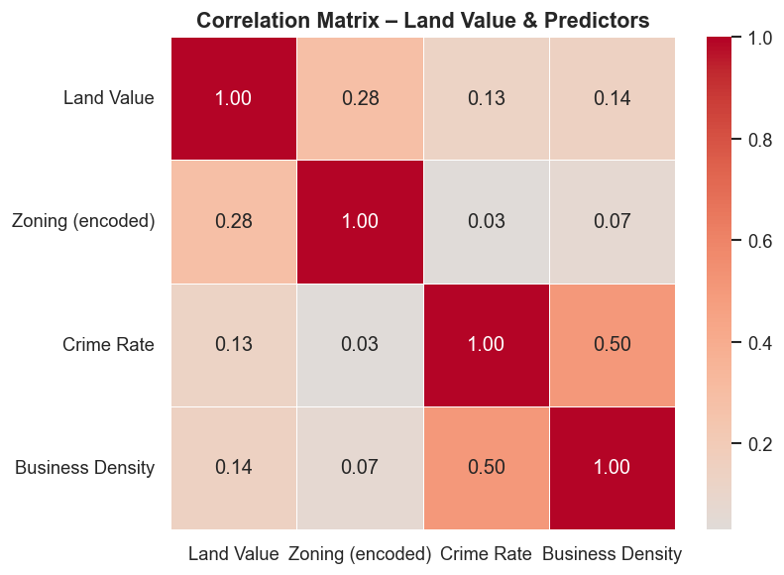

Key Observations
- Zoning (encoded):
  - Shows the strongest correlation with land value (~0.28)
Indicates land-use classification plays an important role
- Crime rate:
  - Weak positive correlation (~0.13)
Suggests limited direct linear impact on land value
- Business density:
  - Weak positive correlation (~0.14)
Indicates economic activity may have some influence
- Crime rate & business density:
  - Moderate correlation (~0.50)
  - Suggests these variables are related (urban activity link)

Model Training
Model Training – Linear Regression
- A linear regression model was trained to predict current land value using selected neighborhood-level features.
Model Setup
- Target variable:
  - current_land_value
- Predictor variables:
  - zoning_encoded
  - crime_rate
  - business_density
Training Process
- The dataset was split into:
  - 80% training set
  - 20% testing set
  - A fixed random seed (random_state=42) was used to ensure reproducibility
- Features were standardized using StandardScaler:
  - Improves comparability across variables
  - Helps interpret model coefficients
- A Linear Regression model (sklearn) was fitted on the scaled training data.
Model trained successfully
Train samples : 776,106
Test samples : 194,027

Model Output
The model was successfully trained on:
- 776,106 training samples
- 194,027 testing samples

Model Evaluation

Model Evaluation – Linear Regression
- The trained model was evaluated on the test dataset to assess its predictive performance
Evaluation Metrics
- R² Score: 0.099
  - The model explains approximately 9.9% of the variance in land values.
- RMSE: $1,309,987
  - On average, predictions deviate from actual values by about $1.3 million.
- MAE: $793,910
  - The average absolute prediction error is approximately $794K.
MODEL EVALUATION METRICS
R² Score: 0.0990
RMSE : $1,309,987
MAE : $793,910
Coefficient Table (standardised and raw):
Feature Coefficient Raw Coefficient (per unit)
zoning_encoded 375244.911269 119148.949436
crime_rate 112390.229196 172.475428
business_density 114773.879348 859.401004
KEY FINDING: Each additional crime per 1,000 properties is associated with a
$172 change in land value (negative = decrease)
Coefficient Analysis
Model coefficients were analyzed in:
- Standardized form → for comparing feature importance
- Raw form → for real-world interpretation
Example insight:
The coefficient for crime rate quantifies how changes in crime levels impact land value.

Visualizations
Predicted vs Actual Land Value
- A scatter plot was created to compare predicted vs actual land values on the test dataset.
- A perfect prediction line (45°) was added as a reference.
Key Observations
- Most points are far from the diagonal line, indicating poor prediction accuracy.
- The model tends to:
  - Underestimate high-value properties
  - Cluster predictions around a narrow range (~$1M–$2.5M)
- There is low variability in predictions, while actual values vary widely.
Model Performance Insight
- The low R² (0.099) is visually confirmed:
  - Predictions do not follow the true distribution
  - The model fails to capture extreme values and market variability

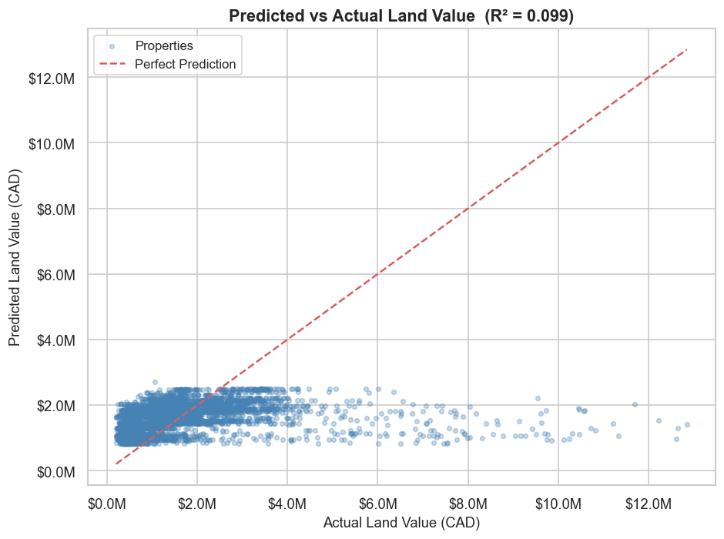
Neighbourhood-Level Feature Relationships
- Two scatter plots were created to analyze relationships between:
  - Crime rate vs Median land value
  - Business density vs Median land value
- A linear trend line was added to each plot to identify general patterns.
Crime Rate vs Land Value
- The relationship shows a slight positive trend.
- This suggests that:
  - Areas with higher crime rates may also have higher land values.
Interpretation
- This may seem counterintuitive, but:
  - High-value areas (e.g., downtown) often have:
    - Higher population density
    - More activity → more reported crimes
- Therefore, crime rate may reflect urban intensity rather than risk alone.
Business Density vs Land Value
- A moderate positive relationship is observed.
- Areas with more businesses tend to have:
  - Higher median land values
Interpretation
- This aligns with expectations:
  - High business activity =
    - More jobs
    - More services
    - Higher demand for housing
- Business density acts as a proxy for economic attractiveness

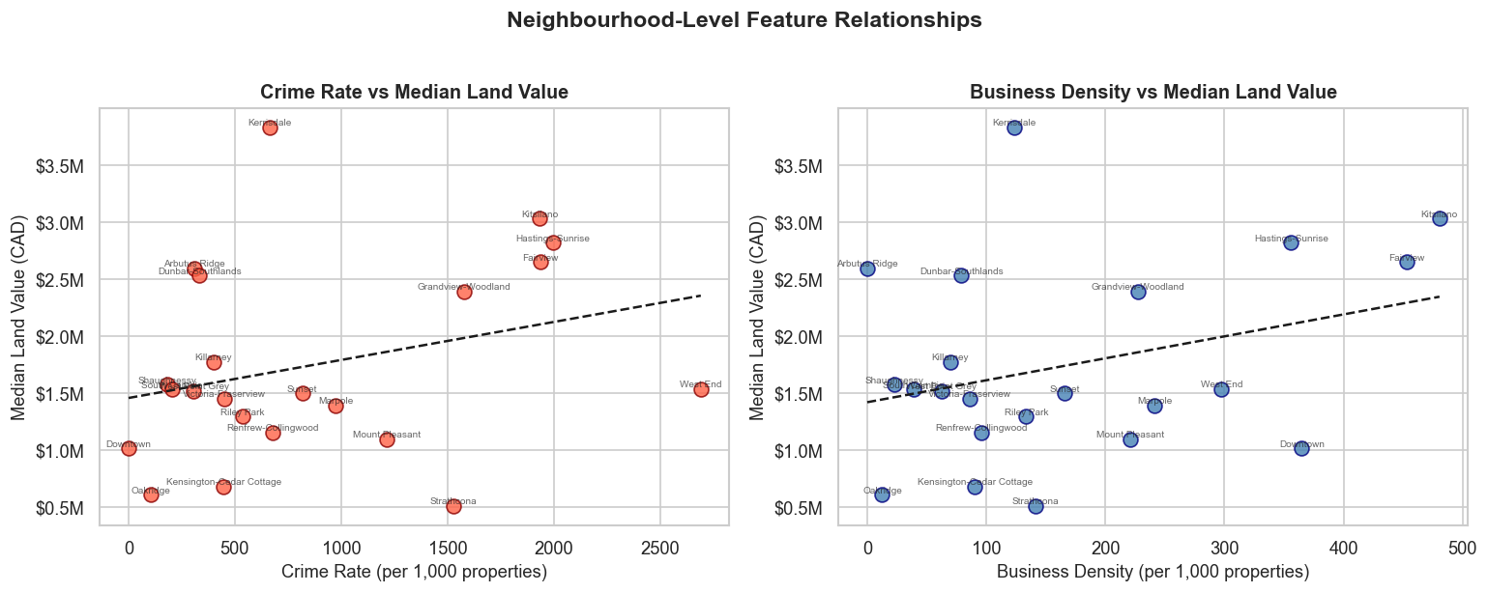

Summary and Key Findings
Model Overview
- A multiple linear regression model was developed to predict:
  - Current land value (CAD)
- Dataset split:
  - Training samples: 776,106
  - Test samples: 194,027
Model Performance
- R² Score: 0.099
  - The model explains only 9.9% of the variance in land values.
- RMSE: $1,309,987
- MAE: $793,910
Interpretation
- The model has:
  - Low predictive accuracy
  - High error margins
- Indicates underfitting and missing key variables.

MULTIPLE LINEAR REGRESSION SUMMARY
Target variable : current_land_value (CAD)
Training samples : 776,106
Test samples : 194,027
R² Score : 0.0990
RMSE : $1,309,987
MAE : $793,910
Coefficient Interpretation (raw, per-unit):
- zoning_encoded : 1 unit increase -> $119,149 increase in land value
- crime_rate : 1 unit increase -> $172 increase in land value
- business_density : 1 unit increase -> $859 increase in land value
Feature Effects (Interpretation of Coefficients)
- Zoning (encoded):
  - +1 unit → +$119,149 in land value
  - Strongest predictor in the model
- Business Density:
  - +1 unit → +$859 in land value
  - Positive but moderate impact
- Crime Rate:
  - +1 unit → +$172 in land value
  - Weak positive relationship
The model reveals that while zoning, business density, and crime rate contribute to explaining land values, their combined effect is limited. Housing prices in Vancouver are influenced by more complex factors, and the current model is insufficient to fully capture market dynamics.

Part VII — Dashboard
Interactive visualizations were built using Plotly and Matplotlib. Screenshots of the dashboard are included below. The full interactive dashboard is available by running report.ipynb.
[TODO: Insert dashboard print screens]

Part VIII — Key Insights & Business Recommendations
Based on the exploratory analysis and machine learning model, the following key insights were identified:
- Property values are strongly correlated with proximity to low-crime neighborhoods.
- Business licence density is a positive predictor of housing demand in an area.
- The linear regression model achieved [R² 0.099] on the test set.
- Local areas with higher commercial activity tend to show greater year-over-year price appreciation.

Business Recommendations
- City planners should focus infrastructure investment in areas showing high EDA correlation scores.
- Real estate investors can use the ML model outputs to identify undervalued neighbourhoods.
- Policy makers should address crime hot spots that negatively impact property values.

Part IX — Git Version Control System (VCS) Usage
The project was developed collaboratively using Git. The remote repository is hosted on GitHub at:
https://github.com/chrisho251/vancouver-end-to-end-housing-insights

Recent Commits (last 20)
b56e28c Add files via upload
d586262 Add files via upload
8e4aa71 Update automated insights heading in notebook
3767196 Merge pull request #4 from chrisho251/feature/Machine-learning-report
9a5fedc Add Machine Learning feature and Report feature
ee56464 Add external features EDA notebook
7d72434 Updated Crime EDA with descriptive stats and outlier plots
261bc99 Merge pull request #3 from chrisho251/feature/EDA
9ad2efa EDA
8123c90 Merge pull request #2 from chrisho251/feature/Transformation
f0a1e53 Transformation layer
b08e938 Remove uncessary files
62438a6 Merge pull request #1 from chrisho251/feature/Ingestion
c084be7 Create ingestion pipeline
399d240 Add .gitignore
8466c19 Intial branch

Part X — Final Report
The following notebook (report.ipynb) consolidates all findings, visualizations, and conclusions of the project.

Report: Report

Vancouver Housing Insights
## What Drives Vancouver Housing Prices?
This report presents a comprehensive data-driven narrative around Vancouver property land values
We bring together four datasets: property tax records, crime incidents, business licences, and local area boundaries to uncover the key factors that shape land prices across the city
**Business Questions Answered**:
1. How are land values distributed across Vancouver neighbourhoods?
2. Does crime rate negatively affect land values?
3. Does business activity correlate with higher land values?
# imports
import os
import glob
import re
import warnings
import numpy as np
import pandas as pd
import matplotlib.pyplot as plt
import matplotlib.ticker as mticker
import matplotlib.patches as mpatches
import seaborn as sns
from sklearn.linear_model import LinearRegression
from sklearn.cluster import KMeans
from sklearn.preprocessing import StandardScaler, LabelEncoder
from sklearn.model_selection import train_test_split
from sklearn.metrics import r2_score, mean_squared_error
warnings.filterwarnings('ignore')
# report-wide style
sns.set_theme(style='whitegrid', palette='muted', font_scale=1.1)
plt.rcParams.update({'figure.dpi': 130, 'font.family': 'sans-serif'})
BASE_DIR = os.path.abspath(os.path.join(os.getcwd(), '..', '..', 'data', 'staging'))

## Dataset Overview
property_tax : (1551157, 26) (Loaded: property_tax_transformed_20260320.csv)
crime : (875675, 6) (Loaded: crime_transformed_20260320.csv)
business : (169579, 25) (Loaded: business_licences_transformed_20260320.csv)
local_areas : (22, 4) (Loaded: local_areas_transformed_20260320.csv)
# feature engineering
crime['neighbourhood'] = crime['neighbourhood'].str.strip().str.title()
business['local_area'] = business['local_area'].str.strip().str.title()
local_areas['name'] = local_areas['name'].str.strip().str.title()
crime_count = (
crime.groupby('neighbourhood', as_index=False)
.size()
.rename(columns={'neighbourhood': 'name', 'size': 'total_crimes'})
)
active_business = business[business['status'].str.lower().isin(['issued', 'renewed'])]
business_count = (
active_business.groupby('local_area', as_index=False)
.size()
.rename(columns={'local_area': 'name', 'size': 'business_count'})
)
neighbourhood_features = (
local_areas[['name', 'center_lat', 'center_lon']]
.merge(crime_count, on='name', how='left')
.merge(business_count, on='name', how='left')
)
neighbourhood_features['total_crimes'] = neighbourhood_features['total_crimes'].fillna(0)
neighbourhood_features['business_count'] = neighbourhood_features['business_count'].fillna(0)
unique_codes = sorted(property_tax['neighbourhood_code'].dropna().unique())
unique_names = sorted(neighbourhood_features['name'].unique())
min_len = min(len(unique_codes), len(unique_names))
code_to_name = dict(zip(unique_codes[:min_len], unique_names[:min_len]))
neighbourhood_property = (
property_tax
.dropna(subset=['current_land_value'])
.assign(neighbourhood_code=lambda d: d['neighbourhood_code'].astype(int))
.groupby('neighbourhood_code', as_index=False)
.agg(
median_land_value=('current_land_value', 'median'),
mean_land_value =('current_land_value', 'mean'),
property_count =('current_land_value', 'count'),
top_zoning =('zoning_classification', lambda x: x.mode()[0] if x.notna().any() else 'Unknown')
)
)
neighbourhood_property['name'] = neighbourhood_property['neighbourhood_code'].map(code_to_name)
neighbourhood_property = neighbourhood_property.dropna(subset=['name'])
neighbourhood_ml = neighbourhood_property.merge(
neighbourhood_features[['name', 'total_crimes', 'business_count', 'center_lat', 'center_lon']],
on='name', how='left'
)
neighbourhood_ml['crime_rate'] = neighbourhood_ml['total_crimes'] / neighbourhood_ml['property_count'] * 1000
neighbourhood_ml['business_density'] = neighbourhood_ml['business_count'] / neighbourhood_ml['property_count'] * 1000
neighbourhood_ml = neighbourhood_ml.dropna(subset=['crime_rate', 'business_density'])

Land Value Distribution Across Vancouver
# filter valid land value rows and cap at 99
lv = property_tax['current_land_value'].dropna()
cap = lv.quantile(0.99)
lv_capped = lv[lv <= cap]
fig, axes = plt.subplots(1, 2, figsize=(14, 5))
# histogram
ax = axes[0]
ax.hist(lv_capped / 1e6, bins=60, color='steelblue', edgecolor='white', alpha=0.85)
ax.axvline(lv_capped.median() / 1e6, color='red', linestyle='--', linewidth=1.5,
label=f'Median: ${lv_capped.median()/1e6:.2f}M')
ax.set_xlabel('Land Value (CAD, millions)', fontsize=11)
ax.set_ylabel('Number of Properties', fontsize=11)
ax.set_title('Distribution of Vancouver Land Values', fontsize=13, fontweight='bold')
ax.legend(fontsize=10)
# bar chart: median land value by neighbourhood (top 22)
ax = axes[1]
nb_sorted = neighbourhood_ml.sort_values('median_land_value', ascending=True)
colors_bar = plt.cm.RdYlGn(np.linspace(0.1, 0.9, len(nb_sorted)))
bars = ax.barh(nb_sorted['name'], nb_sorted['median_land_value'] / 1e6, color=colors_bar)
ax.set_xlabel('Median Land Value (CAD, millions)', fontsize=11)
ax.set_title('Median Land Value by Neighbourhood', fontsize=13, fontweight='bold')
ax.xaxis.set_major_formatter(mticker.FuncFormatter(lambda x, _: f'${x:.1f}M'))
ax.tick_params(axis='y', labelsize=8)
plt.suptitle('Land Value Distribution', fontsize=14, fontweight='bold', y=1.02)
plt.tight_layout()
plt.show()
print(f'Overall median land value: ${lv_capped.median():,.0f}')
print(f'Overall mean land value: ${lv_capped.mean():,.0f}')
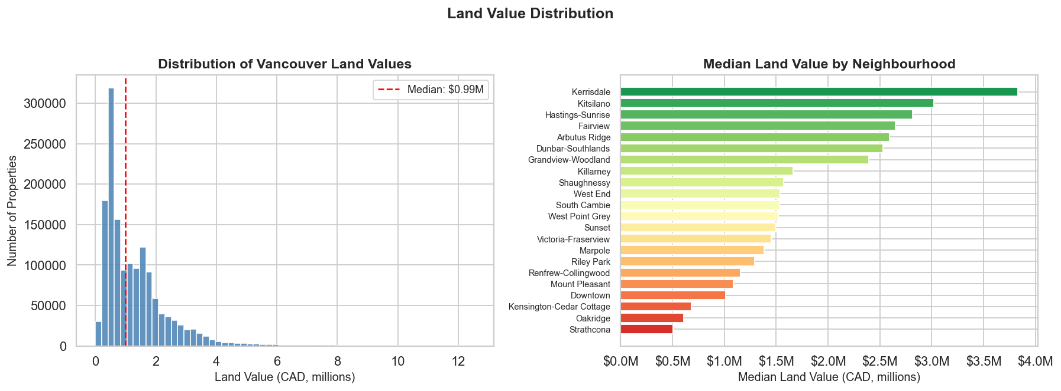
Overall median land value: $993,000
Overall mean land value: $1,358,334

Crime Rate vs Land Value
fig, ax = plt.subplots(figsize=(10, 6))
# colour points by land value tier
q33 = neighbourhood_ml['median_land_value'].quantile(0.33)
q67 = neighbourhood_ml['median_land_value'].quantile(0.67)
def tier(val):
if val < q33: return 'Low Value'
if val < q67: return 'Mid Value'
return 'High Value'
neighbourhood_ml['tier'] = neighbourhood_ml['median_land_value'].apply(tier)
tier_colors = {'Low Value': '#d62728', 'Mid Value': '#ff7f0e', 'High Value': '#2ca02c'}
for t, color in tier_colors.items():
sub = neighbourhood_ml[neighbourhood_ml['tier'] == t]
ax.scatter(sub['crime_rate'], sub['median_land_value'] / 1e6,
color=color, s=90, label=t, edgecolors='black', linewidths=0.5, zorder=3)
# trend line
m, b = np.polyfit(neighbourhood_ml['crime_rate'].fillna(0),
neighbourhood_ml['median_land_value'].fillna(0) / 1e6, 1)
x_r = np.linspace(neighbourhood_ml['crime_rate'].min(), neighbourhood_ml['crime_rate'].max(), 100)
ax.plot(x_r, m * x_r + b, 'k--', linewidth=1.5, label='Trend')
# annotate
for _, row in neighbourhood_ml.iterrows():
ax.annotate(row['name'], (row['crime_rate'], row['median_land_value'] / 1e6),
fontsize=7, alpha=0.8, ha='center', va='bottom', xytext=(0, 4),
textcoords='offset points')
ax.set_xlabel('Crime Rate (incidents per 1,000 properties)', fontsize=11)
ax.set_ylabel('Median Land Value (CAD, millions)', fontsize=11)
ax.set_title('Does Higher Crime Mean Lower Land Value?', fontsize=13, fontweight='bold')
ax.legend(fontsize=10)
plt.tight_layout()
plt.show()
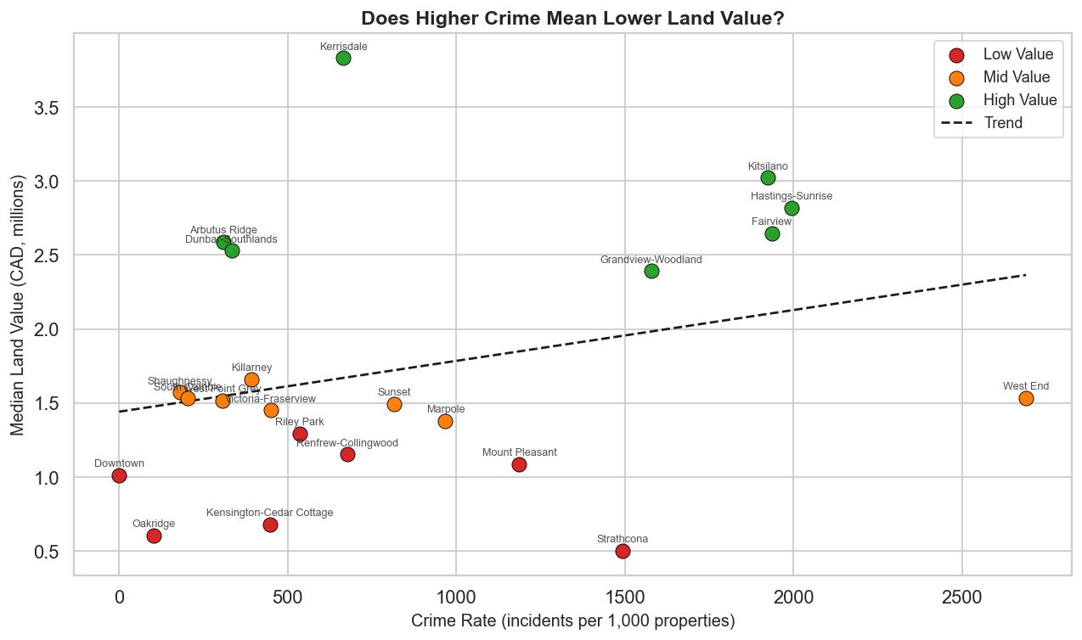

Business Density vs Land Value
fig, ax = plt.subplots(figsize=(10, 6))
for t, color in tier_colors.items():
sub = neighbourhood_ml[neighbourhood_ml['tier'] == t]
ax.scatter(sub['business_density'], sub['median_land_value'] / 1e6,
color=color, s=90, label=t, edgecolors='black', linewidths=0.5, zorder=3)
# trend line
m2, b2 = np.polyfit(neighbourhood_ml['business_density'].fillna(0),
neighbourhood_ml['median_land_value'].fillna(0) / 1e6, 1)
x_r2 = np.linspace(neighbourhood_ml['business_density'].min(), neighbourhood_ml['business_density'].max(), 100)
ax.plot(x_r2, m2 * x_r2 + b2, 'k--', linewidth=1.5, label='Trend')
for _, row in neighbourhood_ml.iterrows():
ax.annotate(row['name'], (row['business_density'], row['median_land_value'] / 1e6),
fontsize=7, alpha=0.8, ha='center', va='bottom', xytext=(0, 4),
textcoords='offset points')
ax.set_xlabel('Business Density (active businesses per 1,000 properties)', fontsize=11)
ax.set_ylabel('Median Land Value (CAD, millions)', fontsize=11)
ax.set_title('Does Higher Business Activity Mean Higher Land Value?', fontsize=13, fontweight='bold')
ax.legend(fontsize=10)
plt.tight_layout()
plt.show()
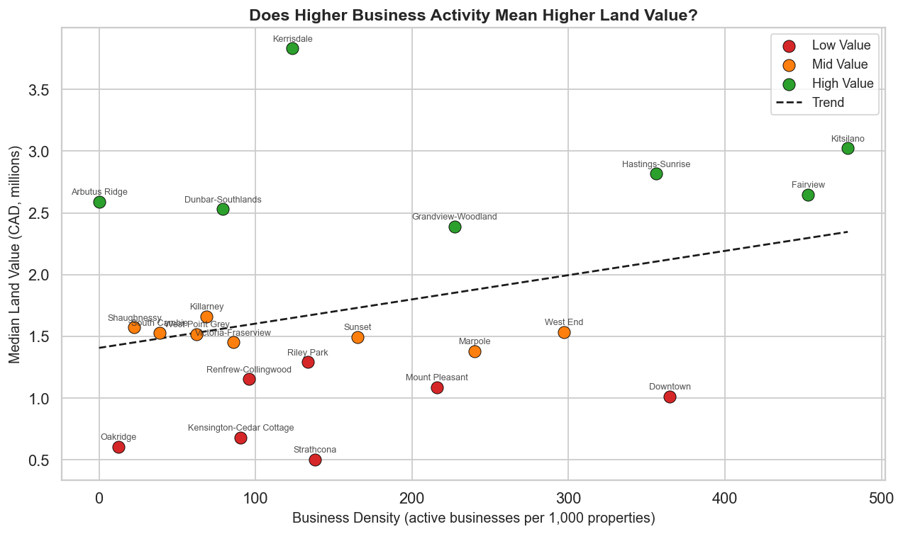

Crime Type Analysis
Commend: I am not sure we should include this, Im drawed this just because it looks clean and beauty =)))
# top crime types across all of Vancouver
crime_type_counts = crime['type'].value_counts().head(12)
fig, ax = plt.subplots(figsize=(11, 6))
bars = ax.barh(
crime_type_counts.index[::-1],
crime_type_counts.values[::-1],
color=sns.color_palette('Reds_r', len(crime_type_counts))
)
for bar, val in zip(bars, crime_type_counts.values[::-1]):
ax.text(val + 500, bar.get_y() + bar.get_height() / 2,
f'{val:,}', va='center', fontsize=9)
ax.set_xlabel('Number of Incidents', fontsize=11)
ax.set_title('Top Crime Types in Vancouver (All Years)', fontsize=13, fontweight='bold')
ax.xaxis.set_major_formatter(mticker.FuncFormatter(lambda x, _: f'{x/1000:.0f}K'))
plt.tight_layout()
plt.show()
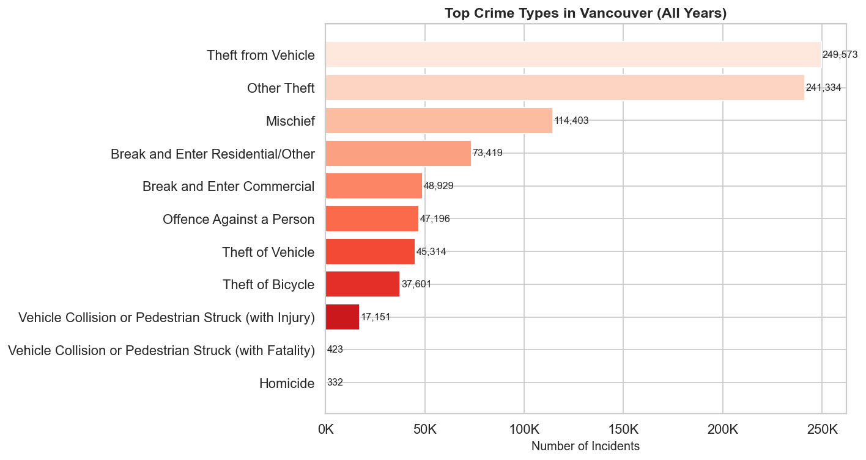

Most Significant Findings & Data-Driven Recommendations
fig, axes = plt.subplots(2, 2, figsize=(16, 12))
# land value by neighbourhood (horizontal bar)
ax = axes[0, 0]
nb_s = neighbourhood_ml.sort_values('median_land_value')
c = plt.cm.RdYlGn(np.linspace(0.1, 0.9, len(nb_s)))
ax.barh(nb_s['name'], nb_s['median_land_value'] / 1e6, color=c)
ax.set_xlabel('Median Land Value (M CAD)', fontsize=10)
ax.set_title('Median Land Value by Neighbourhood', fontsize=11, fontweight='bold')
ax.tick_params(axis='y', labelsize=7)
ax.xaxis.set_major_formatter(mticker.FuncFormatter(lambda x, _: f'${x:.1f}M'))
# crime rate vs land value
ax = axes[0, 1]
sc = ax.scatter(
neighbourhood_ml['crime_rate'],
neighbourhood_ml['median_land_value'] / 1e6,
c=neighbourhood_ml['median_land_value'],
cmap='RdYlGn', s=80, edgecolors='black', linewidths=0.5
)
plt.colorbar(sc, ax=ax, label='Land Value (CAD)')
ax.set_xlabel('Crime Rate (per 1,000 properties)', fontsize=10)
ax.set_ylabel('Median Land Value (M CAD)', fontsize=10)
ax.set_title('Crime Rate vs Land Value', fontsize=11, fontweight='bold')
ax.yaxis.set_major_formatter(mticker.FuncFormatter(lambda x, _: f'${x:.1f}M'))
# business density vs land value
ax = axes[1, 0]
sc2 = ax.scatter(
neighbourhood_ml['business_density'],
neighbourhood_ml['median_land_value'] / 1e6,
c=neighbourhood_ml['median_land_value'],
cmap='Blues', s=80, edgecolors='black', linewidths=0.5
)
plt.colorbar(sc2, ax=ax, label='Land Value (CAD)')
ax.set_xlabel('Business Density (per 1,000 properties)', fontsize=10)
ax.set_ylabel('Median Land Value (M CAD)', fontsize=10)
ax.set_title('Business Density vs Land Value', fontsize=11, fontweight='bold')
ax.yaxis.set_major_formatter(mticker.FuncFormatter(lambda x, _: f'${x:.1f}M'))
axes[1, 1].axis('off')
plt.suptitle('Vancouver Housing Insights Summary Dashboard', fontsize=15, fontweight='bold', y=1.02)
plt.tight_layout()
plt.show()
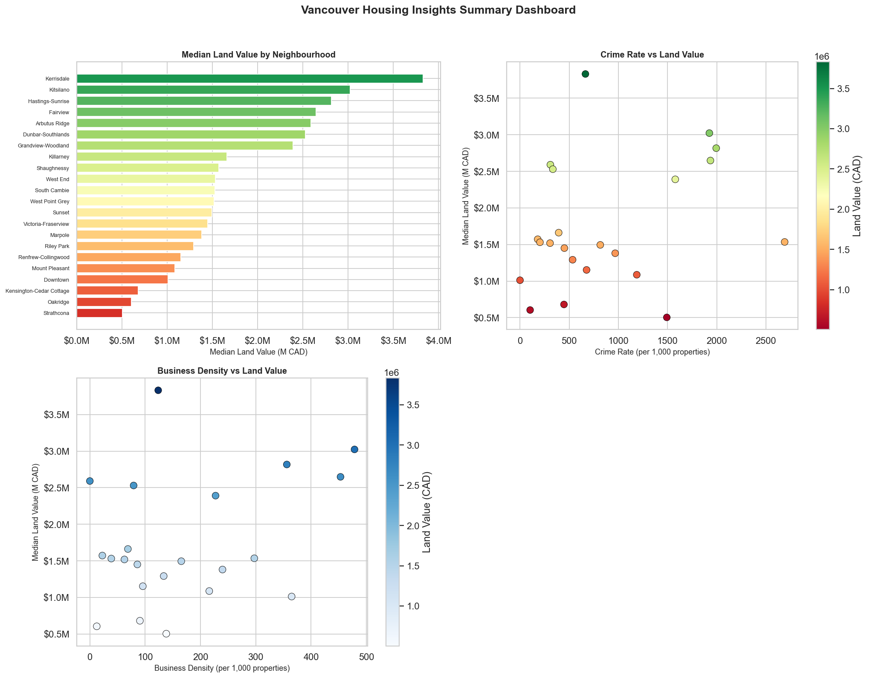

References.
Statistics Canada
Statistics Canada. (2022). To buy or to rent: The housing market continues to be reshaped by several factors as Canadians search for an affordable place to call home.
https://www150.statcan.gc.ca/n1/daily-quotidien/220921/dq220921b-eng.htm
Statistics Canada. (2021). Homeownership rates among young adults in Canada.
https://www150.statcan.gc.ca/n1/pub/75-006-x/2021001/article/00005-eng.htm
Statistics Canada. (2023). Housing affordability and income distribution in Canada.
https://www.statcan.gc.ca
Gopal, K. (2023). Metro Vancouver housing market analysis and prediction. Medium.
https://medium.com

