# Miscellaneous Configuration Options of Oracle REST Data Services

## 5.2.3 Using Jetty XML Configuration Files

This section describes how to configure the ORDS Jetty server (i.e., Standalone mode) for additional functionality using Jetty XML configuration files.

When ORDS is in Standalone mode (i.e., relying on the embedded Jetty server as its web server), ORDS can detect and “pick up” user-provided configuration settings found in the [ORDS configuration directory]/global/standalone/etc directory.

**NOTE:** You must create the [ORDS configuration directory]/global/standalone/etc directory. The /etc directory is not part of the standard ORDS configuration.

If you are familiar with Jetty, then just know that the ORDS /etc. directory is analogous to the JETTY_BASE directory, found in a standard Jetty deployment.[1]

### 5.2.3.1 Jetty Access Logs

**NOTE:** Beginning with ORDS version 24.1, the standalone ORDS Access Log format was updated to include additional format codes[2].

| ORDS versions | Jetty Format codes used | Access Log example |
| --- | --- | --- |
| 23.4 and earlier | “%h %l %u %t”%r” %s %b” | 127.0.0.1 - frank [10/Oct/2000:13:55:36 -0700] “GET /ords HTTP/1.1” 302 |
| 24.1 and later | “%{client}a %u %t”%r” %s %{CLF}O “%{Referrer}i” “%{User-Agent}i” %{ms}T %{Host}i” | 192.168.122.1 - [27/Mar/2023:23:00:07 +0000] “GET /ords/ HTTP/1.1” 302 - “-” “Mozilla/5.0 (X11; Linux x86_64; rv:109.0) Gecko/20100101 Firefox/111.0” 132 192.168.122.149:8080 |

ORDS Standalone access logs will automatically be enabled once an access log location has been configured. You may enable Standalone logging by executing the following command:

ords config set standalone.access.log [/Path to the access log location of your choosing]

![Setting the access log location using the ords cli.](./images/setting-the-ords-access-log-location.png ” “)

After issuing this configuration command, the ORDS CLI will echo back the location. You can review your configuration settings by executing the ords config list --include-defaults command.

![Displaying the access log location using the ords cli.](./images/ords-config-list-showing-access-log-location.png ” “)

You will also see a new <entry></entry> has been saved to your /global/standalone/settings.xml file in your ORDS configuration folder.

![New entry in the ORDS settings.xml file.](./images/ords-configuration-settings-xml.png ” “)

In most cases, the ORDS-provided Access Log data should be sufficient. However, should you choose to create *your own* custom access log, you may do so with Jetty XML files. [3]

#### 5.2.3.1.1 Jetty examples

The access log behavior will differ depending on your configuration settings. Below are three possible scenarios for access logs.

**NOTE:** The inclusion of these XML files at runtime changes Jetty server behavior and not ORDS behavior.

##### Scenario 1: a jetty-access-log.xml file IS included and standalone.access.log location IS NOT set

In this first scenario, you do not need to “set” the standalone.access.log location. As can be seen in the below image:

![Standalone access log location not set.](./images/standalone-access-log-location-not-set.png ” “)

*You will*, however, need to create an /etc directory in your ORDS configuration folder, similar to how you see below:

[ORDS configuration directory]/global/standalone/etc

An example:

![An example etc folder location.](./images/the-etc-folder-location-no-files.png ” “)

In the above image the /etc folder is nested under the /standalone folder, the /standalone folder is nested under the /global folder, and the /global folder is nested under the ORDS configuration folder (*your unique configuration folder name and absolute folder paths will differ*).

Place the following jetty-access-log.xml[4] file into that /etc folder.

![The etc folder with the jetty access log folder.](./images/etc-folder-with-jetty-access-log-file.png ” “)

This jetty-access-log.xml file is comprised of the following properties:

<?xml version="1.0"?>  
<!DOCTYPE Configure PUBLIC "-//Jetty//Configure//EN" "http://www.eclipse.org/jetty/configure.dtd">  
<Configure id="Server" class="org.eclipse.jetty.server.Server">  
 <Ref id="Handlers">  
 <Call name="addHandler">  
 <Arg>  
 <New id="RequestLog" class="org.eclipse.jetty.server.handler.RequestLogHandler">  
 <Set name="requestLog">  
 <New id="RequestLogImpl" class="org.eclipse.jetty.server.CustomRequestLog">  
 <Arg>/Users/choina/ords_access_logs/access.log</Arg>  
 <Arg>%{remote}a - %u %t "%r" %s %O "%{Referer}i" "%{User-Agent}i"</Arg>  
 </New>  
 </Set>  
 </New>  
 </Arg>  
 </Call>  
 </Ref>  
</Configure>

![Reviewing the jetty.xml file.](./images/viewing-the-jetty-xml-file-arguments.png ” “) *Notice the <Arg> tags.*

Pay special attention to the <Arg></Arg> tags. The first *<Arg>ument* informs Jetty where and how to save the access log file (i.e., save as access.log at the location indicated). The second argument specifies the format strings to include in the log file. For a detailed explanation of these format strings, see the Jetty Access Logs section of this document.

**NOTE:** The format strings used in this sample XML file were chosen arbitrarily. You can include whatever relevant information, assuming it is available. [See here](https://javadoc.jetty.org/jetty-10/org/eclipse/jetty/server/CustomRequestLog.html) for details.

Once you have saved this file, you may then start ORDS normally (i.e., with the ords serve command). ORDS will then save and append Jetty (Standalone) access log information to the access.log file. You can later view the results and formatting of this log at the location you specified:

![The new access log in the access log folder.](./images/new-access-log-in-file-location.png ” “) *An example access log file.*

![The format of the access log.](./images/reviewing-the-content-of-the-access-log-scenario-one.png ” “) *Reviewing the contents of the access log file.*

**NOTE:** You can remove this file from your ORDS configuration prior to the next time ORDS is started, and it will have no impact on your service.

##### Scenario 2: A jetty-access-log.xml file IS included and standalone.access.log location IS set

In this scenario you will have already completed the following two steps:

1. Configured the standalone.access.log setting using the ORDS CLI, *and*

* ![Setting the access log location using the ords cli.](./images/setting-the-ords-access-log-location.png ” “)  
  *Configuring the standalone.access.log location.*
* ![Displaying the access log location using the ords cli.](./images/ords-config-list-showing-access-log-location.png ” “)  
  *Verifying the configuration setting with the ords config list --include-defaults command.*

1. You have included a jetty-access-log.xml file (or whatever file name of your choosing) in the /etc folder.

* ![The etc folder with the jetty access log folder.](./images/etc-folder-with-jetty-access-log-file.png ” “)
* **NOTE:** You will also see a new <entry></entry> has been saved to your /global/standalone/settings.xml file in your ORDS configuration folder.
* ![New entry in the ORDS settings.xml file.](./images/ords-configuration-settings-xml.png ” “)

After executing the ords serve command, you’ll also see the standalone.access.log configuration setting included as ORDS initializes.

![Observing the access log location in the ORDS initialization](./images/standalone-access-setting-in-ords-configuration.png ” “)

You’ll also notice *two* versions of the access log files in the /[access log] folder location.

![Two versions of the access logs](./images/ords-access-log-files-two-types.png ” “)

One file for the access.log, which was created from the jetty-access-log.xml file you included.

![An example access log provided by an xml file.](./images/example-jetty-xml-access-log.png ” “)

The other will be a log file with the format of: ords_[log file date].log.

![An example access log provided by ords, the standard method.](./images/example-ords-provided-standard-access-log.png ” “)

This second file (and subsequent log files saved *by date*), is the one that is automatically created for you as a result of setting the standalone.access.log property in your ORDS configuration.[5]

##### Scenario 3: A jetty-access-log.xml file IS NOT included and standalone.access.log location IS set

This is *effectively* the standard, typical way you would configure ORDS for Standalone access logging.

Set the standalone.access.log configuration setting with the following command:

ords config set standalone.access.log [/Path to the access log location of your choosing]

![Setting the access log location using the ords cli.](./images/setting-the-ords-access-log-location.png ” “)

**NOTE:** You will also see a new <entry></entry> has been saved to your /global/standalone/settings.xml file in your ORDS configuration folder.

![New entry in the ORDS settings.xml file.](./images/ords-configuration-settings-xml.png ” “)

Remove any [jetty].xml files from your /etc folder.

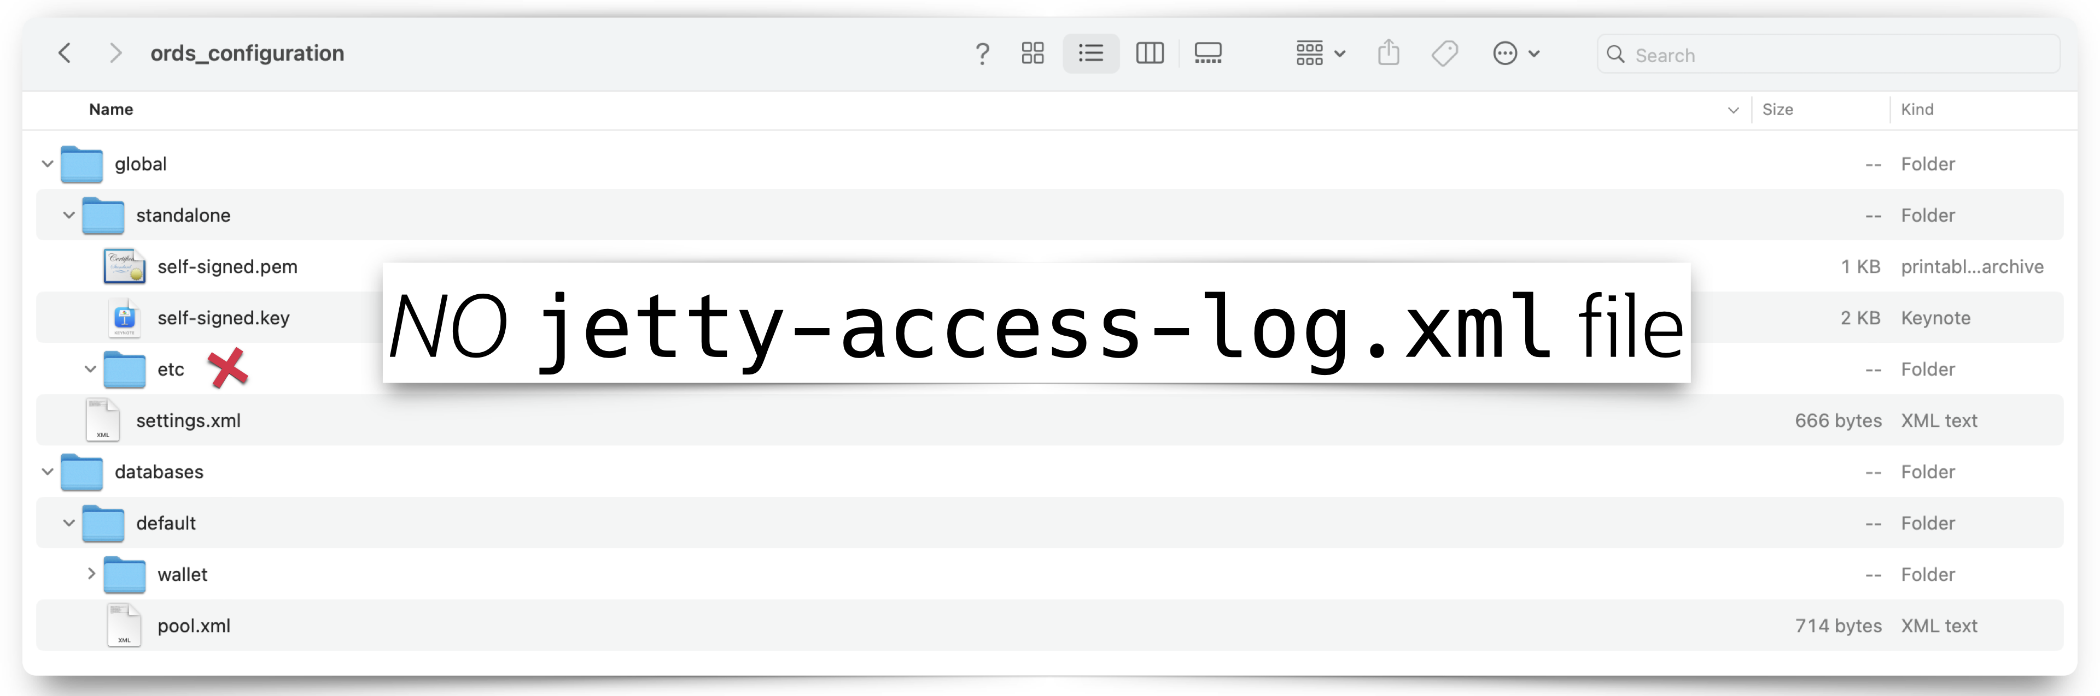

The jetty-access-log.xml file has been removed.

Once you start ORDS (i.e., ords serve) you’ll find access logs in your access log folder.

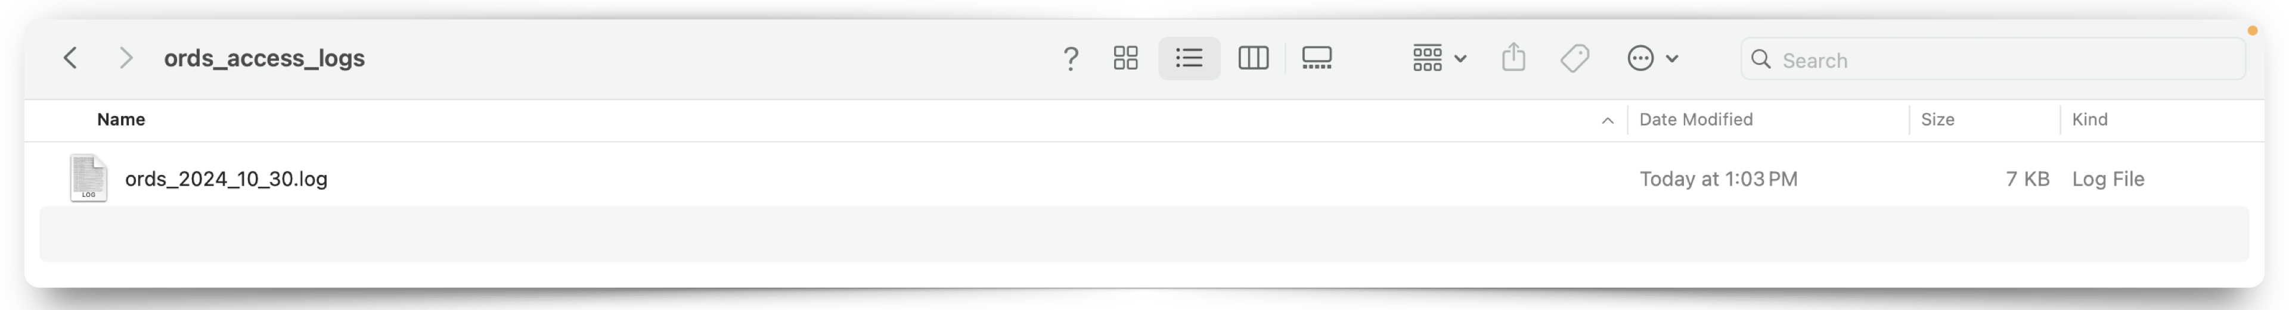

Example of a single access log, with date included

These and subsequent logs will be saved in the ords_[log file date].log format.

##### Considerations

This seems to be the most logical and convenient method for saving Standalone access logs, for a few reasons:

* No need to rely on XML files
* Log files are conveniently saved with an intuitive naming convention
* Log files are saved in a recognized format; making it easier for third-party logging analytics tools to ingest the data

1. It’s not crucial for you to have a deep understanding of how Jetty works. At a basic level, just know that there will always be a JETTY_BASE as well as a JETTY_HOME directory. And, in a standard Jetty installation, JETTY_BASE is where your modules and any customization live. While JETTY_HOME is where the Jetty binaries live. For the purposes of ORDS, the [ORDS configuration directory]/global/standalone/etc directory can be looked at as your JETTY_BASE. That is where you’ll place JETTY.XML files; similar to the ones you’ll see in this section’s examples. Again, none of this is important for you to know unless, of course, you’d like to learn more about Jetty.
2. [About Jetty Custom Request Log format codes and syntax](https://javadoc.io/doc/org.eclipse.jetty/jetty-server/10.0.24/org.eclipse.jetty.server/org/eclipse/jetty/server/CustomRequestLog.html)
3. Jetty XML files can be viewed as a simpler way to add additional configuration settings to your Jetty server without having to create a custom Jetty Module. For a deeper dive into Jetty modules, how to configure them, and customizations [see here](https://jetty.org/docs/jetty/12/operations-guide/modules/index.html).
4. This file can be named [anything].xml. The format, contents, and arguments therein are what are important.
5. The ORDS-provided access logs, automatically save in the NCSA Common log format. Since other logging applications and tools may *expect* to ingest logs in this format, it might be worth considering whether or not you actually want to customize your own Jetty access logs. You can find details on the NCSA Common log format [here](https://en.wikipedia.org/wiki/Common_Log_Format) or visit the *now-archived* [HTTPd page](https://web.archive.org/web/20081218093425/http://hoohoo.ncsa.uiuc.edu/docs/setup/httpd/Overview.html) for more information on the creation of this format.